QUESTION 1:
*Answers are for the x and y pairs given in the assignment sheet respectively*
- 8 and 76
- 11 and 55
- 5 and 30
- 11 and 143

QUESTION 2:
#include <stdio.h>
int main()
{
if (0)
printf (" Good Bye World ,");
else
printf("Where am I?");
printf(" if the world ended on December 21, 2012.\n");
return 0;
}

This program does compile and run. Its executive output and program processing is as follows:
- The code line “if (0)” (highlighted black in the figure shown above) is first read by the compiler. It is not executed because there is no set of variables defined as “(0)” nor is there any command given that would prompt the user to enter it.
- Since the “if” statement is ignored, the “printf” statement (highlighted yellow in the figure shown above) is also ignored. The reason being is that when a “printf” command is entered after an “if” statement, it becomes part of that “if” statement. If the “if” statement is false or invalid, the “printf” statement also becomes invalid and is ignored by the compiler. The compiler then jumps on to the next line of command which in this case is the “else” (highlighted green in the figure above).
- The program registers the “else” statement as true, which is due to the “if” statement being invalid. It then jumps down to the “printf” sections. It prints both statements in chronological order at the same time.
- The program ends with an exit code: 0
This code can be rewritten to allow user(s) to enter a number of their choice.
the template shown below introduces a variable, which can be defined as “0” to give the same results as the code given in the question. It will also allow user(s) to enter a value other than zero, in which case the “if” statement will become effective and the “else” statement will not be executed.

#include <stdio.h>

int main()
{
int x;
printf("Please enter a value");
scanf("%d", &x);

{
if (x==0)
printf("Good Bye World,");
{
if (x!=0)
printf("Where am I?");
{
if (x!=0)
printf("if the world ended on December 21, 2012. \n");
}

}

}
return 0;

}

QUESTION 3:

#include <stdio.h>

int main ()
{
printf ("3/4 = %f\n", 3/4);
printf("3.0/4=%f\n", 3.0/4);
printf("1+2/3+0.4=%f\n", 1+2/3+0.4);
return 0;
}

This code does compile and prints:

3/4 = 0.000000 (line 1)
3.0/4=0.750000 (line 2)
1+2/3+0.4=1.400000 (line 3)
Program ended with exit code: 0

It prints 3/4=0.000000 because it takes that number as an integer. 3/4 is equal to 0.75, the computer ignores the .75 because integer value doesn’t take numbers after the decimal.

For line 2, it prints 3.0/4=0.750000 which is the real answer. It does that because 3.0 is a float number which takes into account numbers after decimal place.

For line 3, it prints 1+2/3+0.4=1.400000. The real answer should be 2.066666667. 2/3 is an integer but its answer, 0.66666666 has decimal places. The compiler takes the value of 2/3 as 0 and adds it to 1+ 0.4 which is equal to 1.400000.

QUESTION 4 (Programming)

Step 1: Problem Identification and Definition

A software shall be developed to print letter grades for percentage values entered by the user(s).

Step 2: Gathering of Information, I/O Description

Letter Grade | Percentage scale value
A+ | 90-100
A- | 85-89
A | 80-84
B+ | 75-79
B | 70-74
C+ | 65-69
C | 60-64
D+ | 55-59
D | 50-54
E | 40-49
F | 0-39

I/O Description:

PROGRAM

Percentage grade Letter Grade
value

STEP 3: Algorithm Development and Verification
READ PERCENTAGE VALUE
BEGIN
END
PRINT LETTER GRADE ON SCREEN
ASSIGN LETTER GRADE TO PERCENTAGE VALUE FROM TABLE ABOVE

Test Cases:

 | Percentage Value | Letter Grade
Test Case 1 | 55 | D+
Test Case2 | 82 | A-
Test Case 3 | 76 | B+

STEP 5: Implementation in C

See attached c. file.

Step 6: Verification

Test Case 1:
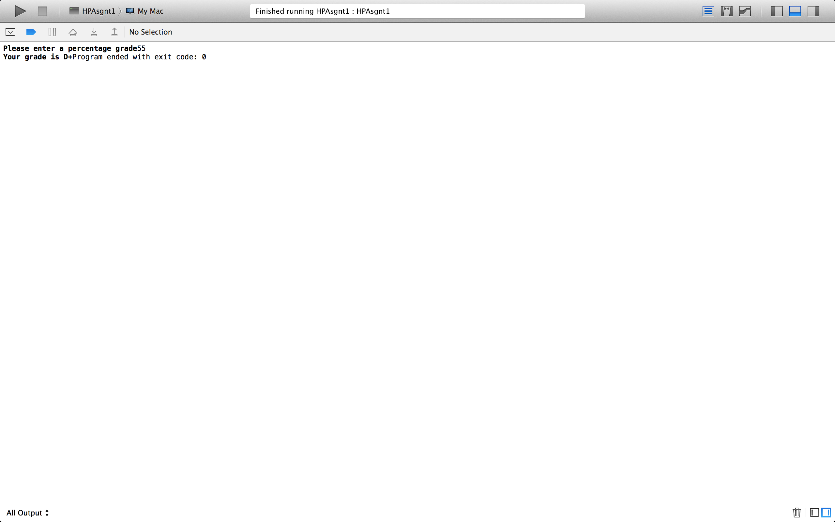

Test Case 2:

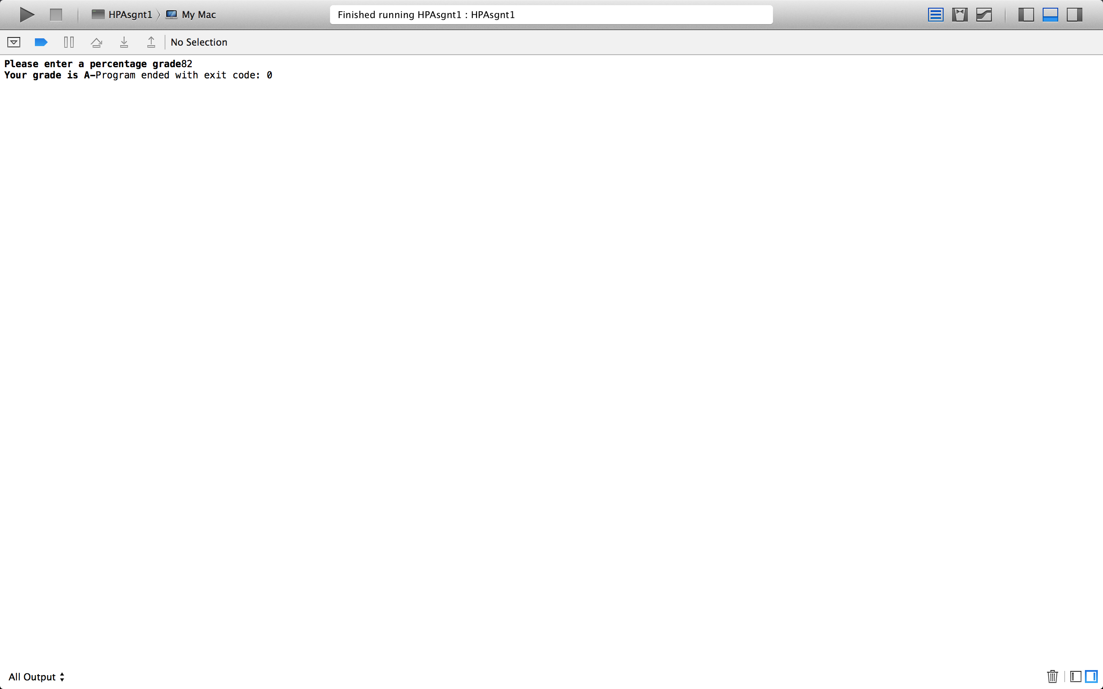

Test Case 3:



