Experiment 1
Thin Layer Chromatography

Experiment Completed: January 9th, 2018
Due: January 16th at 10:00 a.m.

Billie Jo Mendoza
Student number: 0300026799
Partner: Woosol Yoo
Student number: 300018178

CHM 1321
TA: Filipe Matos

University of Ottawa, Department of Chemistry in Biomolecular Science

Protocol
- As described in the lab Manuel. (Experiment 1: Thin Layer Chromatography, Dr. Rashmi Venkateswaran, 2014, Exp. 1, p. 17-19)
- Do not keep the capillary on the plate because it may cause a bad resolution.
- The TLC plates should not be fully wet when they are stored in the jar with the solvent. Under the UV light the spot may look smudged. Therefore, make sure the TLC plate is not stored until the TLC plate is wet until the solvent front, so should not be more than 5 minutes.
- Using a tweezer is better for placing the TLC plates.
- While placing the TLC plates into the jar, make sure that the spots are located at the bottom side of the plate, and solvent front located at the top side of the plate.
- Take image of the plate parallel to it so that it can produce the best result for Image J.
- Break the tip of the capillary so that the capillary is reusable for other solution.
Observation
Solution | Observation
Biphenyl | Clear, colourless liquid
Benzophenone | Clear, slightly brown liquid
Solvent System: EtOAc | Clear, colourless, strong alcohol odour
EtOAc and Hexane mixed solution | Clear, colourless, strong alcohol odour
Hexanes | Clear, colourless, strong alcohol odour
Unknown solution #2 | White and small crystals varied with size, translucent solid, able to dissolve completely with dichloromethane
Unknown solution #2+ dichloromethane | Colourless and clear liquid
Unknown solution YY | Clear, colourless liquid

- Received unknown compound #2 and unknown compound YY.
- Approximately 1.2 ml of dichloromethane and 11 mg of unknown compound was used for every trial
- If too much time were consumed, the liquids: biphenyl, benzophenone, unknown solution and dichloromethane mixture evaporated, only salts were visible on the container
- each solution was dipped 4 times to form a spot

Rf Values of TLC plates
Part C: Solvent system: Hexanes: EtOAc: 9:1
Diagram 7 | Rf Value
p-bromonitrobenzene | 0.55
Co-spot | Top: 0.55
 | Bottom: 0.49
Unknown sample YY | Top: 0.55
 | Bottom: 0.49
Diagram 8 | Rf Value
m-bromonitrobenzene | 0.43
Co-spot | Top: 0.48
 | Bottom: 0.43
Unknown sample YY | Top: 0.48
 | Bottom: 0.43
Diagram 9 | Rf Value
o-bromonitrobenzene | 0.39
Co-spot | Top: 0.55
 | Middle: 0.48
 | Bottom: 0.39
Unknown sample YY | Top: 0.55
 | Bottom: 0.48

Part A: Solvent system: EtOAc: Hexanes 2:8
Diagram 1 | Rf Value
Reference: Benzophenone | Top: 0.66
Reference: Benzophenone | Bottom: 0.59
Co-spot | Top: 0.66
Co-spot | Bottom: 0.59
Unknown sample #2 | 0.66
Diagram 2 | Rf Value
Reference: Biphenyl | 0.83
Co-spot | 0.81
Unknown sample #2 | 0.84

Part B: Solvent system: EtOAc
Diagram 3 | Rf Value
Reference: Benzophenone | 0.75
Co-Spot | 0.75
Unknown sample #2 | 0.75
Diagram 4 | Rf Value
Reference: Benzophenone | 0.81
Co-Spot | 0.82
Unknown sample #2 | 0.82
Part B: Solvent system: Hexanes
Diagram 5 | Rf Value
Reference: Benzophenone | 0
Co-Spot | Top: 0.23
Co-Spot | Bottom: 0
Unknown sample #2 | 0.23
Diagram 6 | Rf Value
Reference: Biphenyl | 0.20
Co-Spot | 0.19
Unknown sample #2 | 0.19

TLC Plates drawn with ChemDraw
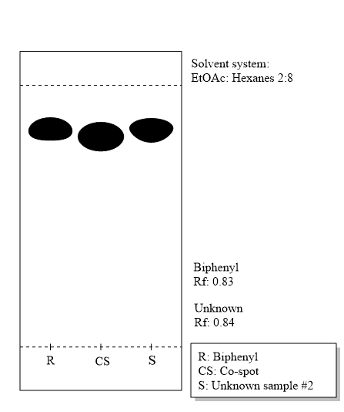
Part A
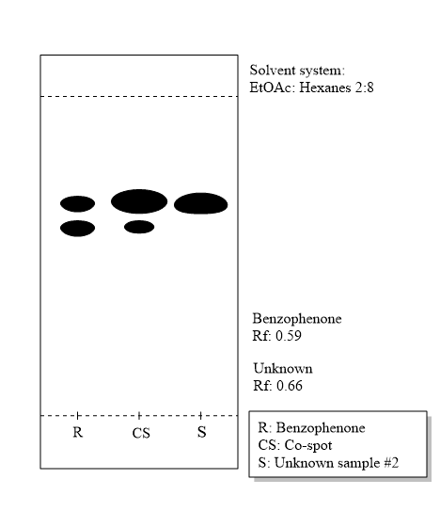
Figure 2. Biphenyl and Unknown Sample #2; solvent system: EtOAc: Hexanes 2:8
Figure 1. Benzophenone and Unknown Sample #2; solvent system: EtOAc: Hexanes 2:8

Part B-1
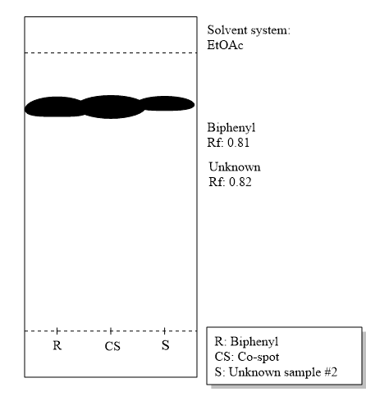
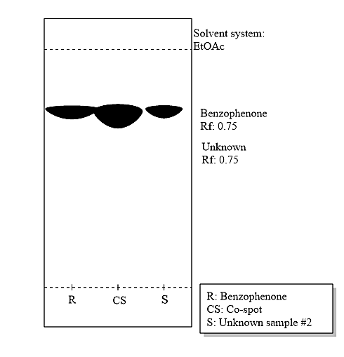
Part B-2
Figure 4. Biphenyl and Unknown Sample #2; solvent system: EtOAc
Figure 3. Benzophenone and Unknown Sample #2; solvent system: EtOAc
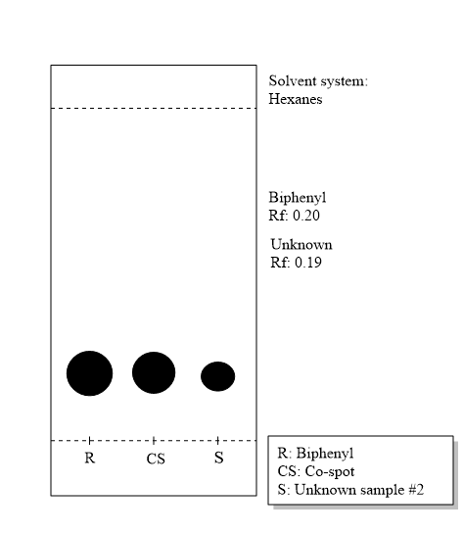
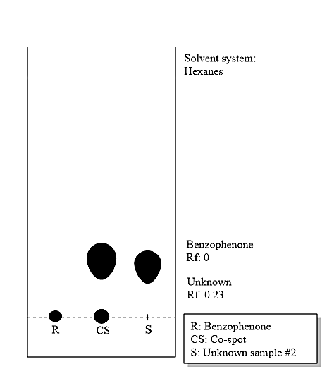
Figure 6. Biphenyl and Unknown Sample #2; solvent system: Hexanes
Figure 5. Benzophenone and Unknown Sample #2; solvent system: Hexanes

Part C
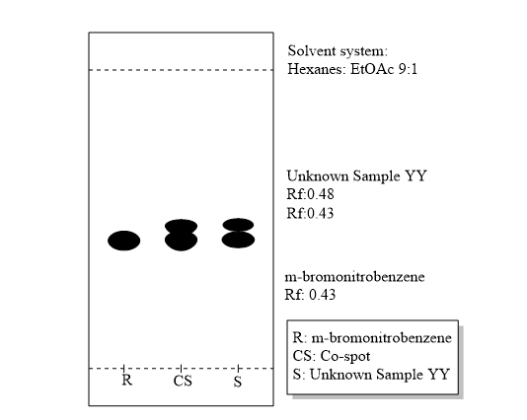
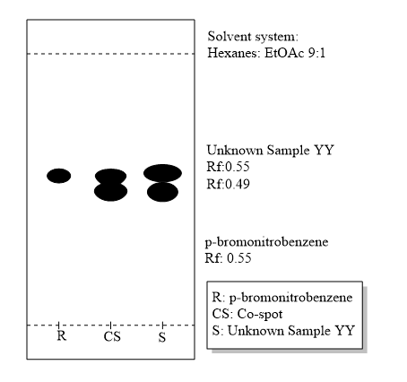

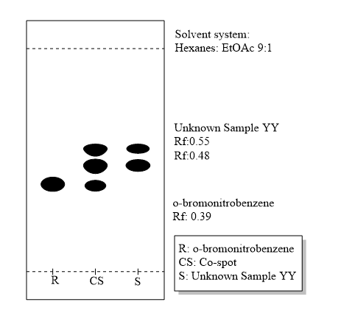
Figure 8. m-bromonitrobenzene and Unknown Sample YY; solvent system: Hexanes: EtOAc 9:1

Figure 7. p-bromonitrobenzene and Unknown Sample YY; solvent system: Hexanes: EtOAc 9:1
Figure 9. o-bromonitrobenzene and Unknown Sample YY; solvent system: Hexanes: EtOAc 9:1
Images from Image J
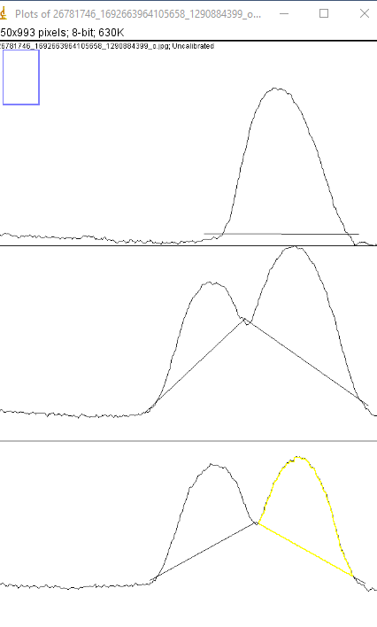
Figure 11. Image J Analysis for m-bromonitrobenzene
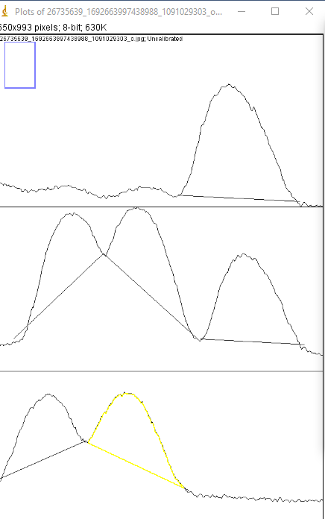
Figure 12. Image J Analysis for o-bromonitrobenzene
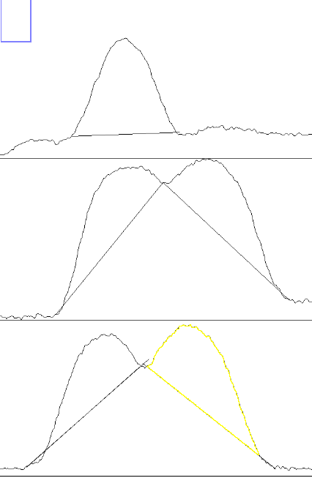

Figure 13. Image J Analysis for o-bromonitrobenzene

Calculations
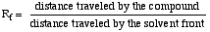
Example:
Part A. Biphenyl and Unknown Sample #2; solvent system: EtOAc: Hexanes 2:8
R_{f} = 3.6 cm/4.3 cm = 0.83
Absorbance of meta=20523.354
Absorbance of para=20233.156
% absorbance (meta)=$\frac{Absorbance of meta}{Absorbance of meta+ absorbance of para}=\frac{20523.354}{\left(20523.354+20233.156\right)}$=50.356%
% absorbance (para)=100%-50.356%=49.644%
Calibration Curve
y=% absorbance (meta)= 50.356%
y= 0.976x+0.804
Due to the locations of the spots, the equation y=mx+b was used. When looking at the TLC plates, it was found that m-bromonitrobenzene and p-bromonitrobenzene share a similar location on the spot plate. O-bromonitrobenzene does not, which concludes that the sample was made out of both meta-bromonitrobenzene and para-bromonitrobenzene
x=50.77%
% mole (meta)=50.77%
% mole (para)=49.23%

Discussion

Part A:
-Biphenyl is likely the unknown substance.
-The Rf values are very similar (more similar than that of benzophenone)
-On the TLC plate, the dots appear to be fairly high, which means it was a fairly non-polar substance.
-Benzophenone is more polar than biphenyl, so if it were benzophenone, the dots would appear to be much lower on the TLC plate.

Part B-1:
-Ethyl acetate was used in part 1 of B.
-Ethyl acetate is polar.
-Ethyl acetate has an oxygen located near the middle of the molecule with two lone pairs.
-The lone pairs are what make Ethyl acetate more susceptible to bonding to the silica gel.

Part B-2:
-Hexanes were used in part 2 of B.
-Hexanes are symmetrical.
-Because they are symmetrical, they have no poles, and are non-polar.
-The silica gel makes a dipole dipole bond with the developing solvent, which cannot be broken by a hexane.
-The conclusion of Part B is that the Rf value for hexanes is less than the Rf value of ethyl acetate.

Part C:
-Image J (which shows m-bromonitrobenzene and p-bromonitrobenzene) coincides with the reference section.
-This shows that the reference dot contains both m-bromonitrobenzene and p-bromonitrobenzene.
-Therefore sample YY is made up of m-bromonitrobenzene and p-bromonitrobenzene.

Questions
1)The less polar the compound is, the more it will travel up the TLC plate. A large Rf value coincides to a non-polar molecule. This is due to the solvent polarity; the silica is a polar solvent, so when a polar molecule gets dropped onto the silica, they form a bond. And if there is a non-polar compound that gets added to the silica, the molecule is likely to travel high up the TLC plate because it does not experience the bonding to the silica.

2)
a)
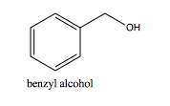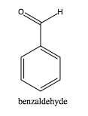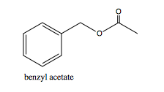

To have the smallest Rf value, the compound must be more polar than the other compounds in question. Thus, Benzyl alcohol has the highest Rf value because it is the most polar. Benzyl is the most polar compound of the three above because it has a hydroxyl group located on the carbon ring structure. The other compounds do not have this polar molecule at one end of the molecule.
b)
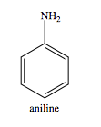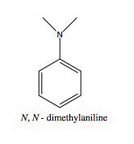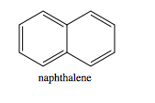
N,N-dimethylaniline is the most polar molecule due to the two hydrogens attached to the nitrogen atom. These two extra electrons make the molecule more able to bond than the aniline molecule. Naphthalene is not a candidate of being polar because it is completely symmetrical, thus there is no positive or negative charge on any end of the molecule. Therefore the molecule with the smallest Rf is N,N-dimethylaniline.
2c.
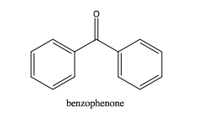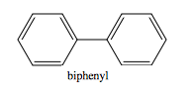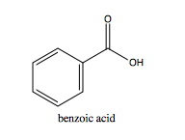
Due to the hydroxyl functional group on the end of the benzoic acid, benzoic acid is the most polar molecule out of the three listed above. The hydroxyl will be more likely to bond with the silica than the keytone located in benzophenone, as indicated in Table 3 on page 13 of the lab manual. Thus, benzoic acid has the smallest Rf value out of the three.

Methods of Error
-The dots were not of equal size which could have altered the way the dots looked under the UV lamp.
-Some dots were too big which resulted in the individual dots merging together.
-This makes it difficult to measure because the measurements need to be from the centre of each dot to get an accurate Rf value.
-The TLC plates could not be in the solvent solution for too long.
-If the solvent got to the top of the TLC plate, it would run back down the TLC plate and smudge the dots. This was shown in Figure 10. Where the dots appear to be in a
-The measurements made of the TLC plates were not very accurate because the ruler was not to touch the silica because it might have damaged the coating.
-One way that errors could be avoided is by using substances that have a natural colour to them, so you do not have to see the spot patterns with a UV lamp.
-Another way that more errors could be avoided would be to completely do the experiment electronically, because computers are very good at math and calculations, whereas humans mess up.

Conclusion
In Part A of the experiment, it was found that biphenyl is the unknown substance (unknown compound #2). Part B of the experiment showed that EtOAc is more polar than the other solvent which made a difference in the Rf values on the TLC plates. The Rf values on the TLC plates that rested in the EtOAc solution showed higher Rf values than in the other solvent. Lastly, in Part C, the unknown solution YY was found to be made up of 50.77% m-bromonitrobenzene and 49.23% p-bromonitrobenzene.
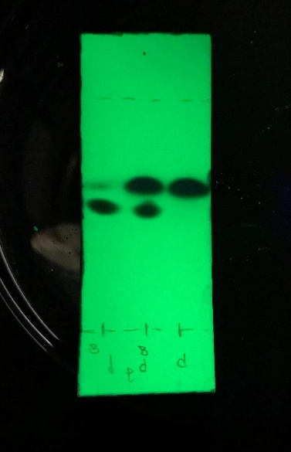
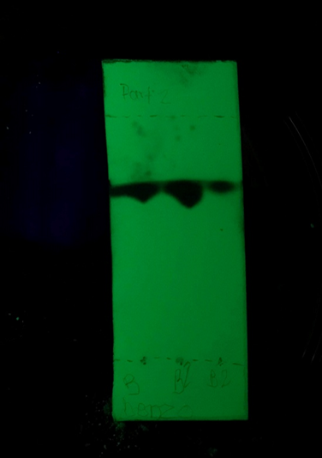
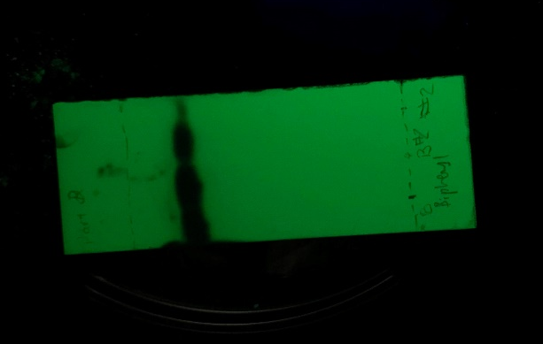
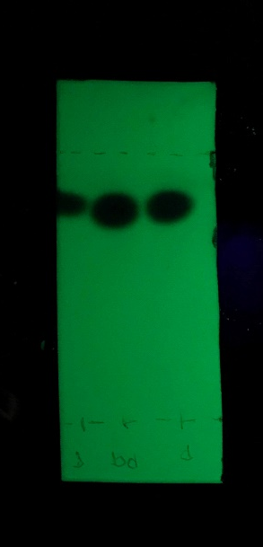
Raw Data
Raw Data of Figure 4.
Raw Data of Figure 2.

Raw Data of Figure 3.
Raw Data of Figure 1.

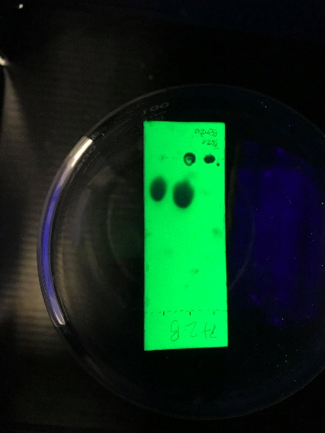
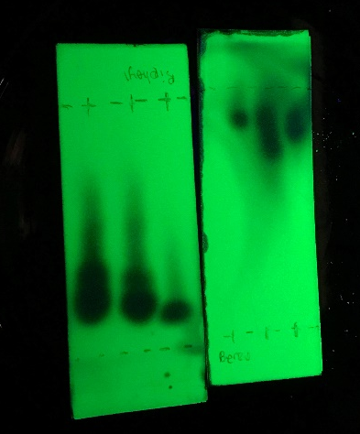
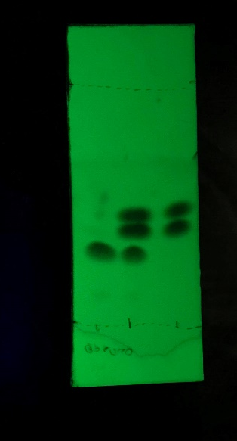
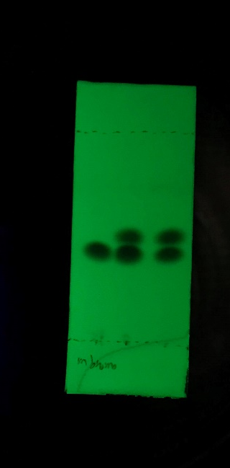
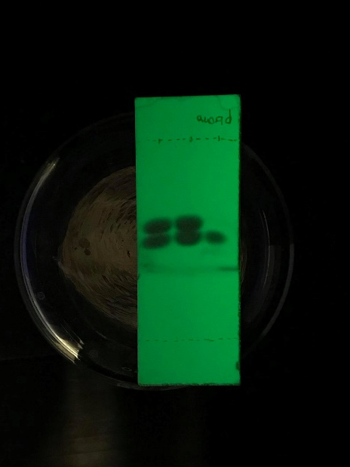
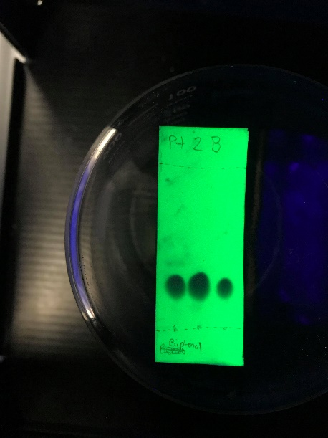
Raw Data of Figure 10.
Raw Data of Figure 9.
Raw Data of Figure 8.
Raw Data of Figure 7.
Raw Data of Figure 6.
Raw Data of Figure 5.


