Communication and Health Final Notes
For the final we have:
Chapter 6, 7, 4, 9, 10, 11, 3, 12

Chapter 6: Nonverbal communication

6.1 Communicating Without Words

- Nonverbal communication: message component other than words that generate meaning
  - Anything that is beyond written or oral communication
- A large portion of the info we get is nonverbal
- Multidimensional: depends on things such as
  - Physical Appearance
  - Body movement
  - Facial expressions
  - Touch
  - Vocal
  - Characteristics
  - Communication context
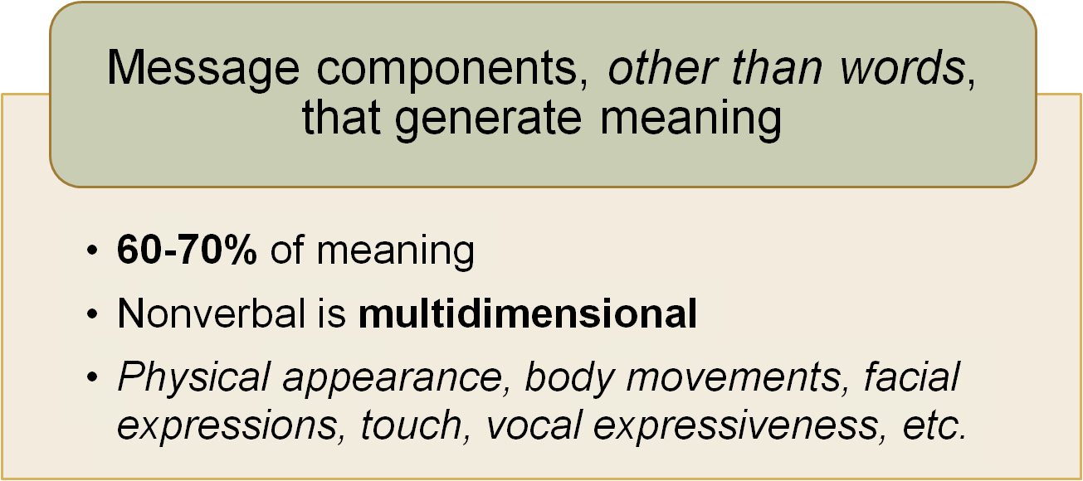

- Awareness of nonverbal b/v can result in academic and occupational success, satisfying rltshps, a more satisfying marriage, less stress, anxiety and hypertension

The Nature of Nonverbal Communication

- Nonverbal communication allows for --- when it is used in addition with verbal communication

Nonverbal communication is:

More convincing
- Because spontaneous and revealing
- Perception can be deceiving, though “He seemed so honest when I met him” or “She acted like she really cared”

Highly contextual
- Message is dependent on situation’s psychosocial, logistical and interactional context
- For example, depending on situation a laugh can be interpreted as amusement, approval, contempt, scorn or embarrassment

Continuous
- Never interrupted and therefore people interpret your opinions and feelings even when you are not talking

Less structured
- personal experiences based on your childhood developed them
- few agreed upon rules
- can be difficult to interpret because nonverbal b/v can communicate multiple and ambiguous meanings

Learned informally
- Learn to communicate nonverbally by watching others and interpreting feedback about your nonverbal b/v
- Failure to learn appropriate b/v can embarrass you and result in misunderstanding and confusion
- even when these are the things that we understand how it’s broken down, they are subjective

Functions of Nonverbal Communication
- Allows you to send and receive messages through all five of your senses
- More info to draw on when generating or interpreting message

Create an Impression
- Nonverbal messages create strong impressions
  - E.g. attorneys tell witnesses how to dress and how to look and sound sincere and confident because will be judged as soon as walk in through the door
- All these things create an impression when walk into room: physical appearance, clothing, posture, facial expression

Identify and Express Emotions
- Someone can say something but it is their vocal intensity, facial expression and body movement that tell you how to interpret the emotion and in doing so, can make words unnecessary if correctly interpreted

Define Relationships
- Closeness and duration of hug can describe level of intimacy b/w two people
- Establishing leadership by taking a central position at the head of a conference table
- More than just friends: holding hands, kissing

Establish Power and Influence
- Take up more space
- Touch others more than are touched
- Look at others less frequently unless want to convey a strong message
- Powerful voice and confident posture

Interpret Verbal Messages
- Metamessage: message about a message
- “I’m feeling fine after my fall” whilst wincing while walking (know person is actually not fine)
- “I’m glad to see you: but is looking over your shoulder to see who else is in room (distrust sincerity)

Deceiving Others and Detecting Deception
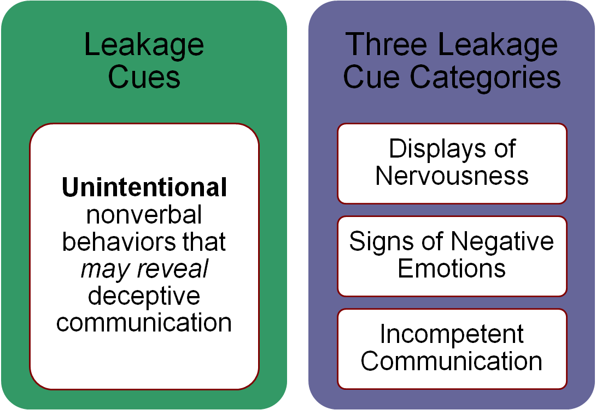

Displays of Nervousness: vocal tension, more blinking, fidgets, longer pauses, fewer facial changes

Signs of Negative Emotions: reduced eye contact, agitated vocal tone, fewer pleasant facial changes

Incompetent Communication: physical rigidity, lack of spontaneity, hesitations, exaggerated movements

- A skillful liar can look you in the eye
- Some things are more giveaways than others: vocal pitch is less controllable than facial expressions
- Nonverbal behaviours differ from culture to culture so context and culture is an important consideration

6.2 Linking Verbal and Nonverbal Communication
- Reliance on each other to generate and interpret the meaning of a message
  - Verbal expression of anger is accompanied by frowning, standing farther away and/or using a harsh voice

Repeat

- Repeating a verbal message
- Nodding while saying “Yes” to a decision
- Pointing while saying “I want this”
- Holding up two fingers while saying “Two pieces.”

Complement
- Nonverbal communication is consistent with the verbal message
- At an interview, not only what you say will convey your confidence, but posture, facial expression and vocal quality will, too

Accent
- Accenting important elements in a message will highlight its focus on the emotional content
- Saying “I’m angry” with louder volume, forceful gestures and piercing eye contact
- Stressing a word or phrase

Regulate
- taking turns talking and who is directing the conversation
- Want to speak: raise hand in large group or lean forward in small group
- Listening is indicated by nodding, as in to continue what you are saying

Substitute for
- No verbal message, only nonverbal
- “saying no” OR nodding, waving to say hello or goodbye, moving a single finger to signal stop

Contradict
- what you are saying and the way you look do not match with one another
- Receive a gift and thank person for it, but flat vocal expression, forced smile and lack of eye contact suggest otherwise
- Causes messages to be confusing and difficult to interpret

Expectancy Violation Theory

- Your expectations about nonverbal behaviour affect how you interact with others and how you interpret the meaning of nonverbal messages (Based upon your personal experiences, which is tied to your culture, you expect certain things from people)
  - Communicator characteristics: age, gender, ethnicity, physical appearance, personality, reputation
  - Relational characteristics: level of familiarity, past experiences, relative status, type of rtlshp with others
  - Contextual characteristics: physical, social, psychological, cultural and professional setting and occasions
- Two different scenarios involving grabbing a coffee and interacting with a male
  - Grab coffee at a coffee shop and interact with a poorly dressed man who stands right next to you, smiling and brushes against your arm- uncomfortable you head to the door only to see him follow you
  - Grab coffee in work break room where colleague and dear friend Henry is as well- does same things mentions above

Examples of expectancy violation include:
- Not facing forward in an elevator
- 2
- 3

6.3 Types of Nonverbal Communication

- How we use nonverbal cues to make judgements about people based on these types of nonverbal communication

Physical Appearance
- Attractiveness: perceived as kinder, more interesting, sociable, successful, and desirable.
  - ex. body weight, height, shape, etc. (changed through dieting, healthy eating, fitness training, tanning, plastic surgery and chemical enhancements)
  - Montreal & Retail: resume wants a photo of you attached
  - Body build: mesomorph, endomorph, ectomorph, etc.
  - may give an advantage e.g. more attractive doctor gets more patients
- Clothing and Accessories: message about socioeconomic status, education, sophistication and moral character
  - ex. Wearing Canali or Zegna suit with expensive briefcase
  - tapered and fitted clothing shows that person puts effort into clothing and therefore is at a more professional career
  - Tattoos and Body Piercings: now very common in our social landscape e.g. banks (once considered deviant, but are changing in the subculture)
  - Easy to purchase products that denote superiority than to actually be superior in economic achievement
- Hair: highly valued in affluent cultures
  - Can reveal how you feel about aging, how extravagant or practical you are, how much importance you attach to impressing others, your socio-economic bg and sometimes even the part of the country you live in or were raised
  - ex, long hair (hippie), JB hair flip in 2010,
  - ex. Money spent on hair products and services ($Billions) → African American women
  - Hairstyle does not define a person though or their personality
- Hygiene is also really important

Body Movement and Gestures

Gestures: movements that express an idea or emotion; more gesturing used to make communication easier
- Emblem: express same meaning as a word in a particular group or culture
  - Making the okay sign (but not universal, means different things in different cultures)
- Illustrator: used with a verbal message that would lack meaning without the words
  - Holding up two fingers and saying “She called twice”
- Adaptors: habitual gestures that help manage and express emotions
  - thinking and rubbing chin with hand
  - Pounding your fist in anger
Touch
- Important: can send strong messages and can affect well-being (survival and development, ex. newborns)
- Can express control and/or dominance
  - ex. Person with higher status/power more-likely to use touch
- Some forms of touch, context dependent
  - ex. at work vs. at a restaurant
- Norms and culture have different rules about touch e.g. north american men avoid hugging e/o as a greeting wherein it is completely normal in other cultures
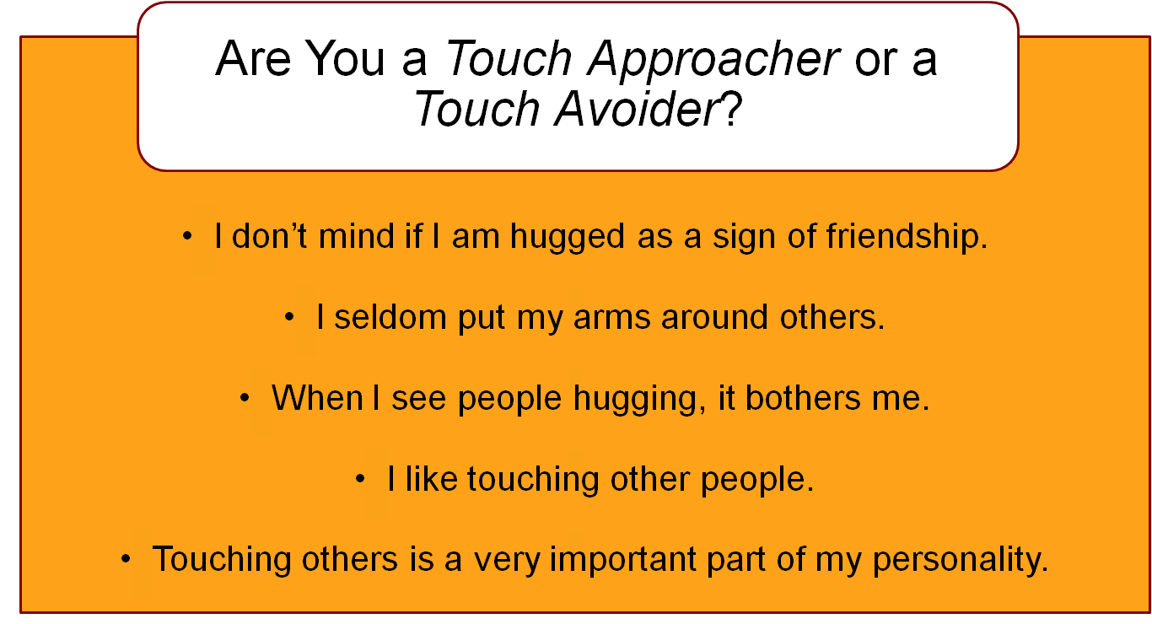

- Touch approacher: comfortable with touch and often initiate touch with others vs. Touch avoider: less comfortable initiating touch or being touched
  - When interacting with one another, cause problems
    - Touch approacher finds touch avoider cold and unfriendly
    - Touch avoider finds touch approacher invasive and rude
  - Most people are somewhere in between these two spectrums

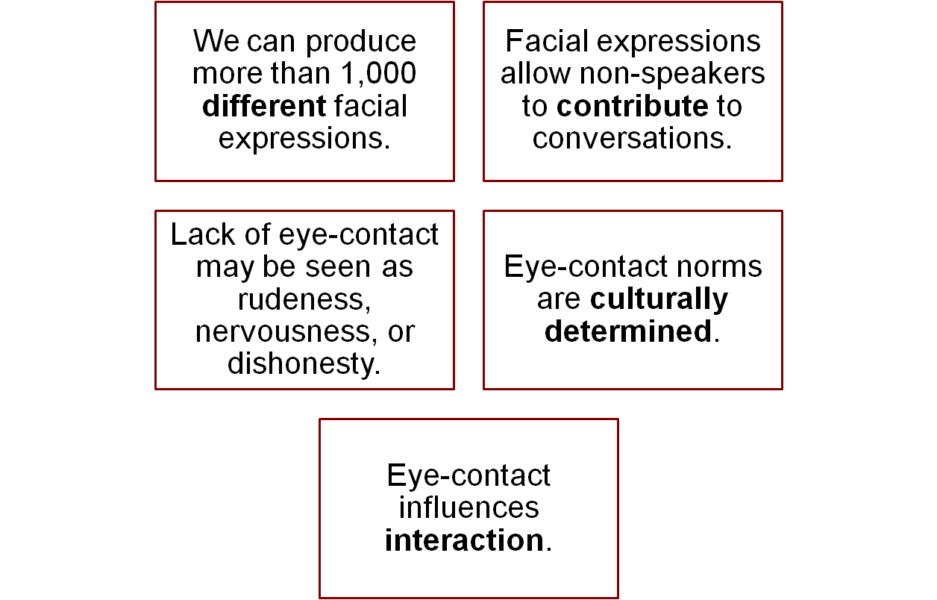
Facial Expression
- Lets others know if interested, agree with, to understand what you have said
- Men more likely to limit emotion they reveal
- Emoticons: typographical characters that express emotions
  - ☺ ☹ ;-)
- Used to convey or conceal an emotion
- We adapt facial expressions to particular situations:
Masking
- conceals true emotions by displaying expressions considered more appropriate for a particular situation
- Smiling and congratulating a colleague for getting a promotion you wanted
- Looking stern when reprimanding a toddler who has dumped a bowl of spaghetti on his head
Neutralization
- shows no emotion e.g. passport photo, acting as juror on a trial, poker face

Intensification
- exaggerates facial expressions to meet other people’s needs or to express strong feelings
- Hugging someone a few more seconds than usual to communicate how much you care
- Pouting dramatically when you do not get your way

Deintensification
- Reduces or downplays emotional facial expressions to accommodate others
- Looking mildly disapproving when a group member rudely interrupts another speaker during a meeting
- Subduing smiles of happiness after defeating a highly competitive friend in a tennis match

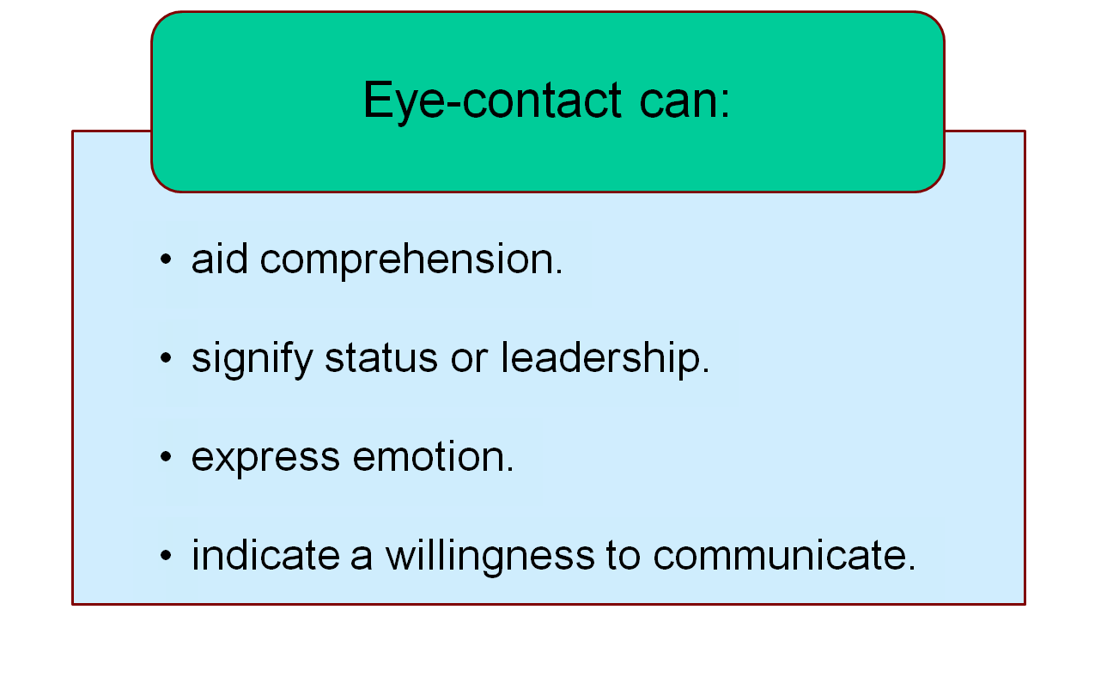
Eye Behaviour
- Can signify social position, express both positive and negative emotion and indicate willingness to relate
- We look at a speaker about 80% of the time
- Increase gaze when positive, decrease when negative
- Use to get another person’s attention
- Women > Men
- Western > Eastern
  - Western: lack of eye contact perceived as rudeness, indifference, nervousness or dishonesty
  - Asian: opposite, seen as insult, taboo or invasion of one’s privacy

Vocal Expressiveness
- How you say a word influences its meaning and how others perceive you
- Volume: loudness of voice
- Pitch: how high/low a voice sounds
  - Deep: authoritative and effective
  - Men, high: effeminate, weak
  - Women, high: silly, anxious, childish
- Rate: speed of speech (how fast/slow we talk)
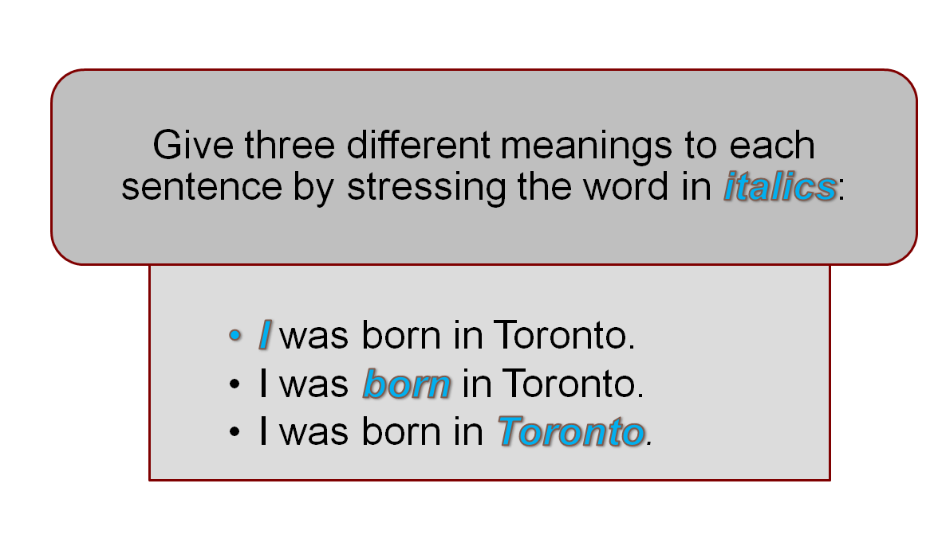
- Word stress: parts of the word we emphasize -at what point are we emphasizing each word?

Silence
- can be more important than speaking
- Putting thoughts together, showing respect for others, modifying behaviours

Space and Distance
- Territoriality: the sense of personal ownership that is attached to a particular space
  - Your usual seat in a classroom or meeting room
  - Markers: marking your territory with objects e.g. purse, coat, book, food
- Proxemics: the study of spatial relationships and how the distances between people communicates information about their rltshp
  - Intimate: 0-18 inches
  - Personal distance: 18in-4ft
  - Social distance: 4-12ft
  - Public distance: 12+ feet
Time
- Cultural dimension
- Monochronic individuals: want things to be on time
- Polychronic individuals: able to tolerate interruptions
- Social rules: ex. being late for interview vs. a party
- Students see other students who walk in as late as disruptive

Environment
- Is crucial part of nonverbal communication
- Ex. Size of space, furniture arrangement, lighting, colour, temperature, smell.
  - An office with unorganized papers, uncomfortable chairs, ugly orange walls, stale smell may create a -ve impression of the occupant
  - Compare fine dining space with fast food restaurant

6.4 Improving Nonverbal Skills
- Be other oriented: give serious attention to, concern for and interest in other communicators
- Use immediacy strategies: degree to which person seems approachable or likeable
  - Be open and approachable
  - Use direct eye contact
  - Use natural body movements and vocal variety
  - Maintain closer physical distance
- Will walk to person who is more approachable, friendly looking and approachable, clean, neat and pleasant-smelling

Chapter 6: Nonverbal communication (Additional Notes)

Types of Communication

Vocal Non-vocal
Verbal spoken words written words
Nonverbal vocal qualities (tone, tempo, pitch), sighs, screams, etc. gestures, movements, physical expressions, etc.

Characteristics of Nonverbal Communication
- Nonverbal communication exists
- Nonverbal behaviour has value
- Nonverbal communication is relational
- Nonverbal communication is ambiguous
- Nonverbal skills are important
- Nonverbal communication is different than verbal communication (Table 5.2, p.176)
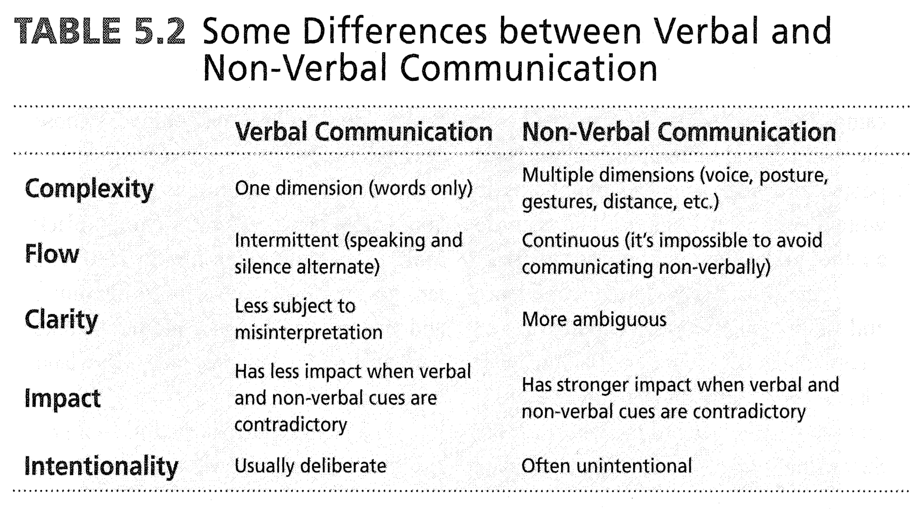

- Clarity is more ambiguous because of other factors that need to be taken into consideration e.g. masking
- Words can have more of an impact when they contradict with one’s facial expression e.g. Smiling and saying you’re happy about the fact that ama Nadira moved in with you but knowing otherwise → people will pick up on this

Influences on nonverbal communication
Culture:
- Eye-contact (gaze) – ex Japanese
  - High context: don’t give eye contact
  - Low context: give eye contact
- Personal space – ex Middle East
  - Middle east → close to one another when talking or something is off
- Assertion and passivity – ex Aboriginals
  - Aboriginals → do not give feedback unless prompted to, can be seen as not caring, but just how the culture actually is
- Universal signs – smile, laughter, sour expression
  - Differences in intensity of expression and appropriateness
- Ex. French-Canadian and English-Canadian women
  - FC women > EC women nonverbally communicative

Gender:
- More similarities than differences
- Obvious differences in physiology – ex lean body mass, depth of voice, etc.
- Social differences – women more adept at recognizing nonverbal cues
  - Women more vocally expressive, make more eye-contact
- Body position – men tend to lean forward more but stand on an angle (women face forward)
- Women smile and gesture more frequently

Functions of Nonverbal Communication
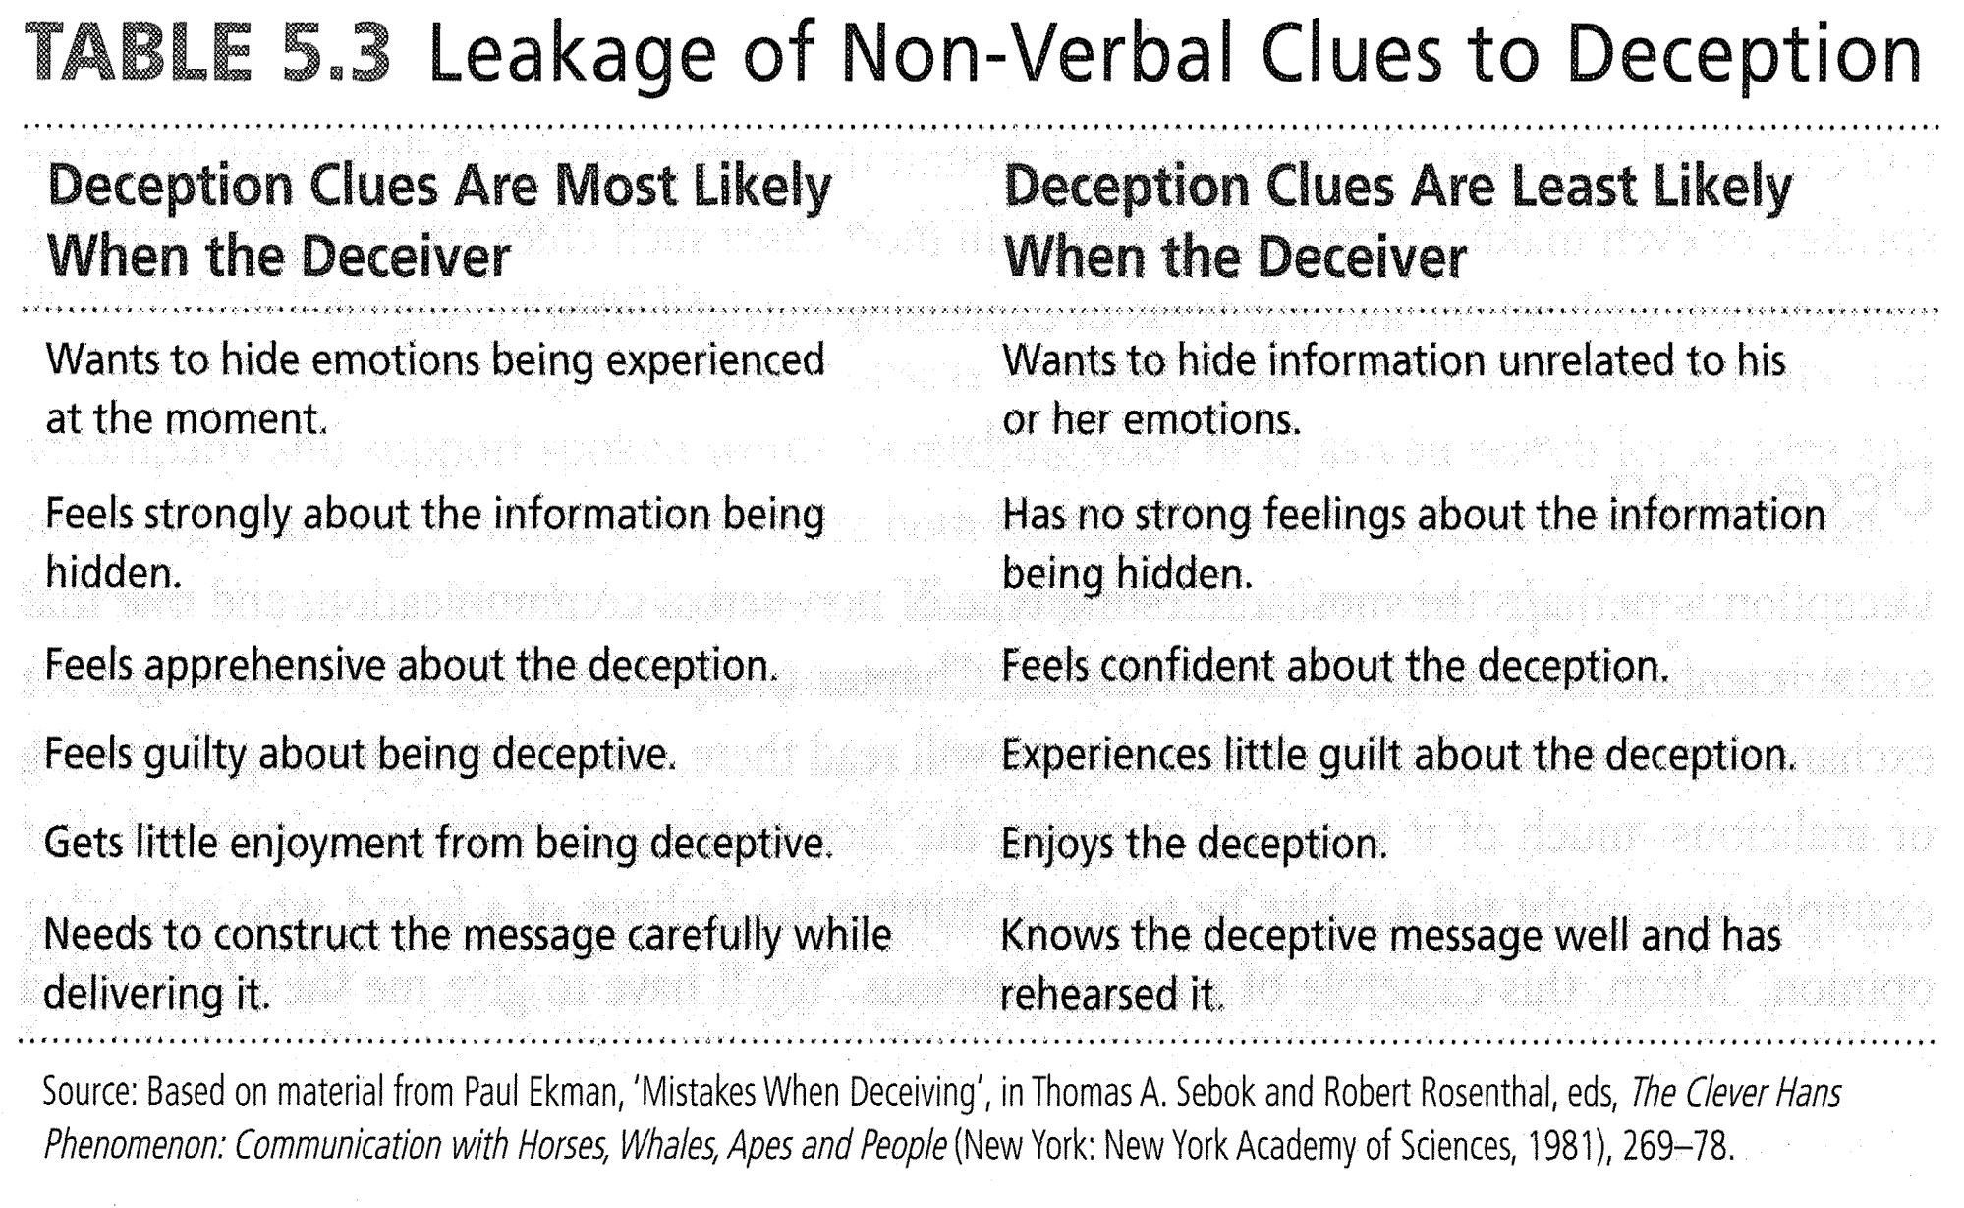

Have invested emotional interest Have no invested emotional interested

Types of Nonverbal Communication
Voice
- Paralanguage: non-linguistic means of vocal expression
  - tone, tempo/rate, pitch.
- Disfluencies: non-linguistic verbalizations ( fill in gap when bridging thought processes)
  - “um”, “ah”, “like”, “oh my God”, etc.
- Sarcasm: words that mean opposite of what they say (the use of “irony”)
  - That’s wonderful :-s

Patient and Professional Attentiveness
Patient perspective:
- Get information before verbal content is given
- When patients cannot understand terminology
- Supplement missing or omitted information from the professional
- Seek the “truth” if they feel the professional is withholding information

Professional perspective:
- In certain clinical settings, only nonverbal cues are available to help assess situation
- Direct expression of emotions usually transmitted through nonverbal cues
- Can allow for greater sensitivity to the patient’s needs and situation

Chapter 7: Understanding Interpersonal Relationships

7.1 Interpersonal Communication and Relationships
- Affective communication in close personal rltshps influence your psychological and physical health, identity and happiness, social and moral development, ability to cope with stress and misfortunes and the quality and meaning of your life
- Interpersonal relationship: when a limited number of people (usually two) interact, using verbal and nonverbal messages, to generate meaning for the purpose of sharing information, achieving a goal or maintaining relationship
  - Ex. personal (friends, romantic partners, family members) and professional (people you associate and work with to accomplish a goal or perform a task) relationships
- Relationship: continuing and meaningful attachment or connection to another person
  - Success depends on
    - Meaningful and lasting personal relationships lead to a happy life
    - Success of those relationships depends largely on how well you communicate
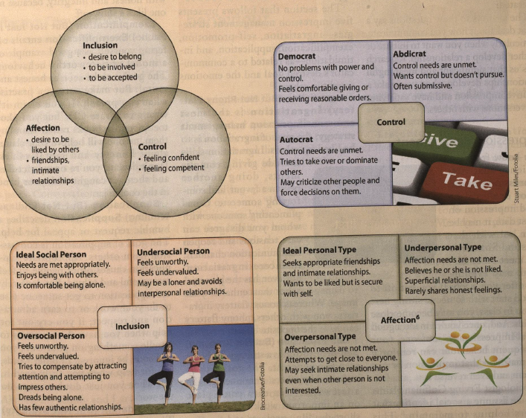

Schultz Interpersonal Needs Theory
- People interact with others in order to satisfy one or all of three basic interpersonal needs: inclusion, control, affection (ABOVE^^^)

7.2 Developing Interpersonal Relationships
Impression Management
- 5 strategies we use to shape and control the way other people see us (our ability to gain influence, power, sympathy, approval)
- The type of Q’s we ask when we are in a communication episode- if you want communication flow to continue, advocate with more open ended q’s vs/ closed
  - Open-ended: really get into storyline e.g. describe what you’re experiencing, describe, elaborate, etc.
  - Close ended: 5W’s and one word answers
- Ask open-ended questions
- Avoid asking a lot of close-ended questions

Managing the Impression you Make

Ingratiation
- But not phony flattery
- To be liked by others
- Comforting someone, complimenting someone, doing something kind for someone e.g. classmate needed study notes and give it to them
  - Too much may be look like there is a lack of genuity → What does this person want since they’re being so nice?
Self-Promotion
- But not bragging
- It’s okay to express that we are competent e.g. “I’m a fast writer” in a group where a scribe is needed but don’t go overboard because if actual performance does not live up to self-promotion, can create a bad lasting impression

Exemplification
- But not just in public
- leading by example; being congruent; complimenting words with actions, being seen as honest and moral
- Be consistent and practice what you preach
  - Claim it’s wrong to use pirate stuff, but have no shame in using it yourself
  - Claim you’re on a strict diet and yet are caught stealing cookies from the jar
Supplication
- But not whining
- A humble request or appeal for help; goal is to receive compassion from others; when done right, causes other people to feel resourceful and valued
- Express oneself in a way that is truthful to the situation but not to the extent that you’re feeling sorry for yourself; fine line b/w being genuine and whining
Intimidation
- But not brutality
- Goal: to provoke fear → assertive vs. aggressiveness
- There are fine lines b/w how it can be received by the person who receiving the message
- Not recommended in communication situations, but rather if people are taking advantage of you, you may need to stand up for yourself and demonstrate that you won’t be intimidate

Effective Conversations
- Conversation: often informal interaction in which we exchange speaking and listening roles with another person
- Starting a conversation
  - Introducing yourself and sharing some superficial information
  - Ask simple questions
- Maintaining a Conversation
  - Ask open-ended questions that encourage specific or detailed responses “What do you think about Mr. Pearson’s course and assignments?”
  - A close-ended question requires only a short and direct response and can generally be answered with a yes or no “Is this class required for your major?”
  - Start broad and become more specific (funneling technique)
- Listening to Conversations
  - Ability to actively listen (assist in picking up nonverbal cues)
  - Turn requesting cues: verbal and nonverbal messages that signal a desire to speak, such as leaning forward, providing direct eye contact and lifting one hand as if beginning to gesture
  - Turn yielding cues are verbal and nonverbal messages that signal that you are completing your comments and are preparing to listen, such as slowing down your speaking rate, relaxing your posture or gestures and leaning slightly away.
  - What it means to actively listen: Fully absorbed into person’s head space
  - Suspending your needs for the other person: more genuine communication and makes others feel valued
- Ending a Conversation
  - Ending abruptly can send negative message, look for a moment in the conversation where an ending seems natural (topic is fully exhausted or someone shifts to edge of chair, stands up, looks/leans away, or picks up personal belongings
  - At times, need to be courteous
  - At times, need to be direct -”I hate to cut our conversation short, but I have to get going.”
  - How do we avoid miscommunication e.g. having to end a communication episode/dynamic
    - “You know i don’t mean to be rude, but I have to…” → preludes the fact that this is an inappropriate time to stop the conversation but at the same time, needs to happen

7.3 Strengthening Personal Relationships
Friendship
- Intimacy: the feeling or state of knowing someone deeply
  - Emotional, intellectual, collaborative
- Close friends sharing secrets, hopes, and fears but whether we do so depends on our ability:

- to disclose information in a way that maintains relationship
- to recognize that most of these disclosures are every day, mundane, issues
- to respect that some topics are taboo, such as negative life events and serious rltshp issues

- Young adult years: can be loneliest times due to life changes
- Can see social dynamics changing: closest rltshps usually disclose closest info to you
  - At a time when get closer to colleagues who become friends than other friends and family

Mindfulness
- Mindfulness: total absorption during communication process and packed into active listening
  - Fully immersed into nonverbal cues and how they’re being expressed
  - Physiological factor changes e.g. feeling adrenaline, heart rate, etc.
  - Create an atmosphere of trust
- Environment: eliminate distractions, make eye contact
- Others: pay attention and have appropriate listening strategy
- Yourself: physical/health health, learn to listen to your body

7.4 Sharing Yourself with Others

Self-Disclosure
- The process of sharing personal information, opinions, and emotions with others that would not normally be known to them
- Does not require sharing the most intimate details of your life to others
- Does require judgements about whether and when sharing with others is appropriate

The Johari Window Model
- A model for understanding how the connections between self-disclosure and feedback can produce greater self-awareness and a positive self-concept
- Depending on how willing you are to self-disclose and how receptive you are to feedback, each of the four panes in the model differs in size; does a good job of reflecting your level of self-awareness
- Two interpersonal communication dimensions:
  - willingness to self-disclose: extent to which you are prepared to disclose personal information and feelings to others people
  - receptivity to feedback describes your awareness, interpretation, and response to someone else’s self disclosure about you

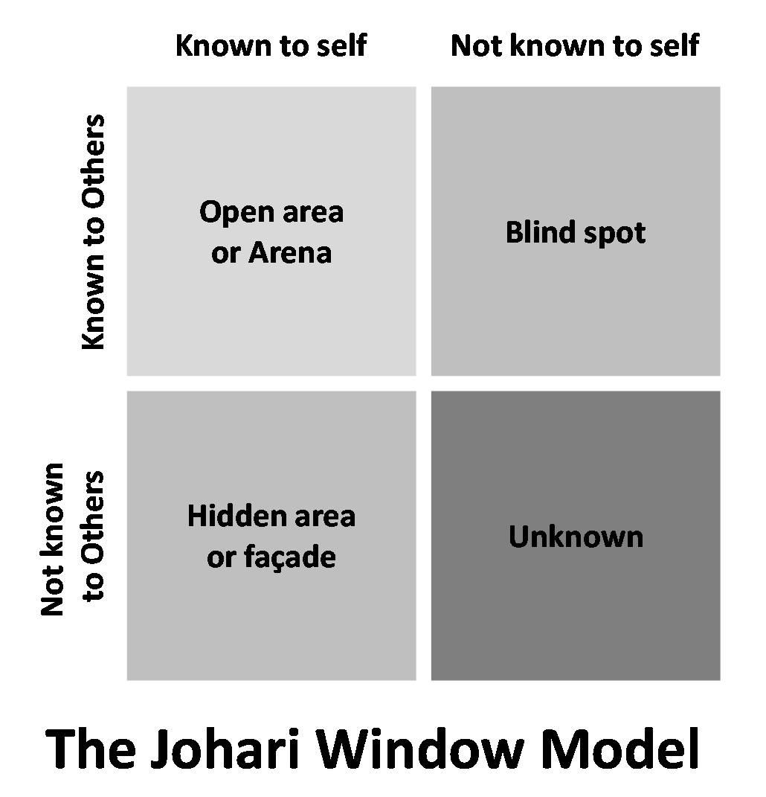
Open Area
- Information you are willing to share with others as well as information you have learned about yourself by accurate interpreting others feedback
  - E.g. wonder if okay to tell funny or embarrassing story, take risk and when people genuinely react +vely to it, learn that safe to share personal stories with this group and that you are funny

Hidden Area
- Private self, information you know about yourself but that you are not willing to share with others
- Secrets
- Some people retain information here that could enhance their personal rltshps and likability if were shared

Blind Area
- Information others know about you but that you do not know about yourself because you don’t pay attention or correctly interpret feedback from other
- If don’t notice that someone disapproves of your b/v or wants your praise for a job well done, you may not develop or maintain a close rltshp with that person

Unknown Area
- Information unknown both to you and others
  - E.g. don’t think you are a great writer, but when working in a group, you and group members discover that in fact you are

7.5 Expressing Yourself Appropriately

Social Penetration Theory
- The process of rltshps bonding that occurs when individuals move from superficial communication to deeper, more intimate communication
- Deep self-disclosure is intimate and near the core of the onion
- As two people get to know one another better, they reveal personal info, feelings and experiences below the public image lawyer
- Rltshps develop when this process is reciprocal- one person’s openness lead to another’s, and so on
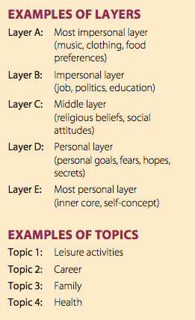
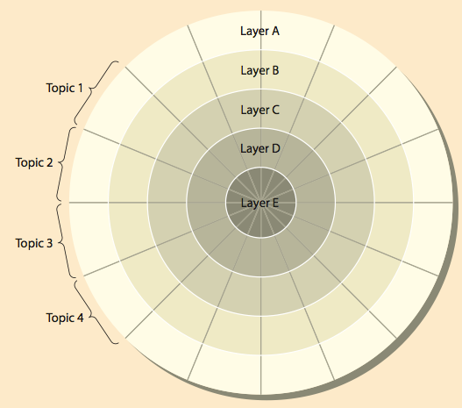

Social Penetration dimensions: three interconnected dimensions of self-disclosure
- Depth: level of intensity
- Breadth: number of topics
- Frequency: how often are you feeling these things
- Highlights what is important to a person you’re communicating with them

Effective Feedback
- When giving/getting feedback, should not be threatening or demanding environment
- Try to avoid too much (may be overwhelming)
- When you’re getting feedback, sometimes it’s not possible b/c of the e/t
- There’s a time and place for everything
- Able to give feedback to someone in a more private setting
  - E.g. friend has breakdown about boyfriend on bus vs. in her kitchen
  - Sometimes have no controls over emotions and have to deal with as is → silence can be great catharsis

The Communication Climate
- Six opposing pairs of behaviour explain a supportive or defensive communication climate
- No such thing as good or bad b/vs, depends on situation and context
  - Strategic: have important and strong motives
  - Certainty: experience is well recognized and a critical decision must be made
  - Neutral: issue is of little consequence to you or others
- Defensive behaviours reflect our instinct to protect ourselves
  - Evaluation: try not to have preconceived notions in situations, judge another person’s b/vs “What you did was terrible. Why did you insult Sharon like that?”
  - Control: impose your solution on someone else “Give me that report and I’ll make it better”
  - Strategy: manipulate others, hide or disguise personal motives, withhold info “Remember when I did this for you? Pay up.”
  - Neutrality: Appears withdrawn, detached, or indifferent, won’t take sides. “Life’s a gamble, doesn’t matter to me, whatever.”
  - Superiority: thinking that you’re better than other people, promote resentment and jealousy “I’ve done that a million times, let me do it. I’ll finish it in no time.”
  - Certainty: belief that your opinion is the only correct one, refuse to consider ideas and opinions of others, takes inflexible positions. “I can’t see how doing it any other way makes sense.”
- Supportive behaviours create a climate in which sincere self-disclosure and responsiveness to others and benefit everyone
  - Description: describe another’s b/v, make understanding statements, use more I and we language. “When we heard what you said to Sharon, we were really embarrassed for her, I’m sorry about that.”
  - Problem orientation: seek a mutually agreeable solution, “Let’s figure out how we can both enjoy this vacation”
  - Spontaneity: makes straightforward, direct, open, honest and helpful comments “Can I help you move those boxes.”
  - Empathy: accepts and understands another person’s feelings: “I can understand that you’re feeling upset, it sounds as though you are having a hard time deciding.”
  - Equality: suggests that everyone can make a useful contribution “Let’s tackle this problem together.”
  - Provisionalism: offers ideas and accepts suggestions from others “We have a lot of options here, which one make most sense. I feel strong about this but I would like to hear what you think.”

Assertiveness
- Willingness and ability to stand up for your own needs and rights while also respect the needs and right of others
- Promotes your needs and rights while also respecting the needs and rights of others (GOLDEN STANDARD)
  - Can under compensate or overcompensate
- Passivity: gives into others at the expense of your needs or avoids conflict
  - Fail to take responsibility for own actions and their consequences, blame others for their unhappiness
  - Jackson’s boss needs him to work this weekend when he wasn’t scheduled and Jackson agrees even though he had a family event that he wanted to attend
- Aggression: puts your personal needs first, often at the expense of others’ needs
  - Raised voice, rolled eyes, withering glance
- Passive-aggressive: the manipulation of others for the sake of one’s own needs
  - Backdoor aggression
  - When refuse to do a favour for your brother, mopes around house until actually do it for him
  - In long run, can damage interpersonal and professional relationships

7.6 Developing Assertiveness

DESC scripting (Bower & Bower) - 4 step process
- Describe: the situation or behaviour
  - The last time we had a group project due, I did most of the work
- Express: your feelings clearly and calmly
  - As a result, I was exhausted and angry
- Specify: what you want to happen
  - For this next project, I would like the two of us to work together
- Clarify: the consequences of accepting or denying your request
  - If we work together on this project, the report will be done better and fast and hopefully we’ll earn a good grade.”

Edmund Bourne and Setting Limits
- Saying no means that you set limits on other people’s demands for your time and energy when such demands conflict with your own needs and desires
- Acknowledge the other person’s request by repeating it. “I’d love to have lunch with you tomorrow.”
- Explain your reason for declining. “But, I have a deadline on Friday, so I have lots of work to do and can’t take the time this week.”
- Say no. “So I’ll have to say no.”
- (Optional) Suggest an alternative proposal so that both your needs and the other person’s needs will be met. “I’d love to get together though. How about next Tuesday or Wednesday?” leave out this option when there isn’t a reasonable alternative: I hear that you need help with moving. I’d like to help but I promised my boyfriend we would go away this week so I’m not going to be around. I hope you can find someone else.

Chapter 6 Additional: Self-disclosure and Styles of Expressing Conflict (Assertiveness)
Self-Disclosure

Factors influencing self-disclosure

- You (who you are)
  - introversion and extroversion
    - Extroverts are more likely to self-disclose regardless of who they’re with and the environment they are in
- Your culture
  - if we compare yourself to our South American neighbours, they are more likely to expect self-disclosure than here in North America. Whereas in comparison to Europe, we disclose more than them. Europeans disclose more than Asians (disclose the least amount
- Your gender
  - women > men (especially one on one- diatic) disclose more with same gendered partner in a conversation. Men tend to disclose more on an initial meeting to show assertion
- Your listeners (dyadic effect)
  - Context colours the depth of your conversation e.g. crowd vs two people
  - upstream affect: more likely to disclose upstream than downstream; aka disclose information with people who are more closer to you
- Your topic

Rewards and dangers of self-disclosure

Rewards:
- Self-knowledge (self-acceptance)
- Physiological health: catharsis is related to less stress, better health, etc.
- Relationship effectiveness: people who communicate more emotional content tend to have longer lasting relationships than those who don’t

Dangers:
- Personal: with.g. Revealing sexual orientation
- Professional: can affect credibility
- Relational: can change family dynamics or your rltshp with a significant other

Guidelines for making self-disclosure
- Is the self-disclosure appropriate
  - when someone reveals something that you don’t know how to respond to -is the e/t the greatest place for this to happen?
- Is the other person also disclosing
- Will the disclosure impose burdens

Guidelines for facilitating and responding to disclosures
- Practice “active listening”
- Be willing to reciprocate
  - Willingness to reciprocate can maintain flow of conversation
- Keep disclosure confidential
  - must have stipulations connected to medical profession

Styles of Expressing Conflict
- Don’t be concerned about how it breaks it down
- Indirect → you’re looking to achieve something but do so in a way that someone can “save face” → not feel embarrassed
  - I don’t know how to interpret that but I think it’s directed at me
  - It’s late and you have to have a serious discussion using the DESC methodology with lab partner but want them to leave because tomorrow you have a party -What do you do? “i’m getting tired”, yawning, cleaning
    - Indirectly saying that I can't get that you’re late but STILL trying to be respectful
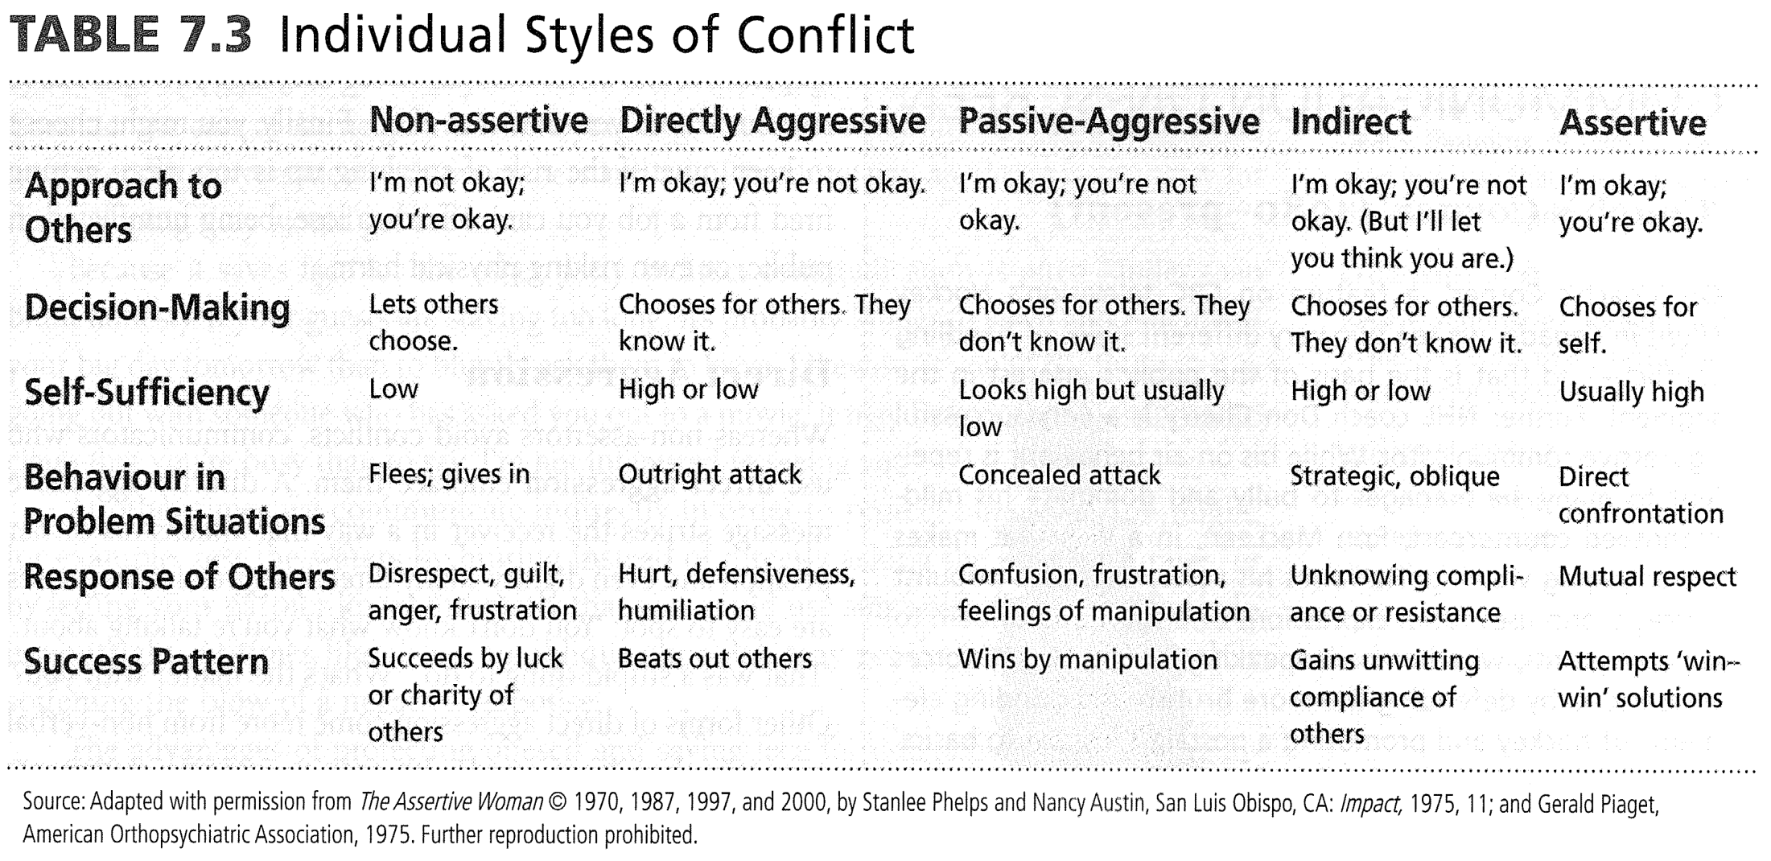

Characteristics of an Assertive Message
Behavioural description: non-judgmental
- I’d like to discuss what happened at our last group meeting specifically when I made the suggestion to the group that we should make our meetings shorter but more efficient
The interpretation of the other person’s behavior: perception checking
- I’m not sure if you were aware or if you meant to do so on purpose but you laughed at that suggestion to the group
A description of your feelings
- That hurt and offended me, I felt disrespected

A description of the consequences
- You, the speaker: This means that I will be likely to be very hesitant and closed off when I am around. I may not be as open or willing to reciprocate your communication
- The person being addressed
- Others

A statement of your intentions
- Your stance on an issue:
  - So if we are to have a healthy working rltshp (in order to be more open at work)
- Requests of others:
  - What I would need from you is to be more aware of these things, from this point onwards
- Descriptions of how you plan to act in the future
  - If you think you are not able to do so, the next step would be for us to bring this to the attention of our manager/leader

Developing Assertiveness
- Becoming less shy? How can you become more assertive in social situations?
  - Set a goal
  - Appear warm and friendly – body language
  - Conduct anonymous conversations
  - Greet strangers
  - Practice being decisive

Chapter 4: Listening, Critical Thinking and Reflective Practice

4.1 The Nature of Listening

How well do we listen?
- We spend most time listening (speaking, reading, writing)
- After a short talk, most only recall ~50% of content (~25%, without training)
- Active listeners: increase in BP, HR, and perspiration (in the process of understanding the speaker, at an emotional level, and the conclusion the speaker is making without stating it openly)
- Listening: receiving, constructing meaning from, and responding to spoken and/or nonverbal messages
  - Hearing: sensory capacity to take in auditory stimulus
  - Listening: fully decipher the stimulus -physical ability + complex thinking ability

Assessing your Listening Habits
- Knowledge: unless you understand the principles of human interaction, you may not even know you need to listen
- Skills: Even if you know you need to listen, you may not have this skill
- Desire: Knowing you need to listen and knowing how you listen are not enough. Unless you want to listen, listening won’t be an enduring habit

Poor Listening Habits?
- Defensive: focus on how to respond
  - ex. feeling threatened by critical remarks
- Disruptive: interrupt others when they speak
  - ex. sigh, rolling eyes, head shaking etc.
- Pseudolistening: fake listening
  - ex. the mind is elsewhere
  - Selective: avoid listening to those you do not like
  - ex. avoid technical information
- Superficial: more focused on nonverbal
  - ex. how they look and speak… not the content of the message

4.2 The Listening Process
The HURIER Model

Hearing
- The ability to make clear, aural distinctions amongst the sounds and words in a language; prerequisite to all listening
  - I sometimes have trouble hearing a soft-spoken person particularly if there’s background noise
Understanding
- Ability to accurately grasp the meaning of someone else’s spoken and nonverbal messages
  - When you say wait, do you mean we should wait a few more minute or wait until Caleb gets here?
- Asking q’s is a great way to make sure you understand

Remembering
- Ability to store, retain and recall information you have heard
  - Hi George, I remember meeting you last month. Did you end up selling your old truck?
- Repeat an important idea of piece of info after you hear it
- Associate a word, phrase or idea with something that describes it
- Visualize a word, phrase or idea e.g. when woman was told to take Ca2+ calcium channel blockers, thought of swimming English channel with floating Ca2+ pills
- Mnemonic: memory aids based on pattern or rhyme
- Memory
  - Short term: recall immediately after listening e.g. series of number or words
  - Working: memory subsystem used to comprehend, remember and form a mental image of what is going on around us (used to learn new thing, solve problems, form and act on goals)

Interpreting
- Ability to empathize with another person’s feelings without judging the message; focus on their situation, feelings or motives b/c if don’t may overlook message
  - It must be frustrating and discouraging to have such an unsympathetic instructor
  - Kim saying she doesn’t want to go for a drink after the class discussion could mean
    - She has more important things to do during exam week
    - She doesn’t drink
    - She doesn’t want to share her notes

Evaluating
- Ability to analyze and make a judgement about the validity of someone’s message
- Understand that someone is trying to persuade rather than just inform
  - I see two reasons why that proposal won’t work….

Responding
- Ability to respond in a way that indicates you fully understand someone’s meaning
  - You seem to be saying that it’s not a good time to confront Mercedes. Am I right?
The Art of Paraphrasing
- Restating what people say in a way that indicates you understand them
  - Form of feedback: “Am I right? Is this what you mean?
  - Matches content, depth, meaning and language of the person’s message
- In the role of a health care practitioner, in order to maximize job, put headspace that you’re talking to someone that you really care for so that you can more naturally paraphrase and ACTUALLY listen
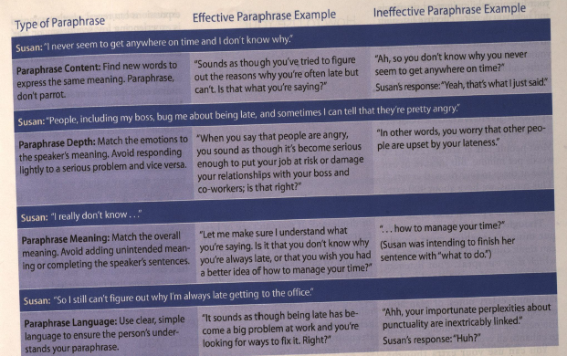

4.3 Listening Strategies and Skills
- Thinking Faster than Speaking: how to use your extra thought speed (speed at which most people can think compared with the speed at which they can speak)
  - Most people, 125-150 words/min (think 3-4x faster)
  - Bad listener will use that extra time to daydream, engage in side conversations, take unnecessary notes or plan how to respond to a speaker whilst a conscientious listener will use it to enhance all types of listening
- Listen to Feedback: Helps you determine how your message is being received (also nonverbal cues)
- Listen to Nonverbal Behaviour: ex. Toddlers can judge intentions by nonverbal actions (i.e. gestures, etc.)
- Listen Before You Leap: ex. If someone swears or uses a certain tone of voice, use extra thought speed to decide how to react to controversial, prejudiced or offensive comments
- Minimize Distractions: nonverbal factors (spacing, temperature, lighting, noise, speaker vocal/nonverbal, etc.) if distracting, take action to remove them e.g. close a door, ask to speak up/be quiet, open a window, turn on more lights, etc.
- Take Notes that Matter: research, taking notes = greater recall than not taking notes (but too many notes can hinder recall)

Personal Listening Styles Research
- Action oriented: seeks results; impatient with those who don’t
- Time-oriented: rash decision-maker; wants short answers to questions
- People-oriented: tries to understand rather than to criticize others
- Content-oriented: Focuses on what is said, not who says it

4.4 Listening to Gender and Culture
- Gender and Listening:
  - Women, relationship (mood, empathy, appreciation)
    - on average, better at focussing on rltshp b/w speaker and listener (empathic and appreciative listeners)
    - Give more feedback
  - Men, content (facts, comprehension) of message
    - on average, better at taking the content of what is being said (comprehensives and analytical thinking)
    - “Silent” listener (not as much nonverbal cues)
- Culture and Listening:
  - High-context culture, more nonverbal and relationship component
  - Low-context cultures: expect being direct

4.5 Critical Thinking about Facts and Inference
- Critical thinking: thought process used to analyze what you read, see, hear to arrive at a logical conclusion or decision
  - Result in a more meaningful conversation: develop and defend a position on an issue, ask probing questions, be open-minded, draw reasonable conclusions
- A claim: statement that identifies one’s belief or position on an issue or topic
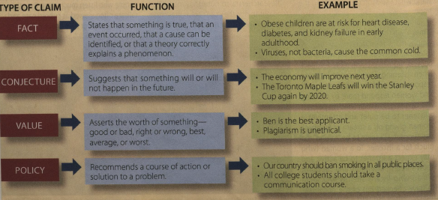
- Inference: a conclusion based on claims of facts; need more information to make a justifiable and accurate inference
  - Fact: Julia has been late to the last three meetings
  - Inference: Julia does not care about her job

Common Fallacies of Argument
Fallacy: an error in thinking that has the potential to mislead or deceive others
- Attacking the Person: irrelevant attacks against a person’s character (name-calling, labelling, attacking a person)
  - Property taxes should be increased → What do you know? You don’t own a home!
- Appeal to Authority: the supposed expert has no relevant expertise on the issue (media*)
  - “I play a doctor on TV and I recommend Nick’s cough syrup”
- Appeal to Popularity: an action is acceptable or excusable because others do it
  - The Kindle is much better than the Nook because more people own it
- Appeal to tradition: Continue a certain course of action because it has always been done that way in the past
  - Grandma says that drinking brandy with honey is the best way to cure a cold
- Faulty cause: claiming that a particular event caused another even before ruling out other possible causes
  - In our family we rarely get sick because we drink brandy with honey when we feel a cold coming on
- Hasty generalization: using too few examples or experiences to support a conclusion
  - My neighbour told me that vaccines cause autism and other disabilities in children

4.6 The Nature of Reflective Practice
- Reflection: critically thinking about an experience as it occurs or after it occurs
- Reflective practice: taking time to review and ask questions to understand yourself and others

Gibb’s Reflective Cycle
Chapter 4 Additional A: Interviewing

The Nature and Types of Interviews
- Information-gathering
- Appraisal
- Problem Solving
- Persuasion
- Job

Interview Structure
Opening
- prep work, getting a certain amount of base knowledge about the person you’re working with
- Skilled interviewer
- puts interviewee at ease e.g. ask about weather, event they both attended, other light topics
Body – Asking Questions

Questions Types
- Open & closed questions;
  - probing questions: encourage clarification and elaboration of superficial responses
  - hypothetical questions: what would you do in this situation?
- Want to gravitate towards open ended questions if want to increase flow of communication

Questioning Sequences
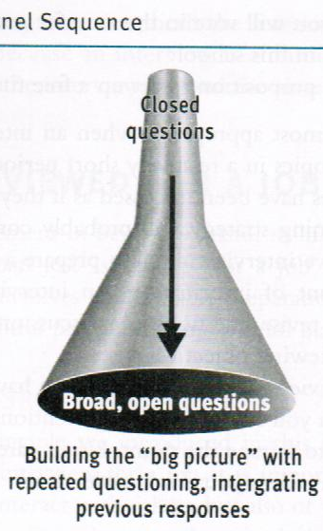
Funnel Sequence Inverted Funnel Sequence
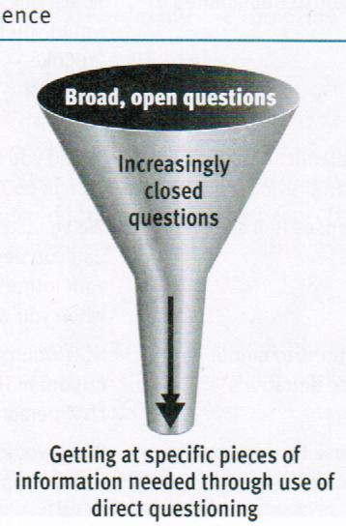

Example:  - Why do you find communication interesting?  - What is your primary interest in the study of communication?  - How long have you studied intercultural communication?  - Why do you think intercultural communication theory is useful?  - What would you do to test intercultural communication theory? | Example:  - Do you believe that your supervisor wants to fire you?  - What makes you think you will be fired soon?  - What do you think caused this problem?  - How has this problem developed?  - How would you describe the working climate in your department?
- Conclusion
  - Summarize proceedings- all parties should be aware of and agree on what happened during the meeting
  - Encourage continued friendly relations to feel like had a positive and productive encounter e.g. “I’m so glad we had a chance to talk about this problem”
Undergoing a Job Interview: Helpful hints
- Be aware of your skills and abilities
- Preparation of your resumé
  - Personal information, career objective, education, experience, honours and special accomplishments, select optional information, and references
- Identification and anticipation of your employer’s needs
  - If you really want to go into a situation with true confidence, don’t try to deflect q’s
    - Rather, the interaction needs to be more transactional, and be more natural
- Listening, responding, and asking appropriate questions
- Following-up, after the interview

Techniques in Counselling

Phases in the Interview/Counselling Process
- Preparation: behind the scenes
  - Planning for the first meeting (research and preparation)
  - Logistics and paperwork (administration)
  - More experience means less prep (physician)
  - Being professional means clearing your mind and focusing on the task at hand rather than letting other aspects of life leak in
- Initiation
  - First contact with client; establishing therapeutic climate
  - Clarification of the purpose
  - Formulating a contract and establishing mutual goals
  - no indication of length of time, but is determined by nature of health care group
    - E.g. walking at health care clinic, 20 minutes with a patient and then never seeing them again vs. a therapist that you may spend years with
- Exploration
  - This is the main working stage (can be indefinite)
  - Clients’ determination of their challenges, and subsequent management of their feelings
  - Development of coping skills
  - here you as an expert are assisting someone
    - Uncover deeper layers of someone’s awareness - could last any amount of time (spanning for minutes to years)
    - Where you help the individual help themselves
- Termination
  - Plan for interview (relationship) closure
  - Summarization of challenges and accomplishments
  - Discussion of the client’s emotional state
  - May require maintenance or referral to other HCP
  - where communication dynamic dissolves

Communication Techniques in Interviews/Counselling
Questions
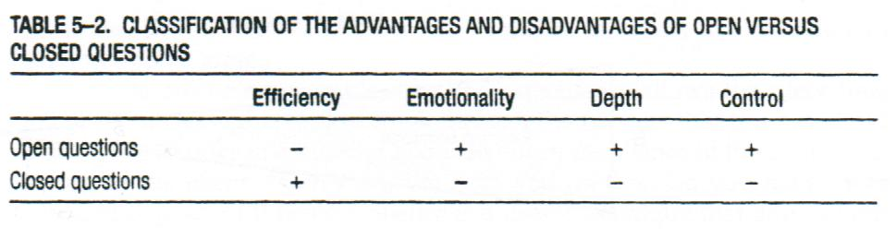
- Open questions means that you are more likely to trigger an emotional response than a closed question
- But a closed question can trigger: “Did you ever feel that you were loved by your parents?” → despite being just a yes or no question, can trigger an emotional response
- Depends on degree of disclosure and the deeper the dialogue, the deeper the disclosure
- Control:
  - Open questions: patient can direct where this question can go “Explain your current state about how do you feel about your education?” VS. a closed question- “Do you feel good about school?”

Silence
- Encourages client disclosure (ex. when client has difficulty expressing thoughts/feelings)
  - May lead to client experiencing catharsis
- Allows clinician to collect her/his thoughts
- Appropriate & therapeutic (if not overused)

Restatement
- The “what” (content) that is being expressed
- HCP does not add personal thoughts/feelings
  - “I hear you saying”, “it sounds like”, etc.
- Shows active listening; acts as feedback
- Confirms and validates the client
- Paraphrase: saying what you heard in your own words to reconfirm with your client what they just said
  - Showing that you are fully understanding of the situation without reference to emotional evaluation

Reflection
- “How” things are expressed
- More difficult than restatement; requires picking out the emotional aspect
  - Helps the client to handle their feelings
- Use to check accuracy of understanding
  - Did HCP correctly understand patient’s concerns?
- Use when appropriate
  - Do not use too soon or too frequently
  - Will allow confirmation and validation even more than paraphrase b/c of emotional aspect
Clarification
- From broad to more focused topics
- Helps clinician determine what issue (challenge) is most pressing (primary)
- Allows better understanding of client’s thoughts and feelings
- May require closed-ended questions and client to provide specific examples
- With use of reflection and restatement, trying to get the patient understand the level of importance to help the physician found out what is the most pressing issue at hand
  - Challenging the person
  - I am hearing these things, so clarify for me if it’s right

Interpretation
- Clinician offers: explanation, new frame of reference, or way of looking at things
- Designed to connect meaning to a feeling
- Client should have control over accepting or rejecting the clinician’s interpretation
- Suggestions for effective interpretation:
  - Use same language as the client
  - Prelude you are offering ideas; ask for feedback
- Professional’s side of the story

Narrative model
Hear client stories → listen for strengths/assets → re-story → action and change

Patient-Centered Clinical Method (Medicine)
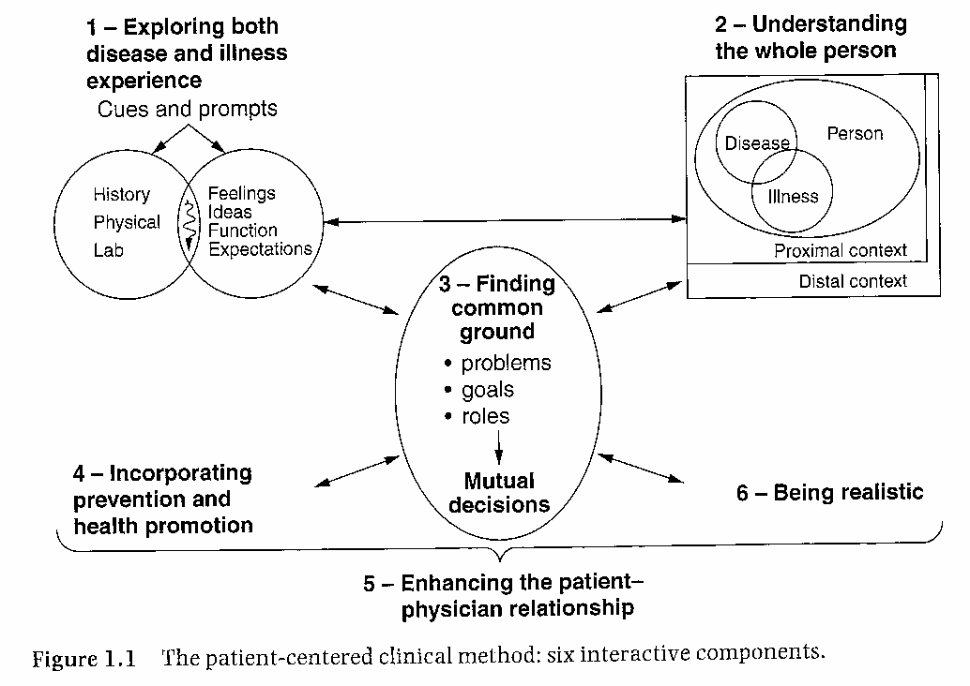

Responsibilities of the Interviewer

- Awareness of biases
  - Bias: when walk through the door, leave your preconceived notions there
- Adapting to an interviewee’s behaviours
  - use language that make patient comfortable, get into head space
- Recording information
  - Ensures that consider best candidate for position
- Listening effectively, responding thoughtfully
  - Asking appropriate questions
  - Dealing wisely with sensitive content
- Be in the moment so that the appropriate question comes about
  - May not be a perfect funnel shape, but more like timer shape

Chapter 4 Additional B: Therapeutic Communication

Five Factors of Human Spirit
- Existential factors: learning from life
  - regardless of framework and theory, nothing better to understand than interactions in real life
- Corrective recapitulation: transference
  - in your life, you will look at patterns in relationships that will transcend into other relationships
    - will see rltshps end, and will see new ones start where the other ones end
    - Looking at this can better understand yourself and your rltshps
    - E.g. A friend of his moved back to Victoria from Ontario halfway through high school but still tried to keep in touch, friend finds new friend who is also Asian Q: “Is he my replacement?” A: “I guess he is.”
- Catharsis: learning to express/release feelings
  - letting emotional release happen when it’s supposed to happen so you don’t suppress it
    - Really hard to document b/c needs to be genuine
    - E.g. John Elway (football player) retirement after 16 NFl seasons gets very emotional during speech. Supposed to be alpha male but when intense, these things can happen
- Altruism: the realization that one can assist a fellow human being, despite one’s own difficulties
  - regardless of whatever situation one finds oneself in, you can still help your neighbour e.g.
- Universality: the human condition of hope & unity
  - underlying feeling of hope and unity that can transcend in your spirit
  - Allows for disclosure, trust, control, empathy → application of these can make us better communicators

Health Care Professional (HCP) focuses on:
- Patient’s perception of their most important concern
  - Want to establish essence of person’s condition → physical, emotional or both
- Facilitating the expression of emotions
- Guiding towards a course of action
  - application of how a person can handle their life
    - emotionally and psychologically: having a disease and what it may hinder them to do/ left behind
    - physically by following through with their treatments, social support groups
- Management and coping
- Video shown comparison: same doctor appt, but two different creations of atmosphere
  - First one was a lot more comforting, talked about personal life, inform patient of what you’re actually doing vs. the second one where the patient just did what he thought was right and then sent the patient on his way

Therapeutic Factors

Control

- Perception individuals have about how they are connected to others
- Includes the degree to which they feel able to influence the nature and development of relationships
- Complementary and symmetrical
- Restores control to patient when HCP shares control
- The more we engage with the patient, the more they feel they have autonomy and empowerment
- They are more than just a sick person who is enslaved to the physician’s treatment to get better
- Complementary: as an HCP if you are demonstrating through verbal and nonverbal that affirm to the patient that they are human beings and that their feedback is important and that it’s not one way, make it more transitive than you are going to create a more therapeutic atmosphere
- Symmetrical: Is it going both ways?

Trust

- We trust when we see people act in a positive, consistent, reliable manner
- HCP: competent, sincere, and caring
- Trust = patient feels valued as a person
- Recognize the act of “thing-ing”
  - ex. the heart specialist, the MS clinic; hip replacement on Ward B
- Can divulge personal information and will not be judged by it
- When there is integrity: when you say something and then act in that manner, then you are showing consistency, not being hypocritical to yourself and
  - Want actions to mirror the words
- Make person to feel like they’re more than just a number

Confirmation
- Uncovering meaning in one’s life
- How one chooses to respond to life (ex. Man Search for Meaning)
- Patients desire the feeling of acceptance

Cyclical process of disconfirming communication:
  - HCP disconfirmed
  - HCP less attentive to client
  - HCP disconfirms client
  - Client feels disconfirmed
  - Client is less responsive to HCP
  - Client disconfirms HCP
  - Back to #1
- “Everyone’s got a plan until they got a shot to the face” -Always think in control, but when things that don’t go your way and you lose control, how do you react to that?
  - Stress can really affect a person’s thinking capacity
- Man Search for Meaning: written by physician in Nazi concentration camps and realized that there is such an array of responses to people
  - some scared for life, others were completely serene and was interested in that because how you can have the same external conditions but different interpretations of it?
- Use cyclical process as a tool to see how miscommunication perpetuates more miscommunication
  - If there is a lack of clarification, it colours the subsequent communication episodes and causes person to get offend, other person picks up on it and changes communication and suddenly it creates a lack of assertion and miscommunication
  - Agressive/Passive aggressive b/v

Empathy
- Feeling “with” the client, but not losing objectivity
  - Ability to put yourself in the position of the other person
- Patients are empowered and have positive perceptions of health care experience
- Associated with better outcomes (assists with coping & resilience)
- Ability to put yourself in person’s state of mind
  - Sympathy: you know EXACTLY what the person has gone through
  - Empathy: haven’t gone through exact things, but have felt similar emotions and that is how you can connect with the person
- Associated with better outcomes: SLIDE 2 and how they learn to cope

Barriers to Empathy
HCP:
- Inexperience: person is not sure of what to do and second guessing that the patient feels like they do not care
- lack of motivation (caring): we have to be less forgiving about this one because ultimately if you’re in a career to make money, that would cause potential challenges because if connecting with people and honing your craft are second, then it makes it difficult to sustain your career
  - Therefore you have to find your right fit and what will make you happy and motivate you to be your best
- Distractions: If you’re busy, have things on your mind, have a high tempo in your life that you don’t check yourself
  - But when you walk through the door, you need to clear your mind and focus on what’s in front of you
- fatigue (burnout) : Spending too much time working and trying to get to as many patients as possible can diminish your ability to work @ your best and perhaps a solution would be to reduce your work hours e.g. as a GP, see less patients in a given day
Patient:
- lack of openness, fear and rejection: will not be likely to disclose and open up and will be closed off
- inability to communicate through words (ex. language barrier): language barrier can make it uncomfortable to have conversation with physician
Increasing Listening Effectiveness

Empathy and Objective Listening
- An attitude: view others as being equal
  - being able to check yourself, clear your mind and give total engagement
    - Hard to do when not passionate about career, have too many distractions, facing burnout,
- A skill (unifying thoughts, feelings, emotions): As a HCP, so focused on verbal communication, but also need to focus on nonverbal too

Nonjudgmental and Critical Listening
- With an open-mind, question our own assumptions (i.e. listen for facts)
- Be more tentative about what we think we know
- Don’t be afraid of being “wrong”
- We all have learning curves and if you communicate with someone in various sorts of way, and it may be wrong, but people will continue to respect because you’re trying → as professionals, may look to medical journals, reference books to make sure giving best health care available
  - Better solution: if you don’t understand what you’re saying, be honest about it

Surface and Depth Listening

- Being able to use right words, say right things and communicate properly with patient making them fully in tune with what you have to say
- Most messages: more than one level of meaning
  - Meaningful contact = awareness of these multiple levels of meaning (literal and hidden)
- Content vs. Relational aspect of message (use nonverbal cues)
- “What” is being said; “why” is it being said

Chapter 9: Professional Relationships

9.1 Types of Professional Relationships

“Superior-Subordinate” Relationships
- The supervisor has formal authority over the productivity and b/v of workers
- Superior: people at top with the vision for their organization, direct activities, authorize projects, interpret policies, assess subordinates’ performance
- Subordinate: front line workers who are executing everyday work
a) productivity
b) job satisfaction
c) employee retentions
- Many workers state that the most stressful part of their job is dealing with their supervisor
- Most workers who quit their jobs do so because they are unhappy with their boss/supervisor
  - This is found out by surveys that can be given to employees to see their satisfaction in the workplace and see what changes can be made
  - enjoy the work, enjoy the people they are with, but don’t have the rltshp they want to bring out their best abilities
- Workplace vitality (large organizations do this well)
  - Collaboration
  - Engagement
  - Well-being: sleep, everyday spirituality,
  - Productivity

Effective Supervisory Strategies
**All of this is used to offset stress of everyday life and buffer the challenges of communication and interprofessional rltshps**

- B/v: in a consistent and predictable manner
  - have integrity, what you say and what you do being the same,
  - be genuine and doing in a respectful, assertive manner
- Honesty: keep your promises
- Sharing: decision making control
- Explain: policies, procedures, and decisions in a clear manner
- Concern: express concern for employee well-being
- Creating a positive workplace
  - Give benefit of doubt:
  - Practice generosity of spirit/ALTRUISM: you don’t have to wait for something nice to happen to you, to do an act of kindness
  - Speak well of others: and if you have nothing kind to say, don’t say it or say it in a gentle manner (whilst maintaining assertiveness)
  - Look at what works: If something is working and it’s out of the game plan, go along with it (be pragmatic → patch work of ideas but at least it reaches the end goal)
  - Show appreciation: e.g. say thank you more often

Criteria for a Satisfying Co-Worker Relationship
- Co-worker relationships: little or no official authority over one another but who must work together to accomplish the goals of an organization
- If you’re looking at teamwork, there’s a lot of synergy, bringing the best out of e/o
  - dependent on how you communicate, time and effort, resources that you put in, compatibility of team members (so basically the criteria above)
- Individual Excellence: all have good performance in job
- Interdependence: complementary skills to complete work t/g
- Investment: devote time, energy to help one another succeed
- Information: sharing openly with one another
- Integration: compatible work values and styles of work
- Integrity: mutual respect for each other

Needs of Customers/Clients
- Customer relationships: interactions between someone communicating on behalf of an organization and an individual who is external to the organization
- Career will be dependent on whether you want to work under someone or for themselves
- Need to feel welcome
- Need enough information to make decisions or solve problems regarding a service or product
- Need to be treated with respect, they have the power to take their business elsewhere

Is the Customer/Client Always Right?
- to a certain degree, you have to draw the line
- if someone crosses the line, tell them that you respect their perspective, but don’t feel that it is congruent with your protocol
- want to be able to separate personal factors from actual situation
  - want to disarm situation

Effective Strategies to Calm and Problem-Solve
- Don’t take a complaint personally.
- Listen attentively, ask questions.
- Separate the issues from the emotions.
- Make statements that show empathy, “I can understand why you’re upset.”
- If company at fault, acknowledge it.
- Share/explain decision (but do not argue with customer).
- Ask customer how she/he would like to resolve

Classic Organization Hierarchy
Board of Directors: Make policies and decisions
- most $, have mission statement, vision and values for organization
  - looking purely at bottom line
Upper Management : Implement policies and decisions
- CEO, chief directing officer
  - more communication with company
Middle Management : Link upper and lower
- chief
Lower Management: Supervisors or team leaders
- Department heads
Support Staff: Secretaries and admin staff
- No tech staff
Frontline Workers: Perform fundamental tasks
- running and providing the resources e.g. healthcare
  - disengaged, not enough acknowledgement, caring or transparency b/w all people above them, overworked and underpaid
- Mission statement: one shot phrase of the approach and what a company and organization stands for
- Vision statement: where the company or organization aspire to
- Values: things you can associate with everyday actions and b/vs in order to maintain the mission and to reach the vision

Examples
- Brockville General Hospital is very categorized and these things are seen without any question as to what is what
- TOH has all of them put together

Organizational Culture Theory

Organization Culture
- Shared symbols, beliefs, values, and norms affect the behaviour of people working in and with an organization.
  - university
Organizational Subculture
- Group of people who engage in behaviour and share values that differ from the larger organizational culture.
- Faculty (any)

9.2 Strategies for Managing Office Gossip
- How do we manage communication that takes away from the company’s mission statement?
- gossip is communication that is harmful to team adhesion
  - inescapable
  - happens when people are not happy and it festers
  - miscommunication that occurs in aggressive/passive-aggressiveness
- Rumour: unverified story or statement about facts of a situation
- Gossip: a type of rumor that focuses on private, personal or even scandalous affairs of other people
  - Can help humanize work e/t because way to bond with co-workers

Best Thing to do?
- Do not spread rumours
- Evaluate the reliability of the information
- Change the subject when others gossip
- Consider confidentiality
- Protect yourself before self-disclosing, assume you secrets will be shared
- If you believe gossip is causing serious problems, talk to someone in authority

Sexual Harassment in the Workplace
- Sexual harassment: unwanted sexual advances, sexual advances for sexual favour, inappropriate verbal or physical conduct of a sexual nature, or an intimidating, hostile or offensive work e/t
- Characterized by:
  - deliberate touching
  - sexually suggestive looks, gestures, or comments
  - sexual teasing, jokes, remarks, or questions
  - letters, calls, or materials
  - pressure for dates or socializing
- Impact:
  - Decreased work performance
  - Anxiety and depression
  - Self-blame and feelings of helplessness
  - Fear of further or escalating harassment
  - Anger
  - Fear of reporting the incident

Working with friends
- Strains on Friendship
  - Equal status, compromised (inequality at work)
  - Confidentiality: affects openness of friendship
  - Collaboration at risk (decision-making power)
  - “Negative” feedback can hurt friendship
  - Public expression of friendship may need to be minimized

- Strains on Professional Relationships
  - Difficult to manage unequal levels of power
  - Sensitive work information with discretion
  - Can compromise objectivity at work
  - Friend may be held to higher/lower standards
  - Socializing and productivity

The Important Exit Interview
- Leaving Your Job (Best Practices)
  - First: inform your immediate supervisor
  - Resign in person (letter, recommended)
  - Give appropriate advance notice
  - Phrase feedback/explanations in *positive light

9.3 Workplace and Job Interviews
Before the Job Interview:
- Research the employer/organization
  - Mission statement, company values, research person who will interview you
- Assess your strengths and weaknesses
  - Use them to your advantage to explain why you would be a good fit @ company
  - For weakness, be ready with a thoughtful response
- Practice interviewing

Common Interview Questions
- Briefly, tell us about yourself.
- Where do you hope to be in 10 years?
- What is your greatest Strength? Weakness?
- What motivates you to work hard and do your best?
- What are some characteristics you look for in a good job?
- Given that we have other applicants for this position, why should we hire you?

Things to Ask the Interviewer
- Please tell me about the specific responsibilities of this position.
- What is the most important characteristics you want in an employee for this position?
- How would you describe the culture of the organization?
- How will “success” be measured for this position?
- What other departments will I be working with?
- What are the main challenges facing this organization?

During the Job Interview:
- Questions associated with type of interview - be strategic with answers
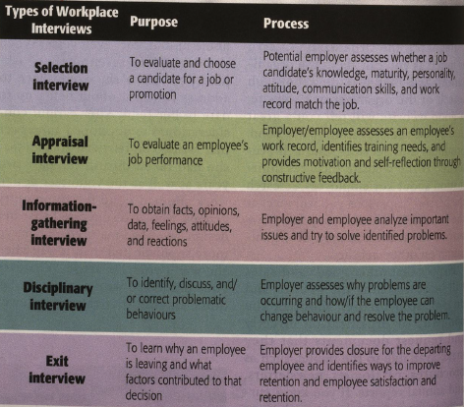

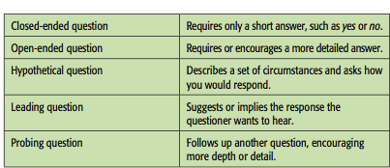
Can you work overtime with little notice?
What are the major challenges in this job?
How would you handle a colleague who is always late for work?
Do you think experienced workers are the best people to mentor new employees?
Explain how you justified the staff cut-backs at your last job?
How would you handle inappropriate questions?
- Sometimes asked for legitimate reasons, so think before you speak - may be a way to engage in conversation or asked out of simple curiosity

What does your husband or wife do? Do you have or plan to have children? Which religious holidays will you take off from work? Do you have any disabilities? What country are you from? What country are your parents from?
Avoid:
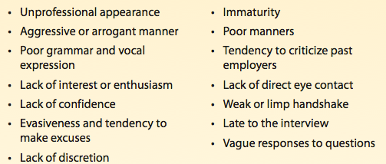

After the Job Interview
- Follow-up message (email, phone call, etc.) to thank them for time and consideration
- In some instances, no feedback given
- View interviews as a chance to practice

Chapter 9 Additional A: Interprofessional Communication
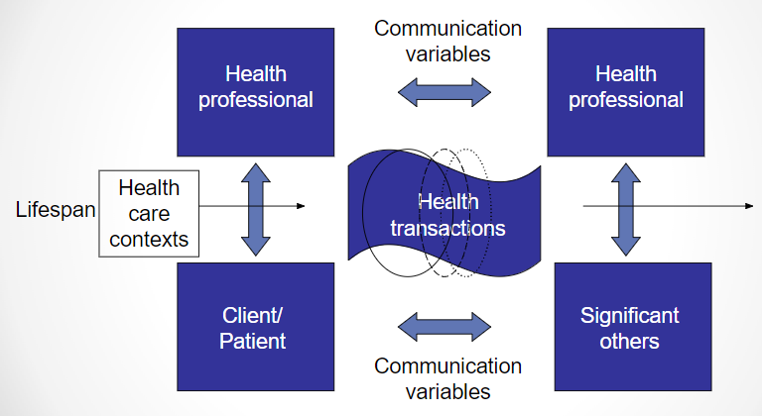
Model of Health Communication (Northouse and Northouse)

Relationships:
1) professional-professional
2) professional-client
3) professional-significant others
4) client-significant others

Transactions: interactions; verbal and non-verbal.
- Includes content & relationship dimensions of messages.

Contexts: setting of health care communication.
- Can also refer to the number of participants

Professional-client Relationships

Barriers to Effective Communication

Role uncertainty in patients
- Hesitation; only express physical concerns
- Reinforces traditional communication
  - Nurses only there to dispense medication, dieticians to plan meals
- how to communicate in healthcare e/t in biomedical setting
- challenge: communication has moved over to tech and therefore reinforces a lack of inequality b/w healthcare practitioner and pt
  - doesn’t allow pt to fully disclose (express their story line and situation) thereby affecting their therapeutic

Responsibility Conflicts
- Two factors: responsibility for disease and responsibility for cure
- from pt’s perspective, how much influence they have on the impact of their health
- traditional: inequality maintained b/c pt feels they have less say on their own health
- How do you communicate something that allows person to understand that they have a lot more say in their health?
- Don’t want to change procedure but rather clear up roles in procedure are a lot less rigid

Power Differences
- HCP = dominant; Patient = submissive
- How someone’s temperament affects situation and is translated in the episode by pt
  - Aggressiveness vs. assertiveness
  - Affection or no affection
  - No empathy

Unshared Meanings
- Person-minded, not word-minded
- Paraphrase; use many communicating methods
- If we can change the ways the way we communicate with pt, will it develop a more therapeutic rltshp
- want pts to feel comfortable and be able to share without hesitation or fear

Role Stress
- Role conflict and role overload
- lack of communication b/w professionals who are w/i the same bracket
  - working on same night shift with team (nurses) and there might not be proper communication leading to inefficiencies such as who’s doing
    - want to avoid redundancy and miscommunication
  - due to miscommunication, burnout occurs

Lack of interprofessional Understanding
- different HP’s who are all dedicated to a person’s healthcare are not communicating with e/o b/c they are not working under the same context
- Examples:
  - pt is seeing a naturopathic doctor and has herbs they’re taking and also taking medication prescribed by their GP → consequences? (what venn diagram describes)
  - pt is seeing a chiropractor and a physiotherapist and the two HP’s communicate with e/o to make sure that both their treatments aid the pt instead of hurting them
- how do we make sure we don’t lose our cool?

Professional-Professional Relationships
Autonomy Struggles
- Scope of practice (governing laws)
- Ability to access facilities
- Ability to gain reimbursement
- perspective of HP
- things have to set up to deliver care: resources, reimbursement, short staffed, do pts have insurance?
- e.g. family doctor that runs a private practice is the same as someone who is running a coffee shop
  - rental space, how many pts you have, do you work with other professionals in the building, do you have the resources?

Professional-Family Member relationships
Limited contact with professionals
- significant others doesn’t have capacity with person who is giving the care

Limited Info
- Privileged: available to family but not yet to pt
  - after surgery, doctor gives info to family b/f pt receives: condensed summary of what went on and next steps
- Filtered: family receives after patient or third party
  - same example above but from nurse, p/t themself

Patient-Family member Relationships

Disruption of Family Roles
- Role adaptation
  - Ambiguity: too loose
  - Rigidity: too constricted
- Family structures can be different: structures (very close) vs. loose (not so close)

Closed Communication Patterns
- Perpetuated by family rules, protectiveness
- Define rules, rules need discarding; new rules needed?
- Are there things happening in the family that are limiting their decisions regarding their health care
  - Lebanese family: wife was supposed to go see a gynecologist (male) and immediately the husband said you can’t see this person

Chapter 9 Additional Notes B: Health Communication Models

Leary Model
- Two dimensions:
  - “Dominance-Submission” & “Hate-Love”

- Rule 1: Dominant or submissive behavior stimulates opposite behavior in others
- Rule 2: Hateful or loving behavior stimulates same behavior from others.
- Describes ambiguity and power differences
If there is one on one communication....
- If a HP has a dominant, aggressive approach, then the pt will will assume a submissive/passive role
  - Won’t disclose info because don’t feel comfortable
  - Some pts will naturally take on naturally submissive role, then need to balance that
  - Some pts will have passive role, an HP may vent to them and be more expressive regarding any misgivings
- Demonstrating a sense of caring and empathy and attention, the natural tendency is for people to have the same natural response, rather than the opposite

Communication Networks
- Flow of communication between group members
- Sociogram: 1) who talks to whom, & 2) how often
  - Line = verbal interaction between members
  - Arrow = who sent the message
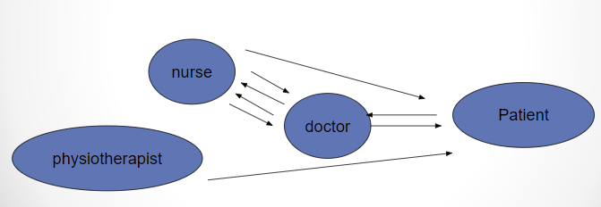

- Ideally, want patient in the middle and have equal communication b/w HPs

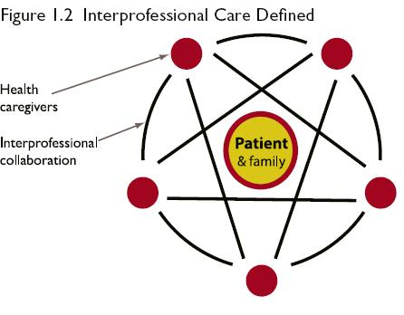

Chapter 10: Working in Groups

10.1 The Nature of Group Communication

Group communication: interaction of 3+ interdependent people using verbal & nonverbal messages to generate meaning for the purpose of achieving a common goal.

Working in Groups
- Ideally want 5-7 members, odd numbers
  - Larger tender to divide into subgroups where more talkative members drown out others
- Interdependent: actions of one group members affect everyone
- Goal: what unifies the group

ADVANTAGES

- Generally, accomplish more and perform better.
  - but just because accomplish more, doesn’t necessarily mean that quality of care is there
- Higher standards of achievement and enhanced learning.
- Social element.
  - having a confidante at work, having same beliefs and values that allow you to relate to others in the workplace
- More diversity of knowledge and perspectives

DISADVANTAGES

- Group work requires time, energy, resources. (can be $$$)
- Greater likelihood of conflict between members.
- Cooperation challenges.
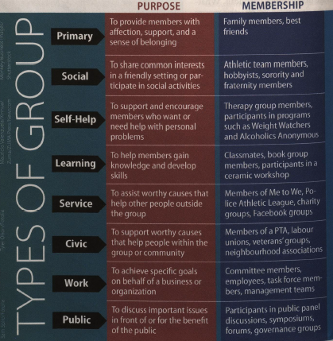

Working in Virtual Groups (responsibilities)
- Be prepared: materials and technology
  - Speak, listen, make suggestions, follow-up
- Types of virtual groups:
  - e-mail/text; telephone/computer audio conference; video/web conference.
  - Nonverbal communication
- Potential miscommunication b/c no nonverbal communication

10.2 Balancing Individual and Group Goals

Primary tension:
- The social unease and inhibitions that accompany the getting-acquainted period in a new group
- Overly polite with one another b/c want to create good first impression
- people aren’t familiar with each other professionally or personally, yet in a group together.

Characteristics of PRIMARY TENSION
- Members rarely interrupt one another
- Long, awkward pauses often come between comments
- Members are soft-spoken and very polite
- Members avoid expressing strong opinions

Hidden agenda: a member’s private goals conflict with group’s goals (what people really want vs. what they say they want)
- When becomes more important, the result can be group frustration, unresolved conflicts, and failure

Group Membership

Homophily: Preference to be with others who share your values, attitudes, and even personal characteristics.
- For academic and personal reasons
- Inspire feelings of trust and comfort
- But not always beneficial because need different sets of skills and viewpoints to reach goal successfully sometimes

Competence:The necessary skills, knowledge, and abilities to contribute to the group work and to achieve the goal of successful completion.

Familiarity: Reduces anxiety, and if the group work is successfully completed, members are more likely to re-form for subsequent projects.

Tuckerman’s Group Development Model/Primary Tension Stages
- Helps explain why and how group and their members behave at different stages in their development
- Can help predict, explain and improve group productivity and member satisfaction

Stage 1: Forming
- Are polite, cautious and uneasy
- getting to know people professionally and personally, their skill sets, temperaments
- Little gets done in this stage

Stage 2: Storming
- Are argumentative and emotional as discuss important issues and vie for leadership
- Conflict can help members develop rltshps, decide who’s in charge, who can be trusted and clarify group’s common goal
- where do I fit in this? potential elevated miscommunication or arguments

Stage 3: Norming
- Roles are defined and norms established
- Group members are more comfortable with one another and are willing to disagree and express their opinions
- Begin to work as a cohesive team

Stage 4: Performing
- Energy is focused on working harmoniously to achieve group goals
- Decisions are reached, problems are solved and ideas are implemented
- Going well: members are highly energized, loyal to one another, and willing to accept every challenge that arises
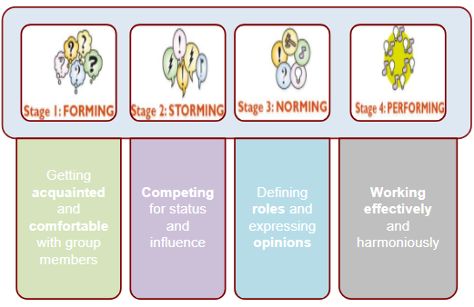

(Sometimes) Stage 5
- journey: group breaks up, but sometimes, this team can be very long term e.g. career

10.3 Balancing Conflict and Cohesion

Secondary tension: the frustrations and personality conflicts experienced by group members as they compete for social acceptance, status and achievement
- Solve: joke about the tension, work outside the group setting to discuss any personal difficulties and anxieties with individual group members

Characteristics of SECONDARY TENSION
- Energy and alertness levels are high
- The group is noisy and dynamic; members are loud and emphatic
- Several members may speak at the same time
- Members sit up, lean forward, and squirm in their seats

Group Cohesion
- “The mutual attraction that holds members of a group together”
- Establish group identity and loyalty.
- Establish a sense of teamwork and pride.
- Praise and reward contributions.
- Respect and concern for members
10.4 What are the Norms?
- Group Norms: set of expectations held by group members concerning what behaviours are un/acceptable, good/bad, right/wrong, in/appropriate.
  - How you dress, speak, listen and work e.g. one group may view interruption and overlapping conversations as acceptable, whilst another does not
  - explicit: can refer to a guidebook
  - implicit: just know that what have to do e.g. listening to what everyone has to say until the end
- Constructive Nonconformity: member(s) resist(s) norms, while still working to promote group goals; preventing members from ignoring important information or making poor decision
- Voice opinions without fear of criticism or exclusion
  - Allows for group evolvement
- Deconstructive Nonconformity: member(s) resist(s) conformity without regard to best interest of the group
  - Set examples of behaviours detrimental to group e.g. show up late to attract attention or interrupting others to exert power
  - Detracts from greater good of common goal and adds no value to it

10.5 Group Member Roles
- Group role: a pattern of behaviours associated with an expected function within a particular group context
  - “Who will get the information we need for our next meeting?” All eyes turn to Zhu because his skill set is researching and sharing information
- Task Role: Behaviour that positively affects a group’s ability to manage a task and to achieve its common goal.
- Maintenance Role: Behaviour that positively affects how group members get along and work harmoniously, while pursuing a common goal.
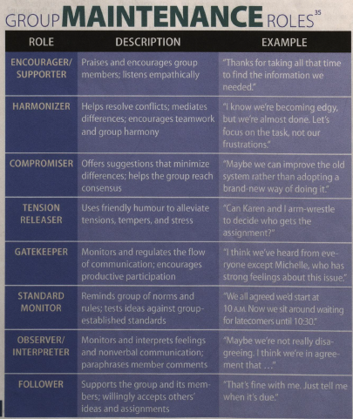
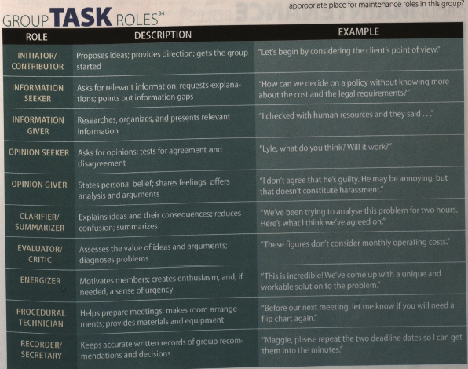

Common Self-Centred Roles
- Aggressor: sarcastic, critical, antagonistic
- Block: delays or derails work and progress
- Dominator: interrupts, manipulates other
- Recognition seeker: boasts and brags
- Clown: goofs off, uses inappropriate humour
- Deserter: withdraws, appears annoyed
- Confessor: shares personal problems, emotionally needy

Disruptive Group Behaviours
- The Laggard: late to meetings, fails to complete tasks, never volunteers
- The Put-Downer: assumes other members are wrong; often mistakes negative remarks
- The interrupter: starts talking before other finish; exhibits impatience when others talk
- The nonverbal negative naysayer: frowns, shakes head in disapproval, rolls their eyes, groans
- The Chronic Talkaholic: compulsive communicator who talks too much and too often

10.6 Leadership and Leaders
- Leadership: The ability to make strategic decisions and effectively use communication to mobilize group members toward achieving a common goal
  - Leader is a person
  - Leadership is a behaviour

Three Leadership Theories

Trait theory
- you are either born with the qualities to be a leader or you don’t
- Leaders are born, not made
- Identifies specific characteristics of good leaders
(self-confidence, intelligence, enthusiasm, communicator, trustworthiness, and organizational skills)
- Weakness of theory: doesn’t account for the fact that many effective leaders possess only a few of these traits and just because you have most of these traits, doesn’t mean you will be a good leader

Styles theory
- Examines a collection of specific behaviours that constitute three distinct leadership styles
- you can reflect the style of leadership based on your communication style
  - e.g. laissez faire = laid-back and no micromanagement
  - VS. autocratic/authoritative = micromanagement
  - VS. democratic = in the middle between this (not micromanaging but also not leaving everything to turn into chaos)
  - 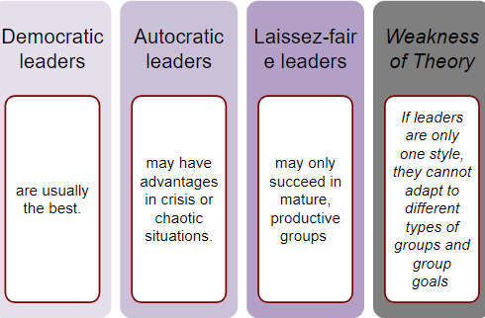

Situational Leadership theory
- Seeks an ideal fit between leaders and leadership roles; leaders can become more effective by analyzing themselves, their group and the context
- depending on the context and the team you are working with, you can accommodate on what kind of leadership style will most benefit the goal that you’re working towards
- Requires leader to match leadership style based on the situation
- Two Leadership Styles
  - Task-motivated leaders: want to get the job done, may overlook group morale
  - Relationship-motivated leaders: gain satisfaction from working well with other people even if the cost is failing to complete a task; criticized for paying too much attention to how members feel and for tolerating disruptive b/v
- Task-Motivated Leaders: excel when there is complete or no control over leader/member relations
  - Perform best in extreme situations e.g. high level of leader control or almost out of control
- Relationship-Motivated Leaders: excel when there is a moderate level of leader/member relations
  - Mix of condition e.g. semi structured task or a group of interested but not eager followers
- Leadership member relations: +ve, -ve, neutral
- Task structure: range from disorganized and chaotic to highly organized and rule driven

10.7 The 5-M Model of Leadership Effectiveness
Model Leadership Behaviour
- Confidence, competence, trustworthiness
- Speak and listen effectively, confront problems head-on, work to find solutions
- Focus on group and goals, not themselves

Motivate Members
- Guide, develop, defend and inspire group members

Manage Group Processes
- Must be organized and fully prepared to be effective
- Can troubleshoot to improve group performance

Make Decisions
- No one likes an indecisive leader- better to make a wrong decision than none at all
- Strategies: get feedback, explain reasons for choosing your decision, open communication

Mentor Members
- Leader helps group members to reach their potential
- Sometimes, this means letting them succeed and fail on their own

Chapter 10 Additional Notes: Group Dynamics, Small Group Communication

Small Groups vs. Large Groups
Small Groups  - Close relationships  - Full participation  - Shared goals | Large Groups  - Greater pool of talent and experience available for solving problems  - Shared effort (strength in numbers)

Optimum Number for Effectiveness
- 5-7 member is the optimum
- Content and Process
  - Content: a task at hand, duties, specifics, distinction b/w roles but also not big enough to not keep track
    - receives more attention
  - Process: rltshps and how people interact in that group that has nothing to do with tasks at hand
    - is usually what determines whether a group works effectively or not
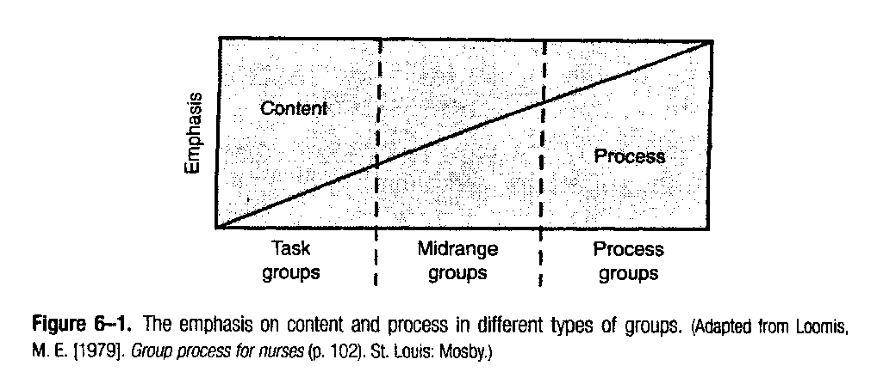
Phases of a Group
- Developmental sequence of phases, similar for most groups; content & duration of phase vary with the kind of group and the group task

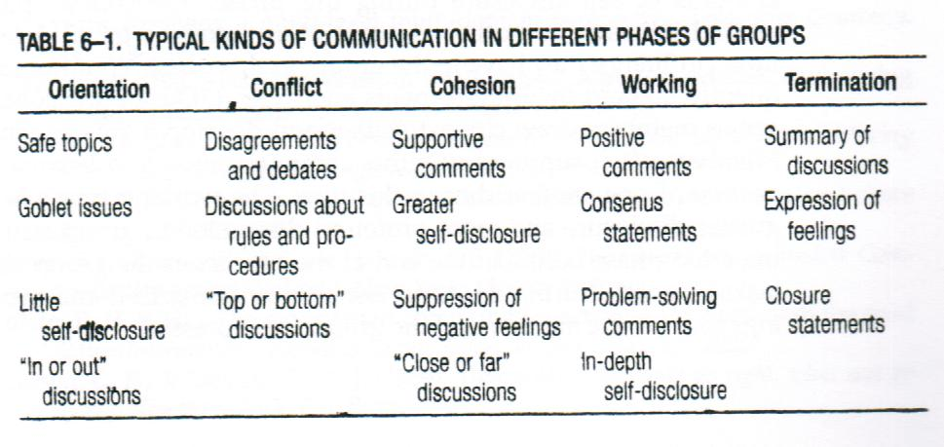

\

Orientation
- Do I belong here?
- introduce yourself and this is merely the beginning in which people are trying to get a feel of one another

Conflict
- Control issues
- secondary tension, more familiar with one another, will begin to argue and talk over one another

Cohesion
- Establishing unity
- People have an idea of where they fit, gel and the second tension could still be there but people are becoming more efficient in their scope

Working
- Time, energy, depth in disclosure
- start being really productive, group works at a high level, things get done efficiently

Termination
- Closure
- Assuming group doesn’t stay t/g, the group disassembles and each person goes their separate ways
- No termination phase in the other model seen b/c assumption of long term groups
- E.g. jury

Chapter 11: Group Decision Making, Problem Solving and Conflict

11.1 Decision Making and Problem Solving
- Decision making: making a judgment, reaching a conclusion, or making up your mind
- Problem-solving: a complex process in which groups make multiple decisions as they analyze a problem and develop a plan for solving the problem or reducing its harmful effects
- Prerequisites for effective decision making and problem solving
  - Clear Goal: make sure everyone understands and supports it
    - Word as a question
    - Answer to question will shape discussion (ch.4 fact, conjecture, value, policy)
  - Quality Content: being a well-informed group equates to making good decision
    - Lies in ability of members to share, collect and analyze information needed to achieve goal
  - Structured Procedures: specify how groups will make decisions and solve problems

Structured Procedures: Benefits
- Balanced participation
- Effective conflict resolution
- Clear organization
- Group empowerment

11.2 Decision Making Methods
- Voting: Majority or two thirds vote
  - Some members win, others lose
  - Best when:
    - a quick decision needs to be made
    - Issue is not highly controversial
    - A group is too large to use any other decision-making method
    - There is no other way to break a deadlock
    - A group’s constitution or rules require voting to make decisions
- Consensus: When all group members agree to support a group decision
  - Group members trust one another and expect honesty, directness and candor
  - Avoid rushing and make sure everyone’s opinion is heard, don’t let one person overpower everyone else
- Authority rule: When a single person or group of people outside the group makes a final decision, with or without recommendations from the group
  - Group may be asked to gather info and make recommendations
  - If ultimate decision maker doesn’t take these into consideration, group could become demoralized, resentful, and unproductive on future assignments, or mayhap even mislead group based on what tehy think is best

Groupthink
- The deterioration of group effectiveness as a consequence from in-group pressure
- Highly cohesive groups are at greater risk of succumbing to groupthink
- Irvis Janis identifies symptoms and expressions of groupthink
  - Group is highly cohesive and members overestimate their competence and perceptions of rightness; in order to maintain cohesiveness, may discourage disagreement to achieve total consensus
  - Structural flaws in group process can inhibits flow of information and promote carelessness in the application of decision making procedure (leader maybe have too much influence and limit access to outside or contrary info)
  - Volatile situation: when members have to make a decision, do it quickly, ruling out reasonable decisions, ends up being flawed)

Possible Effect of Groupthink
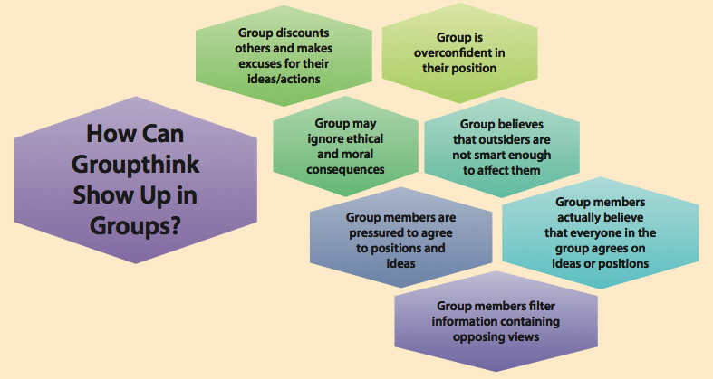

Avoiding Groupthink
- Assign several members to work on the same problem independently
  - is there a coherence in terms of how people come to a solution to a problem? i.e. propose similar/same solutions
- Invite an expert to join the group periodically to provide feedback
- Encourage honest critique
  - if a third person is not brought in, then give a group an opportunity to feel that they are not rushed into making a decision
- Every member should be a critical evaluator (discuss potential negative consequences)
- Before finalizing decisions, give members chance to express lingering doubts

Decision Making Styles
- Rational: I make logical decisions in a systematic way
  - Fully weigh information and options before making a decision, but may overanalzye
- Intuitive: When making a decision, I usually trust my feeling of gut instincts
  - May not always be a reason to explain why they feel that way
- Dependent: When a decision is important, I often see the opinions of others
  - May sometimes make decision they aren’t happy with to please others
- Avoidant: I tend to put off decisions that make me uncomfortable or that are unpleasant
- Spontaneous: I often make impulsive decisions
  - ...and may end up regretting them later
- Important to recognize and adapt to different decision-making styles while pursuing a common goal

Ethical Group Decision Making
- The Research Responsibility: Be well-informed and prepared with good information
- The Common Good responsibility: Look beyond your needs and consider others
- The Reasoning Responsibility: Avoid presenting any faulty arguments. Build valid arguments. Recognize fallacies.
- The Social Code responsibility: Promote an open and supportive climate

11.3 Resolving Interpersonal Conflict
Destructive Conflict
- Result of behaviours that create hostility or prevent problem solving
- Active destructive: winning at all costs, displaying anger, demeaning others, retaliating
- Passive destructive: avoiding, yielding, hiding emotions, self criticizing

Constructive Conflict
- Express disagreement in a way that respects other’ perspectives and promotes problem solving
- Active constructive: perspective taking, creating solutions, expressing emotions, reaching out
- Passing constructive: reflective thinking, delay responding, adapting

Conflict Styles

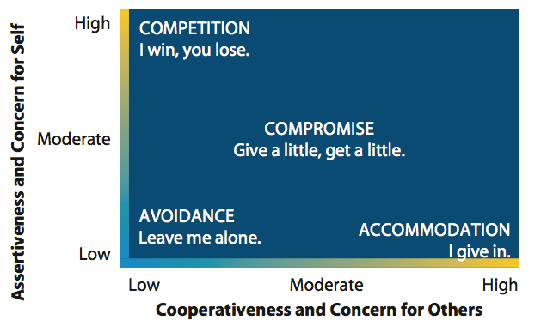

Avoidance
- Unable or unwilling to stand up for your own needs or the needs of others
- Change subject, sidestep a controversial issue, deny that a conflict exists
- Counterproductive b/c fail to address a problem and can increase tension in a relationship

Accommodation:
- Give in to others are expense of meeting your own needs in order to preserve peace and harmony
- Can make you seem less influential OR can be appropriate and effective when issue is not important to you
- all parties get what they want

Compromise:
- Conceding some goals to achieve others so that everyone can win and lose equally
- Good for when a unanimous decision can’t be reached or a problem resolved and there is not enough time to explore more options
- dealing with things where they can’t be equal distribution e.g. 100 people have applied for job but only have 60 positions to fill → what we strive for

Competition
- More concerned with fulfilling own needs than others’ needs
- Can result in hostility, ridicule and personal attacks against others
- Good for when immediate action is needed in an urgent situation
- society’s whole concept of race to success has led us to be this way so may not be blameworthy e.g. going to an Ivy League school in the states

Collaboration
- Reach your goals and the goals of others
- Works best when both parties welcome new and creative ideas and are committed to the resulting decision

Conflict Resolution Strategies

AEIOU Model of Conflict Resolution: try and understand the attitudes, beliefs and values of those involved in the conflict; focuses on communicating personal concerns and suggesting alternative actions to resolve a conflict
- Assume other person means well (wants to resolve conflict)
  - I know that both of us want to do a good job and complete this project on time.
- Express your feelings
  - I’m frustrated when you ask me to spend time working on a less important project
- Identify what you'd like to happen
  - I want to share the responsibility and the work with you
- Outcomes you expect should be made clear
  - If both of you don’t make a commitment to working on this full time, we won’t do a good job or get it done on time
- Understanding on a mutual basis is achieved
  - Could we divide up the tasks and set deadlines for completion or bring in another person to help us?

The 6 Step Model of Conflict Resolution: series of steps to help move a conflict toward successful resolution
- Preparation: identify issues
  - Where and how did things go wrong?
- Initiation: “we need to talk”
  - Can we get together for lunch and talk about the late report?
- Confrontation: discussion the conflict and the need to resolve it
  - I want you to come to the family reunion with us
- Consideration: empathy and consider the other person’s view
  - I didn’t realize your mother was sick when I asked you stay late
- Resolution: mutual understanding and reach an agreement
  - Okay, I’ll make sure I call you if they make me stay later than 6pm
- Reevaluation: follow-up on the solution
  - Let’s meet for lunch in two week to see if this is working as we hope it will

11.4 Problem Solving: Brainstorming
- Can generate many ideas in a short period of time
- Works best when members are comfortable with an unstructured process
- Can be limiting is members are self-conscious and sensitive to implied criticism
- Can enhance creativity and produce numerous worthwhile ideas
- set up a parameter and allow people to be engaged
- trying to think outside of the box: what are we doing that is not effective and what we can do to make it better?
- Have to make a nobling e/t, make people comfortable and are fully participatory
- Not good for formal plan of action or a critical problem with a single right answer but for tackling open-ended, unclear or broad questions and need lots of ideas

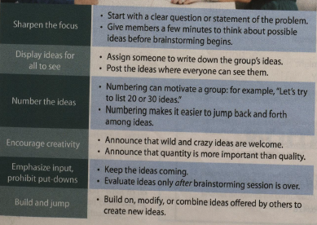
Brainstorming Guidelines
- Write idea down, not currently evaluating, just seeing what ideas we have, put ideas t/g, build on them; allows you to be dynamic, see leadership qualities come out, different styles of collaboration and what that means
When not to brainstorm
- In a crisis: when there is little time
- To repair: when group knows root cause of challenges
- For planning: when group knows its objectives to reach goal
- If a group is self conscious and sensitive to implied criticism
The Decreasing Option Technique (DOT) Method
- Helps groups reduce and refine a large number of suggestions and ideas into a manageable set of options
- Can be used to assist small and large groups facing a variety of decisions making tasks
- Generate Ideas: can be full sentence or single word suggestions
- Post Ideas: everyone should see, only after members have finished writing their ideas on separate pieces of paper
- Sort Ideas: members will have same/similar ideas so good to group things that overlap t/g and then give title
- Prioritize Ideas: begin to narrow down where to go
- Purpose: to reduce quantity of ideas to a manageable number

When to use the DOT method
- When group is too large
- When there are significant competing ideas that need to be evaluated
- When members want equal opportunity for input
- When dominant members do not exert too much influence
- When there is not enough time

Effective Meetings

An agenda…
- is an organizational, time management tool.
- helps members prepare for a meeting.
- provides a measure of success.

The minutes of a meeting are…
- the written record of a group’s discussion and activities.
- legal documents as well as historical records of an organization’s business.
- a way to share proceedings with members who don’t attend.
- a way to prevent disagreement over member assignments & group decisions.

Chapter 11 Additional Notes: Conflict and Communication
Levels of Conflict
- Personal Conflict: ongoing, never removed, with us for the rest of our lives e.g. look into the mirror and contemplate about what you’re doing with your life
- Interpersonal conflict: dyadic communication episode, one on one
- Intragroup conflict: 5-7 members, e.g. in a group and having problem coming up with an idea or agreeing on the same thing
  - Can be constructive or destructive
- Intergroup conflict: highest level of conflict, do we agree with what groups are do

Two Kinds of Conflict

Content Conflicts
- Task at hand
- Regarding values and beliefs: Conflict can arise with what you expect as a HCP to align by e.g. the code of ethics → can we
- Goals: can we see in accordance how things needs to be done, not necessarily rltshp content

Relationship Conflicts
- Outside of duties at hand e.g. do you get along with a group member
- Humanistic relations
- Issues of esteem: do you feel as if you have some sort of work in terms of your abilities to contribute? Your competence as an individual
- Issues of control: Do you feel like you have a stake in the group? As a professional and your rtlsp
- Issues of Affiliation: acceptance, feel included in scope of group dynamic

Conflict on the Content Level
Conflict regarding values and beliefs
- Religious, cultural, professional, etc.

Conflict regarding goals
- Procedural: the “how” - should we approach it
- Substantive: the “what”- should be done about it

Conflict on the Relational Level

- Issues of esteem: worth, respect, etc.
- Issues of control: power struggles.
- Issues of affiliation: inclusion, affection.

Techniques for Managing Conflict

Disarm the opposition
- how do you allow someone to put their guard down; disarm situation by agreeing with criticizer’s criticism
  - Can we close the door? Can we start over again?
  - Take a deep breath, systematic restart
  - How do I get someone in a potentially destructive conflict to get their guard down and become comfortable

Cognitive restructuring
- used with reframing of psych to say can we look at same objective situation with a different view? How can we see something that looks initially -ve to +ve?
  - in conjunction with person’s personal conflict

Face-detracting / face-enhancing
- treating the other person as incompetent or untrustworthy
  - Opposite of “saving face” → common in high context culture: if someone makes a mistakes, mention through indirection communication to save their honour

Blame / empathy
- strive to be empathetic rather than blame the person
- e.g. kid has a run in with the police and rather than dealingw ith the problem itself, parents blame each other for the child’s troubles

“Gunnysacking” / present focus
- inprpductive practice of storing up grievances so as to unload them another time
- repression of emotions e.g. things nurse wanted to express to supervisor but didn’t until this conflict came up **video** VS. present focus: being mindful, always feeling something immediately, be assertive and won’t repress emotions
  - “I wish I had said something different”
- E.g. focus on clift you’re having with this person not on the person’s mother, child or friends
Verbal aggressiveness / argumentativeness
- Verbal aggressiveness: wining an argument by inflicting psychological pain by attacking the other person’s self concept e.g.
- Argumentativeness: willingness to argue for a pov, tendency to speak mind on significant issues
- argumentativeness: willing to be rational and open to discussion e.g. third clip the operating physician wanted to hear these things from the nurse herself” Please tell me what happened. Did you use force on the patient.”

Appeal to a third party (mediator)
- in the event that a conflict can’t be resolved between these two parties, get someone else involved to dissolve the situation by choosing what the right course of action would be

A Model for Resolving Conflicts: 5 Steps

Define the conflict
- Define both content and rltshp issues (in specific terms)
- Empathize
- Avoid mind reading
- Can we separate the content b/w the rltshp? What’s at the heart of the issue here?

Examine possible solutions
- What are the changes that need to be made- change idea, change who is working?

Test a solution
- see how this solution works out

Evaluate the solution
- talk about what happened when the solution was applied

Accept or reject the solution
- Accept: out
- Reject: back to steps 1, 2, OR 3
- did it work? If not, how do we revise it to work?

Chapter 3: Adapting to Canada’s Changing Faces

3.1 Defining Culture

- Culture: learned set of shared interpretations about beliefs, values, and norms which affect the behaviours of a large group of people
- Co-culture: people who exist in mainstream society and yet remain connected to one another through their cultural heritage e.g. Hispanic/Latino, Irish Canadian, etc.

3.2 Barriers to Understanding Each Other

- Ethnocentrism: a belief that you culture is superior to others with special rights and privileges that are or should be denied to others
  - This is the right way because it’s the only way you’ve seen it
- Stereotyping: generalizations that oversimplify a person’s characteristics
  - May not always be a bad thing, at least on paper e.g “Women are compassionate than men”
  - Usually though attribute negative traits to all group members when only true of a few members “Athletes are poor students” but ultimately can lead to unfair judgments and prevent from seeing person’s strengths and characteristics
- Prejudice: attitudes about an individual or cultural group based on little or no direct experience with that personal or group
  - Based on this stereotype, I can judge this person and say that they are like this
  - Usually a -ve character or type of of person
  - Video with Asian woman from San Francisco**
  - He must be brilliant if he went to university of Toronto, he’s too old to understand technology, I don’t want a disabled person working with us on the project
- Discrimination: How we act out and express prejudice
  - Prevent assimilation and causes marginalization-age gender, race, physical appearance
- Racism: accommodation of everything that we just discussed, racists believe their superiority and that person with certain characteristics also has negative characteristics and abilities
  - Pattern of privilege and oppression within society
  - Abuse of power, domination, restraining, mistreating and harming people
- Race: a neutral human characteristic, as devised by social and genetic contexts
  - Scientists claim there is no such thing as race b/c 99.9% of DNA sequences are common to all humans
- Regardless of our culture, we share similar b/vs with people
  - We smile when we’re happy
  - We laugh when we’re amused
  - We blished when we’re embarrassed
  - We cry when sad or in pain

3.3 Understanding Cultural Diversity
- Canadian views on racism in Canada
  - 46% say racism is increasing whilst 45% say it is decreasing
  - 65% believe minorities are treated equally in the workplace
  - 38% say they observed a racist incident in the last year
- Social identity: our self-concept as derived from the social categories to which we see ourselves belonging

3.4 The Dimensions of Culture
- Intercultural dimension: an aspect of culture that can be measured relative to other cultures

Individualism/Collectivism
- Kids strike out on own, pursue career and find own place to live vs. stay home and work until married
Individualism  - Values independence  - Seeks personal achievement  - “I” focused  - United States | Collectivism  - Emphasizes group identity  - The needs of the group come first  - “We” focused  - Latin America

Power Distance
- Physical and psychological distance between those who have power and those who do not in relationships, institutions and organizations

High: accept differences in power as normal  - Accept inequalities b/w people  - Do not challenge authority  - All people are not created equal | Low: power distinction is minimized  - Seek equality and interdependence  - Power distinctions are minimized  - All people are created equal

Masculine/Feminine Values

Masculine  - Assertive, decisive, dominant  - Gender roles are separate  - Japan | Feminine  - Nurturing and cooperative  - Gender roles overlap  - Sweden

High/Low Context
- Context: psychosocial, logistical and interaction environment in which communication occurs
  - The information that surrounds an event inextricably bound up with the meaning of the event
    - Message’s context may hold more meaning than the actual words in a message

High  - Messages are implied and context sensitive  - Consider meanings of nonverbal cues | Low  - Messages are explicit, factual and objective  - Want clear facts and direct talk

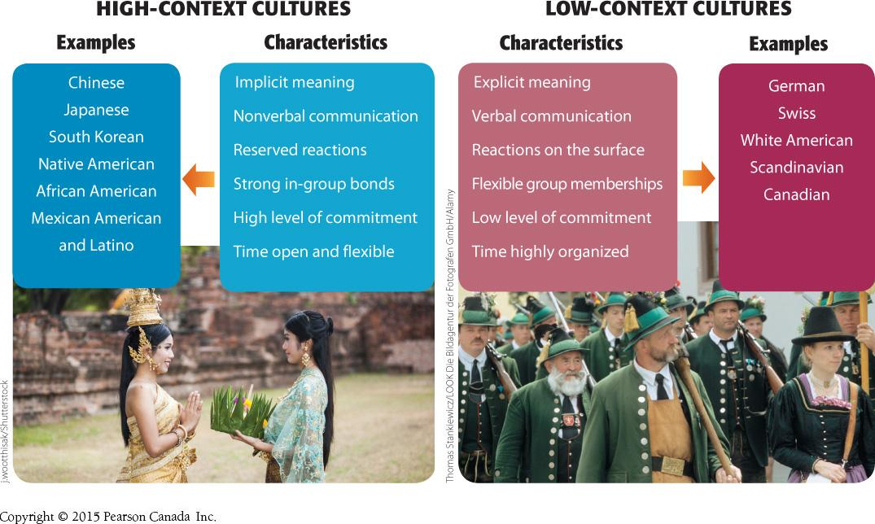

Monochronic/Polychronic Time
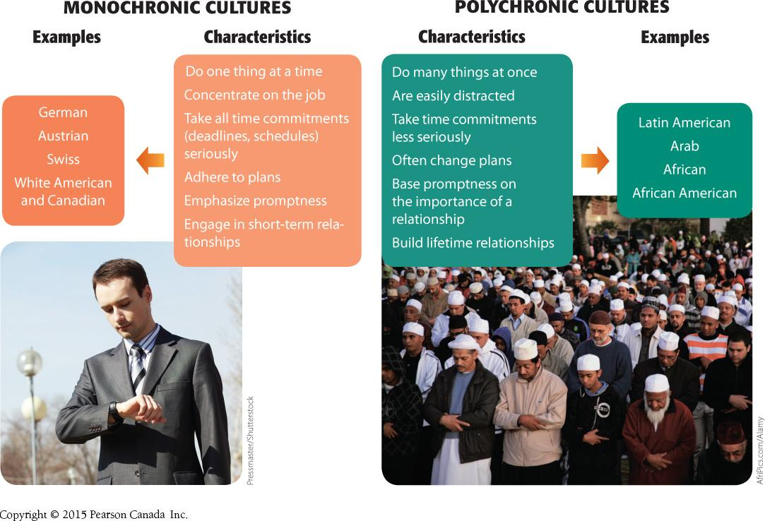

3.5 Intercultural Communication Strategies
- Be mindful
  - Be fully aware of the present moment, without making hasty judgments
  - Occurs when you allow rigid categories and false distinctions to become habits of thought and behaviours
  - Allows you to overcome prejudice and stereotypical thinking
- Adapt to others
  - Communication accommodation theory: Accommodate your conversations to the accepted speech b/vs and norms of that group if believe that group has more power or desirable characteristics
- Actively engage others
  - Spend time and energy interacting with people from other cultures to help develop effective communication with people

Range of thinking

Western  - Focuses on discovering the basic and predictable nature of objects/events  - Tries to control objects, events, and environments  - Puts things in discrete categories  - Uses formal logical rules  - Insists on the correctness of one belief vs. another | East Asian  - Focuses on interacting, unpredictable relationships among events  - Does not believe in control of objects, events and environment  - Relationships and connections, not categories  - Accepts contradictions and dissimilar beliefs

Development Model of Intercultural Sensitivity

6 distinct stages as develop intercultural sensitivity:
Denial
- People avoid noticing or acknowledging cultural differences
Defense
- Focus only on the common characteristics of all human; the opposite response involves attempting to correct stereotypes and failed attempts at multiculturalization of communities
Minimization
- Become immersed in culture for a limited amount of time; lack of depth of understanding, therefore not culturally sensitive e.g. exchange student programs
Acceptance
- Able to understand another culture and use that knowledge and skill in culturally appropriate contexts; can value another culture and acknowledge the levels of complexity within that culture
Adaptation
- Keep your beliefs and values and add to the parts of other cultures’ values and beliefs that fit w/i your life; become authentic means broadening who you are
Integration
- Ability to see people, culture and world contexts through a variety of perspectives; move easily with confidence and sensitivity b/w various cultures

Chapter 3 Additional Notes: Culturally Sensitive Communication
Canadian Diversity
- More than ⅓ of all people in Toronto are immigrants
- Most immigrants tends to live in large metropolis

Understanding Culture: Key Concepts
- Enculturation: learning the ways of your culture though the teaching of your family, peers, schools, faith-based organizations, government, media
  - 2nd gen.
- Acculturation: when a person’s culture is modified through direct contact or exposure to another culture

Improving Intercultural Communication
Recognize and reduce ethnocentrism
- unconsciously incompetent
  - Not being sensitive or having aptitudes about different cultures
- consciously incompetent
  - Conscious about culture: try new foods, meet people from various background, try to break your sensitivity
- consciously competent: overcome culture shock, become more aware of different culture and become more open
- unconsciously competent : being open to diversity and understanding culture become a reflex

Recognize “culture shock”
- Common psychological reaction
- the feeling of disorientation experienced by someone who is suddenly subjected to an unfamiliar culture, way of life, or set of attitude

Identify uncertainty and ambiguity
- Active listening and perception checking (seek feedback)
- Face fears

Effects of Cultural Barriers

↑  - Health costs  - Risk of liability  - Hospital re-admissions  - Possibility of errors  - Health costs | ↓  - Representation of minorities in clinical and health research  - Staff satsifaction and effectiveness  - Compliance  - Adequate management of chonic illnesses  - Quality of care  - Informed consent  - Understanding of condition  - Patient satisfaction  - Access to mental health and counselling

How to Overcome Intercultural Communication Barriers
- Use straightforward language: speak slowly, clearly.
- When appropriate, speak in the language of the people from the other culture. Code switching
- Observe cultural differences in etiquette and nonverbal communication. Way dressed, yes or no eye contact, call them a certain name
- Listen for understanding (not agreement)

Traditionally vs. Culturally Competent Approach to Care
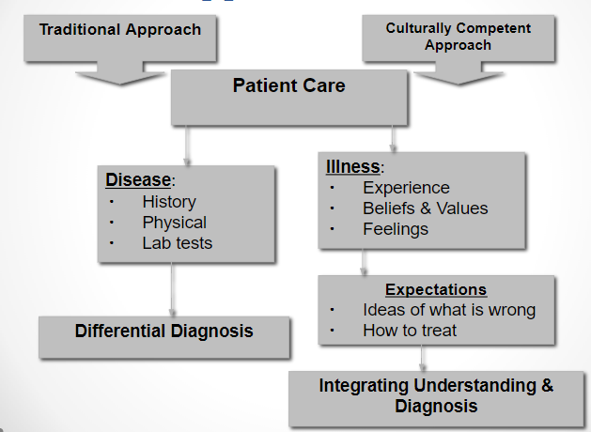

Chapter 11 Additional Notes: Gender, Aging and Communication

Gender and Communication
The Importance of Gender in Culture
- Gender-based expectation and conditioning from birth
- Results on development as adult: rltshsp, careers, etc.

Why vs. How
- Instrumental orientation: men
  - Characterized by assertiveness and wanting to get things done
  - More emphasis on the content of the communication messages: focuses more on the information being exchanged (the what) rather than the relational elements (the how) in the message
- Expressive orientation: women
  - Characterized by an emphasis on connecting with others and fostering harmonious relationships
  - More emphasis on the relational elements: focuses more on the quality of rtlshps b.with communicators than on info exchanged, attends more to nonverbal elements, how something is said rather than what is said
- Content (verbal) and relational (nonverbal) dimensions

- Women tend to disclose more than men
  - Especially in same-sex dyads
  - Women tend to disclose more intimate information than men
  - Equal in negative disclosures
  - Women tend to increase the depth of disclosure as relationship becomes more intimate (not so for men

Listening and Gender (as a function of socialization)
- When talking: men lecture (superior) and women listen (non-expert)
- Women: “people-oriented” listening style (rapport)
- Men: tend to interrupt more, “time-oriented” listening style
- Both genders communicate in similar fashion to their gender counterparts
- Men: display of knowledge and expertise = “respect”
- Women: seek to be “liked”; expresses interest and sends more cues than men
- Women: more nonverbal cues when listening (ex more eye contact), less pure silence; proximity and body posture

Gender Differences in Communication Style
- Women prefer to use communication for rapport building
- Men prefer to use talk to preserve independence and status (via knowledge and skill)
- Women want empathy, not solutions
- Men prefer to solve problems alone but women prefer to discuss their problems with another person
- Men tend to be more directive and less apologetic; women more apologetic and polite
- When facing differences: men more intimidating
- Attention to accomplishments and hogging recognition
- Interruption used differently
- Women tend to use more gentle expletives (“oh dear”, “f@*!”)

Gender and Conflict Style (due to socialization)
- Women more-likely to use indirect strategies, instead of confronting conflict head-on (harmony)
- Men more likely to use direct aggression
- Relational content: men more-likely to withdraw if uncomfortable or do not get their way
  - Hypothesis: women get more by “complaining”?
- Men: aggression can be part of friendship
- Women: more-likely logical reasoning and bargaining than aggression, during competition
- Men: more co-operative with other women than other men
- Differences are less pronounced, as sex-role stereotyping diminishing in our current society

Gender Communication: A comparative analysis of communication approaches of men and women at Workplaces

The female communication pattern and traits tend to be nurturing, indirect, and respectful. It is considered “rapport” type talk. The communication behaviors women tend to possess are as follows:
- • feeling
- • empathy
- • harmony
- • closeness
- • relationships
- • sharing
- • cooperation
- • group
- • intuitive

The male communication pattern and traits tend to be honest, direct, and factual. It is considered “report” type talk. The communication behaviors men tend to possess are as follows:
- reason
- logic
- power
- rank
- status
- compete
- winning
- team
- Think

Aging and Communication

Communication is central to figuring out the role of elderly people in society because
- Reflects understanding and perceptions of aging
  - Shapes experiences of aging; what message do people receive? Old people ether SUPER nice or SUPER grumpy mean
- Age-group memberships fundamentally important to our sense of “Self” (social identity)
  - Styles and content of communication

Gerontology
- The study of aging and older adult
- Multidisciplinary
- Specialized area w/.i various disciplines including nursing

Geriatrics
- Associated with the medical care of the elderly

Ageism
- does someone have the physical capabilities as they age
- Personal: As a society, have notion that as people grow older, become more independent, harder to communicate and requires patience and is challenging to deal with them
  - Language, ignoring/excluding, abuse
- Institutional: in professional e/ts can’t work over the age of 65
  - Mandatory retirement, lack of representation in clinical trials
- Intentional: if you’re someone in marketing and trying to promote things, don’t necessarily think about the older generation to be represented b/c won’t appeal to our consumers
  - Language used in media, lack of preparedness (ex crisis intervention)
- Unintentional: dig beyond stereotypes and figure out how to better communicate with older generation
  - Marketing stereotypes in pop culture, job discrimination

Internal Ageism
“Self-adopted ageism is the idea that I cannot do that at my age. For many seniors, the personal definition of what I am capable of may be one of the biggest barriers to overcome”

Culture as a Source of Ageism
- Negative images of aging in art and culture throughout history
- Schoolbooks rarely portray older people as examples
- Lack of knowledge e.g. technology (get manipulated to buy more than need)
- Service sector slower or less attentive to older people

Elderspeak
- Thing we do when we feel we need to maximize communication with elderly
- Condescending way like person does not have capacity to communicate normally
- Baby talk to older people
  - Few clauses; shorter phrases
  - More filled e.g. you know, like
  - Dearie, sweetie, cutie
- Based on stereotypes
  - Older person has low mental ability or other impairment
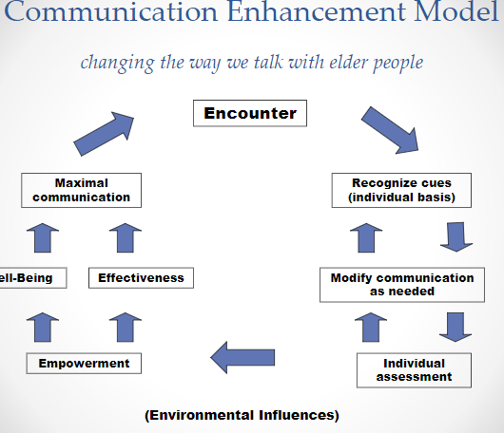

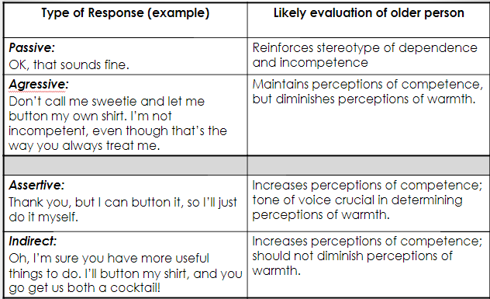

Recommendations

General tips for improving interactions with older adults
- Be aware of the tendency to stereotype older adults
- Avoid speech that may be patronizing (“elderspeak”)

Tips for optimizing interactions between HCP and older patients
- Express understanding and compassion (during times of fear and uncertainty)
- Ask questions about living situation and social contacts
- Be aware of any cultural beliefs and values (illness and disease)
- Shared decision-making (enhance autonomy)

Tips for optimizing interactions between HCP and older patients (continued)
- Not only “what you say” but “how you say it”
- Use direct and concrete language
- Technical knowledge and emotional appeal when discussing treatments
- Make sure to “check” for comprehension
- Enhance patient satisfaction
- Assist with IT challenges (internet, telecommunications)
- Use humor, with discretion

Chapter 3 Additional Notes: Ethics and Communication

Healthcare Ethics
- Ethics:
  - Set of moral principles that serve as a guiding philosophy for behaviour
  - Code of ethics, in each health care profession (ex. CCPA)
  - Functions: education, policy, consultation (deal with facts and emotional issues)

- Healthcare Dilemma:
  - Conflict that requires careful consideration of all possible solutions to identify the one that balances the interests of all involved
- Ethical dilemmas: occur when there is clear conflict b/w 2+ competing moral principles or claims
  - When nurse wishes to be truthful with patient but family physician, wishing to spare patient distress prohibits informing patient about his condition
  - Resolved b/c of guidelines provided by codes of ethics of medical associations or health care institutions, ethics training and implementation of ethical decision-making models

Four Ethical Principles:
- Autonomy: patient makes the decisions.
- Beneficience: healthcare professional decides what is best for patient.
- Nonmaleficience: “to do no harm”.
- Justice: resources, distributed responsibly.

Autonomy
- Self-determination
- Trust, respect, truthfulness, sharing, confidentiality
- Adult, sound mind, written consent
- The following needs to be addressed:
  - Language: appropriate (lay terms, primary language)
  - All risks and benefits must be outlined
  - Any and all alternatives must be discussed
  - Client must sign statement that indicates understanding and acceptance of treatment

“Informed Consent”
- How much information is enough?
  - Impossible to provide information in all of its detail
  - Patients: understand “pros/cons” from medical perspective?
- Information overkill = more stress to patients (?)
  - Did patient feel pressured to make a decision?
- HCP must address unique conditions of each patient
- Family members can be gatekeepers

Beneficience and Nonmaleficience
- To do good and to provide benefit (Paternalism)
- To do no harm
  - Hippocratic Oath:
    - http://www.royalcollege.ca/rcsite/bioethics/primers/medical-ethics-past-present-future-e

Justice
- Ethical obligation to be fair
- Rights-based, legal, and distributive

Approaches to Truth Telling: Patient and Professional Relationship
- Strict paternalism: Blatant “deception” by the HCP for the patient’s best interest
- Benevolent deception: HCP withholds some (not all) of the truth from the patient
- Contractual honesty: HCP discloses as much info as the patient desires
- Unmitigated honesty: HCP tells all, even if patient does not want to hear the truth

Chapter 12: Communicating in a Digital World
12.1 The Nature of Digital Communication
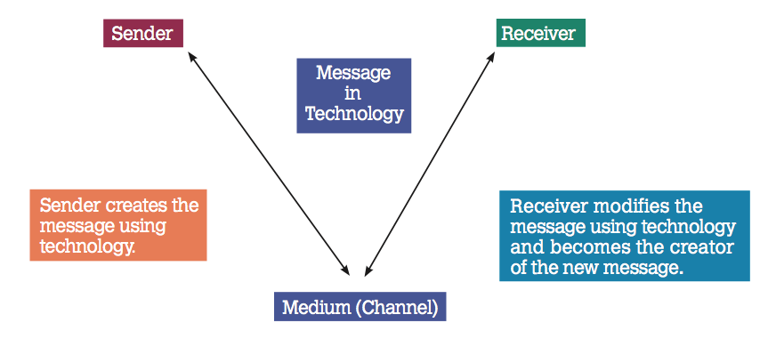
- Expanded role of channels in the communication process
- the medium is the message: user’s experience of an act of communication differ greatly depending on the medium being used
  - b/c technology becomes the medium
  - If we’re not careful, we lose a lot of substance in our communication b/c worried more about substance than what the message is actually relaying
  - Ex. Orgnaizations have social media platforms… CHEO → website, facebook, twitter, youtube platforms
The Importance of Social Media in Communication

- “SOCIAL MEDIA”: forms of electronic communication through which users create online communities to share info, ideas, and messages.
  - Canadians: among the most prolific users of social media
  - Positive: mass way of communication
  - Negative: how it affects our human development
    - Addictive
    - Depressed mood b/c comparing self to others (see pictures and how they are enjoying life)
    - Reduces productivity
    - Always stimulated, hard to relax
    - Increases sadness
  - Negative: how it affects our brain:
    - Brain structure is changed when social media is used b/c lacks nonverbal signals
      - Specifically right region, lower, to create emotions is being used less
      - Surface level of experiencing the world

- Social Networks
  - Personal profiles, commenting opportunities, ability to include/exclude others
  - Meeting others: hobbies, ideas, groups, relationships
  - Purpose: organization’s structure or personal socializing

12.2 Understanding Digital Citizens and Citizenship
Digital Native
- Describe the generation of young adults who have always had access to the Internet and all of the available digital tools and gadgets
- Expect to be able to use technology in all aspects of their lives
- Exploration of new media and technology is intuitive

Digital Immigrants
- Need to learn how to navigate
- Complain that they don’t like communicating using technology due to lack of nonverbal cues
- Find it difficult to interpret messages effectively

Digital Citizenship
- The norms of b/v with respect to the use of technology
Nine Elements and Strategies
- Etiquette: follow rules and policies
- Communication: model good use of electronic communication
- Education: continual learning of internet resources
- Access: advocate universality of access
- Commerce: effective use and consumerism
- Responsibility: code of ethics
- Rights: copyright protection
- Safety: personal physical health e.g. eye strain addiction, physical strain
- Security (self-protection): online safety, be aware of spyware, share personal info carefully

How Much Online Sharing is too Much?
- Young adults more likely to not share private info than older generation and prefer to keep info private
Before updating your status or posting a picture, ask the following questions…
- Q: Would you want the Dean or an employer to see everything you post online?
- Q: Would you share this information with them (above) face-to-face?
- Q: Does this information have a legitimate purpose (is it necessary information)?

12.3 Ethics and Digital Communication
- The laws that govern Canadians when we are offline are the same laws that are in place when we are online.
- In 2013, the Canadian federal government was trying to have legislation passed that would further protect online users, while keeping the freedom of ideas.

Digital Code of Ethics
- Privacy Issues: to what extent do you put your person info on internet using social media/protect info you post?
- Accuracy Issues: monitoring personal info, verify info?
- Property Issues: do you or friends give credit to material obtained online
- Accessibility Issues: satisfaction with extent to which you can access information on the internet and also how limited in access to social media or specific sites on the internet

12.4 Online Communication Tools

- Collaboration tool: Google
- Presentation tool: PPT
- Meeting tools: Skype
- Curating and Sharing tools: Pinterest

Twitter: Quality Tweets
- Does it answer question being posed?
- Follow-up question (to continue conversation)?
- Are the links provided useful and ethical?
- Is the tweet free of bias, prejudice, racism?
- #qualitytweets

Meeting Skills in the Virtual World
- Email agenda, prior to.
- Ensure proficient use and working order of software/hardware.
- Set goal for meetings and respect timeframes.
- Acknowledge/encourage participation.
- Follow-up email with main points.

Benefits of Virtual Meetings and Collaboration
- Reduce travel time and costs
- Reaching a wider audience
- Improving spectator experience
- Encouraging online participation
- Conveying professional image of organization or group

Chapter 12 Additional Notes: Mass Communication and Health

Two Perspectives of Media Influence:

Cultivation Theory
- Long-term exposure to media shapes our understanding of the world in ways that are consistent of how reality is portrayed in the media.
- Television has a “normalizing” effect (i.e. what is desired and accepted)

Uses and Gratification Theory
- People actively choose certain types of media content to satisfy psychological and social needs

Needs Fulfilled by the Mass Media Concerning Health:
- Information seeking
  - TV, radio, newspapers, magazines, social media

- Entertainment, diversion, tension release
  - Divert our attention from the stress of everyday life

- Fulfill social needs
  - Helps foster connection with others (interpersonal needs), “social self”

Media Usage, Health Portrayals, and Health Behaviours:

- Unrealistic portrayals of health situations
  - Skewed perceptions of the HCP and the medical practice
  - Overemphasizes the biomedical issues
  - Reinforces stereotypes (older adults, disabled, etc.)
- Unhealthy role models and the promotion of unhealthy behaviours in advertising
  - Glorifies high-risk behaviours (drugs, sex)
  - Reinforces the physical attributes
The Influence of media on eating habits
- Obesity: actors constantly around food yet none are overweight; advertisements of foods
- Eating disorders: distorted perceptions of ideal body image for men and women (ex fashion and cosmetic industry)

Media content and cosmetic surgery
- Promoted by images in TV and film (Hollywood)
- In some severe cases, linked to body dysmorphic disorder

Media content and acts of violence
- Researchers: most children will witness 8,000 murders and 100,000 acts of violence in media before finishing elementary school
- Relationship not so clear with violence in video games

Relationship between media & substance abuse
- Alcohol: associated with excitement, wealth, prestige, power, and social approval. Sophistication and intelligence also portrayed with those well-liked and attractive (ex. Sex and the City)
- The relationship between media and substance abuse (continued)
- Tobacco products: seen as glamorous and sophisticated (cigar sales over 250 million per year)

Media and sexual behaviour
- Popular media often emphasizes positive aspects and ignores consequences such as pregnancy, STIs (does not reinforce safe-sex practices)
- Reinforces gender stereotyping (“macho”, popularity)

Direct-to-consumer advertising of prescription medications
- Encourages use of pharmaceuticals (“ask your Doctor if…”), ex. Viagra
- Multi-billion dollar industry
- Mixed feelings: increases communication between patient and HCP vs. misleading, unrealistic, promises of effectiveness and risks of use
- Targets middle-aged white adults (minorities and elder population underrepresented)

Chapter 14: Language and Delivery
14.1 Speaking Style
- How you use vocabulary, sentence structure (length), grammar/syntax and language devices to express a message
- Effective speakers find the speaking style or styles that ----

The CORE speaking style
- C and O are more closely related
- R and E are more closely related

C: Clear style
- Clarity is number one
- Short, simple and direct words/phrases
- Active verbs, concrete words, plain language
- E.g. Given instructions,

O: Oral Style
- SHort, familiar words
- Short, simple, even incomplete sentence
- More personal pronouns
- Colloquial expressions
- Examples provided through videos

R: Rhetorical Style
- Uses languages designed to influence, persuade, and/or inspire
- Art of using language to persuade someone
- Lawyers, politicians have a natural affinity for this

Characteristics
- Intense language
- Rhetorical Devices
  - Repetition
  - Metaphor

The Intensity of Language Choices
- The degree to which language deviates from bland or neutral words

Intense  - Disaster  - Gorgeous  - Extraordinary  - Elated | Bland/Neutral  - Mistake  - Nice  - Good  - Happy

Repetition
- Alliteration: repeated sounds
  - “Step forward, Tin Man. You dare to come to me for a heart, do you? You clinking, clanking, clattering collection of caliginous junk. . . .”
- Repeated words, phrases, sentences: can drive home an idea and provoke action
  - I have a dream -Martin Luther King (9 times)

Metaphor
- Stimulate audience members to find the meaning for themselves
- Are the most powerful figure of speech: windows in the working of the human mind
  - Art is a rebellious child, a wild animal that will not be tamed
  - All the world’s a stage

E: Eloquent Style
- Uses poetic and expressive language in such a way that makes a speaker’s thoughts and feeling inspiring and memorable
- “Today’s eloquent speakers call upon their own past or their own sense of ethics to inspire an audience”
- The idea of igniting the human spirit

14.2 Modes of Delivery
- Language: how you choose words to express the content of your message

Delivery
- how you use your voice, body and presentation aids to express your message to others
- Impromptu: speak without preparation or practice improv
  - Learn to think quickly and on your feet
  - Can cause you to have nerves if feel like being put on the spot
- Extemporaneous: use outline or notes as a guide
  - Allows you to collect thoughts
  - Can veer off in tangent but as long as you stay within main points, still reach conclusion
- Manuscript: write and read word for word
  - Something sensitive, related to law, published in newspaper
  - Want no area of misconception
- Memorize: Memorize and present without notes
  - Most rare, comedian

Speaking Notes Guidelines
- Use as keywords and few cards as slide
- Use cardstock, not paper; only one slide
- Number the cards

Preparing a manuscript
- Larger front (14-16), double spaced, wide margins
- Number page, top ⅔ of page
- Do not staple pages together

Are you more nervous than most people?
- Speaking anxiety is common and signs are not visible
- More information you know, more confident you will become
- Probably not as bad as you think b/c ppl don’t know your internal monologue, might have gone more smoothly than you think

14.4 Vocal Characteristics
- Breathing: controlled exhalation
- Volume: a voice’s loudness level
- Rate: number of words/minute
- Pitch: how high or low a voice is
- Fluency: speaking smoothly
  - Not fluent e.g. stuttering,
- Articulation: speaking clearly
  - Physical movement of places in mouth to say sound
- Pronunciation: speaking correctly

14.5 Physical Delivery

- Eye contact: establish and maintain direct, visual links with individual audience members
- Facial expression: When in doubt and if appropriate for the topic, smile
- Gestures: do what comes naturally
- Posture and movement: Stand comfortably and confidently. Move purposefully.

Eye Contact Strategies
- Talk to audience members and look at them the same way you would talk and look at a friend, co-worker or customer.
- Move your gaze around the room, settle on someone, and establish direct eye-contact.
- Talk to audience members and look at them the same way you would talk and look at a friend, co-work or customer.

Facial Expression
- Your face reflects your attitudes and emotional states. Unless your topic is very serious, smile
- Smiling shows
  - You are comfortable speaking
  - You are eager to share your message
  - Audience is more eager to smile as well

Posture and Movement
- Stand straight but not rigid, lean forward a little
- Feet = foot apart
- Head up, chest out, stomach in
- Move between major sections
  - Move closer to your audience for important points
  - Move to fill a pause

What about your Hands?
- If move and natural for you, do it
- If not, then don’t make up new unnatural stuff

14.6 Design Principles for Presentation Aids
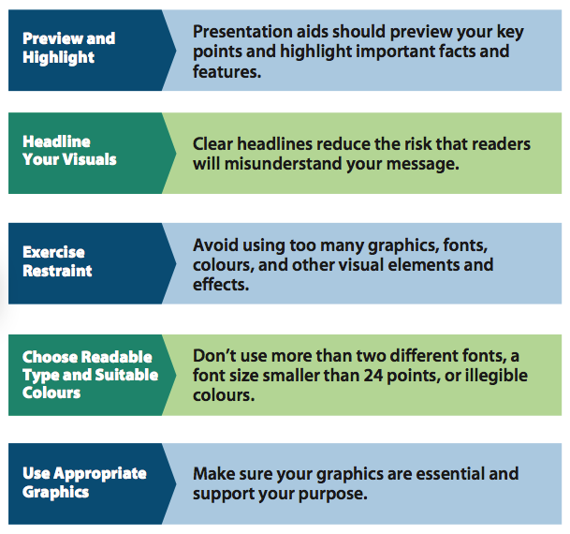

14.7 Practice, Practice, Practice

Do you practice your presentation?
- Avoid practicing one long single session
  - Divide each session into manageable chunks (to be establish a beginning, middle and end)
  - Full run = 3 times
  - Reinforcing the vocal and nonverbal qualities
- Complete three run-throughs.
  - Make changes during practice
- Use A-V recorder

Wednesday, December 12, 2017
Final Lecture: Exam Review

Chapter 4 ADDITIONAL Nonverbal Communication: 1, 7-9
- S1: Understand that things we refer to-tone, tempo-breath, pitch can be described as nonverbal, non-nonvocal
- S2: Reinforces what we saw from reading (nonverbal communication is continuous, etc.)
- S3: Reinforces what we saw from the reading, just synonyms
- S4: Don’t worry too much about it, build you up on subsequent factors of gender
- S5: don’t need to memorize necessarily, reinforcement
- S6: TABLE 5.3 – don’t worry about it
- S7: disfluencies* filler words like like, oh my god, (lack of fluency), *paralanguage is pitch/tempo and nonverbal non-vocal
  - Trying to piecemeal coherence in their speech
- S8: Why is nonverbal important? Can see from perspective from patient: think something is missing/not being said (whole story is not being given to us) sugarcoat
- S9: HCP nonverbal: piecemeal missing info: does this person get it? Should I say more, less, change my language? W respect to dyadic communication with individual

Chapter 6 ADDITIONAL Assertiveness and Self-Disclosure
- S1: focus on dyadic effect: one on one communication episode
  - The more sensitive the topic, the more closer you are in rtlshp, the greater the level of disclosure
- S2: At the end of the day, in terms of benefits, ties into unit on self-awareness and intelligence b/c in order for you to take internalize communication, lead to self knowledge
  - Self-disclosure is a way to arrive at that – better at that, better at self-knowledge
  - Dangers? Have to be careful in interprofessional- with who, to who, about what? HCP by trade must be conscientous about when to disclose, how to disclose and is this appropriate?
- S3: Look at guidelines for facilitating and respond to disclosures *active listening*
- S4: Styles of expressing conflict take focus on indirect conflict, but not so -ve by definition (neutral or +ve)
  - Allowing person who said something that they were erroneous in communication and not let them feel incriminating but allow them to “save face”
- S5/6: understand the general suggestions, not prethink, always asking someone for feedback (perceptual checking), consequences, statement (THINK OF DESC VERY SIMILAR JUST BROKEN UP DIFFERENTLY)
- S7: Look through and understand how to break out of your shell e.g. smile more, communicate more with random ppl, practice being decisive, etc

Chapter 7 ADDITIONAL: Interviewing and Counselling
- S1: Yeah cool stuff, but whatevs
- S2: Generic interview framework, more concerned about four stages of therapeutic interview
- S3: Questioning is important
  - Open to close (funnel sequence) V
  - Close to open (inverted funnel sequence) upside down V
- S4-6: Types of questions: open and closed
  - look at open questions (more info): explain, elaborate, what
  - Closed (one word, short phrase answer): when, do you, how, was?
- S7: undergoing a job interview whatevs
- S9-10: Starts techniques in counselling; THE FOUR STAGES FOCUS ON THESE
  - Preparation: admin, planning first meeting e.g. research
  - Initiation: in contact w person
  - Exploration: Working stage, main therapeutic part of actual interview, longest, all of challenges and ways to deal and cope happen here
  - Termination: dissolving rltshp
    - Referral (true termination), psychotherapist and intermittent sessions with individual in future (goodbye…for now)
- S12: Table 5.2
  - Efficiency: time ( o = more time)
  - Emotionality: how likely is to trigger a response (o = more likely)
  - Depth: detail in answer (o will give a more elaborate a)
  - Control: pts perspective; how much influence do they have with where they go with this question (o = more flexibility)
- S13: Silence is a therapeutic technique
  - Allows both to collect thoughts and remove self from catharsis (pt)
  - Can ground things
  - Too much can become mechanical
- S14: Restatement and paraphrasing = same but…
  - Paraphrase: has no connotation of emotional content, but regurgitating message using synonyms to denote same message to summarize essence of what they’ve said to you
  - E.G. so what I’m hearing from you, you feel that you just don’t have time in your schedule
  - Don’t need to ask for feedback b/c pt can pick it out
- S15, 16: Reflection is about adding feeling to what the pt has said
  - E.g. when you describe how you don’t have time and you feel stressed, a sadness came over your face
  - Adding the fact that the person was sad even though they did not mention it
  - Ask for feedback if that’s okay, smart speculation
- S17: Clarification is all about giving the person clarity in what they’re trying to express
  - Summary but giving a scenario of what you’re ingesting while you’re actively listening
  - E.g. You’re telling me about your stress and are talking about work and school, but I’m not sure which one is causing you more stress/
  - Not sure where the pt is going and want them to be more clear about what they’re disclosing to you
- S18: interpretation
- ***just know the differences between them***
- S19: Just know why important to use narrative model
  - Letting person to tell personal storyline allows them to repackage how they see themselves in a predicament
- S20: Need to be pt centered, but don’t need to systematically memorize i
- S21: Interesting, but whatevs

Chapter 7b ADDITIONAL: s3-7
- S2: Know differences and terms b/w them
  - Existential factors
  - corrective recapitulation: patterns in rltshp
  - catharsis: “crying like a baby”
  - altruism: assist other even while in own trouble
  - universality: unity w existential factors
- S3: not too much time
- S4: Know the therapeutic factors
  - Control: how we get beyond role uncertainty, away from traditional approach of authority in physician and submissive pt, want evenness
- S5: Trust: having faith in someone’s statements and what they say to you; allows you feel that you’re beyond just an object, personal factor
- S6: Confirmation: someone feels like they’re validated in terms of their experiences, person feels that they are affirmed as an individual and their storyline is important
  - Don’t need to know cyclical process
- S7: Empathy: ability to project yourself in someone else’s condition even if you haven’t gone through that
- *KNOW DIFFERENCES*
- S8: Barriers to empathy
  - HCP: lack of exp, motivation, or burnout/fatigue
  - Pt: bad experiences, lack of familiarity
- S9-10: Don’t have to stress over this too much

Interprofessional Communication
- S2: zero memory
- S3: no need for memory
- S4: leads into following slides
- S5-9: professional-pt rltshps
  - Role uncertainty: trying not to reinforce traditional communication patterns
  - Responsibility conflict: associate with who has responsibility of care (physician or pt) in end product of being healthy?
  - Power differences: traditional ways that ppl communication that reinforce archaic ways we want to get away from
  - Unshared meanings: less technical, more accessible language towards ppl can understand
- S10-12:
  - Role stress: understaffed, overworked
  - Lack of interprofessional understanding: no communication between HCPs that are working to help the same pt e.g. family doctor, chiropractor, etc.
  - Autonomy struggles: $$ problems that HCP have to deal with e.g. other HCPs, certification, continuing education, resources, etc.
- Professional-Family Member: not enough contact time to derive info, but in the event that there is, still not enough
  - How much disclosure is there? Direct = privileged or indirect = filtered
- Pt-family member rltsphs
  - Family dynamics can be different e.g. strict vs. don’t talk too eachother, some share EVERYTHING, etc.
  - Closed patterns has to do with cultural contexts

Health Communication Models
- S2: Leary Model understand concepts b/c tie in w rltshp with patient-HCP
  - Inverse rltshp : if show dominance, see submissiveness
  - Not inverse: If show validation and affirmation then expect same thing
- Sociogram: think about interaction and who initiates, who responds, who gets not time with some

Group Dynamics
- Small vs. large groups: know what it means and also what you can accomplish with more hands
- 5-7 member optimum group size
- Content and process: small groups mean more content than process (backseat); cohesiveness and effectiveness is ultimately determined by process though
  - Content: task
  - Process: does a group affectively or not- rltshp aspect
- Types of Groups; figure 6.1 reinforces that some groups are only about content e.g. jury, ethics board and some only about process e.g. support group
- Phases of a group – same thing as tuckerman’s – forming, storming, norming, performing
  - Table is reinforcement, natural progression towards group cohesiveness and performance

Conflict and Communication
- S2: Different places where conflict can happen
  - B/W GROUP AND OUTSIDE
- S3: two kinds of conflict: content and process
  - C = goals, beliefs and values (what’s the vision statement, goals, objectives, mission statement)
    - Procedural: We agree something should be done but we don’t know how to go about it “This person needs surgery, but how do we go about it?”
    - Substantive: “Should we go ahead with this person’s surgery despite the fact that he cancer has spread too much?”
  - P = esteem, control, affiliation
- Techniques for managing conflict – you have these examples
- 5 Steps – generic , whatevs

Culturally Sensitive Communication
- Don’t need tables
- Enculturation and acculturation
- Culture shock: not being accustomed to other ppl’s b/vs
- Cultural Barriers
  - Recognize these things, does it increase or decrease HC
- Memorize and spot out key words in overcoming intercultural barriers
- Understand from flow the reinforcement that there can be a separation in culturally sensitive communication from archaic ways that we’re trying to move away from

Gender and Communication
- First couple slides 6-7 are where derive questions from -tag q’s, aggressions etc.
Aging and Communication
- Gerontology vs. geriatrics
- What is ageism and where it can happen
- Elderspeak: words we use that don’t come off as therapetuic because sound patronizing and belittles them
  - Have examples swhich should be obviou
- Should know better ways to interact with elderly

