“...But a Hot Temper Leaps O’er a Cold Decree”
- Enthalpy of Various Reactions

Students:

Sahil Thorul
(0300010471)

Melenna Awaju
(300025621)

CHM1311 Section A10

Teaching Assistant:
Tom Burns

Lab Date: Friday, October 6th, 2017
Submission Date: Friday, October 13th, 2017

Department of Chemistry

University of Ottawa

Introduction:

According to Silberberg (2017), the energy change in a chemical process is determined by measuring the quantity of heat transferred, q, between a system and its surroundings. If heat is absorbed or released under constant pressure conditions, then the variable associated is denoted as q_{p} and therefore the following equation holds true:
q_{p} = ΔU + PΔV = ΔH [1],

where ΔU is the internal energy, which is the sum of all energies of a system, including the transfer of heat and work. Work can be derived from the formula -PΔV, where p is the pressure, ΔV is the volume change. The transfer of heat is represented by the variable q_{p}. Being that the definition of enthalpy change is the transfer of heat of a system under constant pressure, the variable q_{p} equals to the change of enthalpy change, represented by the variable ΔH.

The variable q_{p} may also be determined by a different, more simpler equation:
ΔH = q_{p} = c ⋅ m ⋅ ΔT [2],
Where c [in units of J/(g ⋅ K)] is the specific heat capacity (the amount of heat needed to change the temperature of one gram of substance by 1°C), m is the mass (in grams) and ΔT is the change in temperature (in °C).
A coffee cup calorimeter is used to determine the enthalpy of solution (ΔH_{sol}) which is also equivalent to q_{p} and is the sum of the lattice dissociation enthalpy of an ionic compound (ΔH°_{lattice dissociation}) and the enthalpy of hydration of a gaseous ion (ΔH°_{hydration}) as the following:
ΔH_{soution} = ΔH°_{lattice dissociation} + ΔH°_{hydration} [3]
The following is the calculation involved in finding the enthalpy of solution of NH₄Cl.

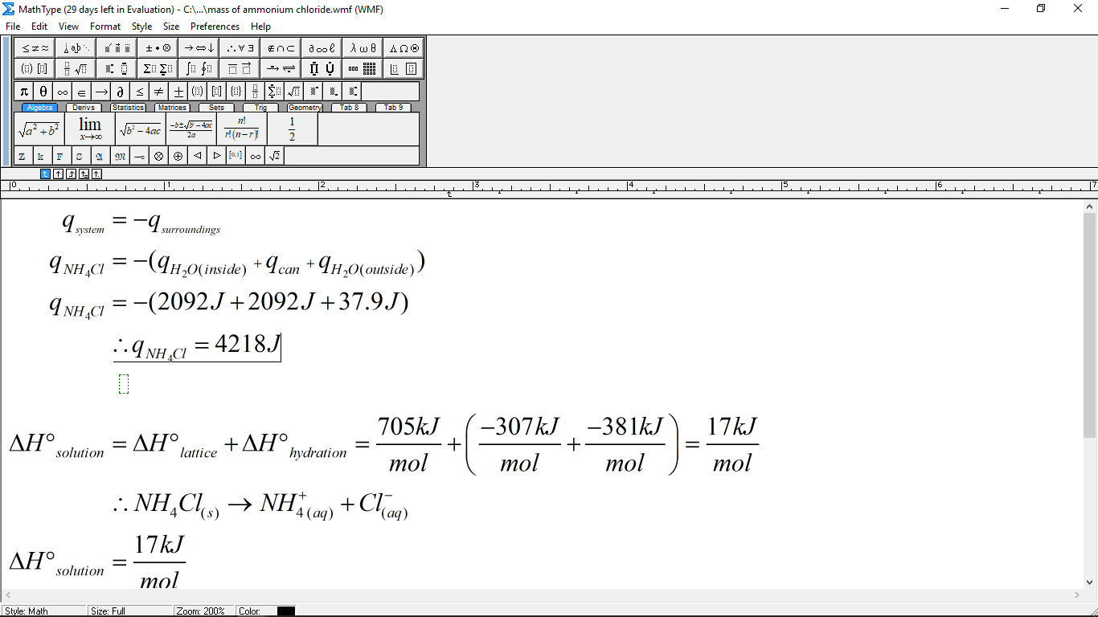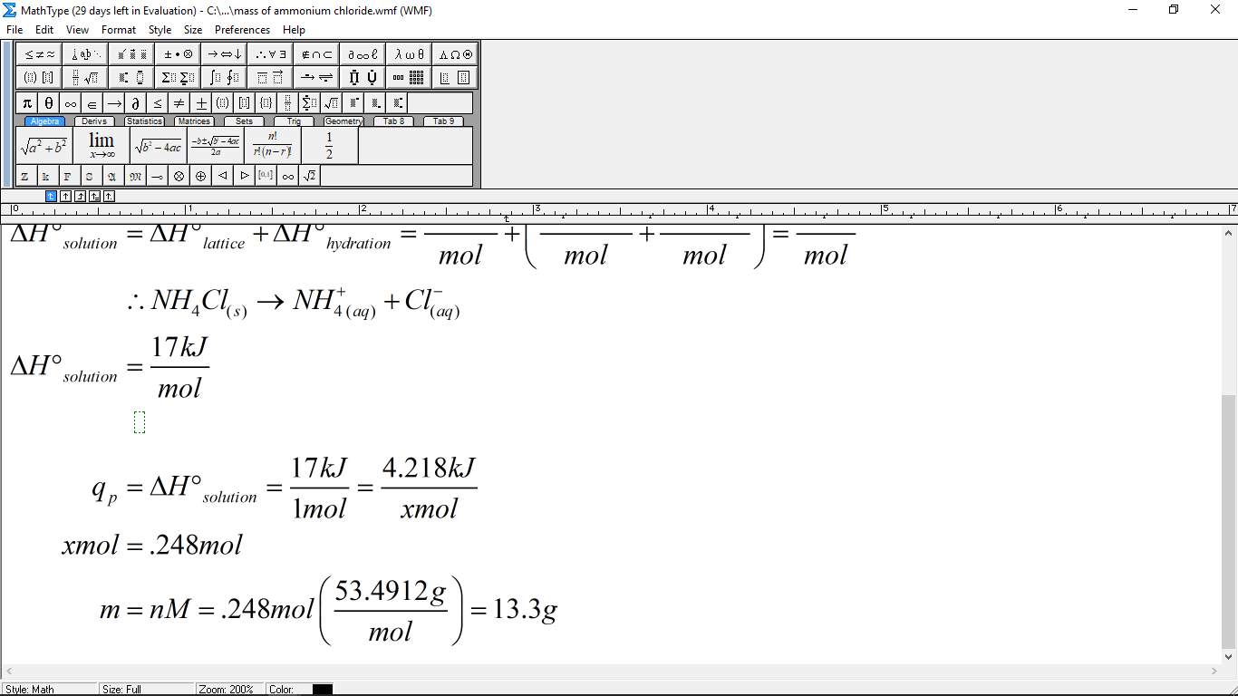
The following figure visually demonstrates the relationship between the aforementioned enthalpy changes:
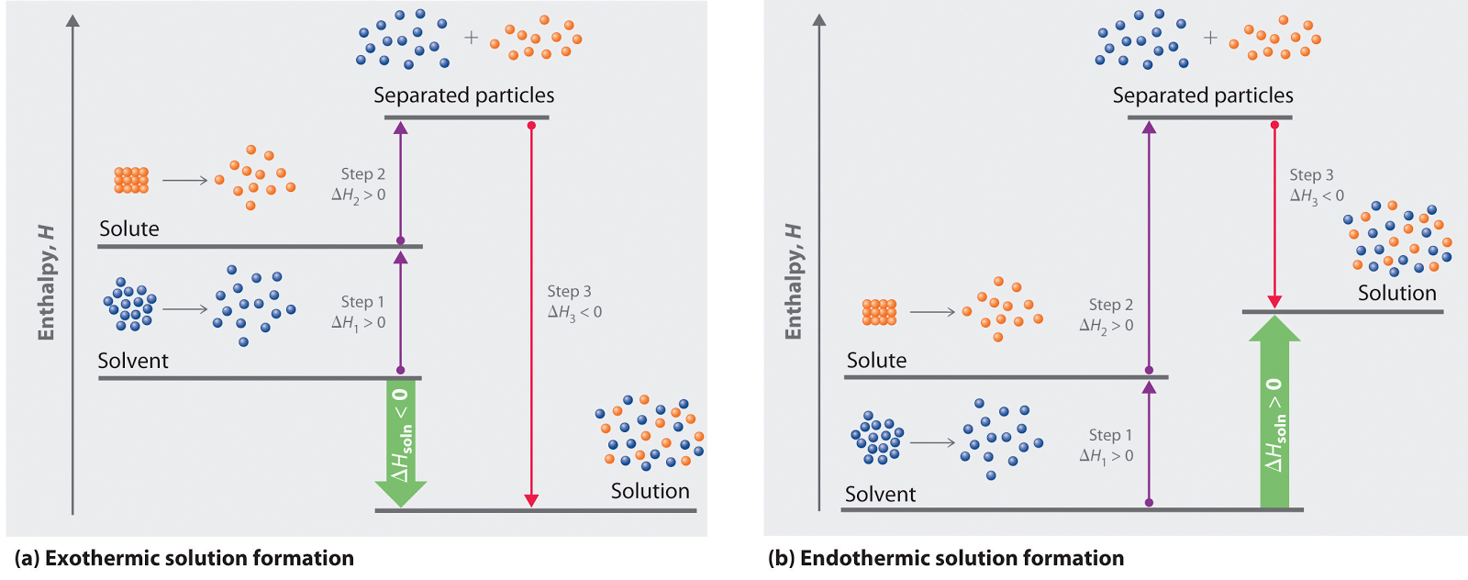
Figure 1: The relationship between enthalpy of solution, lattice dissociation enthalpy and enthalpy of hydration in an exothermic (a) and endothermic (b) reaction, according to Averill (2011). The lattice dissociation enthalpy is denoted with purple arrows and the enthalpy of hydration is denoted with red arrows.

The purpose of this experiment was to chemically design a product that can cool 100 cm³ of drinking water in 5 minutes by no more than 5°C. (The change in temperature could not pass 5°C because of the health and safety restrictions imposed by Health Canada). In order to do so, two chemicals were considered: ammonium chloride (NH₄Cl) and ammonium nitrate (NH₄NO₃). After a period of analysis, it was determined that the former would be used primarily because the latter’s chemical properties are both dangerous and explosive and under a financial lens, it is slightly more expensive to use (22 cents more than the former). In addition, since ammonium chloride has a smaller enthalpy of solution value, +17.0 kJ/mol compared to +25.0 kJ/mol for ammonium nitrate, it is more controllable and would be relatively safer to use considering the designed product will be ingested by consumers.
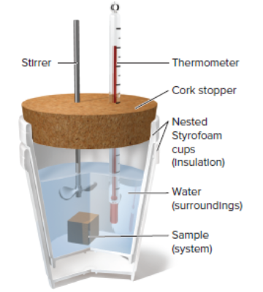
A coffee cup calorimeter was used as the experimental design since the reactants used in the experiment (water and ammonium chloride) were not involved in a vigorous reaction and also because coffee cup calorimeter models are inexpensive to use. Calorimeters are tools meant to measure the heat transfer between chemical reactants (the system) and the surroundings. The following figure, Figure 2, is an annotated example of a calorimeter. For the purpose of this lab however, there were some slight modifications in the calorimetry design that deviated from this visual representation. For instance, the cork stopper was just a styrofoam lid. Secondly, there was another container (with no second lid however) within the calorimetry that carried just water, and an equal mass of water floating in the gap within the inner surface of the calorimeter and the outer surface of the second container along with our solid. (The reason why the contents were separated is explained in the procedure.) Finally, Figure 2 implies that the stirrer is meant to stay within the calorimeter throughout the duration of the reaction, however, the stirrer is used and then quickly put aside right before the chemical reaction initiates (also described in Procedure).

Figure 2: Coffee cup calorimetry (the mechanism used to determine q_{p}), found in Silberberg (2017).

Within the experiment, the variables used are categorized as the following:
Variable | Variable Type
Mass of water | Constant
Mass of ammonium chloride | Independent
Time | Independent
ΔT of the calorimeter | Dependent
The RPM (frequency rotation) of the stirrer | Constant
*N.B. Although we were trying to determine the mass of ammonium chloride that will give us a temperature change as close to -5°C as possible, we had decided on set values of ammonium chloride mass to work with, which would make mass independent and temperature dependent.

Pre-experimental Calculations:
The purpose of this lab was to find a mass of NH₄Cl that would cool 100cm³ of drinking water by a temperature change of -5°C within a time frame of 5 minutes. Before the experiment
was started, a theoretical mass of NH₄Cl was calculated. The following is an explanation of those calculations.
According to the enthalpy of dissolution calculation, the dissolution of ammonium chloride was an endothermic reaction, meaning that the solute absorbed heat as it dissolved. Therefore, the q-value of the system, which was the ammonium chloride, was positive. On the other hand, this meant that the q of the surrounding released heat, making it negative. In this calculation, the q of the water inside, of the can and of the water outside the can were considered to be the surrounding. This resulted in the creation of equation 4.
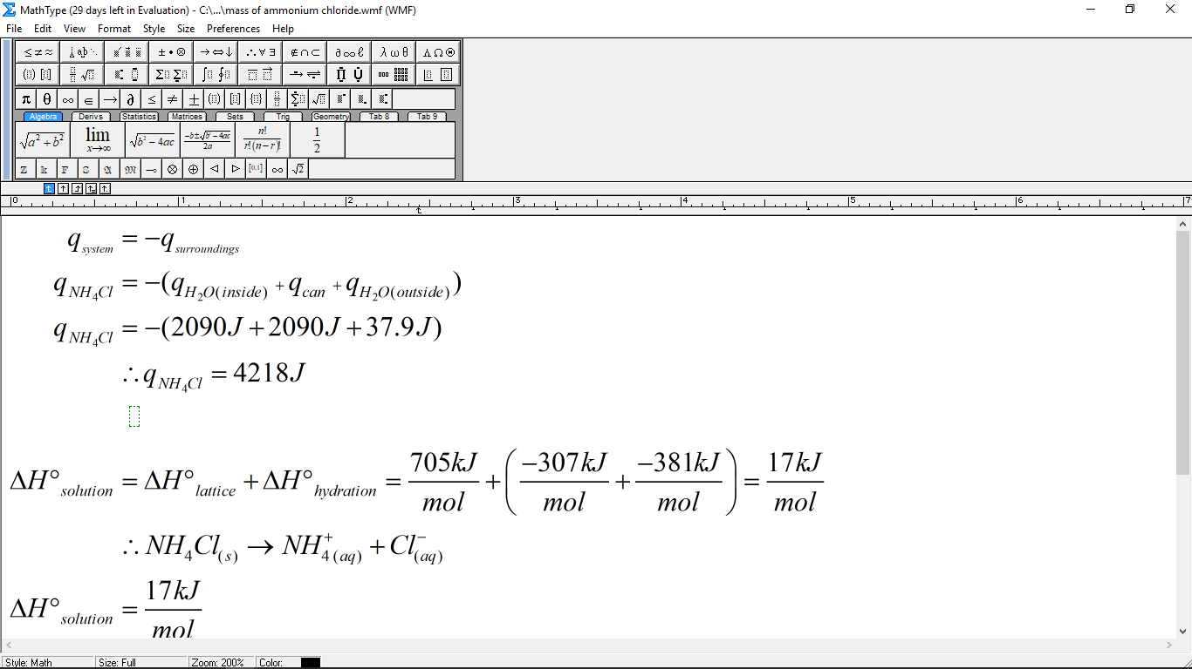 _{[4]}
To continue the calculation, the q-value of the water outside the can, the water inside the can and the can itself had to be found. The q-value of the water inside the can was found using this equation 5. The same principle was used for the q of the water outside the can.
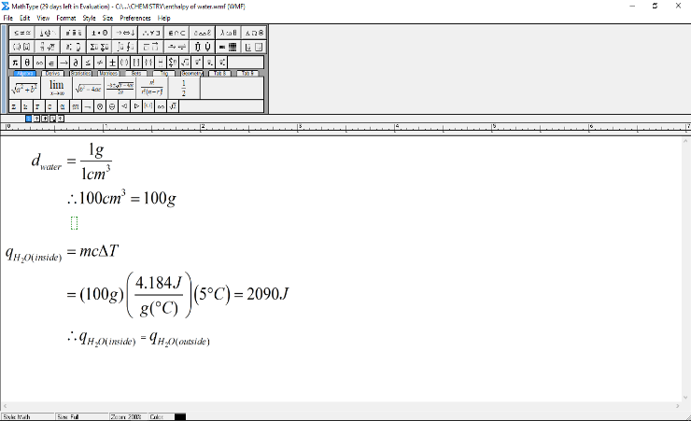 [5]

As seen by the equation 5, the mass of water was required. The mass of water was calculated by rearranging the density of water. The mass of water obtained was 100g.
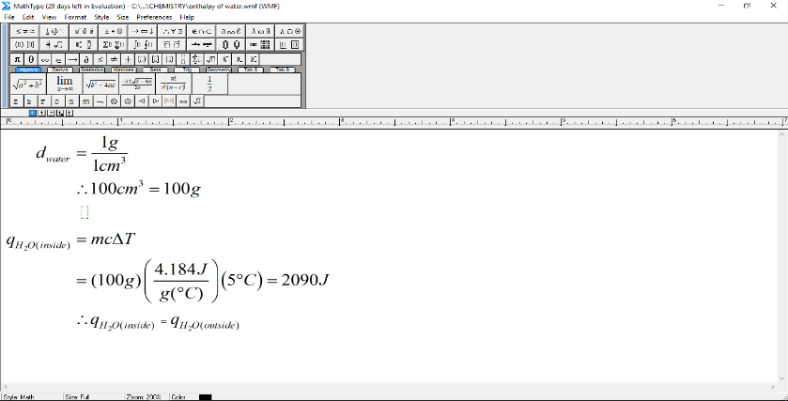
This mass was then inserted into the equation 5. The specific heat capacity of water was a given value. The change of temperature, the required 5°C, was also inserted into the equation 5. Therefore the q-value of water was calculated to be 2092 J. Being that the masses of the both waters are identical, the q value of the water inside the can was equal to the q value of the water outside the can.
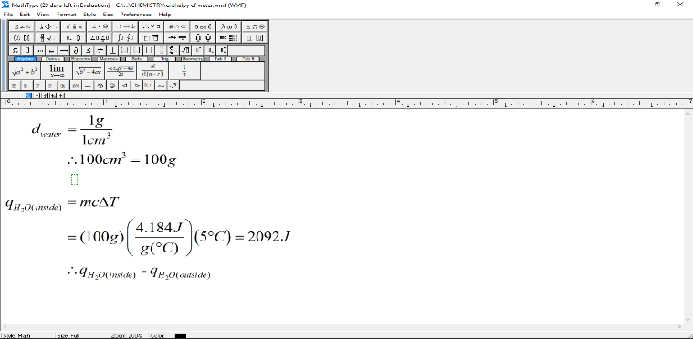
Next, the q-value of the can had to be calculated. This was calculated using equation 5. Three different cans of different masses were used in the experiment. Different masses, meant that each can absorbed different quantities of heat. To solve this issue, an average was derived from each different change of heat.
It was assumed that the specific heat capacity of the cans was the same as the specific heat capacity of aluminium, .900 J/g°C, according to Silberberg 2017. The specific heat capacity of aluminum, along with the desired temperature change of 5°C, was inserted into equation 5. 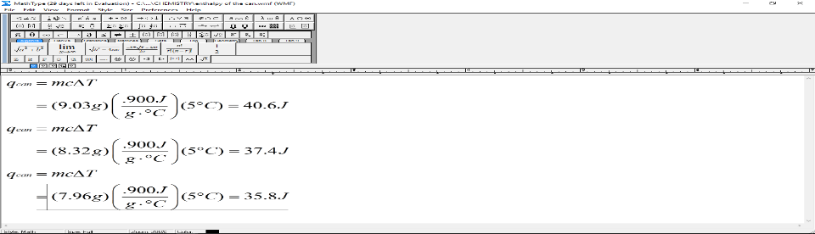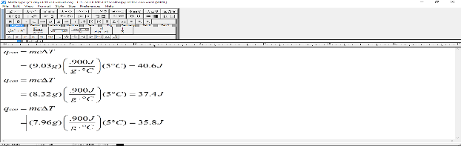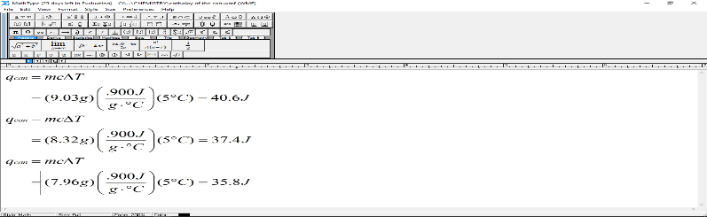
Finally, the enthalpy of both waters and the average enthalpy of the cans were inserted in equation 4, meaning that 4218 J must be absorbed by NH₄Cl in order for 100cm³ to be cooled down by 5°C.
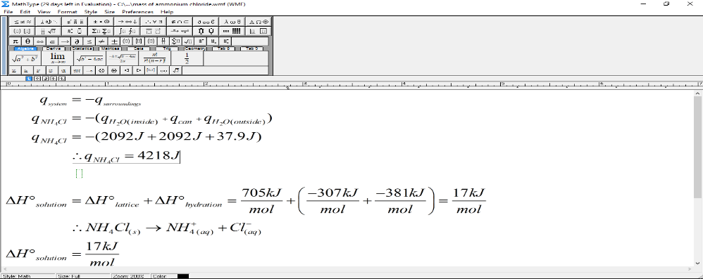
With this information, it was possible to calculate the theoretical mass of NH₄Cl. The enthalpy of dissolution from equation 3 was used to find this mass, which was a value of 17 kJ/mol. It was predicted that 13.3 grams of NH₄Cl is enough to cool 100cm³ down by 5°C.
In order to find this value, the molar mass of NH₄Cl was required.
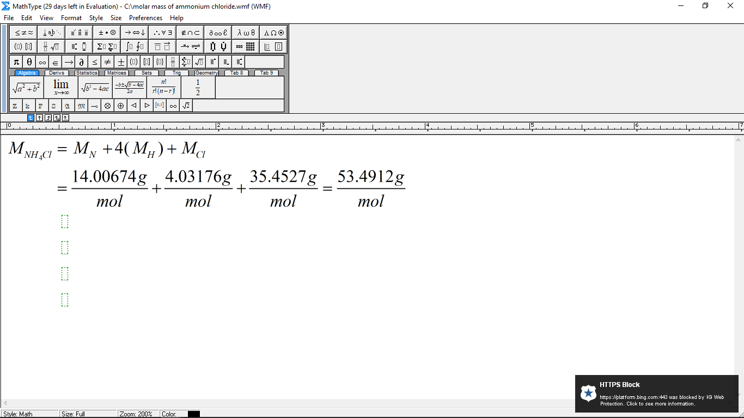
After all these calculations, it was decided that there would be 5 different masses of NH₄Cl that would be used in this experiment. These five masses were selected in context to the theoretical mass of NH₄Cl of 13.3g. The fives masses are the following: 9.01g, 11.00g, 13.01g, 15.00g and 17.00 grams of NH₄Cl. Therefore, it was predicted that 13.01 grams of NH₄Cl will meet the requirements.
Limitations:

There were, however, four limitations to this experiment. Firstly, an isolated system is defined as one where both energy and mass cannot be exchanged with an outside system, however, isolated systems only exist ideally because in reality, systems aren’t perfectly insulated, according to Berger (2001). Therefore, the calorimeters used only represented closed systems, where small amounts of energy exchanges occurred between the ammonium chloride and water reaction system and the environment outside of the calorimeter. In other words, not only did the system absorb the heat from the surroundings (the calorimeter contents including the distilled water and the aluminum can), but some theoretically also came from the environment outside of the calorimeter, which would result in a ΔT reading less than what it should have been). Secondly, the calculations assume that the surroundings are composed of only the distilled water and the aluminum can, however, the temperature probe, a metal object, was also a part of the surroundings which lost heat to the system. Since this was a component that was not factored into the calculations as the q_{probe}), the final ΔT readings of each trial were less than what should have been). Thirdly, it is important to note that specific heat capacities of various substances change as temperature changes. So, when the c_{Al}, or the specific heat capacity of aluminum was derived from the Silberberg textbook, the textbook had assumed that the temperature was standard conditions, or 25 degrees Celsius. However, since the calorimeter reaction involved a transfer of heat and thus a temperature change (since temperature is defined as the average kinetic energy of the particles of an object, system or surrounding, depending on the perspective), the specific heat capacities were actually changing ever so slightly as the chemical reactions progressed and more and more energy was being transferred. The calculations imply that c is constant when it isn’t in actuality, even if only by a small degree which is why these calculations are slightly flawed. Fourthly, when doing the theoretical calculations to find the enthalpy of solution, SATP (Standard Ambient Temperature and Pressure) conditions were assumed (T = 25°C and p=101.325 kPa), when the experiment was not in an SATP environment. For starters, the initial temperatures of the distilled water should have been equivalent (or just off by an insignificant degree) to the room temperature of the lab (since the distilled water in the beaker had time to sit in the lab before trials were initiated). Since the initial temperatures ranged between (22.5-23.4)°C and were not 25°C, that already proves that the theoretical value of 13.3 g of the mass of aluminum chloride necessary to reduce the temperature of 100 cm³ of water by 5 degrees Celsius was incorrect.

Equipment:

Apparatus | Materials
*Coffee Cup calorimeter (set up prior to experiment by Lab TAs) | 65 grams of NH₄Cl_{(s)}
*Thermometer | *400 mL distilled H₂O_{(l)}
*Stirrer
*Small cubic sheets of translucent paper (1-2)
*2 200 mL beakers
*Scapula
Electronic balance
*Empty pop can; rinsed and with lid removed
*LabQuest 2.0
*= quantity per team or pair of individuals (if there is no astrix, then what’s labelled is the total amount used and shared by the entire group of six individuals)

Procedure:

- A coffee cup calorimeter was retrieved. (The coffee cup calorimeter for this lab was already set up prior to the experiment, however, to replicate it for future trials, refer to Figure 2 and to the corresponding description followed by the diagram.) Fill the two small beakers with 100 mL of water.
- In preparation for the first trial, 100 mL of distilled water was poured into two clean beakers (for a total of 200 mL) and then the water from the first beaker was poured into the calorimeter and the second volume of water in the pop can. (The inner surfaces of both the calorimeter and pop can were cleaned prior to.)
- For this procedure, a team of six individuals collaborated together by using three calorimeters operated by pairs of students, meaning that steps 1 and 2 and the remainder of the steps within the procedure were completed by each pair of students. For each trial, a pre-determined x grams of mass of chemical (ammonium chloride, NH₄Cl) was used and the trials were divided amongst the three pairs within the team of six as the following:
Team | Trials # | Mass of NH₄Cl (x grams)
#1 - Andrew & Kaz | 1,4 | 9.01 g; 15.00 g
#2 - Christopher & Alex | 2,5 | 11.00 g; 15.00 g
#3 - Sahil & Melenna | 3
- Each team initiated by using an electronic balance and the small sheets of paper to carefully retrieve their first mass of product (9.01 g, 11.00 g and 13.01 g respectively). (Note that the individuals had tried to attain exact whole number quantities of mass, but the added 0.01 grams of mass in trials 1 and 3 would soon not make a significant difference in the results of this lab.)
- The first set of trials (1,2 and 3) ran in the following order:
  - The initial temperature of the distilled water in the pop can was taken.
  - The Lab Quest 2.0 tool was then set up with the following parameters:
    - Time (from 0 to 10 minutes) as the independent variable;
    - The temperature (in degrees Celsius) as the dependent variable, where the temperature was recorded once every two seconds..
  - The ammonium chloride was then poured into the calorimeter and stirred in briskly for five seconds. Then, with the Lab Quest 2.0 tool set up, the Start button was selected immediately after. The pop can with distilled water was placed in the calorimeter, the lid with the stirrer was attached and the entire calorimeter was swirled slowly around for almost the entirety of the trial. [Note that all of the steps in part 5.c) were all done quickly and collaboratively amongst the lab partners to avoid random errors (e.g. leading to heat lost for being too slow to close the lid, for instance).]
  - Right at 5 minutes and 30 seconds, the Stop button on the Lab Quest 2.0 tool was pressed in order to complete the run, and the run was saved as “Run X” and with the initials of the students who completed the trials, where X is was trial number between 1 and 5.
- Steps 2, 4, 5.c) and 5.d) were repeated (in this order) one more time for the remaining two trials (trials 4 and 5) by teams #1 and #2.
- The data was then saved on a USB key for later use by the Logger Pro tool.

Observations:

Table 1: Qualitative Observations Written by Hand
Substance | Description
NH₄Cl_{(s)} | White crystals slightly larger than table salt; opaque
H₂O_{(l)} | Clear and colourless transparent liquid
Can | Aluminum like appearance with tiny white spots at the bottom.
NH_{4(aq)}+Cl_{(aq)} | Same appearance as distilled water.

Table 2: Quantitative Observations Written by Hand
Mass (g) | Final Temperature (°C) at 5 mins | Initial Temperature (°C) before | Temperature Change (°C)
9.01g | 20.9°C | 23.4°C | -2.5°C
11.00g | 20.3°C | 23.4°C | -3.1°C
13.01g | 19.7°C | 23.1°C | -3.4°C
15.00g | 18.4°C | 23.4°C | -5.0°C
17.00g | 19.0°C | 22.5°C | -3.5°C

Graphs:

After the five trials, the final and initial temperatures were recorded and the temperature change was recorded for each different mass of ammonium chloride. A graph, Figure 1, was created that represented the relationship between the mass of ammonium chloride (x) and the resulting temperature change (y). A line of best fit was inserted in the graph to find the required mass of ammonium chloride that would result in a temperature change of -5°C. With the line of best fit, it was possible to extrapolate and find the experimental mass of ammonium chloride.
Using the equation of the line of best fit, it was extrapolated that the mass at a temperature change of -5°C, was 20.69 grams.

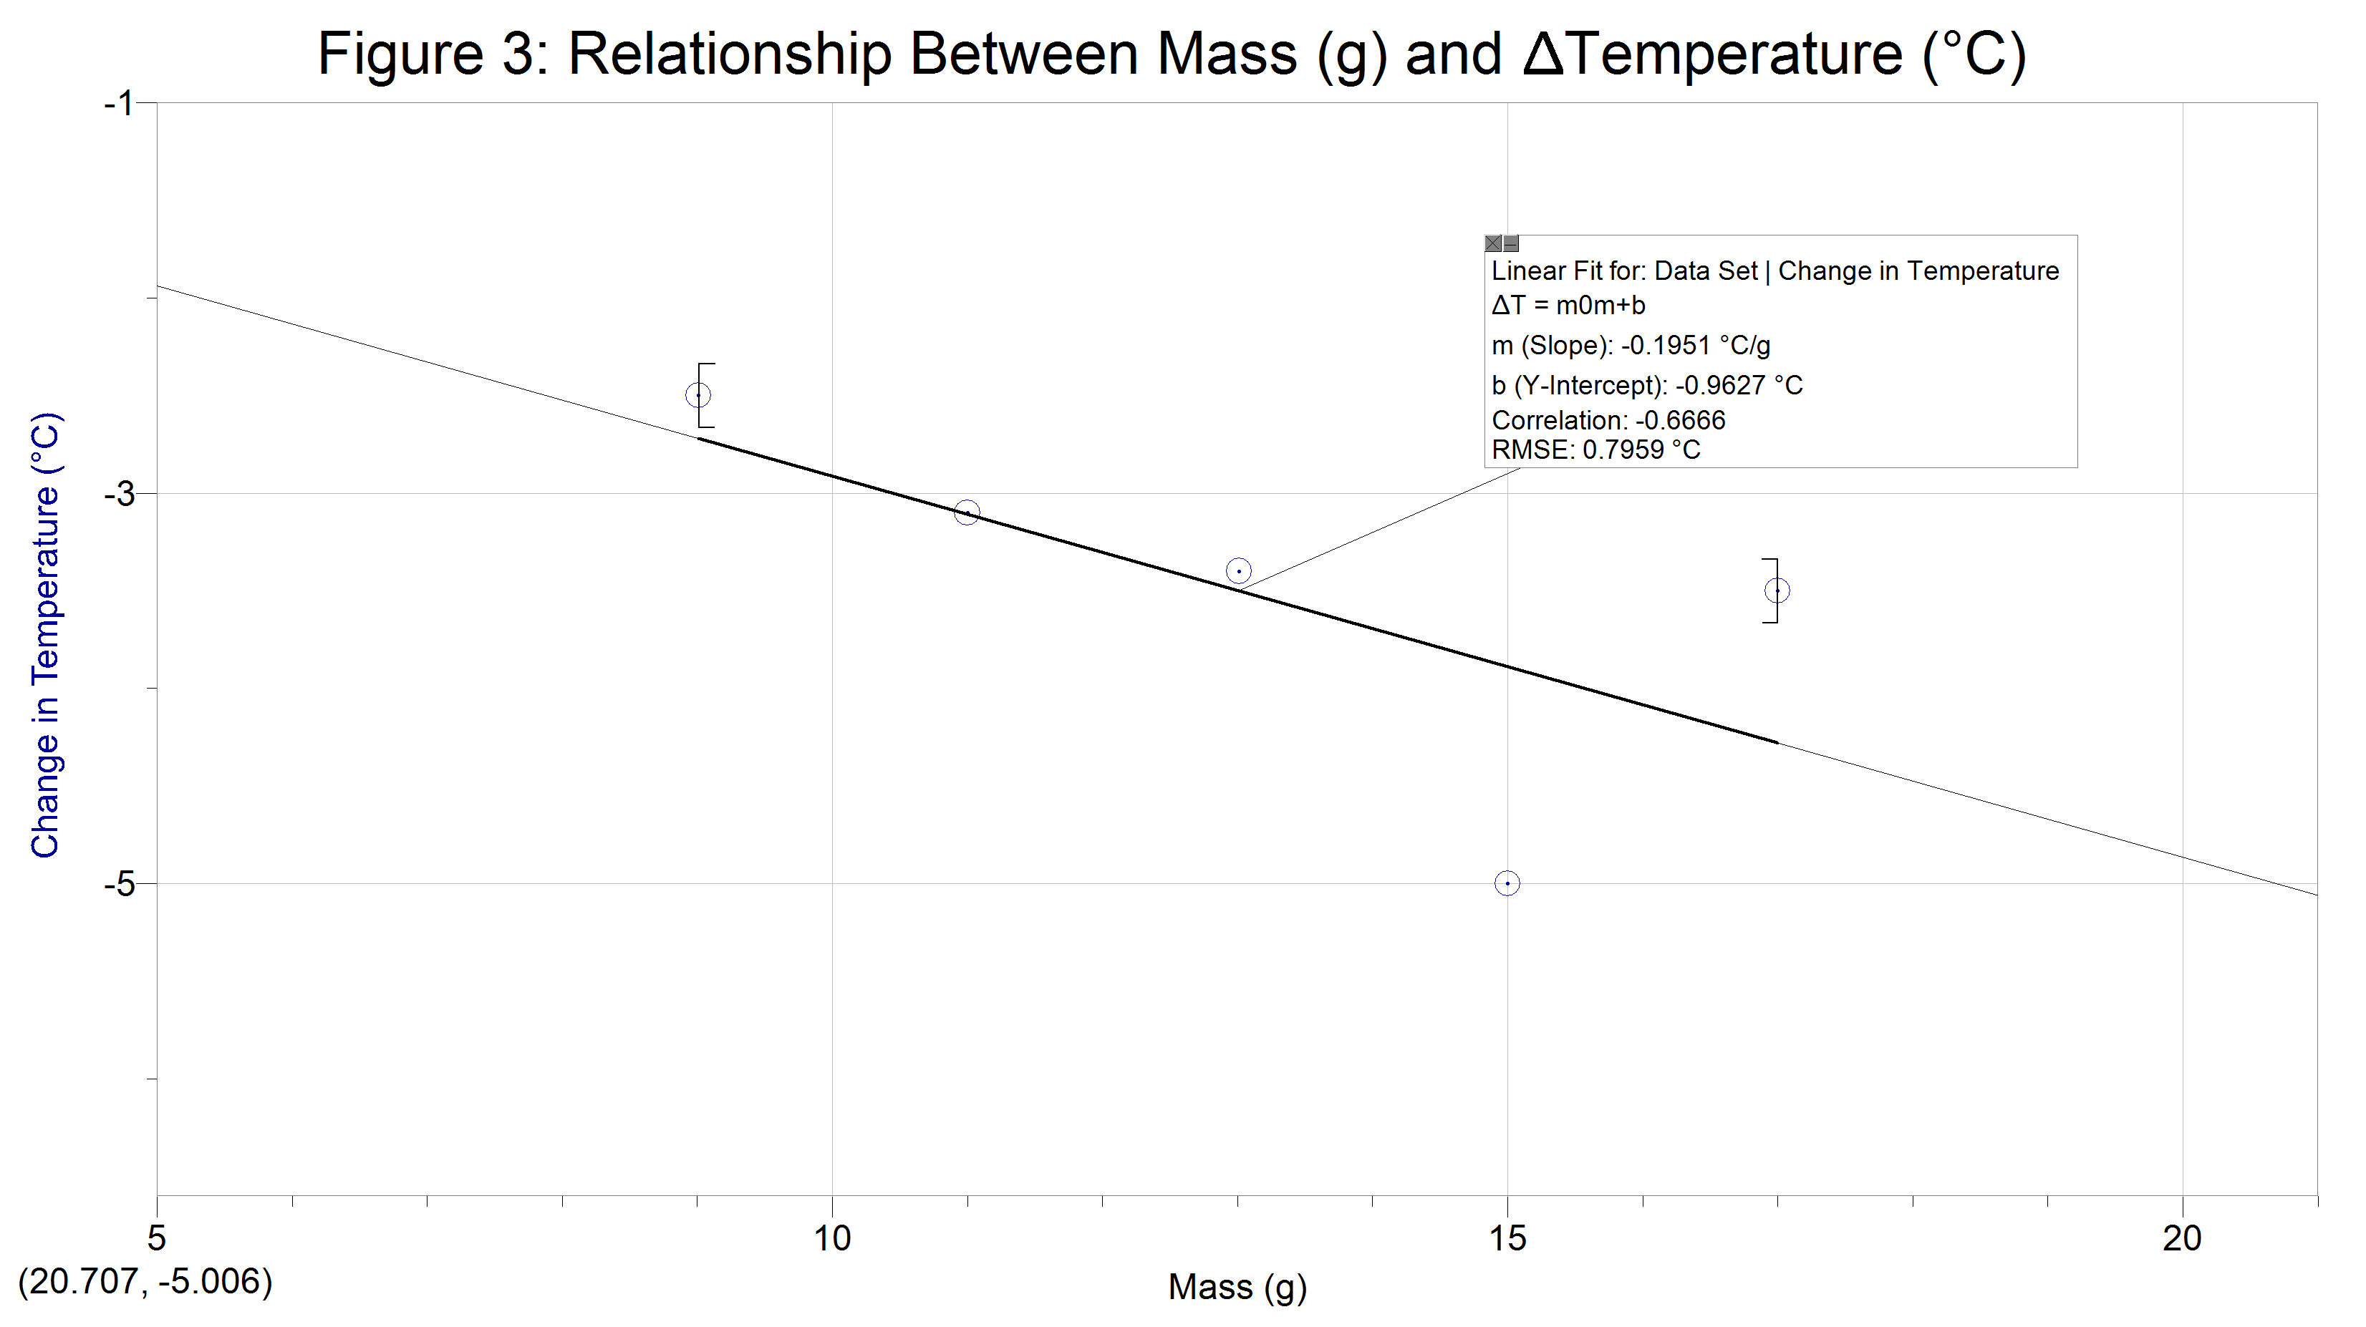

. 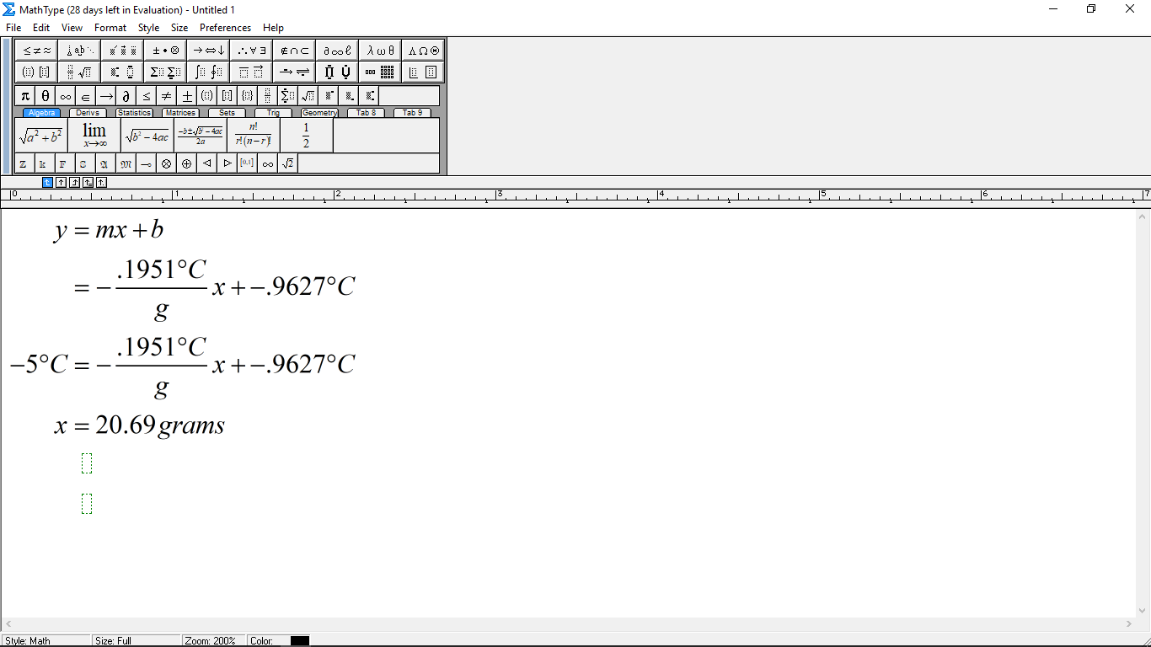
Discussion:

The theoretical mass of 13.3 grams, the predicted gram of ammonium chloride, is very different when compared to the experimental value of 20.69 grams. The experimental mass is inaccurate by 7.4 grams. The reason for this inaccuracy lies in the number of systematic errors within the experimental process that affected the level of accuracy of this experiment. These are the following systematic errors that affected the results. Each error will be explained, how it impacted the results and possible suggestions for improvement.

Assumption 1: The heat capacity of ammonium chloride solution had the same heat capacity as water
This was an incorrect assumption made at the beginning of experiment, where the theoretical mass of ammonium chloride was calculated. It was assumed that the water outside the can (the ammonium chloride solution) had the same exact specific heat capacity as the water inside the can. This is incorrect, being that the solution outside the can no longer was distilled water, hence it couldn't have a specific heat capacity of water. It was a solution of ammonium chloride. There should have been a different specific heat capacity for the solution outside the can. This difference would have led to a different amount of joules absorbed by the surrounding, a different amount of joules absorbed by the ammonium chloride solute in order to cool the water and hence a different theoretical mass of ammonium chloride.
A separate experiment should have been performed to find the specific heat capacity of the ammonium chloride solution and that value should have been used in those calculations and not the specific capacity of water for the solution outside the can.
Assumption 2: Solid ammonium chloride is not hygroscopic
Secondly, solid ammonium chloride in its crystallized form is hygroscopic. This means that ammonium chloride will actually absorb water moisture from the surrounding air. The ammonium chloride mass that was measured before starting the experiment was not 100% ammonium chloride. In reality, the ammonium chloride contained water, therefore some of that mass was water moisture. Therefore the experiment most likely did not evaluate the temperature change of 9.01 grams, 11.00 grams, 13.01 grams, 15.00 grams and 17.00 grams. The ammonium chloride mass of each trial was actually lower than assumed.
This error can be solved by calculating the mass percent of the solid ammonium chloride. The actual mass of ammonium chloride could be calculated and used in the experiment, which would make the experiment value more accurate to the theoretical value.

Assumption 3: The can was made of 100% aluminum
This systematic error played a smaller role, but nevertheless it did affect the results. In the calculations, where the theoretical mass of ammonium chloride was derived, it was assumed that the specific heat capacity of the can was equal to the specific heat of aluminium. The reason for this assumption came from the belief that the soda can was made of 100% aluminum. According to the New World Encyclopedia (2016), aluminium cans are not made of 100% aluminum. Therefore, the specific heat capacity of the can should not be the equal to the specific heat capacity of aluminium. The enthalpy of the can and of the surrounding would have been different, hence a different theoretical mass of ammonium chloride.
A possible solution for this systematic error iis to evaluate a separate experiment where the specific heat capacity of a can is calculated. This value can therefore be used in the calculation for the theoretical mass of ammonium chloride.
Assumption 4: The can did not react with the ammonium chloride solution
It is quite likely that the metallic can reacted with the ammonium chloride solution during the experiment. In fact, qualitative observation shows that there did exist a few white spots at the bottom of the can. These white spots were likely the residue from the reaction between the can and the ammonium chloride solution. This was a possible systematic error being that this reaction possibly involved a transfer of heat as well. This would have been a transfer of heat that was not considered by the equation when calculating the theoretical mass. Had this transfer of heat being considered, then the amount of joules that ammonium chloride had to absorb to the water would have changed and hence a different mass of ammonium would have been predicted.
All these systematic errors that affected the accuracy of the results and including the human errors during the experiment help explain the large discrepancy between the theoretical mass calculated in the introduction and the experimental mass derived from the graph.

Conclusion:
The theoretical mass of ammonium chloride was predicted to be 13.3 grams. This value was used to set the context of what could the experiment mass be. Using extrapolation, it was found that the experimental mass of ammonium chloride was actually 20.69 grams. Systematic errors were discussed that may explain the large discrepancy.

References:

Averill, B., Eldredge, P. (2011).General Chemistry: Principles, Patterns, and Applications (1st
ed.). Saylor Academy.

Berger, Daniel J. (2001) II. Thermodynamic systems. Bluffton University: NSC111:
Physics/Earth/Space Resource page: Thermodynamics. https://www.bluffton.edu/homepages/facstaff/bergerd/NSC_111/thermo2.html

“Beverage Can.” New World Encyclopedia. Retrieved October 11, 2017
from Newworldencyclopedia.org:
http://www.newworldencyclopedia.org/entry/Beverage_can

Silberberg, M. S., Vavieri, S., & Venkateswaran, R. (2017). Chemistry: The Molecular
Nature of Matter and Change (2nd ed., Canadian Edition). McGraw-Hill Education.

Scanned Pages: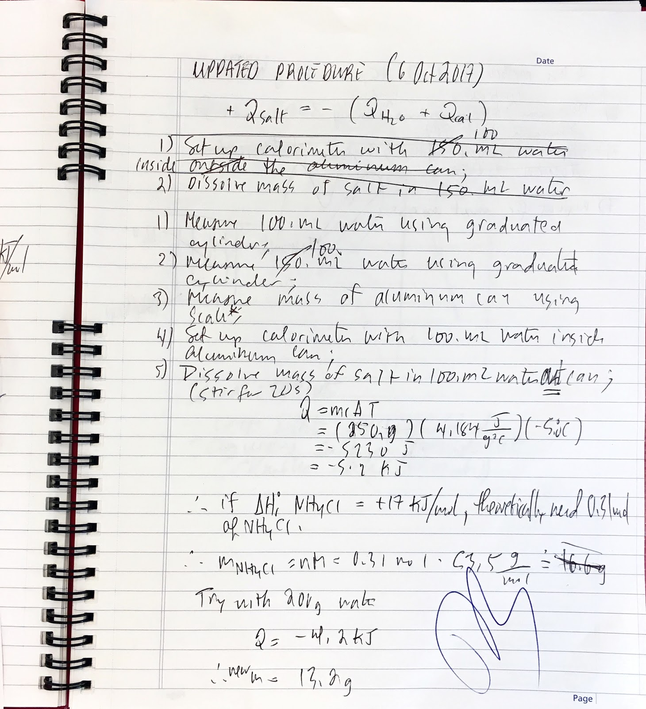
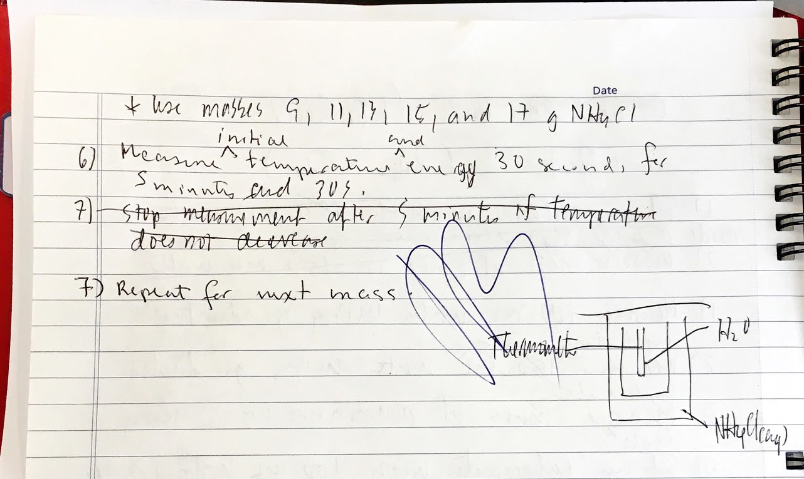

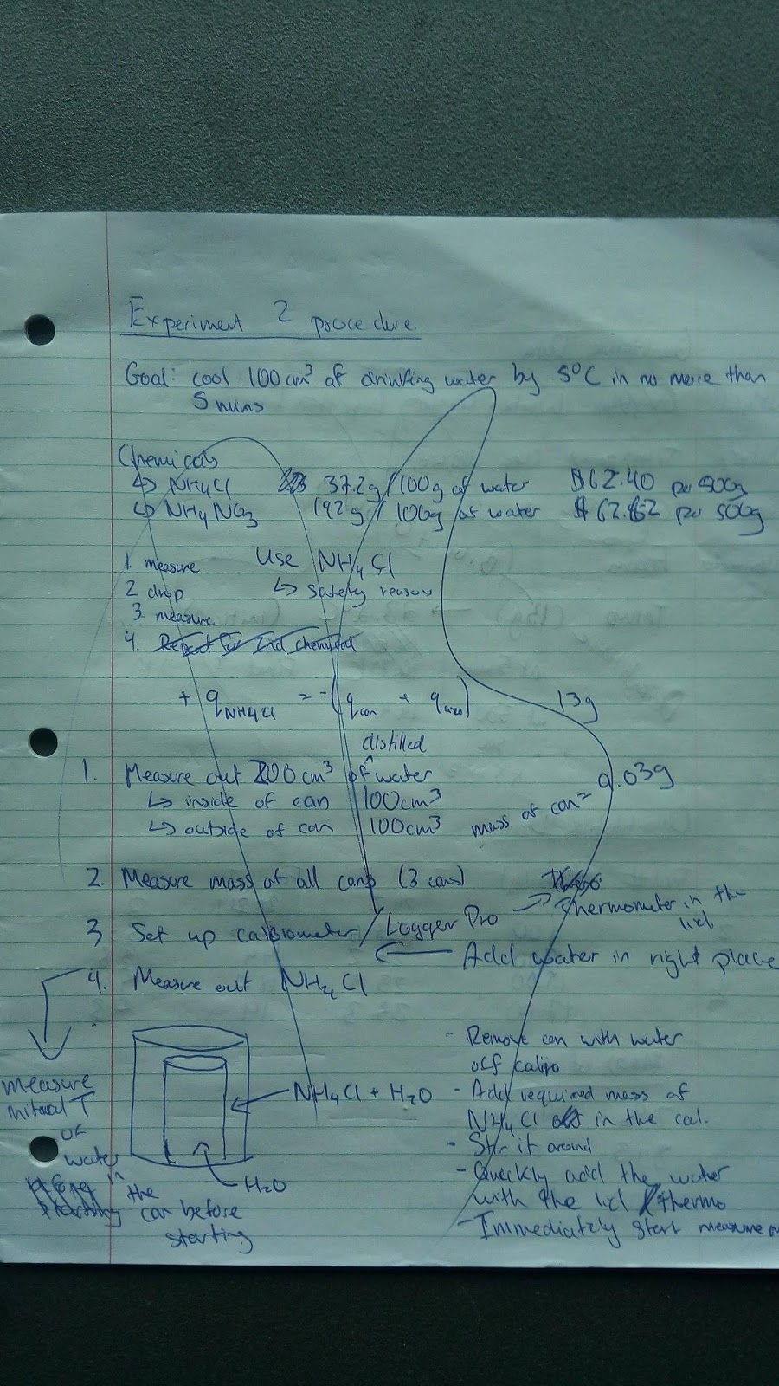

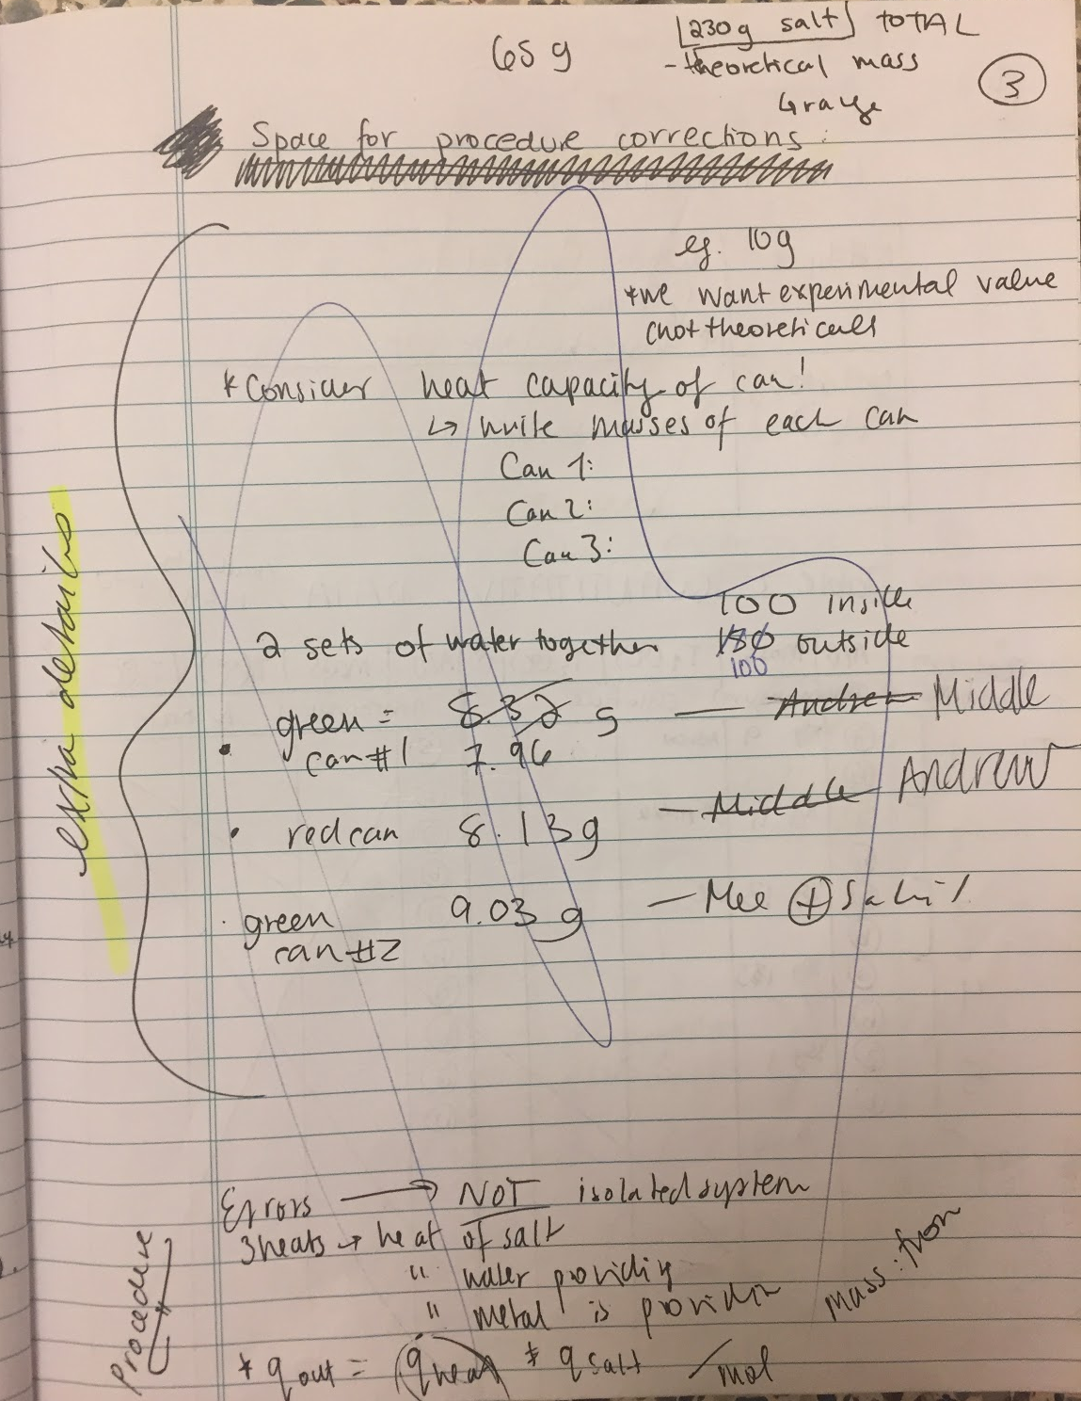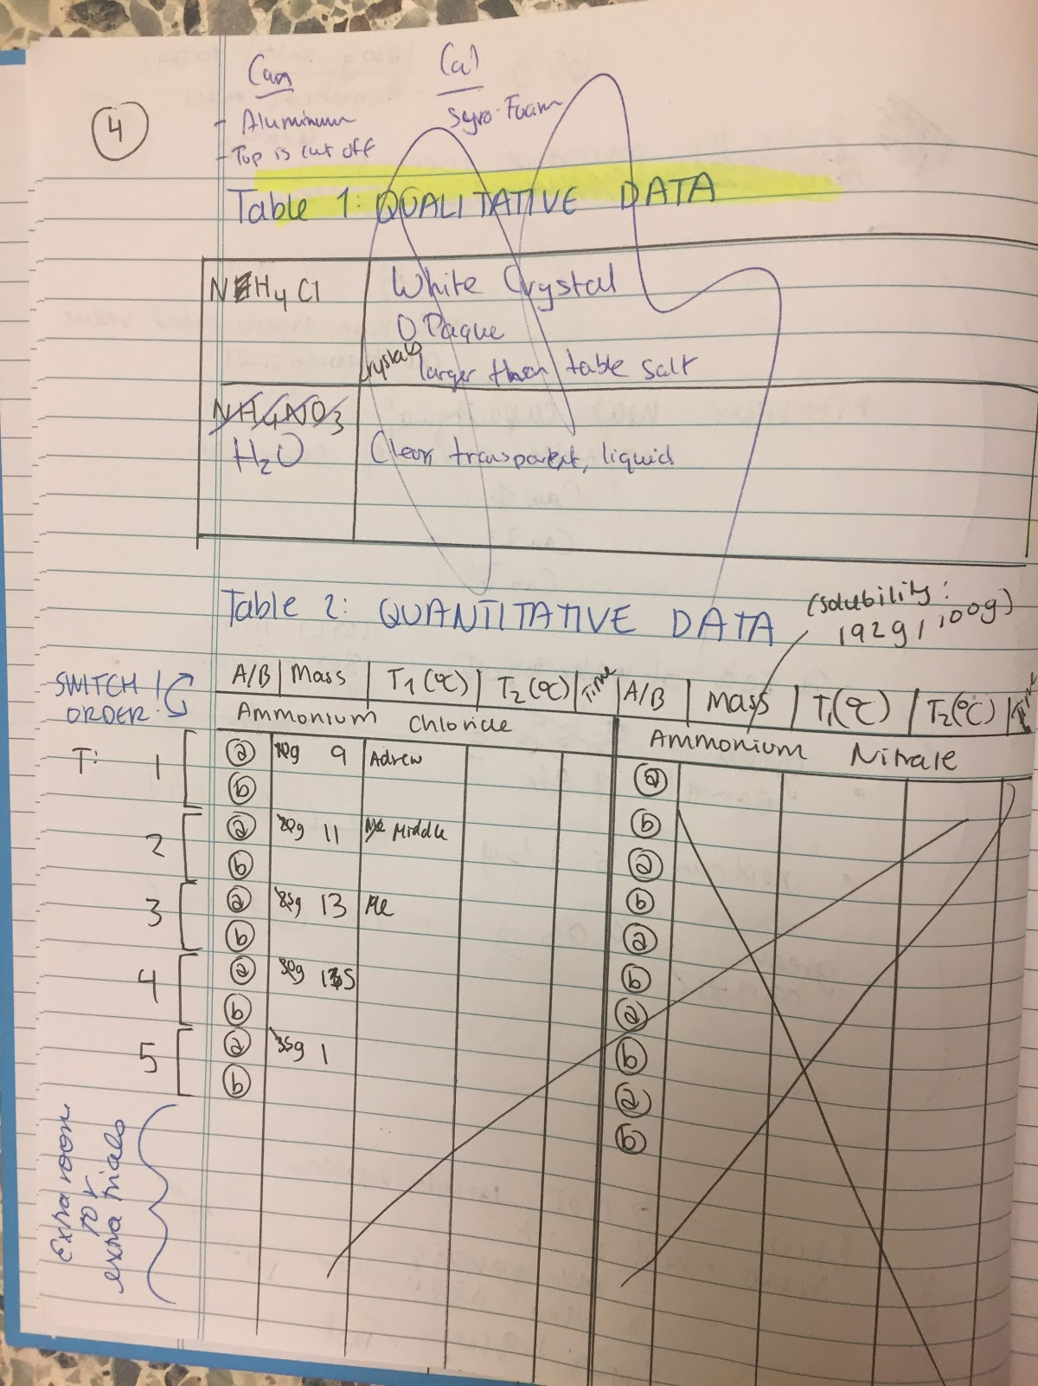

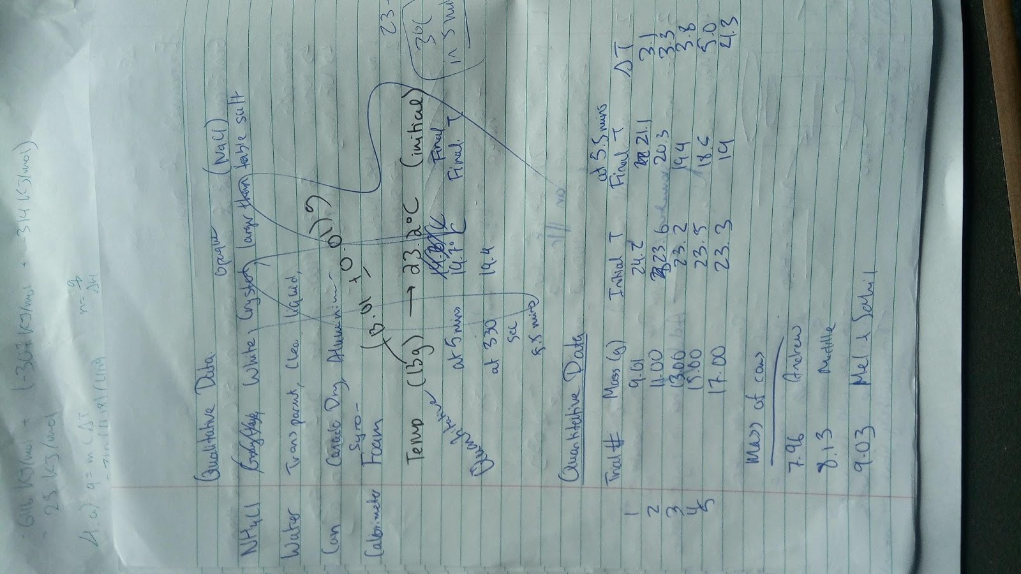

Self-Grading



