BLOOD VESSELS

• As heart contracts: arteries arterioles capillaries venules veins

• Arteries carry blood away from the heart (systemic = oxygenated blood; pulmonary = deoxygenated blood).
• Veins carry blood toward the heart (systemic = deoxygenated blood; pulmonary = oxygenated blood).
• Only capillaries directly serve cells.

Structure of Blood Vessel Walls (except the thinnest vessels):
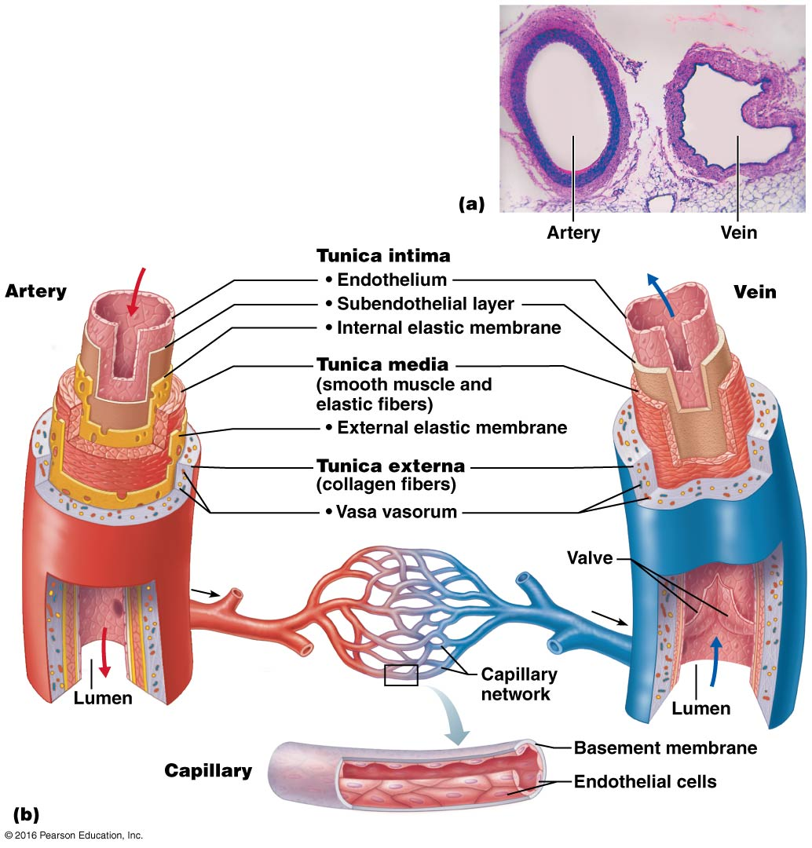
• Tunica intima:
- Contains simple squamous epithelium minimizes friction as blood moves through the lumen.
• Tunica media:
- Smooth muscle cells and sheets of elastin.
- Activity of smooth muscle regulated by sympathetic vasomotor nerve fibers of the ANS and a whole battery of chemicals.
- Vasoconstriction: lumen diameter decreases as smooth muscle contracts.
- Vasodilation: lumen diameter increases as smooth muscle relaxes
• Tunica adventitia (externa)
- Outermost layer of blood vessel wall.
- Composed of loosely woven collagen fibres protect, reinforce, anchor
- System of tiny blood vessels: vasa vasorum

Three Types of Arterial Vessels:

• Elastic (Conducting) Arteries
- Thick-walled; large-diameter; near heart.
- Highest proportion of elastin smooth out pressure fluctuations.
- Recoil helps maintain pressure & flow of blood aorta.
• Muscular (Distributing) Arteries
- Deliver blood to specific organs.
- More smooth muscle vs. elastin more active in vasoconstriction and less capable in stretching.
• Arterioles
- Tunica media is primarily smooth muscle; a single layer in smallest arterioles.
- Arteriole diameter determines which capillary beds flushed, minute-to-minute.

Three Types of Capillaries:
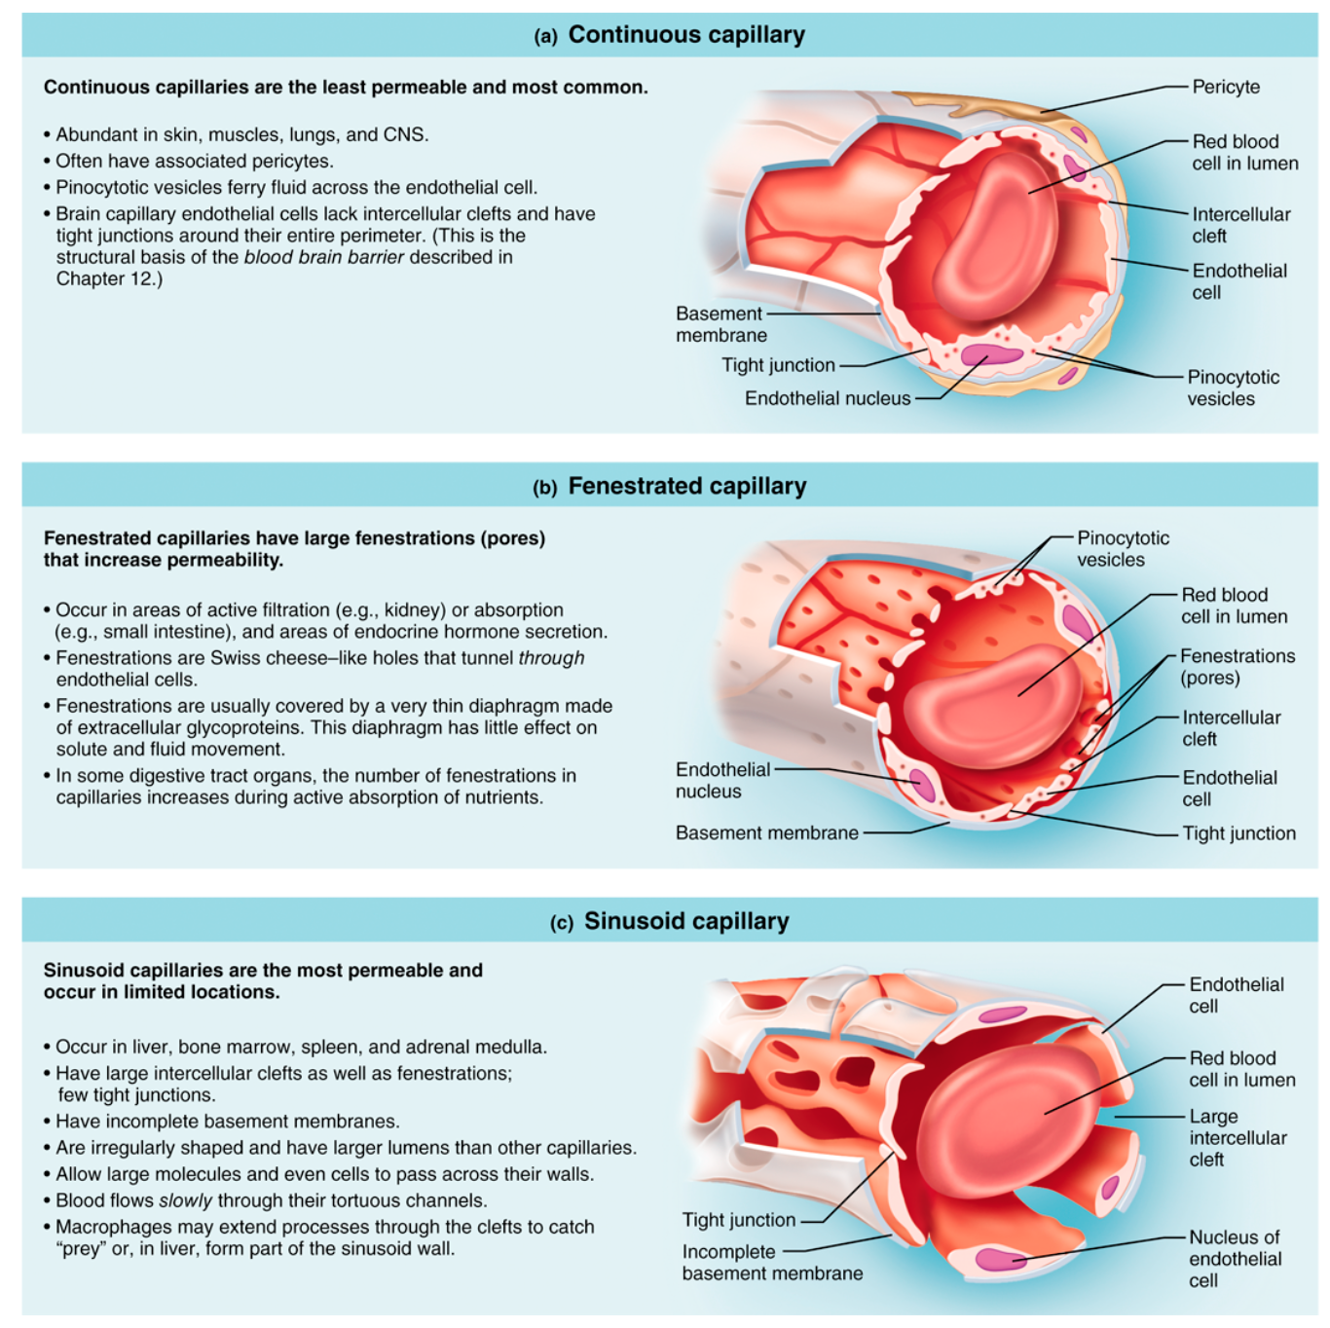

• Microcirculation
- Flow of blood from an arteriole to a venule through a capillary bed; two types of vessels:
- Vascular shunt: metarteriole + thoroughfare channel.
- True capillaries: actual exchange vessels.
- Precapillary sphincter: surrounds root of each true capillary.

Structure and Functions of Venules and Veins:

• Venules
- 8-100 $μm$ diameter
- Post capillary venules just endothelium + a few fibroblasts
- Larger venules have sparse tunica media and thin tunica adventitia
• Veins
- 3 tunics but walls thinner & lumens larger.
- Relatively little elastin/smooth muscle in tunica media; tunica adventitia is heaviest layer.
- Up to 65% of blood in veins at any one time = capacitance vessels or blood reservoirs.
- Two structural adaptations of veins that promote blood return?
- Large diameter lumens offer little resistance to blood flow.
- Venous valves (folds of tunica intima).

• Blood flow: volume of blood flowing through a vessel, organ or the entire circulation (mL/min).
• Blood pressure
- Force per unit area exerted on the wall of a blood vessel by its contained blood (mmHg).
- Refers to systemic arterial blood pressure in the largest arteries near the heart (e.g.: average aortic BP = 90 mmHg).

$$F= \frac{∆P}{R}$$
• Resistance: the major determinant of blood flow because a change in blood vessel radius increases resistance to the 4th power.
• Arterioles can regulate their diameters.

• Resistance: measures total of frictional forces that impede flow flow and resistance are inversely related; influenced by;
- Blood viscosity.
- Total blood vessel length: more length = more resistance (extra adipose tissue).
- Blood vessel diameter: fluid not touching walls moves faster.

• Pulse pressure = systolic BP – diastolic BP
- Indicates vigor of contraction of ventricle.
- Information on elasticity of aorta and major arteries.
• Mean arterial pressure (MAP) = diastolic pressure + 1/3 pulse pressure
- MAP is the pressure that propels blood to tissues during the cardiac cycle
- NOT mean of systolic & diastolic pressures; ventricular diastole is longer than ventricular systole.
- MAP & pulse pressure decreases with distance from heart by end of arterial tree, blood flow is steady and pulse pressure has disappeared.

Blood Pressure in Capillary Beds:
• Low pressure: 35 mmHg at entry and 15 mmHg by end.
- Capillaries are fragile high pressures would rupture them.
- Most capillaries are extremely permeable lots of exchange at low BP.

Venous Blood Pressure:
• Steady, changes very little during cardiac cycle; factors aiding venous return:
- Respiratory pump: breathing encourages movement in upward direction.
- Muscular pump: movement helps propels blood in forward direction.

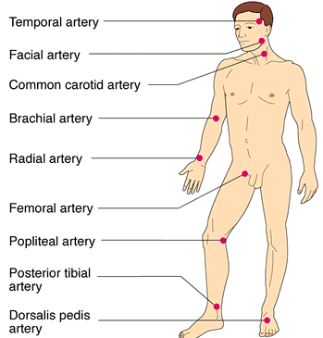
Pulse:
• Pressure wave due to alternating expansion and recoil of elastic arteries.
• Push surface artery against firm tissue (usually radial pulse).
• Also called pressure points because you can feel pulse and stop blood loss distal when someone is injured by exerting pressure.
- Auscultatory method: brachial artery sing sphygmomanometer.
- Sounds of Korotkoff: blood flow sound.
- Cuff fully inflated (artery fully collapsed = no flow).
- Cuff pressure lowered to peak systolic pressure (momentary high velocity spurt) record cuff pressure as systolic BP.
- Cuff pressure lowered to diastolic pressure (continuous flow - sounds disappear) record cuff pressure as diastolic pressure.
• Main factors influencing blood pressure are: cardiac output, peripheral resistance, blood volume.
• Blood Pressure = Cardiac Output x Peripheral Resistance
• What determines CO?
- Heart rate (neural & hormonal factors).
- Stroke volume (venous return, neural & hormonal factors).

Short-term Neural and Chemical Mechanisms for the Regulation of Blood Pressure:
• Two main goals:
- Alter blood distribution to respond to specific demands
- Maintain adequate MAP by altering blood vessel diameter
• Usually reflex arcs involving baroreceptors, vasomotor center of medulla, vascular smooth muscle.
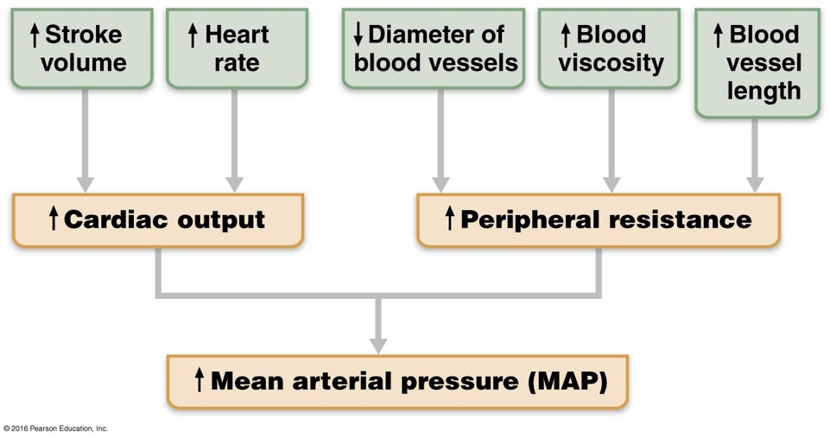

• Vasomotor Centre: cluster of sympathetic neurons in medulla: part of cardiovascular center.
• Vasomotor tone: constant input, especially to arterioles (NE)
• Any increase in sympathetic nervous system activity generalized vasoconstriction and rise in BP (decrease has reverse effect).
• vasomotor center responds to input from:
- Baroreceptors
- In carotid sinuses, aortic arch & other large arteries of neck & thorax.
- Increasing MAP stretches receptors; response (via vasomotor center) is:
- Dilation of arterioles.
- Venodilation to shift blood to venous reservoirs.
- Afferents also to cardiac centers to stimulate parasympathetic NS & inhibit sympathetic NS decreasing heart rate and contractile force.
- Decreasing MAP initiates reflex vasoconstriction.
- GOAL: protect against short-term changes in BP (standing, bending); ineffective chronically (e.g. body adapts to hypertension).
- Chemoreceptors (CO₂, O₂, H⁺)
- Drop in O₂, pH or rise in CO₂: chemoreceptors in aortic arch and large arteries of neck to vasomotor centre reflex vasoconstriction.
- Result = rise in BP that speeds return of blood to heart & lungs.
- Higher brain centers or hormones
- Fight-or-flight”, stress, exercise cerebral cortex & hypothalamus get involved.

Hormones and the Short-Term Regulation of Blood Pressure:

• Adrenal medulla hormones: NE/E & fight-or-flight
- Generalized vasoconstriction (except skeletal/cardiac muscle).
- Increases CO.
- Nicotine mimics effects of catecholamines.
• Angiotensin II: renin-angiotensin system; decreased renal perfusion
- Intense generalized vasoconstriction to increase systemic BP.
- Release of aldosterone, ADH.
• Atrial natriuretic peptide (ANP): produced by atria of heart
- Causes blood volume & blood pressure to decrease.
- Generalized vasodilation.

• Antidiuretic Hormone (ADH): (source = hypothalamus/posterior pituitary)
- Stimulates kidneys to conserve water (eg: severe hemorrhage) – long term effect
- Not usually important in short term unless BP drops very low – then much more ADH is released and high levels can cause vasoconstriction.

Role of the Kidneys in the Long-term Regulation of Blood Pressure

• Baroreceptors adapt to prolonged/ chronic high/low blood pressure.
• Kidneys restore BP by adjusting blood volume.
• Anything that changes blood volume will change blood pressure.
• If blood volume is increased, kidneys will excrete more salt & water:
- Direct Action: increased blood volume/pressure = increased rate of filtrate formation → insufficient time to reclaim water → increased volume of urine.
- Indirect Action:
- Renin-angiotensin system - MAP decreases → kidney cells release renin → cascade of reactions to yield angiotensin II (potent vasoconstrictor) → increased blood pressure to restore renal perfusion.
- Angiotensin II stimulates secretion of aldosterone (adrenal cortex) → increases renal absorption of Na⁺ (& water if ADH present).
- Increased secretion of ADH (post pituitary) promotes water reabsorption.
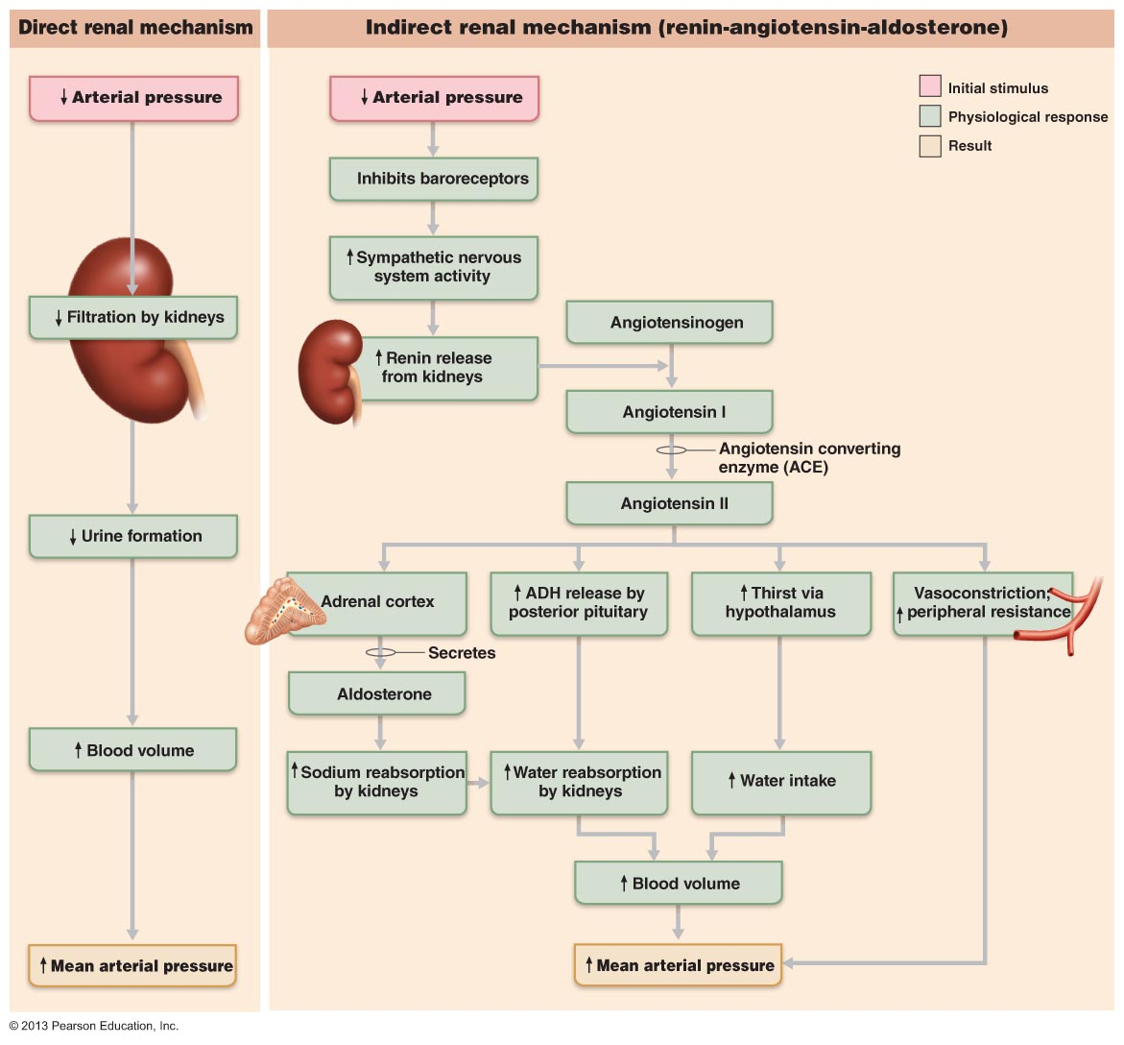

Mechanisms of Autoregulation with Respect to Local Blood Flow:

• Blood flow to each organ regulated to meet needs.
• Resting vascular tone: in resting state, smooth muscles in walls of arterioles somewhat contracted (sympathetic NS) can increase flow by vasodilation.
• Immediate adjustments to changes in local conditions:
R varies 1/r⁴
• Organs regulate individual blood flow by varying resistance of arterioles.

Metabolic Controls (Local):
• Declining tissue levels of oxygen
• Increasing levels of CO₂, adenosine, H⁺, K⁺, heat, inflammatory chemicals.
• End result: immediate increased perfusion of “needy” tissues.

Myogenic Controls (Local):
• Vascular smooth muscle responds to increased stretch with increased tone stretch is resisted vasoconstriction.
• Decreased stretch results in vasodilation.
• Result: tissue perfusion homeostasis so cells not deprived/capillaries not damaged.
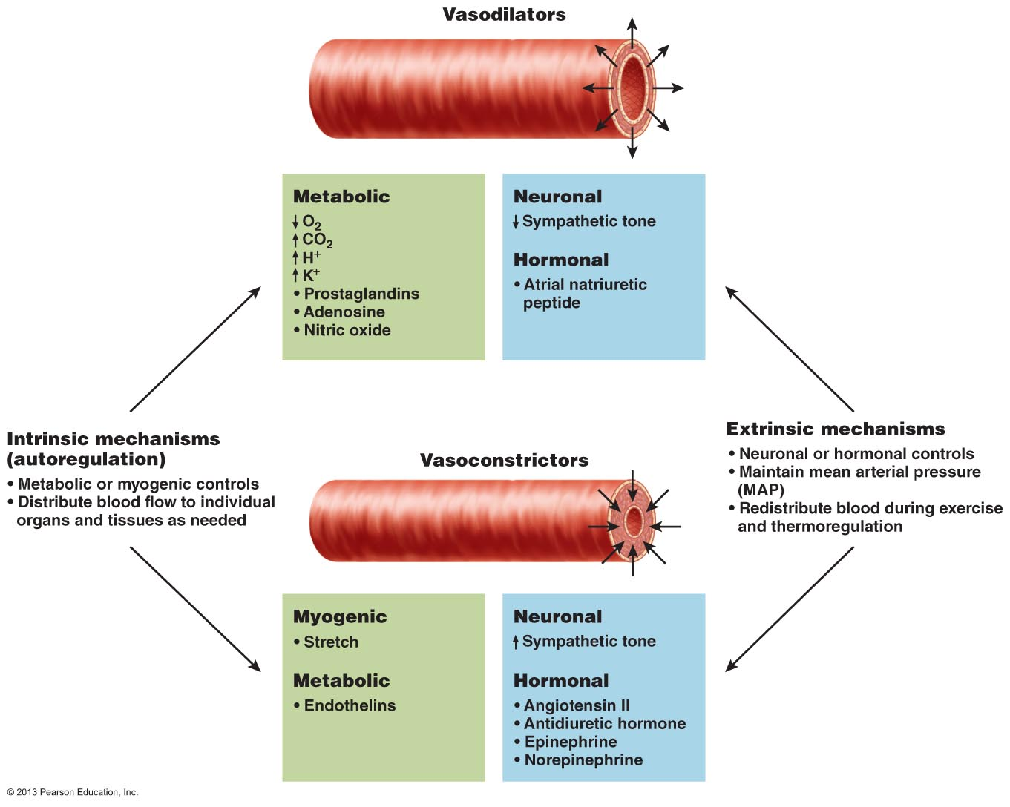

Forces that act to influence capillary exchange:

• Capillaries: major point of communication between interstitial fluid & blood
- Most cells in body within 0.02 mm of a capillary diffusion works
- Capillary walls only 1 cell thick: mix of diffusional, osmotic and hydrostatic forces
• Precapillary sphincter: cuff of smooth muscle at beginning of capillary; capillary walls themselves have no smooth muscle.
• Vasomotion: contraction and relaxation of precapillary sphincter sporadic flow through each capillary.
Capillary Exchange Mechanisms:

• Vesicle Transport:
- For relatively large, lipid-insoluble molecules (e.g.: insulin).
- Shuttling via endocytosis, then exocytosis.
- Also, antibody molecules from maternal to fetal circulation.
• Diffusion:
- Primary mechanism for dissolved solutes & gases – e.g.: O₂, CO₂, glucose.
- Follow gradients.
- Heat moves via convection down a thermal gradient.
- Water-filled pores (Na+, K+, Cl-, glucose) or through bilayer (O₂, CO₂, urea).

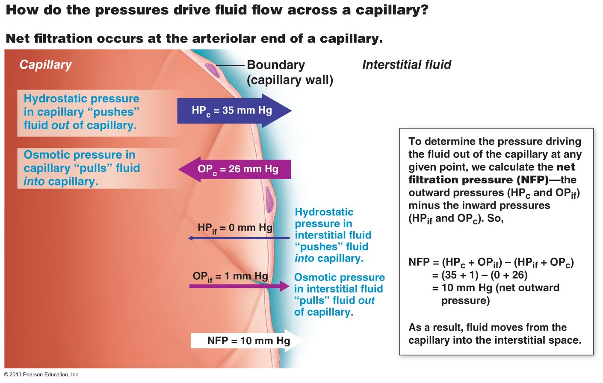

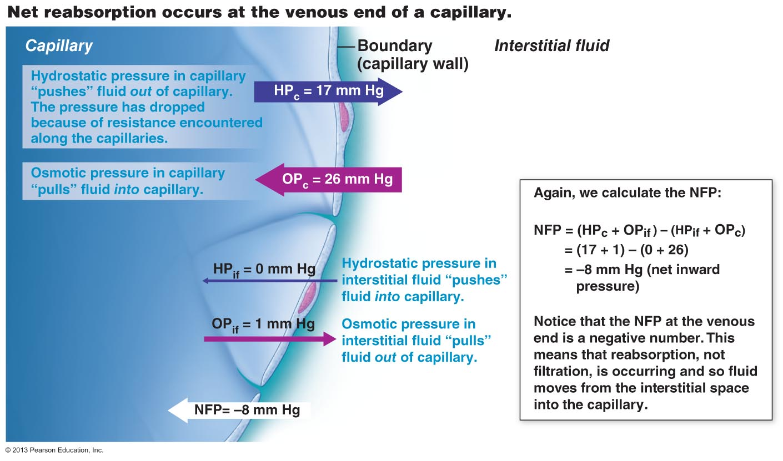

• Overall deficit of 1-2 mm Hg some fluid (3-4 ml/min) lost to tissues - returned by lymphatic system.
- Increased arteriole pressure means increased filtration pressure = more fluid loss to tissues (edema); liver disease also edema (salt retention).
- Hemorrhage favours reabsorption.

