University of Ottawa
Principles of Chemistry

Verification of Boyle’s Law

Name: Rosemary Velez (300025209)
Section: E07
TA: Yousef Risha
Date: September 21, 2017

September 21, 2017
Experiment 1. Verification of Boyle’s Law
Introduction:
As stated in Chemistry: The Molecular Nature of Matter and Change, gases adapt to fill the shape of the container that they are in, due to the particles being in a constant random motion. By taking up all available space, these gas particles exert a pressure within the inner walls of the container that they are confined to. In addition, this diffusion of gas particles is also what gives this type of matter a large volume. For example, if the amount of gas remains constant, the volume and pressure both change significantly if there is any change in temperature. This interdependent relation between these three variables can be expressed as:
P₁V₁/T₁=P₂V₂/T₂ [1]
This relationship is known as the combined gas law.
When working with a variety of gases, it becomes difficult to describe them without any sort of information to compare it to. According to the article, Chemistry, Ideal Gas Behaviour, by K. Tenny and J. Cooper, the concept of an ideal gas was therefore made as an approximation to be able to predict the changes made by a real gas in its surroundings. Four main assumptions define what consists of an ideal gas:
- Gas particles have a negligible volume.
- Gas particles are of the same size and do not have any intermolecular forces with the other gas particles.
- Gas particles move in a random, constant motion.
- Gas particles have perfect elastic collisions, where no energy is lost.
In reality, ideal gases do not exist due for several reasons, including that any particle of gas has a given volume. However, under the right conditions, real gases can behave very similarly to that of a theoretical ideal gas. Unknowingly, Robert Boyle used this concept to postulate that at a constant temperature, the pressure and volume of a gas are inversely proportional. In other words, this meant that if pressure were to increase, volume would decrease and the same would apply vice versa,
PV=k [2]
The relationship is known as Boyle’s Law.
Procedure:
- Put on safety goggles, lab coat and tie long hair back.
- Connect Gas Pressure Sensor to the Lab Quest 2. Turn on Lab Quest 2 and select New from under the File menu.
- Go to Meter icon, select Mode. Change the mode to Events with Entry.
- Enter the Name (Volume) and Units (mL). Select OK.
- Prepare a data table to record measurements of Volume and Pressure.
- Move the plunger of the plastic 20mL syringe to the value of 3mL.
- Attach 20mL syringe to Gas Pressure Sensor and lock it in place by half-turning the syringe.
NOTE: Do not overturn, equipment can be damaged.
- When pressure reading stabilizes, select Keep and 3mL + 0.8mL. Select OK to proceed.
- Move plunger up to change the volume of air in syringe and hold plunger in place. After reading stabilizes, tap Keep and re-enter volume. Select OK to proceed.
- Repeat steps 5-9 with volumes (mL): 5, 7, 9, 11, 13 and 15.
- Remeasure the pressure with the syringe plunger at 3mL and repeat steps 5-9.
- Graph data using Lab Quest 2 and save onto USB.
Observations/Data/Results:
When plunger was pulled up, force is felt in the opposite direction (back towards initial placement on syringe).
NOTE: Had to release plunger between measurements due to tiring hands. Plunger automatically returned to 3mL.

Table 1. Determining the Correlation Between Volume and Pressure
 | Pressure (kPa)
Volume (mL) | Trial 1 | Trial 2 | Trial 3 | Average
3.8 | 100.63 | 101.37 | 102.92 | 101.64
*3.8 | 102.31 | 103.01 | 102.95 | 102.76
5.8 | 66.93 | 67.68 | 67.23 | 67.28
7.8 | 48.19 | 48.51 | 49.35 | 48.68
9.8 | 38.12 | 38.20 | 38.17 | 38.16
11.8 | 32.06 | 31.59 | 31.48 | 31.71
13.8 | 26.86 | 27.49 | 27.30 | 27.22
15.8 | 23.71 | 24.17 | 24.11 | 24.00
* repeated measurement
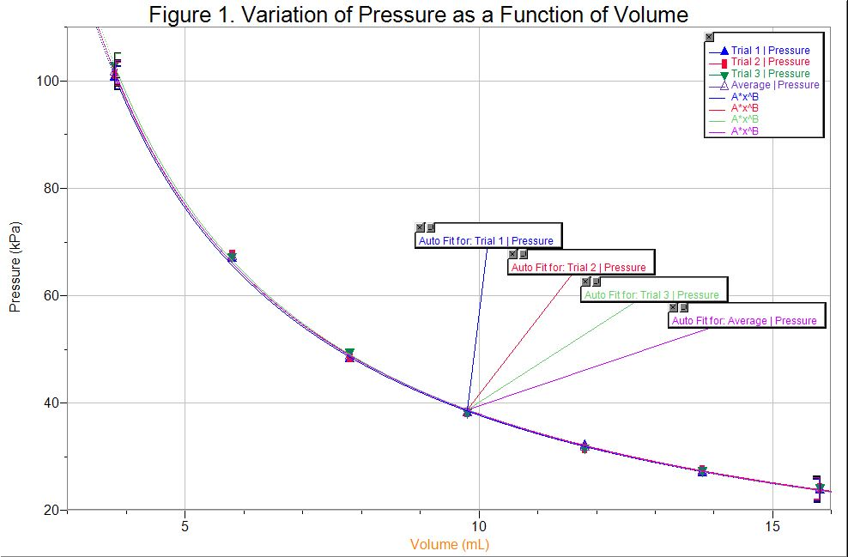
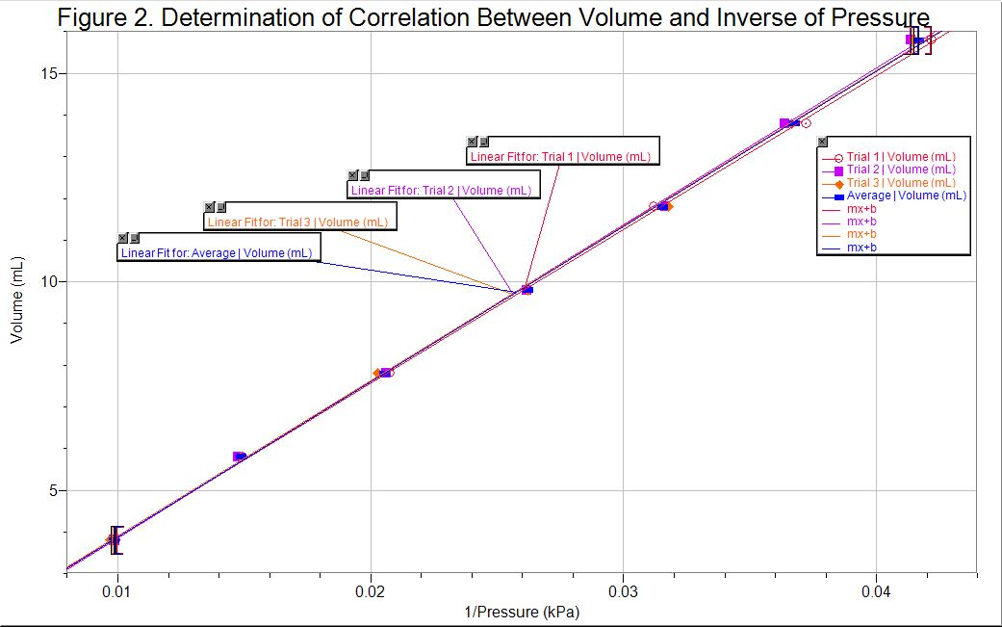
Calculations:
- k_{Trial3}
  - P₁V₁=(102.92kPa)(3.8mL)=391.096=3.9 x 10²
  - P₂V₂=(67.23kPa)(5.8mL)=389.984=3.9 x 10²
  - P₃V₃=(49.35kPa)(7.8mL)=384.93=3.8 x 10²
  - P₄V₄=(38.17kPa)(9.8mL)=374.066=3.7 x 10²
  - P₅V₅=(31.48kPa)(11.8mL)=371.464=3.7 x 10²
  - P₆V₆=(27.30kPa)(13.8mL)=376.74=3.8 x 10²
  - P₇V₇=(24.11kPa)(15.8mL)=380.938=3.8 x 10²
All products k approximately equal 3.8 x 10².
*alternately, the k constant can be calculated as such:
V=k (1/P)
V₃=k (1/P₃)
7.8=k (1/49.35kPa)
k=384.93=3.8 x 10²
- Average Pressure _{for 9.8mL}=(Pressure 1+Pressure 2+Pressure 3)/3 =(38.12kPa+38.20kPa+38.17kPa)/3=38.16 kPa
Discussion:
In this experiment, the objective was to validate Boyle’s law by using a syringe to hold a certain volume of air and a Gas Pressure Sensor to measure the changes in pressure due to the manipulation of volume. When the plunger was pulled up to create more volume, there was a decrease in pressure as shown by the data collected. For example, in Trial 1 the volume was initially at 3.8mL and had a pressure of 100.63 kPa and then when the volume was increased to 5.8mL, the pressure decreased to 66.93 kPa. According to the Kinetic Molecular Theory, a gas takes up all the space of the container that it is in. Therefore, when the volume is increased, the gas particles will have more space to reside in, having fewer collisions with each other and the walls due to its increase in volume. Now that the particles have more space to move in, they exert less of a force within the container, meaning a decrease in pressure. Since Boyle’s Law states that pressure and volume are inversely proportional, it goes to say that if instead of pulling up the plunger to increase the volume, one pushes down to the plunger to decrease the volume, the same type of relationship would result when the data is graphed. For instance, assume that the initial volume in the syringe was 15.8mL and the plunger was pushed down to 13.8mL. Regardless of the initial pressure, if the amount of space that the initial gas was in is compressed, there is less space for the gas particles to reside in. This will result in more frequent collisions in between gas particles, as well as the walls of the syringe that they are confined in, increasing the pressure in the container. Therefore, the results of this data validate the equation PV=k as stated in Boyle’s law.
In accordance with this data, the graphs demonstrate that the relationship between pressure and volume is inversely proportional to each other. For example, in Figure 1 for Trial 1, the volume is 3.8 mL, the pressure is 100.63kPa. When the volume increases to 5.8 mL, the pressure decreases to 66.93kPa. Therefore, as one variable increases, the other decreases in value. Similarly, if we graph volume as a function of the inverse of pressure (as shown in Figure 2), the same relationship between pressure and volume is demonstrated. However, in this case, it demonstrates their relationship as a straight line instead of a hyperbola. This straight line has the form of,
y=mx+b
Consequently, we can substitute in the dependent and independent variables from Figure 2 into the above equation, such that b=0 and m=slope,
V=m(1/P)
If we call the slope k instead of m, the equation now becomes,
V=k(1/P)
Which can be further simplified to,
PV=k
This relationship shows that the product of pressure and volume equals a constant value, just like is stated in Boyle’s Law. In this way, k can be calculated two ways: as the product of pressure and volume (Figure 1) or as the slope of the linear relationship (Figure 2). In either case, k is a value of approximately 3.8 x 10² (refer to Calculation a). Therefore, as a constant, k does not have any units.
For Boyle’s law to be valid, both the amount of the gas and the temperature must remain constant. During the lab, we tried to ensure that temperature remained constant by staying inside the lab and in the same lab section. To ensure that the amount of the gas remained constant, we kept the syringe connected to the Gas Pressure Sensor throughout the duration of the experiment. Without a constant temperature or amount, Boyle’s law would no longer be valid for the experiment and instead, we would need to use the Ideal gas law, which states,
PV=nRT
Where n is the number of moles of the gas, R is the universal proportionality constant, and T is the temperature. In this mathematical relationship, if either n or T are increased, the pressure is affected and will increase in value. In terms of the Kinetic Molecular Theory, if the number of moles and temperature increase, there would be more frequent collisions of the gas particles within the contained space and this is what causes the pressure to increase.
There are several possible sources of experimental error in the investigation performed. During the experiment, we were required to pull back the syringe in order to increase the volume within it. Throughout this time, while pulling it back, we experienced a force in the opposite direction, towards the initial volume of 3.8mL. Towards the end of the experiment, we let go of the syringe to be able to remeasure the first value again and instead of the plunger returning to 3.8mL, it reached a lesser volume. This means that the seal between the syringe and the Gas Pressure Sensor must not have been airtight, which resulted in some air escaping. Due to this, our data was partially inaccurate because although similar, the k constants calculated were of different values. To avoid this error in future experiments, it is recommended to use a more airtight syringe to measure the volumes. In addition, there was random error and a measurement limitation regarding the use of the Lab Quest 2. While measuring the pressure, the reading on the sensor kept fluctuating, therefore making it difficult to get an accurate reading for each of the volumes. In addition, the Lab Quest 2 rounded the pressure to only 2 decimal places, which affects the accuracy of the results. Another method of improving the overall experiment would be to perform more trials in order to get a better consistency between the pressure readings as well as measuring a greater variety of volumes.
Furthermore, during the experiment, the first and last measurements were taken at the same mark on the syringe. It is very important to take multiple readings of the dependent variable for the same value of the independent value because this allows for more accurate and consistent readings. Data can be compared more accurately and an appropriate percentage of error can be calculated in the experiment performed.
Overall, this experiment provided a precise value for the k constant when validating Boyle’s Law.

Conclusion:
The purpose of this experiment was to demonstrate the validity of Boyle’s Law, which states that the volume and pressure are inversely proportional when the temperature is constant. The data obtained from the investigation was consistent with the specifications in Boyle’s Law. An approximate k value was calculated of 3.8 x 10².
References:
Dr. Rashmi Venkateswaran , “Verification of Boyle’s Law”, Exp1, p 4-5 (2017)
Dr. Rashmi Venkateswaran, “What in the World ISN’T Chemistry - General Chemistry
Laboratory Manual” (2017)
Silberberg, M. S., & Amateis, P. “Chemistry: The Molecular Nature of Matter and Change.” Chapter 4, New York, NY : McGraw-Hill Education, P 149 (2016)
John B.West, The original presentation of Boyle’s Law, Volume 84 (1999) P.1
http://jap.physiology.org.proxy.bib.uottawa.ca/content/jap/87/4/1543.full.pdf , The
American Physiological Society
Web: https://www.ncbi.nlm.nih.gov/books/NBK441936/ , Kevin M. Tenny; Jeffrey S. Cooper,
NCBI

Assessment Criteria for Procedure:
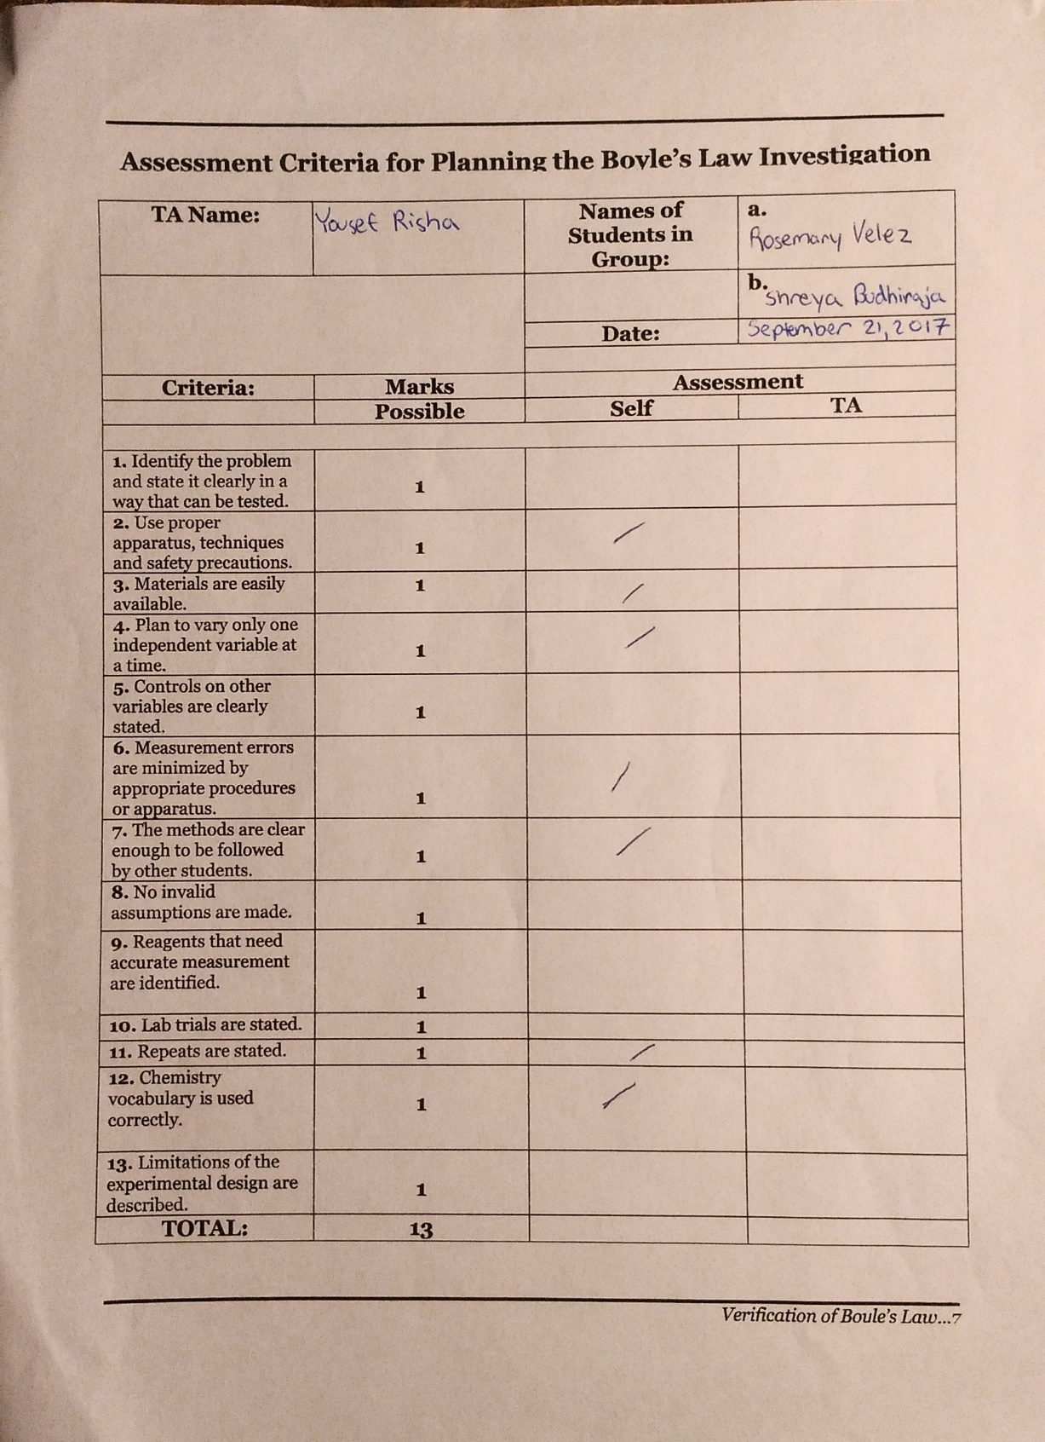

Raw Data:


