HSS 2305
PRETEST : Chapter 5
Multiple choices
1) Which is true according to the location of different steps of ACR within mitochondrion?
a) TCA cycle as well as electron transport chain occurs in the matrix
b) glycolysis as well as preparatory reaction occur in the cytosol
c) TCA as well as the preparatory reaction occur in the matrix
d) electron transport chain as well as glycolysis occur on a cristae
2) The mitochondrial outer membrane has a low protein/lipid ratio, but it is highly permeable, even to substances that cannot usually travel through the phospholipid bilayer. What allows this? TELL HER OUTER IS ACTUALLY HIGH PROTIEN/Lipid RATIO
a) elongation of fatty acids
b) oxidation of epinephrine
c) the presence of porins
d) degradation of tryptophane
3) What is a cristae junction?
a) a tubular connection between ATP synthase complex and a cristae
b) a tubular connection between the inner boundary membrane and a cristae
c) a flattened connection between the outer membrane and a cristae
d) a flattened connection between the inner boundary membrane and an ATP synthase complex
4) Aerobic exercises are a good way of reducing the body’s fat content because:
a) after 20 minutes, about 50% of calories used by muscles come from fats
b) as soon as the exercises begin, fats are broken down instead of glucose
c) muscles are using free fatty acids released by their own tissues
d) none of these situations
5) The average volume occupied by mitochondria in a mammalian cell is around _____ while that of a heart cell is around: _____
a) 40% 20%
b) 20% 40%
c) 50% 10%
d) 10% 50%
6) The number of six molecules of CO₂ produced by breaking down one molecule of glucose in a mitochondrion is fractionated as follows:
a) two are coming form preparatory reaction and four from glycolysis
b) two are coming from glycolysis and four from Krebs cycle
c) two are coming from preparatory reaction and four from Krebs cycle
d) four are coming from glycolysis and two from Krebs cycle
7) Which is false according the spherical F₁ head of ATP synthase complex?
a) contains five different types of polypeptides
b) all polypeptides are encoded by mtDNA
c) sites for ATP synthesis are located on the β subunits
d) is connected to the basepiece by a γ subunit
8) Which is false according to the F_{o} basepiece of the ATP synthase complex?
a) embedded in the inner membrane
b) the b subunit contributes the peripheral stalk
c) mammalian ATP synthase has only 8 subunits in the c ring
d) F_{o} base contains no channel
9) In the Electron Transport Chain, a proton electrochemical gradient is established when H+ protons are translocated:
a) from the intermembrane space to the cytosol
b) from the cytosol to the matrix
c) from the matrix to the intermembrane space
d) from the intermembrane space to the matrix
10) Which is true about an electron transport chain?
a) particularly important for fast-twitch fibers
b) is driven by a coenzyme NADH only
c) contributes to the highest amount of ATP per molecule of glucose while coupled with glycolysis
d) is composed of peripheral proteins as well as integral protein complex

11) Which is the right sequence in transportation of electrons on the mitochondrial matrix, using NADH as the coenzyme?
a) complex I UQ complex III cytochrome c complex IV
b) complex II UO complex III cytochrome c complex IV
c) complex I UQ complex II complex IV cytochrome c
d) complex II Q complex I complex III cytochrome c
12) At what time does an ATP synthase complex make ATP from ADP during oxidative phosphorylation?
a) when electrons are passed from NADH + H+ to a first electron transporter
b) when H+ protons flows down an electrochemical gradient
c) when H+ protons travel through a channel located in the ATP synthase complex
d) b and c are correct
13) Which component of an ATP synthase complex is responsible for the entrance of H+?
a) the β subunit
b) the a subunit (Note that in the Ppt there is a mistake: it is a instead of α that must be written)
c) the c ring
d) the γ subunit
14) Which peroxisomal components can be very many in the myelin sheat that insulates brain cells and that can cause severe neurological dysfunction?
a) plasmalogens
b) very long chains of fatty acids
c) uric acid
d) hydrogen peroxide
15) What is particular according to VLCFAs?
a) they have more than 30 C
b) they are linked to glycerol by an ester linkage rather than an ether linkage
c) their accumulation in the cytosol can cause Zellweger syndrome
d) in normal condition they must be oxidized within the peroxisomes

16) Which of these statements is false?
a) mitochondria communicate with peroxisome through vesicles
b) unlike peroxisomes, mitochondria can split
c) mitochondria and peroxisomes can both import proteins from cytosol
d) mitochondria and peroxisome have similar oxidative metabolism
17) Mitochondrial disorders principally affect:
a) only old people
b) only young people
c) muscle cells and epithelial cells of the respiratory tract
d) muscle cells and brain cells
18) There are different levels of severity of mitochondrial disorders. Which is true about it?
a) aggregates of mitochondria and abnormal inclusions can lead to death
b) blindness can be caused by a mitochondrial disorder
c) sperm motility can be a consequence of mitochondrial disorder
d) all of these statements are correct
19) Which is not related to Parkinson’s disease?
a) ROS
b) mutation on mtDNA
c) loss of dopamine-producing cells
d) H₂O₂ accumulation in brain cells
20) Which is not an avenue to treat young boys with X-linked adrenoleukodystrophy?
a) bone marrow transplantation
b) transplantation of fetal neurons
c) administration of drugs
d) gene therapy

True or false
1) the average size of a mitochondrion is about 5 nm, that is the same as a bacterial size. This supports the endosymbiotic theory: __F___
2) if mitochondrial fusion is higher than fission, mitochondria tend to be more numerous: _F____
3) cholesterol is found in mitochondrial inner membrane and contributes to regulate the activity of protein complexes involved in the electron transport chain: ___F__
4) polypeptides that are present within a mitochondrion only have been encoded by the mitochondrial DNA: ___F__
5) once lactic acid is carried to the liver it is converted into glucose, but it cannot be a constant source of glucose because it contributes to decrease the pH from7,00 to 6,35: _T____
6) aerobic exercises depend more on fast-twitch fibers than slow-twitch fibers: __F___
7) during aerobic exercises, lactic acid is produced as a source of glucose: __F___
8) β subunit of ATP synthase complex is responsible for the phosphorylation of ADP: __T___
9) Only mutation in gene nucleus can lead to a mitochondrial disorder: __F___
10) Cells taken from older persons have an increased number of mtDNA mutations compared to the same cells of younger ones: __T___
11) Peroxisomal disorders especially strike young child: __T___
12) X-ALD principally strikes young boys: __F___

Matching test
Match the inner membrane domain of a mitochondrion (column A) to a specific function/feature (column B). Each domain might have more than one feature.
Column A
1) inner boundary membrane: b,d
2) cristae: __a,c,e___
Column B
a) located inside the matrix
b) contribute with the outer membrane to form the double-membrane envelop
c) contribute to the transduction of energy
d) responsible for the import of mitochondrial proteins
e) responsible for the high membrane surface required to produce ATP

Short answer
- Explain why the inner membrane of a mitochondrion is an excellent example of correlation between structure and function.
Inner membrane contains cristae which have many folds within the mitochondria. The folds allow the structure to maximize membrane surface required to house the machinery needed for aerobic respiration and ATP production
- Genes that encode mitochondrial fusion machinery can mutate. What would a consequence be?
A number of inherited neurologic diseases are caused by mutations in genes that encode components of mitochondrial fusion machinery
- What allows a mitochondrion to produce its own proteins and RNAs?
Within the matrix, the mitochondria has its DNA (circular; mtDNA) which allows for all genetic material and all machinery to produce its own RNAs and proteins
- A mitochondrion is more than an organelle that produces heat and energy, but can also regulates the Ca⁺² level in the cytosol. How does it do so?
Role in the uptake and release Ca+2 ions (play a role (with ER) in regulating the Ca+2 concentration within the cytosol). It does this by monitoring Ca+2 concentration that if Ca+2 concentration rises to abnormal high levels in the cytosol, Ca+2 transporter in the inner mitochondrial membrane takes up some of these excess Ca+2 ions.
- Other than the mitochondrial size, indicate two other similarities between mitochondria and bacteria that support the endosymbiotic theory.
Endosymbiotic theory: The mitochondria developed from bacteria.
-Mitochondria located in eukaryotic cells, its has been indicated that they have been developed through bacteria because they contain DNA and Ribosomes. -Mitochondria are the same size as bacteria
6) ATP can be provided to muscles at work from three sources. What are these sources? Compare the three sources in terms of how long ATP can be supplied to muscles at work.
1. ATP stored within skeletal muscle cells (usually lasts for 2-5 seconds)
2. Creatine phosphate (CrP) stored in muscle cells reacting with ADP to produce ATP and Cr (lasts for 15 seconds)
3. Oxidative metabolism (longest out of all sources )
7) Here a list of number, each indicating the amount of ATP produced at a certain time of the ACR: 2 2 6 6 18 4. The total amount is 38 ATP produced per molecule of glucose. Use these number to tell how many molecules of ATP are produced during the following steps:
- Glycolysis at the substrate level: _2____
- Krebs cycle by oxidative phosphorylation using NADH + H⁺: __18___
- Glycolysis by oxidative phosphorylation: ___6__
- Preparatory reaction by oxidative phosphorylation: ___6__
- Krebs cycle at the substrate level: __2___
- Krebs cycle by oxidative phosphorylation using FADH₂: __4___
8) Why are muscle tissues and brain tissues particularly affected by mitochondrial disorder?
Muscle and brain tissues are particularly affected by mitochondrial disorder because they tend to use up large amounts of ATP and mtDNA tends to accumulate is cells that are older such as brain and muscle tissue.
9) Explain why:
a) mitochondrial disorders are inherited maternally.
Mitochondria present in the cells of a human embryo exclusively come from those that were present in the egg at the time of conception: there was no contribution of the fertilizing sperm
b) members of a same family can exhibit different symptoms of a mitochondrial disorder.
Mitochondria of a cell contain a mixture of normal mtDNA and mutant mtDNA and clinical symptoms appear only in the dominance of mitochondria that contain defective genetic information (Domanace of mutant mtDNA) thus this varability of mutant mtDNA can explain why members of a same family can exhibit different symptoms of a mitochondrial disorder.
10) Victims of Parkinson’s disease could be treated by receiving transplant of fetal neurons. Why is this kind of treatment controversial?
Its controversial because it requires taking neurons from a fetus that have been aborted
11) Reproduce a diagram that indicates that you well understand the molecular cause of each of these two disorders:
a) Zellweger syndrome
b) X-linked adrenoleukodystrophy

FILL IN THE BLANKS
Fill in the blank on the structure of ATP synthase:
ATP-synthesizing enzyme (ATP synthase) is a mushroom-shaped protein complex composed of two components: ______Spherical F₁ Head_________ and _____Basal F₀ Sequence__________ (o stands for oligomycin); the two portions are connected by both a ____central__________ and a _____peripheral stalk__________; a typical mammalian mitochondrion has roughly ______15000_________ copies of the ATP synthase
Fill in the blanks on the proton diffusion through the a subunit of the c ring:
1º each proton from the ____intermembrane space___________ enters a _____half-channel_________ within the a subunit and then binds to an acidic residue that is available on one of the c ring subunit;
2º proton binding induces a conformational change that causes the ring to move (around __30___ degrees);
3º the bound proton is carried in a full circle by rotation of the c ring and is then released into the second _____half channel _________ that opens into the ______matrix_________.

Figures
This figure illustrates an electron micrograph of a mitochondrion. By using arrows, indicate:
- a location where a TCA runs (letter A) In Matrix
- a location where we can find porins (letter B) Outermembrane
- a location of an ATP synthase complex (letter C) Cristae
- a location where we could find a mtDNA (letter D) Matrix
- a location where we could find ribosomes (letter E) Matrix
- a location where glycolysis occurs Cytoplasm
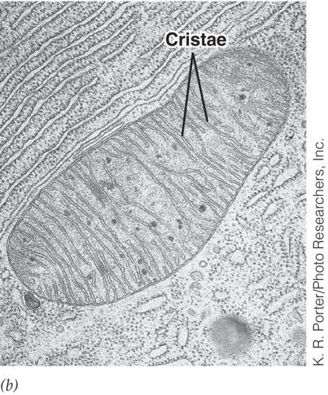
ASK IF ON MIDTERM!!!
Looking at this picture, answer to the following questions:

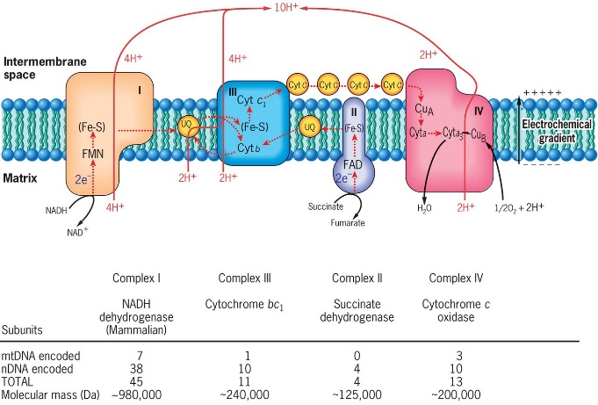

- By which ways can electrons enter the chain?
Complex I (NADH) and Complex II (FADH2)
- Which type of molecule becomes a pool within the phospholipid bilayer?
UQ
c) What protein is peripheral and accepts electrons from complex III?
Cyt C
In the reaction below and which occurs in a peroxisome, RH2 stands for a reduced compound that is oxidized by some peroxisomal enzymes. Name three of these compounds.
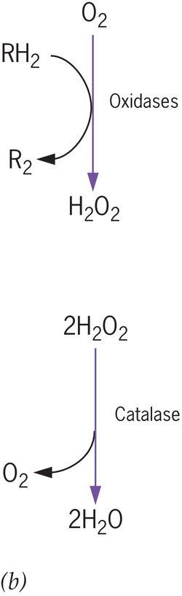

What is this picture related to? ________________________________________________
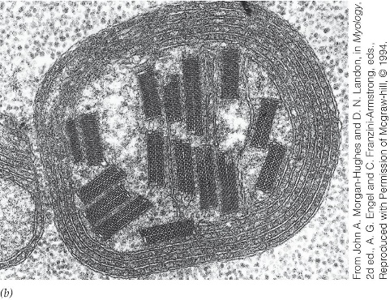

Questions on figure 5.5 (Aerobic and anaerobic metabolism)

TRUE OR FALSE:
1) in presence of oxygen, reactions of glycolysis generate pyruvate and NAD+: __T__
2) glycolysis occurs in the cytosol: _T____
3) during a fermentation that leads to lactate, NADH is oxydized while pyruvate is reduced: __T___
4) fermentation can lead to ethanol in yeast: __T___
5) during a fermentation, NAD+ which is formed is reutilized in the continuation of glycolysis: __T___

SHORT ANSWERS ON GLYCOLYSIS IN PRESENCE OF OXYGEN :
- What helps pyruvate move into the matrix?

Reaction within two pyruvate molecules are oxidized to acetyl group

- What happens to pyruvate once it has moved into the matrix?
Pyruvate becomes oxidized as it converted to acetyl-CoA and 1 carbon atom is extracted from each pyruvate and CO₂ is given off

- NAD+ is reduced into NADH during conversion of pyruvate into acetyl CoA. What happens to NADH and what happens to acetyl CoA?

4) TCA generates NADH and FADH2. What happens to the electrons of these two molecules?
5) What is the electron transport chain made of and where is it located?
6) What is the contribution of molecular oxygen (O₂) during cellular respiration and which product is oxygen converted to?
7) Energy released during electron transport chain is used to generate molecules of ATP (especially through chemiosmosis). Approximately how many molecules of ATP are generated from a single molecule of glucose? (two numbers are possible).

QUESTIONS ON GENERAL FEATURES OF AEROBIC CELLULAR RESPIRATON (ACR) AND EACH OF ITS PHASES (GLYCOLYSIS, PREPARATORY REACTION AND TCA CYCLE)
All are at multiple choice

GENERAL FEATURES
1) Which statement is true according to the characteristics of ACR
a) the whole process is endergonic because glucose must be phosphorylated first during glycolysis
b) last acceptor of electrons is NAD+
c) atoms of a molecule of water are coming from atoms of a molecule of glucose
d) this is a process that allows the reduction of molecular oxygen
2) Which is the highest-energy molecule?
a) glucose
b) carbon dioxide
c) molecular oxygen
d) water
3) According to this equation:
C₆H₁₂O₆ + 6O₂ 6CO₂ + 6H₂O + E (stored in ATP)
which molecule loses electrons?
a) the sugar
b) ATP
c) molecular oxygen
d) carbon dioxide
4) What explains that reduction of NAD⁺ with 2 electrons does not lead to NADH₂ but NADH + H⁺?
a) when NAD⁺ accepts an electron, it becomes neutral, so it cannot bind to a H⁺
b) the enzyme dehydrogenase keeps one electron, so NAD⁺ cannot be provided with it
c) one electron is released free in the surrounding
d) none of these statements is good
5) ATP is used to:
a) perform synthesis reactions only
b) perform mechanical reactions only
c) perform transportation reactions only
d) all of these works
6) Why can we tell that aerobic cellular respiration is a downhill transfer of energy?
a) electrons are easily passed from carbon dioxide to molecular oxygen
b) ATP is hydrolyzed into ADP
c) NADH + H⁺ is converted into NAD⁺
d) glucose in broken down in the cytosol instead of in the matrix
GLYCOLYSIS
7) Which is true about glycolysis?
a) occurs in the matrix of a mitochondrion
b) one molecule of pyruvate is produced per molecule of glucose
c) does not allow any production of ATP at the substrate level
d) contributes to the production of 6 ATP through chemiosmosis
PREPARATORY REACTION
8) Which is true about preparatory reaction?
a) involves FADH₂ as an electron transporter to the electron transport chain
b) contributes to the production of one molecule of Acetyl-CoA per two molecules of pyruvate
c) has nothing to do with chemiosmosis
d) does not allow any production of ATP at the substrate level
TCA CYCLE
9) Which is true about TCA cycle (also called: Krebs cycle or citric acid cycle)?
a) its first product is oxaloacetic acid
b) allows the production four ATP molecules at the substrate level
c) allows the production of 6 molecules of NADH + H⁺ leading to the production of 18 molecules of ATP, through chemiosmosis
d) occurs on a cristae

