BIO110 Course Notes – By Midori Clark-Baba (300014057)
Chapter 1
Scientific Process
Observation: This orange is sweet
Hypothesis: All oranges are sweet.
Prediction: If I taste all kinds of oranges, then they will always be sweet.
Tests: Tasting all kinds of oranges.
Travel to Madagascar: tasted a very sour orange (Hypothesis is falsified)
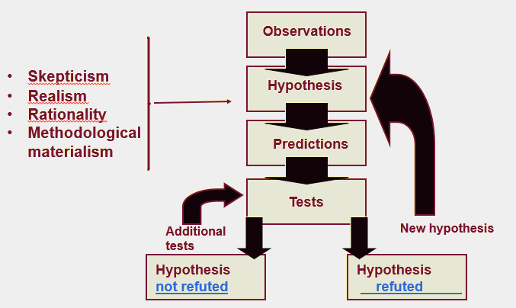
Contract between science and knowledge (or the ability to know)
- Initial skepticism on facts
- We ask honest questions on facts and hypothesis (tangible/real things) and we always re-test what has been found.
- Skepticism is necessary to retest hypothesis, because nothing can be proven in science, the best hypothesis is one that cannot be falsified
- Papers can be revoked if other scientists cannot recreate the experiment with the same results
- Try to steer away from original ideas and perceptions that derive from personal life or opinions, no personal influence
- Realism
- The world is older and exists independently from my perception of it (the realm of ideas does not have the priority over the real world)
- Rationality
- Logic: demonstrations from a scientist must be the result of coherent steps.
- Parsimony: methodological principle which states that acceptable theories are hypothetically the most economical in assumptions.
- Methodological materialism
- All that is experimentally accessible in the real world is material or has a material origin.
Chapter 3
Evolution and Natural Selection Related to Darwin
- In 1837, we find in Darwin's notes the first mention that species resemble themselves because they share a common ancestor (and not a common environment).
- Rejects fixity of species and accepts the concept of descent with modifications (evolution).
- It is a very materialistic vision, thus in contradiction to the religious dogma of the time.
- Rejects Lamarck’s evolutionary mechanism (environmental determinism)
- Thus, he begins the search for an evolutionary mechanism.
- Darwin created the phylogenetic tree – tree of life
- Maybe if species look alike they share a common ancestor, then you can go back far in their history and try and find a link between species
- NOT common environment, they had a common ancestor
- This led to the idea that species were able to evolve as they changed over time and became many kinds of species
- Rejected the fact that species didn’t change (idea of god) Darwin disputed said that they are modifying with the descent with modifications
- Meant that the world had been alive for more than 6000 years as these changes would take a very long time for the species to adapt over time
- Didn’t want people to confuse his view of evolution with the idea of social evolution that was growing at the same time, so he adapted the term descent with modification
- Said when he finds the mechanism it should be easily verifiable, adapted a materialistic view of science at that point
- Found the pattern/tree like evolution of species
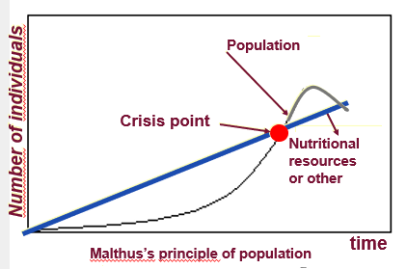
- To find the pattern of life you cannot look at current species you must look at the species that are extinct and verify many things about them based on their fossils
- 99% of species that have lived on Earth are extinct.
- Most of the evolutionary branches finish in a dead-end.
- Without fossils it creates a gap between morphology; the fossils lessen this gap compared to just looking visually at the species itself
- Every human population tends to increase geometrically whereas the available resources to feed these populations increase arithmetically.
- The human population increases faster than its capacity to feed itself. This leads to chaos and eventually to a substantial reduction in population size.
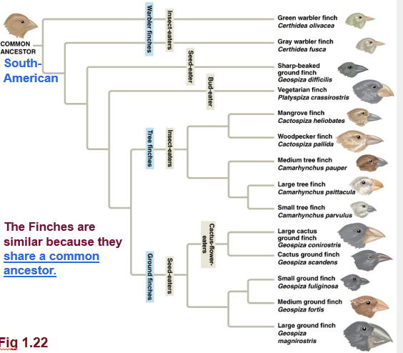
The Voyage on the Beagle
Sometimes species look alike sometimes they don’t, had to find explanation for when 2 species were related but didn’t not resemble each other, to verify this he would look at the fossils of the 2 species
Darwin’s observations
- All species can produce more offspring than their environment can sustain and many of these offspring fail to survive and reproduce
- Members of a population often vary in their Inherited traits.
- Two inferences:
- Individuals whose inherited traits gives them a higher probability of surviving and reproducing in each environment tend to leave more offspring than other individuals
- From generation to generation, this unequal capacity of survival and reproduce (differential reproductive success) results in an accumulation of favourable traits in a population.
- This is natural selection It enables the emergence of adaptations.
Natural Selection + Evolution
- Important notions linked with natural selection:
- Individuals do not evolve, populations evolve.
- Only hereditary traits are subject to natural selection.
- For evolution to occur, we need genetic variability.
- Natural selection corresponds to differential reproductive success within a population from generation to generation.
- With time, natural selection enables individuals to become better adapted to their environment.
- Environmental factors vary in time and space. Thus, the selective forces are variable.
- Traits in populations will change and can modify the species.
- For evolution, genetic variability is essential, Darwin contradicted everyone who said it was not important and insisted it was one of the MOST important factors
- For Darwin this mechanism is valid because:
- It respects the principle of uniformity of Lyell and Hutton.
- The results of natural selection are visible in nature
- The mechanism can be verified on current populations. (e.g. artificial selection)
- It is a material concept (no need for divine intervention):
- The mechanism is not random Natural selection enables individuals that are better adapted to their environment to become more abundant than those who are not (differential reproductive success).
- Not a quest for perfection (evolution is not a directed process). It does not lead to the appearance of “perfect” traits. Organisms only adapt to their environment.
- Artificial selection is finalized because the goal, fixed well in advance, precedes the causes. The result can be obtained in a few generations.
- Natural selection is not finalized. It can take a long time for changes to occur (geological time scale).
- Some of these traits provide an advantage compared to the other individuals
- Artificial selection can change, and it can take a long time for change to occur
- No final goal, just want to survive
- If they can’t adapt to their environment anymore they just die off and disappear
EXAMPLE OF ALTITUDE (IN SLIDES)
Chapter 4
Modern Additions to Mendel’s Law
- Incomplete dominance (1st picture)
- Codominance (2nd picture)
- Polygenism
- when a phenotypic trait is under the combined action of 2+ genes, very common phenomenon with regards to expression of the genes
- Epistasis (3rd picture)
- when the effect of a gene hides or blocks that or another
- Pleiotropy
- when a gene influences more than one trait
- Ex. Manx cat (M) = incomplete dominance to normal cat (m)
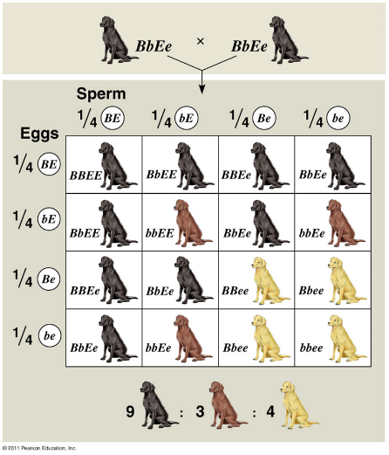
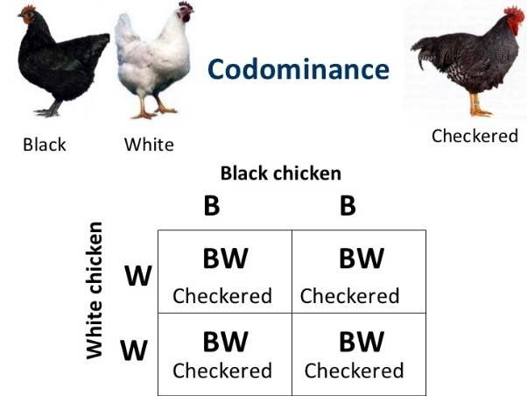
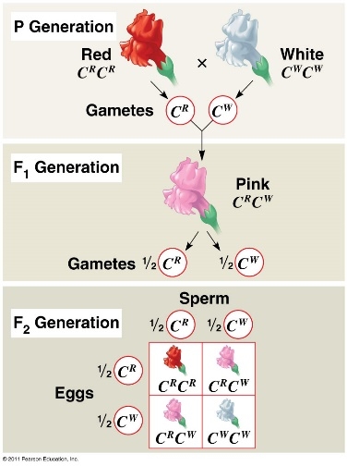
- Gene responsible for lack of tail when homozygous

Chapter 5 – Evolution Populations
Hardy-Weinberg's principle
- Gametes for each gen. are drawn at random from the gene pool of the previous gen.
- Punnet square is created with sperm on one end and eggs on the other
- p² = Expected freq. of genotype C^{r}C^{r}
2pq = Expected freq. of genotype C^{r}C^{b}
q² = Expected freq. of genotype C^{b}C^{b}
These together should equal 1 to be in HW equilibrium
- A population is in HW equilibrium when:
- The frequencies of alleles and genotype will remain constant (according to the equation p2 + 2pq + q2 = 1) from generation to generation if the following conditions are respected:
- no mutations.
- Mating is random
- population is extremely large
- no genetic (gene) flow (no migration of alleles between populations)
- no natural selection.
- Hardy-Weinberg's principle = a hypothetical population that does not evolve
Mutation
- Changes in the DNA sequence of an organism
- Source of genetic variability
- Mutations are
- Random.
- Transmissible (only if they are in the gametes).
- Frequent throughout the gene pool, but rare at each locus (a place on the chromosome where they have a gene)
- Will influence allele frequencies but is a weak evolutionary force from generation to generation
- Many of the mistakes and mutations occur during meiosis
- In small pop it will be a major change however a large pop one mutation will not cause much change
- Can be chromosomal (DNA segment loss, repetition of DNA segments, addition or loss of chromosomes)
- Point mutations (addition, deletions or substitution of a base; A-C instead of A-T).
  - Negative effect (dwarfism)
  - Lethal effect (will cause death)
  - Neutral effect
  - Positive effect – enables the individual to be better adapted to their environment
Assortative Mating
- Random mating: panmixia
- Choice of partners in relation to the phenotype (modifies HW equil.)
- Positive – more frequent mating between similar individuals (increase in homozygosity), autogamy, geographical proximity of individuals, physical appearance
- Negative – more frequent mating between individuals that don’t look alike (increase heterozygosity)
- Does not change allele frequencies; changes genotypic frequencies
- When paired with natural selection, + assortative mating can lead to an increase in homozygosity and a loss of genetic variability
- Phenomena of endogamic depression since the harmful alleles will express themselves
- Natural selection will purge the population of a portion of its harmful alleles
Genetic Flow
- Migration: exchange of genes between populations
- Tends to standardize the genetic pool of the populations involved
- can play a similar role as mutations by introducing new genes in one of the populations.
Genetic Drift
- result of chance
- Chance will have more impact on a small population
- In small populations, genetic drift will trigger a decrease in genetic variability and a decrease in heterozygosity
- In a large population genetic drift will cause little changes to the allelic or genotypic frequency of a population
- If there are no other processes which affects the allelic frequencies at a locus, genetic drift will eventually result in the fixation of an allele and the elimination of all others for this locus.
- Under the only effect of genetic drift, the probability that an allele will become fixed is equal to its frequency
- The population bottleneck:
- In small populations, genetic drift can lead to the fixation of deleterious alleles and a loss of genetic variability. Thus, this correspond to an increase in the risk of extinction.
- Founder effect: when a few individuals from a large population create a new colony, the genetic make-up of the colony differs from the source population
Natural Selection
- Adaptive value - fitness or the adaptive value of a genotype corresponds to the contribution of an individual to the genetic pool of the next generation when compared with the contribution of other individuals.
- Types of hereditary traits:
- Qualitative (discreet variation: colour)
- Quantitative (continuous variation: height, weight)
- Polymorph populations showing distinct morphological types or genetic variability.
Preservation of Genetic Variability in Nature
- Maintaining genetic variability in nature (polymorphism)
- Diploid and genetic load
- Advantage of the heterozygotes
- Frequency-dependent selection
- Neutral genetic variability
- Other mechanisms
- Diploidy
- Considerable amount of genetic variability of diploid individuals is hidden from natural selection – the mass of little expressed or unexpressed genes in heterozygotes (genetic load)
- The heterozygote advantage: when heterozygous individuals have more offspring than homozygous individuals
- The selection depends on the positive frequency; phenotype = more abundant = favoured.
- Case of Mullerian mimicry: a case of mimicry between two toxic species.
- Neutral Variation
- A good portion of the genetic variability found in genes do not show selective advantages or is not affected by natural selection
- External mechanisms (or ecological):
- Result of simultaneous impacts of different selective pressures
- Temporal changes in selection pressure
- Habitat mosaic
- Non-assortative mating
Sexual Selection
- Originally formulated by Darwin
- For of evolution in which individuals that possess some specific hereditary traits are more susceptible than other to find partners
- Intersexual selection – choice of sexual partner based on traits indicating quality of genetic baggage of the other
- Intrasexual selection – selection between individuals of the same sex
Chapter 6 – Adaptation
Evolution of speech
- Unique to humans
- Length of snout – chimps have long snout, humans have a flat face; these have an impact of morphology
- Length of tongue – chimp has a large tongue, humans have a small round tongue
- Soft palate separates respiratory organs from mouth (able to chew and breathe)
- Chimp - soft palate touches the epiglottis, swallow food it will automatically enter the oesophagus and the epiglottis will flatten on the trachea
- Humans - much smaller tongue, space in-between the end of soft palate and tip of epiglottis, becomes an issue - only species that can choke on our food, it could get caught in-between and enter the respiratory system generally, mammals don’t choke on food or end up with food in their trachea
- When we make noises, we modify the shape of the tubes
- In the chimp they don’t have a clear language and cannot articulate as many words/sounds
- The tubes being the same length creates many issues, the vibration of them creates the different sounds
- Scientists think that the capacity to speak is one of the biggest discoveries
- The fact that we can articulate a conversation is accompanied by the slight possibility that you could choke on your food; however, this can be considered an evolutionary compromise, as it benefits us more than hurts us
Studying Adaptations
- initial function of fins was to stabilize the fish body in its environment
- In terrestrial animals (tetrapod), limbs are used to support the body in an aerial environment = exaptation for terrestrial mobility (locomotion)
- Exaptation - Adaptation whose current function is not the one for which the structure initially evolved
Chapter 7 – Geographic Speciation and Variation
A. afarensis
- Tropical forests
- Bipedal and arboreal
- Diet of fruits, tubers and leaves.
- Sedentary way of life
Homo ergaster (= H. erectus)
- Less fruit available; meat added to the diet
- Walks longer distances for prey and water.
- Adapt to life on the plains
- More active lifestyle (hunter-gatherers)
- Natural selection acts on the shape of the body (ability to run).
- Abundance of sweat glands and less fur to have a more efficient thermoregulation.
- Furry animal glands Human glands
Especially sebaceous and apocrine Especially eccrine
Oily sweat Watery sweat
Perspiration difficult Easy perspiration (up to 10 litres per day)
- Human sweating - 10-12 litres per day, 2-4 litres per hour, a lot of eccrine sweat glands (loss of fur to facilitate sweat evaporation)
Evolution of Dark Skin
- Selection in favor of darker skin (1.2 Ma) at the same time as fur loss.
- Natural selection favored the individuals having thicker, darker and more acid skin (more melanosomes = more melanin’s).
- Protection against: Ultraviolet rays (UV), drought, bacterial attacks and vitamin deficiencies.
- 1,2Myr to 100 000 years: the skin of all hominins species was dark.
- We need to find an inherited trait that gave those who had it a positive survival and reproduction differential (adaptation) from generation to generation compared to other members of the population.
- dark skin offers a protection against the UV rays that offers a survival and reproductive advantage (that’s an adaptation).
- Pale skin in low UV radiation would maximize the absorption of UV rays and the survival of human population in areas of UV deficiency
- Links between the quantity of UV rays reaching the Earth and human skin colour.
- Great human migration (100 000 years ago) = humans invade northern habitats and evolve paler skin to maximize UV absorption where it is weak for adequate synthesis of vitamin D3
- deficit of UV rays, colonization by humans was made possible because we compensate for deficiencies in vitamin D3 through diet (hunting, fishing and domestication)
Conclusion
- lifestyle changes due to climate change, more than 1,2 Myr years ago = loss of fur
- after fur loss = dark skin, for 1 Myr
- pale skin = colonization of habitats north as adaptation to maximize the absorption of UV rays in zones where radiation is low = synthesis of vitamin D3
- individuals with darker skin in regions of high UV intensity synthesize Vitamin D3 at a much slower rate than individuals with pale skin.
- A selective advantage of darker skin in regions of high UV intensity is to minimize the degradation of folic acid by UV rays.
Origin of Species
Sympatric speciation
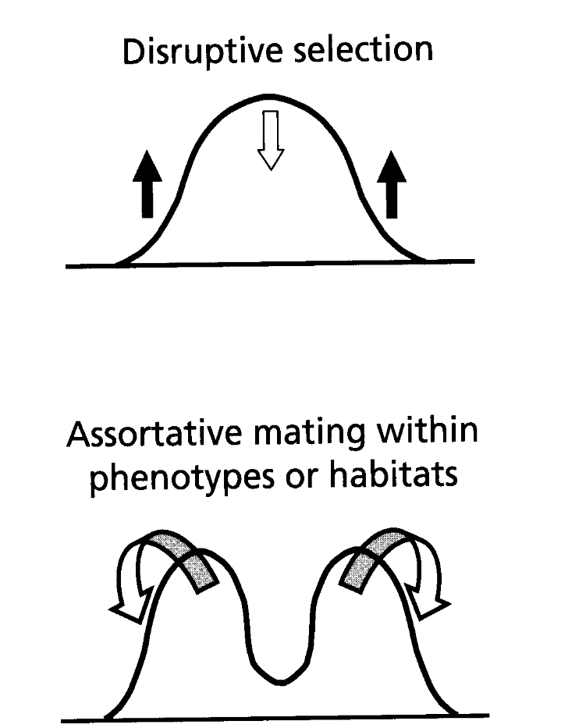
- new species evolve from a single ancestral species while inhabiting the same geographic region
Hybrid Zones
Grolar Bear – Grizzly bear and Polar bear hybrid
- Stay on main land then maybe polar bears will get more in contact with grizzly bears, creating this hybrid
- Skin from hunter + DNA analysis can determine it was a hybrid
- Due to global warming this hybrid could be more common as the polar bears environment would have to change
- Breaking reproductive barriers = fusion of species, but can never be sure
- May be more common as polar bears have lost feeding grounds
Enhancement of reproductive barriers in the contact area (hybrid zone)
- Character Displacement: the differences between two related species are often greater in sympatric areas.
- If the reproductive isolation is incomplete, there could be the creation of a stable of hybrid zone that containing hybrids. In these narrow zones from a geographical standpoint, there are genes or alleles of a species that pass freely into the gene pool of another species. (Gene introgression.)
Tempo of Speciation
- Species are viewed as individuals, born through speciation, exist, then go extinct
- Process of speciation takes less than 4000 years based off studies on fish
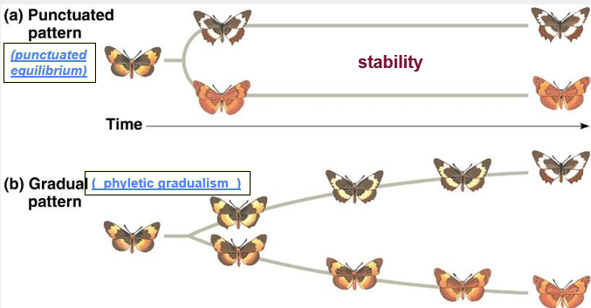
- Some are more than 4 million, tend not to be less 5000 years, the average was 6.5 million years

Chapter 8 – Phylogenetics
Systematics: A scientific discipline focused on classifying organisms and determining their evolutionary relationships.
Phylogeny: The evolutionary history of a species or a group of species.
Taxonomy: a scientific discipline concerned with naming and classifying the diversity of life.
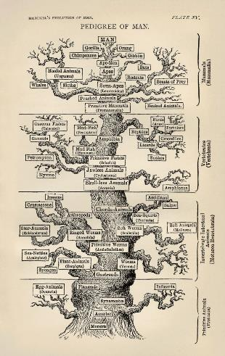
Taxon (pl. taxa) : A named taxonomic unit at any level of the phylogenetic hierarchy or classification.
Graphical Representation of Life
Tree
- 1st comes from a scale, ladder of life, system represented the diversity of life by a ladder, top of the ladder is humans, bottom is earth fire and air
- 3rd the base of the tree includes primitive kind of life (virus, bacteria, etc.) humans are still at the top of it, being the superior part of the tree
- Inferior vs superior
- One major problem is that there is a presence of a trunk, very imaginative and false
Bush
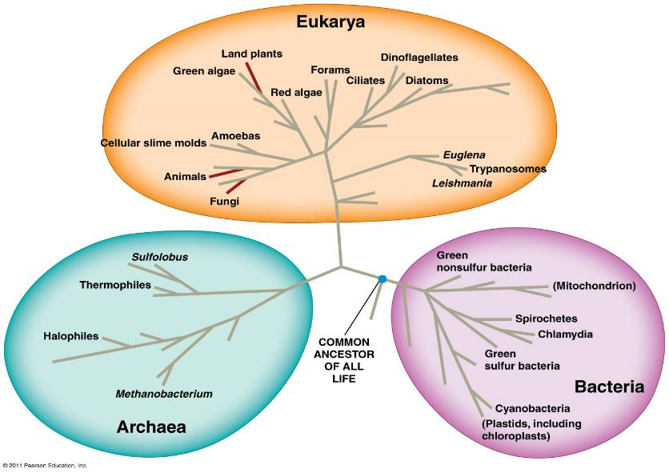
- Everything starts in center divides in 3 main branches and moves out, all living species found at the surface
- Broken branches = fossil, Middle = dead branches = extinct
- Margin species are real, things at the tip of the branches exist they are living species
- Can put a new perspective on anything found in nature – the ancestor of life (LUCA- last universal common ancestor basically the first living being is in the middle)
- Bacteria and humans are equally evolutionized, different way of life, still equal and living species
- All somewhat similar and related to LUCA
- The 3 domains of life (eukarya, bacteria, archaea)
- LUCA is not in the center of it, morphological and molecular evidence shows that archaea are not as closelt related to bacteria
Homology and Homoplasy
Homologous Structures
- indicative of a common ancestor and the data that is used to reconstruct phylogenies.
Homoplasy
- Convergent evolution
- Ex. ability to hover in sugar gliders vs. flying squirrels
- Evolutionary Reversion
- Ex absence of fur in whales
Taxonomy and Classification
- Classification: System of words used to group species into increasingly generalized categories.
- Classification must reflect the phylogeny
Phylogenetics
- Cladogram indicates the sequence of appearance of taxa.
- No time frame incorporated in cladogram
- Classification reflects ramifications of the cladogram.
- Branching point, related groups, and polytomy
- Cladistics: taxa should be based on shared derived characters (synapomorphy, homology)
- not shared ancestral characters (symplesiomorphy)
- only valid group: monophyletic group
- Monophyletic: contains all and only the descendant from a common ancestor
- Non-monophyletic groups:
- Paraphyletic: does not contain all the descendants from a common ancestor
- Polyphyletic: contains descendants from several ancestors
- Reference group: used to distinguish the derived character traits from ancestral character traits.
- Cladistic
- In case of conflicts in the distribution of traits in the cladograms:
- Principle of parsimony is invoked: the phylogeny must offer the simplest explanation with respect to the facts.
- Hypothesis with the fewest evolutionary steps is considered the most parsimonious and the hypothesis closest to the truth.
Chapter 9 – Biosphere and Ecology
Definitions, Concepts and Issues
Ecology: Scientific study of interactions between organisms and between organisms and their environment.
- Environment:
- abiotic factors (non-living)
- biotic factors (living)
Scope of ecology:
- Organism ecology: interactions between an organism and the environment (physiology, behavior)
- Population ecology: groups of organisms of one species living in the same area (dynamics of population size fluctuations).
- Community ecology: groups of populations of different species in an area (how interactions between species (predation, competition) affect the structure and organization of communities).
- Ecosystem ecology: community of organisms in an area and the interaction of organisms with physical factors (study of energy flow, chemical cycling).
- Landscape ecology: mosaic of connected ecosystems (study of factors controlling of energy, materials and organisms across multiple ecosystems)
- Global ecology: study of the biosphere; sum of all ecosystems (study of regional exchange of energy and materials its global impact on the biosphere.
- Precautionary Principle: strategy to cope with possible risks where scientific understanding is yet incomplete. (better be safe than sorry)
The Climate
Abiotic factors
- Light
- Temperature
- Wind
- Precipitation
In polar regions
- The solar rays are slanted whereas they are vertical in equatorial regions.
- The solar energy spreads over a larger surface area.
Effects
- Circulation of surface water in the oceans
Terrestrial and Aquatic Biomes
- Tropical forests:
- Humid (constant precipitation; 200 to 400 cm of rain per year)
- Dry (6-month dry season; 150 cm of rain per year)
- Desert:
- Especially found on a band between the 30o latitude (north) and 30o (south)
- Little precipitation (30 cm per year)
- Warm temperature during the day and cold at night
- Temperate Grassland (steppe):
- Large regions of herbaceous plants (especially grasses)
- Seasonal precipitations; dry winter and humid summer. 30 to 100 cm of rain per year. Frequent droughts.
- Temperature: cold winter (average temp; -10C); Warm summer (up to 30C)
- Northern Coniferous Forest (Taiga):
- Largest terrestrial biomes large band just south of the tundra.
- Precipitations 30 to 70 mm of rain; forest on the North American Pacific coast (300 cm per year)
- Temperature: cold in winter (sometimes -50oC) and warm summer (sometimes more than 20oC)
- Temperate broadleaf Forest:
- Especially in the Northern hemisphere; deciduous trees
- Precipitation during all seasons: between 70 and 200 cm.
- Average Temp. In winter around 0oC and warm in winter (max temp. around 35oC)
- Tundra:
- Arctic and alpine (summit of high mountains)
- Small bushes and plants adapted to cold climates.
- Arctic tundra: 20 to 60 cm of rain; alpine, up to 100 cm.
- Temperature: Average winter temp. sometimes: -30oC; summer between 5 and 10oC.
- Zonation of a lake
- Littoral + limnetic zones
- Photic vs aphotic zones
- Pelagic vs benthic zones
- Lakes:
- Oligotrophic - Poor in nutrients and rich in oxygen
- Eutrophic - Rich in nutrients but poor in oxygen
Species Distribution
Study of biogeography: study of species distribution
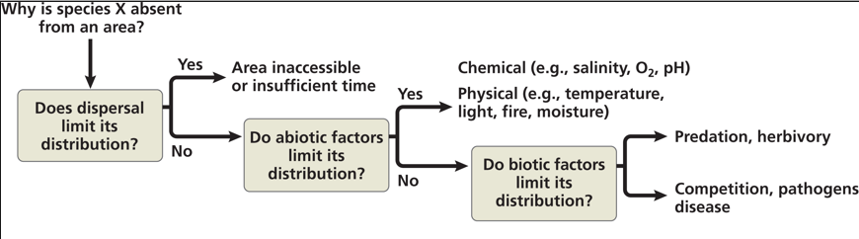
Factors that may limit geographic distribution of species:
Limiting Factors
- Species associated with forest and streams.
- Atlantic Ocean and prairies are limiting its distribution.
- Temperature limits its northern distribution.
- Abiotic factors (chemical or physical): temperature, water, oxygen, salinity, sunlight.
- Parasitism
- Symbiosis - Dispersion of the cattle egret follows the creation of pastures by humans.
Chapter 10 – Ecology of Populations
Definition
- Population - a group of individuals of the same species living in each geographical area.
- Study of Biological cycle study of characteristics that influence the survival and reproduction of individuals of a population.
Density
What is it?
- the number of individuals by unit area or volume. The density is the result of a dynamic interaction between the processes of addition (immigration and birth) and elimination of individuals (emigration and mortality)
- Determination density
- Direct counting
- Aerial survey
- By their song (song birds of our forests)
Sampling
- Capture-recapture:
- Conditions to respect:
- marking has no health effect of the animal;
- marked or non-marked individuals are distributed randomly in the population;
- no immigration or emigration in the population;
- chances of catching marked or unmarked individuals are equal.
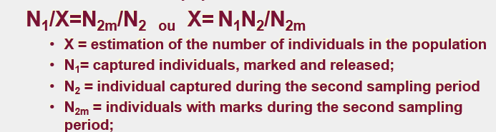
- Estimation of the total population
Dispersion
What is it?
- spacing of individuals inside geographical limits of the population
- clumped (aggregate in patches: feeding mating, predation or defense
- Uniform (competition for resources, territoriality)
- Random (unpredictable spacing)

Demography
- Quantitative study of populations and their variations over time (birth rate and death rate)
- Quantitative Demography
- Cohort analysis (group of individuals of the same age):
survivorship curve of a species
Types of survival curves
- low mortality rate during early and middle life and fast increased mortality in older individuals (big mammals: significant parental care)
- constant death rate during the organism life span (multiple rodents, plants, invertebrates),
- high mortality rate for the young and life and a death rare that declines in the adults that survive (fishes with small eggs: absence of parental care).
Population Growth
- exponential growth – curve shaped like a “J”
- logistic growth – sigmoid curve, plateau = carrying capacity
Biological Cycles
- Life history traits: traits that affect an organism’s schedule of reproduction and survival.
- Life history traits are the result of natural selection.
- Examples of life history traits:
- Age at first reproduction or age at maturity.
- Number of reproduction events
- Number of offspring per reproductive event
- Trade-off between reproduction and survival:
- Frequency of reproduction, number of offspring or investment in parental care.
Population Dynamics
What is it?
- studies the size and age composition of populations as dynamical systems, and the biological and environmental processes driving them
- applied to complex interactions between biotic and abiotic factors responsible to the variation of population size.
Factors that regulate population growth
- can be density-dependent or density-independent:
- A birth rate(b) or death (m) that does not change with population density is said to be density independent
- If death rate that increases when population density or a birth rate that falls with rising density is said to density dependent.
Population Dynamics
- Metapopulations: small local populations that occupy a area of an appropriate habitat for the survival of a population.
- Dynamics of emigration, immigration, extinction and recolonization of patches.
- Important in species conservation.

Chapter 11 – Conservation Biology
3 levels of Biodiversity
- Genetic Diversity
- Importance of intra- and inter-populational genetic variation
- Specific biodiversity
- 99% of species that have existed on Earth are now extinct.
- This does not take into consideration cases of extirpation local disappearance of species
- Ecosystem biodiversity
- Role of keystone species in the ecosystem
- Ecosystem engineers
- Disruption of interaction networks
Info
- Food webs – top down or bottom up methods
Threats to Biodiversity
- Human activity threatens biodiversity
- Destruction of habitats is the main issue (cities, residences etc.) – contributed to 73% of species in danger
- Introduction of new species - Predator or species who are successful in obtaining resources.
- Example: zebra muscles
- Overexploitation – fish, elephants, whales, rhinoceros in specific
- Global climate change
- Greenhouse effect - Without the greenhouse effect, the Earth’s average temperature would be -18C
- Rise in global temperature in the last 150 years due to human activity (increase in CO2)
- Decrease in albedo (reflectivity of a surface)
- Loss and modification of the oceanic ecosystem
- loss of Arctic ecosystem
- loss of coral reefs
- acidification of the sea
- rising of sea levels
Conservation of Populations
Small populations
- the extinction vortex
- forces affecting small populations that cause them to spiral into a vortex of increasingly smaller populations and endanger their long-term survival
- Positive assortative mating
- Inbreeding causes more homozygote recessive and alleles
- More locus become homozygous, might have a negative affect on the survival of an individual this could have a large impact
- Small population means genetic drift will act on it, one allele will survive and everything else will be gone, no more genetic variability, tendency to go towards fixation
- Translate into lower individual fitness and pop adapt.
Chapter 12 – The Origin of Life
Perception of Time
- Age of universe = 13,700 Myr
- radiometric dating technique based on the decay of radioactive isotope, determined that Earth was, approximately, 4,600 Myr.
Age and Origin of Earth
- The origin of the solar system
- Solar nebula
- Following the action of diverse forces spread over 100 Myr, a protoplanetary disk was formed around a proto star (the sun)
- center of nebula collapsed, ignited = Sun.
- outer part of nebula, gravity = condense matter
- protoplanetary disk separating into rings, created successively larger fragments of dust and debris = planets
- The accretion of materials = planets on the outer rim.
Origin of Life
- Stromatolites: Similar disk-shaped structures in the rocks composed of sediments deposited by many successive layers of bacteria (mainly cyanobacteria).
- Glycine and alanine
- Enzymes are necessary in every step (1-4)
- Possible scenario in four stages:
- Abiotic synthesis and the accumulation of small organic molecules (monomers) such as amino acids or nitrogenous bases.
- Joining of small molecules to form macromolecules notably proteins and nucleic acids.
- Packaging of macromolecules into protocells droplets with membranes that maintained an internal chemistry different from that of their surroundings.
- Origin of self-replicating molecules that eventually made inheritance possible.
Protocells
- aggregate of molecules spontaneously produced by abiotic means and surrounded by a membrane-like structure.
- Reproduction and rudimentary metabolism. For ex. liposomes.
- Liposomes: Hydrophobic vesicles form a double membrane, capable of swelling or contract. Membrane show selectivity for the absorption of polymers.
Geological Archives
Eons → Eras → Periods → Epochs
Chapter 13 – Bacteria and Archaea (Prokaryotes)
Bacteria and the oxygen revolution
- Bacteria and archaea (prokaryotes): only living beings between 3,500 Myr and 2,200 Myr
- More diverse than any other group of living beings
- Atmospheric oxygen was a key point it is actually a biological origin and a result of life
- Stromatolites: fossilized bacterial mats
- First organisms:
- First bacteria were probably anaerobic (H2S) heterotrophs
- Cyanobacteria first organisms to use oxygen from H2O to fix CO2 and synthesize organic compounds.
- By-product of photosynthesis is O2 (beginning of the oxygen revolution)
Oxygen Revolution
- At first, the oxygen formed a precipitate with iron: iron oxide.
- Afterwards (in a few Myr):
- Depletion of iron in solution.
- saturation of O2 in water
- emission of O2 in the atmosphere (started about 2,700 Myr ago)
- O2 goes from 1% to 21 % of atmospheric gasses.
- Life revolution on Earth (because of oxidation)
- Mass extinction of anaerobic prokaryotes
Three Domains
- Bacteria
- Archaea
- Eukaryotes
- Archaea are more related to eukarya
- Molecular and physiological characters are much closer
- Archaea are extremophiles, live in extreme environments
- Paraphyletic group, monophyletic group, LUCA
Prokaryote
- Essential for life
- Unicellular
- Microscopic
- Abundant and everywhere
- Several pathogenic forms
- greatest diversity of adaptations to the env.
- Forms:
- Spherical: coccus, diplococci, streptococci, staphylococci
- Rod: Bacillus or Streptobacillus
- Spirals: spirals and spirochetes
Microbiome: Bacterial flora in and on humans
- bacteria everywhere on humans
- 500-1000 species
- Parasitism, commensalism and mutualism
- Important role in human physiology and health
Adaptations
Autotroph
- Photoautotroph
- Energy – light
- Carbon – CO2 (photosynthetic prokaryote – cyanobacteria)
- Chemoautotroph
- Energy: comes from inorganic chemicals: sulfur hydrogen; ammonia and ferrous ions
- Carbon: CO2
- Some archaea
- Photoheterotroph
- Energy: light
- Carbon: organic compounds
- Certain prokaryotes
- Chemoheterotroph
- Energy: organic compounds;
- Carbon: organic compounds
Metabolism and dioxygen
- Prokaryote organisms
- Obligate aerobes
- Facultative anaerobes (O2 + fermentation in an anaerobic environment)
- Obligate anaerobes (survive through fermentation
Archaea
- Extremophiles
- extreme thermophiles: resistant to extreme temperatures
- Extreme halophiles (live in very saline environments)
- Methanogens (anaerobic that produces methane: marsh gazes
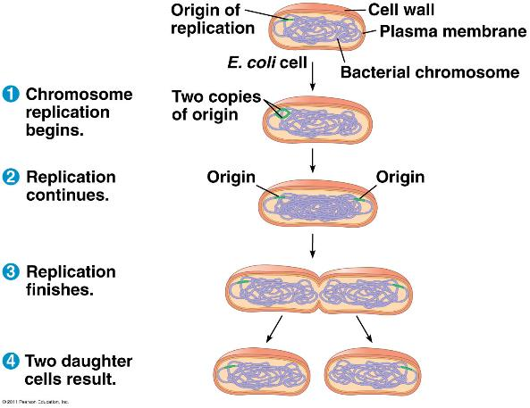
Reproduction and Genetic Transfer
- Fission – doubling of cell size and is divided in 2
- Transformation - absorption of an environmental DNA molecule.
- Transduction - transfer of a DNA segment from one bacterium to another through a virus
- Conjugation
- Transfer of genetic material from one cell to another
- Process is very simply
- Could be a plasmid or elements of a bacteria chromosome
- Above is a transfer of a plasmid
- When the bridge is made the plasmid will make a replicate and transfer
Chapter 14 – Protists
Introduction
- Larger and more complex cells than prokaryotes
Eukaryote Cell
- Presence of a cytoskeleton and a generally non-rigid cell wall: capacity to change shape and move its internal structures to facilitate mitosis.
- Formation of a nuclear envelope which is probably the result of infolding of the plasma membrane
- Far more flexibility in the membrane therefore the cells are more flexible, larger because there are organelles inside less of a constraint concerning diffusion
- Externally more complex (shapes etc.)
- Cytoskeleton within the cell that allows the animal to keep a certain shape and helps in terms of mitosis facilitates movement during mitosis
- envelope = derivative of the plasma membrane of a prokaryote, somehow infolding surrounded the chromosome to form a nuclear envelope
Endosymbiont theory
- Endosymbiont refers to a cell that lives inside another cell (host cell).
- Host cell: ancient eukaryote
- Ancestors mitochondria and plastids (chloroplasts and associated organelles) were absorbed as preys or parasites and establish a symbiotic relationship with the host.
- Proof: both organelles have their own DNA.
Evolution of Multicellularity and Sexual Reproduction
Why sexual reproduction?
- Asexual reproduction offers an advantage in numbers
- Asexual reproduction offers an advantage in terms of hereditary transmission to the next generation.
- Sexual reproduction offers an adaptive advantage (by the production of genetic variability and the elimination of recessive alleles).
- Sexual reproduction is a complex trait that probably evolved only once very early in the evolution of eukaryotes.
Diversity of Protists
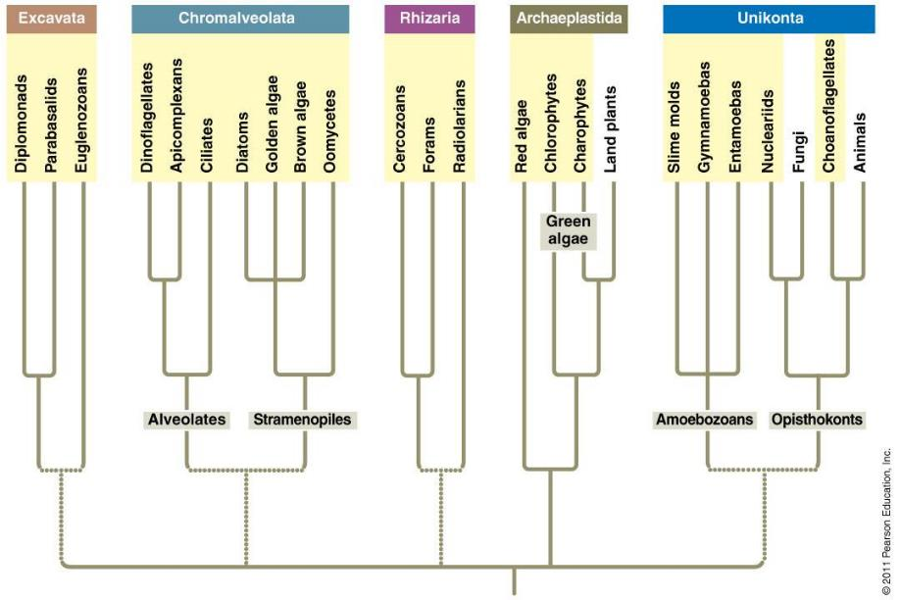
Overall
- Protists from a complex paraphyletic group.
- Protists cells contain a well-defined nucleus and several cellular organelles and a cytoskeleton.
- The serial endosymbiosis explains the origin of mitochondria and chloroplasts in eukaryotic cells.
- The evolution of multicellularity (several times) and sexual reproduction (probably only once) has occurred in this group.
- In general, asexual reproduction is the most common means of reproduction, sexual reproduction is a complementary method.
- Green algae (Charophytes) form the sister group of plants.
- The choanoflagellates contains the sister group of animals.
Chapter 15 - Cambrian Explosion
Ediacran
- Glacial periods
- First fossils: 600 Ma
- 1400+ fossils in dozen locations
- No fossils due to soft bodies no skeletal remains imprints were in the rocks or sediments and they were covered in bacterial mats and when it dried we had imprints of the fossil, however we have no physical fossils from this time
Cambrian Explosion
- 535-525 million years
- Appearance of most modern animal groups and strange fossils in a short time.
- Spectacular fauna
- Hard structure in those species and why are they there, skeleton must do something with it
- Evolution of them are in Cambrian explosion however groups may have revolutionized before Cambrian even maybe before edicambrian
- Causes:
- Diversification of skeletal structures (calcium abundance)
- Atmospheric changes (important increase of O2)
- Mass extinction Ediacaran fauna followed by an adaptive radiance.
- Complexification of the food chain
- More predators
- Arms race predator-prey relationships as a catalyzer for evolution)
Chapter 16 – Evolution of Animals
Introduction
- Fossils are weak evidence of animal as they are embryos and we’ve only assumed they belong to animals however there is no fossil to confirm
- We know animals are way older than this though
- Many groups of animals, especially the sponges, are much older than 575 Mya
- Sponges can’t leave any fossil due to its makeup
- 1.3 million catalogued animal species
What is an animal?
- Heterotrophic eukaryotes
- Sponges: (most primitive animals) suspensivores, no real tissue sequential hermaphrodites
- They have no real tissue just a series of cells, it has a flagellum towards the centre of the cell
- They can move around the animal and carry food around
Major Changes of an Animal Body
- Evolution of tissues
- Porifera (sponges); cell clusters (sometimes specialized) showing minimum cell coordination.
- Eumetazoan have distinct tissues
- Evolution of bilateral symmetry
- independent development of the various regions of the body
- facilitates mobility (useful for feeding, breeding and avoiding predators)
- Radials: diploblastic (two embryonic germ layers: ecto- and endoderm)
- Bilateral: triploblastic (three embryonic germ layers: ecto-, endo-, mesoderm)
- Evolution of a body cavity
- Digestive tract (food reserve+ efficient digestion = more time allocated to other tasks)
- Development of gonads (greater storage capacity and massive production of gametes)
- Coelomate:
- organs suspended in the mesoderm
- Mesoderm-endoderm contact allows the development of complex organs (i.e., stomach)
- Development of a vascular network for the organs (circulatory system)
- Evolution in embryogenesis
- Spiral cleavage oblique to the axis of the body
- Radial cleavage: parallel to the axis of the body
- Determinate cleavage: each cell defines a part of the embryo
- Indeterminate cleavage: each cell has the potential to produce a complete embryo.
- Mesoderm formation differs
- Mouth = blastopore = protostome
- Mouth = second opening= deuterostome
Chapter 17 – Evolution of Animals: echinoderms and chordates
Chordates and echinoderms share characteristics of deuterostomes:
- radial and indeterminate cleavage
- development of the coelom from the archenteron
- Formation of the mouth at the opposite end of blastopore.
Chordates
- there are 7-8
- Notochord replaced by vertebral column
- Pharyngeal slits are there but disappear
- The nerve chord and post anal tail remain
- We reversed our body system, all the ventral things became dorsal and vice versa, reversal of body plan, not sure why or what circumstance this occurred
- 4 common derived characteristics
- Notochord
- Dorsal, hollow nerve cord
- Pharyngeal slits or clefts
- Post-anal tail
Gnathostomes
- Derived features of gnathostomes:
- Big brain (more sensory organs; e.g.: sight, smell)
- Lateral line especially in aquatic gnathostomes)
- Mineralization of the endoskeleton
- Jaws
- All fish have these lateral lines and sometimes have more complex patterns on their head
- Detect pressure changes in water, don’t hear the same way as us but this is their version of it due to the way they detect the pressure change of something coming near them (ie. Boats)
- Mineralization starts with sharks but gets fully ossified with boney fishes and such
- Arches are found in the pharynx, will bare gills
- No jaws there will be skeletal rods with gills in them
- A few of them were modified into jaws
- Conclusion: jaws are basically gill arches that have been modified for feeding holding onto prey
- When this first occurred, it was an immediate success in turn of evolution, jaws=predators=larger meals =more complex

