Psych Midterm 1 Review:
Lecture 2: Prologue
- 4th century BCE Aristotle used observation and question to understand the body-mind relationship
- Wilhelm Wundt:
- Psychology= science of mental life
- Leipzig, Germany
- Reaction Time experiment
- 1879
- Structuralism:
- Edward Titchener:
- Mentored by Wundt
- “self-report” data
- Introspection, reporting on sensations and other elements of experience in reaction to stimuli
- Used reports to build a view on the minds STRUCTURE
- Functionalism:
- William James:
- Studied human thoughts feelings, and behaviours to figure out what function they may serve and how they may have helped our ancestors to survive
- Author of ‘Principles of Psychology’
- Mary Whiton Calkins:
- First female APA president in 1905
- Studied with James but denied PhD from Harvard
- Margaret Floy Washburn:
- First female PhD
- Second female APA president in 1921
- Wrote ‘The Animal Mind’
- Behaviourism:
- ‘scientific study of observable behaviour’
- No reference to mental processes
- Major force in psych in 1960’s
- John Watson, an B.F. Skinner both dismissed introspection
- Watson and Rayner= ‘Little Albert’ experiment- conditioned 11-month-old baby to fear white rats
- Skinner tested animal behaviour and developed the Skinner box
- Freudian Psychology:
- Sigmund Freud- focused on ways unconscious thought processes and emotional responses to childhood experiences affect later behaviour
- 2nd major force until 1960’s
- Id, Ego, Super-ego
- Humanistic Psychology:
- Study of mental processes
- Focused on ways current environments nurture or limit growth potential and importance of having need for love and acceptance satisfied
- Carl Rogers and Abraham Maslow
- Cognitive Psychology:
- Cognitive revolution
- Ways in which information is perceived, processed, and remembered
- Cognitive neuroscience ties together cognitive psychology and neuroscience, focusing on the brain activity underlying mental activity
- Modern definition: science of behaviour and mental processes
- Nature vs Nurture
- Evolutionary Psychology: focus on how humans are alike because of common biology and evolutionary history
- Behaviour Genetics: differences relate to differing genes and environments
- Cross-Culture Psychology: the ways culture shapes behaviour, but same underlying processes are universal
- Gender psychology: focuses on male’s vs females
- Evolutionary and behaviour genetics:
Nature | Nurture
Plato: character and intelligence inherited; some ideas inborn | Aristotle: content of mind comes through senses
Descartes: some ideas are intuitive | Locke: mind is blank slate
Darwin: some traits, behaviours, and instincts are part of species; natural selection (also acknowledged environmental context)

- Cross-culture and Gender:
Culture | Gender
Shapes attitude and behaviour | There are gender differences (emotional expression, dreams, depression, eating disorders, alcohol abuse, etc.)
Shared and passed on | More similar than different, no matter how we identify – we are a species
We share biology (studies show that loneliness, facial expression, an learning disorders are similar across cultures)

- Positive Psychology:
- Martin Seligman
- Explores human flourishing
- 3 main levels of analysis: biological, psychological, and social-cultural

Lecture 3: Critical Thinking
- Humans cannot rely on intuition and common sense only
- 3 phenomena: hindsight bias, judgmental overconfidence, and tendency to perceive patterns in random events
- Hindsight bias:
- Believing that after learning an outcome, we could have predicted it
- AKA, I knew it all along phenomenon
- Ex: Deepwater horizon
- Overconfidence:
- People tend to think they know more than they do
- Perceiving order in random events:
- People perceive patterns to make sense of their world
- Random sequences often do not look random
- People trust their intuition, but tuition is often flawed
- Hindsight bias, overconfidence, an patterns in random events often leads us to overestimate our intuition
- Scientific Enquiry:
- Curiosity, skepticism, and humility
- Curiosity: a passion to explore an understand the world without misleading or being mislead
- Curiosity + Skepticism: leads to ‘what do you mean?’ and ‘how do you know?’
- Humility: being aware that we are capable of error, an openness to new ideas
- Critical Thinking:
- Smart thinking
- Question assumptions, appraise the source, look for hidden values, evaluate evidence, assess conclusions
- A more careful way of forming and evaluating knowledge than simply using intuition
- Scientific Method:
- Testing ideas about the world by: setting up situations that tests our ideas, making careful ad organized observations, and analyzing whether the data fits with our ideas
- Theory, hypothesis, operational definition, replication
- A good theory: effectively organizes, leads to clear predictions, often stimulates research, may be replicated
- Research strategies in psych:
- Test hypotheses and refine theories using 3 strategies: description, correlation, and experiments
- Description: to provide a clear, accurate picture of behaviours, thoughts, and attributes of people. Case study, naturalistic observation, survey
- Case study: examines 1 person in depth, provides fruitful ideas, cannot be used to generalize
- Naturalistic Observations: records behaviour in natural environment, describes but does not explain behaviour, can be revealing
- Surveys and interviews: examine many cases in less depth, wording effect, random sampling, utilizes random sampling of population for best results
- Correlation: a measure of how closely 2 factors vary together, or how well you can predict a change in one from observing a change in the other
- Positive= 0 to +1.00
- Negative= 0 to -1.00
- Correlation does not prove causation

Lecture 4: Critical Thinking part 2
- Correlation cont.
- Illusory correlation: a correlation that is perceived as strong (close to 1) but is really weak or non-existent (close to 0)
- Regression toward the mean: tendency for extreme or unusual scores or evens to fall back (regress) toward the average
- Experimentation: concerned with isolating cause and effect. Everything else you know from science
- Double-blind procedure: neither participants nor experimenters know which group is receiving the treatment (real or placebo)
- Experiment purpose: test theoretical principles, not recreation of exact everyday life behaviours
- Resulting principles: help explain everyday behaviour, not specific findings
- Psychological science: focuses on seeking general principles that help explain many behaviours and less on particular behaviour
- Controlled artificial environments are create in lab exp. to test general theoretical principles
- Ethics: moral philosophy, established set of rules of conduct, values determine the importance of a rule
- Animal Research: medical treatments, investigate systems like ours
- Society is pretty split about whether or not it is okay to experiment on animals
- There are professional associations and funding agency guidelines for protection
- Human Research Participants: many different organizations have ethic codes
- Obtain potential participants’ informed consent before the experiment
- Protect them from harm and discomfort
- Keep info about individual participants confidential
- Fully debrief people (about the research afterward)
- Values in research:
- Affect what is studied, how it is studied, and how results are interpreted
- Can colour “facts”
- Can be influenced by popular application of psychology
- Knowledge is power (so research results can be used to manipulate people)
- The challenge is do research that addresses human problems in an ethical way
- Statistical Reasoning: accurate statistical understanding is important
- Casual estimates often misread reality and misinform
- Big, round, undocumented numbers warrant caution
- Measures of central tendency include a single score that represents a set of numbers: mode, mean, median
- Measures of variation reveal similarity or diversity in scores: range, standard deviation, normal curve (normal distribution/bell curve)
- Representative samples are better than biased samples
- Less-variable observations are more reliable than those that ae more variable
- More cases are better than fewer
- Generalizations based on a few unrepresentative cases are unreliable
- When sample averages are reliable and difference between them is relatively large, the difference has statistical significance
- Observed difference is probably not due to chance variation between the samples
- In psych research, proof beyond a reasonable doubt means that the odds f its occurrence by chance are less than 5%

Lecture 5: Biology part 1
- Everything psychological- every idea, mood, and urge- is biological
- Humans are biopsychosocial system in which biological, psychological, and social-cultural factors interact to influence behaviour
- Plato= mind located in spherical head
- Aristotle= mind found in heart
- Gall= thought that phrenology could reveal mental abilities and character traits
- Franz Gall
- Physiologist and neuroanatomist
- Localizing function to parts of the brain
- Thought the bumps on the skull reflected the shape of the brain
- Thought there were 27 “fundamental faculties”: everything from musical ability to a murder instinct- could tell by feeling the bumps on some one’s skull
- This is some localization of function (ex: language, speech, and visual processing), but there are a lot of sub systems that underlie a lot of brain function
- In the past century it was discovered that:
- Nerve cells conduct electricity and communicate through chemical messages across synapses
- Specific brain systems serve specific functions and information is integrated to construct a wide rang of experiences
- The adaptive brain is wire by experience
- Neurons:
- Cells of the nervous system
- Neuron Theory (Cajal)= neurons are the building blocks and functional units of the nervous system
- Cell Body: the cell’s life-support center
- Dendrites: receive messages from other cell’s
- Axon: passes messages away from the cell body to the other neurons, muscles, or gland
- Myelin Sheath: covers the axon of some neurons and helps speed neural impulses
- Terminal branches of axon: form junctions with other cells
- 86-100 billion neurons
- 100,000 trillion
- 70% of neurons are in the cerebellum- rest in brain and spinal cord
- Neurons last majority of your life
- Glial Cells:
- Glial=glue
- Support cells
- Lots of different locations and several different kinds
- Provide nutrients
- Form myelin
- Guide connections (structural support) between neurons
- Receive chemicals (ions and neurotransmitters) that are not in use
- Communicate with other neurons
- How they communicate:
- Neuron receives signals from other neurons, some tell it to fire, some tell it not to fire
- When the threshold is reached, the action potential starts moving. It either fires or it does not; more stimulation does nothing (all or nothing)
- The action potential travels down the axon from the cell body to the terminal branches
- The signal is transmitted to another cell but must find a way to cross a synapse
- Action Potential:
- A brief electrical charge that moves down the axon
- All or none
- Neurons can do this many times a second (1-200 times)
- Cells have a resting potential
- Energy is generated from chemicals
- Ions pass back and forth across the cell membrane
- Places where cells might get in or out are called gated channels
- Resting Potential:
- Mostly Positive ions outside, mostly negative inside
- K+ and A- inside, Na+ and Cl- outside
- Creates potential
- Action Potential Cont.:
- Rapid influx of + charged ions (Na) into the cell
- Domino effect as neighboring gates open to let Na in
- In myelinated neurons, the charge skips from node to node all the way down the axon
- Neuron stimulation causes a brief change in electrical charge. If strong enough, this produces depolarization and an action potential
- This depolarization produces another action potential a little farther down the axon
- As the action potential continues speedily down the axon, the first section has now completely recharges
- Action potential= cell receiving info from other cells
- Some info is excitatory= the sending cell is saying “I’m excited! Let everyone know they should be excited too!”
- Some info is inhibitory= “I’m not excited at all. Let everyone else know they should not be excited either.”
- If more excitatory than inhibitory, the cell can reach a threshold level= the result is an action potential
- After, there is a refractory period where the cell cannot fire again
- During this, Na+ are pumped back out
- When resting potential, I achieved, cell can fire again
- Neurotransmitters and Synapses:
- Chemicals (neurotransmitters) are release from terminal branches
- The chemicals travel across the synapse an bind to proteins on the receiving cell
- Synapse gap= 20-40 nanometers
- Not all of the neurotransmitters get use in each firing
- 1/3 things can happen to extra neurotransmitters: 1. Reuptake by sending cell, 2. Broken down by enzymes, 3. Drift away
- Neurotransmitters travel designated pathways in the brain and may influence specific behaviours and emotions
- Acetylcholine (ACh) affects muscle action, learning, and memory.
- Endorphins are natural opiates released in response to pain and exercise
- Drugs and other chemicals affect the brain chemistry at synapses
Neurotransmitter | Function | Examples of Malfunctions
Acetylcholine (ACh) | Enables muscle action, learning, and memory | With Alzheimer’s, ACh producing neurons deteriorate
Dopamine | Influences movement, learning, attention, and emotion | Oversupply liked to schizophrenia. Undersupply linked to tremors and loss of motor control in Parkinson’s
Serotonin | Affects mood, hunger, sleep, and arousal | Undersupply linked to depression. Some drugs that raise serotonin levels are used to treat depression
Norepinephrine | Helps control alertness, and arousal | Undersupply can depress mood
GABA (gamma-aminobutricacid) | A major inhibitory neurotransmitter | Undersupply linked to seizures, tremors, and insomnia
Glutamate | A major excitatory neurotransmitter; involved in memory | Oversupply can overstimulate the brain, producing migraines or seizures (which is why some people avoid MSG, monosodium glutamate in food)
- Agonist: molecule that increases a neurotransmitter’s action
- Antagonist: molecule that inhibits or blocks a neurotransmitter’s action
- Agonist rug mimics neurotransmitter, opening receptor site can increase the likelihood f action potential
- Antagonist drug blocks neurotransmitter from opening receptor site, blocking normal activity

Lecture 6: Biology part 2
- 3 basic types of neurons: Sensory, motor, and interneuron
- Sensory:
- Carries info from sensory receptors o the CNS
- Afferent
- Motor
- Carry instructions from CNS to muscles and glands
- Efferent
- Interneuron
- Processing between the sensory and motor neurons
- Many more of these than sensory and motor
- Allow for a lot of complexity
- Neurons that fire together, wire together (neural networks)
- Connections within these networks can strengthen (more connections can be made between neurons in response to experience
- A nerve= a bundle of axons that form a ‘cable’
- Nervous system has 3 division: central, peripheral, and enteric
- CNS:
- Brain and spinal cord
- Decision-making system
- PNS:
- Connection between CNS and everything else
- Sensory and motor neurons
- 2 subdivisions (somatic and autonomic)
- Enteric (ENS)
- Between the gut and the CNS
- Sometimes grouped in with PNS
- Sheet of neurons lining the entire GI tract
- Communicates with gut and sends info to CNS
- Autonomic System:
- Sympathetic and parasympathetic
- Sympathetic:
- Arouses and expends energy
- Allows voluntary movement
- Fight or flight
- Parasympathetic:
- Calms and conserves energy
- Involuntary movements
- Rest and digest
- Both systems send messages to almost all internal organs
- Lets them be balanced but prepared
- Estimates of # of neurons goes from 40 billion to 100 billion
- Brain accounts for 2% of body weight and uses 20% of energy
- Neural networks and pathways allow for reflexes: through electrochemical info systems
- The spinal cord:
- Connects PNS to brain
- Site of certain reflexes (i.e. Burning your hand)
- The endocrine system:
- Slower than nervous system
- Structures=glands
- Glands secrete hormones
- Intricate feedback system to the hypothalamus
- Hypothalamus influences the pituitary gland
- Pituitary influences other glands
- Other glands release hormones that influence the brain and therefore hypothalamus
- Excess cortisol can cause damage
- Older methods (>100 years ago)
- 1. Notice that injury somewhere was associated with a deficit
- 2. Most-mortem studies showing that a person’s deficit was associated with damage to certain area
- EEG’s were invented in 1920’s, CT’s were invented in 1970’s
- Experimental Methods (last 100 years, animals first)
- Scientists can selectively manipulate the brain (easier in animals than humans)
- Destroying tissue: the damaged area= lesion, measure behavioural effects when particular areas are destroyed
- Electrical, chemical, or magnetic stimulation: measure behavioural effects when particular areas are stimulated
- Brain Imaging Today:
- Electroencephalogram (EEG): measures electrical activity from the surface of the scalp
- Positron Emission Tomography (PET): radioactive glucose is injected an a detector tracks release of gamma rays while person does something
- Magnetic Resonance Imaging (MRI): head in magnetic field; temporary misalignment of atoms; when atoms reorient, a signal is sent
- Functional MRI (fMRI): like MRI but adds function, by recording blood flow to different areas (while the person does something)
- EEG: when someone is falling asleep, specialized EEG can show face recognition and integrity of the auditory system
- PET &fMRI: brain areas active when people are happy, sad, doing math problem, solving spatial task, etc.
- MRI: detail of brain structures- a useful medical diagnostic
- The Old Brain:
- Less complex brain in primitive vertebrates handle basic survival functions
- More complex brain in advanced mammals (including humans) contain new brain systems built on the old
- The brainstem and related areas are similar in all mammals
- The brain stem, including the medulla and pons, is an extension of the spinal cord. The thalamus is attached to its top. The reticular formation passes through both structures
- The brain stem= the oldest and innermost brain region
- Medulla= at the base of the brain stem. Controls heartbeat and breathing
- Pons= above the medulla. Helps coordinate movement (through connections to cerebellum)
- Cross-wiring= nerves from one side of the brain most linked to the body’s opposite side. A lot of crossover occurs at the brain stem
- Reticular formation: involves nerve network running through the brainstem and thalamus. Plays an important role in controlling arousal (you need it in order to be awake)
- Thalamus: the area at the top of the brainstem. Directs sensory messages to cortex and transmits replies to the cerebellum and medulla. Often called the ’sensory relay’
- The cerebellum:
- Lots of functions: aids in judgement of time, sound and texture discrimination, and emotional control
- Coordinate voluntary movement and some life-sustaining functions
- Coordinating ballistic movement
- Helps process and store info outside of awareness
- The limbic system:
- Amygdala
- Hippocampus
- Hypothalamus
- Sits between the old structures and the newer cerebral hemispheres
- Amygdala: linked to emotion
- Hypothalamus: directs several maintenance activities- homeostasis. Helps govern endocrine system via the pituitary gland. Linked to emotion and reward
- Hippocampus: linked to explicit memory. Linked to spatial navigation
- Hypothalamus an reward centers:
- Rat studies by Olds & Milner in 1950’s to 1970’s
- Stimulating electrode placed in hypothalamus
- Rats will press a lever to self stimulate/ fell reward
- They will even walk across an electrified grid to press the lever
- New Ways of using Brain Stimulation:
- Animal research: control animal’s actions in search and rescue
- Human research: we have a complex system involving dopamine, reward deficiency syndrome= can be used to treat substance abuse disorders
- Parts of the Brain and Functions:
- Corpus Callosum: axon fibers connecting the 2 cerebral hemispheres
- Thalamus: relays messages between lower brain centers and the cerebral cortex
- Hypothalamus (Limbic system): controls maintenance functions such as eating; helps govern endocrine system; linked to emotion and reward
- Pituitary: master endocrine gland
- Reticular formation (old brain): helps control arousal
- Pons (old brain): helps coordinate movement and control sleep
- Medulla (old brain): controls heart rate and breathing
- Spinal cord: pathway for neural fibers travelling to and from brain; controls simple reflexes
- Cerebellum: coordinates voluntary movement an balance and supports learning and memories of such
- Amygdala (limbic): linked to emotion
- Hippocampus (limbic): linked to conscious memory
- Cerebral Cortex: ultimate control and information-processing center
Lecture 7: Biology part 3
- The Cerebellum:
- Ball thing at back of brain
- Aids in judgement of time, sound and texture discrimination, and emotional control
- Coordinates voluntary movement
- Helps process and store info outside awareness
- Limbic System:
- Amygdala
- Hippocampus
- Hypothalamus
- Sits between old brain and newer cerebral hemispheres
- Amygdala: emotion
- Hypothalamus: homeostasis, pituitary gland control, emotion and reward
- Hippocampus: explicit memory, spatial navigation
- Amygdala experiments: kluver and bucy removed a monkey’s amygdala and made it mellow; humans with amygdala lesions show no fear of fear inducing stimuli; electrical response in cats= one area caused hissing, another caused cowering
- Hypothalamus experiments= rat crossing electrified grid for pleasure in reward
- Animal and human research
- The cerebral Cortex:
- A thin layer of interconnected neurons (grey matter)
- 2 hemispheres
- Each hemisphere has 4 lobes: frontal, parietal, occipital, temporal
- Frontal: speaking, muscle movements, planning, judgement
- Parietal: sensory input for touch and body position
- Occipital: receives info from visual fields
- Temporal: receives info from ears
- Complex functions don’t happen in one place
- Fritch and Hitzig= animals in 1870- discovered motor response on opposite sides of body
- Forester and Penfield= humans in 1950’s/1960’s= mopped motor cortex and discovered body areas requiring precise control and mouth occupied most cortical space
- Jose Delgado=humans in 1969- electrically stimulating motor cortex can cause body part movement, even when person attempts to counteract the movement
- Somatosensory Cortex:
- Processes info from sking senses and body parts for feedback on movement
- Specialized receptors receive info and pass it onto the brain
- Primary sensory functions:
- Visual cortex is at back of brain and receives input from eyes
- Auditory cortex= right above ears, receives info from ears
- Association areas are found in all lobes
- Parietal- spatial reasoning, and preparedness for grasping things
- Temporal- face recognition, object recognition
- Frontal- judgement, planning, and processing of new memories
- Phineas cage= guy with railroad spike through his brain and lived
- Brain Plasticity:
- When another area of the brain compensates for the area lost: not always possible- must have a small dedicated area that was not affected
- Neurogenesis: more rare than reorganization, small turnover of cells in the hippocampus
- Constraint-Induced therapy: After stroke, person does not use good arm- brain is forced to reorganize and person experiences recovery of function
- Hemispherectomy: removal of 1 Hemisphere in cases of life-threatening seizures in young children. Other hemisphere takes over normal function. Some motor deficit observed
- The Corpus Callosum joins the hemispheres
- The divided brain:
- Data received by either hemisphere is transmitted to the other side across the corpus collosum
- When corpus is severed, the info sharing does not take place
- Left hemisphere= quick, exact interpretations of language
- Right= inferences, modulating speech, and facilitating self-awareness
- People with split brains can see 2 things clearly at the same time
- No such thing as a left-brained or right-brained person
- Right= increases activity during perceptual tasks
- Left= increases activity during speaking or calculation tasks
- Handedness:
- 90% of people are right handed and process speech primarily in left hemisphere
- Left-handed people are more likely to: have reading disabilities, allergies, and migraines. But are more likely to be musicians, mathematicians, athletes, and artists
- World is physically organized for right-handed people

Lecture 8: Consciousness part1
- History:
- 1880’s: psych defined as description and explanation of states of consciousness
- 1st half of 20th century: direct observation of behaviour
- 1960’s consciousness nearly lost; science of behaviour
- After 1960’s: study of consciousness altered by hypnosis, drugs, and meditation; importance of cognition
- Today: guided by cognitive psych, neuroscience, and cognitive neuroscience
- Consciousness: awareness of self and environment
- Why? Assemble info from past and present- act in long term interests; anticipate what happen next- immediate survival
- 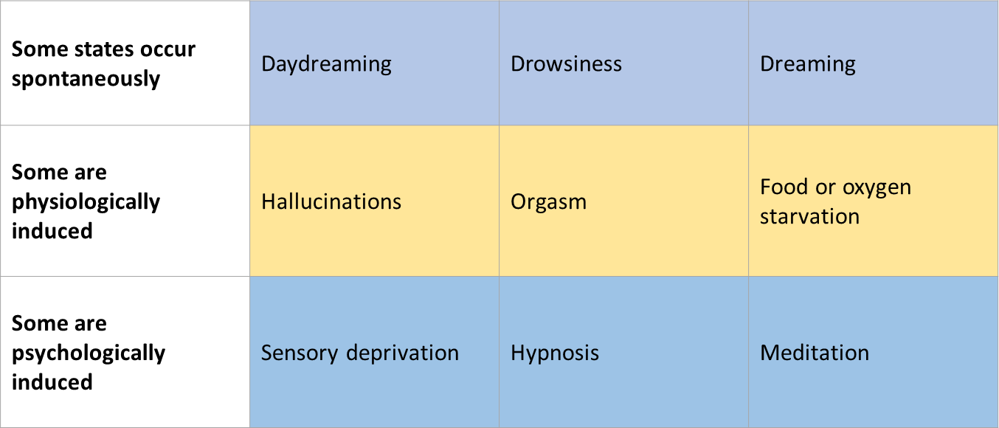

- Cognitive Neuroscientists:
- Explore and Map conscious function
- Suggest consciousness arises from synchronized brain activity
- Dual Processing:
- Info is often simultaneously processed on separate conscious (explicit), and unconscious (implicit) tracks
- Perceptions, memory, attitudes, and other cognitions are affected
- Blindsight Awareness: condition in which a person can respond to a visual stimulus without consciously experiencing it
- Weiskrantz led blind-sight patient down cluttered hallway, bind person moved around items without being told where they were
- Consciousness and Selective Attention:
- Selective attention: focusing conscious awareness on a particular stimulus; cocktail party effect- hearing your name in a crowd
- Parallel processing: processing many aspects of a problem simultaneously; the brain’s natural mode of info processing for many functions
- Inattentional blindness: failing to see visible objects when attention is directed elsewhere
- Multitasking distracts brains resources from completing 1 task well. Ie. Texting while driving
- Sleep: periodic, natural LOC- as distinct from unconsciousness resulting from a coma, general anesthesia, or hibernation
- Biological rhythms:
- 24-hour biological clock
- 90-minute sleep cycle for younger adults
- Circadian rhythm:
- Internal biological clock of 24-hour cycle of ay and night
- As morning approaches, body temp rises, peaks during day, dips in early afternoon, and begins to drop in evening
- Altered by age and experience
- Measuring sleep activity:
- Sleep researches measure brain-wave activity, eye movements, and muscle tension by electrodes that pick up weak electrical signals from the brain, eyes, and facial muscles
- Beta waves of an alert, waking state and the regular alpha waves of an awake, relaxed state differ from the slower, larger delta waves of deep NREM-3 sleep
- Although the rapid REM sleep waves resemble the near-waking NREM-1 sleep waves, the boy is more aroused during REM sleep than during NREM sleep
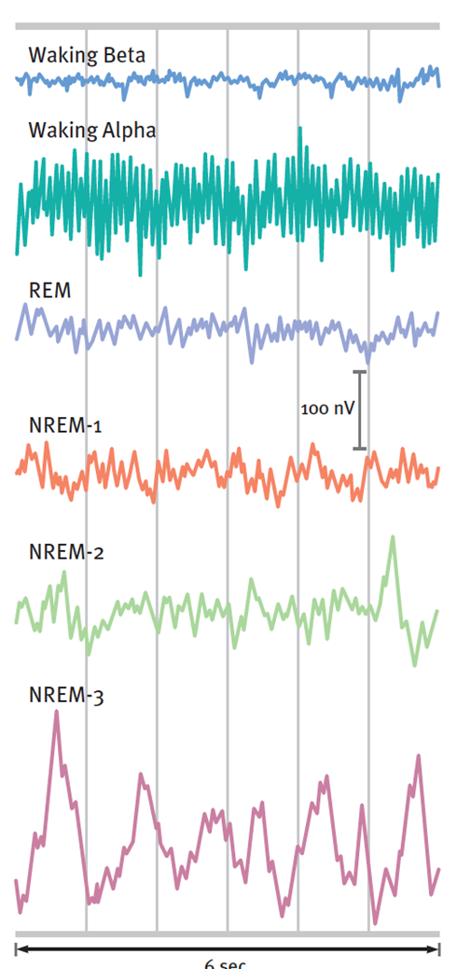
- REM Sleep:
- Rapid eye movement
- Sleep stage during vivid dreams commonly occur
- REM bound: tendency for REM sleep to increase following REM sleep deprivation
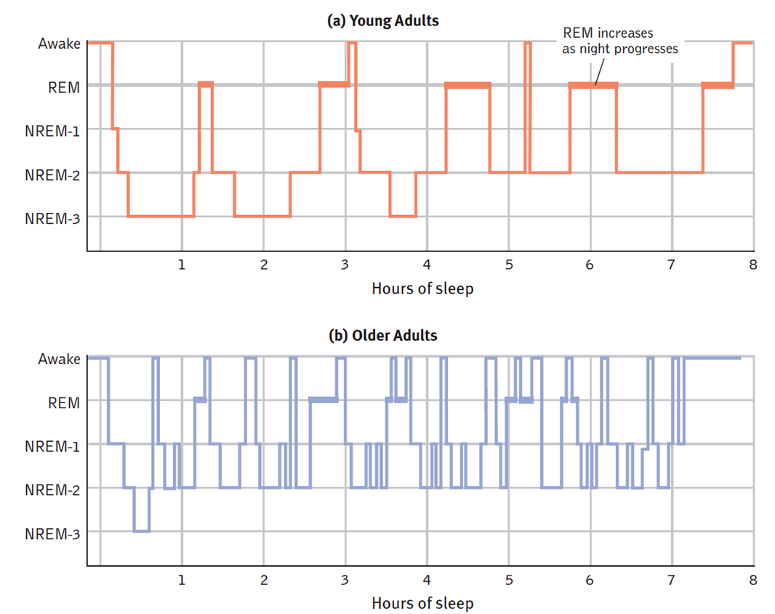
- Alpha Waves: relatively slow brain waves of a relaxed, awake state
- Hallucinations: false sensory experiences, such as seeing something in the absence of a external visual stimulus (NREM-1)
- Delta Waves: large, slow brain waves associated with deep sleep (NREM-3) – deep sleep
- Sleep patterns are genetically and culturally influenced
- Morning light triggers light-sensitive proteins that trigger suprachiasmatic nucleus (SCN) to decrease melatonin n the morning and increase it at night
- Social jet lag= sleep routines being disrupted on the weekends
- Why do we sleep?
- Protective role in human evolution
- Helps restore and repair damaged neurons
- REM & NREM-2 sleep help strengthen neural connections that build lasting memories
- Promotes creative problem solving the next day
- During deep sleep, the pituitary gland secretes a growth hormone necessary for muscle development
Lecture 9: Sleep and Dreams
- Sleep Deprivation:
- Fatigue and irritability
- Impairs concentration, productivity, and memory consolidation
- Can lead to depression, obesity, joint pain, a suppressed immune system, and slowed performance with a greater vulnerability to accidents
- Many of the risks are many, varied, and subtle
- Sleep deprivation is more common than we thing (trying to balance sleep, work, family life is difficult)
- Affects students a lot
- Poor sleep associated with conflict in personal relationships
- Improve sleep by adding a few minutes each night (15 or so minutes)
- 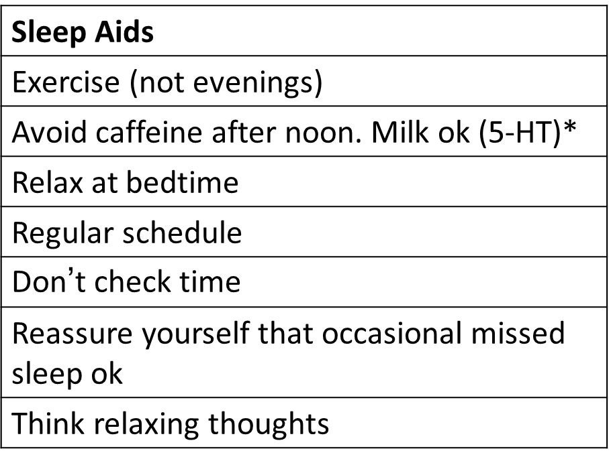
- Alcohol and sleeping pills can disrupt REM sleep, can cause more problems like tolerance
- Major sleep disorders:
- Insomnia: recurring problems in falling or staying asleep
- Narcolepsy: sudden uncontrollable sleep attacks, sometimes lapsing directly into REM sleep
- Sleep apnea: stopping of breathing while asleep; associated with obesity, especially in men
- Night terrors: high arousal and appearance of being terrified; common in young children (in NREM-3 sleep, really difficult to arouse them)
- Sleepwalking and Sleeptalking
- Dreams:
- We usually dream od ordinary events and everyday experiences, most involving some anxiety or misfortune
- Dreams incorporating previous days’ experiences: most common
- Daydreams: familiar details of our life
- REM dreams: vivid, emotional, bizarre
- Dreams with negative event or emotion: 8/10 dreams
- Dreams with sexual imagery: 1/10 in young men, 1/30 in young women
- Genitals aroused during REM sleep, even when dream content is not sexual
- Brainstem blocks messages from motor cortex: when waking person can feel sleep paralysis; REM is called paradoxical sleep bc brain is active but body is relaxed
- 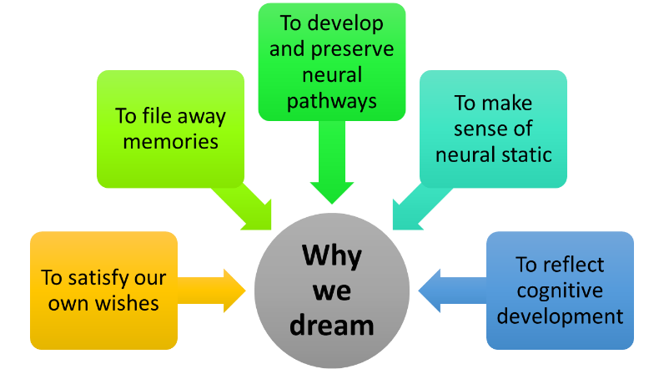
- 1. Freud 2. Information processing 3. Physiological function 4. Neural activation 5. Cognitive development


