CHM 1311: Midterm #1

Chapter 1: Keys to the Study of Chemistry
Properties of Matter:
- Matter: occupies space and displays mass and inertia
- Composition: relative proportions of the components of a sample of matter.
- Physical property: a property that can be measured or observed without a change in the composition of the matter
- Chemical property: a property that results in observing a change in chemical composition
- Extensive property: depends on the quantity of the matter present
- Intensive property: does NOT depend the quantity of the matter present

Energy and Chemistry:
- Energy: ability to do work
- Kinetic energy: energy possessed by an object in motion (as a result of movement)
- Potential energy: energy an object has because of its position relative to another object.

Measuring Matter (Units)
- Mass: kilogram (kg)
- Length: meters (m)
- Time: seconds (s)
- Temperature: kelvin (K)
- Electrical Current: ampere (A)
- Amount of Substance: mole (mol)
- Luminous Intensity: candela (cd)

SI Prefixes:
- Giga: Billion: 1x10⁹
- Mega: Million: 1x10⁶
- Kilo Thousand: 1x10³
- Centi: Hundredth: 1x10⁻²
- Milli: Thousandth: 1x10⁻³
- Micro: Millionth: 1x10⁻⁶
- Nano: Billionth: 1x10⁻⁹
- Pico: Trilionth: 1x10⁻¹²

Dimensional Analysis:
- Use the conversion factors to convert a quantity from one unit to another.
- Cancel out units on the top and bottom in order to get desired unit at the end of calculation
- Stoichiometry: use given measurements and units to solve for an unknown (conversion factors and fractions)

Length: Conversion factors
- 1cm = 10mm
- 100cm= 1m
- 1nm = 1x10⁻⁹

Volume:
- The size of a cube. Often use the liter (L) for measuring volumes.
- 1000mL = 1L
- 1mL=1cm³
- 1L=1000cm³
- 1000L = 1m³

Mass:
- Mass: Measures the quantity of matter in an object
- Weight: measures the force of gravity acting on an object
- Kilogram (kg) is the official SI (International System) unit for mass, but we often use grams (g). 1000g = 1kg

Temperature:
- Kelvin (K) is the SI unit, absolute zero temperature is -273.15 °C or 0K
- Water’s freezing point is 0°C or 273.15K
- Water’s boiling point is 100°C or 373K
- To convert between Kelvin and Celsius, use K=C+273

Scientific measurements:
- Scientific Notation: Nx10^{n}
- Move decimal left or right depending on # and # of zeros. Small #s have (-) exponent, large #s have (+) exponents.
- Significant figures: digits considered significant to the calculation or measurement of the quantity.

Rules for Significant Figures:
- All non-zero numbers are significant
- Zeros between two non-zero numbers are significant
- Zeros to the left of a significant figure are not significant
- If the number is greater than 1, zeros to the right of the decimal are significant
- Whole numbers have an infinite number of significant figures.
- When adding or subtracting, the answer must have the same number of sig. figs. after the decimal as the element of calculation with the least number of sig. figs. after the decimal.
- When multiplying or dividing, the answer must have the same number of sig. figs. as the element of calculation with the least number of sig. figs.
- For logarithms, the answer must have the same number of sig. figs. as the log element (the number in brackets). Remember to use log rules to separate log element.

Chapter 2: The Components of Matter
Elements and Compounds
- Element: can’t decompose into a simpler substance through chemical process; unit of atom.
- Compound: substance made from atoms of 2 or more elements bonded chemically. Can only decompose into elements through chemical processes.

Pure Substances and Mixtures
- Pure substance: has a fixed and uniform composition and distinct properties. Ex. H₂O
- Mixture: combination of two or more pure substances, varying in composition and properties. Homogeneous: uniform appearance. Heterogeneous: visible difference in substances.
- Matter can either be a substance or a mixture. If a substance, either element or a compound. If a mixture, either homogeneous or heterogeneous.

Early Chemical discoveries
- La Voisier (1743-1794): conservation of mass, a chemical equation must be balanced for mass.
- Dalton (1766-1844): atomic theory, equation must have same number of atoms (of the same kind) on both sides.

Law of Conservation of Mass
- The total mass during chemical processes must remain constant

Law of Definite Composition
- All samples of a given compound have the same composition.

Law of Multiple Proportions
- Combinations of elements are in ratios of small whole numbers
Development of Dalton’s Theory
- Daltons work helped to explain several empirical observations such as…
- The law of constant composition, The law of multiple properties, The law of conservation of mass

Dalton’s Atomic Theory:
- Matter is composed of small atoms
- Atoms of given elements are identical, atoms differ for different elements
- Atoms of one element cannot be transformed into atoms for another element
- Atoms of different elements combine in simple, whole number ratios to form compounds.

Development of Atomic Theory
- The concept of the indivisible atom proposed by Dalton inspired other scientists:
- Led to the discovery of subatomic particles
- JJ Thompson: electron. Millikan: Z of the electron. Rutherford: atomic nucleus.

Atomic Structure: the electron
- JJ Thompson (1889-1903). Discovered the existence of subatomic particles with a negative charge.
- Demonstrated it with a cathode ray tube.
- R. Millikan (1909): established the charge on a single electron is 1.60x10⁻¹⁹C.
- Used Thompson’s Z/m ratio, electron mass is 9.09x10⁻²⁸g

Atomic Structure
- E. Rutherford: thin foil of gold bombarded with alpha particles.

The modern view of Atomic Structure
- Rutherford and Chadwick discovered that the nucleus of an atom contains protons, & neutrons.
- Nuclear radius is 20,000 times smaller than atomic radius

Atomic Structure
- Mass of an atom: due to the nucleus (protons and neutrons)
- Volume of an atom: due to the electron orbits

Isotopes, Atomic Numbers and Mass numbers
- Atomic number (Z): # of protons
- Atomic mass (A): # of protons & neutrons
- Each element has a different atomic number (# protons)
- Isotopes: have the same Z, different A due to a change in the number of neurons.

Isotopes
- Have the same number of protons, but different # of neutrons.
- Have the same chemistry because # of neutrons doesn’t really effect the reaction.
- Atomic masses are used to identify different isotopes:

Atomic Masses
- Standard atomic mass is pure carbon-12. Mass = 12 amu.
- Masses of all other elements measured relative to ¹²C atom.
- Conversion factor: 1g = 6.022 x 10²³ u

Average Atomic Masses
- In nature, the elements exist as a mixture of isotopes. Must account for relative properties of each isotope
- Atomic mass = weighted average of respective atomic masses of natural isotopes of elements.
- AAM=M₁f₁ + M₂f₂ +M₃f₃… where f= fraction representing natural abundance of isotope, M= mass number of isotope.
- Note: ensure that f is a decimal value between 0 and 1 (because 1 represents 100%)

The Periodic Table
- Elements are grouped by similar chemical and physical properties
- Horizontal = periods, Vertical = groups
- 3 categories: metals (good conductors), non-metals (bad conductors) and metalloids/semi-metals.

Naming Compounds
- Naming only inorganic compounds for CHM1311

Introduction to bonding
- Electrons form chemical bonds between atoms.
- Covalent bonding: both are non-metals, electrons are shared.
- Ionic bonding: metal and non-metal, electrons are transferred.

Covalent Compounds
- Atoms bond covalently; form individual discrete assemblies: “molecules”
- Molecule: 2 or more atoms join chemically. Compound: a molecule containing 2 or more elements.

Naming binary covalent compounds
- 2 non-metals. Name the lower group # element first, then add the suffix “–ide”
- Greek prefixes used to indicate the number of each element in a compound.
- Greek prefixes: mono, di, tri, tetra, penta, hexa, octo, nono, deca.

Ionic Compounds
- Metals and nonmetals.
- Metals lose electrons to make positive cations, Non-metals gain electrons to make negative anions.

Predicting Ions
- Atoms want to lose/gain electrons to form ions with the same number form elecrons as that of the nearest noble gas (extreme right of the periodic table).
- Stable octet is goal.

Ionic compounds
- No distinct molecules. Ions combine to form an ionic lattice.
- Ex. NaCl salt is an ionic compound resulting from the bonding of Na⁺ and Cl⁻

Naming binary ionic compounds
- Binary ionic compound nomenclature
- Name cation, avoid prefixes.
- If necessary, the oxidation state of the cation is added in roman numerals.

Polyatomic ions
- Polyatomic ions stay together as one charged unit.

Naming Ionic Compounds
- Hydrates: ionic compound containing a fixed number of molecules of H₂O water.
- Just name the ionic compound, then use prefixes to name the number of waters, and add suffix “hydrate”

Oxoanions
- Polyatomic ions of the general formula XO_{n}^{m-}
- The suffixes “ite” and “ate” and the prefixes “hypo” and “per” are used to indicate the state of the nonmetal atom.
- Based on number of oxygen atoms: 1. Hypo-ite, 2. ite, 3. ate, 4. per-ate.

Naming acids
- Bronstead-Lowry definition of an acid is a proton donor
- Binary acids (hydroacids): compound with formula H_{n}X. Ionizes in water.
- Prefix “hydro”, suffix “ic”. Ex. Hydrosulfuric acid is H₂S

Naming oxoacids
- Oxoacids: compounds with formula H_{m}XO_{n.} Combination of an oxoanion and H⁺ ions
- Ionizes in water. Names based on the original oxoanion.
- “ate” becomes “ic”. “ite” becomes “ous”

Masses from Chemical Formulae
- Covalent compounds: molecular mass is sum of atomic mass of each atom in the molecule (u)
- Ionic compounds: formula mass is sum of each atom in the formula unit (u)
- Use stoichiometry/dimensional analysis to find atomic mass or formula mass of each molecule or formula unit.

Molecular Mass vs Exact Mass
- Molecular mass: use naturally occurring mixture of isotopes.
- Exact mass: use the most abundant isotopes.

Chapter 3: Stoichiometry and Chemical Equations
Avagadro’s number:
- The mole: an amount of substance that contains the same number of elementary entities as there are carbon 12 atoms in exactly 12 g of carbon-12.
- N_{A}= 6.02x10²³ mol⁻¹

Molar mass
- Molar mass (M) is mass of one mole of a substance.
- Numerical value of the atomic mass and the molar mass of an element are identical, but they have different units.
- Atomic mass is amu or u. Molar mass is g/mol.

Molecular Mass from atomic masses (on periodic table)
- Molecular mass is sum of atomic mass of each atom in the molecule (u)

Molar mass vs. Molecular Mass
- Molar mass: mass in grams of 1 mole of the molecule.

Percent composition
- Number part of a component in 100 parts of the whole. Can be different units.
- Must be defined by a unit. Ex. “by volume” is (L). “by mass” is (g). “by abundance” is percent (%)
- When expressed as a conversion factor, numerator and denominator must have the same units.

Chemical Formulas
- Empirical formula: simplest whole number ratio of elements
- Molecular formula: exact number of atoms of each element
- Structural formula: shows relative placement and connectivity of atoms.

Determination of Empirical Formula: Combustion Analysis
- Usually get these by performing experiments, burning things, combustion analysis
- Create combustion oxides of elements.
- If compound contains O₂, then find quantity using the difference

Combustion Data:
- The data obtained from combustion analysis of a sample. Elements present in relative proportions = empirical formula
- Combustion: X + O₂ CO₂ + H₂O
- In order to find the empirical formula, first find the moles of all components, then divide the co-efficient (moles) by the smallest value.
- MFmass = EFmass * n. The molecular formula mass is the empirical formula mass multiplied by some integer value.

Chemical Equations
- Depict the kind of reactions and products and their relative amounts in a reaction
- Physical state of the reactants and products may be indicated (s) (l) (g). If reaction involved change in state, ALWAYS include phases.
- For dissolution of compound in water, H₂O may be written above the equation arrow.
- Law of Conservation of matter: equations must always be balanced.
- Must have same number of atoms of the same kind on both sides.

Balancing Equations
- Never add in random atoms. Never change a formula for the purpose of balancing an equation.

Stoichiometry
- Stoichiometry: the study of quantitative aspects of chemical reactions.
- If quantity of reactant is known, it is possible to calculate quantity of product that will be formed
- To simplify, use mole method. Use units of moles instead of (g) or (mm)

Using Stoichiometry
- First, identify all the reactants and products, balance the chemical equation and follow the mole method.
- Start with given, then use stoichiometric ratios and conversion factors to convert to units for unknown values.
- Can be used with other conversion factors such as density (g/cm³), concentration (mol/L) and percent composition.

Reactions involving a limiting reactant
- In a given reaction, there is not enough of one reactant to use up the other reactant completely.
- The reactant in short supply limits the amount of product that can be made
- Stoichiometric co-efficient are used to determine the limiting reactant.

Reaction Yield
- Theoretical yield is amount of product expected to be made if the reactants react to completion
- Actual yield is always smaller than this value; it’s what was actually made during an experiment.
- This is because inverse reaction occurs (equillibrium), other side-products are products, difficult to collect all products.
- To find percent yield, (actual/theoretical) x 100%.

Chemical Reactions in a solution
- Solution: solute dissolved in solvent to form a homogeneous mixture
- Solute: present in small amounts. Solvent: present in large amounts. When the solvent is water, (aq) solution.

Concentrations of Solutions
- Molarity = moles of solute/volume of solution in L. (mol/L) or (M) capital M.
- If molarity is known, and liters of solution is known, you can calculate the moles and mass of solute using stoichiometry. C= n/V. Concentration is moles over volume.

Other forms of Concentration
- Parts per million: (ppm). 1 part of solute per 10⁶ parts of solution.
- Molality: (m) lower case m. moles of solute per 1kg of solvent (NOT SOLUTION)
- Mole fraction: (X) moles of whatever reactant per 1 mol of solution

Water as a solvent
- Water is a polar molecule. Arranges itself around ions in solution.
- Water doesn’t ionize; other types of bonding (hydrogen bonding, dipole-dipole)
- Polyatomic ions ex. Ammonium nitrate will break into its constituent ions (NH⁴⁺ and NO³⁻⁾ in water

Solutions and Stoichiometry
- Molar ratio affects concentration of solution.

Concentrations of Solutions
- Dilution: adding extra solvent does not change the amount of dissolved solute, therefore. C1V1=C2V2
- Cconcentrated*Vconcentrated = moles = Cdilute*Vdilute (note that CV is the number of moles! n)

Preparing Solutions by Dilution
- Small fraction of diluted solution “aliquot”. Number of moles doesn’t change, it’s just more

Homeopathy = dilutions
- Homeopathy: discovery of vaccines.
- Exposed to small amount of disease, se by the next time one is exposed, body is ready and immunity is built up
- “the dose makes the poison” idea.

Aqueous ionic reactions
- The “driving force” is the formation of a solid or gas. Ex. AgNO₃ and NaI form a white precipitate.

Writing Aqueous Ionic Reactions
- Molecular Equation: What solutions were being mixed and the end results. Species written as intact compounds.
- Ionic Equation: More realistic, represents all species in their ionic forms. There are spectator ions: ions that exist in the same form, on both sides of the chemical equation. Ion is unchanged on both sides and doesn’t affect reaction.
- Net Ionic Equation: This equation drops all the spectator ions (eliminated on both sides), only includes ions participating in reaction.
- Note: solids don’t break up into ions; they stay as solid. Only (aq) break.

Redox Reactions
- Oxidation-reduction reaction involves the transfer of electrons
- Every redox reaction contains a reducing agent and an oxidizing agent.
- Reducing agent loses electrons, oxidizing agent gains electrons (OILRIG)
- If something has been oxidized, then that means that something else must have been reduced.

Assigning Oxidation States (on data sheet)
- Element=0. Ion=charge number. Sum of oxidation states must equal charge number of entire species. If neutral, 0.
- Remember rule: 12HFOX.
- Group 1=1. Group 2=2. Hydrogen= +/- 1 (depending on what it’s bonded to). Fluorine =-1. Oxygen =-2 (except in peroxides H₂O₂ where it’s -1) Halogens=-1.

Tips for Redox Reactions
- If 2 rules contradict, follow the rule that appears higher on list
- Sum of oxidation state of all atoms must equal charge of ion or molecule
- For multi-atom species, label easy ox. State, then solve for the unknown atoms (x)

Oxidation-Reduction Reactions
- Oxidizing Agent: does the oxidizing, and it gets reduced itself.
- Reducing Agent: does the reducing, and it gets oxidized itself.

Redox Reactions
- Whatever species gains an Oxygen or increases in oxidation number has been oxidized.
- Whatever species loses an Oxygen or decreases in oxidation number has been reduced.

Half Reactions
- A redox reaction is represented by 2 half reactions. Both include only the species being oxidized or reduced.
- Oxidation half reaction: electrons were lost, so they will be on the product side.
- Reduction half reaction: electrons were gained, so they will be on the reactant side.
- Overall reaction is sum of 2 half reactions. Balanced, electrons even and cancelled out.
- Balancing Redox reactions depends on whether it’s in an acidic or basic medium

Balancing Redox Reactions (Half Equation Method) in acidic solution
- (1) write net ionic equations (half reactions) for both oxidation and reduction.
- (2) balance all elements except for O and H
- (3) balance oxygens by adding water H₂O
- (4) balance hydrogens by adding H⁺
- (5) balance charges (not ox states!!) by adding electrons. For oxidation reaction, electrons go on right side, for reduction, electrons go on left. Add total charges on each side (consider molar ratios) then see how much e⁻ is needed on either side to make charge equal.
- (6) multiply the half reactions by the lowest common denominator to equalize electrons added in each reaction
- (7) cancel out electrons, and add the 2 half reactions, then simplify (ex cross out waters on either side).

In basic solution
- Repeat steps 1-4.
- Between steps (4) and (5), for every H+ added, add OH⁻ to BOTH sides of the equations.
- Combine OH- and H+ on each side in order to make waters.

Chapter 4: Gases and the Kinetic Molecular Theory

The 3 major states of Matter
- Three major states of matter (solid, liquid, gas)

Gases and the Periodic Table
- 11 elements exist naturally as gases (25C and 1atm)
- Diatomic gasses are HOFBrINCl
- Monatomic gasses are He, Ne, Ar, Kr, Xe, Rn
- Oxygen has 2 forms, O₂ and O₃

Gas or Vapor
- Gas: substance which is normally gaseous under regular temperature and pressure conditions
- Vapor: gaseous form of a substance which is usually a liquid under regular temperature and pressure conditions.

The Concept of Pressure
- P (Pa) = force/area
- Pressure exerted by a gas is measured using a barometer
- Hg (mercury) rises in tube until the force of Hg (down) balances the force of the atmosphere (pushing up)

Atmospheric Pressure
- Atmospheric pressure is pressure exerted by the column of air situated above a surface.
- Don’t feel this pressure because we’re physiologically adapted to it.

Manometers
- Used to measure the pressure of a gas.
- Closed end: pressure of a gas = Δh (difference in mercury levels on 2 sides)

- Open end: pressure of gas = Δh. but must consider atmospheric pressure!
- If Pgas is less than Patm, (Pgas = Patm- Δh)
- If Pgas is greater than Patm, (Pgas= Patm + Δh)

Common Pressure Units
- Atm, mmHg, Torr, Pa, kPa, bar, mbar

Ideal Gas Law
- PV=nRT. Brings together gas properties,
- Can be derived from either experiment or theory

Boyle’s Law
- Volume and pressure of an ideal gas are INVERSELY proportionate.
- As volume increases, pressure decreases; as volume decreases, pressure increases. Conditions: temperature must remain constant.
- At a constant T; P₁V₁=P₂V₂=constant (k)

Charles’s Law
- Temperature and Volume are directly proportional. Gases tend to expand when they’re heated.
- Temperature must be in Kelvin (K)
- V₁/T₁ =V₂/T₂

Avagadro’s Hypothesis
- Equal volumes of gases at the same temperature and pressure have the same number of molecules.
- As volume increases, the number of moles of gas also increases.

Gas Law Constant
- Combining Boyle’s Law, Charles’ Law, and Avagadro’s hypothesis gives ideal gas law.
- Gas constant is R. Listed in data sheet.

Ideal Gas Law
- Ideal gas: P, V, and T must obey ideal gas law. Assumptions:
- (1) No attraction or repulsion between molecules of an ideal gas. (random motion)
- (2) Volume occupied by gas molecules by themselves is negligibly small with respect to container.
- Works best at high temperatures and low pressures.

Standard Temperature and Pressure (STP)
- STP: reference point for normal temperature and pressure conditions.
- P=1bar, T=0C=273K
- 1 mol gas = 22.7L (molar volume)

Another form of PV=nRT
- useful to measure changes in P, V, and T.
- P₁V₁/n₁T₁ = P₂V2/n₂T₂

Mixtures of Gases and Dalton’s Law of Partial Pressures
- Ptotal in a gas mixture is P_{A} + P_{B} etc.
- Dalton’s Law: total P is the sum of the partial pressures.

Dalton’s Law of Partial Pressures
- First find the partial pressure of each gas in the mixture using PV=nRT, then add these pressures together to get the total pressure.

Partial Pneumatic Trough
- Look for the words “collected over water”, means you must take into consideration the partial pressure of water vapor (H₂O)
- Therefore, Ptotal would be Pgas + PH₂O at a certain temperature.

Dalton’s Law of Partial Pressures
- The partial pressure of a gas A, (P_{A}) in a gaseous mixture is P_{A}=n_{A}RT/V
- The law of partial pressure says that the total pressure of the mixture depends on the total number of moles.
- So P_{T}=n_{T}RT/V

Molar Fractions
- The molar fraction of gas A in a mixture, X_{A} is the number of moles of that gas, over the total number of moles in the mixture
- Note: molar fraction is a decimal.
- Therefore, P_{A}=X_{A}P_{T}

Kinetic Molar Theory (KMT)
- the ideal gas law was derived empirically- not understood why PV=nRT
- Maxwell and Boltzmann tried to explain physical properties of gases using movement of individual gas molecules
- In ideal gas, there are no attractions or repulsions between gas molecules; energy of gas must entirely come from kinetic energy in individual gas molecules
- Kinetic energy of molecule depends on mass and velocity
- E_{k}=1/2mv²

Assumptions of the Model
- (1) the volume occupied by molecules is negligible
- (2) gaseous molecules are in constant, random, straight-line motion in all directions.
- (3) no attractive or repulsive forces between molecules; all collisions are perfectly elastic.

Kinetic energy of gas molecules
- Average kinetic energy of the molecules of a gas: E_{k}=1/2mu²
- Where u² is the mean-square speed;
- u²= u₁² + u₂² + u₃²

So, here’s the point
- (per molecule) Ek = 3/2 * (R/N_{A}) *T at a constant mass; increase in T, increase in Ek, decrease in u
- (per mole) Ek=1/2mu² at a constant temperature, increase in m, decrease in u. (heavier particles are slower)
- note: N_{A} is Avagadro’s number

Effects of Temperature
- When the same gas is measured at changing temperatures, when m is constant.
- As temperature increases, Ek increases and so does speed.

Effects of Mass
- T is constant here, mass is changing.
- Lighter gases are faster than heavier gases.

Root-mean-square speed u_{rms}
- The root-mean-square-speed or u_{rms} increases when T increases, or MM decreases. (Formula is on data sheet)
- As temperature increases, gases move faster. As gases get heavier, gases move slower.
- note: units are m/s

Gas diffusion and effusion
- diffusion: the gradual mixing of molecules of different gases
- effusion: movement of molecules through a small hole into an empty container.

Gas effusion
- Graham’s Law governs effusion of gas molecules.
- The rate of diffusion and effusion are dependent on molecular velocity (root-mean-squared-speed)
- Rate of effusion is inversely proportional to species molar mass. (higher molar mass, lower rate of effusion)
- note: equation is on data sheet. Final is B/A not A/B.

Deviations from the Ideal Gas Law
- real gases don’t always obey the gas laws because the laws are made for “ideal” gases
- The volume of the molecules is not zero.
- There are intermolecular forces between the gas molecules.
- Ideal gas laws begin to break down at low temperatures and high pressure.
- We account for the volume of molecules and intermolecular forces with Van Der Waal’s equation (on data sheet).
- For real gases, you use vanderwaal’s equation to make corrections for intermolecular forces, and volume.

Chapter 5: Thermochemistry

Types of energy
- Energy: the capacity to do work, or produce heat.
- Kinetic, potential, chemical etc. Bodily functions require energy in the form of ATP

Units of energy
- 1J = 1 (kg*m²) /s²
- Sometimes use the calorie instead of the joule. 1calorie = 4.184J (remember number is specific heat capacity of water)
- A nutritional Calorie (capital C).
- 1Cal = 1000cal = 1kcal.

Some Terminology in Thermochemistry
- System: part of the universe under observation. What is being studied (i.e. in a reaction)
- Surrounding: everything else in the universe.

More Terminology…
- Internal energy U (or E): the sum of all microscopic energies of a thermodynamic system:
- ΔU = U₂-U₁

Energy Transfer (q)
- Heat (q): is a transfer of thermal energy from a hot object to a cold object
- during this transfer, the temperature or the phase of the system (or both!) may change.
- q is (+) if system absorbs heat. (endothermic)
- q is (-) if system releases heat. (exothermic)

Transfer of Energy
- Work (W): a force acting on a given distance.
- Chemical reactions: changes in volume (gas expansion/contraction)
- If the surroundings do work on the system, it’s a contraction: W is (+)
- If system does work on the surroundings, it’s an expansion, W is (-)

Work (W)
- chemical reactions can also carry out work;
- (1) electrochemical work by redox chemistry
- (2) PV work by expansion/contraction of a gas.
- Wsystem = -PΔV

Transfer of Energy
- Take the point of view of the system!
- doing work: internal energy decreases, with expansion.
- absorbing energy, internal energy increases with contraction

The first law of thermodynamics
- Energy is neither created nor destroyed, only transferred.
- A system contains only internal energy.
- The transfer of heat or work are only observed during a change in the system ΔU
- ΔU_{universe} = ΔU_{system} + ΔU_{surroundings} = 0 (no change in internal energy)
- ΔU_{system} = - ΔU_{surroundings} : whatever comes out of system must be absorbed by surroundings.
- ΔU = q + W: energy change = heat transferred + work done on/by the system.

State functions
- State function: property of system that is determined by state of the system; independent of how the system go to that state.
- Independent of pathway; getting from point A to point B; doesn’t matter how you got there.
- ΔU is a state function

State vs. path functions, an example.
- different pathways; same starting point and ending point.

The First Law of Thermodynamics

 | (+) q | (-) q
(+) W | Endothermic contraction  ΔU is (+) | Exothermic contraction  ΔU depends on values
(-) W | Endothermic expansion  ΔU depends on values | Exothermic expansion  ΔU is (-)

Work (W) and Heat (q)
- Work is not a state function: quantity of work depends on path taken to get to the final state
- q is not a state function.
- U is a state function.

A new Function: Enthalpy (ΔH)
- majority of chemical reactions and processes are carried out under constant pressure conditions.
- ΔU = q_{p} – PΔV
- enthalpy, H: amount of heat transferred UNDER CONSTANT PRESSURE CONDITIONS.
- ΔH = q_{p}

Enthalpy is a State function
- qsystem (-): heat is leaving the system, exothermic
- qsystem (+): heat is absorbed by system, endothermic

Comparing ΔU and ΔH
- (1) Reactions with no gases: ΔV is very close to zero. very little change in volume. No work, only heat.
- ΔU is very close to ΔH

- (2) Reactions with gases: using the ideal gas law, P & T are constant (expansion or contraction of gas with constants). There is work done here because there is gas.
- PΔV = Δn_{gas} RT (Δn is moles of products – moles of reactants).

- (2a) Reactions where Δngas is =0. no expansion or contraction, ΔV is exactly = to 0. No change in volume, so all heat (q) and no work (W).
- ΔU = ΔH. change in internal energy is only due to change in heat.

- (2b) Reactions where Δngas is not = 0. if moles of gas is changing, some heat has been absorbed or released, and some work has been done.
- ΔU=ΔH – Δngas RT. change in internal energy is due to both heat and work.

Energy diagrams
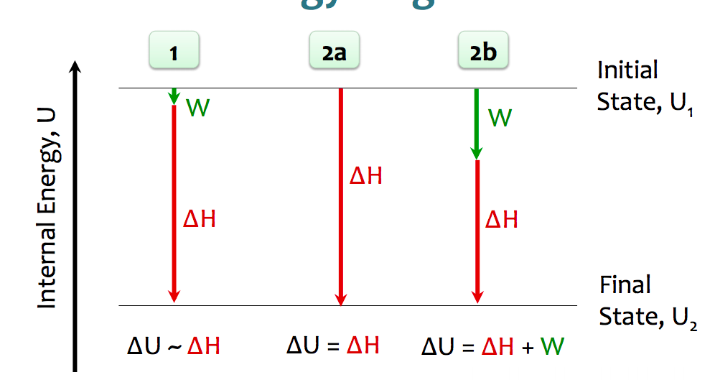

- (1) no gases, ΔV is very small, W is very small. Most of the ΔU is coming from ΔH
- (2a) moles of gas = 0, no expansion or contraction. ΔU is exactly equal to ΔH
- (2b) moles of gas = 0, expansion or contraction occurs. some work and some heat. usually more heat than work.

Calorimetry
- used to measure the amount of heat transferred to/from a reaction.
- because remember First Law of thermodynamics (heat can’t be created or destroyed, only transferred)

Heat Capacities
- Specific heat capacity (lowercase s or c): the quantity of heat required to change one gram of that substance by one degree.
- unit: Jg⁻¹K⁻¹
- Heat capacity (upper case C): quantity of heat required to change the temperature of the system by one degree (Kelvin or Celcius).
- unit: JK⁻¹
- note: K can be substituted with C.

Heat Transfer
- Specific heat capacity = heat transferred to or from a substance (J) divided by (mass of the object (g) * change in temperature (K).
- c = q/mΔT
- or q= mc ΔT

Heats and Calorimetry
- Calorimeter: isolated system in which one measured the change in temperature during a chmical reaction. Heat transfer is measured by calorimeter.
- 2 types: bomb calorimeter, very large, qua

Heats of “ ______”
- ex. combustion, solution, neutralization, vaporization etc.
- Quantity of heat transferred during a process, usually expressed in J/mol or kJ/mol of reactant.

Constant pressure Calorimetry
- Measuring enthalpy ΔH because it’s at constant pressure
- For most reactions, constant pressure conditions suffice.
- qreaction = -(qH20 + q calorimeter)

Constant volume Calorimetry
- used for more vigorous reactions (like combustions), almost always exothermic. “Bomb calorimeter” or “rigid container”
- The heat released by the reaction is absorbed by the bomb.
- make sure to consider whether heat capacity includes water
- qH₂0 = m H₂O*cH₂0ΔT
- Volume is constant, no change in V means no work is done.
- Internal energy change is ONLY due to q, no W.

Constant P vs. Constant V
- Bomb calorimeter bc ΔV=0, W=0, ΔU = qv (v represents constant volume)
- under constant Pressure, W=-PΔV = -nRT
- ΔUv=ΔUp
- qv=qp + W

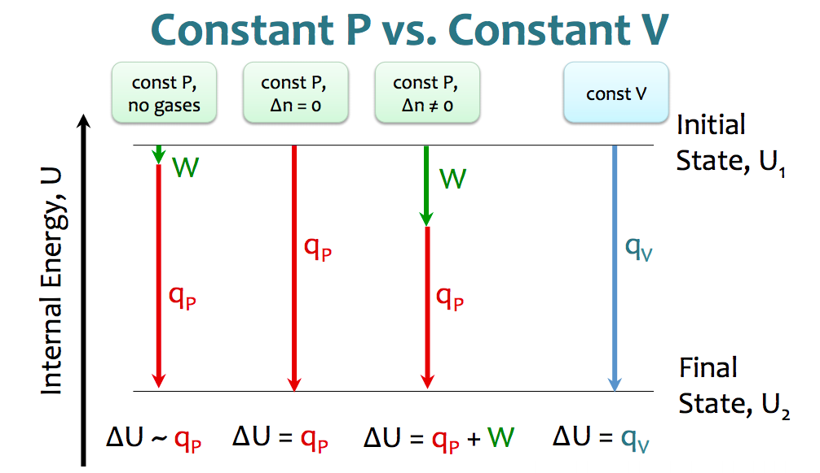
- at constant pressure, with no gases, ΔU is very close to qp
- at a constant pressure, when Δn is 0, qp is ΔU is exactly equal to qp.
- at constant pressure, when Δn is not 0, ΔU is due to both W and qp.
- at constant volume, ΔU is equal to qv

Enthalpy: A State function
- sign: if a reaction is reversed, ΔH is also reversed.
- magnitude: the magnitude of ΔH is proportional to the amount of substance.

ΔH: A state function = independent of path
- You can break up reactions, but overall ΔH is the same.
- Because it doesn’t matter the pathway you took to get somewhere, as long as you get from point A to B.

Hess’s Law:
- The net ΔH is the sum of the ΔH’s of the individual steps.
- When doing Hess law calculations, use equations given and flip them (negative to positive or vice versa) and multiply by integer to get final equation
- Ensure to do this with the ΔH values too.

Standard Enthalpy Values: An “anchor point”
- Measure enthalpy change under standard conditions. ΔH values labeled ΔH°
- Define a standard state (at temperature of interest – often 298.15K)
- Compounds: For a gas, pressure is 1 bar. For a solution, concentration is 1 molar. For a pure substance (liquid or solid), it is the pure liquid or solid
- Elements: The form [N₂ (g), K(s)] in which it exists at 1 bar.

Standard Enthalpy Values
- NIST (National Institute for Standards and Technology’s given values of:
- ΔH°_{f} = standard molar enthalpy of formation. Heat absorbed or released when making 1 mol of a substance.
- This is the enthalpy change when 1 mol of compound is formed from the reference form of the elements under standard conditions.
- The standard enthalpy of formation of a pure element in its reference state is ZERO.

Elemental References forms
- For most elements, it is just the element itself (ex. Gold = Au(s))
- exceptions: must know!
- HOFBrINCl (diatomic molecules) al gases except bromine which is liquid and iodine which is solid.
- Carbon = C (graphite, s)
- Phosphorus = P (white, s)
- Sulfur = S₈ (s)

Standard Enthalpies of formation
- Enthalpy of formation of elements = 0, due to substances only.
- Exothermic means more energy out than what was put in.
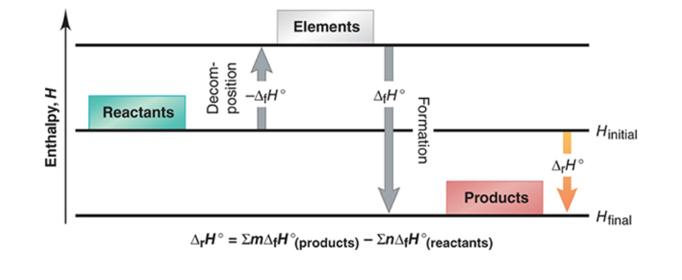

Changes in enthalpy
- using standard enthalpies of formation ΔH°f, we can calculate standard enthalpies of reaction. ΔH°rxn, i.e for a general reaction: aA + bB cC + dD
- Formula is (sum of enthalpies of formation for products) – (sum of enthalpies of formation for reactants)
- Don’t forget to include stoichiometric co-efficients for the reactants and products.

