Final

Lecture 11

Child Maltreatment
- Not a formal DSM diagnosis
- Violence, corporal punishment, and abuse have historically been considered private family matters
- We now have mandatory reporting laws that apply when we hear about child abuse or neglect

Types of Child Maltreatment
- Physical abuse
- Neglect
- Sexual abuse
- Emotional abuse
- Exposure to violence

Neglect
- Most common form of child maltreatment
  - Failure to provide basic emotional, physical or education needs
  - Perpetrator more likely to be female

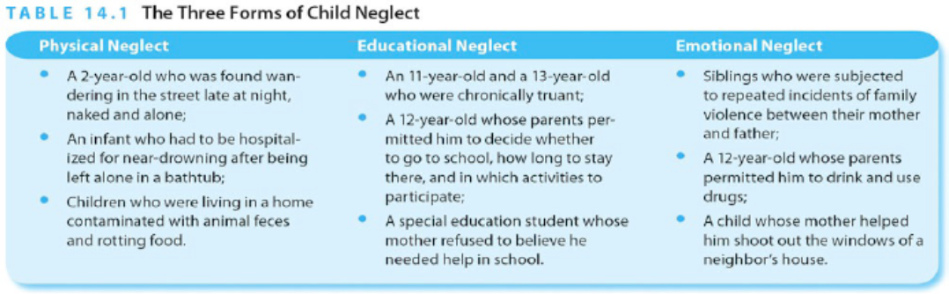

Corporal punishment
- Physical punishment of children has one positive effect: short trem reduction of problematic behaviour
- Every other consequence of corporal punishment has been found to be negative
  - Aggressiveness, antisocial behaviour
  - Poorer relationship between child caregiver
  - Poorer childhood and adult mental health
  - Increased risk of being victim and perpetrator of abuse
- Its puzzling that hitting an adult is called assault (a crime) but hitting a child is considered discipline (not a crime)

Canadian Incidence Study of Reported Child Abuse and Neglect 2008 Report

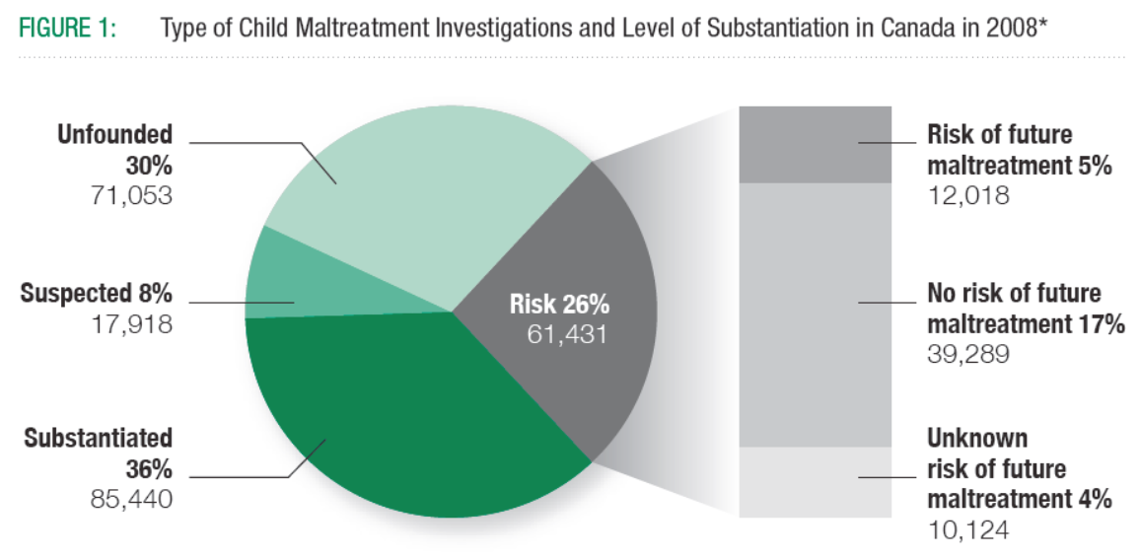

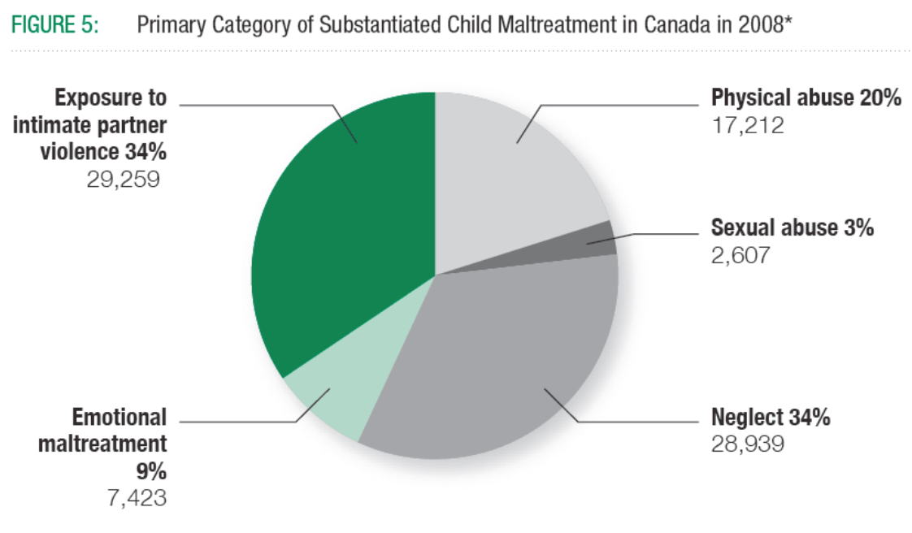
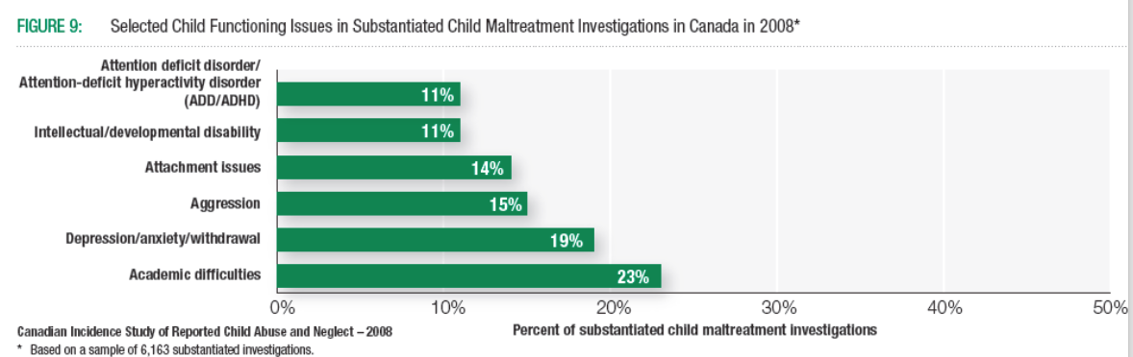

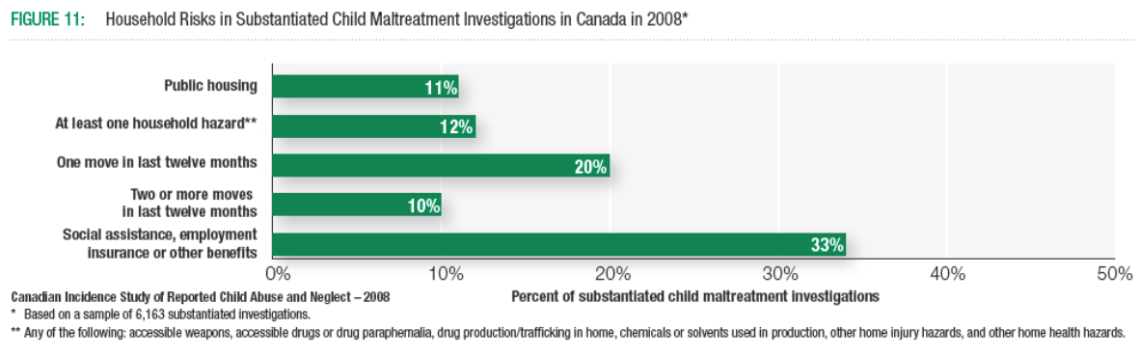

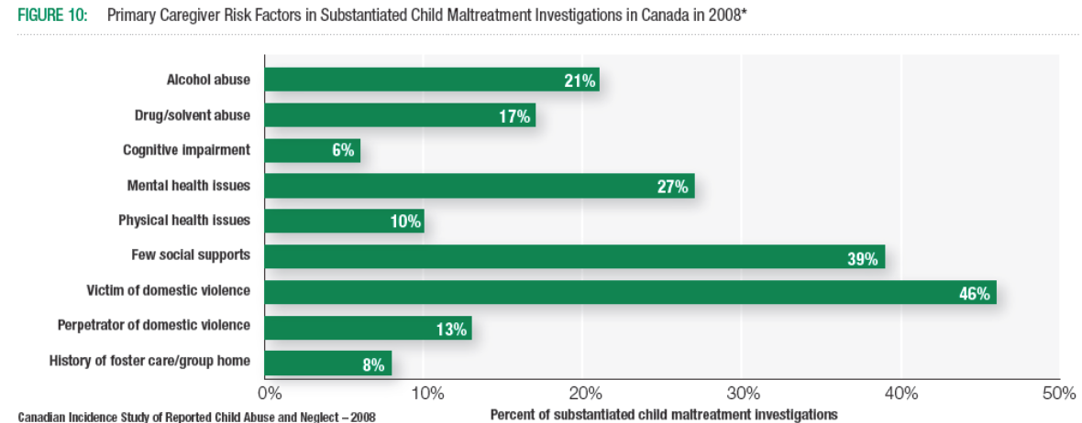

A few notes on risk and etiology:
- Characteristics of the child:
  - age, sex, health/temperament
- Characteristics of the perpetrator and the family:
  - younger parents, large families, stress, social isolation, substance use
  - different for sexual abuse
- Parenting and parent-child interactions:
  - coercive family interactions
- Social and cultural influences
  - poverty, society’s views on violence/sex

Video
- Wards of the Crown: This film examines the lives of 4 young people who grew up in the child welfare system. It is also a critical exposé of a system that couldn't meet their needs, as well as a stirring tribute to the strength, courage and resilience of these foster kids.

Guest Lecture 1: Family and Children’s Services

About us
- Children’s safety is our top priority
- FCSLLG is a non-profit organization that protects children so they can grow up safe from abuse, including physical, emotional, and sexual abuse as well as neglect.
- We are commonly referred to as a child welfare services agency or a children’s aid society.

Our Role Under the Law
- We support families when they need it and, when required, take the necessary steps to make sure children are protected.
- We carry out our work under the Ontario Child and Family Services Act, which requires us to investigate possible abuse or neglect of children and ensure the safety of those who need protection.

Mission
- Our mission is to contribute to the wellbeing of children, youth and families by:
  - Protecting children and youth from abuse and neglect
  - Supporting families
  - Providing a consistent, supportive environment for children and youth
  - Actively engaging with our community to achieve positive outcomes

Vision
- Every child, youth and family shall live in a safe environment, be valued and have opportunity to develop to their fullest potential.

Services
- We seek out and support community-based solutions.
- Together we:
  - Support Positive Parenting
  - Educate about Child Development
  - Offer Child Protective Services (Intake and Ongoing)
  - Promote foster care and permanent care (adoption)

Service Stats
- The Agency received 974 inquiries and referrals and completed 1349 investigations/assessments.
- The Agency served 339 new families at ongoing protection, along with 404 previously opened families.
- There were 222 children in care at year end.
- The Agency finalized 11 adoption placements and provided support to 50 children in adoptive placements.

What is Child Abuse? Eligibility Spectrum
- Harm By Commission
- Physical force and/or maltreatment
- Cruel/inappropriate treatment
- Abusive sexual activity
- Threat of harm
- Harm by Omission
- Inadequate supervision
- Neglect of child’s physical needs
- Caregiver response to child’s physical health
- Caregiver’s response to child’s mental, emotional, developmental condition
- Emotional Harm
- Caregiver causes and/or caregiver response to child’s emotional harm or risk of emotional harm
- Adult conflict
- Abandonment and Separation
- Orphaned/abandoned child
- Caregiver-child conflict
- Child behaviour
- Caregiver Capacity
- Caregiver has history of abusing and neglecting
- Caregiver inability to protect
- Caregiver with problem
- Caregiving skills

Your responsibility
- You have an ONGOING duty to DIRECTLY report suspected child abuse or neglect under Section 72 of the Child and Family Services Act.

Making a Referral
- Be Prepared! When you call, please have as much identifying information as possible, including: full names, DOBs, addresses, tel #s
- The more contextual information, the better (e.g. child/family functioning, support network)
- Call as soon as you receive the information – let us decide urgency, we need time to collaborate with police, safety plan, etc.
- Talk to us about whether we can identify you as referral source

What happens next?
- Assess referral for eligibility, as per our provincial ES
- Determine response time
- Complete safety assessment (traditional vs. customized)
- 30-60 days to complete investigation
- Inform family and relevant collaterals (if consent obtained) of outcome
- Outcome could involve case closure, or transfer to ongoing services

Signs of Safety Project FCSLLG

FCSLLG
- A child protection agency that serves LLG
- Child safety is our priority and mandate
- Engaging with families, children, service partners, communities and each other is key to success in building safety
- Total staff number of 150 with +80 in service

Why SOS?
- Signs of Safety is a philosophical model of child welfare delivery that has as its core beliefs a collaborative, strengths based model of service delivery.
- In 2016 FCSLLG committed to a three year implementation plan to bring SOS to our organization.
- Real desire to be actively helping families build their own safety plans that are lasting and built by them.
- This model allows the family, who are the experts of their own lives, time to put the plan into practice.

What got us here?
- 2012 - Amalgamation
- 2014 - Three child deaths that created necessity for change in practice through lessons learned
- 2014 - Ministry on site review on compliance with standards, practices and organization culture

What is SOS?
- Solution focused practice model that began in 1990’s specific to child protection workers
- Now being practiced in 12 countries around the world
- A model built on continuous learning
- Applicability across the spectrum:
  - From intake and assessment to closure
  - Within alternative care placements and permanency work
  - Across the full spectrum of protection issues, risk levels and cultures

Why SOS is successful?
- Evidence shows using SOS leads to positive collaboration with families.
- Safety for children that extends after the closing of the file.
- Fewer re-openings.
- Greater satisfaction from the families with whom we are working.
- Collaboration and engagement with community partners.
- Greater worker satisfaction.

What is different about SOS?
- SOS not only provides a philosophical framework but a kit of tools for child welfare practitioners including…….
- Three houses, words and pictures
- Harm and danger statements
- Scaling questions
- Mapping

What you might see with staff
- New language about ‘worries’, ‘strengths’, ‘complicating factors’, ‘houses’, ‘mapping’
- Movement from an approach of authority to focus on engaging families actively in solution focused safety planning
- Recognition of ‘exceptions’ to harm and building plans from there

Community Impact
- Approach in practice will be experienced differently – working together towards positive change
- Community forums, steering committee representation and on the ground work with families
- Actively seeking community and family feedback
- Aligning practices to build strong families and children

Patience is a virtue
- Change takes time. Workers need to experience using the tools to integrate them into our work with families.
- It takes a lot of practice and courage to put yourself out there and try something new.
- As an agency we have started to lay the foundation of building a community of care that wraps around children and families. We know success in this area is strengthened when we promote partnerships.

Lecture 12: Intellectual Disabilities (formerly called Mental Retardation)

Intellectual Disabilities
- Long history of mistreatment and rejection of people with MR
- 19th century eugenics movements were related in large part of fear of people with MR
- Segregation still goes on today, but at a much lower rate than in previous decades

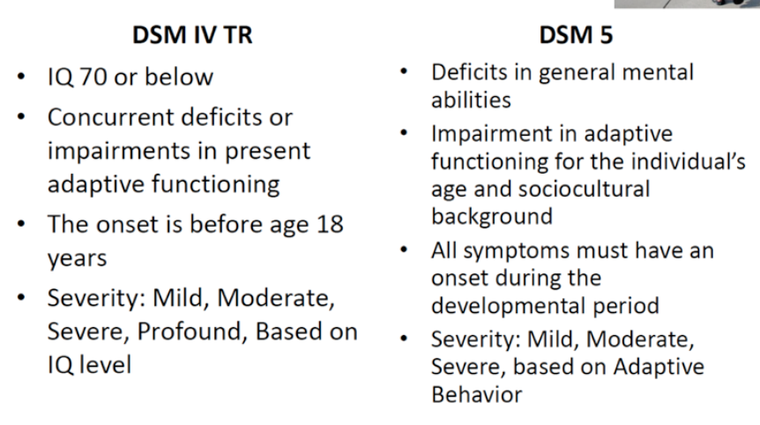

IQ
- IQ testing moved to the body of the text in DSM-5
- However, DSM-5 continues to specify that standardized psychological testing must be included in the assessment of affected persons but that psychological testing should accompany clinical assessment
- Emphasis is on adaptive behavior
- Adaptive behaviour: is the collection of conceptual, social, and practical skills that all people learn in order to function in their daily lives.

Severity Table
- Mild, moderate, severe & profound severity levels
- Table based on 3 domains:
  - Conceptual
    - Language, reading wtiting, math, reasoning, knowledge, and memory, among others, used to solve problems
  - Social
    - Awareness of others’ experiences, empathy, interpersonal communication skills, friendship abilities, social judgement, and self-regulation, among others
  - Practical
    - Self management across life settings, included personal care, job responsibilities, money management, reaction, managing one’s behavior, and organizing school and work tasks, among others

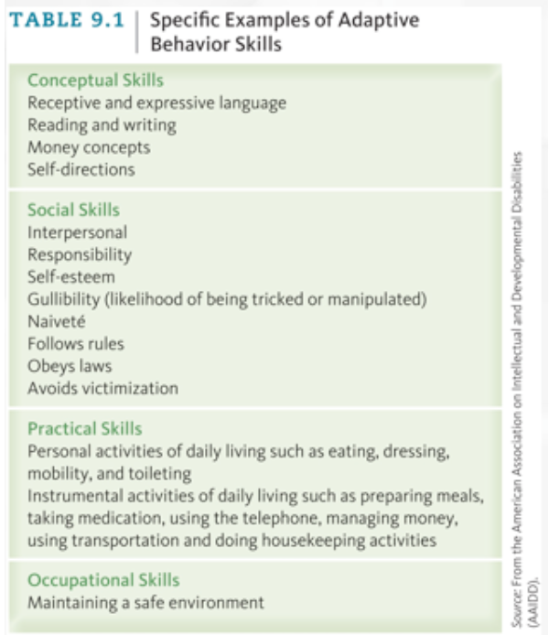

Intellectual Disabilities
- 1-3% of population
  - technically prevalence should be no moer than 2.2% of the population
- Mild MR is twice as common in boys than in girls, while severe MR is 1.5 times as common in boys
  - X-linked genetic disorders
- Diagnosis is strongly linked to SES
- Emotional disturbances are common in mild (~30%) and more severe (~50%) cases of MR
  - Additional stressors, limited ability to cognitively or verbally process information
  - Anxiety, mood, and impulse control issues
  - Pica, rumination disorder, elimination disorders, self-injury
- Take great caution when diagnosing other psychiatric conditions in children with MR
  - Most diagnoses are made based on the child’s developmental level, not their age

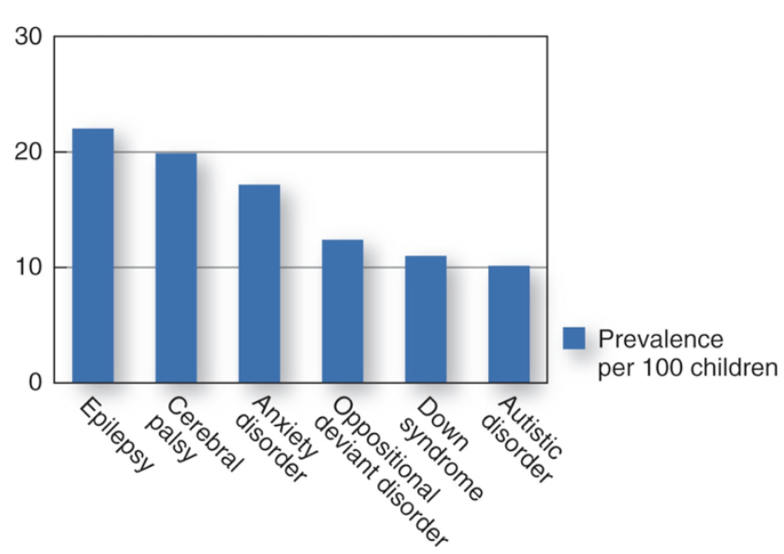
Neurobiological influences
- Adverse biological conditions (e.g. malnutrition, exposure to toxins, prenatal and perinatal stressors)
- Infections, traumas, and accidental poisonings during infancy and childhood
- Fetal Alchohol Spectrum Disorder (FASD): a range of outcomes associated with prenatal alcohol exposure
  - FAS is leading known cause of mental retardation, and is estimated to occur in one-half to two per 1000 live births
    - CNS Dysfunction, facial abnormalities, and growth retardation below tenth percentile
- Teratogens that increase risk of MR are viral infections (e.g., rubella), syphilis, scarlet fever, degenerative nerve diseases, X-rays, drugs, poisons (e.g., lead and carbon monoxide), and tumors and cysts in the head

Social and psychological dimensions
- Least understood and most diverse factors causing MR
- Environmental influences and other mental disorders account for 15-20% of MR:
  - Deprived physical and emotional care and stimulation of the infant
  - Other mental disorders accompanied by MR, such as autism
  - Parents are critically important
    - They can help their child by adapting, using social supports and community resources, strategies for coping with their children’s problems, and families’ level of social support

Emotional and Behavioural Problems
- Rate is three to seven times greater than in typically developing children, largely due to limited communication skills, additional stressors, and neurological deficits
- Most common psychiatric diagnoses: impulse control disorders, anxiety disorders, and mood disorders
- Consistent with their normally developing peers, internalizing problems and mood disorders in adolescence are common
- ADHD-related symptoms are also common
- Pica: seen in serious form among children and adults with ID
- Self-injurious behavior (SIB), which can be life-threatening, affects about 8% of persons across all ages and levels of retardation

Other disabilities
- Can be associated with other pervasive physical and developmental disabilities that affect health and development
  - Related to degree of intellectual impairment
  - Prevalence of chronic health conditions is much higher than in general population
- Despite co-occurring physical and intellectual disabilities, life expectancy for individuals with Down Syndrome is now approaching 60 years

Etiology
- Diagnosis does not depend on the etiology
  - There are over 1000 conditions associated
- Genetic, prenatal, perinatal, postnatal
- Inadequate care, severe neglect, etc. can also contribute to or cause MR
- Down Syndrome
  - 3 copies of chromosome 21
- Fragile-X syndrome
  - Often associated with autistic features
- Prader-Willi syndrome
  - Symptoms include urge to eat continually
- Phenylketonuria (PKU)
  - Can be managed well with diet
- Fetal Alcohol Spectrum Disorder
  - Often associated with mild MR, as well as ADHD, conduct problems, impulse control disorders

FAS
- Distinct facial features
  - Epicanthal folds, flat nasal bridge, railroad tract ears, upturned nose, smooth phitrum, thin upper lip, small head circumference
- Alcohol competes with various enzymes involved in embryonic/fetal development

Prevention and treatment
- Prenatal screening and education
- Early intervention for enhancing social and academic skills
- Behavioural interventions for serious problems (Pica)
- Speech therapy
- Family interventions
- Social inclusion
- Residential care

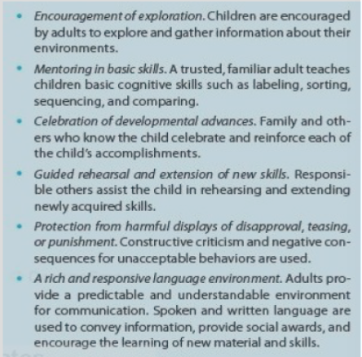

Inclusion of children with ID
- Partial inclusion: child spends parts of the day in special education but is mostly in general education classroom
- Full inclusion: child spends entire day in regular education classroom

Pros and Cons of Inclusion
- Pros
  - Social Advantages:
    - Students get to receive their education with their non-disabled peers who are the same age as them. By doing so, students get to interact with their peers in ways that the special education classroom wouldn’t do. Many students with special needs often have an identified need to improve their social skills. Placing them into classes with a diverse group of students can certainly help increase those skills.
    - It also helps self-esteem as well, because the students know that they are in "regular" education classes with their peers. No matter how hard we work to break down walls and build acceptance, the social stigma of being different still exists. By blending students of differing abilities into one classroom, not only does it help the students with special needs, but it also helps the regular education students as well, by teaching them how to work with others who are different from them. It teaches all students compassion, acceptance, collaboration and patience, life-long skills that will better prepare them for the future.
  - Academic Advantages:
    - Another advantage of mainstreaming is that the students are receiving the same curricula material as their non-disabled peers. Although they may receive accommodations and modifications to the curriculum, they are still learning what everyone else is learning. It gives these students a chance to learn something that they may not have had a chance to learn in a special education classroom.
  - Tolerance:
    - If classrooms aren't mainstreamed, then a great majority of the student population will not be exposed to students with special needs. This means that they will never get to learn or promote the kind of tolerance that will carry with them through adulthood.
    - Mainstreaming special needs students with the rest of the population exposes all students to all types of people, whether they have disorders or not. As the other students learn tolerance, the students with special needs will learn what behaviors are acceptable and which ones aren't.
- Cons of Mainstreaming
  - Social Disadvantages:
    - Some students with special needs have behavioral issues that will need to be addressed in the classroom. These issues are not only disruptive to the rest of the class, but can also be embarrassing to the student, causing more damage to their self-esteem and social world than would happen if the student was not mainstreamed.
  - Academic Disadvantages:
    - While the students with special needs are able to use the same curricula as students without special needs, they may not be able to keep up with the work. This can result in them feeling like the odd man out. The extra effort that teachers have to put into ensuring everyone understands the work may also take away from the rest of the classroom. This can impact the pace of the classroom as a whole. While some mainstreamed students with special needs will have pull-outs into a resource room or some other means of individualized tutoring, any slowdown in the classroom pace that can impact reaching specific goals is a concern.
  - Tolerance:
    - Tolerance is a wonderful thing to learn, but it can also backfire. Students who do not have special needs may be under the impression that the student with special needs "gets away" with more than the rest of the class because of his or her disability. This can lead to resentment and it can also lead to the other students acting out.

Lecture 13:

Learning Disabilities
- What does it mean to be “substantially below”?
- Most clinicians define this as 2 SD discrepancy between IQ and academic achievement
- Two grade levels below in a specific area
- Two SD below the average in a specific area

Assessment
- Standardized tests of language, reading, spelling, and mathematics (e.g., Woodcock-Johnson III Psychoeducational Battery; Kaufman Assessment Battery for Children – II)
- Standardized tests of general intelligence (e.g., WISC-IV) If warranted, additional tests of cognitive processing or motor skills
- Clinical interview with parent, teacher, and/or child to understand:
- Family history and biological factors (e.g., chronic medical conditions)
- Child factors (e.g., study habits, motivation, self-esteem, behavioural functioning)
- Environmental factors that can promote/hinder the child’s functioning (e.g., parental attitudes and practices, supports/encouragement of the child)

3 Main Types of Learning Disabilities:
- Mathematics Disorder
- Reading Disorder (e.g., Dyslexia)
- Disorder of Written Expression

Mathematics disorder
- Mathematical ability, as measured by individually administered standardized tests, is substantially below that expected given the person’s chronological age, measured intelligence, and age-appropriate education
- The disturbance in Criterion A significantly interferes with academic achievement or activities of daily living that require mathematical ability
- If a sensory deficit is present, the difficulties in mathematical ability are in excess of those usually associated with it

Reading Disorder
- Reading achievement, as measured by individually administered standardized tests of reading accuracy or comprehension, is substantially below that expected given the person’s chronological age, measured intelligence, and age-appropriate education
- The disturbance in Criterion A significantly interferes with academic achievement or activities of daily living that require reading skills
- If a sensory deficit is present, the reading difficulties are in excess of those usually associated with it
- Typical difficulties include:
  - Sight reading (reading a whole word short at once)
  - Reversals (b and d)
  - Transpositions (switching letters within word, or words within a sentence)
  - Inversion (q and d)
  - Omissions (missing letters)
  - Decoding (difficulty breaking words down into syllables)
  - All these difficulties can result in slower reading speed and more errors

Disorder of written expression
- Writing skills, as measured by individually administered standardized tests (or functional assessments of writing skills), are substantially below those expected given the person’s chronological age, measured intelligence, and age-appropriate education
- The disturbance in Criterion A significantly interferes with academic achievement or activities of daily living that require the composition of written texts (e.g., writing grammatically correct sentences and organized paragraphs)
- If a sensory deficit is present, the difficulties in writing skills are in excess of those usually associated with it
- Problems with tasks that require hand/eye coordination
- High comorbidity with other learning disabilities

Working Around an LD
- Accommodation:
  - instructional adaptation; does not reduce expectations, rather it changes how info is presented or how students can respond (e.g., more time, read aloud)
- Modification:
  - Instructional adaptation, but reduces target skill therefore lower performance expectations (e.g., spell fewer words)

Guest Lecture 2: Intellectual and Developmental Disabilities (IDD)

Definition: 3 main criteria
- Limitations in intellectual functionning
- Limitations in adaptive behavior: social, practical, conceptual domains
- Neurodevelopmental: diagnosed before 18 years of age (> 18 y.o. = neurocognitive)

Limits of definition
- IQ-based criterion
- Developmental period is arbitrary
- Medical vs. social conceptualisation

Prevalence
- Approximately 1% of the population
- BUT more than 1% of your intervention population

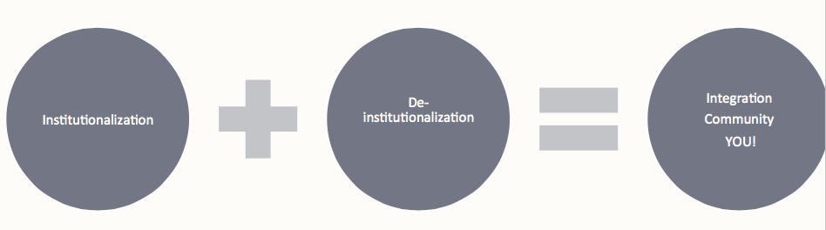
Etiology
- Genetic (chromosomal)
- Parental and maternal factors (age, placenta)
- Infectious
- Teratogenic (in utero exposure to alcohol, drugs, toxins and other substance
- Cancer (brain tumors and lesions, treatment effects)
- Trauma (anoxia, surgery, injury, childbirth)
- Often unknown

Diagnosis/Assessment
- Collaborative and comprehensive:
- Based on 3 criteria + severity level (mild, moderate, severe)
- Neuropsychological assessment
- Speech sound; swallowing
- Genetic testing (ethical challenges!)
- Physical features (caution!)
- Observation: behaviors, adaptive functioning

Comorbidities
- Common examples: ASD, cerebral palsy, Down syndrome, FAS, Fragile X
- Double diagnosis: anxiety and mood disorders, ADHD, impulse-control disorder substance use
  - Diagnostic tool: DM-ID-2
- Medical: cardiac, endocrine, seizure activity
- Sensory: auditory, visual
- Motor: speech production, paralysis

Treatment
- Multidisciplinary approach
- Some examples

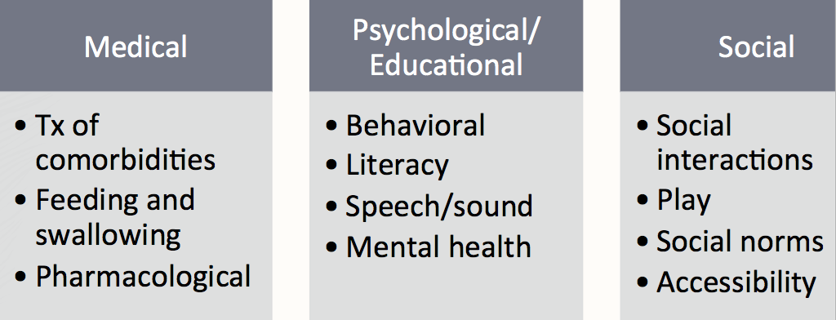

Challenges
- Heterogeneity
- Stereotypes and stigma
- Lack of knowledge, education, and training of students and professionals
- Lack of exposure and positive interactions

KEY MESSAGES
- Segregation is out, inclusion is in!
- As social and healthcare professionals, we have a responsibility toward this
- population
- Focus more on the barriers that need to be adjusted or removed and less on person’s disability (ies)

Lecture 14:

Case study: Shannon
- What information should we gather?
- IQ
  - Academic achievement
  - Cognitive processing
  - Social-emotional functioning
- Sources of information:
  - consultation with school support team review of OSR
  - parent interview
  - teacher interview
  - student interview
  - classroom observation
  - battery of standardized tests:
    - Weschsler Test of Intelligence (IQ)
    - Weschsler Achievement Test (Achievement)
    - Test of Written Language (Writing)
    - Comprehensive Test of Phonological Processing (Reading)
    - Wide Range Test of Memory and Learning (Memory)
    - Conners Behavior Rating Scale (Attention/Hyper/Impul)
- Parent interview:
  - happy child
  - friendly and positive
  - creative ideas in play passionate about art
  - likes to organize things at home enjoys playing with friends loves to cook
  - no major parent-chid conflict, only over homework
- Teacher interview:
  - social
  - liked by peers
  - kinesthetic learner
  - excels in physical education
  - difficulties focusing
  - math and writing lagging
  - rushes her work
- Student interview:
  - she likes school
  - likes to learn new things
  - favourite subject is art
  - dislikes social studies
  - wants to improve math skills
  - finds reading hard
  - likes to watch tv and play with friends
- Classroom Observation:
  - class watched instructional video, followed by lesson and writing task
  - Shannon took longer to get to carpet
  - focused on video, but yawned often
  - not engaged in lesson
  - tuned out during voting question
  - chatty when returning to desk
  - teacher “scaffolds” task
  - completed work, and re-read it
- Behavioural observations during testing:
  - very friendly
  - compliant
  - warmed up easily
  - focus did not wander
  - affect was good
  - laughed at appropriate times
  - seemed to understand directions

Percentile ranks
- Intelligence:
  - Verbal: 55th percentile
  - Nonverbal: 32nd percentile
  - Processing Speed: 27th percentile
  - Working Memory: 34th percentile
- Academic Achievement:
  - Reading: 5th percentile
  - Spelling: 12th percentile
  - Math: 14th percentile
  - Writing: 18th percentile
- Cognitive Functioning:
  - Phonological Processing: 12th percentile
  - Visual Memory: 16th percentile
  - Verbal Memory: 14th percentile
  - Working Memory: 27th percentile
- Social Emotional Functioning:
  - Parent and teacher ratings for ADHD in the borderline range
  - All other indices of social and emotional functioning average

Summary:
- Average intellectual functioning
- Very limited academic achievement
- Deficits in memory and phonological processing
- Attention / Hyperactivity / Impulsivity borderline
- Other social-emotional functioning average
- Strengths

Feedback to parents and school:
- Strengths:
  - Average intelligence
  - Creative and artistic
  - Good social skills
- Needs:
  - support to develop writing, spelling and math skills
  - support to develop phonemic awareness
  - help with focus
Recommendations for school:
- Share with Identification Placement and Review Committee (IPRC) and designate as exceptional with diagnosis of Learning Disability.
  - Reading: slowing down, phonemic awareness instruction, re- read words, ample practice in any genre
  - Math: frequent review, creative ways to remember times tables, begin easy to encourage success, learning to tell time on analogue clock, practice math concepts with money, use visuals when possible
  - Writing: Review of capitals, breaking down ideas, semantic webbing, checklist of important elements in stories
  - Memory: simple language, chunk work, handouts with instructions, repeating instructions back, time to process, use her artistic abilities to help remember, relating newly learned info to prior knowledge

Recommendations for home:
- encouragement not control
- encouraged to keep reading books that interest her
- instructional websites (i.e., www.starfalls.com)
- incorporate math tasks into daily life
- parents can get support (e.g., LDAO)
- foster artistic strengths
- continue play dates to continue social skills development

