GNG1106 Fall 2017 - Assignment 3
October 2, 2017

Question 1 (15 marks)
- (10 points) The following programming model contains in its code memory the indicated C program composed of 2 functions. You will be showing how the working memory is used during the execution of the two functions. Each piece of working memory is associated to a function using a pair of lines. (Note: the first pair of lines associates the piece of working memory allocated to the function main and the second pair of lines associates the piece allocated to the function computeCompression). Show how the given C program affects the contents of the working memory:
- Show how the structure is organized in the working memory for each function.
- Show the values are assigned to the members of the structure. Be sure to show all values that are assigned and replaced. Record successive assignments to variables/parameters as follows:
Variable name
? 2, 6, 4, 10

- Using arrows show how values are copied between the working memory allocated to the function main and the working memory allocated to the function computeCompression. For copying the contents of a structure variable, you need only used a single arrow.
- In the console window show the output of the program.
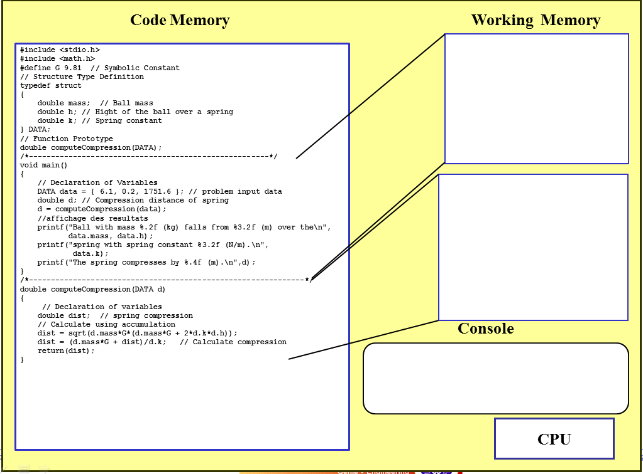
Ball with mass 6.10 (kg) falls from 0.20 (m) over the
spring with spring constant 1751.60 (N/m).
The spring compresses by 0.1560 (m).
d
mass 6.1
h 0.2
k 1751.6
dist ? 213.3259 0.1560
data
mass ? 6.1
h ? 0.2
k ? 1751.6

d ? 0.1560
Note: You do NOT need to show how the CPU interacts with memory.
- (5 marks) The following programming model contains in its code memory the indicated C program composed of a single function, main. You will be showing how the working memory is used during the execution of main. Show how the given C program affects the contents of the working memory:
- Show the values are assigned to the variables and array elements. Be sure to show all values that are assigned and replaced. Record successive assignments to variables/parameters as follows:
Variable name
? 2, 6, 4, 10

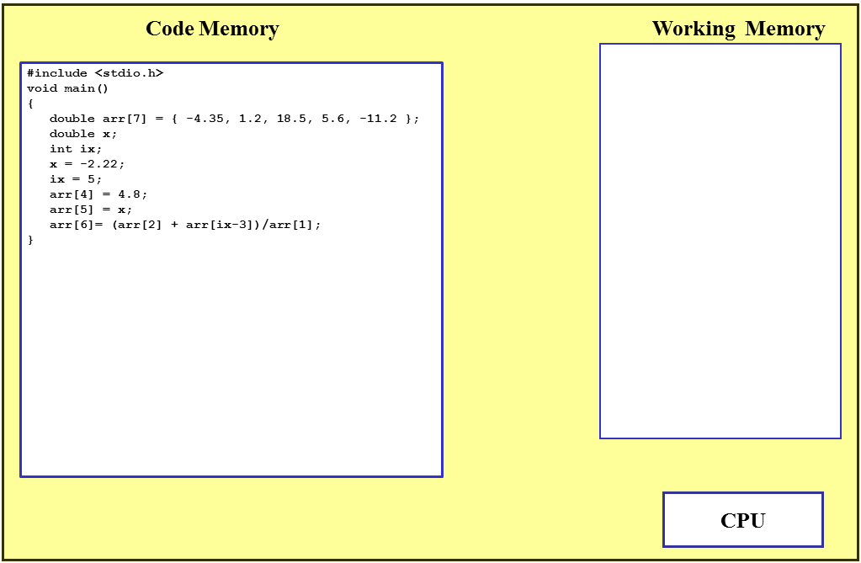
arr
-4.35
1.2
18.5
5.6, 4.8
-11.2, -2.22
0.0, 30.83
0.0
x ? -2.22
ix ? 5

Question 2

Input

/*------------------------------------------------------------------

File: impedance.c

Author: = October, 2017

Description: Calculates the impedance of a circuit with a resistor, an

inductor, and a capacitor in parallel

---------------------------------------------------------------------*/

#include <stdio.h>

#include <math.h>

// function prototypes

typedef struct// structure type definition

{

double R;// resistor

double L;// inductor

double C;// capacitor

double f;// frequency in hertz

} USER_INPUT;

//function prototype

double calculateimpedance(USER_INPUT);

double calculateradians(USER_INPUT);

/*---------------------------------------------------------------------

Function: main

Description: Obtains from the user a resistance, inductance, capacitor and

frequency, calls calculateimpedance to get the impedance and displays the

result to the user.

------------------------------------------------------------------------*/

void main(void)

{

USER_INPUT input;

double Z;

double o;// Variable declarations

printf("Please input the resistance R:");

scanf("%lf", &input.R);

printf("Please input the inductance L:");

scanf("%lf", &input.L);

printf("Please input the Capacitor C:");

scanf("%lf", &input.C);

printf("Please input the frequency f:");

scanf("%lf", &input.f);

Z=calculateimpedance(input);

printf("For a circuit with the following components:\n");

printf(" R = %.3e ohms ", input.R);

printf("L = %.3e H ", input.L);

printf("C = %.3e F ", input.C);

printf("and a frequency of %.3e Hz\n", input.f);

printf("The impedance of R, L, and C in parallel is %.3e\n", Z);

// Instructions

}

/*-----------------------------------------------------------------------

Function: calculateimpedance

Parameters:

input.R- Resistance in ohms

input.L- inductance in H

input.C - Capacitor in F

o- Frequency in radians

Call: calculateradians to get the frequency in radians

Return: Impedance of circuit in parallel

Description: Calulates the impedance of the circuit in parallel:

Z=(o*input.C)-(1/(o*input.L))

Z=pow(Z,2)

Z=((1/pow(input.R,2))+Z)

Z=1/sqrt(Z)

The function returns the impedance value.

------------------------------------------------------------------------*/

double calculateimpedance(USER_INPUT input)

{

double Z;

double o;// Variable declarations

o=calculateradians(input);

Z=(o*input.C)-(1/(o*input.L));

Z=pow(Z,2);

Z=((1/pow(input.R,2))+Z);

Z=1/sqrt(Z);

return(Z);// Instructions

}

/*-----------------------------------------------------------------------

Function: calculateradians

Parameters:

input.f- Frequency in hertz

o- Frequency in radians

Return: Frequency in radians\

Description: Calculates the frequency of radians:

o=(2*M_PI)*input.f

The function returns the frequency in radians value

------------------------------------------------------------------------*/

double calculateradians(USER_INPUT input)

{

double o;//Variable declaration

o=(2*M_PI)*input.f;

return(o);//Instructions

}

Output

Trial 1

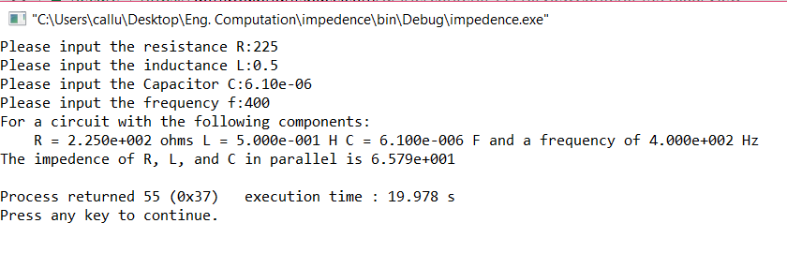

Trial 2

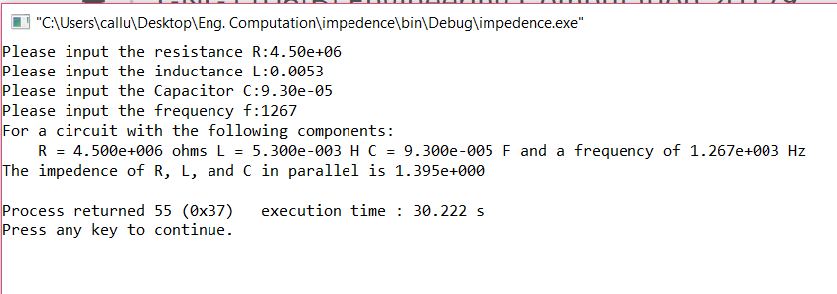

Trial 3

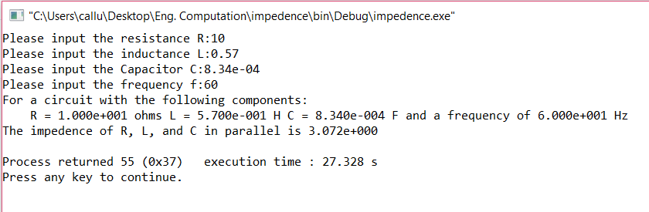

Trial 4

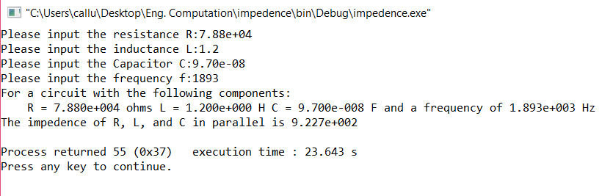

Trial 5



