BIO1140 Final Exam Review

Topic 1 – Introduction to cell biology and the cell’s features

How did life evolve into organisms and cells?
- 200 years of observations and gathering

What are the different types/classes of organisms?
- Prokaryotes:
  - No nucleus, no organelles (ribosomes only)
  - Smaller
  - Examples include: eubacteria, archaebacteria.
  - Do not accomplish complex tasks.
  - Small genomes.
  - Transcription/translation occur freely + simultaneously in a cell.
- Eukaryotes:
  - Nucleus, contain organelles
  - Larger
  - Examples include: animal cells, plant cells, protista (single-celled), algae, fungi.
  - Genome is larger more complex tasks.
  - Transcription and translation occur in separate areas.
- What can we use to classify them?
  - Types of ribosomal RNA
  - Types of phospholipids.
  - Type/# of flagellum

What is a cell?
- Theory developed around the mid-1600’s.
- Small rooms = cellulae= cells.
- Contain genetic information, has a structure, but not all are the same.
- Responds to external environment.
- Has to follow cell theory.

What is a cell made of? Define the different features, organelles, and explain the roles/functions of each.
- Features:
  - Diversity:
    - Wide range of sizes.
    - Can have simple or complex shapes (related to function).
    - Can have a general or specific role.
  - Characteristics:
    - Components
    - Basic chemistry
    - Metabolism (ATP)
    - DNA
  - Organelles:
    - Nucleus:
      - Contains genetic material, mRNA is made in here.
      - Transcription occurs here
      - Nuclear envelope: double envelope, contains nuclear pores.
    - Ribosomes:
      - Either attached to ER or free floating in cytoplasm, made out of two subunits (small/bottom and large/top)
      - mRNA threads its way in-between the two subunits.
      - Large subunit has three sections: tRNA will enter aminoacyl site, adds amino acid to growing peptide chain on peptidyl site, moves to exit site to exit the ribosome.
    - Endoplasmic Reticulum:
      - Rough has ribosomes for translation
      - Smooth has no ribosomes and makes lipids.
    - Golgi Apparatus:
      - Modifies lipids + proteins and packages them in vesicles to be either secreted out of the cell or to another part of the cell.
    - Lysosomes:
      - Contain digestive enzymes to break down waste molecules of the cell.
      - pH is more acidic than in cytosol.
    - Mitochondria:
      - Cellular respiration
      - Cristae folds to increase SA
      - Used to be a prokaryotic organism (endosymbiosis) but became engulfed – contains DNA + ribosomes.
      - Important in apoptosis
    - Cytoplasm:
      - Supports/moves cell structures
      - Helps shape cell
      - Protein fibers extend through it (microtubules, microfilaments, intermediate filaments)
      - Translation can occur here on ribosomes.
    - Chloroplasts (plant cells):
      - Where photosynthesis occurs
      - Also used to be its own organism – endosymbiosis
      - Color pigment provided by chlorophyll.
      - Contain plastids
    - Central vacuole:
      - Tonoplasts allow things in and out of cell
    - Cell wall:
      - Plasmodesmata allow molecules to pass through (like gap junctions of cell membrane)

What are the different scales/sizes for cells and organelles?
- Largest to smallest:
  - Seen with unaided eye:
    - Human height
    - Length of nerve/muscle cells
    - Chicken egg
    - From egg
  - Seen with light microscope:
    - Plant and animal cells
    - Nucleus/mitochondria/prokaryotes
    - Smallest prokaryotes
  - Seen with electron microscopy:
    - Viruses
    - Ribosomes
    - Proteins
    - Lipids
    - Small molecules
    - Atoms

- Why are cells small:
  - High SA/V ratio
  - Easier for nutrients to diffuse

Explain the theory of the cell and the theory of endosymbiosis.
- Cell theory:
  - All living things are made from one or more cells.
  - Nothing living exist smaller than a cell – the cell is the basic structural and functional unit of all living organisms.
  - Cells arise from preexisting cells.
- Theory of Endosymbiosis:
  - Original prokaryotic cell aerobic bacteria made multiple invaginations of the plasma membrane and entered the cell the aerobic bacteria became the mitochondria also, photosynthetic bacteria became chloroplasts
  - Evidence:
    - Shape of mitochondria and chloroplasts and size are similar to bacteria and archaea.
    - They reproduce only by binary fission.
    - Genome: have circular genome.
    - Transcription and translation: can do on their own.
    - ETC: has double membrane to do so.
    - Same branch on tree of life.
  - Mitochondria – aerobic bacteria
  - Chloroplasts – cyanobacteria.

Understand the different types of microscopy.
- Light Microscopy
  - Uses glass lenses to magnify
  - Light passes through specimen
  - Low resolution + magnification
  - Types:
    - Compound light microscope
    - Stereoscopic light microscope: used for thicker specimens (use reflective and transmitted light).
- Electron Microscopy
  - Higher resolution
  - Organism will be killed.
  - Types:
    - Surface electron microscopy: can only view surface
    - Transmitted electron microscopy: can view inside

Topic 2 – Macromolecules and Chemistry of the Cell

Understand polarity (electronegativity) of different biologically relevant macromolecules.
- Nonpolar Covalent Bond:
  - A bond between 2 nonmetal atoms that have the same electronegativity, and therefore have equal sharing of the bonding electron pair.
  - Example: in H-H each H atom has an electronegativity value of 2.1, therefore the covalent bond between them is considered nonpolar.
  - Bond’s electronegativity is less than 0.5.
- Polar Covalent Bond:
  - A bond between 2 nonmetal atoms that have the different electronegativity’s and therefore have unequal sharing of the bonding electron pair.
  - Example: in HCl the electronegativity of the Cl atom is 3.0, while that of the H atom is 2.1. The result is a bond where the electron pair is displaced toward the more electronegative atom. This atom then obtains a partial-negative charge while the less electronegative atom has a partial-positive charge.
  - Bond’s electronegativity is between 0.5 and 1.7.
- Ionic Bond:
  - Results when electrons are transferred between atoms. The result is the formation of ions.
  - Bond’s electronegativity is more than 1.7.

Explain the relationship between polarity, molecular structure, cellular location and function.
- Proteins – polymer of amino acids
- Nucleic acids – polymer of nucleotides
- Carbohydrates – polymer of monosaccharides
- Lipids (triglycerides) – phosphate, glycerol, and 3 fatty acid tails.
- Hydrophobic, Hydrophilic, Structure, Folding
- The polarity of AA determines what secondary and tertiary shapes the protein will take on and in return determines its function, it will also determine how the molecule will interact in solution, if its polar it will prefer a polar environment same with non-polar
- Polar molecules attract and align themselves with other polar molecules and charged ions
- Polar molecules that associate strongly with water are hydrophilic; non polar substances are hydrophobic
- Electronegativity is an atoms ability to draw electrons to its core, they don’t share, the one that’s more electronegative will attract the electrons a bit more so one more neg and one side more positive, not evenly distributed charge which creates a dipole affect you get polarity ex. Water

What is the importance of water?
- Hydrophobic:
  - Hates water
  - Ex: lipids
  - Must be attached to receptor proteins to be transported in aqueous solutions like cytoplasm
  - Cannot be located on outside of membrane
- Hydrophilic:
  - Loves water
  - Ex: carbohydrates, proteins
  - Can freely move in aqueous environment

Identify the main classes of macromolecules, recognize their general structure, and interpret these in relation to their cellular location and their roles in cells.
- Proteins:
  - Structure:
    - Amino acid
    - Has amine group
    - Carbonyl group
    - Variable group
    - Central carbon
    - Contains C-H-O-N in backbone
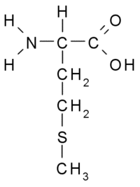

- Functions:
  - Microtubules (actin and filament) – used for movement
  - Histone proteins in DNA
  - Proteins in plasma membrane – act as receptors and transport proteins.
  - Ribosomes – are protein and assemble protein
  - Hormones, i.e. insulin
  - Structural support, i.e. keratin
  - Enzymes
- Polarity:
  - When comparing amino acid to amino acid – the polarity of the molecules in the back bone cancel each other out (amino cancels out with carboxyl group), allowing us only left with the variable group to compare.
  - When comparing the amino acid to another molecule, then you can use the back bone to compare polarities.
  - Amino acids:
    - Nonpolar – only have C-H in R group
    - Polar – have O-S-N in R group
- Protein folding:
  - Primary Structure – linear amino acid sequence, backbones contain peptide bonds
  - Secondary Structure – local folding of polypeptide chain, hydrogen bonds between R groups, from alpha (spiral) and beta sheets (bending over itself)
  - Tertiary Structure – form covalent bonding in the form of disulfide bridges, involves single polypeptide chain.
  - Quaternary Structure – assemble of subunits that have already folded, multiple polypeptide chains could interact to form a fully functional quaternary protein.
- Carbohydrates:
  - Structure:
    - Only contains C-H-O in a ratio of 1-2-1 (rules out proteins and nucleic acids)
    - Arranged in a ring

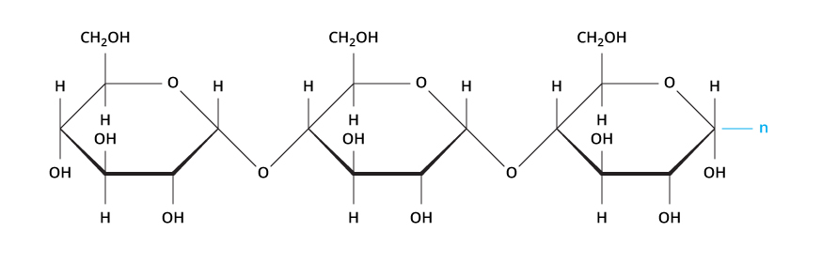
- Functions:
    - Starch in chloroplast
    - Glycocalyx and sugar coating on plasma membrane for cell recognition
    - Makes up cell wall – polysaccharide
    - No function in plasma membrane fluidity
- Lipids:
  - Structure of Triglyceride:
    - Long hydrocarbon chain – fatty acid tail
    - Glycerol head
    - Only made out of C-H-O
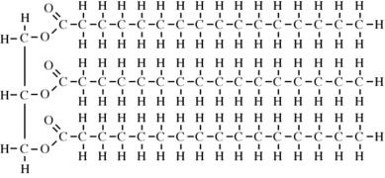
- Functions:
    - Plasma membrane – phospholipids
    - Cholesterol for steroid hormones
- Nucleic Acids:
  - Structure:
    - C-H-O-N-P
    - Phosphate group
    - Nitrogen base
    - Sugar group
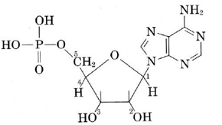
  - Functions:
    - DNA
    - RNA

Topic 3 – Cytoskeleton and Extracellular Matrix

Functions of cytoskeleton
- Provide structure
- Intracellular transport
- Position of organelles within the cell
- Generate force for cell movement
- Contribute to cell division

Relate the structure of the cytoskeletal fibers to their roles in the cell.
- Cytoskeleton: structure that helps cells maintain their shape and internal organization, also provides mechanical support that enables cells to carry out essential functions like division and movement.
  - Types:
    - Microtubules:
      - Largest (25 nm)
      - Composed out of a protein called tubulin (alpha and beta)
      - Involved in mitosis, cell motility, intracellular transport, and maintenance of cell shape.
        - Mitosis – separates chromosomes in anaphase (mitotic spindle).
      - Alpha and beta tubulin subunits assemble to form protofilaments.
      - Single microtubule contains 13 protofilaments.
      - Polarity – Start from (-) end at MTOC centrosome and polymerize at (+) end (grows at + end)
        - MTOC – microtubule organizing center, known as centrosome.
        - Centrosome made up of 9 triplets of microtubules.
      - Create cilia +flagella.
        - 9 pairs of microtubules + 1 pair in the center.
        - Connected by nexin.
      - Use GTP.
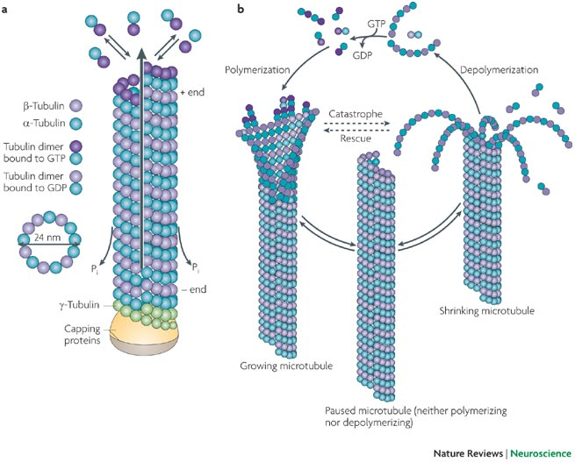
    - Intermediate filaments:
      - Mid-sized (10 nm)
      - Long, strong, ropelike.
      - Commonly work in tandem with microtubules, providing strength and support for the fragile tubulin structures.
      - Formed by an assembly of various proteins.
      - Dimer forms with two IF polypeptides forms protofilament with two aligned dimers dimers form tetramers tetramers stack together and coil to form rope-like structures.
      - No polarity (antiparallel)
      - Withstand stress – give the cell tensile strength.
      - Found in cytoplasm, surrounding nucleus, and radiating out to plasma membrane.
        - Also found in nucleus (nuclear lamina) – found inside the cytoplasm of the nucleus.
      - Microtubules can be rapidly broken down and put together, while intermediate are more stable.
      - No energy used (ATP nor GTP).

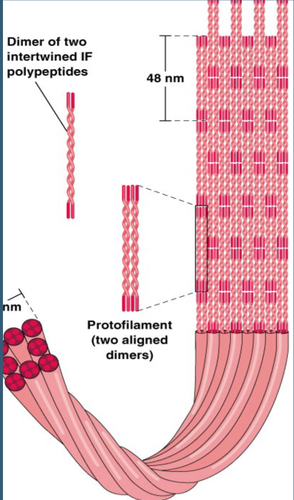
    - Microfilaments:
      - Smallest (6 nm)
      - Monomer – actin
      - Slides along myosin filaments in muscle cells to contract (interaction between actin and myosin).
      - Made up of identical actin proteins arranged in a long spiral chain.
      - Polarity – like microtubules, have plus and minus ends (growth occurring at (+) end).
        - Pushes against cell membrane, gives ability to resist tensile forces.
      - Use ATP

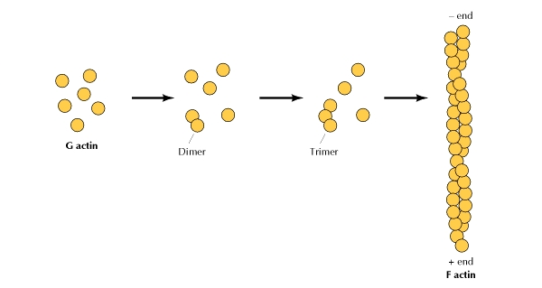

Associate the different cytoskeletal fibers with their preferred molecular motors and contrast their characteristics with respect to their roles.
    - Motor proteins:
      - Structure:
        - Globular ATP-binding heads that function as the motor domain and interact with microtubules.
        - Tail domain that bind to the cargo
      - Types in Microtubules:
        - Kinesin – travel toward positive end (away from centrosome in microtubule/ center of cell), bring cargoes to the periphery of the cell, help keep the ER stretched out towards the periphery of the cell
        - Dynein—travel toward negative end (center of the cell), function to carry cargoes to the center of the cell, keep Golgi towards the center of the cell.
      - Types in Microfilaments:
        - Myosin—binds to actin filaments in muscle cells and releases ATP to contract muscle.

What are the main types of cell-to-cell interactions and their characteristics?
- Required for cell adhesion within a tissue and controlling the shape and function of cells.
- Types:
  - Tight junctions:
    - Hold cells of the same tissue together
    - Prevent movement of water and water-soluble molecules between cells.
    - Ex: tight junction in GI tract serve as a protective barrier from letting low acidity pierce through membrane.
  - Desmosomes:
    - Anchoring junctions bind adjacent cells together like molecular Velcro and help form and internal tension-reducing network of fibers.
  - Gap junctions:
    - Communicating junctions allow ions and small molecules to pass for intracellular communications

Discuss how cellular motility and mobility are different and how they are accomplished.
- Motile – able to move, i.e. a rock rolling downhill is motile
- Mobile – able to move on its own (requires energy, i.e. an animal.
  - Flagellar mobility: a swimming-like motion, i.e. seen in spermatozoa which have flagellum (microtubules)
  - Amoeboid movement: a crawling-like movement, using pseudopods (actin filaments)

Describe what the extracellular matrix is made of, and interpret why it is important to cells.
- Most of a tissues volume is made up of extracellular space
- Provides structural support for the cells embedded within a tissue, also guides division, growth and development.
- Made of—proteoglycans, water, minerals, and fibrous proteins.
- Different in different locations of the body – ECM in bone is thick and highly mineralized (providing a tissue that is hard, inflexible and opaque), in contrast, the ECM of your cornea is water rich, transparent, flexible, jelly like (ideal for transmitting light).
- Also contains fibrous proteins such as collagen, elastin and fibronectin

Centrosome
- Made out of 2 centriole
- Each centriole is made out of 9 pairs or microtubule triplets
- Serves as an anchor for cilia and flagella and for mitotic spindle formation
  - Cilia/flagella structure:
    - 9 x 2 doublets of Microtubules (one pair in the center)
    - Microtubule doublets connected by nexin

Topic 4 – Membrane and Membrane Transport

Discuss the roles of membranes, and in particular the plasma membrane in a cell.
- Membrane structure: defines and encloses the membrane
  - Maintains the physical integrity of the cell (encloses the cytoplasm and organelles.
  - Forms a barrier between the inside of the cell and the outside environment of the cell – allows different chemical environments to exist on each side of the cell membrane.
- Organizes and scaffolds:
  - Organizes different sections of the cell with different environments
  - Ex: enclosed lysosome with low pH does not want to interact with DNA enclosed in nucleus.
- Selective permeability:
  - Allows certain particles to pass through the membrane, into or out of the cell.
  - Allow good things to come in and bad waste to move out.
- Markers and Signaling:
  - Proteins called surface protein markers embedded in the cell membrane identify the cell, enabling nearby cells to communicate with each other.
  - Receptor sites for interaction with specific biochemical such as hormones, neurotransmitters and immune proteins.

Understand and explain the fluid mosaic model. What are the membrane’s properties?
- Fluid mosaic model: components of membrane
  - Phospholipids: 1 polar head two hydrocarbon tails.
    - Hydrophilic head (facing outside) and hydrophobic tail (facing inside – insoluble in water)
      - Known as amphipathic.
      - Double bond in hydrocarbon tails presents kink and influences fluidity
      - Types:
        - Phosphatidylethanolamine – inside
        - Phosphatidylserine (-) – inside; when a cell undergoes apoptosis, the phosphatidylserine (normally located on the cytoplasmic leaflet) is transferred to the outer surface so a macrophage can recognize it.
        - Phosphatidylcholine – outside
        - Sphingomyelin – outside
    - Bilayer – two layers of phospholipids.
      - Why two layers – different environments on inside and outside of cell (outside needs to be more protective), need different receptors to interact with different molecules.
    - Fluidity:
      - Can move side to side (lateral diffusion), flip flop from one layer to the other, rotation, and flexion.
  - Ion channels:
    - Responsible for selective permeability
  - Carrier proteins:
    - Transport specific substances across the cell and membrane
  - Receptors:
    - Receive chemical signals from outside the cell that tell the cell to take specific action.
    - Example – glycolipids (lipid + sugar) important for cellular recognition, antigens, etc.
  - Cholesterol molecules:
    - Support the structure of the membrane and its attachment to other tissues.
    - Play an important role in fluidity
  - Protein markers:
    - Antigens – identify the cell as part of the body.

What affects membrane fluidity
- Length and saturation of fatty acid chains
  - Longer hydrocarbon tails more room to form more bonds low fluidity
  - Shorter hydrocarbon tails less room to form less bonds more fluidity
  - Saturated no double bonds no kinks less fluid
  - Unsaturated double bonds present forms kinks more fluid.
- Polar head groups
  - Phosphatidylcholine – usually on outside, membrane is less fluid
  - Phosphatidylethanolamine – usually on inside, when flipped to outside makes membrane more fluid.
- Sterols
  - Bidirectional regulator:
    - High temperatures (high fluidity): it stabilizes membrane (fills in gaps) and raises melting point.
    - Lower temperatures (low fluidity): intercalates between the phospholipids and prevents them from clustering together and stiffening.
- Temperature:
  - High temperature: gives molecules more energy to move around = more fluid.
  - Low temperature: slows down movement of phospholipids = less fluid.
- Homeoviscious adaptation:
  - The ability to change the membrane’s lipid composition in response the environment in order to maintain membrane fluidity.
  - Enzyme – desaturase, forms double bonds.

Compare the different types of transport across the membrane and give examples for each.
- Functions of proteins:
  - Transport
  - Enzymes
  - Signal transduction
  - Attachment/Recognition
- Types:
  - Integral proteins (transmembrane):
    - Ions channels
    - Transporters
    - Receptors
  - Peripheral proteins: (non-covalently bonded)
    - Spectrin
    - Ankyrin
  - Lipid-anchored proteins: (covalently bonded)
    - Outside protein anchored to lipid in membrane
    - GPI (extracellular – cell adhesion)
    - Fatty acid/prenyl groups (intracellular – cell division and cell growth)

How do we study membranes?
- Microscopy
- Freeze-fracture (inside of membrane)
  - Freeze the membrane
  - Pull apart lipid bilayer
  - Able to see what stays on exterior layer and what stays on interior layer
  - Then you use electron microscopy
- Fluorescence Recovery after Photo bleaching (FRAP)
  - Useful to study to ability of molecules to move within a membrane.
  - Start off with an unlabeled cell surface
  - Cell surface molecules labeled with fluorescent dye
  - Laser beam bleaches an area of the cell surface
  - Fluorescent-labeled molecules diffuse into bleached areas

Movement across cell membrane
- Depends on:
  - Permeability of molecule
  - Concentration/electrochemical gradient (gradients store potential energy)
- Types of transport across membrane:
  - Passive transport:
    - Movement of molecules down the concentration gradient (high low) in order to maintain equilibrium.
    - Types:
      - Diffusion: passes through membrane down its concentration gradient, no need for carrier/channel.
      - Facilitated diffusion: transports across membrane down its concentration gradient with the help of carrier or channel.
      - Osmosis: movement of water through aquaporin to a region with higher osmolality.
  - Active transport:
    - Uses ATP to pump molecules against its concentration gradient (low high)
    - Types:
      - Primary active transport: directly uses ATP to transport molecules across the membrane.
      - Secondary active transport (coupled transport): no direct coupling of ATP, instead it relies upon the electrochemical potential difference created by pumping ions in and out of the cell.
        - Antiport: molecules moving in opposite direction
        - Symport: molecules moving in same direction.
  - Bulk- transport (still requires ATP)
    - Endocytosis
    - Exocytosis
    - Phagocytosis

Topic 5 – Mitochondria and Cell Death

Explain, contrast, and compare the role of mitochondria and chloroplasts in cells with regards to energetics.
- Mitochondria:
  - Found in animal cells
  - Have own DNA (endosymbiosis)
  - Functions:
    - Cellular Respiration: Takes in nutrients and breaks them down to give the cell energy – takes energy from sugar/glucose and converts them into a simpler form called ATP, that the cell can use.
    - Cell death
    - Response to stress
    - Calcium storage
  - Components:
    - Cristae: the compartment formed by the inner and outer membrane of the mitochondria; it is the layer of folds in the mitochondria and is studded with ribosomes.
    - Matrix: the fluid inside the folding’s.
  - How to study mitochondria:
    - Centrifugation:
      - Low speed: separates nucleus from other particles.
      - Moderate speed: separates mitochondria from other particles.
      - High speed: separates membranes from
- Chloroplasts:
  - Found in plan/algae cells.
  - Have own DNA (endosymbiosis)
  - Functions:
    - Photosynthesis: Produces food for the cell – converts solar energy into chemical energy (sugar).
    - Plant immunity – pathogen defense.
  - Components:
    - Thylakoid: traps sunlight
    - Granum: stacks of thylakoid
    - Stroma: fluid inside the outer membrane which interacts with the cytoplasm surrounding the thylakoid and granum.

Metabolic Function of mitochondria
- Fatty acid beta-oxidation
- Krebs cycle – 2 ATP (glycolysis also makes 2 NET)
- Electron Transport Chain – 32 ATP
  - Limitations:
    - Entry of electrons from glycolysis into mitochondrion.
    - Use of mitochondrial proton gradient for transport
    - Oxidative phosphorylation is regulated by supply of ADP.
- Heme biosynthesis
- Steroidogenesis
- Fe/S complex assemble
- Amino acid metabolism -- urea
- Gluconeogenesis
- Ketogenesis

Cellular Respiration
- Glycolysis:
  - Under anaerobic or aerobic conditions
  - Generates 2 ATP NET (2 ATP must be used to convert glucose into fructose-6-biphosphate so that it can create a gradient).
  - End Products:
    - 2 pyruvate
    - 2 ATP
    - 2 H2O
    - 2 NADH
- Krebs’s Cycle:
  - 2 pyruvate converted to Acetyl-CoA before enters mitochondria/Krebs cycle.
  - Only under aerobic conditions.
  - End Products:
    - 2 ATP
    - 3 NADH
    - 2 FADH
    - CO2
- Electron Transport Chain:
  - Uses built up H+ ions from NADH and FADH to create concentration gradient and proton motive force through F pump. Each H+ ion that moves through rotates the F pump and converts ADP ATP.

Understand the importance of calcium homeostasis (availability, storage, regulation, provide examples of cellular functions that rely on calcium).
- Physiological and biochemical functions that need Ca++:
  - Response to stimuli, i.e. vesicle secretion
  - Muscle contraction
  - Signaling (second messenger)
  - Enzymatic cofactor
  - Bones
  - Closing of stomata
  - Metabolism
  - TOO MUCH – toxic to cells.
- Regulation of Calcium:
  - Concentration gradient
    - Channels and transporters
  - Binding proteins
    - Calsequestrin
  - Storage:
    - ER
    - Mitochondria

What is mitophagy and how/why does it occur?
- Mitophagy: selectively remove damaged or reduce the number of mitochondria by autophagy. It often occurs to defective mitochondria following damage or stress.
- Steps:
  - PINK released and increased concentrations in mitochondria.
  - PINK recruits Parkin
  - Parkin is an ubiquitin-ligase (degrades proteins)
  - Ubiquitin signals phagosome of mitochondria.

Describe and differentiate the two cell-death mechanisms and explain the role of mitochondria and calcium in both.
- Why do cells die:
  - Invaded by damaging microorganism
  - Too many cells
  - Cells need to develop – in growth (apoptosis)
- What triggers cell death:
  - Chemical messengers
  - Stress
  - Cell cycle points
- Types of Cell Death:
  - Necrosis:
    - Steps:
      - Normal cell
      - Swelling (reversible)
      - Swelling (irreversible)
      - Disintegration
    - Calpain-cathepsin pathway:
      - Intracellular Ca++ increases from ECF as well as E.R.
      - Calpain becomes activated by increase in intracellular Ca++.
      - Activated calpain degrades lysosome’s membrane.
      - Lysosome ruptures and releases cathepsin.
      - Cathepsin is a protease which digests cellular content.
  - Apoptosis
    - Steps:
      - Normal cell
      - Condensation – chromatin condenses
      - Fragmentation – nucleus is fragmented, DNA laddering, blebbing, loss of adhesion.
      - Apoptotic bodies – phosphatidylserine (negative phospholipid) flips to exterior side of plasma membrane to signal phagocytosis by macrophage.
    - Intrinsic pathway: First seen in C. elegans (nematode)
- Nitric oxide, toxins, cytokines, etc. are released into the cell.
- Increase in toxins releases BAD
- BAD then activates BAX and BAK and inhibits BCL2
- BAX and BAK activate IP3
- Activation of IP3 channel on ER (with no longer BCL2 inhibiting it), releases Calcium from the ER.
- To compensate for increase of intracellular Calcium from ER, the mitochondria increase uptake of Calcium
- Increase in mitochondrial Calcium opens the permeability transition pore (PTP).
- The opening of the PTP releases cytochrome C.
- Cytochrome C binds with APAF-1 and CAS9 to form apoptosome.
- Apoptosome releases caspases.
- Caspases = disrupt cell adhesion, disassembly of nuclear envelope, change cell shape and size, DNA fragmentation.
- Apoptotic bodies are now formed and ingested by phagocytes.
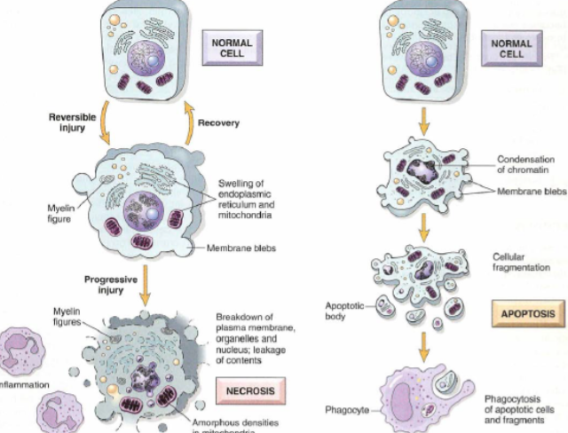

Topic 6 – Signal Transduction

Explain and give examples of cellular communication and the role it plays in cellular biology.
- Functions of Cellular Communication:
  - Development
  - Hormonal regulation and homeostasis.
  - Cell growth, survival, cancer
  - Immunity
  - Physiology

Define the 3 steps of cell communication
- Signaling molecule:
  - Nature of the message?
  - Who sends the message? How?
  - Where is the message sent?
- Receptor:
  - How is the message received?
- Intracellular events:
  - Interpret the message.
  - Relay the message
  - Set-up a response
- Response:
  - Act upon the message.

Know and differentiate the 6 paths of communication between cells
- Autocrine:
  - Signal is received from same cell it is released from.
- Paracrine:
  - Signal is received from a cell in close proximity to the cell that released the signal.
- Endocrine:
  - Release of hormones into the blood.
- Cell-to-cell:
  - Signal travels directly into adjacent cell through gap junctions.
- Neuronal signaling:
  - Release of neurotransmitters.

Identify and differentiate the 6 messenger classes and their characteristics
- Their structure will determine:
  - Their chemical properties (hydrophobic/hydrophilic)
  - Their communication path taken to reach target cell
  - Their mode of action/ interaction with the cell and receptors.
- Types of Ligands:
  - Steroids:
    - Derived from cholesterol
    - Lipophilic— will diffuse across membrane and become bound to transport protein in the cytoplasm (intracellular receptors).
    - Usually act as gene transcription factors.
    - Classes:
      - Mineralocorticoids (aldosterone)
      - Glucocorticoids (cortisol)
      - Sex hormones (testosterone/estrogen)
  - Lipids (Eicosanoids):
    - Derived from arachidonic acid
    - Lipophilic – can diffuse through membrane
    - Paracrine pathway – signal travels to a cell nearby
    - Pathways:
      - Prostaglandins – pain
      - Inflammation – leukotrienes.
  - Peptides/Proteins
    - Hydrophilic – have to bind to surface receptor and activate second messenger.
    - Packaged in secretory vesicles.
    - Secreted by exocytosis.
  - Purines
    - Derived from nitrogenous base adenine or guanine.
    - Need a transporter
    - Use paracrine and endocrine path.
  - Amines
    - Have an amine group
    - Biosynthesized from an amino acid
    - Hydrophilic – need to bind to surface receptor.
    - Many are NT’s – epinephrine, histamine.
    - Exception – thyroid hormones are hydrophobic.
  - Gases:
    - Small (short life span)
    - Passively diffuse
    - Indirect and direct pathways
    - Example – NO, O2, CO.

Know and recognize the 4 different classes of receptors
- Receptors:
  - Activation leads to relaying and amplifying the signal inside the cell.
  - Maximal cellular response with minimal ligand.
  - Interaction with receptor is the first level of discrimination
- Types of receptors:
  - Transmembrane receptors:
    - Integral proteins that span the membrane
    - Ligand binding portion is found on the outside of the membrane
    - Ligands are mostly hydrophilic.
    - Ligand binding induces a change in conformation that relays the message inside the cell to second messengers.
    - Types:
      - Ligand-gated ion channel
      - Receptor-enzyme
      - G-protein coupled receptor
  - Intracellular receptors:
    - Can be found in the cytoplasm or in the nucleus.
    - Lipophilic (steroids, eicosanoids, gases) or very small ligands will diffuse and reach these receptors.
    - Ligand-receptor complex acts as a TRANSCRIPTION FACTOR!
      - Enters nucleus binds to specific areas of DNA (gene promoter sequence) activates or inhibits gene transcription forms mRNA protein is made through ribosome.

Define what is cellular signaling and transduction

Identify and compare the basic signaling pathways:
- Intracellular receptors:
  - Ligand binds to either binding site on DNA or to intracellular receptor
  - Ligand is a transcription factor.
- Ligand gated ions channels:
  - Important for nervous system – binds to many NT’s.
  - Types:
    - Chemically-gated ion channels: respond to ligands and NT’s, i.e. ACh.
    - Voltage-gated ion channels: respond to change in voltage.
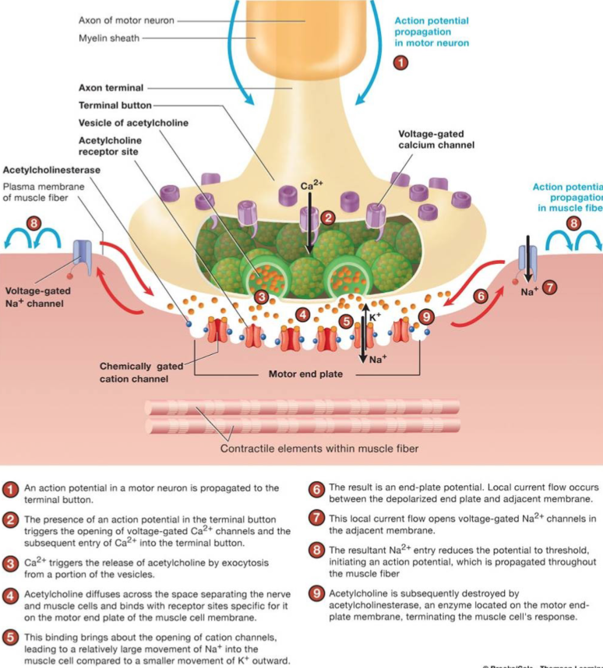

- Enzymatic receptors (tyrosine kinase receptors):
  - Intracellular catalytic domain acts as an enzyme.
  - Initiates a cascade of phosphorylation/dephosphorylation that amplifies the ligand’s impact on target cell.
  - Tyrosine-kinase:
    - Leads to survival, growth, proliferation, and metabolism.
    - Activation requires dimerization and autophosphorylation of receptor.
    - Signaling is initiated via an area called an SH2 domain.
    - Second messengers include RAS and phospholipids.
    - Ligands = insulin + growth factor.
    - Pathway:
- Ligand (growth factor or insulin) binds to receptor.
- Receptor dimerizes THEN auto phosphorylate of tyrosine’s.
- SOS and GRB2 (cytosolic proteins) bind to intracellular SH2 domains.
- Activated GRB2-SOS stimulates RAS GDP exchange for GTP.
- RAS stimulates RAf.
- RAF stimulates MEK
- MEK stimulates MAP-kinase to enter nucleus to signal AP-1.
- AP-1 signals transcription (can be of BCL2 for cell survival)
- BACK TO STEP 3…
- Activation of SH2 domains can activate PLCy.
- PLCy then activates PIP2 to stimulate InsP3 pathway.
- INSP3 is stimulated an opens channel on ER to release Ca++.
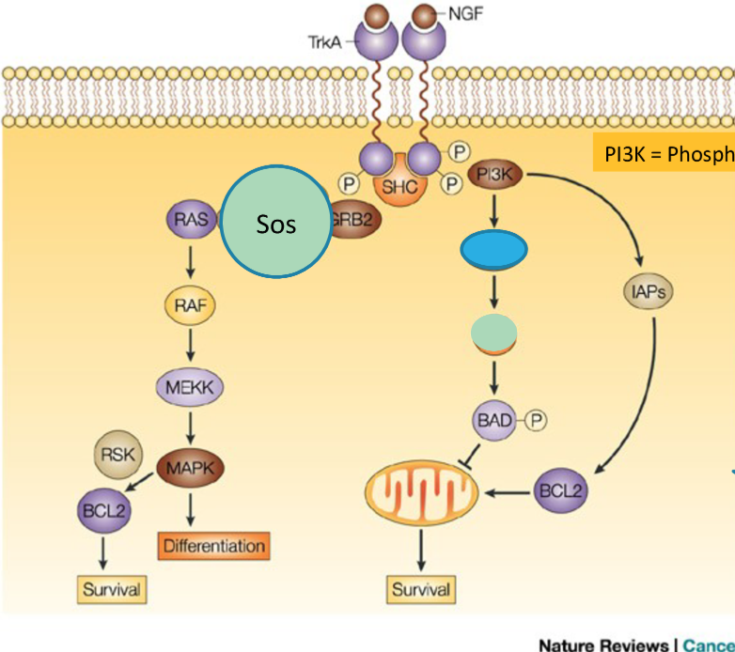

- GPCR (cAMP and IP3 pathways)
  - Responds to NT, hormones, odorants, tastants, and photons of light.
  - 2 main pathways:
    - cAMP
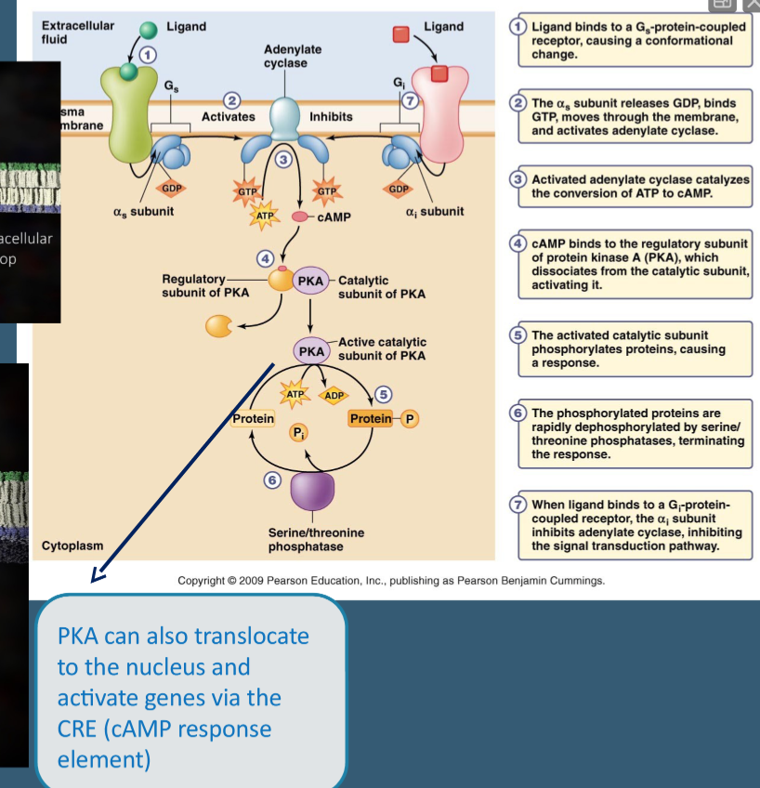
    - PIP (IP3)
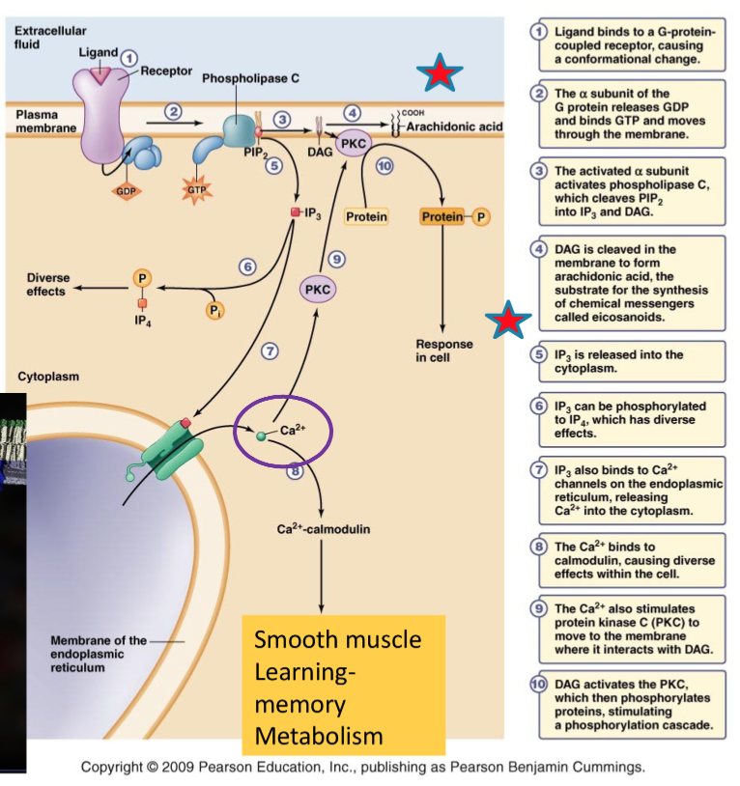

Recognize and describe the mechanisms (6) that terminate a cellular response.
- Ligand removed by distant tissue
- Ligand up taken by adjacent cell
- Ligand degraded by extracellular enzymes.
- Ligand-receptor complex removed by endocytosis.
- Receptor inactivation.
- Inactivation of signal transduction pathway.

Topic 7 – Transcription

Understand, describe, and demonstrate the steps involved in transcribing DNA to mRNA.
    - Although DNA contains the genetic information that is used by the cell to synthesize many different proteins but the DNA molecule is not directly involved in protein synthesis – uses intermediate molecules called RNA.
      - RNA
        - Polymer of nucleotides
        - Contains ribose instead of deoxyribose
        - Uracil instead of thymine (pairs with adenine)
        - Exist as a single strand – allows to pass through nuclear pores from nucleus to cytoplasm.
        - Types:
          - mRNA:
            - From nucleus to cytoplasm
            - Combine with ribosome to form proteins.
            - In prokaryotic organisms – a single mRNA molecule can synthesize many different proteins
- rRNA:
  - Made in nucleolus and combines with appropriate proteins to form ribosomal subunits. These subunits then move into the cytoplasm separately, where they eventually combine to form ribosomes.
- tRNA:
  - When mRNA combine with ribosomes, mRNA contain three sequence nucleotide (codon) which stands for a type of amino acid.
  - tRNA brings appropriate amino acid and bring it into ribosome and attach it to growing polypeptide chain.
- Why use RNA instead of DNA:
  - Ensures we do not damage DNA – it is essential for survival of cell and offspring.
- Transcription: occurs in nucleus or mitochondria
- Initiation
  - First step in transcription is to find initiating point (location where we want to unwind DNA molecule). A group of proteins known as initiation factors move along the DNA until they reach the promoter region. Promoter region is a special sequence of DNA nucleotides that signals the RNA polymerase to join the protein complex and begin synthesis of the RNA strand.
  - RNA polymerase can unwind DNA, DNA polymerase cannot (done by DNA helicase).
    - Eukaryotic promoter.
    - Several transcription factors bind to DNA
    - RNA polymerase binds to transcription factors to from Transcription Initiation complex.
- Elongation
  - Once RNA polymerase unwinds the DNA, it creates a bubble that exposes single-strands of DNA.
  - Forms transcription bubble.
  - Only one of these DNA strands is actually used to synthesize RNA molecule (template strand)
  - Reads DNA from 3’-5’ (template strand) so it can synthesize mRNA 5’-3’ (like DNA polymerase).
  - Thymine is switched to uracil.
  - Not like DNA – does not proofread or make correction
- Termination
  - Just like there is a sequence of nucleotides that initiate the process of transcription, also sequence of nucleotides that signals process of termination – known as termination sequence.
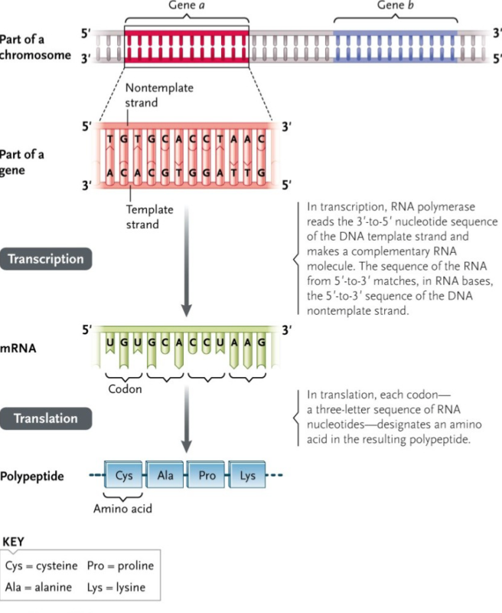

Be familiar with the elements comprised in a transcription initiation complex and its role.
- Begin Transcription:
  - Regions known as promotor regions – specific sequence of nucleotides that can bind easily to RNA polymerase.
  - Eukaryotes:
    - TATAA box.
    - Additional protein come and complete the Transcription Initiation Complex (include transcription factors and regulatory elements).
      - Provides stability and allows RNA pol 2 to come and start transcription.
      - Enhancer sequence – increases efficiency of RNA polymerase, upstream to promotor.
- End transcription:
  - Termination sequence.

Explain and demonstrate RNA maturation and splicing
- Once transcription is over – mRNA is not mature yet (known as pre-messenger RNA).
- To become mature:
  - 5’-Guanine Cap:
    - 5’ of precursor mRNA is altered by addition of guanine nucleotide.
    - 20-40 nucleotides
    - Function of cap is to protect the mRNA from degrading during protein synthesis. It also stabilizes the mRNA and aids in transport across the nuclear membrane.
  - Poly-A tail at 3’:
    - Before leaves nucleus
    - Add adenosine nucleotides
    - 50-200 adenosine added
    - Function: provides stability and keeps the tail from degrading and aids in transport.
  - Splicing of introns:
    - Remove introns and combine exons.
    - Introns do not code for protein.
    - SnRNP’s combine with other proteins to form spliceosomes.
      - Spliceosomes recognize the ends of introns and catalyze their cleavage.
      - The ends of exons after removal of introns will be joined together for a continuous coding sequence.
      - Pre-mRNA can be 27,000 NT’s long and mRNA becomes 1,200 NT’s long to make a protein out of 400 AA’s (from triplet codon).

Compare and contrast RNA transcription in prokaryotes vs. eukaryotes.
- Prokaryotes:
  - DNA is directly transcribed to mRNA – can occur at anytime
  - In termination:
    - Rho dependent – Unwinds at 3’ end.
    - Rho independent – GC rich sequence forms hairpin loop to pull RNA away from DNA.
- Eukaryotes:
  - mRNA must mature before entering translation
  - Termination:
    - Poly-A tail

Know, describe, and/or compare the different elements of control of gene expression in prokaryotes vs. eukaryotes
- Activators (enhancers)
- Repressors (silencers):
  - Binds to repressor and blocks RNA polymerase.
- Alternative splicing
- Operons (in prokaryotes)
  - On and off switch that control transcription
  - Example: lac operon
    - Lactose is absent:
      - Repressor bound to operator, operator repressed.
      - In the absence of lactose, the repressor remains bound to the operator, and RNA polymerase is therefore prevented from moving down the lac operon and transcribing its genes.
    - Lactose is present:
      - Repressor not bound to operator, operon depressed.
      - In the presence of lactose, the repressor is converted to its inactive form, which does not bind to the operator. RNA polymerase can therefore move past the operator and transcribe the lacZ, lacY, and lacA genes into a single mRNA.
miRISC
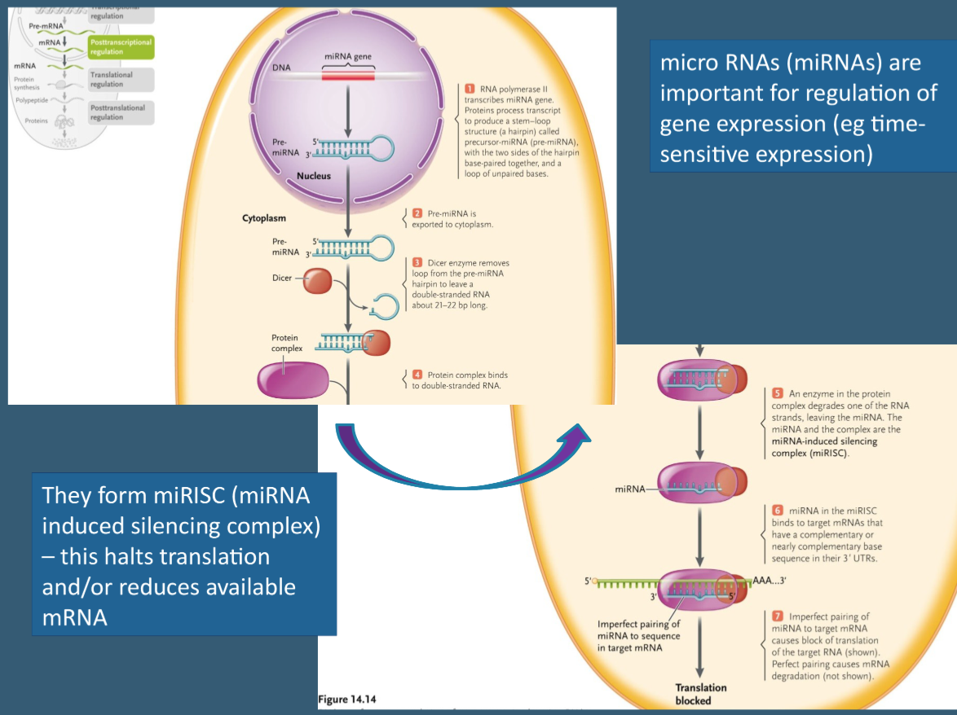

Topic 8 – Translation

Know the components and roles of a ribosome
- What are ribosomes made of?
  - rRNA and protein
  - Separate parts synthesized in the nucleus but put together in cytoplasm.
  - Made of two parts: top (large) and bottom (small)
    - mRNA passes through the two parts
    - tRNA brings amino acids matching codon.
- What are tRNA’s:
  - tRNA’s carry the amino acids to at their 3’ end, and recognize the mRNA sequence (codon) in their anticodon region.
  - Thanks to the wobble effect (oscillation) humans only need 31 tRNA’s to accommodate the 61 codons.
Understand and demonstrate the different steps involved in translation
- Initiation
  - Pre-mRNA must undergo post-transcriptional modifications (G-cap, poly-A tail, splice introns) and exit nucleus through nuclear pore to reach ribosomes in the cytoplasm.
  - Once mRNA enters cytoplasm, proteins called initiation factors help the mRNA find the small ribosomal subunit (ribosome binds to 5’ of mRNA).
  - mRNA runs through small ribosomal subunit until it reaches the start codon (AUG) on mRNA.
  - Once ribosome has found the start codon (AUG), it sends out signaling molecules to help bring the first tRNA containing the amino acid methionine to P site. tRNA contains complementary sequence to AUG on mRNA (aminoacyl transferase is what attaches amino acid to tRNA using ATP).
  - Once first tRNA is in P site, the small ribosomal subunits attach to the large ribosomal subunit to form ribosome.
- Elongation (elongation factors help move the mRNA)
  - Aminoacyl tRNA – amino acid is bound to tRNA by aminoacyl transferase.
  - Three locations in ribosome:
    - A site:
      - To the right of P site.
      - Once the P site is filled with tRNA carrying methionine, the A site fills with next tRNA carrying the next amino acid at its 3’ end and correct anticodon at the bottom.
    - P site:
      - In-between the A and E site.
      - Where first charged tRNA binds to start codon
    - E site:
      - To the left of the P site.
      - Where the last tRNA exits the ribosome to find another amino acid.
  - Once the P site is filled with first tRNA and the second tRNA is brought the A site, an enzyme called peptidyl transferase catalyzes the formation of the peptide bond between the amino acids in the P site and A site. Once the peptide bond is formed, the amino acid detaches from the tRNA in the P site.
  - In the next step, the ribosome complex moves the three nucleotides in the 5’-3’ direction along the mRNA (known as translocation). This moves the tRNA in the P site into the E sit and it relocates the tRNA carrying the growing polypeptide into the P site.
  - Once the tRNA is moved into the E site, it is then expelled out of the ribosome complex.
  - Once the A site is empty, the process can repeat itself to add another amino acid. This continues until the polypeptide chain is complete.
- Termination
  - Translation is terminated when a stop codon arrives at the aminoacyl site.
  - Occurs when tRNA reaches stop codon which signals process of termination.
  - Stop codon makes the ribosomes signal release factor (RF) protein to occupy the A site, promoting the last peptide bond formation and translocation.
  - Makes growing polypeptide chain break off
  - Ribosome breaks down and can be recycled.
  - tRNA leaves from E site and A site.

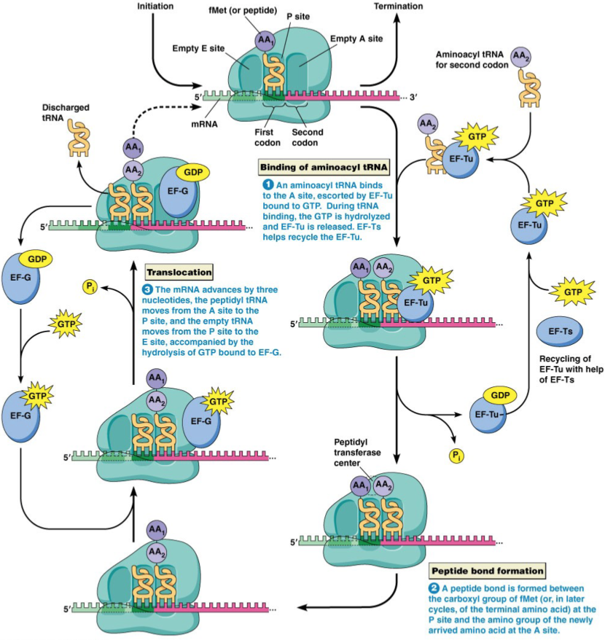
- ** Polysome—an mRNA can be translated by more than one ribosome at a time – giving rise to multiple polypeptides.

Using the codon table, be able to obtain the amino acid sequence corresponding to a given
DNA strand

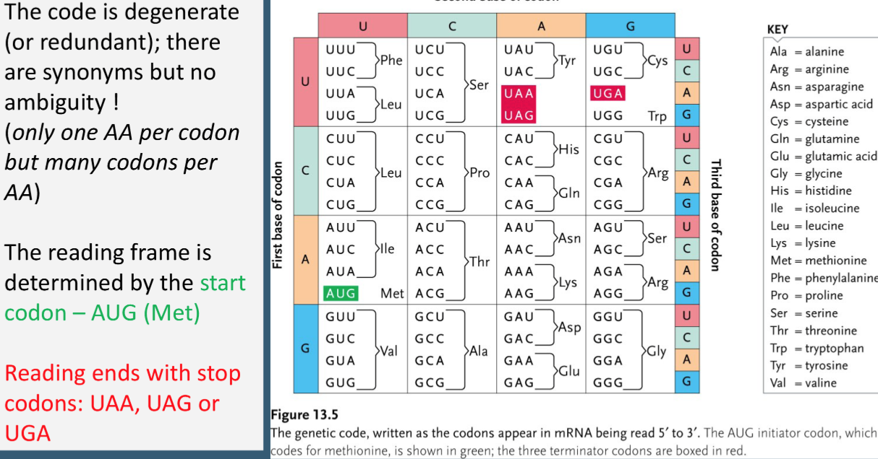

Define and explain, using an example, the different genetic point mutations possible mutagens
- Mutations can be caused by:
  - Errors during DNA replication or transcription
  - Mutagenic agents (radiation, chemicals, UV)
  - Viruses and microorganisms.
- Types of Mutations:
  - Missense mutation: change in nucleotide sequence leads to change in amino acids (can have profound effect).
  - Nonsense mutation: like missense mutation, a nonsense mutation is also a change in one DNA base pair. Instead of substituting one amino acid for another, however, the altered DNA sequence prematurely signals the cell to stop building a protein. This type of mutation results in a shortened protein that may function improperly or not at all.
  - Silent mutation: when the codon sequence on mRNA changed to another codon but codes for the same amino acid, therefore no change in protein.
  - Frameshift mutation: mutation arises from a deletion or insertion of a base pair which shifts the reading frame off by one from here on which leads to coding of different amino acids.

Discuss/Compare the possible scenarios for protein sorting following translation
- Begin in ER, continue in Golgi
- Occur after translation is complete
- Important for folding, sorting, protection, and final location/function.
- Type:
  - Glycosylation: Add sugar to amino acid side chain (sorting in Golgi; functional)
  - Acetylation: add acetyl group to N term (increase stability)
  - Disulfide bond: links s between residues
  - Lipidation: add lipids ubiquitination

Relate vesicular transport to the cytoskeletal elements and motor proteins previously discussed
- ??

Analyze a cascade of events from a messenger molecule to a nuclear response, including protein secretion.

Topic 9 – DNA Replication

Understand the structure and organization of DNA (including nucleotides)
- DNA:
  - Stores genetic information
  - Made up of nucleotides (bind by phosphodiester bonds)
    - Sugar
    - Nitrogenous base
      - Adenine (2 rings – purines)
      - Guanine (2 rings – purines)
      - Thymine (1 ring – pyrimidine)
      - Cytosine (1 ring – pyrimidine)
      - Uracil in RNA instead of thymine.
    - Phosphate group
  - Double helix antiparallel by hydrogen bonds (has to be around 2nm).
    - Guanine always forms hydrogen bonds with cytosine.
    - Adenine always forms hydrogen bonds with thymine.
    - If first strand runs in 5’-3’ direction, the complementary strand will run in 3’-5’ direction.
  - How chromosomes are formed:
- Start with DNA
- DNA wraps around histones
- Each nucleosome consists of 8 histones.
- Nucleosome + 1 H histone combine to form a chromatosome
- Chromatosomes fold up to form a 30 nm fiber.
- 30 nm fibers fold again to form a 300 nm fiber.
- After coiling of 300nm fiber to form 250 nm fiber you produce the chromatid of a chromosome.
- Meselson-Stahl Experiment:
    - Three hypotheses of how DNA makes a copy of itself:
      - Semi-conservative: unfold DNA and make a template from either side.
      - Conservative: make an exact duplicate of both strands without unfolding.
      - Dispersive: DNA chunks itself into 10-12 segments and copies those segments.
    - Experiment:
      - Grew E. Coli in heavy nitrogen (nitrogen is normally 14, but heavy nitrogen has an extra neutron making it slightly heavier)
      - Spin in centrifuge – heavy will go to bottom
      - Added heavy nitrogen to lighter nitrogen
      - First generation of new template strand has N-15 and N-14 (half and half).
      - Second generation – half-light (2 DNA strands) and half-mixed (2 DNA strands)

Understand and demonstrate the steps involved in DNA replication
- Prokaryotes:
  - Circular chromosome is replicated from single origin (ori).
- Eukaryotes:
  - Unwinding:
    - DNA is two single stranded molecules bonded by hydrogen bonds between nitrogenous bases.
    - Before DNA is replicated it must unwind.
    - DNA wants to naturally exist as double strand so to unwind molecule so must use enzyme helicase
    - Helicase binds to DNA on origin of replication – acts to unwind double stranded DNA
    - In addition, have single stranded binding proteins that bind to individual unwound DNA molecules to stay apart from one another.
  - Beginning of replication:
    - RNA primase binds to single stranded DNA and adds RNA primer – a series of RNA nucleotides – this signals DNA polymerase to bind to primer to initiate replication.
    - DNA polymerase binds to primer region and adds nucleotides complementary to template strand.
    - Original DNA – parent strand, new DNA – daughter strand.
  - Bidirectional process:
    - 5’-3’ parent strand: lagging strand
      - RNA primase forms many RNA primers
      - DNA polymerase binds to primer and runs in opposite direction.
      - Fragments are known as Okazaki fragments.
    - 3’-5’ parent strand: leading strand – synthesized continuously
    - DNA polymerase can only read the DNA in the 3’-5’ direction. Therefore, can only synthesize daughter strand in 5’-3’ direction.
    - Starts at origin and moves toward fork of replication.

Explain DNA protection and correction

Topic 10 – Cell Cycle

- Control of the cell cycle is necessary for a couple of reasons. First, if the cell cycle were not regulated, cells could constantly undergo cell division. While this may be beneficial to certain cells, on the whole constant reproduction without cause would be biologically wasteful. Second, internal regulation of the cell cycle is necessary to signal passage from one phase to the next at appropriate times. This regulation is not achieved through strict time constraints, but rather with feedback from the cell.
- A Cdks is an enzyme that adds negatively charged phosphate groups to other molecules in a process called phosphorylation. Through phosphorylation, Cdks signal the cell that it is ready to pass into the next stage of the cell cycle. As their name suggests, Cyclin-Dependent Protein Kinases are dependent on cyclins, another class of regulatory proteins. Cyclins bind to Cdks, activating the Cdks to phosphorylate other molecules.

