Respiratory System – Anatomy

Introduction

The major function of respiratory system is to supply the body with O2 and dispose of CO2. For this to happen, four processes must occur:

- Pulmonary ventilation (Breathing): Movement of air in and out of lungs (during inspiration and expiration) so the gases there are continuously changed and refreshed.
- External respiration: Exchange of gases between blood and air of alveoli. O2 diffuses from the lungs to the blood, and CO2 diffuses from the blood to the lungs.
- Transport of respiratory gases: Role of blood as the transporting fluid in transport of gases between lungs and tissues of the body
- Internal respiration: Exchange of gases between blood in systemic capillaries and tissue cells. Oxygen diffuses from blood to tissue cells and CO2 diffuses from tissue cells to blood.

**The first two functions are handled by the respiratory system and the other two functions are handled by the cardiovascular system.

Two Types of Zones

- Respiratory zone: (Site of gas exchange)
- Composed of respiratory bronchioles, alveolar ducts and alveoli (microscopic)

- Conducting zone: (Passageways)
- Nose, nasal cavity, pharynx, larynx, trachea, bronchi, bronchioles, terminal bronchioles
- As well as providing a passageway, conducting zone organs also cleanse, humidify and warm incoming air

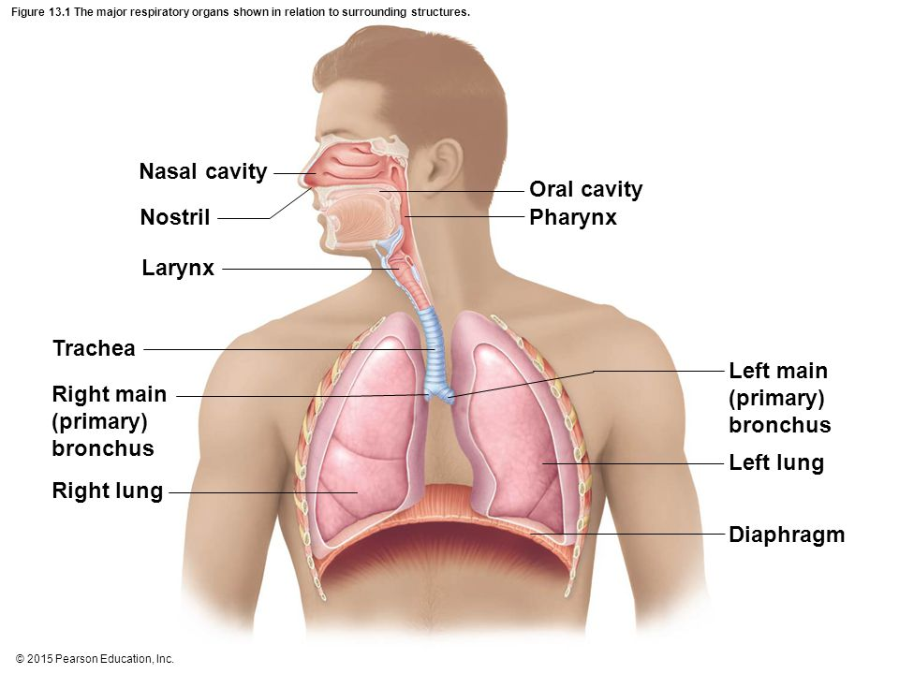

Nose, Paranasal Sinuses and Pharynx (Upper Respiratory System)

The Nose and Paranasal Sinuses

NOSE

- Only external part of respiratory system
- Some functions of the nose include…
- Provides an airway for respiration
- Moistens and warms incoming air
- Filters and cleans inspired air
- Serves as a resonating chamber for speech
- Houses the olfactory (smell) receptors
- The structures of the nose are divided into the external nose and the internal nasal cavity
- External Nose
- External noses vary in size and shape, largely because of differences in nasal cartilages.
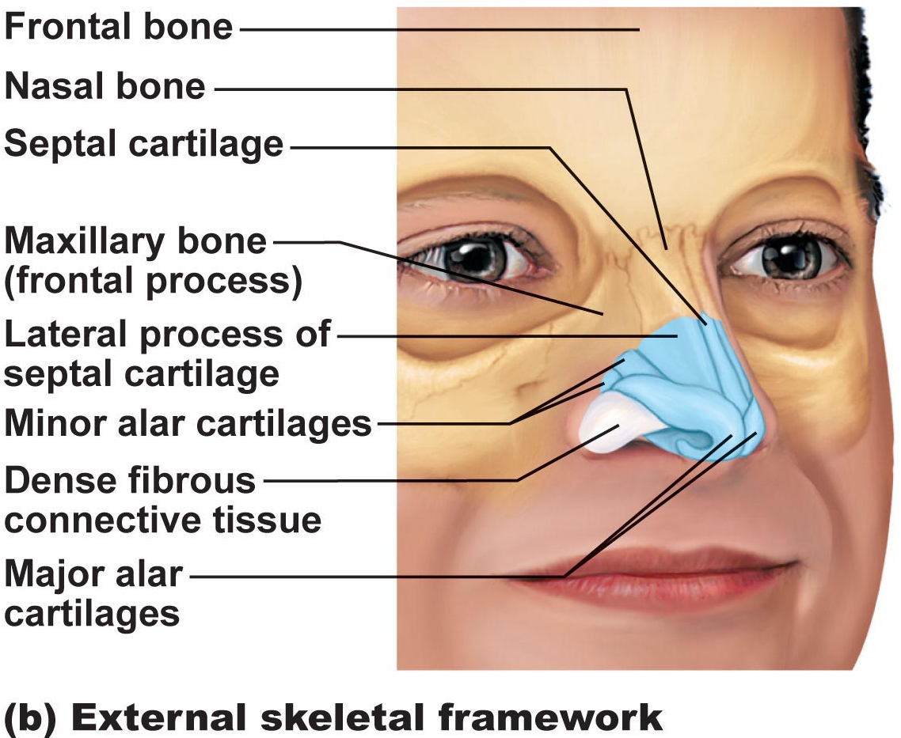
- The skin covering the nose’s anterior and lateral aspects is thin and contains many sebaceous glands.

- Internal Nasal Cavity
- During breathing, air enters the nasal cavity by passing through the nostrils or nares. The nasal cavity is divided by a midline nasal septum, formed anteriorly by cartilage and posteriorly by bone. Air then goes in via internal nares to the nasopharynx.
- Roof of nasal cavity is formed by ethmoid and sphenoid bones of skull
- Floor of nasal cavity formed by palate (anterior is hard; posterior is soft)
- The hairs or vibrissae, filter coarse particles (dust, pollen) from the inspired air.
- The rest of the nasal cavity is lined by two types of mucosa membrane.
- Olfactory Mucosa: Contains receptors for sense of smell
- Respiratory mucosa: Is a pseudostratified ciliated columnar epithelium, containing scattered goblet cells, that rests on a lamina propria richly supplied with mucous and serous glands (1 L/day sticky mucus containing lysozyme, an antibacterial enzyme)
- Respiratory mucosa cilia move contaminated mucus posteriorly to pharynx (throat) where it is slowly shallowed and digested. Cold air slows down cilia resulting in runny nose.
- Thin-walled veins underlie the nasal epithelium. When the inspires air is cold, the vascular plexus becomes engorged with blood, intensifying the air heating process. Because these blood vessels are abundant and located superficially, nosebleeds are common.
- Nasal mucosa is richly supplied with sensory nerve endings, and contact with irritating particles (dust, pollen) triggers a sneeze reflex.
- Nasal Conchae
- Protruding medially from each lateral wall of the nasal cavity are three scroll-like mucosa-covered projections, the superior, middle and inferior nasal conchae. The conchae greatly increase the mucosal surface area exposed to the air and enhance air turbulence in the cavity, resulting for more nongaseous particles to be trapped onto the mucous-coated surfaces.
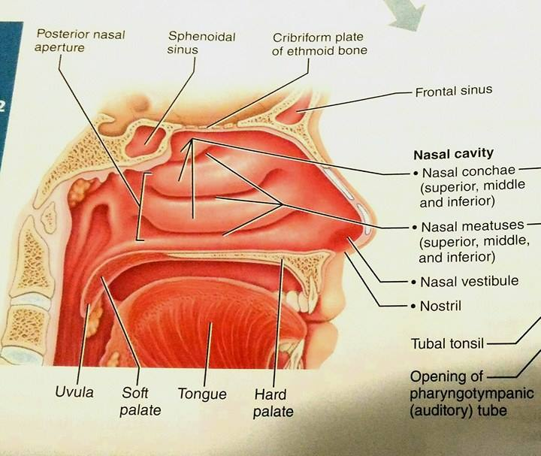

Paranasal Sinuses

- Surrounds the nasal cavity
- They are located in the frontal, sphenoid, ethmoid and maxillary bones
- The sinuses lighten the skull and they help warm and moisten air
- The mucus they produce flows into the nasal cavity, and the suctioning effect created by the nose blowing helps drain the sinuses.
- Sinus headache: Passageways connecting sinuses to nasal cavity is blocked and the air in the sinus is absorbed like a partial vacuum.
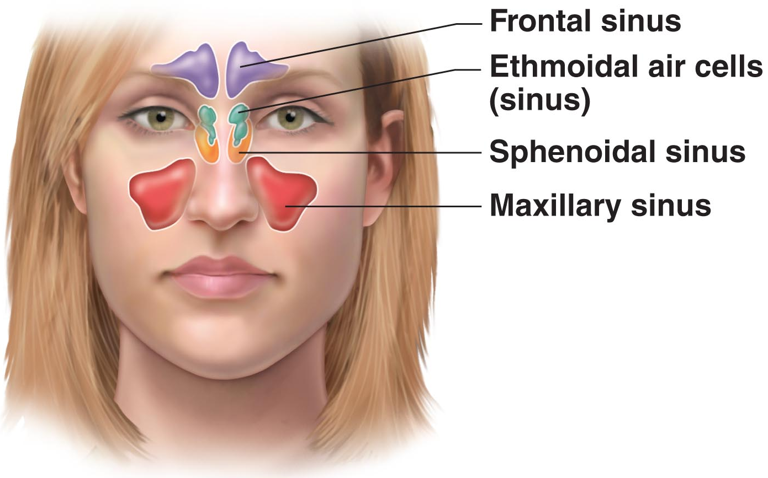

Pharynx (Throat)

- Common pathway for food and air
- It is composed of skeletal muscle throughout its length (13 cm), but its cellular composition of it mucosa varies from one pharyngeal region to another.
- The pharynx is divided into three regions – the nasopharynx, oropharynx and laryngopharynx.

- Nasopharynx
- Is posterior to the nasal cavity, inferior to the sphenoid bone, and superior to the level of the soft palate.
- Because it lies above the point where food enters the body, it serves only as an air passageway. During swallowing, the soft palate and its pendulous uvula move superiorly, an actions that closes off the nasopharynx and prevents food from entering the nasal cavity.
- High on its posterior wall is pharyngeal tonsils which trap and destroy pathogens entering the nasopharynx in air.
- Pharyngotympanic (auditory) tubes, which drain the middle ear cavities and allow middle ear pressure to equalize with atmospheric pressure, open into the lateral walls of the nasopharynx.

- Oropharynx
- Lies posterior to the oral cavity and is continuous with it through an archway called fauces.
- Because the oropharynx extends inferiorly from the level of soft palate to the epiglottis, both swallowed food and inhaled air pass through it.
- As the nasopharynx blends into the oropharynx, the epithelium changes from pseudostratified columnar to a more protective stratified squamous epithelium. This structural adaption accommodates the increased friction and chemical trauma (characteristic hot and spicy foods) accompanying food passage.
- The paired palatine tonsils lie embedded in the lateral walls of the oropharyngeal mucosa just posterior to the oral cavity. The lingual tonsil covers the posterior surface of the tongue.

- Laryngopharynx
- Serves as a passageway for food and air
- Is lined with stratified squamous epithelium
- From epiglottis to larynx, where the respiratory and GI pathways diverge
- Is continuous with the esophagus. The esophagus conducts food and fluids to the stomach; air enters the larynx anteriorly. During swallowing, food has right of way and air passage temporarily stops.

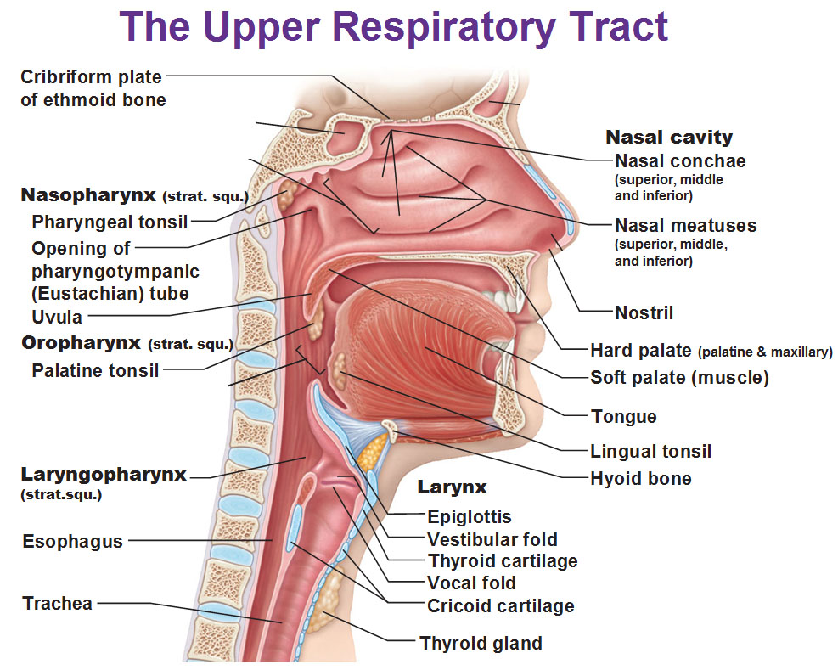

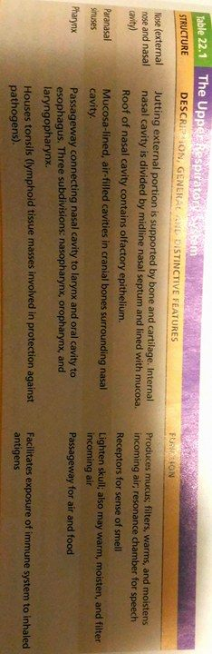

Lower Respiratory System

Larynx (Voice Box)

BASIC ANATOMY

- Extends for about 5 cm (4th-6th cervical vertebrae)
- Superiorly it attaches to the hyoid bone and inferiorly it is continuous with trachea.
- Has three functions:
- Provide a patent (open) airway
- Act as a switching mechanism to route air and food into the proper channels
- Voice production (because it houses the vocal folds or vocal cords)
- Is an arrangement of nine cartilages connected my membranes and ligaments

MORE SPECIFIC
- Thyroid Cartilage: The large, shield-shaped cartilage in front is larger in males than in females because male sex hormones stimulate its growth during puberty.
- Arytenoid cartilages: These are pyramid shaped which anchor vocal cords.
- Epiglottis: Is the 9th cartilage. Composed of elastic cartilage and extends from the posterior aspect of the tongue to its anchoring point on the anterior rim of the thyroid cartilage.
- Vocal Folds
- True vocal cords: They are white because they lack blood vessels (avascular) and vibrate in response to air movement up from lungs producing sounds. The vocal folds and the medial opening between them which air passes are called the glottis.
- False vocal cords: Superior to the true vocal cords are the false vocal cords that play no direct part in sound production but help to close the glottis when we swallow.

VOICE PRODUCTION

- Speech involves the intermittent release of expired air as the glottis opens and closes.
- The length of vocal cords and size of glottis change with action of laryngeal muscles that move arytenoid cartilages.
- As a boy’s larynx enlarges during puberty, his vocal folds become longer and thicker which causes them to vibrate more slowly, hi voice getting deeper.
- Loudness of voice depends on the force with which the airstream rushes across the vocal folds.
- Laryngitis: Inflammation of vocal cords where vibration is impaired.
- Sphincter Functions of Larynx
- Epiglottis closes respiratory tract during swallowing
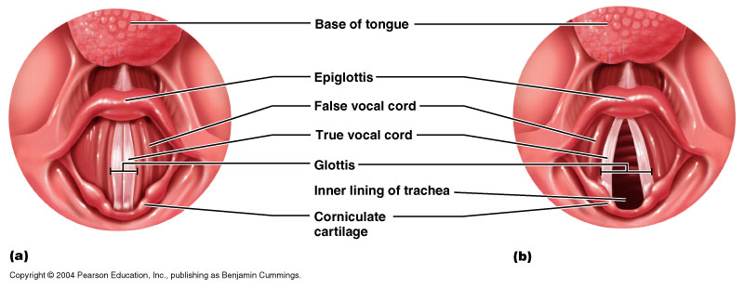
- Valsalva’s maneuver: Help empty the rectum and also splint (stabilize) the body trunk when lifting a heavy load.

Trachea (Windpipe)

- It descends from the larynx through the neck and into the mediastinum. It ends up dividing into the two main bronchi at the midthorax.
- In humans, it is 10-12 cm long and 2.5 cm in diameter. It is flexible and mobile.
- Pseudostratified ciliated columnar; cilia move mucus up to pharynx. Smoking inhibits and then destroys cilia; only coughing can clear mucus
- Submucosa a connective tissue layer deep to the mucosa contains seromucous glands that help produce the mucus “sheets” within the trachea. The submucosa is supported by 16 to 20 C-shaped rings of hyaline cartilage encased by the adventitia, the outermost layer of connective tissue which prevent it from collapsing and keep the airway open despite the pressure changes that occur during breathing.
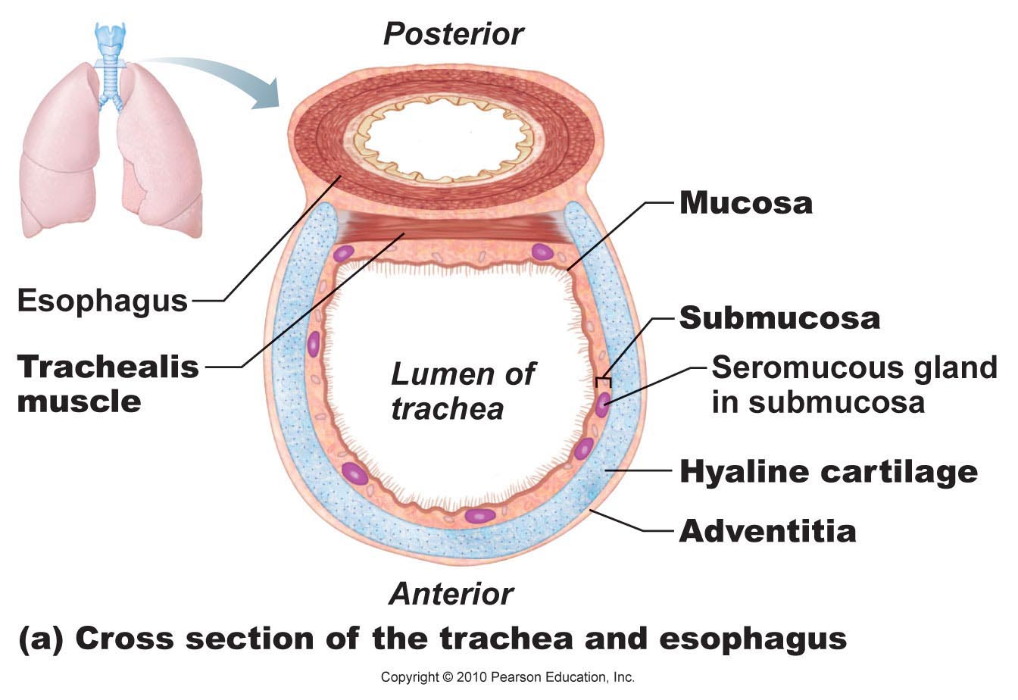

The Bronchial Tree (Conducting Zone Structures)

- The trachea divides to from the right and left bronchi. The right main bronchus is wider, shorter and more vertical than the left one.
- Air in bronchi is warm, humidified and cleansed of most impurities
- ~23 orders of branching air passages in lungs = bronchial or respiratory tree
- Each bronchus subdivides into bronchi and bronchi subdivides into bronchioles and bronchioles subdivides into terminal bronchioles.
- The tissue composition of the walls of the main bronchi mimics that of the trachea. However, as the conducting tubes becomes smaller, the following structural changes happen:
- Support structure changes: Cartilage rings to plates to none.
- Epithelium type changes: pseudostratified columnar to columnar to cuboidal in the terminal bronchioles and no cilia or mucous cells in bronchioles.
- Amount of smooth muscle increases: The relative amount of smooth muscle in the tube walls increases as the passageways become smaller.

The Respiratory Zone Structures

- The respiratory zone begins as the terminal bronchioles feed into respiratory bronchioles within the lungs.
- Respiratory bronchiolesWinding alveolar ductsAlveolar sacsAlveoli (Site of gas exchange). There are ~300 million alveoli which is a huge surface for gas exchange.
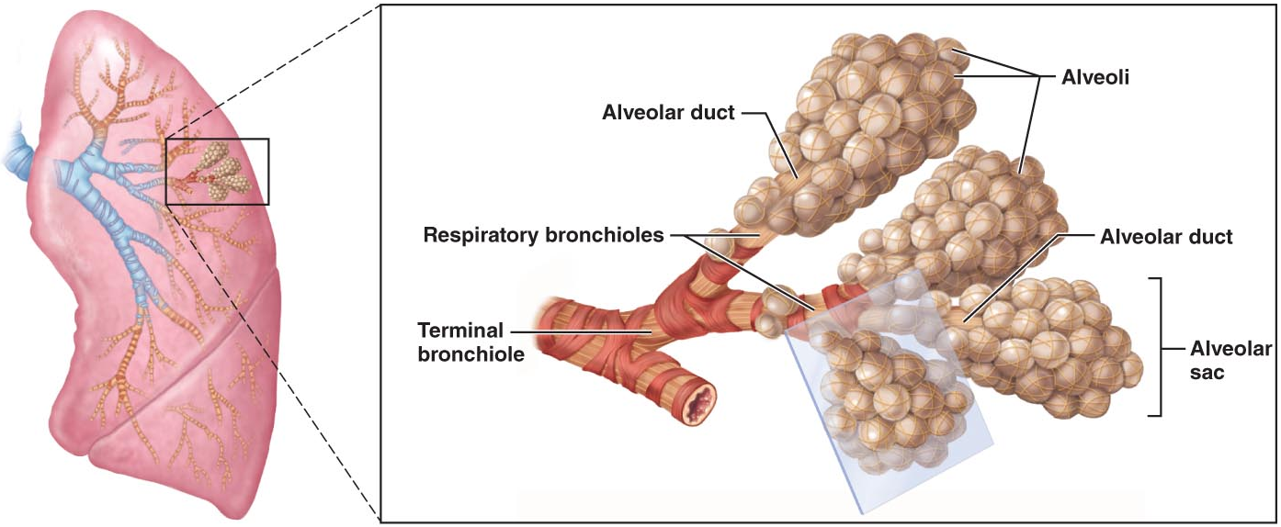

RESPIRATORY MEMBRANE

- Respiratory membrane = alveolar wall + capillary wall + basal laminae
- Respiratory membrane is an air-blood barrier so gas exchange can occur by simple diffusion.
- Type II cells are scattered among type I cells that secrete surfactant that coat the gas exposed alveolar surfaces.
- Other characteristics of lung alveoli:
- They are surrounded by fine elastic fibers of the same type that surround the entire bronchial tree.
- Open alveolar pores connecting adjacent alveoli allow air pressure throughout the lung to be equalized and provide alternate air routes to any alveoli whose bronchi have collapsed due to disease.
- Remarkably efficient alveolar macrophages crawl freely along the internal alveolar surfaces to clear and swallow more than two million dust cells per hour.
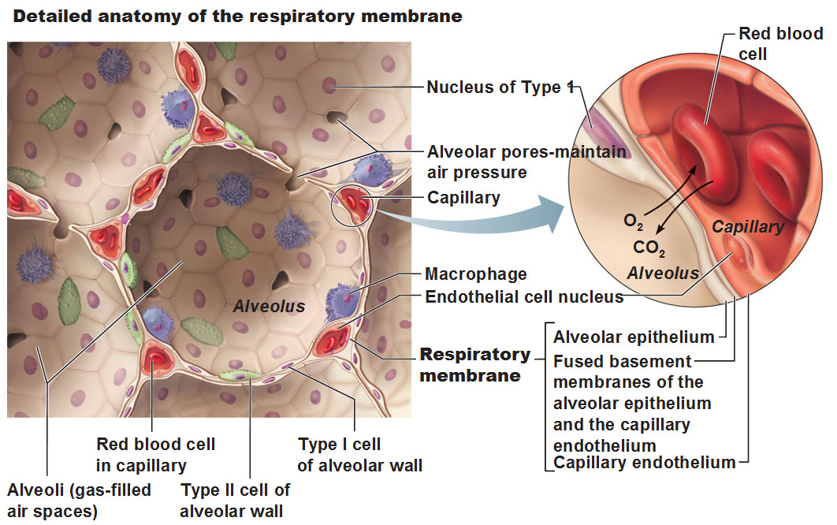

Gross Anatomy of the Lungs

- Each lung is surrounded by pleurae and connected to the mediastinum by vascular and bronchial attachments, collectively called the lung root.
- The anterior, lateral and posterior lung surfaces lie in close contact with the ribs and form the continuously curving costal surface.
- Through the apex, base and also hilus, blood vessels enter and leave lungs.
- Lungs are separated into fissures (lobes) which are separated by septa (CT) into 10 bronchopulmonary segments where each segment is served by its own artery and vein and receives air from an individual segmental (tertiary) bronchus.
- The smallest subdivision of the lung seen by the naked eye is a lobule which appear at the lung surface as hexagons ranging from the size of a pencil eraser to the size of a penny and it is served by large bronchiole

Blood Supply and Innervation of the Lungs

- Pulmonary arteries bring blood to be oxygenated
- Pulmonary veins return oxygenated blood
- Bronchial arteries provide oxygenated systemic blood to lung tissue
- Bronchial veins drain some systemic venous blood from the lungs

The lungs are innervated by parasympathetic and sympathetic motor fibers and visceral sensory fibers. These nerve fibers enter each lung through the pulmonary plexus on the lung root and run along the bronchial tubes and blood vessels in the lungs. Parasympathetic fibers cause the air tubes to constrict, whereas sympathetic fibers dilate them.
Pleura

- Form a thin, double-layered (parietal and visceral) serosa
- Pleural Fluid: Serous secretion that fills pleural cavity which results for lungs slide easily during breathing.
- Surface tension keeps pleurae from separating
- The pleurae also help divide the thoracic cavity into three chambers… the central mediastinum and the two lateral pleural compartments
- Pleurisy: Inflammation of pleurae



