CHAPTER 4: COMMUNICATION RESPONSE MODELS

Communication $→$ Passing information, the exchange of ideas/process of establishing a commonness/oness of thoughts between sender and receiver
COMMUNICATION PROCESS
(1) SOURCE ENCODING
Source (Sender) $→$ Person/organization that has information to share with another person/group of ppl
Encoding $→$ Putting thoughts/ideas/information into a form that provides a meaningful msg
(2) MESSAGE
Message $→$ Contains the information/meaning the source intends to convey
Message Content $→$ information and/or meaning contained in the msg
Message Structure/Message Design $→$ The way the msg is constructed to deliver the information or intended meaning
[ What determines the effectiveness of communication? $→$ The impression/images the ad creates]
(3) CHANNEL
Channel $→$ How the communication travels from the source/send to the receiver
- Non-personal $→$ Method of communication that carry a msg without interpersonal contact b/w sender + receiver
(1) Print $→$ newspapers (2) Broadcast$→$ tv/radio (3) Out of home $→$ outdoor, transit
Note: These channels are generally referred to as the mass media or mass communication, since the msg is sent to many individuals at 1 time
- Personal $→$ Face to Face (ex: sales ppl when delivering msg to buyers)
(4) RECEIVER/DECODING
Decoding $→$ Process of transforming the sender’s msg back into thought
**This process is heavily influenced by the receiver’s frame of reference or field of experience, which is the experiences/perceptions/attitudes/values he/she brings to the communication situation
Common Ground $→$ Overlap of circles
(5) NOISE
Noise $→$ Unplanned distortion or interference (ex: Errors, problems, distractions @ the point of reception)
(6) RESPONSE/FEEDBACK
Response $→$ Receiver’s set of reactions after seeing/hearing/reading the msg
- Non-observable (storing info in memory to immediate action like visiting brand’s FB page)
- Emotional ( Consumers enjoy/dislike msgs they receive )
Feedback $→$ Receiver’s response that is communicated back to the sender

THE RESPONSE PROCESS

Models that illustrate communication effects within the receiver of an “advertising” message.
(1) DAGMAR $→$ Designing Advertising Goals For Measured Advertising Results
$→$ established relevant guidelines for setting communication objectives.
Well-defined target audience. Concrete measurable tasks. Existing benchmark measure.
Degree of change sought. Specific time period.
(2) AIDA $→$ Steps a salesperson must take a customer through in the personal selling process
** Tries to encourage a behaviour other than purchase (ex: Second Cup)
(3) Hierarchy of Effects$→$ Assumes consumer passes through a series of steps in sequential order from intial awareness of a product to actual purchase
(4) Information Processing $→$ Assumes the receiver in a persuasive communication situation like advertising is an information processor or problem solver.

COMMUNICATION RESPONSE MODEL
 | DAGMAR | AIDA | HIERACHY OF EFF. | INFORM. PROCESSING
COGNITIVE STAGE | Awareness  Comprehension | Attention | Awareness  Knowledge | Presentation  Attention  Comprehension
AFFECTIVE STAGE | Conviction | Interest  Desire | Liking  Preference  Conviction | Yielding  Retention
BEHAVIOURAL STAGE | Action | Action | Purchase | Behavior

ALTERNATIVE RESPONSE HIERACHIES
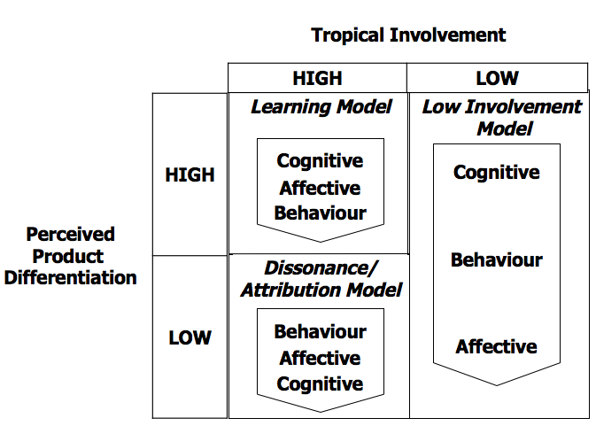
Used to set communication objectives in a plan.
Perceived Product Differentiation
Based on whether the receiver views competition brands within a product category (b1 vs b2) or views competing product categories similarly (pc1 vs pc2)
Standard Learning Model consist of
learn$→$ feel $→$ do
Infor + knowledge acquired or learned about the brands is the basis for developing affect/feelings that guide what consumers will do (Gathers info through active learning) $→$ Ex: Electronics/appliances/cars
Dissonance/Attribution Hierarchy
do$→$ feel $→$ learn
Customers must choose between 2 alternatives that are similar in quality but are complex and/or may have unknown attributes $→$ Ex: Interact puppy ad
Low-Involvement Hierarchy
learn$→$ do $→$ feel Where there are minimal differences among brand alternatives, and mass media ad is important
Ex:
Reasons why consumers are involved
Individual Factors  Needs and wants  Interest and values | Social Factors  Group needs  Role in group decision | Situational Factors  Purchase/use  Occasion | Stimulus Factors  Choice alternatives  Source and content of communication
Communication Response Models
Three consumer response models distinguish two different stages of message response based on time.
- Processing of advertising message (immediate)
- Communication effects of advertising message (lasting)
Change in brand attitude

(1) Cognitive Response Model $→$ Approach for understanding consumer’s cognitive processing of ads
(2) Elaboration Likelihood Model [ELM] $→$ Differences in the ways consumer process and respond to persuasive msgs
(3) Rossiter & Percy Model [R&P] $→$ promotional planners initially consider the msg as being directed to either .....customers purchasing their brand or non-customers who have no purchased their brand
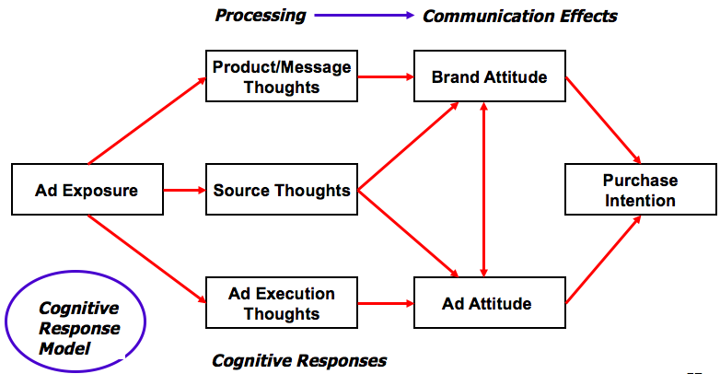
(1) COGNITIVE RESPONSE MODEL
Cognitive Responses The thoughts that occur to consumers while reading/viewing/hearing a communication

(1) Product/Message Thoughts
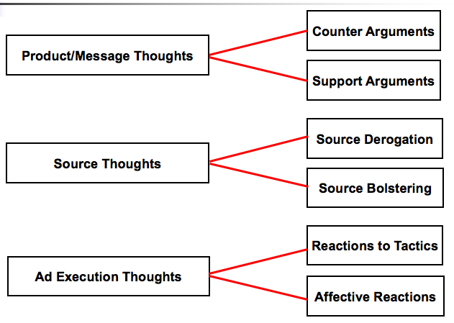
Directed at the product/service and/or the claims being made in the communication
$→$ Counterarguments (-) Thoughts the recipient has that are opposed to the position taken in the msg
(They might feel disbelief/disagreement by wondering why they should be concerned about being scammed)
$→$ Support Arguments (+) Thoughts that affirm the claims conveyed in the msg “Ouu I thin ki’d better take some action to protect my records and documents”

(2) Source-Oriented Thoughts
Directed at the source of the communication
$→$ Source Derogations Negative thoughts about the spokesperson/Organization making the claims
$→$ Source Bolster Receivers who react favourable to the source generate favourable though

(3) Ad Execution Thoughts
Thoughts can be favourable/unfavourable about the creativity of the ad, the quality of the visual effects, colours and voice tones

Attitude Toward the ad (A$→$AD) Represents the receiver’s favourable/unfavourable feelings towards the ad

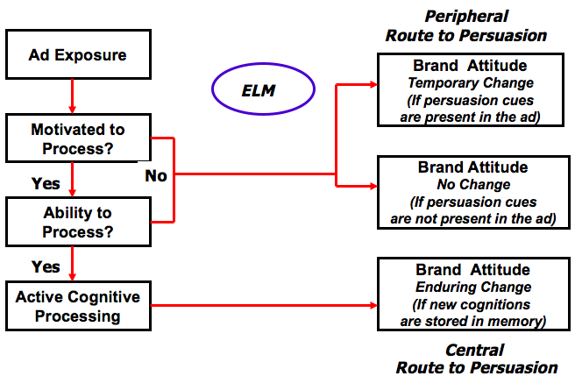
- ELABORATION LIKELIHOOD MODEL (ELM)
ELM $→$ Differences in the ways consumer process and respond to persuasive msgs
Motivation $→$ Depends on invovlemtn, relevance, needs
Ability $→$ Depends on the knowedlege, intellectual capacity
Central Route to Persuasion $→$ The receiver is viewed as very active/involved participant in the communication process who has a high ability/motivation to attend, comprehend, and evaluate msgs
Peripheral Route to Persuasion $→$ The receiver is viewed as lacking the motivation/ability to process information and is not likely to have detailed cognitive processing (good for low-involvement products)
Explanation for ELM
Classical Condition $→$ Assumes that the learning is an associative process with an already existing relationship between a stimulus and a response (which is then transferred to Conditioned stimulus)
Conditioned Stimulus $→$ The elicits a conditioned response resembling the original unconditioned reaction
2 Factors for learning to occur through the associative process
- Contiguity $→$ The unconditioned stimulus and conditioned stimulus must be close in time and space
- Repetition/Frequency $→$ of the association
(3) Rossiter & Percy Model [R&P]
This perspective suggests that promotional planners initially consider the msg as being directed to either .......... customers purchasing their brand or non-customers who have no purchased their brand

Identifies: Processing stage & Communication effects stage
Distinguishes 3 steps for processing advertising messages.
(1) Attention (2) Cognitive responses (3) Emotional responses
Recommends category & brand communication effects.
Provides strategic direction for
$→$ Selecting target audience(s) & behavioural objective(s)
$→$ Setting communication objectives
Establishes guidelines for creating ads to achieve objectives.
Communication Responses
Exposure $→$ opportunity to see communication (“media”) (90% see TV ad)
Processing $→$ Iimmediate responses to communication 60% pay enough attention to understand msg
Communication Effects $→$ lasting responses to brand (33% aware of brand and like benefits)
Action $→$ purchase or shopping (70% access brand and use promotion for trial)

Processing of Advertising Messages
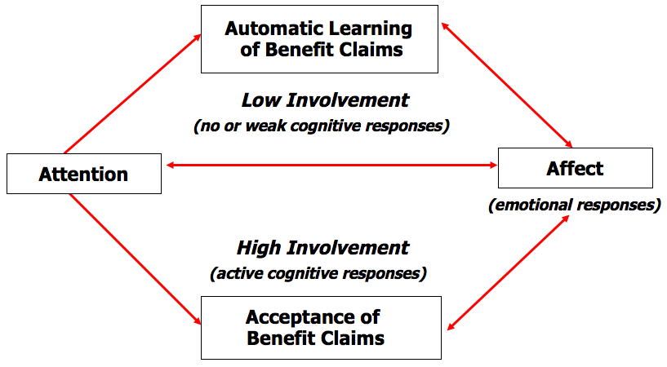

$$↓$$

Communication Effects: Lasting Impression of Brands
Category Need $→$ (Realize how product category meets needs) Target audience perception of requiring a specific product category to satisfy a particular need.
Brand Awareness $→$ (Know Brand) Target audience ability to recognize and/or recall the brand within the product category in sufficient detail to make a purchase.
Brand Attitude $→$ (Understand & like brand) Target audience evaluation of the brand in relation to its ability to satisfy the reason why they want it.
Brand Purchase Intention $→$ (Plan to respond to brand) Target audience self-instruction to respond (shopping behaviour, experience, purchase) to the brand.
ACTION
Trial $→$ First promotion based purchase or use of brand + First non-promotion purchases of brand.
Repeat Purchase $→$ Continued purchase of brand within next purchase cycle.
Shopping Behavior $→$ Conducive consumer responses producing higher probability of actual purchase.
An infinite number of information search and experiential behaviors are possible.
Tips for managers in making advertising.promotion decisions based on the models
1. Should consider/plan for both the cognitive and the affective response of the receiver who is processing ads/msgs
2. Should concern with the resulting effects of the ads/msg for a time period agter the receiver has received the msg
3. The primary characteristics that influences communication success appears to be the reciever’s previous brand experience

2 IMPORTANT IMC PLANNING CONSIDERATIONS
- There is an obvious and clear connection to the target audience’s purchase of the promotional manager’s particular brand
- The managerial model can e applied for all aspects of an IMC program

