CHAPTER 1: THE COMMUNICATION PROCESS: LEARNING FROM MODELS

ARISTOTELIAN MODEL OF COMMUNICATION
- All communication proceeds in a linear fashion, and all communication has the ultimate aim of persuading.
- Linear fashion = Individual efforts to persuade another person to adopt a certain point of view
- Communication involves a communicator using a speech to persuade an audience
The Act of Persuading the communicator relies on 3 kinds of Appeal
1) SOURCE CREDBILITY APPEAL $→$ Personal attractiveness of a communicator to the audience
- Aristotle referred to this kind of appeal as “ethical appeal”
- When we talk about source credibility appeals we are referring to the:
Trustworthiness – One’s character or integrity  Competency – One’s expertise in a given area  Status – One’s standing in relationship to others | Dynamism – One’s boldness, energy, and assertiveness  & Sociability – One’s likeability  .... of a communicator
2) LOGICAL APPEAL $→$ Logic and reasoning
- Communicators may use reasoning from:
  - Example $→$ Support arguments with a number specific examples
  - Generalization $→$ Moving from general to specific
  - Cause-Effect $→$ Observe effects and look for the causes
  - Sign $→$ See visible sign of a condition and try to find out what the sign means
  - Analogical Reasoning $→$ What is true for 1 situation must also be true for another situation
3) EMOTIONAL APPEAL $→$ Expected emotional responses of an audience
- When we react emotionally to an event/person, we experience physiological changes
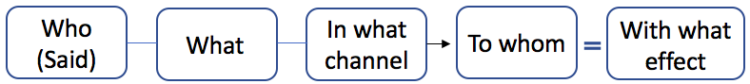
LASSWELL’S EFFECT MODEL
Focussed on a one-way linear process of communication
Laswell added 2 components
(1) Channel $→$ The medium used to transmit a message
(2) Effects $→$ The intended or unintended impacts(s) of a message
@ For Starters
- Who (The people), What (They used speech to create msgs), To whom (The receivers of the msg)
- Channel = air waves (because the communication took place in a interpersonal setting)
- Effects = Ray became angry & his wife became emotional (when the police refused to leave)
SHANNON – WEAVER MATHEMATICAL MODEL
Original Shannon-Weaver mathematical model Revised Shannon-Weaver Model
( One-Way transmission model) (Interactive Model)
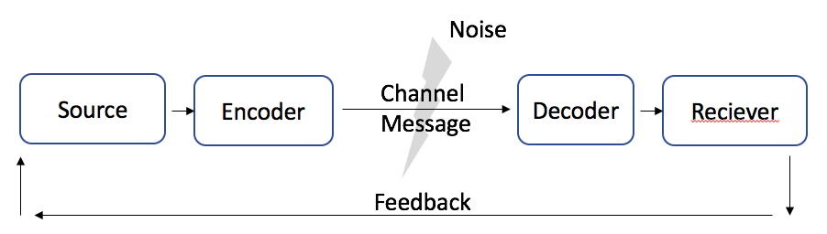
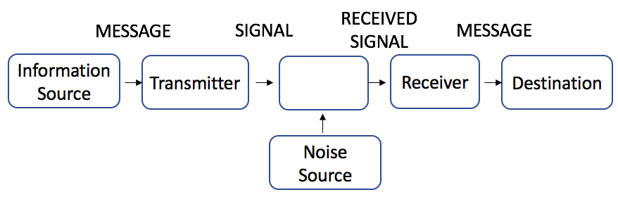

Communication begins with the information source (Where the msg is conceived) gets and idea that he wants to convey to another party. When he places this idea into the form of a communication, he becomes a transmitter (Mechanism for encoding the msg). The communication product is a signal (the msg). When the 2end party receives the signal, they have to figure out what it means. In the decoding part, she asks as a receiver (Mechanism for decoding the msg). Once the idea is decoded in her mind, the signal has reached it’s destination (where it msg ends up).
FEEDBACK – Response to a msg or activity
NOISE – Interference that occurs in the transmitting or receiving of signals
- External Noise $→$ Interference from an environmental source (ex: people talking)
- Internal Noise$→$ Interference from an internal source
  - Physiological noise $→$ Interferenece from a biological condition or function (ex: bad headache)
  - Psychological noise $→$ Interference from a mental state (ex: The feeling of sadness from a break up)
@Revised Shannon-Wear Model
- The addition of a “feedback” changed the process from linear $→$ circular which made it more INTERACTIVE
- The listener is no longer a passive receiver of the information, and the roles of source & receiver becomes interchangeable
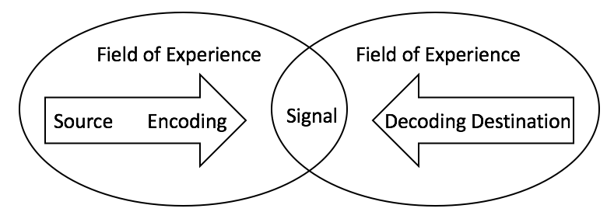
SCHRAMM MODEL *interactive*
Communication is a two-way process where both sender and receiver take turns to send and receive a message.
Schramm added “field of experience” (The totality of all we are at the moment of communication). He also said
“we communicate with each other to the extent that we have overlapping fields of experiences”. (Twins & Backgrounds) + each of us has a unique set of life experiences
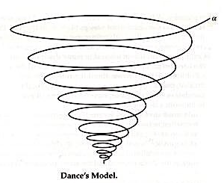
DANCE MODEL
Dance sees communication as a never-ending story with no fixed beginnings or ending
( Helical in shape &d dynamic, ongoing, unrepeatable, additive, and cumulative )
Inward-Turning $→$ “Learning, growth & discovery”
The past will always influence the future and we continue to widen/deepen out perspectives as we go through life. (ex: babies that are growing)
BARNLUND’S TRANSACTION MODEL
Transactional theory sees communication as a process in which communicators act simultaneously as senders and receivers
(1) Not all communication is intentional
(2) Both the history & quality of the relationships makes a difference bc commu. Takes place in a web of interdependencies.
(3) Communication is a dynamic and fluid process, shaped by changes in the communicators and the environment in which they operate.
(4) Theory recognizes the importance of context
Simultaneous Nature of Communication and Interchangeability of Roles
- Transaction model shows that ppl never stop communication (Listening is also communication through facial expressions), body language, and
  - paralanguage (Elements of speech that are not recognized as language $→$tone of voice)
- Interactive $→$ You and your friend alternate the roles of sender & receiver
- Simultaneous $→$ Talk on the phone, meet in person, or chat on msger.
- Transactional $→$ Even when not speaking/typing, you are also listening/reacting
Unintentional Communication
- Non-verbal communication
Importance of Relationships and Interdependencies
- The source needs a receiver, and the receiver needs a source (interdependent)
- Past experiences, attitudes, beliefs, and values influence how they behave in the moment.
Dynamic and Fluid nature of Communication
- Communication is a dynamic and fluid process, characterized by continuous change.
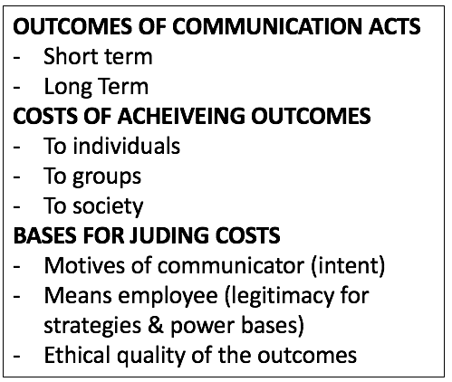
FERGUSON’S CRITICAL COMMUNICATION MODEL (CCM)
Focuses on effects, and it deals with the ethical and power dimensions of communication (See chart on the right)
Not everyone exercise equal power in the scenario of Ray.
WHAT WE LEARN FROM COMMUNICATION MODELS
1) Communication:
- can be intentional or unintentional
- has a relational, as well as content, dimension
- benefits from shared fields of experience
- is irreversible and unrepeatable
- sending and receiving occurs simultaneously, with both verbal and nonverbal elements
- is a dynamic, ongoing process
2) Environment/Noise affects communication
3) Channels Matter
4) Communication has cultural component
- Standpoint theory (Theory that holds that our background and experiences determine our perspectives)
- And our perspective influences how we related to and communicate with others.
5) Communication has power dimensions
5 different sources of power
- Reward Power – Power that comes from offering benefits or gifts
  - Ex: Principal promised that he will milk a cow if they read 10,000 books by the end of the year
- Legitimate Power – Power that comes from holding an office, title or other legitimate position
  - Ex: His position $→$ Principal
- Expert or information power – Power that comes from knowledge or expertise
  - Ex: Computer Hackers
- Coercive Power – Power that comes from making threats or intimidations
  - Ex: Filing law suits against his accusers (drug guy)
- Referent Power – Power that comes from personal attractiveness
  - EX: Drug guy lost his power and fame from fans

Trickle-down access – controlled and restricted access to information, flowing mostly downward
Simultaneous access – Unrestrictive access to information following from mass media & reaching everyone
at the same time
Open Access – Unrestrictive and uncontrolled sharing of information on open platforms, accessible to everyone

6) Communication has a strong ethical dimension

FACTORS THAT CONTRIBUTE TO COMMUNCATION BREAKDOWN
Factors that decrease our ability to communicate/comprehend/understand/difficult successfully:
- Speed $→$ If someone speaks too fast & doesn’t repeat inform. We may get lost $→$tuning out
- Personality $→$ We may be insulted by a remark not intended to be taken personally
- Linguistic Differences$→$ We may interpret words in literal fashion when they are not meant to be literal
- The use of Jargon $→$ (eg. Mathematical terms such as hypotenuse)
- Expectancy $→$ We hear what we expect to hear and see what we expect to see
- Redundant information $→$ Too little or too much context can get people confused
- Fear of pain $→$ When meaning is too painful to us, we switch off $→$advoiding
- Ambiguous or non-specific information $→$ If not specific information is given, it makes things more difficult
HOW TO AVOID COMMUNICATION BREAKDOWN
- Be flexible in communicating and interpreting communication from others
- Be succinct and clean, and listen for unspoken msgs
- Be specific
- Use language that is accessible
- Practice communicating with others
- Develop a larger repertoire of communication skills
- Stick to more formal language patterns when working in second language
- Be aware of the meaning of nonverbal signals
- Ask questions and give feedback
- Find alternative ways of explaining a point and use repetition
- Use analogies and comparisons to convey meanings

CHAPTER 2: PERCEIVING SELF IN RELATION TO OTHERS

Reference groups $→$ A group whose opinions we value in which we hold or aspire to membership

NATURE OF OUR SELF CONCEPT
Self-Concept $→$ Relatively stable/organized collection of thoughts + feelings about who we are and how we differ from other people
(1) Self-Image $→$ Our views of ourselves | (3) Ideal Self $→$ The person we would like to be
(2) Looking-glass Self $→$ How we think others see us | (4) Real Self $→$ The person we actually are
When our different selves come into conflict with one another, 2 factors that suffer:
- Self Esteem $→$ How we perceive our overall sense of worth/value (our perception of our overall value)
- Self-Efficacy $→$ Our ability to accomplish specific tasks and goals (or make a difference)
HIGH (Global Self-Esteem + Self-Efficacy) = more confidence to approach personal/work related tasks
Global Self-Esteem $→$ Self-esteem that shows in many aspects of our lives

SELF-IMAGE: THE ROLE OF INTERNAL VOICE
Life Scripts/Plan $→$ Storylines that we create to guide us through life (It has characters, plots, settings, and action)
Self-Fulfilling Prophecy $→$ A prediction/belief that leads to its own fulfillment (ex: Asley asking guy to concert)

HOW WE (1) CREATE, (2) VALIDATE, & (3) REVISE OUR SCRIPTS

(1) CREATING OUR LIFE SCRIPTS
Some ideas for our life scripts come from direct experience, others come from second-hand experience
Second-Hand Experience $→$ reading/hearing about how someone else handles a situation such as the breakdown of a relationship

(2) VALIDATING OUR LIFE SCRIPTS
A common way to ensure accuracy of our lfe scripts is to compare ourselves with similar others
Social Comparison Theory $→$ Theory that holds that what we look to others for standard of comparison
Assimilation Effect $→$ Heightened self-esteem following a favorable social comparison (Ex: Adele)
Contrast Effect $→$ Feelings of inadequacy + lower self-esteem following an unfavorable social comparison

(3) REVISING OUR LIFE SCRIPTS
We become highly attached to the scripts that we write early in our lives, and we work as hard to maintain negative self-views as to protect positive ones

LOOKING-GLASS SELF: THE ROLE OF EXTERNAL VOICES
Charles Cooley introduced the idea of looking-glass self in 1902 to refer to the power of:
- significant others (People who’s opinions matter to us and influence how we perceive over selves) to influence our self-concept.
Reflected Appraisal $→$ How we think others see us (the imagining process) --- Dove Commercial
[ Influences of significant others ]
(1) Family  (2) Romantic Partners  (3) Peers | (4) Teachers  (5) Coaches  (6) Caregivers | (7) Health Care Providers  (8) Workplace colleagues  (9) Supervisors
Cyber bullying $→$ Malicious communications in the form of text msgs, emails, or positings on social/personal websites

Self-Fulfilling Prophecy $→$ Any (+) or (-) expectation about circumstances/events/people that may affect a person's behavior toward them in a manner that causes those expectations to be fulfilled.
- EXAMPLE: An employer who, for example, expects the employees to be disloyal and shirkers, will likely treat them
in a way that will bring out the very response he or she expects.

IDEAL SELF: THE ROLE OF THE MEDIA
If a gap develops between the real self and the ideal self, we may experience:
Body-image disturbance $→$ Reduced levels of satisfaction with our bodies and a downward spiral in how we see our physical selves
and lowered self-esteem and self-efficacy
- Interaction of Children and Adolescents with Media Images
  - Children consume abou 6.5 hours of meida content each day
  - Between 4th and 8th grades is a time of adolescents to devop a strong awareness of their bodies
  - Teenage girls says that media rank 2end only to parents and peers as source of information/influence
- Shifts in Media Depictions of Women Over Time
  - In 1985, 1/10.8 tv commercials included msgs about attractiveness + between 1900-1980s’ decreased by 50%
- Media Influence on body Satisfaction
  - Myth of perfection $→$ Idea that it is both desirable and possible to achieve perfection
  - Those most at risk of being negatively influenced by the media includes
    - Who are already extremely dissatisfied with their bodies
    - Who place a high value on personal appearance
    - Who suffer from eating disorders
- Variations across cultures

CHALLENGES IN MEASURING SELF-CONCEPT ACROSS CULTURES
Self – Enhancement $→$ The tendency to pay more attention to the information that supports a (+) view of the self
Self – Criticism $→$ The tendency to pay more attention to information the supports a (-) view of the self
Self-Serving Bias $→$ The tendency to credit our successes to internal/personal factors
our failures to external or situational factors
Individualism $→$ Focus on individual needs/goals
Collectivism $→$ Focus on group needs and goals
Face Work $→$ Politeness Strategies aimed at marking other people feel better about themselves

TIPS FOR ACCEPTING + MOVING BEYOND SELF IN COMMUNICATION
- Whenever you/someone else questions one part of your identify, think about some of your other identities
- If you are operating from (-) scrip, rewrite it
- Check to see if your actions suggest low self-esteem
- Engage in (+) self-talk if some aspects of your self-concept appear to be threatened
- Set realistically goals for yourself
- If your ego is too “noise” aim for balance in self-concept; otherwise, your friends may go elsewhere for company
- The quieter ego shows greater interest in-and empath for-others
- Celebrate and learn from differences
- Believe in positive outcomes

CHAPTER 3: PERCETION OF OTHERS
Perception $→$ The process of sensing, interpreting, and reacting to the physical world

PERCEPTION IS LEARNED AND BACKWARD LOOKING
- PERCEPTION IS LEARNED
- Our visual systems are programmed to recognize and learned patterns (ex: Guy wearing upside down glasses)
- Just as we learn sight by experience, we also learn touch by experience (ex: Counting fingers on arm)
  - But after several tries, they will learn to discriminate
- How we perceive taste/sound/smel is also learned
- Culture has a large influence on whether our reactions to what we see/feel/taste/hear/smell are (+) or (-)
- PERCEOTION IS BACKWARD LOOKING
- Past learning influences our interpretation of present events
- Ex: My wife and My Mother-in-law (illusion picture)
- Implication for Communication
- The more we know about a subject, the more expertise we acquire, the more difficult it comes to think “outside of the box”
- Letting our expectations influence our perception of others can be problematic, however, when we reply on:
  - stereotypes (popularly held beliefs about a type of person or group of person that ................... do not take individual differences into account
PERCEPTION IS CULTURE BOUND AND RACIALLY BIASED
- PERCEPTION IS CULTURE BOUND
- Cuz the close connection b/w the past + the present, events in some Aboriginal cultures have no end point (Ex: Sheila, he’s still mad 33 years later)
- Breadth of their perceptual fields $→$ The amount of information we take into our visual or other perceptual systems (Ex: Wearing binoculars where you focus on a very narrow field)
- Optical Communities $→$ A social group that shares a similar view of the world
- PERCEPTION IS RACIALLY BIASED
- Own-Race Bias $→$ The idea that we are more accurate when asked to identify specific members of our own ............................... race than when asked to identify specific members of another race
- IMPLICATIONS FOR COMMUNICATION
- Out-group $→$ A group of which 1 is not a member
- Thus with the right intentions and efforts, we may be able to discard our stereotypes and to see strangers as individuals-not just as members of a larger group to which they may belong
PERCEPTION IS SELECTIVE AND SELF-SERVING
Selective Perception $→$ The process by which we see + retain certain kinds of information while ignoring or ......................................... discarding other kinds of information
Load-induced blindness $→$ Inability to see as a result of information overload in the visual field (Can occur when ...............................................we receive more visual information than we can process)
- If we jut purchased a new car, we try to avoided commercials of other brands of cards
Self Serving $→$ A focus on what serves our own purposes and makes us look best

- PERCETION IS SELECTIVE
$→$ Females and males pays more attention to different things (Female $→$ Clothing) (Male $→$ Type og gun)
Our past experiences and current needs also make a difference.

- PERCEPTION IS SELF-SERVING (SELF-SERVING BIAS)
$→$ We pay attention to and recall info that makes us look better, and we judge ourselves more generously than we judge others (If co-worker is late we would say they are irresponsible, but if we are late.. we come up with excuses)

PERCEPTION IS SPONTANEOUS, LARGELY UNCONSCIOUS, AND VALUE DRIVEN
- PERCEPTION IS SPONTANEOUS AND LARGELY UNCONCIOUS
We often think perception has 4 phases
  - First Phase $→$ We pick out cues that might be important such as the designer dress a person is wearing
  - Second Phase $→$ We use the cues to decide on personal characteristics (eg. High economic status)
  - Third Phase $→$ We make connections in th third phase to other qualities that might fit with personal traits
  - Fourth Phase $→$ We put everything together in order to know how to respond to the other person
- PERCEPTION IF VALUE DRIVEN
$→$ Most religious people saw the word “religion” almost immediately
$→$ Less religious people saw the word only after it has displayed for a longer period of time
$→$ We most quickly perceive the things that matter most to us- the things we value
- IMPLICATIONS FOR COMMUNICATION
$→$ We are more likely to arrive at a favourable opinion of another person when positive information about the person comes from a third party, not from the person herself.
Warranting theory $→$ Theory that sys we are more likely to believe information that someone cannot manipulate
Impression Formation Theory $→$ Theory related to how we put together different pieces of information to form an impression of a person
TAR Effect $→$ Transfer of (-) feelings to the person who expresses dislike

PERCEPTION IS RELATIVE AND CONTEXT BOUND
Stand Point Theory $→$ Tells us that we can never escape our place in the economic, social, & political order of things
* We live in a world, in which our perceptions depend on who we are, where we are, and how we got to this point
(1) PERCEPTION IS RELATIVE
$→$ The presence of social support influences visual perception (Walking up a hill alone vs with someone else)
(2) PERCEPTION IS CONTEXT BOUND
$→$ Context also makes a difference in how we perceive others
$→$ Ex: Someone smoking in front of an office building (it’s tobacco) vs Someone smoking in an alley way (illicit drug)
(3) IMPLICATIONS FOR COMMUNICATION
$→$ Sometimes we fail to perceive the bigger picture or we judge words or actions against some standard ............. that makes them appear worse that they would appear in some other context (ex: Sick days)

PERCEPTION IS MOOD DEPENDENT
Our mood influences how we respond to our external circumstances
- (Ex: we experience pain more strongly when we feel sad or depressed)
(1) IMPLICATIONS FOR COMMUNICATION
- We may communication most effectively when we’re in a (-) mood
- We are more likely to process/remember information accurately when we are in such a
- Our persuasive abilities will be better
- Since we are more skeptical when we are in a (-) mood, we are also more likely to detect deception on the parts of others
- We are more likely to place less importance on first impressions
Mood contagion $→$ We can “catch” the mood of someone else much we catch a cold

PERCEPTION IS COMPLETION SEEKING
- We fill in the missing information when there are gaps in our perceptions
- The completion seeking nature of perception manifest itself in the practice of stereotyping
- Also on vocal qualities, including the extent to which a voice sounds “feminine” or “masculine”
Self-Categorization Theory $→$ The idea that we see ourselves as both individuals and group members, whereas we see others as either individuals or group members based on other factors
* We don’t usually apply stereotypes to people we know well
Perspective talking $→$ Looking at the situation from the other person’s point of view (Perspective-talking does not require that we agree with the other person. It requires only that we try to understand that person’s point of view)
Counter-Stereotyping $→$ Effort to eliminate stereotypes by focusing on similarities (ex: Cosby Show)
In Group $→$ A group of which one is a member
Active Perceivers $→$ Chose the amount and type of information they receive
Passive Perceivers $→$ Rely on others to select the information
STRATEGIES, TOOLS, AND TIPS FOR GAINING AWARENESS AND CONTROLLING PERCEPTION BIASES
- Remember that your first impressions are more often wrong that right
- Be aware that you perceive and remember (-) sensational information more quickly and easily than (+) information
- Remember that you will have more difficulty identifying differences in people from other racial groups
- Beware that not everyone else has the same goals/needs/values
- Recall that level of confidence in your judgments about people is no measure of correctness
- Recognize that you see the world through a filter that is different from that of everyone else in the world, including your closes friends, parents, and co-workers
- Recognize that people from other cultures have different filter through which they see the world
- Be sure you are not judging others against an unrealistic standard, perhaps a standard that you cannot meet yourself
- Realize that your mood influences how you see and react to other people as, well as how they react o you
- Set an example for others in your group by treating people in the way you would like to be treated
- Assume the perspective of the other person
- Make a conscious effort not to stereotype other people

USING PERCEPTION CHECK TO MINIMIZE ERRO
Perception Checking
$→$ A process for confirming what we have think we have seen, heard, or experienced
$→$ Helps reduce errors in communication in 3 steps
- We describe the behaviour we have noticed in the other person
- We give 2 possible interpretations of the behaviour
- We ask for clarification
Low-Context Cultures
$→$ Cultures that rely heavily on words than context (Canada & USA) ** logic and linear thinking
$→$ Statements need to be explicit, not leaving room for more than 1 interpretation
$→$ Tends to be individualistics, valuing independence and accomplishing taks without assistance from others
High-Context Cultures
$→$ Cultures that place great important on context and rely to a lesser degree on words (Japan and Saudi Arabia)
$→$ Context includes: Nonverable elements (Facial expression/tone of voice) Cultural background information ( social standing and occupation) **Just wants to get to point A to point B

COMMUNICATION PREDICAMENT OF AGING (CPA) MODEL – TO IMPROVE INTERACTIONS WITH OLDER PEOPLE
Communication Predicament of Aging (CPA) Model
$→$ Helps us to understand how to communicate with older people in a sensitive and productive way
$→$ A model that predicts the relationship among aging cues, stereotyping, and communication behaviour

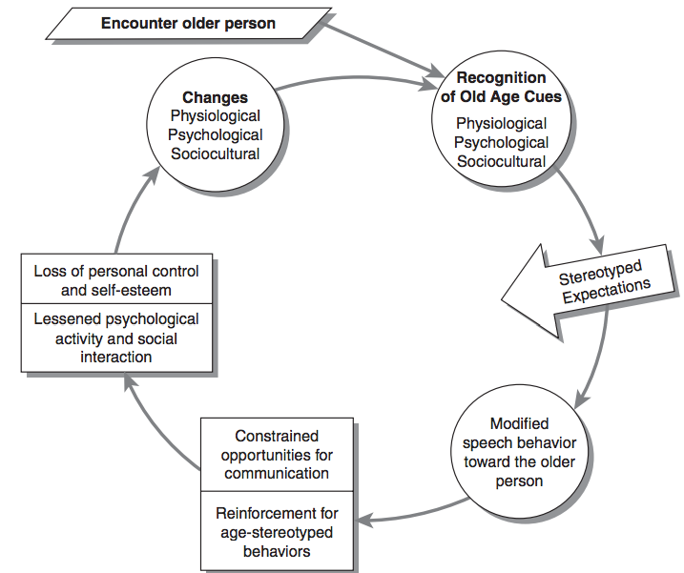

CHAPTER 4: UNDERSTANDING, NAVIGATING, & MANAGING OUR IDENTITIES

Identity$→$ the characteristics that allow others to recognize (who are you?)
Self-concept $→$ refers to how we think of ourselves
- both concepts differ from reflected appraisal (how we think others sees us
Identity markers
Physical (appearance and athletic abilities) Social (competence in relationships)
Academic (intellectual capabilities) Emotional (how we feel)

NAVIGATION MULTIPLE IDENETIE WITH COLLECTIVE DIMENSIONS
Collective identity $→$ the characteristics of our personal identity that we share with members of a large group ( LGBTQ, African Canadian community & ethnic groups encourages this)

(1) NAVIGATING GENDER IDENTITIES
The Bem Sex-Role Inventory $→$ allows users to classify themselves according to the traditional recognized sex/gender roles
Gender Identity $→$ Characteristics we share with others of a particular gender
Androgynous $→$ a mix of both feminine and masculine traits
Undifferentiated $→$ low scores on both feminine and masculine traits
- Our friends and colleagues rely on gender displays to know how to interact with us.

(2) NAVIGATING ETHNIC AND RACIAL IDENTITIES
Ethnic identity $→$ the extent in which we indenting with or connect to others who share our ancestry
Characteristics of ethnic identify
- A distinct sense of belonging to a particular ethnic group
- A commitment to this group’s core value + beliefs
- And a support for traditional values, which we hold common with many other ethnic groups
Racial identity $→$ characteristics we share with others with respect to racial heritage

(3) NAVIGATING RELIGIOUS IDENTITIES
Religious identity $→$ characteristics the relate to a belief system and/or a sense of belonging to a particular religion
- Religion helps immigrants to maintain ties with their home country and cultures, to achieve solidary,
and come together with others with similar beliefs and values

(4) NAVIGATING LINGUISTIC AND CULTURAL IDENTITIES
Linguistic identities $→$ characteristics we share with others who speak a common language
Cultural identities $→$ characteristics we share with others from the same or similar cultural backgrounds
Assimilation the $→$ process of being absorbed into a larger group

(5) NAVIGATING REGIONAL AND NATIONAL IDENTITIES
Regional identity $→$ characteristics we share with others from a particular region of a country
National identity $→$ characteristics we share with others from a particular country

Canadians cluster with Americans on four major dimensions of culture
1. Power distance $→$ The extent to which hierarchical power and structure set people psychologically apart from one another (ie those in power should look, act, and feel more powerful than those with less power)
2. Uncertainty avoidance $→$ The extent to which people accept and need rules, regulations, and clear delineation of responsibilities (Ie, they seem unfamiliar, uncertain, and ambitus situations as threatening and aniety-producing)
3. Individualism-Collectivism $→$ The extent to which people value and reward individuals vs groups
4. Masculinity-Feminitiy $→$ The extent to which people value assertiveness, independence, and achievement (stereotypically masculine values) vs nurturance and sympathy (stereotypically female values)

3 Years later, he added 3 more dimensions
5. Short-term vs Long-term orientation $→$ A focus on the present and past (traditional values, social obligations, and saving face) vs future rewards (perseverance and thrift)
6. Indulgence vs restraint $→$ Enjoyment of the pleasure of life (partying, leisure time, sex, spending, and consumption) vs holding back or controlling the extent to which one indulges in the pleasure of life
7. Monumentalism vs Self-effacement $→$ Emphasis on pride and rigidly vs humility and flexibility.

EXPERIMENTING WITH OUR IDENETIIES
We often think of identities are relatively unchangeable, some parts of our identity are highly flexible
(improve athletic abilities)
Historical Self $→$ An outdated self, someone we used to be
Concealable Stigmatized Identity $→$ An identity that carries a stigma and that can be hidden from others
(A fear that others might see us in a less positive light if they know about the condition)

VALIDATING OUR IDENTITIES
Self-Verification Theory $→$ We want others to use as we see ourselves (Creating the desired public impression)
Self-Monitoring $→$ The extent which we regulate our behaviours in order to look good for others
High-Self Monitors $→$ People who are very aware of the opinions of others (alter their behaviour to fit diff situations)
Low-Self Monitoring $→$ People who don’t worry about the opinions of others

MANAGING OUR IDENTITES
Impression Management $→$ The way we create impressions of ourselves in the eyes of others

- Managing Impressions in Family Contexts
$→$ Impression management in family contexts involves controlling the information that we share with others. Achieving this kind of control in situations involving family is tricky when other questions or interfere with our efforts at impression management

- Managing Impressions in Friendship Context
$→$ we want to create a good impression. As we become more familiar and comfortable with our new friends, however, we probably think less often about managing impressions with these individuals. We become more relaxed, informal, and natural.
Beneficial Impression-Management $→$ Efforts to create positive impressions of close others (we try to create a positive img of the close other in the eyes of another person)

- Managing Impression in Romantic Contexts
$→$ Romantice desires can lead both men and women to adopt strategic self-presentation strategies; however, the strategies mot often used differ for the 2 sexes
$→$ Women are also more likely than men to engage in protective behaviours such as apologizing and hedging
Hedging $→$ Using words that show uncertainty or reduce the negative impact of what we are saying
- Managing Impressions in Professional Contexts
$→$ Involves a delicate dance between being ethical and being effective

COMMON IMPRESSION-MANAGEMENT STRATEGIES

- SELF-PROMOTION
  - Communicate their strengths in an effort to make a positive impression on others
  - Self-enhancement $→$ placing an emphasis on the competencies, abilities, or accomplishments of the communicator
- INGRATION
  - People worry about being liked by others. To increase their likeability they may compliment others, use flattery, or behave in ways designed to get favourable response from others
- INTIMIDATION
  - Try to achieve their goals by provoking fear in others. They do not care about being liked; they want to establish control
  - Bullying $→$ A form of aggressive behaviour that includes punching, name calling, or spreading rumors
- EXEMPLIFICATION
  - Focuses on moral worthiness. They attempt to earn respect by showing sincerity and devotion and taking responsibility for their actions (ex: worker checks email at home)
  - Exemplifies can run the risk of being perceived as hypocrites by those they are trying to impress
- SUPPLICATION
  - Attempt to get sympathy and attention by talking about their limitations or lack of knowledge
  - They present themselves as vulnerable and weak in order to receive help from others
  - The person using the strategy may begin, after a time, to feel alimentation unhappiness, and lower self-esteem
- COMMUNICATION BEHAVIOURS ASSOCIATED WITH IMPRESSION-MANAGEMENT STRATEGIES
Impression Management Strategy | Communication Behaviour
Self-Promotion | Talks proudly about his or her experience or education  Makes other aware of his/her talents or qualifications  Makes others aware that he or she is valuable to the organization  Makes others aware of this or her accomplishments
Ingratiation | Compliments colleagues to seem likeable  Take an interest in the personal lives of colleagues to demonstrate friendliness  Praises colleagues for their accomplishments
Intimidation | Threatens or frightens coworkers with the aim of getting work done  Makes other aware of his/her power to make things difficult  Reacts strongly/aggressively
Exemplification | Stays late at work in order to been seen as hard working  Tries to appear busy, even things are slow  Arrives at work early to look dedicated
Supplication | Pretends not to understand in order to get people to help him or her  Acts like he/she needs assistance so that others will offer for help or sympathy  Pretends to know Less

MANAGING IMPRESSIONS IN ONLINE ENVIRONMENT
Social Presence Theory $→$ Theory that explores the effects of sensing another’s presence in a social interaction
Social information processing theory $→$ Theory that investigates how we process various types of information in collaborative settings such as social media
Hyper personal Theory $→$ Theory that suggest that we use limited online cues to construct idealized images of another person
Computer Mediated Communication (CMC) $→$ The process of using a omputer to communicate msgs
Synchronous Communication $→$ Communicators exchange msgs in real time
Asynchronous Communication $→$ Communicators exchange msgs with a time delay between msgs
Emoticons $→$ Graphic representations of facial expressions that convey mood

TIPS FOR NAVIGATING AND MANAGING IDENEITIES
- Recognize that not everyone is like you and not everyone values the things that you value
- Pay attention to your goals and contexts when using the different impression-management strategies
- Don’t include false information on your resume
- If you are travelling to another country for an extended period of time, take the time to learn about the culture
- Be sensitive to rules of etiquette in online environments
- Develop good communication skills

