CHM2123: EXPERIMENT 8 – HYDROLYSIS OF ESTERS, AND FATS AND DETERGENTS
(38 points)

TA: Yen Truong Date: 24/11/2017

Introduction (8 points)

Part A- Ester hydrolysis
(objective(s), theory, methodology)
- The purpose of part A is to perform a saponification of an unknown saturated mono-ester to determine its molecular mass and to propose a few possibilities for its structure.
- Saponification refers to a base-promoted ester hydrolysis. In this type of reaction, a base acting as a nucleophile attacks the carbonyl carbon of an ester functional group, creating a tetrahedral intermediate. Subsequent collapse of the tetrahedral intermediate results in an ⁻OR leaving group and a carboxylic acid. The carboxylic acid quickly becomes deprotonated by the ⁻OR leaving group to form the final products of a carboxylate and an alcohol.
- The NE is the quantity of ester (in grams) that reacts with an equivalent of base (in moles). In the case of the saponification of a mono-ester, the NE corresponds to the molar mass of the ester and can be calculated by dividing the mass of the ester by the moles of base needed for neutralization.
- In this experiment, the known mass of a mono-ester will be reacted with an excess of base (NaOH) whose molarity is known. Once the reaction is complete, the quantity of base remaining in solution will be determined by back titration with a solution of acid (HCl) of known concentration. In doing so, the number of moles of base that reacted with the ester can be determined. Since the ester is a mono-ester, this value also represents the number of moles of ester. The molar mass of the unknown ester can then be identified.
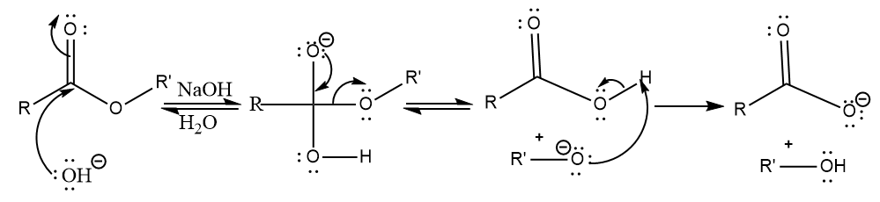

Part B- Fats and Detergents
(objective(s), theory, methodology)
- The purpose of part B is to prepare a soft soap through the saponification of a fat and a hard soap by the process of salting out the soft soap produced. Detergency tests will also be performed to compare the soaps to that of a commercial detergent.
- Saponification occurs when glycerides are heated with sodium or potassium hydroxide. As described previously, the ester functional groups are cleaved to produce glycerol and potassium or sodium salts of the carboxylic acids (known as soaps). Potassium salts are relatively soluble in water, forming soft soaps. Sodium salts are only partially soluble in water, forming hard soaps. By increasing the concentration of sodium ions in solution, a soft soap can be converted into a hard soap resulting in its precipitation out of solution (i.e. “salting out”).
- Detergency refers to the ability of a soap to decrease the surface tension between water and water insoluble material. The hydrophilic end of a soap molecule (the carboxylate ion) is soluble in water, while the hydrophobic end (the hydrocarbon chain) traps grease. As a result, soap with a good detergency can create an emulsion that can allow dirt to be washed away. Calcium and magnesium salts have low solubility in water, causing the detergency of these soaps to be reduced. In comparison, detergents (salts of sulfonic acid), have the advantage of being equally effective in the presence of sodium, potassium, magnesium, or calcium ions.
- Strongly acidic conditions cause soaps to be ineffective. This is a result of an acid-base reaction that can occur, restoring the carboxylate into a carboxylic acid, which is insoluble in water and has no detergency.
- In this experiment, a soft soap will be prepared by reacting a fat with KOH under reflux, and then by removing the distillate (mainly the ethanol solvent) by distillation. A hard soap will be created from the soft soap by salting out the solution with NaCl. Detergency tests will also be performed by qualitatively observing the results of adding calcium chloride, and in another reaction trisodium phosphate, to each of the soft soap and detergent. Finally, sulfuric acid will be added to the soap in a final qualitative reaction to see the effects of strongly acidic conditions.

Tables of Reagents (4 points)
Part A
Compound | MW (g/mol) | Quantity | Density (g/mL) | mmol | Equivalents
NaOH (9 M) | 39.97 | 12.0 mL | 2.13 | 639 | 1
Unknown ester #51 | - | 1.0 mL | 1.046 | - | -

Procedure (2 points)
Refer to pages 83-85 of CHM2123: Organic Chemistry II Lab Manual.
Modifications:
- Part A, Step 3: 1.0 mL of the unknown ester was added to a round bottom flask rather than 1.0-1.3 g of the ester.

Observations (4 points)
Part A – Hydrolysis of an Unknown Ester
Important Steps | Observations
Addition of 9M NaOH and 95% EtOH in erlenmeyer flask. | NaOH and EtOH were both clear, colorless liquids; their addition together caused the solution to remain clear but slightly cloudy.
Titration with 0.5 M HCl | HCL was a clear, colorless liquid; solution turned pink after the addition of 3 drops phenolphthalein indicator; solution turned clear after titration with HCl.
Addition of unknown ester #51 and NaOH solution to round bottom flask | Ester had a minty, root beer scent and was a clear, colorless liquid; addition of the ester to the NaOH solution resulted in a slightly cloudy mixture.
After 30 minutes of refluxing | Solution was slightly cloudy with bubbles on the surface.
Addition of water to the ester solution | Solution turned clear without bubbles.
Titration of the ester solution against 0.5 M HCl | Addition of the phenolphthalein turned the solution pink; solution turned clear after titration with HCl.

Part B – Fats and Detergents
Important steps | Observations
Preparation of a Hard and Soft Soap
30 min reflux with mixture of KOH solution diluted in EtOH and fat; Distillation of the reflux mixture | KOH was a clear, colorless liquid; solution began to bubble, fat dissolved and solution changed from being colourless and transparent to being yellow and transparent.
Addition of water | Solution became orange-yellow, with tiny bubbles formed.
Addition of NaCl | Formation of white, foam-like solid in solution.
Creation of hard soap | Slippery, soft, spongy, opaque, white solid
Shaking hard soap in water | Produced bubbles that floated to the top of the solution
Detergency and acid-base properties of soaps
Addition of CaCl | Detergent: became milky white with bubbles, no precipitate  Soft soap: formation of white precipitate, cloudy with bubbles
Addition of trisodium phosphate | Detergent: solution became more transparent, bubbles formed  Soft soap: solution became milky, some precipitate, bubbles
Addition of sulfuric acid to soft soap, followed by heating | White, flaky precipitate formed at the bottom of the test tube; foaming increased as acidity increased. Solution bubbled while heated, precipitate disappeared, and solution remained white.

Results (4 points)
Part A: Concentration of HCl = 0.500 M
Standardization of NaOH | trial 1 | trial 2 | trial 3 | Average
V_{NaOH} (mL) | 10.0 | 10.0 | - | 10.0
V_{HCl init.} (mL) | 0 | 0 | - | 0
V_{HCl final} (mL) | 15.0 | 15.1 | - | 15.05
ΔV_{HCl} (L) | 0.015 | 0.0151 | - | 0.01505
Moles H⁺(mol) | 0.0075 | 0.00755 | - | 0.007525
[NaOH] (M) | 0.75 | 0.755 | - | 0.7525

Saponification of an Unknown Ester #51
m_{ester} (g) | 1.046 (1.0ml x 1.046g/ml)
V_{NaOH Soln} (mL) | 20.0
Reflux time (min.) | 30
Back Titration to Determine Remaining NaOH
V_{H2O} (L) | 0.020
Drops of phenolphthalein | 3
V_{HCl init.} (mL) | 0
V_{HCl final} (mL) | 26.65
ΔV_{HCl} (L) | 0.02665 (use of a second burette)
Moles H⁺(mol) | 0.0133
Equivalents ⁻⁻ OH consumed | 0.00857
Neutralization equivalents (g/mol) | 122.05

Possible structure(s) of unknown ester (2 points)
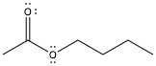  _{Butyl acetate} | 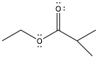  Ethyl isobutyrate | 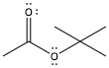  Tert-butyl acetate

Part B:

Preparation of Soft and Hard Soaps
m_{fat} (g) | 5.02
V_{KOH Soln} (mL) | 5.2
[KOH] _{Soln} (M) | 2.17
Reflux time (min.) | 32
V_{NaCl Soln} (mL) | 10
V_{soft soap} (mL) | 10

Calculations (4 points - 2 each)
Part A: Standardization of NaOH
Sample calculation from average of NaOH standardization:
ΔV_{HCl} (L) = (V_{HCl final} - V_{HCl init.}) = (15.05 mL - 0 mL) / 1000 = 0.01505 L
Moles H⁺ = C x V = (0.5 mol/L)(0.01505 L) = 0.007525
HCl + NaOH → NaCl + H₂O, 1 mol HCl:1 mol NaOH, therefore, 0.007525mol of NaOH in solution.
[NaOH] = n_{HCl}/v_{NaOH}
= 0.007525 mol / 0.010 L
= 0.7525 mol/L

Neutralization Equivalents of Unknown Ester
ΔV_{HCl} (L) = (V_{HCl final} - V_{HCl init.}) = (26.65 mL - 0 mL) / 1000 = 0.02665 L
Moles H⁺ = C x V = (0.5 mol/L)(0.02665 L) = 0.0133 mol
HCl + NaOH → NaCl + H₂O, 1 mol HCl: 1 mol NaOH, 0.0133 mol NaOH left in reaction mixture.
Molarity of NaOH left in reaction= n_{HCl}/v_{NaOH}
= 0.0133 mol / 0.041 L
= 0.324 mol/L
Equivalent of base = moles of OH initial- moles of OH consumed
= (0.7525 M x 0.02 L) - (0.324 M x 0.02 L)
= 0.01505 mol - 0.00648 mol
= 0.00857 mol
Therefore, 0.00857 mol of NaOH reacted with the ester.
Neutralization= mass of ester/moles of base required for neutralization
= 1.046 g / 0.00857 mol
= 122.05 g/mol

Discussion (10 points)
Part A
- The purpose of part A was to perform a saponification of an unknown mono-ester to determine its molecular mass and to propose a few possibilities for its structure.
- In this experiment, 9M NaOH stock solution was combined with an unknown ester in a round bottom flask, with ethanol as the solvent. A hydroxide ion acted as a nucleophile and attacked the carbonyl carbon of the unknown ester, creating a tetrahedral intermediate. Subsequent collapse of the tetrahedral intermediate resulted in an ⁻OR leaving group and a carboxylic acid. The carboxylic acid is deprotonated by the ⁻OR leaving group to form the final products of a carboxylate and an alcohol. Ethanol, a polar protic solvent, stabilizes the reaction by hydrogen bonding to the tetrahedral intermediate and final products.
- By using titrations with HCl to standardize the molarity of the NaOH solution before the reaction, and the quantity of base remaining in solution after the reaction, the number of moles of base that reacted with the ester was determined. Since the ester is a mono-ester, this value also represented the number of moles of ester. The molar mass of the unknown ester was then identified.
- After calculating the neutralization equivalent, the molar mass obtained for Sample #51 was 122.05 g/mol. There are several mono-esters with quite similar molar masses. Some of these include butyl acetate (116.16 g/mol), ethyl isobutyrate (116.16 g/mol), and tert-butyl acetate (116.16 g/mol). These are esters with generally 6 carbons in their structures. Other ester structures are possible.
- Without knowing the ester, it is difficult to determine the extent to which the molar mass obtained was accurate. Despite this, the main source of error in this experiment that could have most profoundly impacted the results were the titrations. It is possible that the NaOH stock solution and reaction mixture were over titrated with HCl. Since it often takes several seconds for the added HCl to react with the remaining NaOH in mixture, it is easy to miss the endpoint of the titration and instead add more HCl than needed. To minimize error, titrations were performed multiple times with a given solution to ensure marginal differences were small. In the same light, burette readings are not very precise. To determine the amount of titrant delivered in the future, two readings should generally be made--to the nearest 0.01mL above and below the burette reading, with an average taken of the two numbers.

Part B
(reactions and mechanisms for soap tests)
Addition of calcium chloride to soft soap and detergent, respectively:
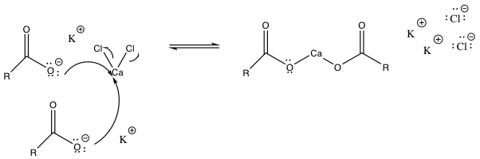
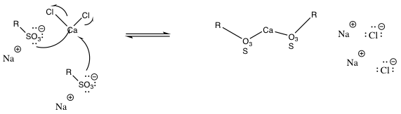
Addition of trisodium phosphate to soft soap and detergent, respectively:
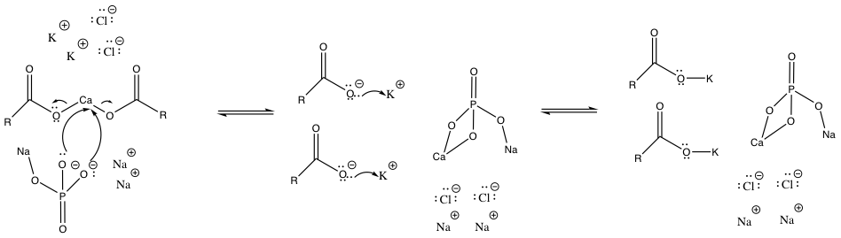
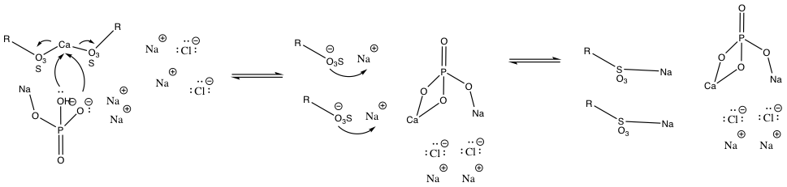
Addition of sulfuric acid to soft soap:
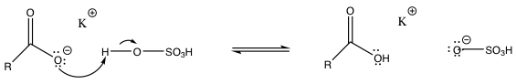
Key steps
- The purpose of part B of this experiment was to create a soap by going through a hydrolysis, more specifically a saponification of a fat (triacylglycerols). KOH, ethanol and a sample of fat were allowed to react together under reflux for 30 minutes. Once the saponification reaction had occurred, with evidence of a colour change, a distillation was performed. The temperature of the steam during distillation was around 80 ºC, a standard temperature to evaporate the undesired alcohol (glycerol in particular) in the mixture. The distillation took place until only 20 mL of thick residue remained in the round bottom flask and the distillate (mainly ethanol and glycerol) was discarded. Distilled water was added to the thick residue in order to make 80 mL of soft soap.
- A sample of soft soap was converted to hard soap through a process called “salting out”. This is based on the physical property of sodium salts which have a low solubility in water. By adding NaCl to the soft soap, the concentration of sodium ions in solution increased, causing the ‘sodium soap’ to precipitate out of solution to form white flakes.
- After the creation of the two soap samples, two detergency tests were performed. The soft soap created in the lab was tested against a commercial detergent to see if the results from the detergency tests were similar and if the soft soap created was effective under these different conditions.
Data Analysis
- In the first detergency test, the two samples were tested by adding equal amounts of calcium chloride. Based on the low solubility of calcium (hard water) salt of soap-forming carboxylic acids in water, the sample of soft soap produced a white precipitate. Since the detergency of the soap-forming carboxylic acid is dependant on the solubility in water, the soft-soap became inefficient. On the other hand, different from soft soap, the commercial synthetic detergent did not precipitate out with the high-water solubility of calcium salt with sulfonic acid. With the special property of a non-polar (hydrophobic) carbon chain and benzene ring and a polar (hydrophilic) end with sulfonic acid, the synthetic detergent had a stronger detergency to clean under both soft and hard water conditions.
- In the second detergency test, equal amounts of trisodium phosphate were added to the resulting mixtures of the first detergency test. In this case, the test tube with synthetic detergent had no change. This is because detergents have the advantage of being equally effective in the presence of potassium or calcium ions (soft or hard water). On the other hand, the soft soap with calcium chloride precipitate had dissolved back into the solution. Trisodium phosphate (or carbonates groups) more strongly bind to calcium ions in water than carboxylates. This caused the detergency of the soft soap to return back to normal as soluble potassium salt of soap-forming carboxylic acids. Thus, the addition of trisodium phosphate had “softened” the hard water to prevent the soft soap from becoming ineffective.
- A final test was done to observe the acid/base properties of soap. Sulfuric acid was added to 5 mL of soft soap until it became acidic. This sample was then heated to around 80 $∘C.$ Under acidic conditions, (addition of sulfuric acid) the soft soap had been protonated and formed precipitate. With the increase in temperature however, the reversible reaction happened and the reaction favored the reactant side.
- In conclusion, the creation of soft soap and hard soap was successful in this experiment. The soft soap can be used as a detergent, but it is unstable. The soft soap would lose most of its detergency by the presence of strong metal ions or under acidic conditions, but both of these reactions are reversible. Synthetic detergent is stable from its polar head and long nonpolar carbon chain. Overall, the synthetic detergent is more suitable for daily use at home/working area.

