Respiratory Topic 6
Objectives:
- Describe the structures of each one of the components of the conduction and respiratory zones
- Describe the gross structure of the lungs & the pleural coverings
- Define & explain the intrapulmonary, intrapleural & transpleural pressures
- Explain the roles of the diaphragm & accessory muscles during inspiration & expiration (quiet & forced)
- Explain the 3 factors that influence pulmonary ventilation
- Describe how lung volumes & capacities are measured; indicate their physiological significance
- Define dead space and indicated its importance in minute and alveolar ventilation
- Explain the mechanisms underlying the non-respiratory air movements

Cardio-respiratory system:
- 2 systems that supply O2 and eliminate CO2 are cardiovascular and respiratory systems
- Respiratory system: provides GAS EXCHANGE = intake of O2 and elimination of CO2
- Cardiovascular system: transport of gases

Pulmonary Ventilation: FUNCTIONS
- Transport O2 (to body)
- Transport CO2 (from body)
- This transport involves 4 processes:
  - External respiration: pulmonary ventilation: air in and out of lungs, pulmonary diffusion: exchange between blood and air of alveoli.
  - Internal respiration: Transport of O2 and CO2: via blood, Capillary gas exchange.
- Control of blood acidity (pH)
- Oral communication
- Olfaction (smell)

Ventilation versus Respiration:
- Pulmonary ventilation (breathing) = the breathing of air into and out of the pulmonary system (nose, pharynx, larynx, trachea, lungs)

The nose:
- Air enters nasal cavity via external nares (nostrils) divided by nasal septum (cartilage, bone); air then goes via internal nares to pasopharynx.
- Nasal cavity lined by 2 types of mucous, olfactory mucous (receptors for smell) and Respiratory mucous (pseudostratified ciliated columnar epithelia, sticky to trap dust and bacteria)
- Cilia of the nose move contaminated mucous posteriorly to pharynx.

Paranasal sinuses:
- Air filled spaces in the maxillary, frontal, ethmoid, and sphenoid bones of skull.
- Sinuses reduce the weight of the skull, warm and moisten air, and serve as resonant chambers for voice production.

The Pharynx (throat):
- Connects nasal and oral cavities with trachea and esophagus.
- Divided into 3 sections:
  - Nasopharynx: only respiration (pseudostratified epithelium to clear mucus)
  - Oropharynx respiration and food (stratified squamous epithelium, tonsils found here)
  - Laryngopharynx respiration and food (stratified squamous epithelium)

The Larynx (voice box):
- Connects pharynx with the trachea
- 3 functions,
  - open two directional airway
  - switching between food or air (epiglottis)
  - voice production
- Loudness of voice depends on the force of air moving across the vocal chords.
- Valsalva’s maneuver: glottis closed and abdominal muscles contract to increase intra-abdominal pressure when lifting heavy load.

The Trechea (wind pipe):
- Decends from larynx and at the end divides into 2 main bronchi.
- It is lined with cilia and has lots of mucous.
- Smoking inhibits and destroys this cilia.

The Bronchi and Subdivisions:
- Conducting portion of bronchial tree:
  - Trachea
  - Primary bronchi
  - Secondary bronchi
  - Tertiary bronchi
  - Bronchioles
  - Terminal bronchioles
- Respiratory portion:
  - Respiratory bronchioles
  - Alveolar ducts
  - Alveolar sacks
- Alveoli allow exchange of gases.
- FUNCTIONS OF BRONCHIAL TREE: conduit, air can reach and interact with blood. Conditions air, is moistened warmed and cleaned. Regulates air flow, smooth muscle regulate lumen diameter of the respiratory tubes controlling airflow.
- Parasympathetic nerve stimulation and histamine cause constriction; sympathetic and catecholamines cause dilation.
- Alveolar capillaries are ONLY location where gases are exchanged between lungs and blood.

The alveoli:
- Very thin squamous epithelial cells, called type I alveolar
- Type II alveolar cells are found interspersed among type I cells. They secrete alveolar fluid for gas exchange.
- 3 other important features:
  - Fine elastic fibres
  - Alveolar pores: allow pressure in lungs to be equalized, and if a bronchi has collapsed allows air passage to functioning alveoli.
  - Contain efficient macrophages (also called dust cells)

Lungs and Pleurae:
- Paired lungs take up whole thoracic cavity except mediastinum
- Each lung is suspended in its own pleural cavity

Blood supply and innervations:
- Pulmonary arteries: bring blood to be oxygenated
- Pulmonary veins: return oxygenated blood to the heart
- Innervations primarily parasympathetic (constriction) some sympathetic (relaxation of air tubes)

The Pleurae:
- Outer layer of the lungs.
- Creates pleural fluid, and this helps the lungs to slide during breathing.
- Divides the throax into 3 sections: mediastinum, + 2 lateral pleural compartments.

Pressure within the lungs:
- Transpleural pressure = intrapulmonary – intrapleural pressure.

Pulmonary Ventilation:
- Mechanical process that depends onf volume changes in thoracic cavity
- Volume changes lead to pressure changes, and this leads to flow of gases.
- BOYLES LAW: volume of gas is inversely proportional to the pressure exerted on the gas.
- Thus pressure and volume change in opposite direction.
- Inspiration depends on: changes in the positioning and shape of the diaphragm, and action of intercostals muscles
- Expiration depends on muscle elasticity.
- Factors affecting PV: friction encountered in air passageways.
- Flow = pressure gradient / resistance
- Very small differences in pressure produce LARGE changes in gas flow
- GREATEST resistance to gas flow is medium sized bronchi

Lung compliance:
- Compliance = delta VL / (Ppul – Pip)
- The more a lung expands for a given increase in transpulmonary pressure, the greater its compliance
- Compliance depends on: distensibilility of lung tissue and alveolar surface tension
- Compliance diminished by any factor that: reduces resilience of lungs

Lung Volumes:
- Tidal volume (TV): volume of air inhaled or exhaled in one normal breath
- Inspiratory Reserve Volume (IRV): max amount of air that can be inhaled above the tidal volume
- Expiratory Reserve Volume (ERV): max amount of air that can be exhaled after expiration of tidal volume.
- Residual Volume (RV): volume that remains in lungs after max exhalation
- Forced expiratory volume (FEV1): volume of air exhaled 1 second after max inspiration
- Dead Space: volume of air that remains in conducting airways
- Inspiratory capacity (IC): max amount someone can inhale following a normal exhalation = sume of tidal volume and IRV
- Vital Capacity (VC): the max amount of a that subject can exhale after max inhalation = sum of tidal volume, IRV, and ERV

Soirometry and spirometers:
- The measurement of human lung volumes and functional capacities with spirometer
- Volumes: non-overlapping measurements
- Capacities: more than one volume added together
- Spirometer: is a device used for quantifying lung volumes and assessing pulmonary function

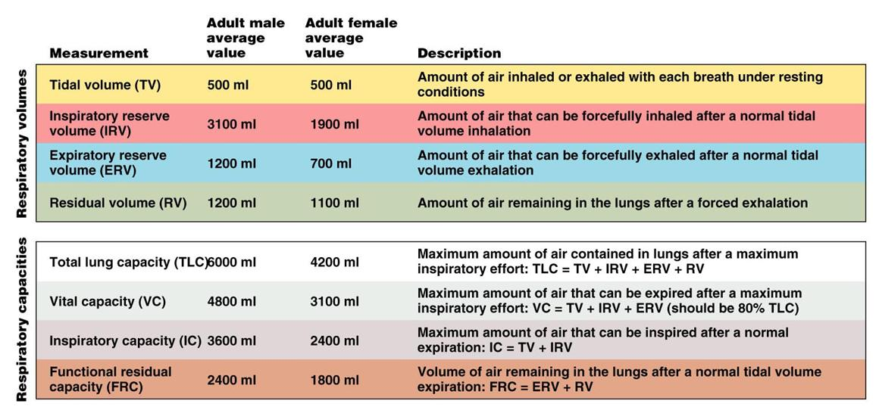

Effects of aging on pulmonary system:
- Loss of elastic recoil of lungs
- Decreased SA of lungs
- Increased dead space (air that fills passage ways but doesn’t participate in gas exchange)
- Decreased rib cage compliance

Minute Respiratory Volume: the amount of air taken in during 1 minute period
- Calculated by TV(ml/breath) X breaths per minute (breaths/min)
- During quite breathing MRV= 6-8 liters/min
- During heavy breathing MRV= 186- 192 liters/min

Ventilation rate:
- Minute ventilation = TV X breath/min
- Alveolar ventilation = (TV – DS) X breath/min

Slide Show #2
Objectives:
- Describe completely the 3 ways in which carbon dioxide is transported in the blood
- Explain the Bohr and Haldane effects
- Associate carbon dioxide levels with blood pH; explain how respiration can regulate blood pH
- Describe how respiration is controlled by the nervous system
- Indicate the effects of the following factors on respiration: Hering Breuer reflex, hypothalamus, cortex
- List the 3 principal chemical factors that influence respiration and explain their mechanisms of action
- Discuss the mechanisms controlling respiration during intense exercise

Partial Pressures of gases:
- Dalton’s law: each gas exerts its own pressure, as if other gases were not present.
- Ptotal = P1 + P2 + P3 …..

Henry’s law:
- When a gas is in contact with a liquid, the gas will dissolve in the liquid in proportion to is PARTIAL PRESSURE.
- At equilibrium: gas partial pressure in 2 phases are SAME
- Temp of liquid is increased, solubility of the gas decreases.

Rate of exchange in lungs:
- Depends on PP gradients & gas solubilites
- Structural characteristics of respiration membrane
- Ventilation/perfusion coupling (they are synchronized)

Diffusion of gases through respiratory membranes:
- Greater SA the more gas can diffuse.
- Diffusion depends on: pressure difference across membrane, thickness of the membrane, diffusion coefficient of the gas.
- Diffusion capacity: volume of gas that diffuses through a membrane each minute per mmHg pressure gradient

O2 Transport:
- Biconcave shape of erythrocytes help make them great O2 transport and exchange vehicles
- Loading and unloading of O2 is facilitated by change in shape of hemoglobin (Hb)
- Hb with 4 O2 molecules is fully saturated.
- Adaptation to chronic hypoxia (not enough O2 in air, more RBCs are created to be able to bring as much O2 as possible.

CO2 transport:
- Dissolved in blood
- Bound to Hb (globin part)
- Deoxygenated Hb combines with CO2 easier that HbO2.

The Haldane Effect:
- The amount of CO2 transported in the blood depends on the oxygenation of Hb.
- The lower the PO2, the less oxygen saturation there is and this means that more CO2 can be carried in the blood.
- The Haldane effect has a relatively larger impact on CO2 transport than Bohr affect on O2 transport!!!

