Week 2 Introduction to HTML

The World Wide Web
 Centered around the idea of being able to link
documents together with hyperlinks
 Was first used for scientific purposes.
 The first draft HTML specification, and the first
graphical browser (Mosaic), were introduced in 1993.
The client/server model
 This model is the basis for the world wide web
 The client (browser) sends a request to a server
(Apache, IIS, etc), and the server returns a response
containing the requested resource back to the browser.
Client Server
Request
Response
Domains & URLs
 A domain name is used to locate an organization or
entity on the internet.
 The domain name system (DNS) translates the
domain name (reddit.com) into an IP address
(165.254.27.96)
 A URL puts together the protocol, subdomain(not
required, but often used), domain name and,
sometimes, a requested resource.
Parts of a URL
http://www.google.com/analytics
Protocol Subdomain Domain name Resource
HyperText Transfer Protocol (HTTP)
 HTTP is a set of rules for exchanging files such as text,
images, videos, and sounds.
 When a URL is entered into a browser, it builds an
HTTP request, which is forwarded to the server.
 The server then responds with the requested file.
HTML
 Stands for HyperText
Markup Language
 HTML is a language,
organized by elements,
that describes how
data should appear in a
browser.
HTML Tags
 A tag is used to define an HTML element.
 Tags are written in the form of <tagname>, where
tagname is the type of html element required.
 Most elements (not all) have an opening tag, and a
closing tag
 The closing tag is the same as the opening tag, with a
forward slash (/) before the tag name.
 Ex: <p>This is a paragraph tag.</p>
HTML Tag Attributes
 A tag attribute provides additional information about
an HTML element.
 For example, the src attribute of the img tag tells the
browser where to locate the image to be displayed.
 Proper syntax is <tag attribute=“value”>
 The following would display an image found in a folder
called images:
<img src=“images/image.jpg”>
Nested HTML tags
 HTML elements can contain other HTML elements.
 Consider the following:
<!DOCTYPE html>
<html>
<head>
<title>Web Page Title</title>
<meta charset=“utf-8”>
</head>
<body>
<h1>Welcome to Web Programming!</h1>
</body>
</html>
HTML Comments
 Comments are defined as follows:
<!-- This is an HTML comment -->
 Comments are ignored by the browser.
 Comments can be anywhere in the HTML document
after the <!DOCTYPE> tag.
Document type declaration (DTD)
 The DTD tells the browser the version of HTML in
which the document is written.
 The DTD must be the first line of an HTML page.
 The DTD for HTML5, which we will be using, looks
like this:
<!DOCTYPE html>
 The DOCTYPE tag does not have a closing tag.
The html Element
 The html is the parent element for all other elements
in a web page.
 The opening <html> tag indicates the beginning of
an HTML document, and the closing </html> tag
indicates the end of the document.
 HTML element can also indicates the spoken language
of the document, with the lang attribute.
 Ex. <html lang=“en”>
 The HTML holds two sections of a web page: the
head, and the body
The head Section
 Holds information about the webpage, such as the
title, encoding, links to scripts and css files, and
metadata for search engines.
 Most of what is shown here does not appear on the
webpage itself.
 The head section is contained in <head>……</head>
tags.
The head section – common elements
 <title>…</title>
 Holds the title of the page that is displayed in the browser, as
well as by search engines.
 <meta>
 Describes a characteristic of the webpage
 Is a standalone tag, does not have a closing tag
 <link>
 Used to link to an outside resource, such as a script or a css
file.
 Uses the href attribute to specify the resource location, and
the rel attribute to describe the type of data (script, stylesheet, etc)
 Is also a standalone tag.
The body section
 Defined by the <body>…</body> tags
 Most of the webpage code that you write will be within
these tags.
 The body contains the code for the visual part of your
web page.
HTML Text Headings
 There are six sizes of headings to choose from: h1 – h6,
with h1 being the biggest font size, and h6 being the
smallest
 Ex:
<h1>Welcome</h1>
<h2>Welcome</h2>
………………………………
<h6>Welcome</h6>
The paragraph <p> element
 Text contained in a paragraph element is displayed in a
block with spacing above and below the text.
Ex:
<p>This is text in a paragraph tag.</p>
 By default, text in a paragraph element is aligned to
the left, but that can be changed with CSS.
The <strong> element
 Text contained in a <strong> element will appear in
bold.
 Ex:
<p>When cooking bacon, <strong>use a
splash screen</strong> to keep yourself
from getting burned.</p>
When cooking bacon, use a splash screen to keep
yourself from getting burned.
The <em> element
 Used to emphasize text
 Text in an <em> element will appear in italics
 Ex:
<p>Both hard work <em>and</em>
perseverance will help you reach your
goals.</p>
Both hard work and perseverance will help you reach
your goals.
The <a> tag
 Primarily used to create Hyperlinks to other web pages
 Text or images contained in an anchor tag with an
href attribute will become a hyperlink.
 Can also use do define an anchor point on a page,
which can be linked to within the document (ex. Jump
to top of page)
 Ex:
<a href=“http://www.google.ca”>Google</a>
The <a> tag
 Defining an anchor point:
<a name=“top”></a>
 Linking to an anchor point:
<a href=“#top”>Return to top</a>
Lists
 Two types of lists: ordered and unordered.
 Unordered list uses <ul>….</ul> tags
 Ordered list uses <ol>…</ol> tags
 List items defined by <li>…</li>
Ordered List Example
 <ol>
<li>This is item 1</li>
<li>This is item 2</li>
</ol>
1. This is item 1
2. This is item 2
Unordered List Example
 <ul>
<li>This is item 1</li>
<li>This is item 2</li>
</ul>
- This is item 1
- This is item 2

Week 3 Images, Tables and Forms

Website Structure
 Websites typically contain multiple files,
images, scripts, etc.
 A site can have many folders.
Paths in website files
 When locating a file (image, css, script, etc),
the path given is relative to the file that is
looking for it.
 For example, if style.css is in the css folder
references an image called logo.jpg in the
images folder, the correct path would be:
../images/logo.jpg
Images
 Browsers will display jpg, gif & png images.
 There are a few ways to display images in
an HTML document.
 Some ways involve CSS, but it is
commonly done using the <img> tag
The <img> tag
 The <img> tag is a standalone tag.
 The <img> requires two parameters in
HTML 5:
◦ The src parameter, which tells the browser
the location of the image, and
◦ The alt parameter, which is a description of
the image.
 The alt tag is displayed when users have disabled
images.
 The alt tag is also used by search engines and
screen readers.
The <img> tag
 Optional attributes include:
◦ width & height – measured in pixels
◦ id – a unique id for the image which is used
by CSS and JavaScript
◦ title – contains advisory information about
the image. This is displayed in most browsers
when the mouse hovers over the image.
The <img> tag example
 <img src=“images/welcome.png”
alt=“Welcome” width=“500”
height=“200” title=“Welcome to
our web page!” />
Turning an <img> element into a link
 The process is the same as text; wrap the
<img> tag with an <a> element
 Ex:
<a href=“http://www.reddit.com”><img
src=“images/snoo.jpg” alt=“reddit
alien” width=“150” height=“300” /></a>
Tables
 Used to display data in rows and columns,
much like a spreadsheet
 In the old days, entire website layouts
were done in tables
 Now, used mostly for web forms and
displaying data.
The <table> element
 All information for a table is contained in a
table element, defined by the <table> tag.
 Rows are defined with the <tr> tag, within
the table element.
 Table data, or cells, are defined by the <td>
tag. <td> elements are children of the
<tr> element.
 The number of <td> elements in a row
define the number of columns.
 Table headers <th> are used to define
rows and columns. By default, text in a
<th> element will appear in bold.
Sample table
<table border="1">
<tr>
<th>Name</th>
<th>Address</th>
<th>Email</th>
</tr>
<tr>
<td>Michael Freeman</th>
<td>1385 Woodroffe Ave</td>
<td>freemam@algonquincollege.com</td>
</tr>
<tr>
<td>John Doe</th>
<td>44 here st.</td>
<td>doej@testing.com</td>
</tr>
</table>
Sample Table Output
<table> border attribute
 The border attribute defines whether
or not the table should be displayed with
a border.
 Accepts either a 0 (no border) or 1
(display border)
 Ex: <table border=“0”>
colspan and rowspan
 colspan and rowspan are attributes
of the <td> and <th> elements.
 colspan defines the amount of columns
a cell should cover
 rowspan defines the amount of rows a
cell should cover
 Both accept an integer value for the
number of rows/columns to span.
colspan example code
<table border="1">
<tr>
<td colspan="3">This cell
covers three columns</td>
</tr>
<tr>
<td>Column 1</td>
<td>Column 2</td>
<td>Column 3</td>
</tr>
</table>
colspan example
rowspan example code
<table border="1">
<tr>
<td rowspan="2">This
cell covers two rows</td>
<td>Row 1</td>
</tr>
<tr>
<td>Row 2</td>
</tr>
</table>
rowspan example
thead, tbody and tfoot
 Used to group row elements (<tr>)
together in logical sections
 Can be helpful when styling rows with
CSS
thead, tbody and tfoot
<table border=“1”>
<thead>
<tr>
<th>Item</th>
<th>Cost</th>
</tr>
</thead>
<tbody>
<tr>
<td>Computer</td>
<td>750.00</td>
</tr>
<tr>
<td>Software</td>
<td>250.00</td>
</tr>
</tbody>
<tfoot>
<tr>
<td>Total</td>
<td>1000.00</td>
</tr>
</tfoot>
</table>
HTML Forms
 Used to retrieve data from the user
 HTML forms on their own do nothing.
◦ Need some client side/server side processing
 HTML comes with controls to display text
boxes, password fields, radio buttons,
checkboxes, drop-down lists, selection lists,
and more
 HTML5 comes with new features such as
date pickers, color pickers, sliders and
spinners. However, these are not available on
all browsers.
The <form> element
 Contains the form controls
 Tells the browser what to do with the
data using these attributes
◦ method: can be get, or post (required).
 get: form data will be appended to the URL and
sent to the browser (less secure)
 post: transmits data in body of the HTTP request
(more secure, recommended)
◦ action: url of server side processing script
(required)
The <form> element
 Other <form> attributes
◦ name: used to identify the form. Useful for
pages with multiple forms (optional)
◦ autocomplete: can be set to on or off.
Tells browser to remember values entered in
these fields. (optional)
◦ id: a unique identifier for the form. Can not
be the same as any other id value on the page.
(optional)
The <input> element
 Used to display several types of form elements
 Inputs are stand-alone elements.
 Elements identified by the type attribute
 Common attributes for <input> elements:
◦ type: the type of form element to display (text box,
checkbox, etc)
◦ name: unique identifier for the element within the
form, used by client and server side scripting
◦ id: unique identifier for the element within the page.
Used by CSS and scripting.
◦ In general, the name and id are the same.
Textbox
 Displays a single line text box.
 Used for names, email addresses, URLs,
and more.
 The code for a text box is as follows:
<input type=“text” name=“firstName”
id=“firstName”>
 Other attributes
◦ value: assigns an initial value
◦ maxlength: the maximum acceptable value
length, in characters
Submit button
 Used to call the script in the action
attribute of the form element, sending the
form data to the server.
 The code for a submit button:
<input type=“submit”
name=“btnSubmit” id=“btnSubmit”
value=“Submit Form”>
 Attributes
◦ value:The text to be displayed in the
button
Reset button
 Used to return form elements to their
default values.
 The code for a reset button:
<input type=“reset” name=“btnReset”
value=“Reset Form”>
 Attributes:
◦ value: the text to be displayed in the button.
Check box
 Allows user to select one or more of a
group of related items.
 Good for yes/no questions, or scenarios
where a “select all that apply” question is
being asked.
 The code for a check box:
<input type=“checkbox”
name=“agreeToTerms” id=“agreeToTerms”
value=“yes”>
 Other attributes:
◦ checked: box is checked by default when
displayed in browser.
Radio buttons
 Allows user to select one (and only one) item from a
group of items.
 Define multiple elements with the same name to
form a group:
Male <input type=“radio”
name=“gender” id=“genderMale”
value=“male”>
<br>
Female <input type=“radio”
name=“gender” id=“genderFemale”
value=“female”>
 Other attributes:
◦ checked: button is checked by default when displayed in
browser.
Password field
 Similar to a text box, but the contents are
obscured with dots.
 The code for a password is as follows:
<input type=“password”
name=“password”
id=“password”>
Textarea
 Accepts larger amounts of text than a text
box.
 Used for comments, questions, or
descriptions.
 The code for a textarea is as follows:
<textarea name=“comments”
id=“comments” cols=“40”
rows=“6”>Enter
comments</textarea>
 <textarea> attributes
◦ cols: the width of the textarea, in characters.
◦ rows: the height of the textarea, in rows.
Select and option elements
 Can be configured to display a dropdown
list, or an option box.
 Configuration is determined by the size
attribute, where a size of 1 will display a
dropdown box, and a size of 2 or more
will display an option box.
 The option elements configure the
options presented to the user, and the
value of each option that is sent to the
browser when selected.
The dropdown list
 Using the select and option elements, creates a dropdown
list that allows the user to choose one item
 The code for a dropdown box is as follows:
<select name=“favColor” id=“favColor”
size=“1”>
<option>Select a color</option>
<option value=“red”>Red</option>
<option value=“blue”>Blue</option>
<option value=“green”>Green</option>
</select>
 The value the option element’s value attribute is the data
that gets sent to the server
The option box
 Using the select and option elements, creates an option list that
allows the user to choose one or more items item
 The code for a dropdown box is as follows:
<select name=“favColor” id=“favColor”
size=“4”>
<option disabled>Select a color</option>
<option value=“red”>Red</option>
<option value=“blue”>Blue</option>
<option value=“green”>Green</option>
</select>
 The value the option element’s value attribute is the data that gets
sent to the server
 Select attributes:
◦ multiple: allows user to choose multiple items in a list
 Option attributes
◦ disabled: prevents a user from selecting the disabled option.

Week 4 Block vs Inline Elements

· A block element will take the full width of its parent
element, and contains a line break before and after
the element
· Examples of block elements: <p>, <h1>, <h2>
· An inline element takes up only as much space as it
needs, and does not contain line breaks before and
after.
· Examples of inline elements: <a>, <strong>,
<em>
· Inline elements can not have a block element nested
inside. For example, you could not put an <h1> tag
inside an <a> tag.
<div> and <span>
· A <div> element is a block element
· <div> elements are used to wrap
sections of a document
· A <span> element is an inline element
· <span> elements are used to wrap
small sections of text, images, etc.
What is CSS?
· CSS is an acronym for Cascading Style
Sheets.
· Defines typographical style, colors, and
layout of a web page.
· Separates the style from the structure.
· Can apply CSS styles to visible HTML
elements.
How to apply CSS
· Inline
 Apply styles to an HTML element with the
style attribute
· Embedded
 Define styles in a <style> element in the
<head> section
· External
 Coded in an external style sheet
Cascading Styles
· CSS uses “rules of precedence” to apply
styles, with the items on the right
overriding items on the left.
Browser
Defaults
External
Styles
Embedded
Styles
Inline
Styles
Defining a CSS style rule
Here is a basic style rule:
td { background-color: #FF0000; }
selector property value
• The curly brackets contain all of the style rules for
the chosen element
• The property and value(s) of a rule are separated
by a colon (:)
• The property-value pair is called a rule
CSS colors
· Two main properties for applying color
with CSS
 color and background-color
· color configures the text color of an
element
· background-color configures the
background color
CSS colors
· The value of color and background-color
can be of the following types:
 Hexadecimal (ex. #FF0000)
 Decimal (ex. rgb(255,0,0) )
 Hue, Saturation and Lightness
(ex. hsl(0, 100% 50%) )
 Color words (ex. red)
· In this course, we will focus on the hex
color codes.
Inline CSS styles
· Unlike embedded and external style
rules, inline styles do not use a selector
· Styles are passed in the
property: value;
format as the value of the style
attribute
 Style attribute can be applied to any visible
HTML element
· Ex: <p style=“text-align:center;”>
Inline CSS styles
· Element level inline styles will override
all other styles.
· Ex:
<body style=“color:#FF0000;”>
<p>This text will appear red</p>
<p style=“color: #0000FF;”>This
text will appear in blue</p>
</body>
Embedded CSS
· Applies to the entire document in which it is
defined.
· Placed in a <style> element in the
<head> section.
· Uses the same syntax as an external
stylesheet.
· Ex:
<style>
p { color: #FF0000; }
h1 {color: #0000FF; }
</style>
External Stylesheets
· Styles are saved in an outside file with
.css extension
· Useful for defining styles across multiple
pages
· Added to a page in the <head> section
using a <link> element
 Ex. <link href=“css/style.css”
rel=“stylesheet”>
CSS Selectors
· Selectors are used to identify which
element a CSS rule applies to
· Selectors include:
 HTML element
 class
 id
CSS selector – HTML Element
· Uses the element itself as the selector
· Ex: p { text-align: center; }
· Will apply to every occurrence of that
element within the scope of the rule
CSS selector – class
· In embedded and external stylesheets, you
can define a style class
· Class is identified by a dot, then the class
name
 Ex: .red { color: #FF0000; }
· To apply the class to an HTML element,
use the class attribute
 Ex. <p class=“red”>This is red
text.</p>
· Can apply a CSS class to multiple
elements.
CSS selector – id
· In embedded and external stylesheets,
you can define a style for an id
· Id is identified by a # then the id name
 Ex. #header { text-align: center;
}
· To apply the id style, give the HTML
element the corresponding id
 Ex: <div id=“header”>
CSS selectors – id vs class
· An id applies to a single element, where
a class applies to all elements of that
class.
Descendent selector
· You can define a style for an element in
the context of a container element
 Ex: #header h1 { color: #00FF00; }
 The above style would apply to all h1
elements in the header context.
· A selector can have multiple
descendents
○ Ex: #header .nav li { color:
#0000FF; }
The CSS box model
Margin (not visible)
Border
Padding
Content
Top
Bottom
Left Right
Margins and Padding
· Margins are the non-visible space outside
of the element
 Ex. margin: 5px would place a non-visible
space of 5px around the element.
· Padding is the space between the border
and the content of an element
 Ex. padding: 5px; would place a 5px space
between the border and the element’s content.
· Can specify margins and padding at the
top, left, right, or bottom of an element
 Ex. padding-top: 5px; would put 5px of
padding only on the top of the element.
Positioning with CSS
· Positioning can be static, fixed, relative, or
absolute
 static – default positioning.
 fixed – relative to browser window
 relative – relative to its static position
 absolute – relative to first non-static parent
element
· Position with top, bottom, left and right
 Value is a pixel value (px) of how many pixels
between the property and the element
○ Ex. top: 50px would be 50px from the top of
the element
Modifying Text with CSS
· Common CSS properties for modifying
text:
 text-align: positions the text
○ Values include left, center, right, or justified.
 font-weight: changes thickness of letters:
○ Values include lighter, normal, bold, bolder
 color: sets the color of the text
 text-decoration: sets decoration to the text
○ Values include underline, overline, line-through
Modifying Tables with CSS
· Common CSS properties for modifying <table>
elements:
 width – specifies width in pixels or percent of screen
 border-spacing – configures space between cell
borders
 border – configures the border of the table (not the
cells)
 border-collapse: collapse (no space between
borders), separate (space between borders, default
value)
· Styles that modify text and color applied to the
table will apply to all cells in that table, unless
they are overridden.
Modifying table cells with CSS
· Common CSS properties for modifying
<td> elements:
 color: defines the text color
 background-color – defines the background
color
 padding – defines the amount of space
between the cell contents and the border
Float property
· Elements floated horizontally
· Can float an image to the right or left,
not up or down
· Text elements found after a floated
element will flow around it.
· Text elements before a floated object will
not be affected.
· Elements that are absolutely positioned
ignore the float property.

Week 5 Introduction to JavaScript

Review
 So far, we have focused on HTML and CSS
 We have learned:
 The syntax and structure of HTML and CSS
 How to display text and images with HTML
 How to create tables to display data with HTML
 How to create forms (that do nothing)
 How to change the look of HTML elements with CSS
 How to change the layout of HTML elements with CSS
Static vs Dynamic Web Pages
 The content of static web pages does not change,
unless the source code is modified.
 Static web pages do not allow for user
input/interaction.
 Dynamic web pages have content that changes,
without having to edit the source code.
 Most web pages have some dynamic content.
 All the pages we have done so far have been static
pages.
Adding functionality to a web page
 Some examples of ways to add functionality to a web
page:
 HTML5 & CSS (beyond the scope of this course)
 Flash
 JavaScript
 PHP
 In this course, we will focus on the last two.
Client-Side vs Server Side
 In web programming, you can have client-side
programming, or server-side programming
 Client side code runs in the browser.
 Server side code runs on the server
 The client and the server don’t know what the other is
doing.
Client-Side VS Server Side
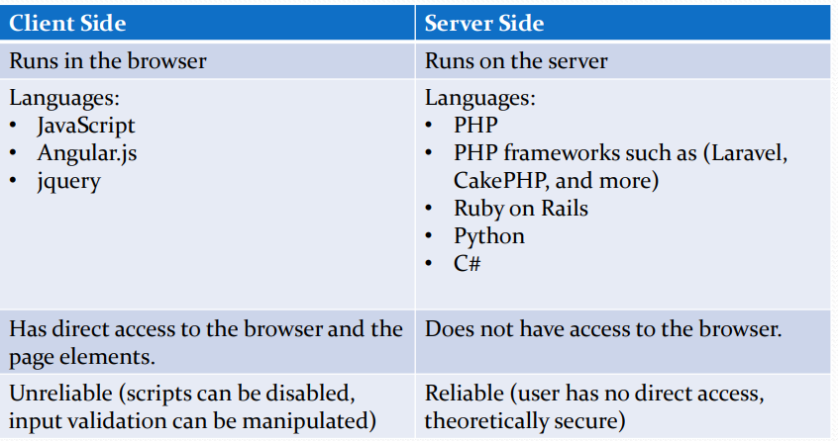
What is JavaScript?
 JavaScript is a versatile, interpreted client-side*
programming language.
 Supported by all major browsers
 Used to add functionality to web pages
 JavaScript can respond to events
 JavaScript can access and modify HTML elements
 JavaScript is NOT JAVA!
Using JavaScript in your web page
 You can put JavaScript in you web page in two ways:
 Inside a <script> element
<script>
document. write(“Hello World”);
</script>
 Link to a JavaScript file (.js) using the <script> src
attribute:
<script src=“scripts/jquery.js”></script>
When is JavaScript used?
 Like all programming languages, it is used to solve a
problem.
 Examples of uses for JavaScript:
 Form Validation
 Hide/Show elements
 Dynamically change text/images
 Mathematical problems
 Responding to events (clicks, key presses, etc)
The Basics
 What we will cover:
 Declaring functions
 Declaring variables
 Data Types
 Operators
 Comparisons
 Conditions
 Prompts and Alerts
 DOM Events
Function Declaration
 A basic function declaration looks like this:
function myFunction () {
//do stuff here
}
 A function declaration with parameters looks like this:
function myFunction (param1, param2){
//do stuff here
}
 There are two other ways to define a function, but we will
focus on the function declaration for now.
Declaring Variables
 Variables are declared with the term var
 Ex 1: var myName = “Matt”;
 Ex 2: var myName;
 Variables declared outside of a function have global scope.
 Variables declared inside of a function have local scope.
 The equals sign (=) is the assignment operator
 Variables are dynamically typed – they do not require a data type specification
Data types - String
 Strings can be enclosed in single or double quotes
 Examples:
var a = “hello world!”;
var b = ‘hello world!’;
var c = “55”;
 You can use quotes in a string so long as they don’t match the container quotes
 Ex:
var statement = “He said ‘Hello World!’ to me.”;
Data types - String
 Strings can be added together using the + operator
 Examples:
var firstName = “Matt”;
var lastName = “LaCasse”;
var fullName = firstName + “ “ +
lastName;
Data Types - Number
 JavaScript only has one number type
 Can be written with or without a decimal
 Examples:
var a = 50;
var a = 50.5;
 Very large and very small numbers can be written in scientific notation
 Examples:
var a = 19e7; //190000000
var a = 12e-7 //.0000012
Data Types - Boolean
 Can be true or false
 Ex:
var isThisANumber = false;
var isThisABoolean = true;
Arithmetic Operators
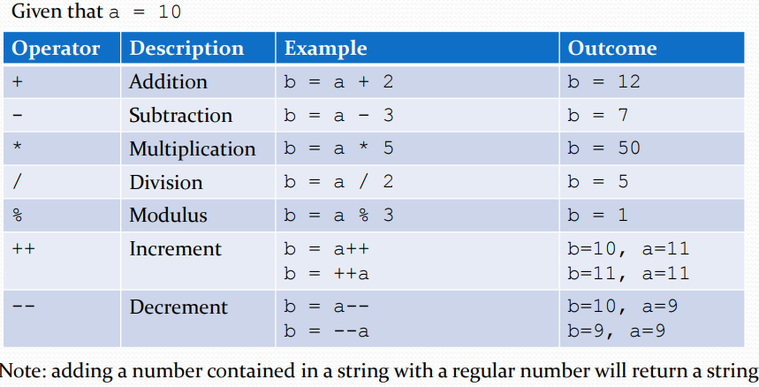
Assignment Operators
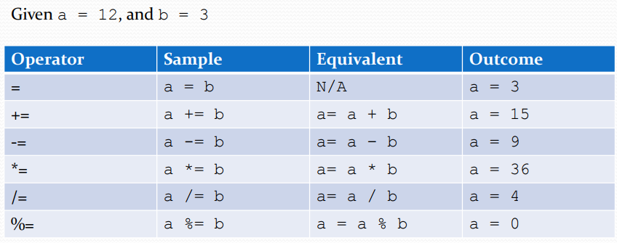
Comparisons
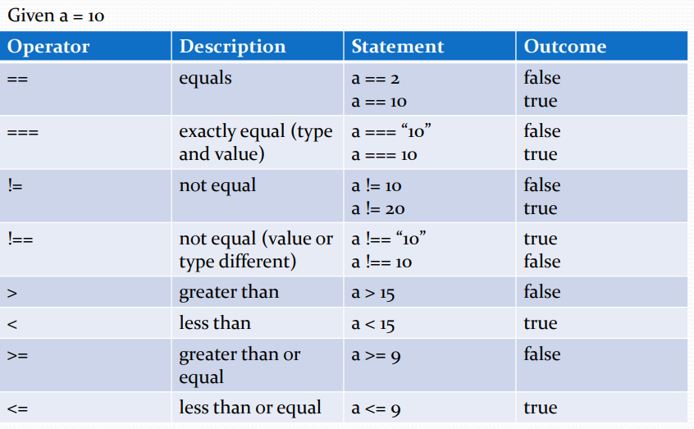
Logical Operators
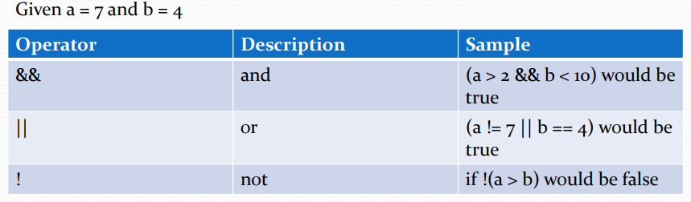
Conditional statements
 JavaScript uses the if, if…..else, if…..else if…..else, and
switch statements for conditional actions
 if statement syntax:
if(expression){
//do something
}
Conditional statements
 if…..else example:
if(expression){
//do something if the expression is true
} else {
//do something if the expression is
false
}
Conditional statements
 if…..else if……else example:
if (expression1){
//do something if expression 1 is
//true
} else if (expression 2){
//do something if expression 2 is
//true
} else {
//do something if neither
//expression is true
}
Conditional Statements
 Switch example:
switch(variable)
{
case 1:
//do something
break;
case 2:
//do something
break;
default:
//do this if none of the above
//cases are true
}
Conditional Statements - Switch
 The value after case is called the case label
 The code found after the case label will run if the
variable matches the case label.
 If there is no match between the variable and the case
label, the code after default will run.
 The break; statements tells the switch statement to
stop.
Prompt
 A JavaScript prompt displays a message box to the user
with a message, and a textbox for them to reply.
 Called by the prompt function
 You can assign the result of a prompt to a variable
 Ex:
var name = prompt(“What is your name?”);
 A prompt can have a default value, specified by a
second parameter.
 Ex:
var name = prompt(“What is your name?”,
“noname”);
Alert
 An alert is similar to a prompt, but it does not accept
user input.
 Ex:
alert(“Transaction was successful.”);
DOM Events
 HTML elements have attributes that can run JavaScript
when a certain event happens
 Some common events are:
 onclick
 onmouseover
 onload
 onchange
 onmouseup
 onmousedown
DOM Events
 To run a JavaScript function, add the name of the
function as the event attribute’s value.
 Ex:
<input type=“button” name=“btnConvertTemp”
id=“btnConvertTemp” onclick=“convertTemp();”
value=“Convert Temperature”>
 When the above button is clicked, the convertTemp() function will be run.

Week 8 JavaScript DOM and Arrays

DOM – Document Object Model
 Used for HTML and XML documents
 In web programming, it provides the link between
web pages and programming languages
 Organizes HTML elements into objects
 The HTML DOM is big! We don’t have time to cover everything in class.
The Document Object
 The document object contains all of the elements of a webpage that’s loaded into a browser.
 The elements, attributes, and comments of an
HTML page are nodes of the document object.
 The document object is the root node for all other
nodes.
 The document object provides access to these
nodes through its properties and methods.
Key Document Object Properties
 document.cookie – returns name/value pairs for all cookies in the document
 document.forms – returns an array of all forms in the document object
 document.images – returns an array of all images in the document object
 document.title – sets or returns the title of the
document
 document.URL – returns the full URL of the
document
document.getElementById() – returns an element based on its id attribute
 document.write() – writes text or HTML code to the document.
 document.getElementsByTagName() – returns a NodeList of all elements of a specified tag name
 document.createElement() – creates a new element
The Element Object
 The Element object represents an HTML element from a web page.
 Nodes contained within an element object are called child nodes.
◦ Can be comments, other elements, or attributes.
All types of elements have shared properties and methods (ex: element.childNodes will return a NodeList containing all child nodes of an element)
The NodeList
 Contains a list of nodes.
 Can loop through the items of a NodeList using a for loop.
 Although similar, a NodeList is not an array.
 Nodes are accessed using an index.
◦ Ex. document.childNodes[1]
* List is not live if retrieved using the querySelectorAll method
Key Element Object Properties
element.attributes – returns a NamedNodeList of all the element’s attributes
 element.id – sets or returns the id of the element
 element.innerHTML – sets or returns the content of an element
 element.className – sets or returns the class of an element (useful for applying CSS styles dynamically)
Key Element Object Methods
 element.setAttribute() – sets the named attribute’s value
 element.clodeNode() – clones an element
 element.appendChild() – appends a new node as the element’s last child node
 element.insertBefore() – inserts a new node before specified child node
 element.removeChild() – removes a specified child node.
The Attribute Object
 Represents an HTML attribute
 Attribute objects are always a child node of an element object.
 Attributes accessed via the element object’s attributes property are returned in a NamedNodeList.
◦ The NamedNodeList is like the NodeList, but you can access an attribute by its index or by its name.
Key Attribute Object Properties
 attribute.name – returns the attribute’s name
 attribute.value – sets or returns the attribute’s value
 attribute.specified – returns true if the attribute is specified, otherwise returns false
Events
 Used to register event handlers
 Examples of different types of events:
◦ Mouse events (onclick, onmouseup, onmousedown)
◦ Frame/Object events (onload, onerror, onabort)
◦ Form events (onchange, onfocus, onsubmit, onreset)
Usually used in conjunction with a function
◦ ex. document.forms[“myForm”].onsubmit =
validateForm();
will call the validateForm() method when the form is submitted.
Element-Specific Objects
Certain HTML elements have their own objects
◦ Examples include form inputs (checkboxes, textboxes, etc), images, links, buttons, etc
These options have properties/methods specific to the element
◦ Example: the image object has height and src properties.
The Input Text Object
Properties:
◦ value – returns or sets the text inside the text box
◦ maxlength – returns or sets the maxlength of the textbox
◦ size – returns or sets the size of the textbox, in characters
Methods
◦ select() – selects the contents of the text box.
The Input Radio/Checkbox Objects
Although they are different types of objects, their key properties are the same.
 Properties
◦ checked – returns or sets the checked value of the button
◦ value – returns or sets the value attribute’s value
JavaScript Arrays
 Stores multiple values in one object
 Can store different object types in one array
 Arrays in JavaScript are objects, and have
predefined methods and properties, such as:
◦ length – returns or sets the number of elements in an array
◦ sort() – sorts an array’s elements
◦ push() – adds a new element onto the end of an array
◦ concat() – joins two or more arrays, returns the joined array
Defining JavaScript Arrays
Constructor
◦ var newArray = new Array();
Literal
◦ var newArray = [“Item1”, “Item2”, “Item3”];
Condensed
◦ var newArray = new Array(“Item1”, “Item2”,“Item3”);

Week 9 Introduction to PHP
What is PHP?
○ PHP is a recursive acronym for PHP:
HyperText Processor
▪ Used to be called Personal Home Page, but that was boring.
○ PHP is a server-side scripting language
○ PHP is free to use, well maintained, and widely available
▪ Most (dare I say all) hosting companies support PHP
Why use PHP?
○ It makes pages easier to update
▪ You can store repeated pieces of code (web page header, footer, navigation) and re-use them across pages.
○ You can save user information
▪ Data sent to the server can be saved in a database, and recalled later
○ You can change your page without changing your code.
How to create a PHP file?
○ A PHP file is defined by the .php extension
○ Any HTML page can be turned into a PHP page by changing the extension to .php
Adding PHP to a PHP file
○ PHP code is contained in the following tags: <?php ?>
○ These tags can be placed anywhere inside a PHP document.
○ An entire file can be a PHP file by placing the opening tag at the beginning of a file, and the closing tag at the end.
XAMPP, Apache and the htdocs file
○ XAMPP should have installed Apache, MySQL and PHP (the AMP in XAMPP) on your computer
○ Apache is a free, open source, and popular web server
○ By default, XAMPP designates the htdocs folder in the XAMPP installation directory as the Apache web directory
Using a PHP file
○ PHP files must be on a server to run.
○ Unlike JavaScript, opening a PHP file directly in a browser will do nothing.
○ To run a PHP file on your computer, simply copy it to the htdocs foder.
○ Open XAMPP, and make sure that the Apache service is running.
○ Navigate to
http://localhost/yourFileName.php
echo and print()
○ echo and print() both write text inside the HTML document before it is sent to the browser
○ There are a few differences between the two,but for the most part, they have the same functionality.
○ Example!
Declaring variables
○ Variables are defined using the dollar sign ($)
▪ ex: $variableName
○ Variable names must start with an underscore (_) or a letter (A-Z, a-z)
▪ $3names is an invalid variable, because it starts with a number
▪ $_3names, however, is valid, because it starts with an underscore
Assigning variables
○ PHP uses the equals sign (=) as the assignment operator
○ The default way to assign variables in PHP is to assign by value.
▪ If $x = $y, then $x will be assigned the value of $x.
○ However, PHP does offer a way to assign by reference, using the ampersand (&).
▪ If $x = &$y, then $x will be a reference, or alias, for $y.
○ Example!
Declaring Functions
○ A function is defined using the following syntax:function myFunction($arg1, $arg2){ echo “Do something here;
return $aValue
}
○ Like variables, function names must start with a letter or an underscore
○ Any valid PHP code can be put in a function
○ Example!
Variable Scope
○ PHP variable scope works different than JavaScript or Java!
○ The scope of a variable is the context in which the variable is defined
○ That means that unless specified, variables declared outside of a custom function are not available within that function!
○ To use an out of context variable, you can use the global keyword
PHP Data Types
○ PHP is loosely typed. Meaning, you do not need to specify the data type.
○ Having said that, PHP does support different primitive data types:
▪ Boolean
▪ Integer
▪ Float (double)
▪ String
○ There are others, but we’ll save those for later.
Boolean
○ Holds a true or false value.
○ Defined by assigning a variable either the true or false keyword (not the word in a string)
○ Ex: $myBool = true;
○ The true and false keywords are case insensitive.
Integer
○ Can be specified in decimal, hexadecimal, octal or binary notation
○ Defined by assigning an integer value to a variable
▪ Ex: $myInt = 8675309;
○ PHP does not have a division operator for integers. An integer divided by an integer will yield a float.
Float
○ Defined by assigning a float value to a variable
▪ Ex: $float1 = 11.567;
▪ $float2 = 1.9e4;
▪ $float3 = 9E-8;
○ Floating point numbers have issues with precision when dealing with very large numbers.
String
○ Strings can be defined in four ways:
▪ Using single quotes - $myVar = ‘this is a string’;
▪ Using double quotes = $myVar = “this is also a string”;
▪ Using Heredoc (not covered)
▪ Using Nowdoc (not covered)
○ To concatenate strings, use the dot .
ex: $helloWorld = “Hello “ . “World!”;
PHP gettype()
○ If you need to know the data type of a variable in PHP, use getType.
○ Ex:
$x = 10;
echo gettype($x); //would
output ‘integer’
○ The output for gettype() that is passed a float
data type will return “double”. This is due to
historical reasons.
○ Example!
Single vs Double quotes
○ In PHP, there is a difference between using single and double quotes
▪ If you use single quotes, the string will be interpreted literally.
▪ If you use double quotes, certain evaluations will occur. Most notably, variables will be evaluated.
○ Example time!
PHP Arithmetic Operators
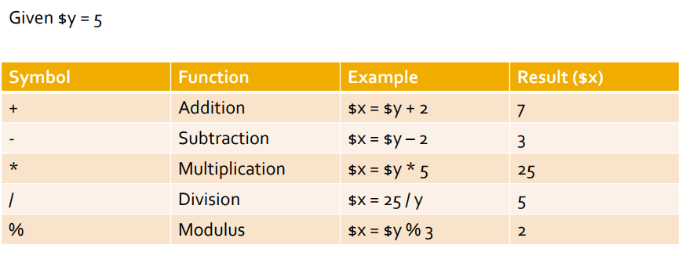
PHP Comparison Operators
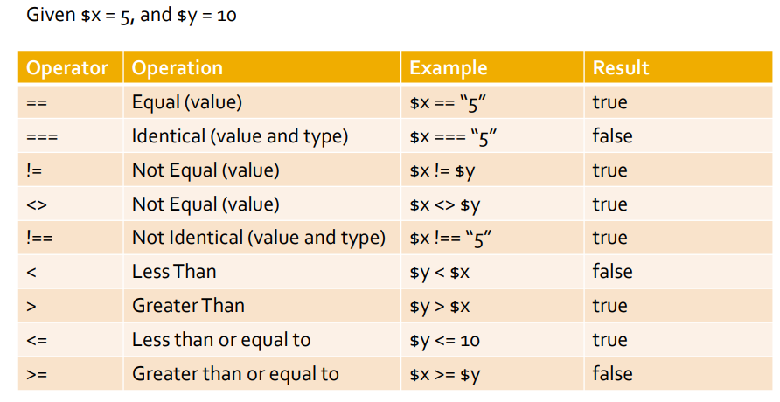
PHP Logical Operators
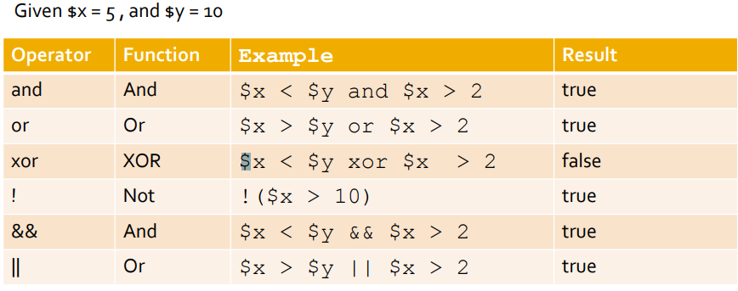
Conditional Statement (if)
○ Two ways of defining an if statement
▪ If you only want to execute one statement, you can write it as follows:
if($x > $y)
echo ‘$x is the larger number’;
▪ If you want to execute one or more statements, the syntax is as follows:
if ($x > $y){
echo ‘$x is the larger number’;
$y++;
}
$_GET and $_POST
○ $_GET and $_POST are associative arrays that give PHP scripts access to form data sent from a browser
○ $_GET and $_POST are superglobals, which means that they are accessible anywhere in a PHP script.
$_GET
○ When a URL is sent to the server, it can contain parameters.
▪ Ex:http://localhost/hello.php?yourName=Matt
○ The parameters are passed to PHP scripts in an associative array ($_GET)
○ To get the above parameter in PHP, do the following:
▪ $userName = $_GET[“yourName”];
$_POST
○ $_POST is an associative array of variables sent to the server via the HTTP POST method.
▪ If an HTML form has its method set to “post”, the form values are in the $_POST array.
○ To access a form field’s value in PHP, the name attribute of the form field is used to search the $_POST array
▪ Ex: $firstName = $_POST[“firstName”];
isset ()
○ isset() is a PHP function that takes a variable as a parameter. It returns true if the variable is set (ie: has a value), otherwise it returns false.

Week 10 PHP – OOP and Arrays
PHP & OOP (Object Oriented Programming)
○ PHP scripts can be both procedural and OOP since PHP 5 OO.
▪ Once again this is a vast subject and we will simply be scratching the surface in this program.
▪ This subject could be a course all on its own.
○ What is object oriented programming?
▪ Think of it as having smaller programs inside of a larger program
OOP Uses / Advantages
○ What are the advantages or OOP?
▪ Allows you to better organize your code
▪ Allows you to reuse code
▪ Makes updating the application and maintenance much easier and efficient
Why would we use this type of programming PHP?
▪ Especially with larger applications
▪ Having a vast collection of code libriaries can increase your ROI
▪ Take advantage of existing PHP frameworks
Classes
○ To use an object you need to create a class
  - A class is like a blueprint for the object
○ The class itself contains all the code (data and functions)
- Inside a class data/variable are called properties
- Function inside a class are called methods
▪Encapsulation – this is a method whereby only the methods inside the class can manipulate its properties
▪ This makes it easier to maintain the class/code
Declaring a Class
○ Define a class using the class keyword
<?php
$object = new User;
class User
{
public $name, $password
// the variable $name and $password are the properties of the class User
// The save_user function inside the class User is called a method
function save_user()
{
echo “Save User code goes here”;
}
}
?>
Inheritance – Superclass / Subclass
○ Inheritance
▪ One class inherits all properties of another class
○ At times you may require two classes that are similar but accomplish a different tasks
▪ Instead of rewriting code you can simply inherit and therefore use the properties of the other class
▪ To extend the use of one class to another you use the extends operator.
○ The original class is called the superclass and new class is called the subclass.
Creating an Object
○ Think of an object as a jukebox
○ To create a class you use the keyword new
○ Example:
$object = new User;
Assigned an object
named $object to the
User class
Referencing the class to
use.
Accessing Objects
$object = new User; // assigned the object
$object->name = “Michael”;
//sets the value of the name property in the class User
$object ->password = “pass123”;
//sets the value of the password property in the class User
$object->save_user();
// calls the method save_user in the class User
○Notice the use of the “->” pointer. The pointe allows access to the classes properties and methods.
Constructors
○ Similar to a function call, you can pass a list of arguments to a class being called.
○ Arguments are passed to a special method within the class called the constructor.
○ The constructor method initializes various properties within the class.
Class User
{
function __constructor($param1,$param2)
{
//constructor codes goes here
}
}
Methods
○ Functions inside classes are called methods
○ Methods are created and called the same way as functions are.
▪ Do not start your method names with underscores
▪ These are reserved for special methods as methods as constructors and destructors
○ In methods you have access to a special variable called $this
○ The $this variable is used to access the current objects properties
Methods Con’t
<?php
$mypass = new User;
echo $mypass->get_password();
class User
{
public $name = “Michael”;
public $password = “mypass”;
function get_password()
{
return $this->password;
}
}
?>
○Observe the get_password method above.
○Using the special $this variable give access to the current object ($mypass) and then returns the value of the password property.
○Notice the $ is missing from the property $password when using the“->” pointer
Declaring Properties
○It is not necessary to declare properties within classes. They can be defined when first used.
▪ However, not declaring properties is not a good practice.
○This makes your code within the class very clear
○You can define Constant Properties using const keyword.
const tax = 0.13;
○Constant variables can be referenced using the self keyword and the double colon operator.
echo self::tax;
Property and Method Scope
○ There are 3 keywords for controlling the scope of both properties and methods.
○ public
▪ Is the same as var and is the default when declaring properties and methods.
○ protected
▪ Properties and Methods declared protected can be referenced only by the objects class and subclasses
○ private
▪ Properties and Methods declared private can only be referenced by that particular class.
The final word on OOP
○There is so much material to cover we cannot cover it all in one class!
▪You will do your own research on the following;
▪ The extends operator
▪ The parent operator
▪ Investigate the Subclass constructors
○ The final keyword
○These will be on the final exam and you will be expected to know what they mean and how they are used.
○I implore you all to take the time to play around as much as possible with OOP and all the keywords and operators discussed in these slides.
PHP Arrays
○ PHP arrays are like ordered maps that associates values to keys.
○ There are three types of arrays
1. Numerically indexed arrays
2. Associative arrays
3. Multidimensional arrays
Indexed Array
○ Numerically Indexed Array
<?php
$paper[] = “Copier”;
$paper[] = “Inkjet”;
$paper[] = “Laser”;
$paper[] = “Photo”;
$print_r($paper);
?>
Try this example to see what print_r does!
Associative Arrays
○ Associative arrays allow you to reference the items in an array by name rather than by number (as per the indexed array)
▪ Here is an example of an associative array
<?php
$paper[‘copier’] = “Copier & Multipurpose”;
$paper[‘inkjet’] = “Inkjet Printer”;
$paper[‘laser’] = “Laser Printer”;
$paper[‘photo’] = “Photo Printer”;
?>
○ Each item has a unique name that can be used to reference its value.
○ The names are called indexes
○ Research how to create an array using keywords!
Accessing Arrays
○ There are multiple ways of accessing
arrays.
▪ for loops (easy for numeric arrays)
▪ foreach … as loop
▪ The list() and each() functions
Array Functions
○ There are a number of array functions that help us manage and manipulate the values inside arrays
○ Become familiar with these functions
▪ is_array()
▪ Determines if a variable is an array
▪ count()
▪ Determine how many elements are in an array
▪ sort()
▪ Sorts the values of an array (numeric and string)
▪ shuffle()
▪ Arranges the values of an array in random order
Array Functions Con’t
▪ explode()
▪ Takes a string and places it into an array
▪ extract()
▪ Useful for creating associative arrays from GET and
POST arrays
▪ compact()
▪ Creates arrays from variables
▪ reset()
▪ Places the pointer to the first element in an array
▪ end()
▪ Places the pointer to the last element in an array

Week 11 PHP & My SQL
Overview
○ PHP provides core functionality for web programming
○ PHP extensions allow for increased capability of PHP programs
○ Some examples of extensions include:
▪ Calendar – extension for working with dates
▪ SimpleXML – converts xml documents to objects
▪ MySQLi –Allows PHP to interact with a MySQL database.
My SQLi Extension
○ Builds off the original MySQL extension
▪ MySQLi stands for MySQL improved
○ Provides an API for PHP applications to access and use a MySQL database
○ Installed by default as of PHP5
Procedural vs Object Oriented
○ MySQLi provides an interface for both procedural and object-oriented programming paradigms.
○ The use of either is based on developer preference.
○ In this course, we will be using the ObjectOriented paradigm.
Before we start
○ From this point on, MySQL will need to be functioning properly on your PC.
○ If you are having issues with MySQL, please do not wait until the day your lab is due to
tell me. No lab extensions will be given due to issues with MySQL.
The MySQLi Object
○ Contains methods to connect to, query, and administer a database.
○ Constructor takes minimum 4 arguments
▪ Database host (eg: 127.0.0.1)
▪ Username – MySQL username
▪ Password – MySQL password
▪ Database Name
○ Ex: $mysqli = new mysqli(‘127.0.0.1’,‘root’, ‘password’, ‘db_name’);
▪ The above code will create a mysqli object and establish a database connection.
Important MySQLi Properties
○ The MySQLi object provides properties with details about connections, queries, results, and more.
○ Some important properties to note:
▪ connect_errno and connect_error
▪ Provides information about connection errors
▪ errno and error
▪ Provides information about non-connection related errors
▪ affected_rows
▪ Provides the number of rows affected by the previous query.
Important MySQLi Methods
○ query()
▪ Accepts an SQL query and returns a mysqli_result object
○ prepare()
▪ Accepts an SQL query returns a statement object
The mysqli_stmt class
○ Contains methods to prepare and execute a prepared statement against a MySQL database.
○ Properties
▪ error & errno – contains information about errors encountered during execution
▪ affected_rows – contains the number of rows affected by the previous INSERT, UPDATE, or DELETE statement.
○ Methods
▪ prepare()
▪ prepares an SQL statement for execution
▪ bind_param()
▪ used to bind variables to a prepared statement as parameters
▪ execute()
▪ executes a prepared statement
▪ get_result()
▪ returns a result set from the previous query execution
The mysqli_result class
○ Holds the result of a database query
○ Key properties
▪ num_rows – indicates the number of rows in the result
▪ field_count – indicates the number of fields in the result (columns)
○ Key methods:
▪ fetch_assoc()
▪ returns the next row in the result as an associative array (column_name=>value)
▪ free()
▪ Clears the memory holding the result
▪ fetch_row()
▪ Returns the next row as an enumerated array (ie: integerkey starting at zero)
Closing Connections
○ Although the MySQLi class provides a method to manually close database connections, it is not necessary to use. This is because MySQLi will automatically close the database connection at the end of the script.
Sample Application
○ In BlackBoard, there is a sample application that can be found under Course Documents -> Week 11 -> Week 11 Lecture. Download the file called Week11Demo.zip.
○ Extract the Week11Demo folder to your htdocs folder (or whichever directory is used by your server)
Setting up the database
○ In the Week11Demo project, there is a folder called sql. Inside that folder is a sql script called initCST8285.sql
○ Using phpMyAdmin (or the MySQL workbench, or the command line), run that script to create the CST8285 database and database user.
○ If your project is set up correctly, you should see the following when you navigate to http://localhost/week11demo/index.php:

