Lab#4: Acid and Base Titrations

Student Name: Zena Benazzouz
Student Number: 0300025665
Demonstrator’s Name: Hana Durekhova

Lab Partner: Eric Lee

Lab Date: October 31st,2017
Lab Due date: November 7th, 2017 (9:30)

Department of Chemistry
Faculty of Science
University of Ottawa

Introduction:
Acids and Bases are present all around us and both have various properties that distinguish the two. Acids tend to have a sour taste, are corrosive, have a pH that is less than 7 and become less acidic if they are mixed with a base (3). Bases on the other hand, have a slippery feel to them, have a pH more than 7 and become less basic when an acid is added (3). The Arrhenius definition of acids and bases states that “An Arrhenius acid is any species that increases the concentration of H+ in an aqueous solution” (1) and “An Arrhenius base is any species that increases the concentration of OH- in an aqueous solution” (1). Arrhenius acids and bases can be represented in the following equations:
Acid: HA--------------- (H+) + (A-)
Base: BOH------------------ (B+) + (OH-)
Where HA donates a proton when it is dissolved in water and BOH donates a hydroxide ion when it is dissolved in water.
This lab revolves around titrations, titration is defined as “the process of finding how much of substance X is contained in a solution, by measuring how much substance Y is necessary to add to the solution in order to produce a given reaction.” (2). In a titration, an acid and a base react together to form water and salt, this is known as neutralization which is presented in the following reaction:
HCl+ NaOH ---------------- H2O +NaCl
In this equation, the acid(HCl) and the base (NaOH) have a 1:1 mol ratio, this mol ratio is best described as: n(acid)=n(base)
By determining the mole ratio, we can easily find the concentration of the base or acid using the following equation:
Cbase x Vbase= b/a Cacid xVacid
Lastly, Titrations require indicators, the indicator used in this lab is phenolphthalein, which produces a constant pink colour when the endpoint is reached. The equivalence point on the other hand, is the point where we notice a slight change in colour (in mL) which later disappears.
In this lab, we will dilute a solution of NaOH, standardize the diluted NaOH solution and use that standardized base to titrate an unknown acid solution and finally a juice sample which will help us find the Mass % of the acid in the juice.
Procedure:
Please refer to (1)

Equipment:
- 150 mL beaker
- pH probe
- stirrer
- drop counter
- burette
- funnel
- 50mL
- 400 mL beaker
- 10 mL graduated cylinder
- stirrer plate
Chemicals:
- 6mol/L NaOH
- Standard Acid Solution
- Unknown Acid solution
- Juice Sample
- Phenolphthalein
Observations:

Formation of Stock Solution
Data | NaOH
Concentration of NaoH | 6.0M
Value of NaOH from burette | 4.25mL
Volume after 250mL is added to NaOH | 254.25mL
Approx. Concentration | 0.1M

Standardization of Stock Solution (NaoH)
Data | Trial#1 | Trial#3
Concentration of Standard Acid | 0.1M | 0.1M
Volume of Stock Solution | 14.18mL | 15.63mL
Exact Concentration of Stock solution | 0.071M | 0.06M
Average Concentration | 0.07M | 0.07M

Concentration of Unknown Acid

Data | Trial#4 | Trial#5
Unknown acid # | 6 | 6
Initial volume of Acid | 5.55mL | 6.55mL
Final volume of Acid | 15.55mL | 16.55mL
Exact Concentration of Unknown Acid | 0.107M | 0.13M
Average concentration | 0.1M | 0.1M

Mass Percent of Acid in Juice

Data | Trial#6 | Trial#7
Unknown Number of juice | #3 | #3
Initial volume of Juice | 3.51ml | 13.51mL
Final Volume of juice | 13.51ml | 23.51mL
Exact Concentration | 0.3M | 0.4M
Average Concentration | 0.4M | 0.4M
Density of Juice | 0.9993g/cm^3 | 0.9993g/cm^3
Molar Mass of acid in Juice | 192.1235 | 192.1235
Mass Percent (%) | 7.7% | 7.7%

Part1:
NaOH: clear and colourless liquid
NaOH+water: clear and colourless solution
Part2:
Diprotic acid: clear and colourless liquid
Phenolphthalein: clear and colourless liquid that gives off a magenta pink colour during titration
Trial#4: Colour changes at 3.55mL of added base.
Trial#5: colour changes at 3.45mL of added base.
Part3:
The Acid used was Acid#6 and it was also a clear, colourless liquid
Part4:
Triprotic acid (juice #3) –clear, colourless liquid
There was a change in colour at 9.15mL for trial#6 and 5.3mL for trial#7
Trial#1:
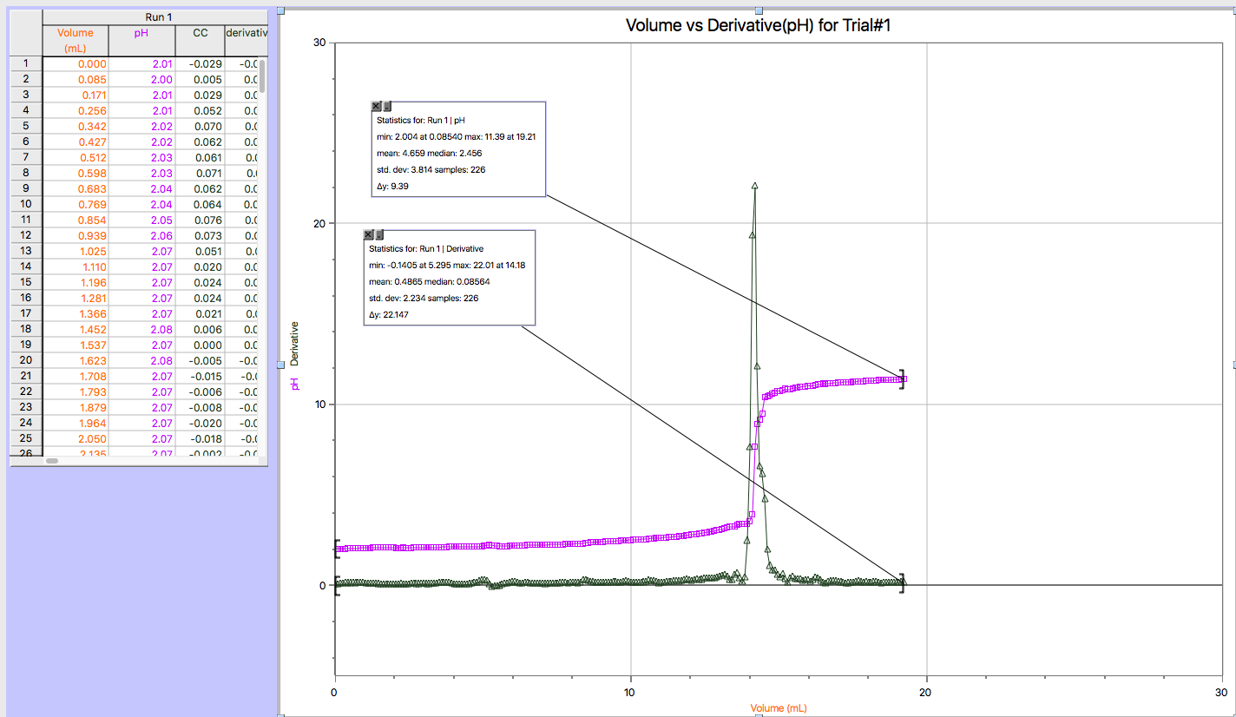

Legend
K-pH graph
K- derivative graph

Trial#3
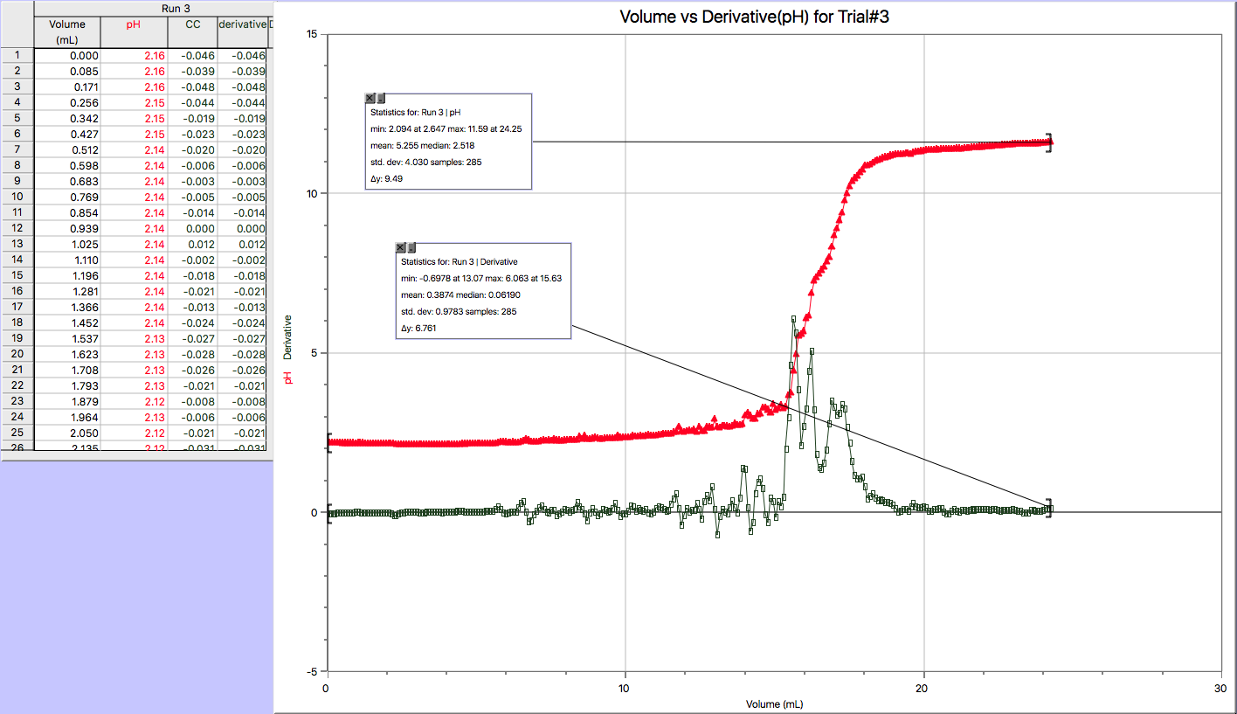
Legend
K-pH graph
K- derivative graph

Trial#4:Unknown Acid
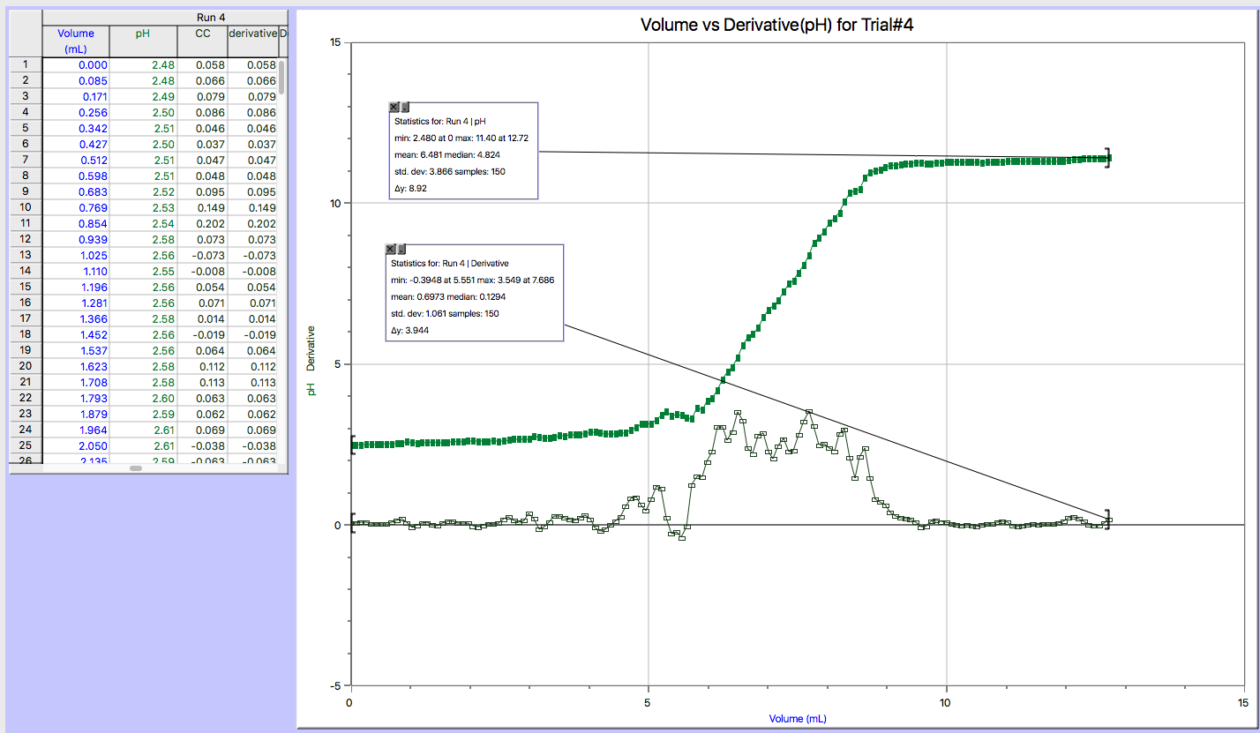
Legend
K-pH graph
K- derivative graph

Trial#5:Unknown Acid
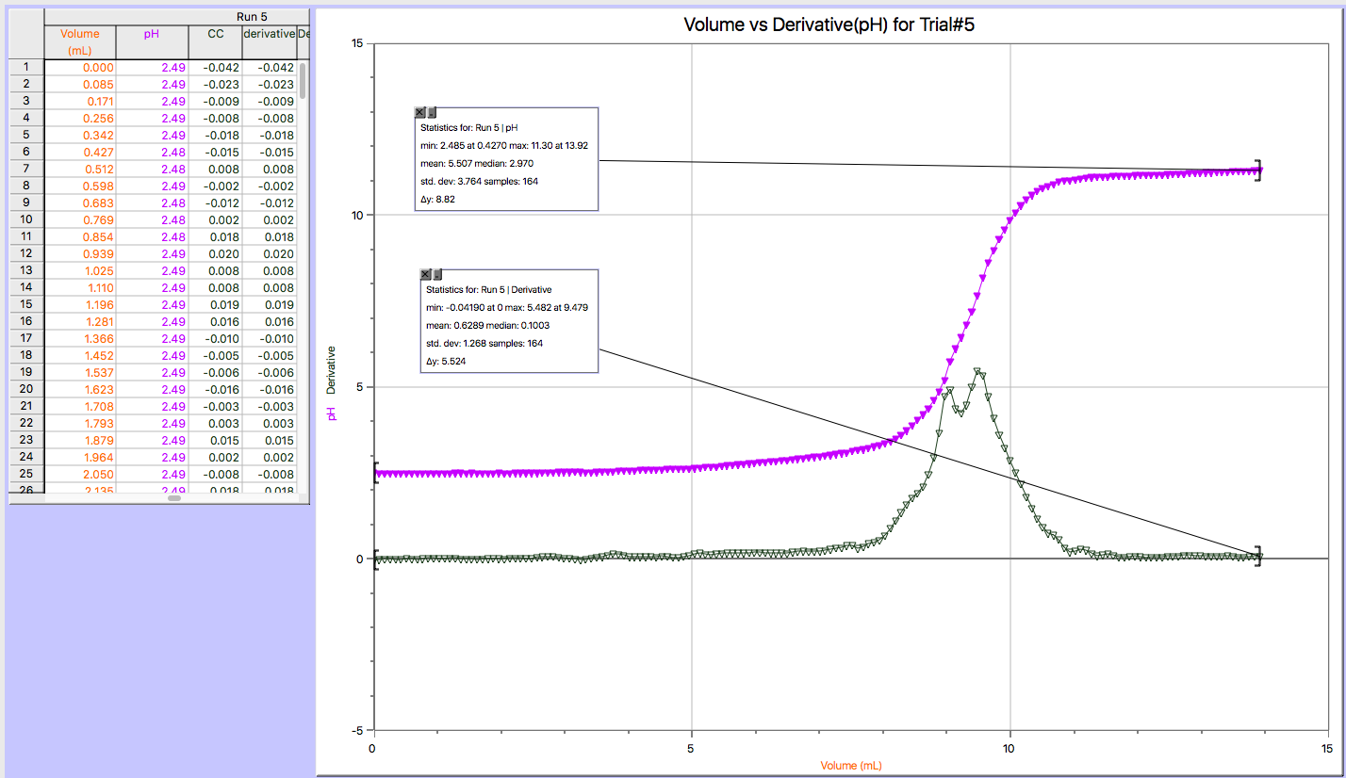
Legend
K-pH graph
K- derivative graph

Trial#6: Acid In juice

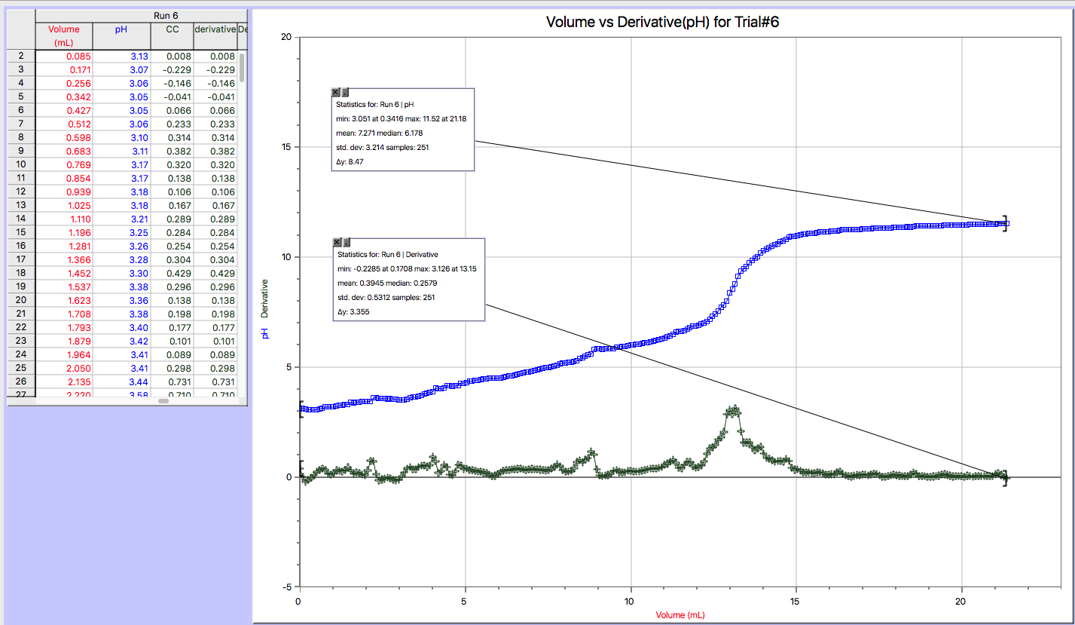
Legend
K-pH graph
K- derivative graph

Trial#7: Acid in Juice

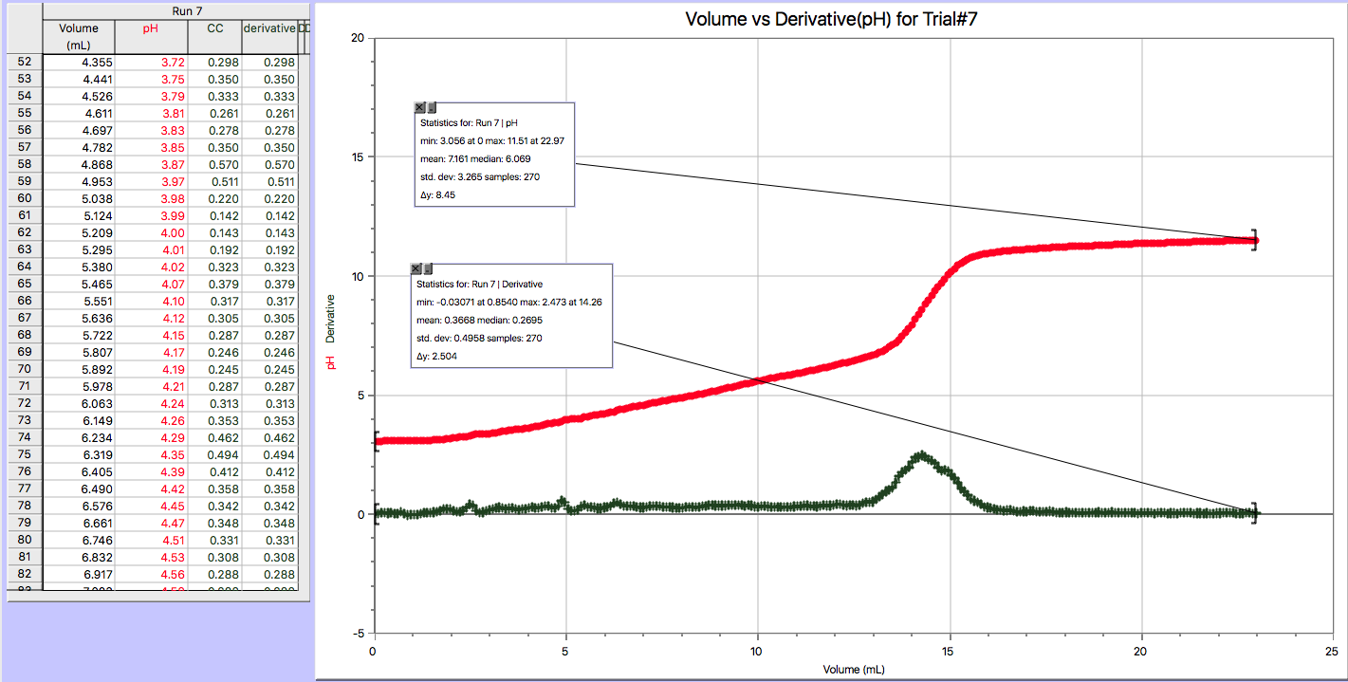
Legend
K-pH graph
K- derivative graph

Note: Only 6 graphs are included because pH and Derivative are on the same graph.
Calculations:

C1=6.0mol/l
V1= 4.25mL
V2=0.25425L
C1V1=C2V2
C2=C1V1/V2
C2=(6.0M) (0.00425L)/(0.25425L)
C2=0.1M

- Exact concentration of the stock solution: For trial#1+3
Trial#1
Cbase x Vbase= b/a Cacid xVacid
Cbase = (b/a)(Cacid xVacid)/Vbase
Cbase= (1/1) ((0.1M) (0.01L))/ (0.01418)
Cbase=0.071M=0.07M (sig digs)

Trial#3
Cbase x Vbase= b/a Cacid xVacid
Cbase = (b/a) (Cacid xVacid)/Vbase
Cbase= (1/1) ((0.1M) (0.01L))/ (0.01563)
Cbase=0.064M=0.06M (sig digs)

3.Average concentration For Trial#1+Trial#3:
Cavg(base)=(C1+C2)/2
Cavg(base)= (0.07+0.06)/2
Cavg(base) = 0.07 M

Exact concentration of Unknown acid: For Trial #4 and #5
Trial#4
Cbase x Vbase= b/a Cacid xVacid
Cacid= a/b(CbasexVbase/Vacid)
Cacid= 2/1(0.07Mx0.007686L/0.01L)
Cacid=0.107M=0.1(sig digs)

Trial#5
Cbase x Vbase= b/a Cacid xVacid
Cacid= a/b(CbasexVbase/Vacid)
Cacid= 2/1(0.07Mx0.009479L)/(0.01L)
Cacid=0.13M=0.1(sig digs)

3.Average concentrations of unknown acid (Trial#4+Trial#5):

Cavg(acid)=(C1+C2)/2
Cavg(acid)= (0.1+0.1)/2
Cavg(acid) = 0.1 M

- Exact Concentration of acid in Juice (Trial#6+Trial#7)

Trial#6
Cbase x Vbase= b/a Cacid xVacid
Cacid= a/b(CbasexVbase/Vacid)
Cacid= (3/1) ((0.07M) x(0.01315L))/ (0.01L)
Cacid=0. 28M=0.3M(sig digs)

Trial#7
Cbase x Vbase= b/a Cacid xVacid
Cacid= a/b(CbasexVbase/Vacid)
Cacid= (3/1) ((0.07M) x(0.01426L))/ (0.01L)
Cacid=0.43=0.4(sig digs)

- Average concentration of acid in juice:
Cavg=(C1+C2)/2
Cavg= (0.3+0.4)/2
= 0.4M

5. Mass percentage of acid in juice

Molar mass of citric acid, H3C6H5O7=192.1235g/mol
Mass Percent= ((Cacid, mol/L) (MM acid, g/mol)/ (density juice, g/mL) x1000)) x100%
= ((0.4M) X (192.1235g/mol))/((0.9993g/mL) x1000)) x 100%
= 7.7%

Discussion:

This experiment consisted of qualitative (appearances of the substances used) and quantitative (volume and pH) results. The qualitative results were expected and didn’t affect our results in any way but the quantitative results could have definitely impacted our final data. The sources of error that impacted our quantitative results include the following:
- Burettes aren’t completely dry; even after cleaning them with a paper towel there is still some residue leftover.
- The volumes of acid and base used in the lab were less than what was initially measured.
The first source of error poses problems because it will affect the concentration of the acid and base, as the water can dilute the solutions slightly, causing them to become less concentrated. For the second source of error an initial volume for the acid and the base was obtained, since burettes were used some of the acid and base could cling to the walls of the burette. This means less of the acid and base was obtained.
Furthermore, in this experiment we obtained a specific volume of concentrated NaOH. This matter because by producing a lot of the diluted base there was enough to use up throughout the whole experiment. This causes accurate results since a constant amount of base is being used at all times. Also, we have to determine the concentration of NaOH just before we use it because NaOH can easily absorb moisture from the air which in turn will make the solution less concentrated.
Lastly, when it comes to the calculations there are things that we should take into consideration. First, in the mass% equation we used a factor of 1000 because the density is in g/mL and by multiplying it by 1000 (which is a number in mL to L) will help with the cancelation of units. Also by the taking the average concentration, it will give us more accurate results as we are using all the data that was obtained.

Conclusion:
In conclusion, the exact molarity for the stock solution(NaOH)was 0.07M Using this concentration, the average concentration for the unknown acid #6 was 0.1M. Furthermore, the average concentration of unknown juice 3 was 0.4M and finally the mass percent was 7.7%.

References:

- Dr. Rashmi Venkateswaran, “Acid Base Titration,” EXP.1, pp.1-7,2017
- Dukhin, Andrei S., Goetz, Philip J., Titrations, VOL 24, p.401
- https://www.youtube.com/watch?v=seeX3btvjhs, SPM Malaysia IPTV, YouTube

Raw Data

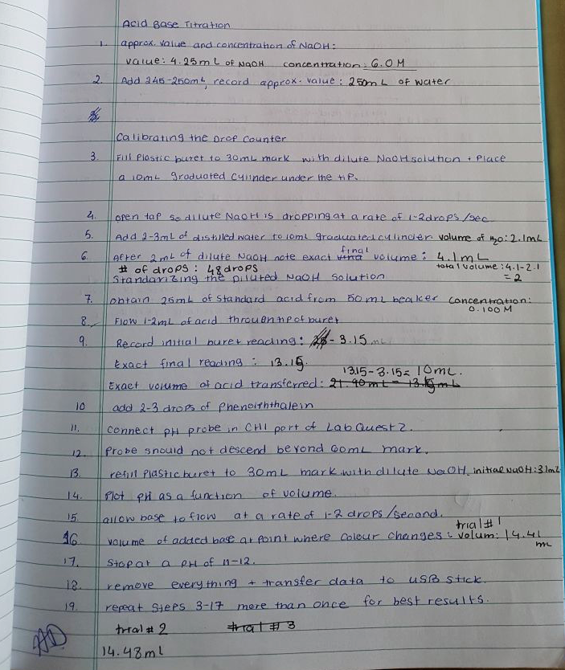

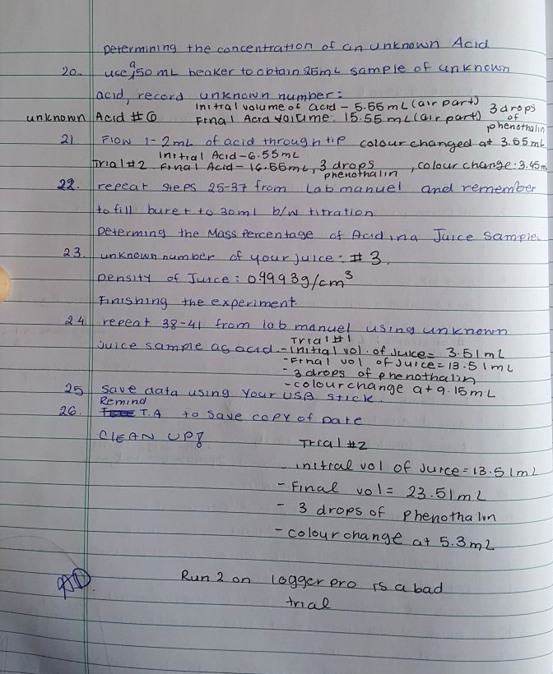

Rubric for Correction of Experiment 4

Title page (1) +  Introduction (5) |  | Clear explanation of relevant theory; clear ties to expected results. | Explanation of relevant theory; ties to expected results | Some explanation of theory; some ties to expected results | Either explana- tion of theory or expected ties to results | Poor explanation of theory or expected ties to results | No introduction
Tables -3 or 4 (12) Points per table |  |  | Data is recopied neatly from raw data, complete and well organized/ presented | Data is recopied neatly from raw data and complete | Data is recopied neatly from raw data but some information missing; | Data is recopied neatly from raw data but much information missing | Data is not recopied and not complete or not included
Observations |  |  | Complete for all parts | Partial for all parts | Complete for one part | Partial for one part | None
Calculations (9 | All calculations shown & explained | All calculations shown | Most calculation shown neatly | Most calculation shown | Some calculation shown neatly | Some calculation shown | Calculations incomplete
12 Graphs at least (12) + 1 bonus for additional trials (no matter how many) | Points per graph 1 | For the Logger Pro/Lab Quest Raw DATA: Simply Screenshot/Print Screen the TOP of the data (whatever fits on the screen) as proof.
Discussion (10) |  | Clear explanation of results based on observation and data; reasonable explanation for errors; comparison between trials; ties to theory clearly shown | Explanation of results; some connection to observation/data; explanation of errors; some comparisons; some ties to theory | Explanations are vague; connections to observation/data unclear; comparisons or ties to theories poorly explained | A few important points missing | Many important points missing | no discussion
Conclusion (3) |  |  |  |  | One statement per part. Results clearly stated. | Results somewhat evident. | Results not evident/missing.
TOTAL: | 55 | (max points): 56

