Lecture 3 pt 2: Perioperative Care II

RNAO BPG readings:
- Pain assessment and management (select readings: pp.17-40), and
- Risk assessment and prevention of pressure ulcers (select readings: pp.20-37).

Learning Objectives:
- Assess and manage pain;
- Apply NP to care of patients in PACU and post surgery;
- Define wounds;
- Define pressure ulcers;
- Apply NP to prevent & care for pressure ulcers.

Pain management
- Remember - effective pain management:
    - Promotes optimal healing
    - Prevents complications
    - Allows clients to participate in necessary activities
      - Should be timed to ensure it is in effect during painful activities (e.g., ambulating)

- What you need to know for the mid-term
  - Definition of pain
  - Acronym OPQRSTU
  - Understanding of opioid tolerance
  - Harmful effect of unrelieved pain (i.e. recovery)
  - Pain in older adults

Postop Care
Postoperative Care in the PACU
PACU = Post-anaesthesia Care Unit

While in the PACU, priority care includes monitoring and management of:
- Respiratory and circulatory function
- Pain
- Temperature
- Surgical site
- Patient’s response to anaesthetic reversal

- Initial assessment:
  - Airway, breathing, and circulation (ABC)
A: Airway patency
B: Rate and quality of respirations
      - Auscultate breath sounds in all fields
      - O2 saturation (pulse oximetry)
      - Supplemental oxygen
C: ECG monitoring (rate and rhythm)
      - Measure BP and compare to baseline
      - Temperature and colour of skin
      - Peripheral pulses

- Initial assessment (cont’d):
  - Conduct initial neurological assessment
    - Emergence delirium
  - Assess intakes and outputs (I/O)
  - Assess surgical site and condition of dressing
  - Explain all activities from admission as hearing is first sense to return

Main Issues during Posop care:
-airway obstruction
-resp complciations
-cardiac compromise (HTN, dysrhythmias)
-hypertherima (esp. if long surgery)
-pain
-N/V

Care of Postop Patient on Clinical Unit:
- PACU nurse gives report to receiving nurse summarizing operative and postoperative periods
- Receiving nurse assists with transfer onto bed
- Vital signs obtained and compared to report
- Next is an in-depth assessment
- Initiation of postoperative orders

Full Assessment: **
- Respiratory
- Cardiovascular
- Temperature
- Neurologic
- Urinary
- Gastrointestinal
- Psychological

1)Respiratory Function
Potential Alterations in Respiratory Function:
- In post-op period, the most common causes of airway compromise include
  - Obstruction (most common: patient’s tongue)
  - Hypoxemia (<90% oxygen saturation)
  - Hypoventilation (< respiratory rate)
- Patients at particular risk include those who:
  - Receive general anaesthesia
  - Older
  - Smoke heavily
  - Lung disease
  - Obese
  - Have undergone airway, thoracic or abdominal surgery
Respiratory Function – Assessment
- Evaluate airway patency; chest symmetry; and depth, rate, and character of respirations
- Assess oxygen saturation, respiratory rate, patterns, and breath sounds
- Breath sounds auscultated anteriorly, laterally, and posteriorly
    - Notify anaesthesiologist of crackles or wheezes

Respiratory Function -Nursing diagnoses
- Ineffective airway clearance
- Ineffective breathing pattern
- Impaired gas exchange
  - Potential complication: Hypoxemia
- Potential complication: Pneumonia
- Potential complication: Atelectasis (alveolar collapse)

Respiratory Function
- Position to ease respirations/protect airway
    - Lateral position unless contraindicated
    - Patient allowed in supine with HOB elevated
- Deep breathing and coughing techniques
    - Help prevent alveolar collapse/move respiratory secretions to larger airway to expectorate
    - Deep breathing 10x q hour while awake
    - Incentive spirometer is helpful in providing visual feedback of respiratory effort
    - Splinting abdominal incision provides support to the incision and aids in coughing
2) Cardiovascular Function
- Most common complications:
  - Hypotension
  - Hypertension
  - dysrhythmias
- Those at greatest risk:
  - Cardiac history
  - Older adults
  - Debilitated or critically ill patients

Cardiovascular Function - Assessment
- Frequently monitor vital signs
- Notify anaesthesiologist if:
    - Systolic <90 mm Hg or >160 mm Hg
    - Pulse < 60 or > 120 beats per minute
    - Pulse pressure narrows(difference between systolic and diastolic)
    - BP gradually increases
    - Irregular cardiac rhythm develops
    - Significant variation from preop readings
- Assess apical-radial pulse carefully and report irregularities
- Assess skin colour, temperature, and moisture

Cardiovascular Function - Nursing diagnoses:
- Decreased cardiac output
- Deficient fluid volume
- Ineffective peripheral tissue perfusion
- Excess fluid volume
- Activity intolerance
- Potential complication: Hypovolemic shock
- Potential complication: Venous thromboembolism

Cardiovascular Function - Nursing implementations:
- Accurate I & Os
- Monitor laboratory findings
- Assessment of infusion rate of fluid replacement and infusion site
- Adequate mouth care (discomfort due to dryness)
- Leg exercises to facilitate venous return from the lower extremities
- Elastic stockings or compressive devices
- Unfractionated or low-molecular-weight heparin per physician order (prophylactic for VTE and pulmonary embolism)
- Ambulation
    - Slowly progress (raise head of bed, etc)
    - Monitor pulse
    - Assess for feelings of faintness
3)Temperature
Potential Alterations in Temperature:
- Hypothermia may be present in immediate postoperative period
- Fever may occur at any time
  - Mild temp elevation (<38º C) usually reflects the surgical stress response (first 24 to 48 hrs)
  - Temp elevation above 37º C (Third day or later) can be due to infection

Hypothermia
- Core temperature less than 36º C
- Occurs when heat loss exceeds production
- Loss of heat to cold OR from body organs exposed to the air
  - Increased risk associated with:
      - Age
      - Debility
      - Intoxication
      - Prolonged anaesthetic administration

Temperature- Nursing Assessment
- Vital signs
    - Oral, tympanic, or axillary temperature
  - Assess colour and temperature of skin
  - Frequent temperature assessment
  - Observe for early signs of inflammation and infection

Temperature - Nursing diagnoses
- Hypothermia
- Risk for imbalanced body temperature
- Hyperthermia

Temperature - Nursing implementation:
- Nurse’s role may be:
    - Preventive
    - Diagnostic
    - Therapeutic
- Hyperthermia –sweating+++: change linens frequently to prevent heat loss and subsequent chilling and to provide comfort

4) Neurological Function- Nursing Assessment
- Level of consciousness (LOC)
- Orientation
- Ability to follow commands
- Size, reactivity, and equality of pupils
- Sensory and motor status

Neurological Function - Nursing diagnoses
- Disturbed sensory perception
- Risk for injury
- Disturbed thought processes
- Impaired verbal communication

Neurological Function - Nursing implementation
- Attention on evaluation of respiratory function
  - Hypoxemia causes postoperative agitation
- Sedation may be beneficial for controlling agitation and providing safety
- PACU:
  - Side rails up
  - Secure IV lines and artificial airways
  - Verify presence of identification and allergy bands

5) Urinary Function
- Low urinary output may be expected in the first 24 hours, regardless of intake
  - Due to↑ aldosterone and antidiuretic hormone secretion from stress of surgery, fluid restriction, fluid losses during surgery, drainage, or diaphoresis
  - Anesthesia depresses nervous system, allowing bladder to fill more than normally before urge to void is felt
  - Anticholinergic and opioid drugs may also interfere with ability to initiate voiding or fully empty bladder

- Retention more likely with lower abdominal or pelvic surgery
  - Pain may alter perception of filling bladder
- Recumbent position in bed greatly impairs ability to void
  - ↓ smooth muscle tone and reduces the ability to relax perineal muscles and external sphincter

Nursing Assessment
- Urine examined for quantity and quality
    - Note colour, amount, consistency, and odour
- Assess in-dwelling catheters for patency
- Urine output should be at least 30 mL/hr
- If no catheter, client should be able to void 200 mL following surgery
    - If no voiding, abdominal contour inspected and bladder palpate/percuss for distension
Nursing Diagnoses
- Impaired urinary elimination
- Potential complication: Acute urinary retention

Nursing Implementation
- Position client for normal voiding
- Reassure client of ability to void
- Use techniques such as running water, drinking water, pouring water over perineum, ambulation, or use of bedside commode

6) Gastrointestinal Assessment
Potential Gastrointestinal Problems
- Nausea and vomiting are significant problems in postop period
- N & V most pronounced after abdominal (ABD) surgery
- ADB distension from decreased peristalsis d/t handling of bowel in surgery
- Distension or gas pains d/t swallowed air and GI secretions accumulated in colon

GI Function
- Nausea and vomiting caused by
    - Anaesthetic agents
    - Opioids
    - Delayed gastric emptying
    - Slowed peristalsis
    - Resumption of oral intake too soon postop
- Hiccups
    - Gastric distension, intestinal obstruction, intraabdominal bleeding, subphrenic abscess
    - Acid-base/electrolyte imbalances
    - Drinking hot or cold liquids
    - presence of an NG tube
Assessment
- Nausea and vomiting
  - Question about feelings of nausea
  - Document characteristics of vomitus
- Paralytic ileus/ abdominal distension (> 3 days postop)
  - Auscultate abdomen in all four quadrants to determine the presence, frequency, and characteristics of the bowel sounds
    - Can be absent or diminished in immediate postoperative period
    - Return of bowel motility accompanied by flatus
Nursing Diagnoses
- Nausea
- Risk for aspiration
- Risk for deficient fluid volume
- Imbalanced nutrition: Less than body requirements
- Risk for electrolyte imbalance
- Potential complication: Hiccups

Gastrointestinal Assessment (Cont’d)
Nursing Implementation:
- Antiemetic drugs
- Oral fluids only as indicated and tolerated
- Suction at bedside
- Turn client’s head to side to protect from aspiration (lateral recovery position)
- Upright position
- Slow, deep breathing
- May resume intake upon return of gag reflex
- NPO until return of bowel sounds for client with abdominal surgery
  - Clear liquids, advance as tolerated
  - Regular mouth care when NPO
- Antiemetics administered for nausea
    - NG tube if symptoms persist

- Early and frequent ambulation to prevent abdominal distention
- Assess for resumption of normal peristalsis
- Encourage client to expel flatus and explain it is necessary and desirable
- Relief of gas pains by frequent ambulation and repositioning
- Suppositories as needed

7) Psychological
Psychological function
- Anxiety and depression may be more pronounced
  - Attention with history of neurotic or psychotic disorder
  - Responses may be part of grief process
  - Risks with lack of knowledge, assistance, or resources
- Confusion and delirium may result from psychological and physiological sources
  - Fluid and electrolyte imbalances, hypoxemia, drug effects, sleep deprivation, sensory alteration or overload
  - Delirium tremens (DTs) from alcohol withdrawal

Nursing Diagnoses:
- Anxiety
- Ineffective coping
- Disturbed body image
- Decisional conflict

Nursing Implementation
- Include patient in discharge planning & provide information/support to make informed decisions about continuing care
    - Listen and talk with client, offer explanations, reassure, and encourage involvement of significant others
    - Discuss expectation of activity and assistance needed after discharge
- Recognition of alcohol withdrawal syndrome
- Report any unusual behaviour for immediate diagnosis and treatment

Wounds
Nursing Management: Potential Alterations in the Integument
- SSIs (Surgical site infection) occur within 30 days after surgery or within 1 year of implant surgery
  - Characterized by:
    - A combination of purulent discharge
    - The isolation of organisms, most commonly Staphylococcus aureus
    - A reopening incision
    - Physician or radiological diagnosis
- SSI
  - Local manifestations of redness, edema, pain, and tenderness at the site
  - Systemic manifestations of leukocytosis (increase wbc) and fever

Surgical Site
Nursing assessment
  - Knowledge of type of wound, drains, and expected drainage related to the specific type of surgery
  - Drainage should change from sanguineous(blood) to
serosanguinous (watery discharge tinged with blood) to serous(watery discharge) with decreasing output
  - Wound dehiscence may be preceded by sudden brown, pink, or clear discharge
Nursing Diagnoses:
  - Risk for infection
  - Potential complication: Impaired wound healing

Nursing Implementation
- Note type, amount, colour, consistency and odour of drainage
- Assess affect of position changes on drainage
- Notify surgeon of excessive or abnormal drainage and significant changes in vitals

Wound Classification
Red Wound
- Traumatic or surgical wound
- Colour: pink to dark red
Yellow Wound
- Slough (ivory to yellow green), soft necrotic tissue
Black Wound
- Grey, black, brown, necrotic tissue

Wound Treatment
Red wound
- Protect granulation
- Keep moist
- Gentle cleansing
Yellow wound
- Cleanse to remove non-viable tissue
- Absorb excess drainage
Black wound
- Debridement of eschar
- Bacteria control

Pressure Ulcers
- Localized area of tissue necrosis
- Caused by pressure that occludes blood flow
- 4 stages of pressure ulcers

Etiology and pathophysiology
  - Pressure (intensity and duration)
  - Shearing force (pressure exerted on the skin when it adheres to the bed and the underlying skin layers in the direction of body movement)
  - Friction (two surfaces rubbing against each other)
  - Excessive moisture (incontinence or perspiration)

Most common sites:
- Sacrum
- Heels
Influencing Factors
- Amount of pressure (intensity)
- Length of time pressure exerted (duration)
- Patient’s tissue tolerance

Pressure Ulcer Assessment: Braden Risk Assessment Scale
Pt is confined to bed (1); skin is often moist (2).
Pt is responsive but not always aware (3) and rarely eats more than 1/2 of any meal (2).
Pt frequently makes slight changes of position (3) and slides down occasionally (2).
Total: 13(moderate risk)

Stage I
- Intact skin
- Nonblanchable redness
- May be:
  - Painful
  - Firm/soft
  - Warmer/cooler
  - Difficult to detect with darker skin
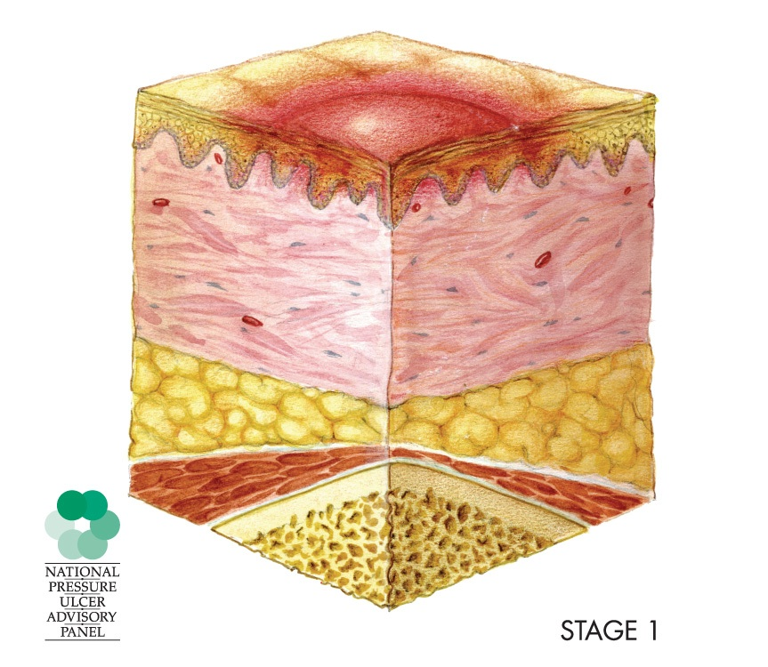

Stage II
- Partial thickness loss of dermis
- Without slough
- Can also be an intact or open blister
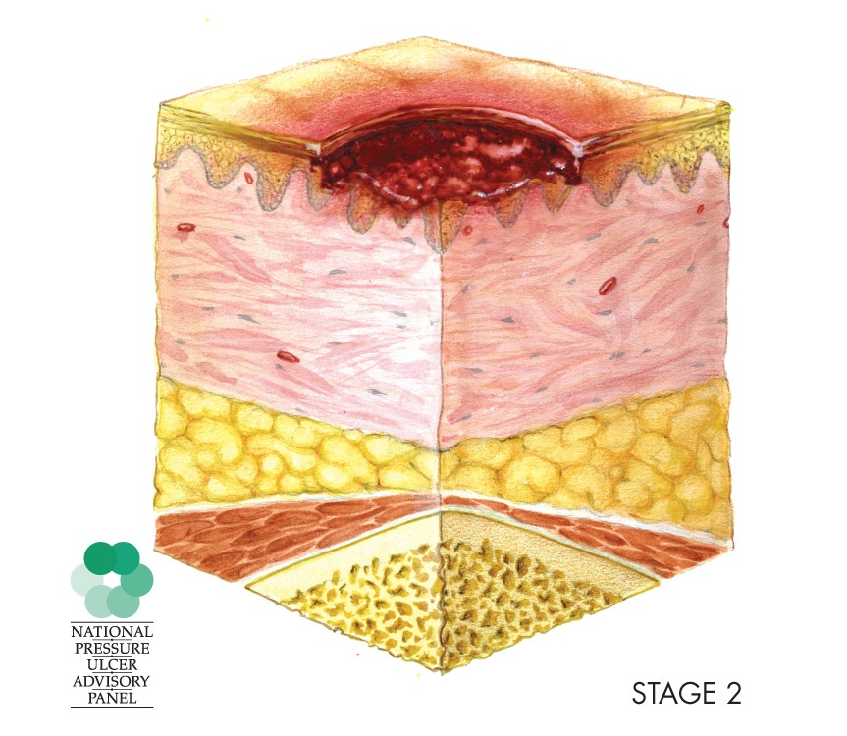
Stage III
- Full thickness skin loss
- May see subcutaneous tissue, slough or tunnelling or undermining
- Will not see bone, tendon or muscle
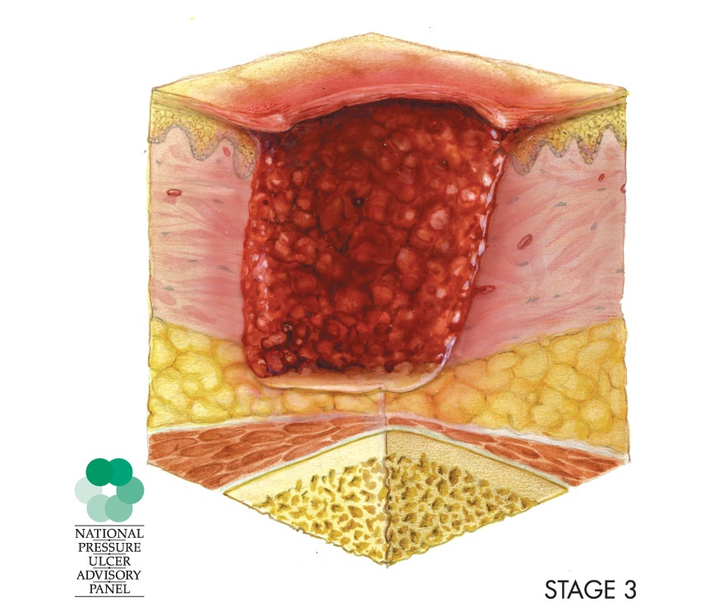
Stage IV
- Full thickness skin loss
- May see: slough, eschar, bone, tendon, muscle
- Often have undermining or tunnelling
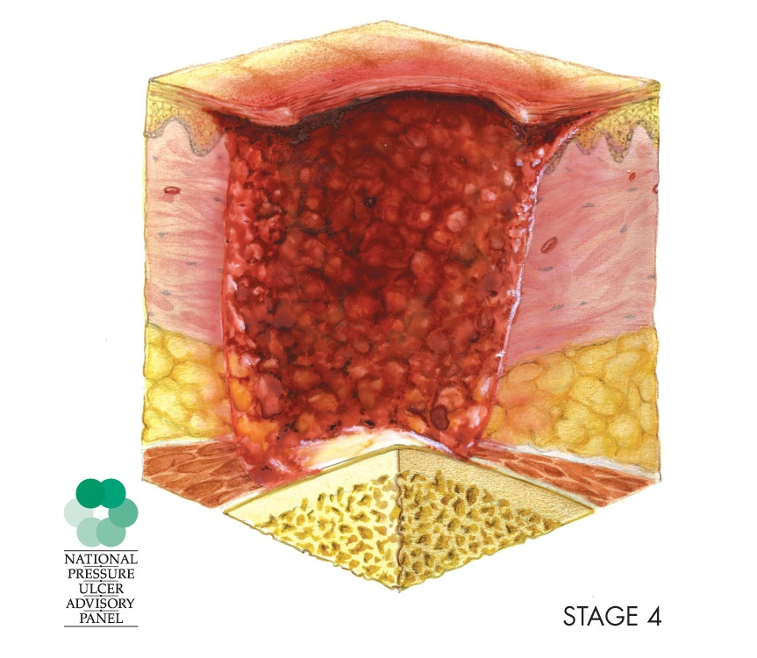

Assessment: patients with dark skin
- Look for areas of darkness (purplish, brownish, bluish)
- Use natural light or halogen light to assess
- Palpate skin, feel for:
- Temperature
- Skin consistency
- Patient experiences pain, itchiness

Diagnose
-problem related to cause as evidence by S &S
-Impaired skin integrity related to pressure and inadequate circulation as evidence by signs of pressure ulcer

Plan & Intervene
Prevention
- Prevention best treatment for pressure ulcers
- Apply interventions based on risk factors

Prevention: Moisture
Excess moisture r/t:
- Incontinence
- Perspiration
- Wound drainage
Interventions:
- Moisture barrier creams
- Moisture absorbing surface under the client
- Catheter
- Regular toileting
- Pads with wicking surfaces
- Wound dressings

Prevention: Nutrition
Inadequate nutrition can:
- Weaken the skin
- Slow healing
Interventions
- Assess albumin for clients protein level
- Dietary supplements
- May require enteral/parenteral nutrition
- Assess reasons for inadequate intake

Prevention: Friction and Shear
Friction and Shear
- Friction: When skin is pulled across a coarse surface
- Shear: When forces pull underlying tissues one way and the skin the other way
Interventions:
- Use proper lift/transfer techniques
- May need to use lift
- Pressure reducing surfaces
- Refer to wound care nurse for special orders
- Keep bed below 30 degrees
- No doughnuts

Prevention: Skin Integrity
- Do not massage bony prominences
- Keep skin dry and clean
- Keep skin moisturized prn
- Protective dressings

Prevention: Pressure
- Reposition
- Use pillow, wedges
- Teach to shift q 15 minutes
- Pressure reduction devices
- Sheep skin

Transparent Film Dressing

Exam Questions

Topics
Week 1: Critical judgment, nursing process, patient teaching: 20
Week 2: Preoperative care, intraoperative care, CAUTI, delirium:
20
Week 3: Postoperative care, pain, pressure ulcers: 20
NCLEX research – additional questions: 5
TOTAL: 60

