Bloody Easy blood Administration

Whole Blood processing:
- Collection of donor blood into an anticoagulant preservative solution
- The majority of WBCs are removed by filtration
- Four components may be made from one unit for whole blood
  - Red blood cells (RBCs)
  - Platelets
  - Plasma
  - Cyroprecipitate

Individual blood component processing methods
- Buffy coat
  - Whole blood donations are separated into individual components
- Apheresis
  - Individual components are collected directly on a cell separator machine

Blood products can also be
- Extracted from plasma
- Manufactured by a fractionation process

The plasma from donations is used to manufacture the following blood products:
- Albumin
- Intravenous immune globulin
- Rh immune globulin
- Coagulation factor concentrates
- Prothrombin complex concentrate

BLOOD COMPONENTS
1) Red Blood Cells (RBCs)
- cells that transport oxygen from the lungs to cells

2) Plasma
- the fluid portion comprising about 55% of whole blood containing all the coagulation factors necessary for clotting

3) Platelets
- a cellular component of blood suspended in plasma. They are the first responders in the clotting process.
available in 2 formats
- Apheresis: platelets collected from 1 donor
- Pooled: platelets collected from 4 donors suspended in plasma from 1 of the male donors using buddy coat production method

4) Cryoprecipitate
- a component prepared from plasma. Contains fibrinogen, and small amounts of factor VIII, von wilebrand factor, and factor XIII.
- for infusion to an adult:
- Pooled from several donors to provide an adequate dose

BLOOD PRODUCTS (aka plasma protein products)

1) Albumin
- a blood product available in 2 concentrations
  - isooncotic (5%)
  - Hyperoncotic (25%)

2) Intravenous immune globulin (IVIG)
- A blood product containing concentrates of human immunoglobulin
- Available intravenously and subcutaneously
  - Subcutaneous Immune Globulin (SCIG)
    - Enables pts to self-administer
    - Offered primarily to pts with primary immune deficiency

3) Rh immune globulin (RHIG)
- A preparation of human immunoglobulin with antibody directed against the Rh (D) antigen

4) Prothrombin complex concentrate (PCC)
- A freeze dried preparation containing clotting factors: II, VII, IX, and X

***chart with indications etc for all blood components/products****

Blood Volume, Storage and Expiration
Volume
- You will find exact volumes for RBCs, Plasma, and platelet components listed on the Canadian blood service blood bag label
Storage
- Blood components and blood products must be stored properly- never place them in ward or medication fridges
- Never put platelets in a refrigeration device or cooler
Expiration
- Always check the expiration date of blood before transfusing

ABO Blood Group System
- Blood groups are genetically inherited
- Your patients ABO group is the most important blood group system used to determine compatibility for a blood transfusion
  - The presence of absence of A and B antigens on the surface of RBCs determines the ABO groups of your pt
  - Starting at 4 months of age, Antibodies are naturally acquired to the antigens absent from a person red blood cells

For a Compatible RBC Transfusion
Your pt must receive:
- RBCs from a compatible ABO group that does not have antigens that your patient has an antibody against
  - Anti-A and anti-B antibodies will hemolyze incompatible RBCs

For a Compatible Plasma Transfusion
Your pt must receive:
- Plasma from a compatible ABO group that does not have ABO antibodies against the corresponding patients red blood cells

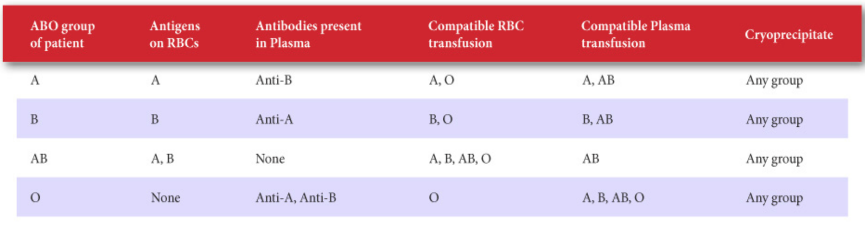***know the chart ****

When transfusing RBCs,
- group O is considered the universal donor and is safe for most patients

When transfusing plasma,
- group AB is the universal donor and is safe for all patients

The Rh System
- also known as the Rhesus system, is the second most important of the blood group systems that patients are routinely typed for. The Rh (D) antigen is either present or lacking on the surface of the red blood cells.

Rh- negative patients can develop the Rh (D) antibody if they are exposed to Rh-positive red blood cells or Rh-positive platelets which may contain small amounts of red blood cells. Females of child-bearing potential who are Rh-negative should not be exposed to Rh-positive RBCs to prevent the development of the Rh (D) antibody.

Historically
when a pt whose blood group was unknown required an emergency transfusion
- group O Rh-negative RBCs provided (until blood group determined)

In recent years
Demand for group O Rh-negative RBCs exceeds the supply
- chronic shortage
- result:
  - TML will now issue group O Rh-negative for females of child bearing potential ( <45 years)
  - All males and women past child bearing potential will be given O Rh-positive
  - This practice carries minimal risk to parcipitant

Pregnant Rh-negative females may develop the Rh (D) antibody by exposure to small amounts of blood from their Rh-positive fetus during pregnancy and delivery.
- this can cause haemolytic disease of the fetus and newborn (HDFN)
- Rh (D) antibodies in the mother will cross the placenta and hemolyze the RBCs of an Rh-positive fetus resulting in anemia, jaundice, brain damage or death
- Rh Immune globulin (RhIG) is given to prevent development of Rh (D) antibodies.

Plasma units do not contain RBCs and cannot expose recipients to the Rh (D) antigen. The Rh-groups of plasma is irrelevant for transfusion.

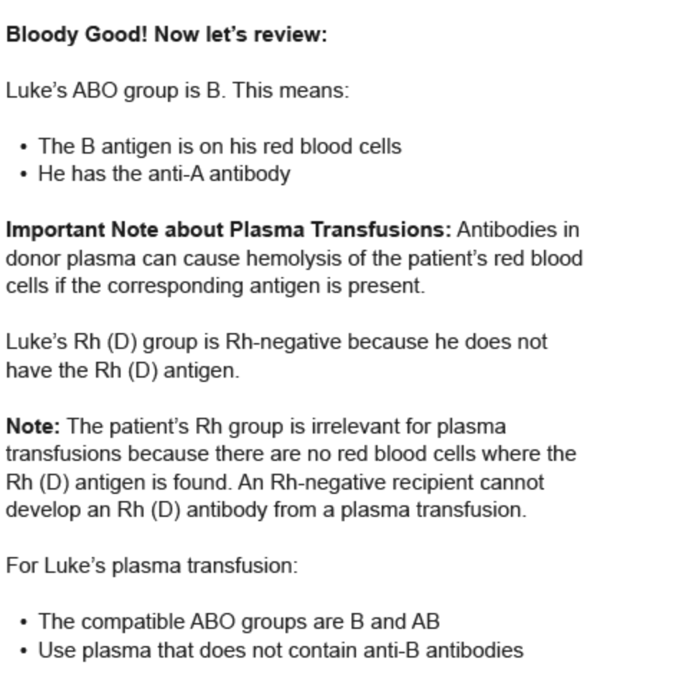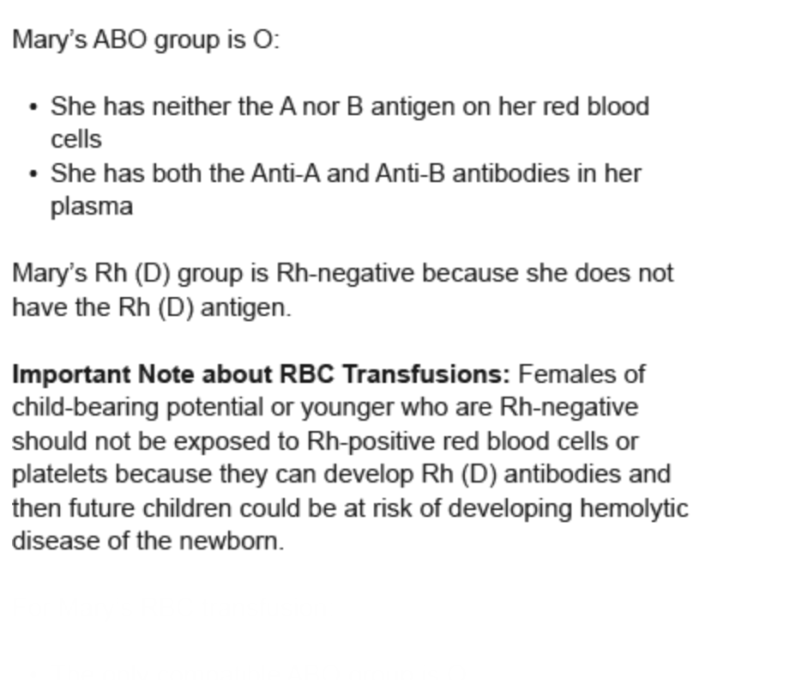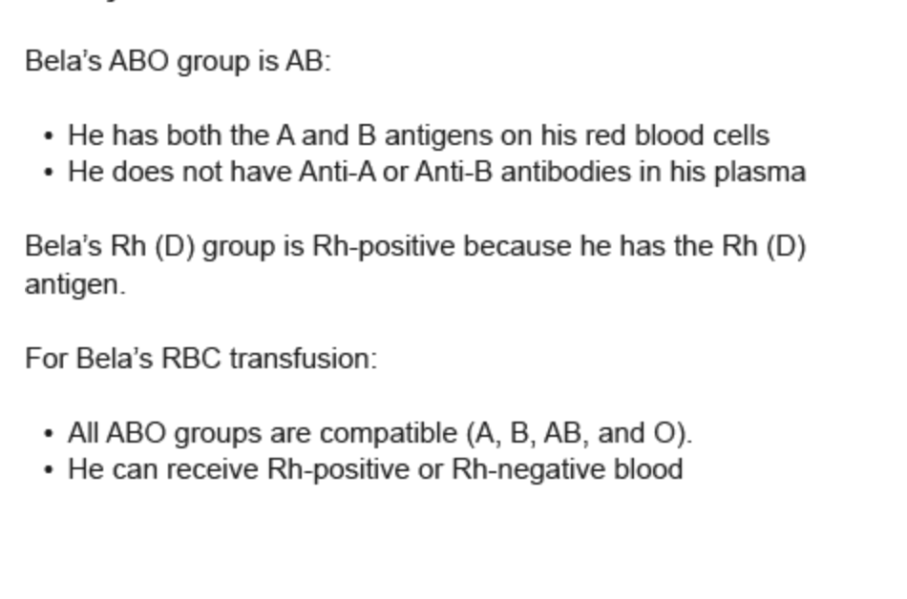

Blood Transfusion Checklist
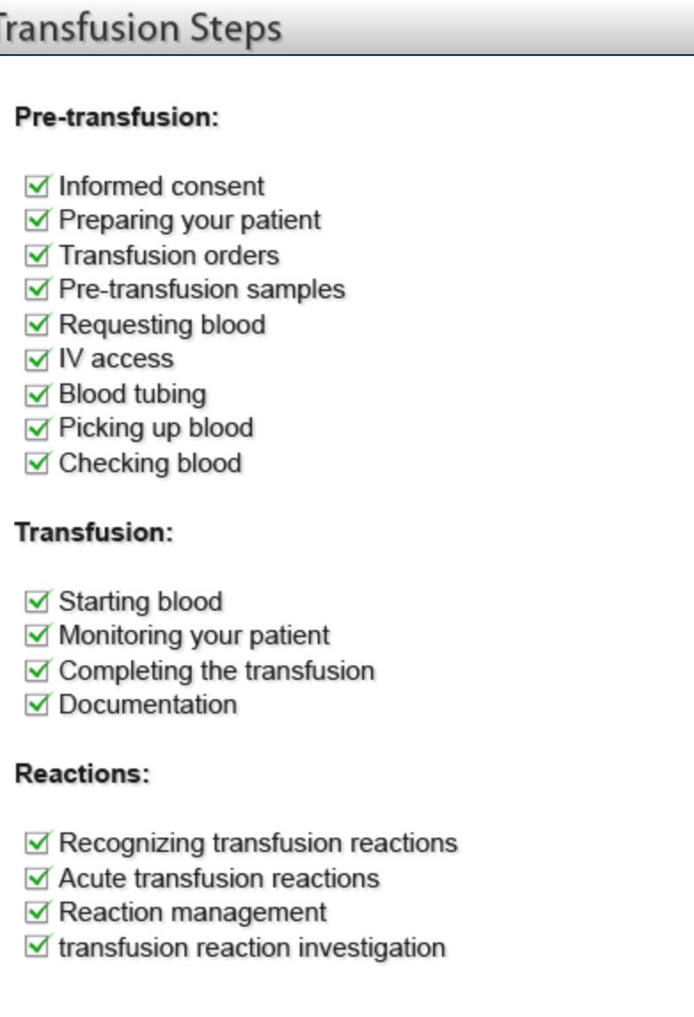
1)consent
- usually obtained by a physician
- in effect for the entire admission or course of treatment
- consent for transfusion is required unless emergency treatment conditions exist
- verify that consent has been obtained/pt has had questions answered

2) Preparing pt for transfusion
- explain purposed of the transfusion and monitoring
- answer all questions
- confirm pt has been properly Identified (must be wearing an ID armband or meet your instutional requirements for confirming positive ID using minium of 2 unique identifiers)
- determine:
  - if pt has had any previous problems/reactions w previous transfusions
  - if premedication is required

Blood tests used to monitor the need for or effectiveness of transfusion
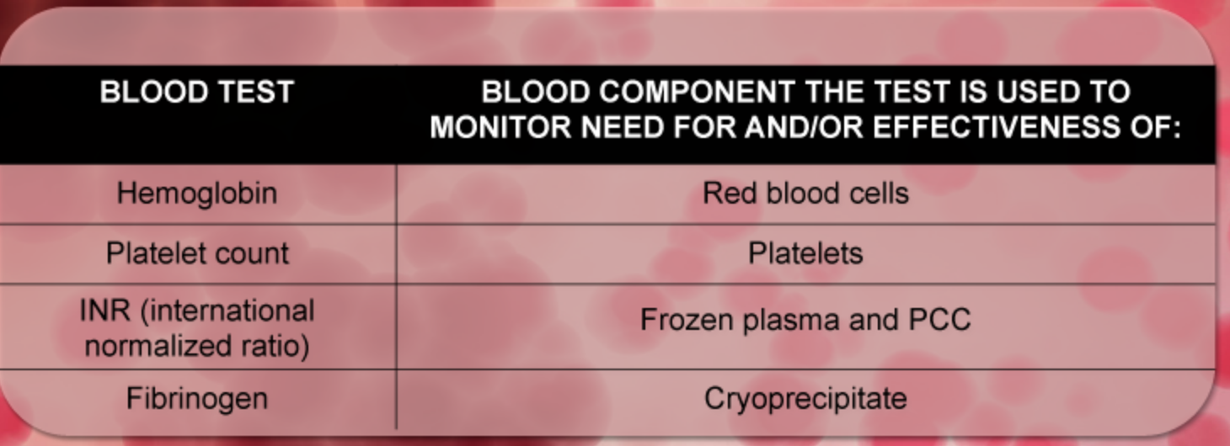
With the exception of the INR, normal ranges vary according to test methodology. Refer to your institutional normal ranges.

3)Transfusion order
- written order required
- must include: pt identification, blood component or product type, amount, rate of administration, special requirements, premedication or diuretic (if required)

-when requesting blood from the transfusion medicine laboratory (TML) be sure to include all items required for appropriate:
- testing
- blood preparation

-it is important for you to know why ur patient requires a transfusion
4)Pre-transfusion sample
- determine if a pre transfusion sample is required for your pt
- used to:
  - determine ABO and Rh blood groups
  - identify antibodies acquired from previous blood exposure or pregnancy
  - crossmatch suitable units of blood

*the expirary or outdate of a sample will vary depending on your pts recent blood exposure and pregnancy history and previous screen results. The age of very young pediatric patients may also be a factor .

Before drawing samples
- 2 steps for patient identification
  - Check your pts arm band or identification to make sure it matches
  - Included your patient in the identification process by asking questions (when possible)

Misidentification or mislabelled samples can result in:
- Incompatible blood transfused to your pt
- Another pt receiving incompatible blood

4 steps for labeling samples
1) Take sample labels with you to your pts bedside
- Verify label matches both your pts arm band or identification, and any paperwork
- Label the collected sample at your patients bedside. Labeling samples away from your pts bedside increases the risk of mislabelling
- Document that you drew the blood sample. Never sign for a sample collected by your colleague.

5)Requesting Blood
- Arrange for pickup and delivery from the TML with appropriate paperwork to ensure the correct unit is retrieved for the correct patient

- When requesting blood from the TML, the following items are required:
  - Correct and legible patient first and last name along with one additional unique identifier
  - Patient location
  - Blood component/product type
  - Amount/dose
  - When required

- Additional info may be required by some TMLs
  - Primary or underlying diagnosis for proper component preparation (such as irradiation)
  - History of recent blood exposure usually through transfusion or pregnancy
  - Indication or reason for transfusion

6)IV Access
-determine the correct IV access required
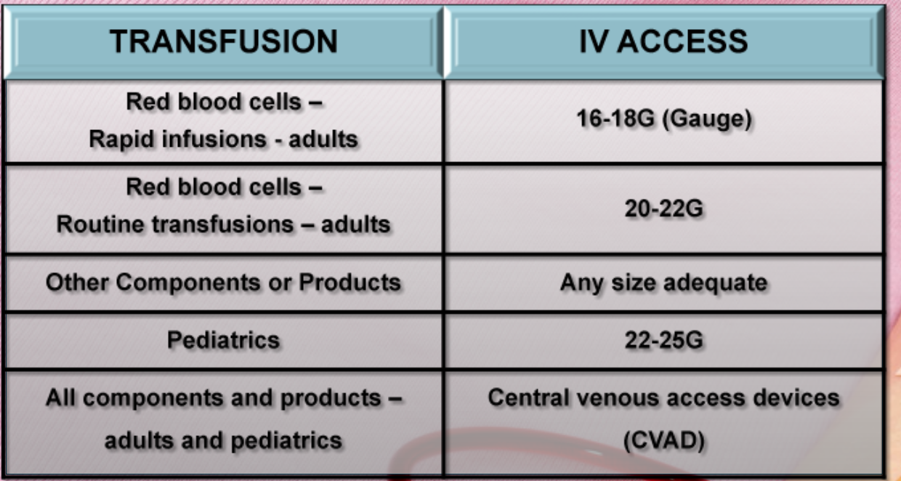

-transfusing rapidly and under pressure through an IV access that is too small can cause hemolysis of RBCs

-Blood must not come in contact with medications or incompatible solutions
- Normal saline is isotonic and is the only solution that is compatible with the fresh components
- Medications and IV solutions other than normal saline may cause hemolysis or clotting of the transfused blood

Ensure that the IV access is dedicated to the transfusion.
- With CVADs, medications/solutions can be infused in other lumens without damaging the blood
- IV pumps, blood warmers, and rapid infusers must be suitable for transfusion and not damage the blood

7) Blood Tubing
- All blood components must be transfused though blood tubing containing a filter of atleast 170-260 microns to capture fibrin debris
- Flush blood tubing with normal saline (0.9% NaCl) completely wetting filter. Normal saline is the only solution that is compatible with all fresh components. Refer to manufacturers instruction for compatible solutions for IVIG preperations.
- Blood tubing must be changed every 2-4 units and within the number of hours specified by your hospital policy
- Note that platelets and some manufactured blood products have different infusion requirements
- At the end of the transfusion the tubing should be disconnected from the pt
  - Blood tubing is required for transfusion of blood components and must be changed at prescribed intervals to decrease potential for growth of any bacteria present

8)Picking up blood
- Confirm informed consent has been obtained prior to picking up blood
- Blood must be
  - Started soon after it is received in the patient care area
- The infusion must be
  - Completed within 4 hours
- If transfusion becomes delayed, return blood quickly to the TML for proper storage
- Confirm that your pt is properly identified
  - All pts being transfused must
    - Be wearing an ID armband
    - Meet your institutional requirements for positive identification using a minimum of 2 unique identifiers

9) Checking blood
- Before checking blood confirm there is an order:
  - Visually check the unit for clots, unusual colour and any leaks
  - Check the expiration date on the Canadian blood services (CBS) label
  - Check that the donors blood group is compatible for your pt
  - Always check blood at your pts bedside*

Steps for checking blood
1.check your pts arm band to make sure it matchs. Include pt in the process if possible (ask how to spell name ie)

2.check that your pts name and unique identifier matches on:
-ID armband or other means of positive identification
-TML label/tag attached to blood

3.check that the blood unit number and donor blood groups matches on:
-CBS label
-TML label/tag attached to blood

*if any discrepancies don’t proceed. Contact the TML immediately.

*to avoid errors, most hospitals have two qualified individuals complete the pre-transfusion check.
*blood must be started immediately after being checked
*the TML label/tag must remain attached to the unit throughout the transfusion
*a chart copy of the TML label/tag is placed in the patients chart

**checking blood prior to a transfusion is the last opportunity to catch any errors

TRANSFUSION
10)Starting Blood
- Before starting blood
  - Record baseline vital signs and assessment
  - Auscultation for patients at risk for overload

- Steps for spiking blood component (RBC, plasma, platelets)
  - Separate the port cover until port is just exposed
  - Position port covers away from opening to prevent contamination
  - Hold bag in one hand and exposed tubing spike the other hand- do not hang from the IV pole
  - Insert blood tubing spike into port while turning clock-wise with ¼ turns- do not over-spike
  - To remove bag, pull gently while turning counter-clockwise with ¼ turns
- Spiking properly will ensure easy removal of the blood bag if required

- Steps for spiking manufactured blood products supplied in glass bottles (IVIG, Albumin)

- remove the seal to expose port and swab with alcohol
- place bottle on a flat surface and spike at a 90^ angle through the centre circle of the stopper
- invert and hang bottle on IV pole
- squeeze drop champer to ½ full
- open vent on drip chamber- this allows air to enter the bottle
- open roller clamp and prime remainer of tubing
- close vent prior to spiking each subsequent bottle, then hang bottle and open vent

- Steps to follow after starting blood
  - For first 15 min
    - Start initially with a slow rate unless transfusion is extremely urgent
    - Monitor your patient closely
  - After the first 15 min
    - Reassess your pt and repeat vital signs
    - Increase flow to prescribed rate
-start blood with caution as serious reactions may present early in transfusion

11)Monitor
-monitor and check and document vital signs:
- Before strating the transfusion
- After the first 15 min
- At prescribed intervals (hospital policy)
- At the end of the unit
- If there is a suspected reaction
-repeat all of these steps with each subsequent unit
-repeat vital signs more often for pts:
- At greater risk for circulatory overload
- With a history of previous reactions
- Already unstable

When possible, instruct pt to notify you if they experience:
- Hives, itching
- Feeling feverish, or chills
- Difficulty breathing
- Back pain or pain at infusion site
- Any feeling different from usual

Pts must be appropriately monitored to detect transfusion reactions as soon as possible
Massive Transfusion
- More than 20 units of RBCs, or transfusing more than one blood volume in a 24 hour period
- Massive transfusion is an independent risk factor for developing multi-organ failure
- Tips for the management of pts during massive transfusion include
  - Monitoring core temp
  - Prompting use of measures to prevent hypothermia, including use of a blood warmer for all iv fluids and blood components
  - Watching for dilutional coagulopathy
    - While patient is actively bleeding transfuse to keep platlet count >50 X 10^9/L (head injury > 100 x 10^9/L)
    - INR >1.5
    - Fibrinogen >1.0g/L
    - Consider the use of tranexamic acid
- watch for hypocalcemia, acidosis and hyperkalemia
- Use SQ40 PE Pall filter or equivalent microaggregate filter to minimize the number of tubing changes

12)Complete
- Guidelines for completing a transfusion
  - Complete transfusion within 4 hours of the blood component/product leaving the TML
  - Disconnect blood tubing when transfusion is completed
  - Check end of transfusion vital signs
  - Repeat vital signs periodically post transfusion (hospital policy)

- To decrease the risk of bacterial proliferation, each bag must be completed or stopped by 4 hours after removal from appropriate storage
- Used blood tubing can harbour bacteria, do not leave it attached to the pt
- Dispose of used blood tubing and blood bags in a biohazard container unless your hospital policy requires you to return the blood bags to the TML

- Assess your pt for symptoms of ractions that might occur up to 6 hours post transfusion

- Outpatients or their care givers should be provided with info detailing;
  - Signs and symptoms of transfusion reactions
  - Info on what to do
  - Contact info for reporting

13)Documentation
- Document each blood transfusion by placing the TML chart document/label in your pts chart
- The tag or label should include:
  - Date, start and finish time
  - Type of component or product transfused
  - Blood unit number
  - Name of person starting and checking blood
- Additional info for each blood transfusion should be documented in your patients chart:
  - Vital signs and pts assessments
  - Volume transfused
  - Any reactions and treatment provided
- Some hospitals require the return of a transfusion form to the TML
Transfusion Complications
-associated non-infectious and infectious complications

- Donors are tested, but transfusion transmitted infections may be a long-term complication
- It is important to also be aware of potential non-infectious acute transfusion reactions to keep your pt safe
- Reaction types include
  - Minor allergic reactions
  - Anaphylaxis
  - Febrile non-hemolytic
  - Bacterial sepsis
  - Transfusion-related acute lung injury (TRALI)
  - Transfusion associated circulatory overload (TACO)
  - Hypotension
  - Acute hemolysis

Initially it can be challenging to distinguish a minor reaction from a serious reaction

Acute reactions usually occur during or up to 6 hours following the end of a transfusion (symptoms may occur for up to 24 hours post transfusion) and may present with:
- Fever
- Chills or rigors( shaking chills) with or without fever
- Hives or rash, itchiness, swelling
- Dyspnea, shortness of breath or wheezing
- Hypotension or hypertension
- Red urince, diffuse bleeding or oozing
- Lumbar pain, anxiety, pain at the IV site
- N/V
- headache
any unexpected or suspicious symptoms must be report as a possible transfusion reaction to the TML for investigation.

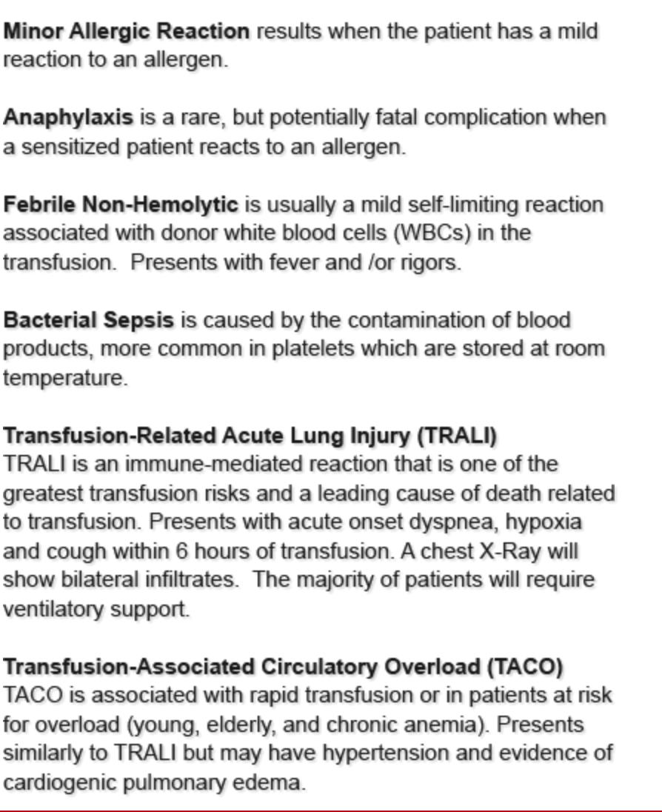
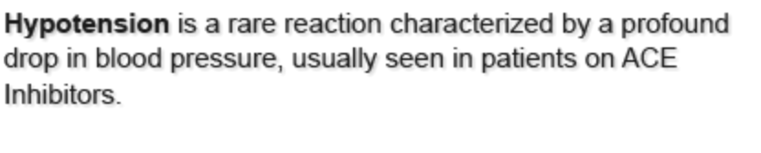

Immediate Hemolytic transfusion reaction (HTR) is caused when RBCs are attacked by antibodies, usually in the ABO blood system.

- Hemolysis causes the release of the normally intracellular haemoglobin out fo the RBCs and into the plasma. The result is red urine and red plasma. An HTR can occur after transfusing just a small amount of incompatible blood. The patient can develop severe complications such as renal failure, shock, coaguolopathy.
- HTR can also occur when blood is damaged by:
  - Improper storage
  - Imxing with incompatible solutions or medications
  - Transfusing under pressure through a small needle
  - Medical devices (ie. cell saver, blood warmer)

3 major reasons why pts may get transfused with incompatible blood ****
- Mislabelled samples
- Misidentified patient wearing the wrong wristband
- Blood hung on the wrong patient

Delayed Hemolytic Transfusion reactions
- Can occur days or weeks post transfusion
- May be associated with an unexplained drop in haemoglobin and are usually caused by antibodies to antigens other than ABO. The patient will not present with symptoms during/immediately after transfusion.

Other Delayed reactions
- Transfusion-associated graft vs host disease
- Post transfusion purpura
- Platelet refractoriness

- Acute hemolysis occurs when blood is hemolyzed due to incompatibility or damage
- Acute hemolysis, anaphylaxis, bacterial sepsis and hypotensive reactions usually present early
- Any bacteria present in a component will proliferate at room temp

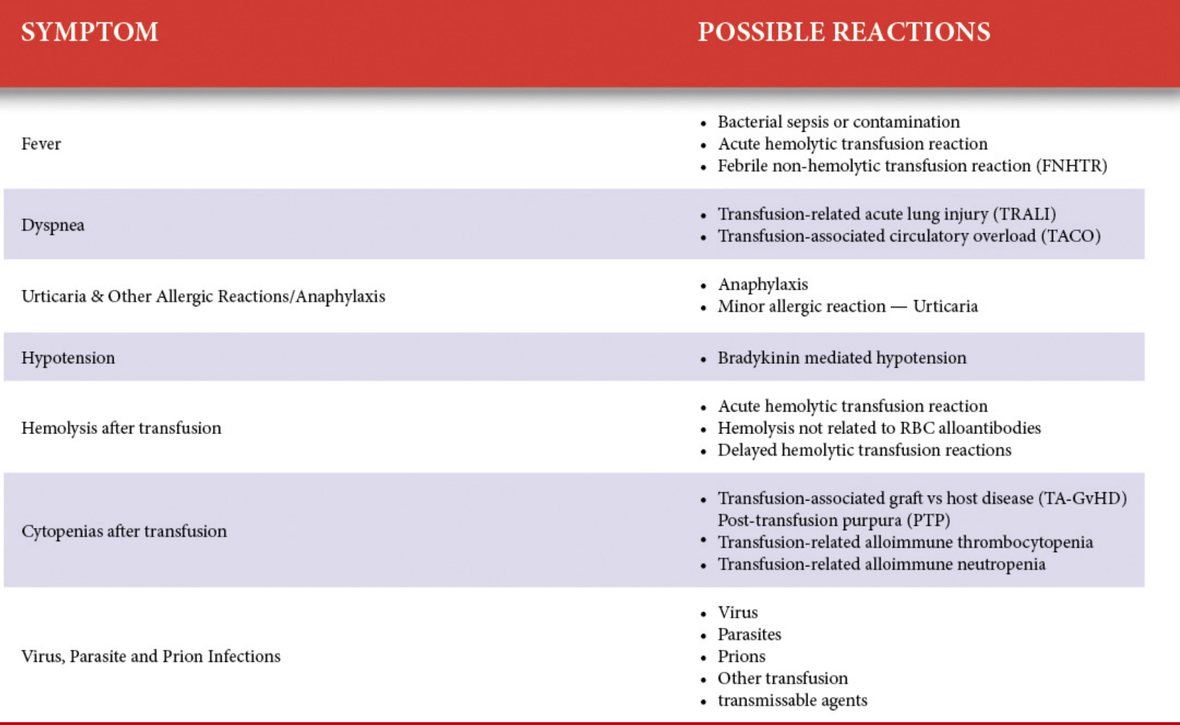

Acute Reaction Management
- Stop the transfusion immediately
- Maintain IV access with saline using a new IV set for treatment if needed
- Check vital signs
- Verify the pt ID matches the TML tag/label
- Verify the blood unit number matches the TML tag/label
- Notify the physician but remain with the patient
- Notify the TML of the reaction
- Treat patients symptoms as ordered by physician

*If your pt experiences minor allergic or minor febrile symptoms only, continuing the transfusion may be possible. Refer to your hospital policy for guidelines.

General Guidelines for continuing a transfusion
- Consult physician to obtain orders
- Medicate pt as ordered
- Proceed cautiously with more frequent pt assessments
- Remember 4 hour limit (maximum time of infusion)

Reaction Investigation
-last step in transfusion checklist

To Investigate a reaction:
Send the following three items to the TML
- Blood bag with attached blood tubing
- Possible culture
- Hemolysis check
- Clerical check
- Previous completed blood bags if available
- Transfusion reaction reporting documents with
- Symptoms
- Pre and post vitals
- Time of onset
- Blood unit number

-generally the following would be performed as part of the investigation (as per hospital policy)
- Repeat type and screen, repeat crossmatch for comparison with pre-transfusion results
- Direct anti globulin test (DAT)
- Hemolysis check/haptoglobin level

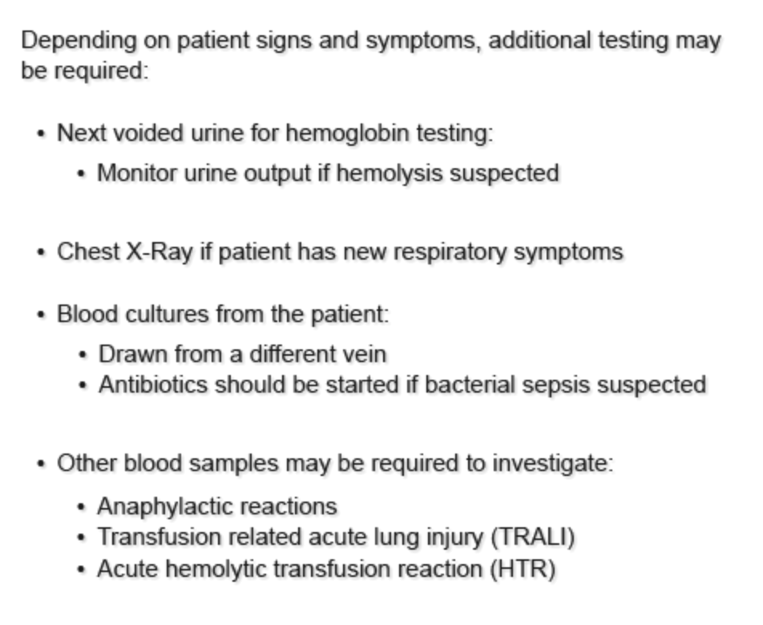

RIGHTS
- Patient
- Blood product
- Reason
- Dose
- Time
- Site
- Documentation
- Response

Associated risk table: probability of an infectious or non-infectious complication


