Social Justice and Nursing practice
- Social justice
  - “All people without discrimination, have the right to live in dignity and freedom and to enjoy the fruits of social progress and should, on their part, contribute to it.” (CNA, 2010).
  - People can live without discrimination
- Social Justice in Healthcare
  - Focus on how to improve the distribution of societal benefits, responsibilities and consequences in order to create equity for all (CNA, 2017).
  - Health equity = everyone has a fair opportunity to live a long and healthy life
  - How to improve the distribution of societal benefits
    - Fair and equal rights to access healthcare
- Importance of social justice in nursing
CNA:
  - Part 1: CNA nursing values and ethical responsibilities
- Providing safe, compassionate, competent and ethical care
- Promoting health and well-being
- Promoting and respecting informed decision-making
- Honouring dignity
- Maintaining privacy and confidentiality
- Promoting justice
- Being accountable

  - Part 2: ethical endeavours related to broad societal issues:
    - describes activities nurses can undertake to address social inequities. Ethical nursing practice involves endeavouring to address broad aspects of social justice that are associated with health and well-being.”
    - What does this mean for nursing?
    - Focus is placed on nurses engaging in social action is to improve systemic and societal structures that cause disparities within populations health status’ (CNA, 2017).

- How can nurses become strong advocates
  - Recognizing
    - how social, economic and political factors can influence health and well-being v that vulnerable groups in society are systemically disadvantaged and how the
    - role of social determinants of health play in affecting peoples health status’.
- There are social forces that we deliver care, and the way pt's are seen in society
- Social determinants of health
  - Being aware
- Recognition --> awareness
  - Advocating
- for policies, procedures and programs that bring equity.
- for changes to unethical health and social policies, legislation and regulations.
- to reduce environmentally harmful practices and promote health and well-being.

How can nurses enact social justice in health care settings?
- Move ”justice” beyond an ethical and legal obligation which helps guide human conduct (Johnstone, 2011).
- Justice, like care, is a basic human need, and necessary for human survival, health, development and welfare
- We can apply different framework and right changes
Relational ethics
“To determine what is “the right thing” nurses must negotiate the requirements of care and responsibility with their patients within the context of a relationship “

  - Relationships that exist that we are constrained in
  - Nurse pt relationship
  - Relationship with society and everything else
  - Promotes social choice

Applying Relational Ethics in order to Engage with the System
- Builds our recognition of the ethical issues that exists within relational spaces which then allows nurses to question ethical issues when they arise.
- Ultimately promotes:
  - Freedom of choice for making decisions
  - Inclusive of individual
  - Promote social choice

Her Thesis: Apprehension of Newborns at Birth: Maternal Experiences of Disenfranchised Grief
- Understanding the lived experiences birthmothers have, in context to the disenfranchised grief they endure, after having their newborns apprehended from their care
- Disenfranchised grief – deprived of the right to grieve
- Population: Women who are homeless, living with mental illness, and/or using substances
What’s the problem?
- Apprehension ---> marginalized birth experience.
- In Ontario, (2012 – 2015), 592 mothers had their newborns apprehended by child welfare authorities
- Long-term adverse outcomes - for both mothers and newborns when separation occurs (i.e. issues in attachment); and the problematic grief reaction the birth mothers experience
- Despite literature delineating a problematic grief, this population of mothers remain socially supported by society; as evidence by the few available supportive interventions.
- Furthermore, not only are these women unsupported by society, they also face stigmatizing attitudes from HCP. Results in avoidance to health care services later in their lives.
- Vicious cycling

Implications to Nursing Practice
- This study is specifically exploring apprehensions occurring at birth, within hospital
- Therefore, directly impacts labor & delivery and postpartum nurses.
- No clear guidelines exist regarding the nurses role in the apprehension process. Guidelines from Child and Family Services persists, unabated.
- Without questioning practice, we are currently practicing against our code of ethics

- Her thesis
  - Newborn apprehension
  - Problematic grief response
  - Given little to no supports
  - Blamed that they have their newborn apprehension
    - Not seen as grieving
  - Implications to nursing practice
    - Are we doing the 7 values of nursing

Aims of the study
- To recognize that newborn apprehension is a complicated form of perinatal loss
- To recognize the role nurses have in terms of advocacy and health promotion to better support the health outcomes of birth mothers’
- To increase awareness and sensitivity to the social challenges birthmothers’ face when involved with apprehensions at birth
- Gain direct insights from birthmothers’ which can then be used to advocate for change in policy and interventions

SECOND PRESENTER:

Women who use IV drugs : a social justice discussion
- Social justice :
  - 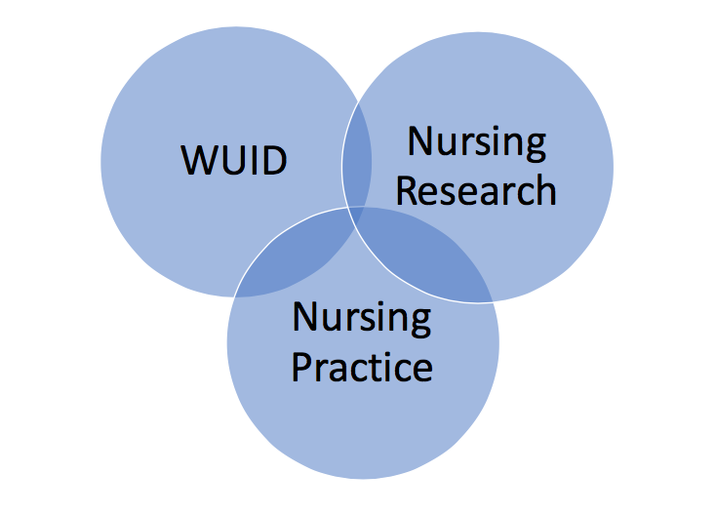

  - Social Justice: “... refers most broadly to fairness and equality, it is also understood to represent a global struggle for human rights, recognition, and dignity” and is “a transformative process that changes society by taking up issues of fairness connected to rights, allocation of resources, and power.”
  - Concepts of human rights
  - Fairness, equailty and global struggle for human rights and dignity

- Nursing role
  - Addicts, desperate, her fault, disadvantage, criminals
  - Highly stigmatized
  - Devalued person in society
  - Considered to be outsiders
  - Stigma: Dirty, deviant , dirty failures
- Ethnographic research
  - What is ethnography?
  - Critical ethnography has it’s purpose: “the need to redress inequalities by giving precedence ... to the voices of the least advantaged groups in society”

- Social justice research
  - is “committed to the breakdown, challenge, and change of social structures and ideologies that perpetuate marginalization, discrimination, and oppression as an integral part of the research process”

From the research what can be learned about how WUID are seen in society?
- Research about IV drug users
  - Interviewing, collection artifacts

Some examples of the everyday life of WUID
- Interactions with police, the public, health care, society
- Experiences of violence, vulnerability and a lack of social justice

- EVERYDAY life of WUID
  - Police
    - “Just because I’m here and in a low place doesn’t mean I’m uneducated and dumb and don’t know my rights. And then they (the police) call you mouthy for it. And if you don’t stop, then they arrest you because you’re putting them in their place. ... If I lived in (a suburb) or something, they would say hi to me. I am still the same person. “
    - Different due to where she lives
  - Public
    - Look at the harassments and bullshit we take. Look at the name calling from every car that drives by ‘you crack whore’. It hurts, I don’t care what anybody says. Anybody that says it doesn’t hurt is a liar. People walk by and ‘here’s ten cents you crack whore’ ... you get dirty junkie...
    - Harassments, and name calling
  - Healthcare
    - If you go to the hospital with (an abscess), you’re treated like shit. ... Right away you‘re red flagged as a drug addict. ... They think that a lot of people who are opiate addicts are just coming in to drug seek. You’re looked at right away like you’re scamming them, you’re guilty until proven innocent type of thing.
    - Accompany by illness
    - Being red flagged, treated like shit when seen as a drug addict

  - Society
    - really find that society does look very badly upon women with addiction issues. ...That’s the biggest thing for me, is the stigma, that’s attached to the addiction. And women get treated very badly, the addicts and alcoholics. We’re not allowed to be like that we have to be perfect, society puts us up on a pedestal and, some of us fall off.
    - Stigma attached to addiction
  - Violence
    - I’ve been robbed, I’ve been beaten for money. ... It’s amazing to me that I’m still alive. ... I could have been killed several times, I’ve had guns to my head, knives to my throat, been choked out. Sorry I don’t mean to cry. I was choked, I’ve been beaten unconscious just to live this life.
    - Suffer violence by the hands of many
    - Srugglingo stop using drugs
      - So much social influences
  - Vulnerability
    - Of course not. Why? Because I have a record for prostitution and everything else. ‘What- did you try and rob one of them or something’? That’s the first thing they say. So do you really want to go to them and tell them that you are hurting? No, not whatsoever.
    - Can't go to the police
  - Social justice
    - But then who cares, because we’re drug users. That’s the way the public looks at it. Just another drug user off the street, all fine and good. ... Everyone is a human on an equal basis, has a mother and a father somewhere, it doesn’t matter if they don’t want anything to do with us or not, and maybe some brothers and sisters. We all have good in us. ... I thought it was supposed to be you treat every human equally. Is that not right?
    - "who cares we are drug users"
- Nurses

- Harm reduction
  - CNA
  - Safe inhalation
  - Programs
  - Thearapy - legalized herion
  - Managed opioid program
    - Dilated
  - HIV testing
  - Supervised injection sites
- CNA and Advocacy ***
  - Engaging others
  - Speaking out against inequality
- Do PWID Need advocacy ?
  - PWID experience:
    - An increased rate of physical and mental health problems
    - A lack of permanent housing, and are often homelessness
    - Little or no access to treatment services
    - Social marginalization
  - ^ problems
  - No homes
  - Socially marginalized
- Harm reduction and advocacy
  - Safe injection sites
  - How nurses can take evidence and more it forward
  - Support marginalized people

In summary: another quote from the research
Everybody thinks a drug addict is a bad person, we’re not bad people. What we are, is in a bad situation. There’s a difference between a bad person and a good person. A bad person will rape you and rob you and kill you or hurt you. A good person- I’m a good person, I just make wrong choices. I make bad decisions, and unfortunately my bad decisions have consequences.

NEXT PRESENTER
Indigenous Peoples: Health Equity and Social Justice

Indigenous people
  - 10 year anniversary of the UN declaration of indigenous rights
    - EXAM SLIDE ( HIM WRITING) ?
    - Sixteen of the 94 calls to action are about the UN declaration. It is about the survival, dignity and well- being of Indigenous Peoples; so implementing the UN declaration has the possibility of healing our peoples, strengthening relationships and promoting peaceful co- existence.” – Littlechild, Truth and Reconciliation Commissioner
    - "There can be no reconciliation unless the core articles of UNDRIP related to Indigenous self-determination, land ownership, implementation of treaty rights, and respect for Indigenous laws, governments and jurisdictions are part of the legal foundation of what is now Canada.” – Pam Palmater

- Final repost of the truth and reconciliation commission of canada
  - Must read
  - We were children
  - Calls to action

- Calls to Action
  - “23. We call upon all levels of government to: increase the number of Aboriginal professionals working in the health-care field, ensure the retention of Aboriginal health-care providers in Aboriginal communities and provide cultural competency training for all health-care professionals ...
  - 24. We call upon medical and nursing schools in Canada to require all students to take a course dealing with Aboriginal health issues, including the history and legacy of residential schools, the United Nations Declaration on the Rights of Indigenous Peoples, Treaties and Aboriginal rights, and Indigenous teachings and practices.” (TRC, 2015)

- Racism that everyone faces
- The journey ***
- Need more aboriginal nurses
- Cultural safety for nursing

- Equality vs equity
- 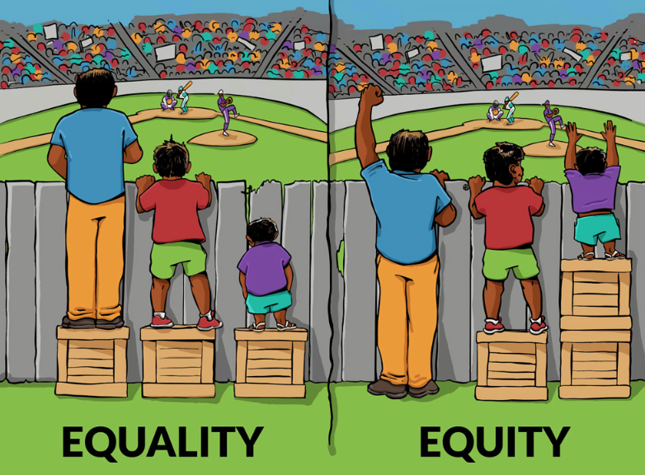
  - should we treat everyone the same ??

NEXT PRESENTER:
Feminism and nursing

Definitions & Concepts
- Social Justice: Equitable distribution of social, economic, and political resources, opportunities, and responsibilities and their consequences.
- Feminism: a range of political and social movements and ideologies that share a goal of defining, establishing, and achieving political, economic, personal, and social equality of sexes; includes equal educational and professional opportunities for all.
- Post-Colonialism: theoretical approach in various disciplines that is concerned with the lasting impact of colonization in former colonies; an academic discipline that analyzes, explains, and responds to the cultural legacy of colonialism and imperialism
- Health Equity: Fair distribution of resources and processes that leads to the absence of systematic disparities in health between social groups who experience different levels of social advantages.

Specialization in Women’s Studies
- Feminist Methodologies
  - Understanding how our research and practice is affected by gender, race, class, sexuality, age, ability, ethnicity, etc.
- Feminist Theories
  - Discussing major themes raised by the vast interdisciplinary field of scholarship called Feminist and Gender Studies, with in-depth consideration of Black and women of colour feminisms and Indigenous feminist theories.

Equality
- It is assumed that everyone will benefit from the same supports. They are all being treated equally.

Equity
- Individuals are given different supports to make it possible for them to have equal access

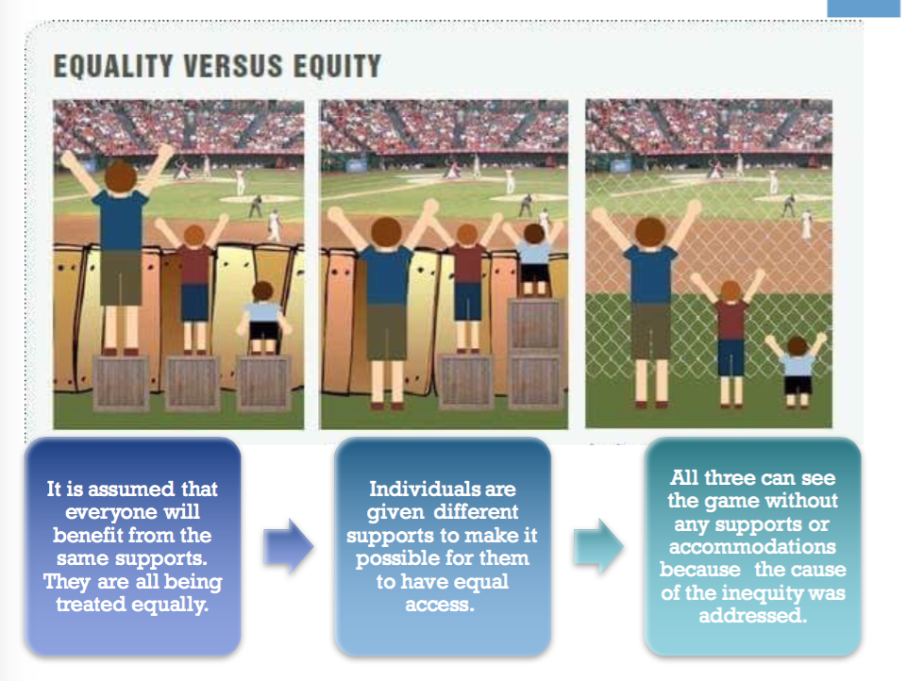

How does this relate to nursing?
- Health is a commodity
  - Prerequisite to individuals’ and communities’ abilities to function
- “The measurement of health disparities without respect to how the disparities are distributed socially is not a measure of equity and does not reflect fairness or justice with respect to health” – Dame Margaret Whitehead (World Health Organisation Collaborating Centre for Policy Research on the Social Determinants of Health)
  - Most challenges to achieving health equity are discriminations based on gender, geographic location or income, all determining the extent of access to treatment and medical products.
“I was nothing like this when I started out ...”

- What is nursing? It is a force for goodness, a way to repair the world, a path toward the creation of more caring communities ... By having first found compassion for my own suffering, I can offer compassion to others. Nursing has given me awareness of the world’s suffering ... it has expanded my vision exponentially: when I look at the world, all roads seem to lead to nursing. Every problem we face in our society – war, famine, poverty, crime, natural disasters, global warming – affects health and safety. The real-life consequences of these challenges have nursing solutions. When there is no peace, there’s no health; if there is no safety, there is no health. Nurses know this and possess the knowledge and skills to ameliorate all of these situations. There is no issue that does not involve nursing. Any discussion about healthcare that doesn’t involve nursing is inherently flawed. And nurses need to speak up more often and more loudly. Our voices can only be heard if we express them.” (Shalof, 2013, p.166).

- **equitable or resouces and consequences
- Feminism
  - Equal opportunities for all
  - Truly what is for everyone
- Post -colonialism
  - Understanding the lasting impact of colonization on community
- Health care is white and very colonized
- Health equity
  - Fair distribution and processes
  - Limited quantity
  - As best we can
- Abortions about contraception counselling
  - what are the barrier that people have to come across
  - Who is disadvantage from the move form equality to equity
    - We must understand that people who are advantage, may feel that equity is not good for them
  - Why not remove the barriers
  - No one needs an extra support
  - Remove the disadvantaging stuctures

