Lecture 1: introduction to nursing ethics

Being a good nurse:
- Caring
  - Shown through active listening
  - Genuine concern for a person's best interest or well being
  - Showing interest and involvemnt
  - Willing to help
- Advocating
  - Well being and for what is in their best interest
  - For what the patient wants
  - For the profession
- Empowering your patient to be independent
- Being a good teacher to patients, family, student, coworkers
- Knowledgeable
  - Meds, health and safety , risk
- Critical thinking
  - About info and values
  - Risk making assumptions about patient
- Being passionate

Conformism in nursing practice?
Morality in nursing practice?

Nursing as moral practice
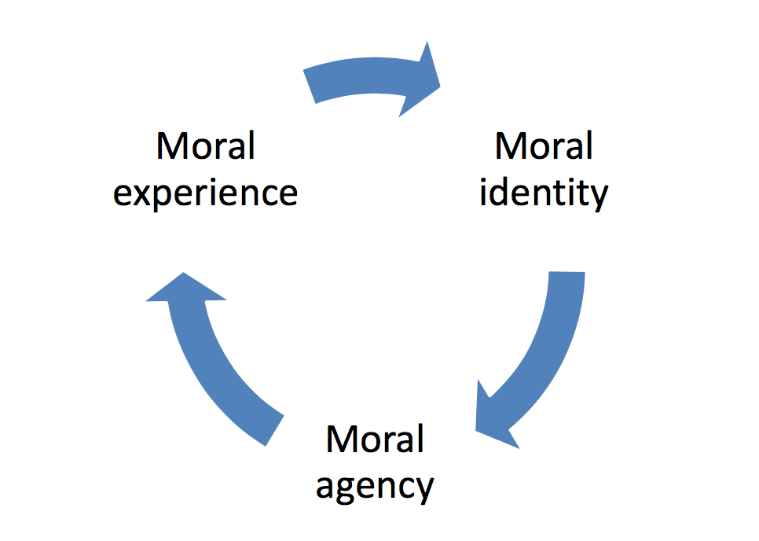
- Moral identity
  - What the nurse values and what they will take responsibility for
  - Influences moral agency
  - Ie: you want your pts to understand drugs
- Moral Agency
  - Actions actually able to support your identity
  - Capacity to put values into practice
  - Ie: you explain medications to pts
- Moral experience
  - Encouraging drug which values are being realized or countered
  - Being at bedside giving drugs

Influences on nurses’ moral agency?
Culture of the practice environment
- Team relationships
- Ethos
  - The values that operate at wider values
- Resources
  - Ie time
- Professional guidelines/standards
  - Can have a protective snese, if you feel like your working in an agency that doesn’t value it- you can show them on paper that those things are ethical guidelines for nursing
- Ethics education
Values-based Practice

Empirical Vs Normative Claims ********
- The home is the best place for people to die

- All mothers should be encouraged to breastfeed their babies

- Empirical
  - Based on empirical evidence
  - Based on research, experience, something we can observe
  - “Most Canadians state a preference to die at home”
  - “Breastfeeding has numerous proven health benefits”

- Normative
  - Makes value judgements. Claim that assers that such and such ought to be the case
  - “The home is the best place for people to die “
  - “All mothers should be encouraged to breastfeed their babies”

Doesn’t consider the situation, might be important values at stake
-ie a home death can be very incompatible with the value “family-centered care” --> its very hard on the family to watch their loved one die at home, doesn’t take their care into consideration, just the pts
-ie “woman should breast feed” is incompatible with a woman who’s choice is not to

Some Key Nursing Values
- Health
- Quality of life
- Dignity
- Choice
- Compassion
- Family-centered care
What does Nursing Ethics mean?

- The application in practice of insights from biomedical ethics
  - Ie..Autonomy, beneficence, non-maleficence, justice
- The application in practice of a set of rules and norms
  - Ie code of ethics, practice standards, the law..

- Ultimately nursing ethics means :
  - A field on inquiry that analyzes nursing practice through a lens of moral experience
- Something to guide practice
- More attitude

Main themes in course
- Moral experience, sensitivity, identity, distress, agency
  - Moral distress: the distress when not able to act on what is right
- Moral dilemmas
- Moral uncertainty and humility
  - Knowing your values
  - Critically questioning yourslef
- Everyday ethics
- Relational ethics
- The landscape of nurses’ ethical practice

Course objectives
- Examine various nursing topics through a lens of moral experience;
- Nurture a sense of moral identity and capacity for ethical action (i.e. moral agency) as a future nurse;
- Identify ethical dilemmas, and propose resolutions through values-based analysis;
- Apply professional standards and ethical theory to nursing issues;
- Articulate and defend moral arguments relevant to nursing ethics;
- Discuss self-regulation and implications of legislation relevant to nursing and health care;
- Critically evaluate how the law, professional standards, and ethical theory /principles come together to define – and guide – nurses’ practice.

