BPS 2110 – Introduction to Biopharmaceutical Science
Structure Activity Relationship (SAR) Notes

Lecture 5
Lecture 6
09/21/2017
09/25/2017

Drug Effects
- Drugs produce effect by binding to biomolecules
  - Enzyme inhibitor
  - Agonist
  - Antagonist
  - Modulator (ion channel agonist/antagonist)
  - Structural effects (protein association/disassociation)
- Drugs bind to targets using intermolecular forces

  - Electrostatics
    - Strongest type of interaction
    - Strength depends on surrounding environment
      - Stronger in hydrophobic environments
    - Non-directional
    - Carboxylic acids, phosphates = mainly negative
    - Nitrogen, oxygen = positively charged
    - Charge on target and drug is complimentary to bring together
    - Location is important
      - Outside interaction = weak because surrounded by solvent
      - Lipophilic insulates positive and negative charge

  - Hydrogen bonding
    - Strong interaction
    - Strength depends on surrounding environment
    - Stronger in hydrophobic environments
    - Directional
      - Strongest interaction when X-H bond points directly towards the axis of the lone pair of the acceptor
      - Strength of hydrostatic depends on distance between two charges
      - Strength of hydrogen bonds depends lone pair direction
    - Hydrogen bond donors
      - Provide the hydrogen
        - X-H group
      - OH, NH
      - Variety of functional groups
        - OH, NH₂, NHR, CO₂H, CONHR
      - C-F bond can act as a donor (rare)
        - Fluorine is very electronegative and attracts lone pairs even though it tends to be the negative part of dipoles
    - Hydrogen bond acceptors
      - Provide lone pair to form hydrogen bond
      - Acceptor has pair of electrons on it
      - Good acceptors = N, O with lone pair
      - Weak acceptors = S with diffuse electron pairs
  - Dipole-dipole
    - Moderate-strength interaction
    - Strength depends on surrounding environment
      - Stronger interaction in hydrophobic environments
    - Carbonyl groups, strong electron withdrawing groups
    - Must be close to one another
  - Van der Walls (Dispersion forces)
    - Relatively weak
    - Strength depends on surface area
      - Strength increases with larger surfaces
    - Important in many binding pockets
    - Lipophilicity can significantly improve potency of drugs
      - De-solvation
        - “Empty” binding pockets are actually full of water
        - Drugs in solution are surrounded by water
        - These water molecules are stripped away as the drug enters the binding site
          - This requires energy
          - Polar drugs “cling” to water
        - Binding pockets are often very lipophilic
          - Facilitates water removal and ligand binding
        - Drugs are often very lipophilic
          - Facilitates de-solvation and improves binding to target
        - Energy required to get water out
        - Drug must strip water from outer surface
        - Water doesn’t stick to greasy drugs
        - Binding sites are lipophilic
        - Lipophilic environments increase strength of bonds, make it easier to remove water from pockets
      - Drug potency (binding) is an equilibrium between drug dissolved in water and drug “dissolved” in protein
        - Potency is usually linked to lipophilicity
        - Many drugs are highly lipophilic
        - Potency = measure of the concentration of drug required to achieve an effect
          - Low concentration = high potency
    - Good for recognition elements
    - Lipophilic plays good role in attracting and amplifying
    - Drugs tend to be non-polar, solvate less well in water
- Optimizing Drug Binding
  - Structure Activity Relationships (SAR)
  - Make structural changes to a molecule
  - Measure various properties of the molecule
  - Measure the potency
  - Relate the effect to the structural change
  - Use this information to design the next compound to test
  - Optimize everything at once using computer and analyzing data
  - Goal
    - Drug like molecule
      - Safe
      - Effective
      - Convenient
    - Potent
      - Small dose for desired effect
    - Bioavailable
      - Drug (%) enters blood stream after dosing (oral)
    - Chemical behavior
      - Solid, liquid
      - Stability – can it sit for a long time in medicine cabinet
      - Ease of synthesis
Common Property Measurements of Drugs
- Solubility
  - Water buffer
- pK_{a}
  - Acid/base nature of the drug
- LogP or LogD
  - Ability to cross membranes
- Molecular weight
  - Solubility
  - Ability to cross membranes
- Permeability
  - Ability to cross membranes
- Melting point
  - Solubility
  - Manufacture
- Metabolism
  - Amount entering the body
  - Lifetime in the body
- Protein binding
  - Amount circulating in the body
  - Lifetime in the body
  - Availability for activity
  - Drugs tend to bind heavily to proteins
- Property Optimization
  - Before a drug can bind to its target, it must enter the body and get to the target
  - Must pass several chemical barriers to do so
  - Chemical properties of drugs control how easily the drug passes these barriers
  - Want to get as much drug to the target location as possible
  - Must optimize these properties as potency is optimized
Creating Bioavailable Drugs
- General biological barrier model
  - Not all drug molecules will pass each barrier
  - Try to maximize the amount that does pass
  - All drugs must pass through various environments
    - Stomach environment
      - Strong acid
        - pH 1.4 to 2.1
      - Drug must be water soluble
      - Drug must survive strong acid
      - Very little or no drug is absorbed
      - Transit time approx. 0.5 to 1 hour
    - Gastro-intestinal tract environment
      - Mildly acidic to neutral pH
        - 4.4 to 6.8
      - Bile salts
        - Form micelles to aid in fat digestion
        - Solubilize lipophilic drugs
      - Most drugs are absorbed here via passive diffusion
- Diffusion of drug across lipid bilayer (into blood)
  - Interior of lipid bilayer is very non-polar
  - Intermolecular interactions primarily Van der Walls type
  - Drug require simultaneous opposite properties
    - Water solubility to reach the bilayer
    - Lipid solubility (water insolubility) to pass through the layer
  - Opposite chemical environments
    - Water
      - Very polar medium (solvent)
      - Lots of hydrogen bonding and dipole interactions
      - Hydrophilic
      - Lipophobic
    - Hydrocarbons
      - Very non-polar medium (solvent)
      - Van der Walls interactions only
      - Lipophilic
      - Hydrophobic
  - Membrane phospholipids
    - Fatty acid = long hydrocarbon chain, glycerol, phosphate group (negative charge), head group
    - Individual molecules that make bilayer
    - Head groups
      - Negative charge on each phosphate
        - 2 head groups have positive charge to balance charge
        - 2 other, cations will be in the area (Na+, Ka+, Ca+) to balance
      - Phosphate group is fixed = layer of negative charge
  - Negatively charged drugs have extra difficulty
  - Most drugs are ionizable
    - Basic 75 %
      - Will be positive at physiological pH
    - Acidic 20 %
      - Will be negative at physiological pH
    - Neutral 5%
- Blood passes through Liver
  - Liver is designed to “detoxify” our food
  - Foreign molecules are metabolized to be removed from blood
  - Metabolism
    - Phase I: oxidation – put OH group on molecule to make less lipophilic
    - Phase II: conjugation – jam sugar/something with charge to increase water solubility
  - Hydrophobic molecules are highly metabolized
- Blood transports drug through body
  - Blood is mostly water
  - Lipophilic molecules bind to carrier proteins in the blood
    - Plasma protein binding
  - Blood contains hydrolytic enzymes
    - Esterases
    - Proteases
- Kidney clears substances from blood
  - Hydrophilic compounds are easily cleared from blood
  - Hydrophobic molecules tend not to be cleared
- Blood Target Organ
  - Passive diffusion from blood to organ
  - Sufficient drug must reach the target to produce a response
- Therefore, there are many barriers to drug delivery (oral dosing)
  - Molecular properties must be tuned to maximize the amount of drug that reaches the target
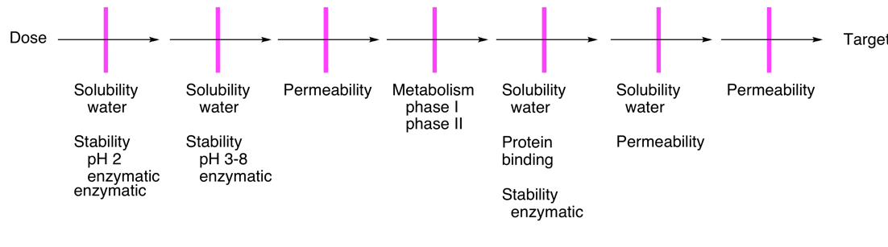
stomach cells liver blood cell organelle

  - Properties measured are associated with ADME
    - Absorption
    - Distribution
    - Metabolism
    - Excretion
- Lipinski’s Rule of 5
  - Rapid way to evaluate drug-like properties
  - Predict poor absorption or permeation
  - Based on computer analysis of World Drug Index
  - Fast, no cost, well documented, widely used

  - Compounds that meet 2 or more of the following criteria are not likely to be well absorbed into the body
    - More that 5 hydrogen bond donors
      - OH’s + NH’s
    - More than 10 hydrogen bond acceptors
      - N’s + O’s
    - Molecular weight greater than 500
    - Calculated LogP (CLogP) greater than 5
      - Or measured LogP (MLogP) > 4.15
  - Rationale
    - Hydrogen bonds
      - H-bonds increase

      - e water solubility
      - H-bonds make it difficult to cross lipophilic membranes
    - Molecular weight
      - Large molecules tend to be less soluble
        - Create a larger cavity in solvents (water or lipids)
      - Large molecules do not pass easily through tightly packed membrane lipids
    - LogP
      - Water solubility decreases as lipophilicity increases
      - Log P = Measure of lipophilicity (how greasy material is)
      - Higher the number, more lipophilic
      - Must be lipophilic enough to cross membrane however not too lipophilic that you cannot dissolve in water
3 (H) 4 (O & N)
Cause of concern!
Bioavailable
Bioavailable
2 (H) 4 (O & N)

Cause of concern!
Cause of concern!
Not Bioavailable
7 (H) 12 (O & N)

Lipophilicity
- Important for drugs
- Drugs must have a balance between lipophilicity and hydrophilicity
  - Dissolve in water
  - Dissolve in lipid membranes
- Drugs discovered via HTS are usually highly lipophilic
- Measurement
  - LogP
    - Log of partition coefficient between octanol and water for drug in neutral form
      - High number = lipophilic
      - Low number = hydrophilic
    - Must be done when drug is in neutral form (overall charge = 0)
    - Measured or mLogP (want less than 4.15)
    - Calculated or ClogP done via computer
    - Advantages
      - Methods well established
      - Correlates well to Rule of Five
    - Disadvantages
      - Each molecule requires different buffer
      - Must measure when molecule is in neutral form
      - Measurements not made at physiological conditions
    - If molecule is neutral at pH 14, no such pH exists in body thus not viable
    - ALWAYS measure LogP – despite relevance as FDA and courts requires
  - LogD
    - Log of partition coefficient between octanol and water for drug at a given pH (normally 7.4)
    - For Lipinski’s rules, can replace LogP criteria with LogD criteria
    - 1 < LogD_{7.4} < 3
    - Switch now to LogD
    - Difference here is pH specified
    - Advantages
      - Methods well established
      - Easier to measure (fixed pH) – thus only one buffer needed
      - Correlates to Rule of Five
      - Physiological relevance (pH 7.4)
    - Disadvantages
      - Less widely used than LogP
- Measurement Methods
  - Solutions
    - Make standard solution in water
    - Add equal volume of octanol
    - Shake
    - Separate layers and measure amount of drug in one of the layers
  - HPLC (high performance liquid chromatography)
    - Run sample through special HPLC column
    - Retention time used to calculate LogP
pKa of Drugs
- pKa controls water solubility
  - Solubility in water is pH dependent
  - Most drugs contain ionizable groups (acids or bases)
    - 75 % of drugs are bases
    - 20 % of drugs are acids
    - Only 5 % are non-ionizable
  - Ionization increases water solubility
  - By manipulating pronation state, can increase lipophilicity and hydrophilicity (change between acid/base)
  - Charged, dissolve in water
  - Neutral, dissolve in membrane
- pKa describes both acidity and basicity
  - Gives info on ionization state of molecule
  - For bases, value refers to corresponding conjugate acid

- Molecule is protonated when pH < pKa
  - Acids
    - Neutral when pH < pKa
    - Charged when pH > pKa
  - Bases
    - Charged when pH < pKa
    - Neutral when pH > pKa
- Some groups are amphiprotic
  - Can act as an acid or a base depending on environment
    - Check both pKa values
  - Amines are usually bases
  - Amines can act as acids
    - Not relevant for drugs
  - Nowhere is pH 33, so not viable in water
- Only consider pKa values inside water range
  - Water = amphiprotic
  - Within range of water = relevant
  - Use -1.7 as a lower pH limit
  - Use 15.7 as an upper pH limit
- Most drugs are ionizable
  - Max water solubility in charged form
  - Able to become neutral to pass membranes
  - Dissolve in water = dissolve in blood, digestive material = transport
  - Converted to neutral form = dissolve in membrane = travel from one side to other of membrane
  - Converted into charged form = dissolve on other side of membrane in water
- Determine if following will act as acid or base
  - Top = pKa = 18.6
  - Bottom = pKa = 6.8
  - Therefore, top one, will not occur as it as outside of pH range of water
  - Thus, it will act as a base
- Using pKa table
  - Find closest to actual structure, may not find exact
  - Consider conjugation and induction
    - Conjugation = resonance, aromatic = double bond beside functional group (must be immediately beside)
    - Presence of double bonds affect pKa as they affect stability of conjugate base
  - Consider conjugation and amphiprotic behavior
    - Amphiprotic = acting as either acid or base
    - No H = not acid
- pH effects on water and lipid solubility
  - Has opposite effects
  - As pH increases, molecule becomes charged
  - As pH increases, solubility in lipid goes down
  - As pH increases, solubility in water goes up
Drug Permeability
- Rate at which a drug passes through lipid membranes
- Influenced by solubility, LogP, molecular weight
- Hard to find other method than passive diffusion to get drug into cells
- Permeability measurement methods
  - Caco-2
    - Human colon carcinoma cells
    - Similar to intestinal membrane
    - Results more relevant to clinic
    - Assay difficult to do
    - Cancer cells grow infinitely
    - Build artificial intestinal membrane using cancerous intestinal cells
  - PAMPA
    - Artificial membrane
    - Easily done
- Assay methods
  - Place sample in Buffer 1
  - Measure the rate at which it is transported into buffer 2
- Classes of Drugs
  - FDA uses the Biopharmaceuticals Classification System (BCS)
  - Compounds in Class 1 receive an FDA Waiver for Bioequivalence and Bioavailability studies
  - FDA uses Caco-2
  - Class 1 – allows bypass of tests because it is very bioavailable
  - Class 1 : soluble and permeable
    - Ideal for oral dosing
  - Class 2: permeable but not very soluble
    - Drugs tend to be lipophilic
    - Special formulations can be used to solubilize
  - Class 3: soluble but not very permeable
    - Drugs tend to be hydrophilic
    - Prodrugs used to improve permeability
  - Class 4: low solubility and permeability
    - Development is expensive
    - Development is risky (high failure rate)
    - i.v. dosing
Metabolic Stability
- Liver hates drug
- 2 phases of metabolism in liver
- Greasy materials are often poisonous – designed to get rid of them
- Phase I
  - Adds polar functional groups to reduce lipophilicity
  - Oxidation = add OH onto drug = get rid of drug easier as it becomes water soluble = chemically altered drug = not original drug anymore
    - Loss of electrons
    - Most likely occurs at electron rich sites
    - Alkyl groups = good oxidation sides
    - Aromatic rings = double bond acts as nucleophile, lots of electrons in it
    - Double bond = nucleophile, electron pair donors
    - X groups (NOS) = heteroatoms with lone pairs (methyl groups attached to heteroatoms are great oxidation sites)
    - N = very susceptible to reacting with oxygen
  - Hydrolysis = cuts molecule into two pieces = destroying drug = makes drug more hydrophilic
  - Oxidation of aliphatic or aromatic groups
    - Electron rich sites
  - Cytochrome P₄₅₀ (iron atoms)
    - Heme iron
    - Oxidized iron can oxidize other materials
    - H site on drug
    - O inserted between H and R group
- Phase II
  - Conjugation to improve water solubility increases water solubility by adding stuff onto drug
  - Adds polar groups
    - Makes it easier for kidney to dispose of
    - Glucuronic acid = add many OH to amplify
    - Sulfonation = add sulfate, negatively charged
    - Acetylation = add acetyl group
    - Glutathione = added ionizable functions, allowing it to dissolve in water
- Common measurements of metabolism
  - Liver microsomes
    - Half-life is measured (T_{1/2})
    - Parts of human liver with drug mixed, calculate how long it takes drugs to get destroyed
  - Plasma stability
    - T_{1/2}
Protein Binding
- If drug is bound to protein, it isn’t doing anything
- Plasma protein bound = soluble in water
- Blood contains proteins that bind to drugs
  - Reduced effective concentration of drug in blood
  - Reduces metabolism and clearance from blood
- Lipophilic drugs are most likely to bind
- Most common proteins
  - Human serum albumin (HAS)
  - a-acid glycoprotein (AGP)
- Measuring protein binding
  - % of drug bound
  - Free drug concentration (best)
  - F_{u} = fraction unbound = [unbound drug]/[total drug] most commonly used
Structure Property Relationships
- Effect of structure on molecular properties
  - Potency
  - Solubility
  - Permeability
  - pKa
  - Melting point
  - Bioavailability
  - Metabolic Stability
  - Chemical Stability
- Difference between SPR, SAR, is number of tests
- Correlate properties to structure
  - How the structure will improve the property
- Drug Optimization
  - Start with lead structure
  - Make related compounds
    - Try to change only 1 factor at a time
  - Measure the potency and properties of each compound
  - Use patterns in the data to identify
    - Site on the molecule to change/not change
    - Modifications that are good/bad
- Techniques of Molecular Modification
  - Additions/deletions
    - Simply adding or removing groups
    - Information is often steric
      - Certain areas of molecular get bigger or smaller
      - Gives information about pocket in which molecule must fit, is it big or small
  - Substitutions
    - Replace one group with another
    - Can provide information about nature of interactions
      - OH is good at hydrogen bonding
      - NH₂ often gets turned into NH₃⁺ is charge important for drug
      - CH₃ has only Vander Waal’s forces
      - Replace certain groups, does drug still work? If not, what changed…
    - Use of isosteres
      - Functional group replacements
        - Bioisosteres (the term isostere is commonly used)
      - Groups of atoms with similar steric and electronics
        - Give similar biological activity
        - Produce similar shapes/sizes
      - Several different definitions
        - Classical isosteres
          - Atoms or groups that have the same valency and similar size
          - Help determine if groups are important for binding or not
          - Alter properties in a very controlled way
          - Isosteres of OH = F, Cl, SH, NH2, CH3
          - CH₂ = NH, O, CH₃(CH)₂CH₃
          - Carboxyilic acids, replace NH with O, CH₂
        - Non-classical isosteres
          - Atoms or groups that have similar chemical properties
          - Differ in overall electronics and steric
          - Isosteres of CO2H (acid) = SO3H, PO4H, CH2N4 (acids)
  - Chain extension/contraction
    - One or two atom extensions
    - Can determine where atoms line up a little better
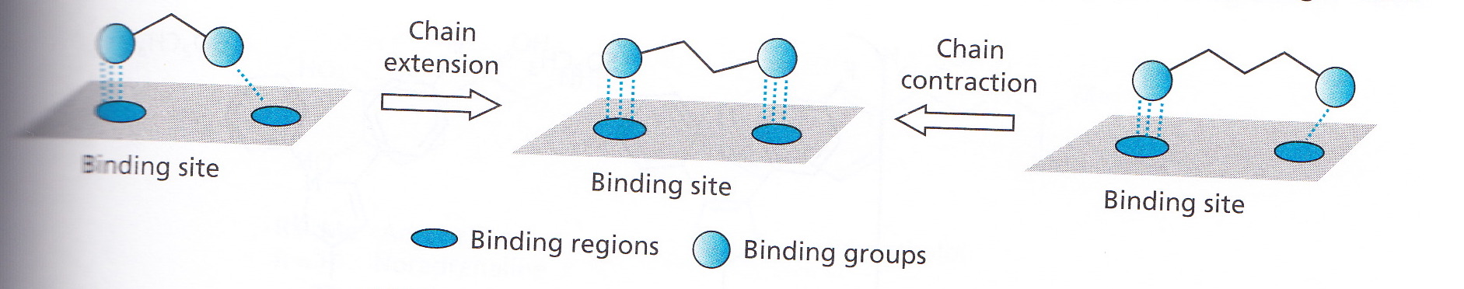

  - Ring expansion/contraction
    - Systematic ring enlargement/contraction
    - Better behavior with an increase/decrease
    - Heteroatoms can be used
      - Size
      - Synthetic simplicity
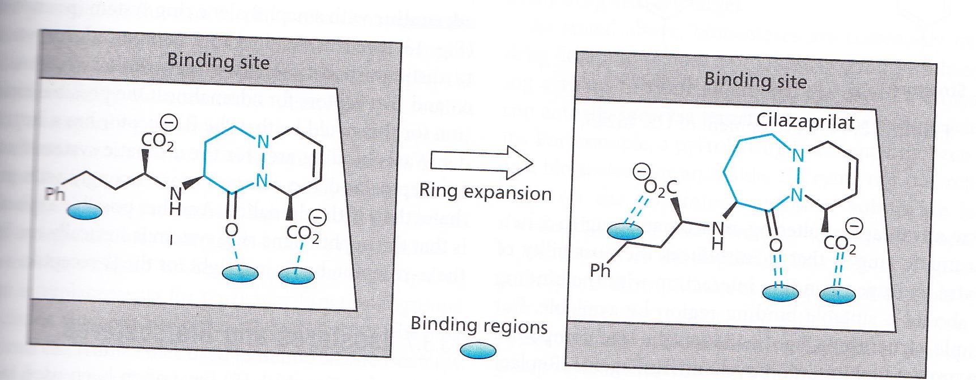

  - Ring variations
  - Ring fusions
  - Simplifications
    - Remove parts that do not affect potency
    - Small molecules work better than big molecules
    - Remove stereocentres
      - Biological molecules are chiral
        - Absolute configurations can have huge effects
      - Avoid stereocenters whenever possible
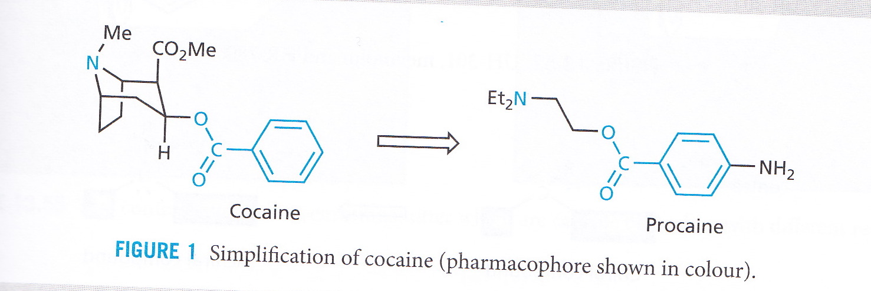
        - Increases manufacturing complexity
        - Requires extra testing
      - Racimates are easier to make and test
        - Make sure to test both configurations
        - Consider enantiomers as separate compounds
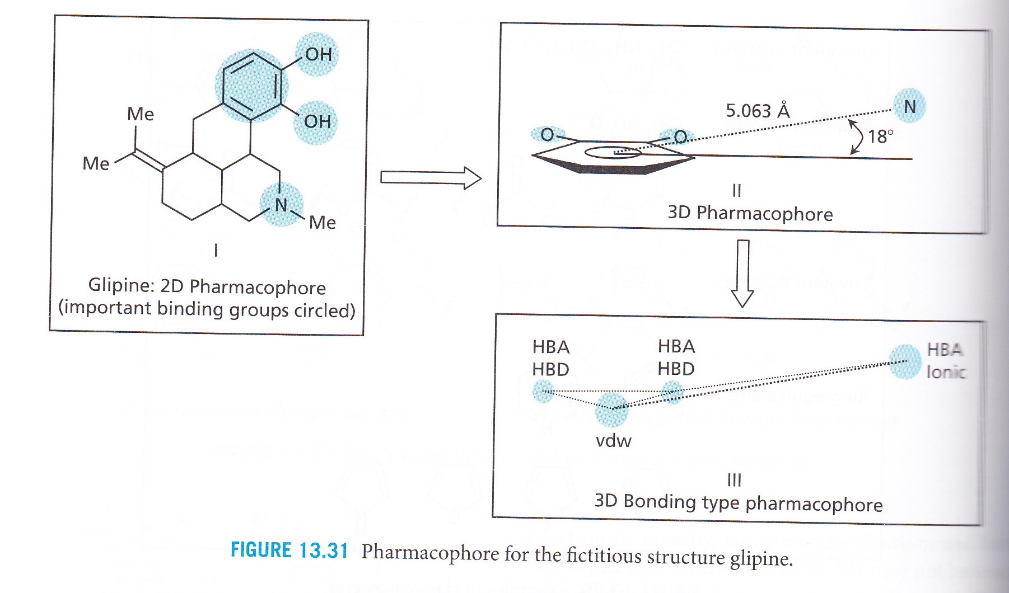
      - Important to test all stereoisomers as each behaves differently
    - Pharmacophores
      - Groups which are important for activity
        - Includes their 3-D spatial relationships
      - Information develops as SAR progresses
      - Used to develop painkiller pharmacophore of cocaine used to create procaine
  - Rigidification

