BPS 2110 – Introduction to Biopharmaceutical Science
Biological Targets Notes

Lecture 3
Lecture 4
09/14/2017
09/18/2017

Biological Molecules
- Modular structure = gigantic molecules made up of small building blocks
  - Easily assemble complex structures using simple ones
  - Only need 1 enzyme system for each biomolecule type
    - Proteins made by ribosome
    - DNA made by polymerase
  - Easily dis-assemble complex structures and regenerate parts for re-use
    - Protein disassembled by proteasome
  - Improves efficiency to build, destroy and regulate
- Protein
  - Linear chain of amino acids
- Nucleic acids
  - Linear chain of nucleotides
- Polysaccharides
  - Linear chains of sugars
  - Some are branched
- Lipids
  - Linear chains of acetate or propionate
  - Chain is modified so the assembly units are “hidden”
Drug Effects
- Drugs produce effects by binding to biomolecules
- Proteins are most common target
  - Nucleic acids less common
- Have well defined three dimensional shapes
- Create three dimensional chemical environments
- Drugs produce effects by binding to biological molecules
- Must make a physical contact with a biological molecule that results in a response
- 3D shape is chiral
Proteins
- 20 different amino acid types are used
  - Occasionally some proteins contain unusual amino acids
- Amino acids share same backbone and stereochemistry in D/L system they are L configuration
- Differ from each other by sidechain
  - Chemical properties of side chains vary
- Amine group = NH2
- Acid group = COOH
- R = side chain
- Alpha carbon (contains R chain)
- Amino acid side chains have various properties
  - At pH 7.4, acidic side chains are basic
  - At pH 7.4, basic side chains act as weak acids
  - Glycine = achiral
  - Proline = secondary amine

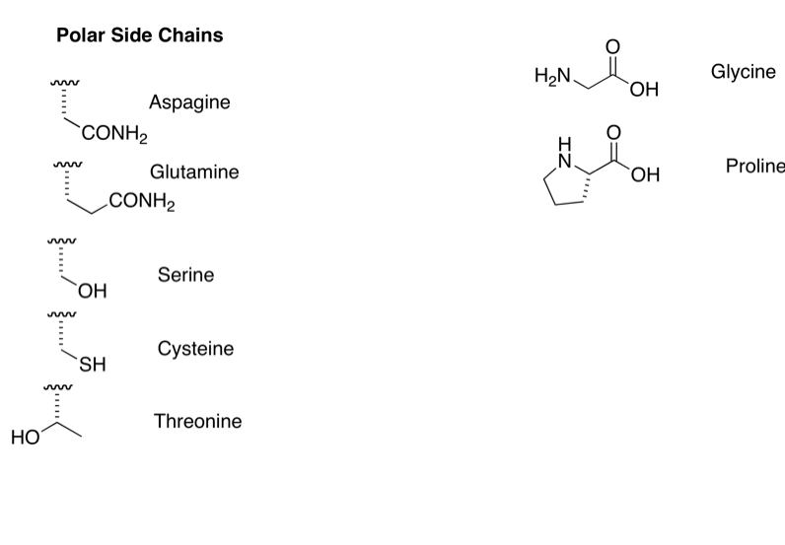

- Primary Structure
  - Sequence of amino acids in a protein
    - This is the only information specified by a gene
  - Amino acids are joined by peptide bonds (amide bonds)
    - Amide bond = amine + carboxy acid
  - By convention, amino acids in a protein are listed in order from the N-terminus towards the C-terminus

- Secondary Structure
  - Regions of local order in the backbone chain
  - Form small-scale structures
    - a-helix
    - b-sheet
    - b-turn
    - Loop
  - Represented in ribbon structures
  - Occur somewhere along the amino acid strand
  - Origin of Secondary Structure
    - Conformational restrictions in amide bonds
    - Conformational restrictions between amide and a-carbon
    - Interactions between amide bonds
      - Intermolecular forces acting in an intramolecular way
      - Same forces that control solubility
    - Side chain interactions within a region of the chain
    - Amide groups allow for resonance (extremes of all position)
    - If carbon is sp2 hybridized in one structure, it will likely be hybridized in all resonance structures
    - Side chain at 90-degree angle to double bond
  - Side Chain Interactions
    - Negative charges attract positive charges
    - Hydrogen bonding between side chains and backbones
    - Non-polar side chains interact with other non-polar chains
    - Result of the chemical interactions is the folding of the amino acid chain to produce large-scale structures
  - Alpha Helix
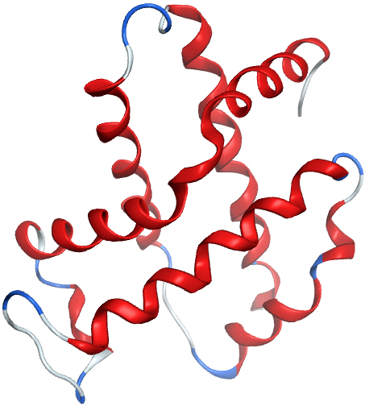
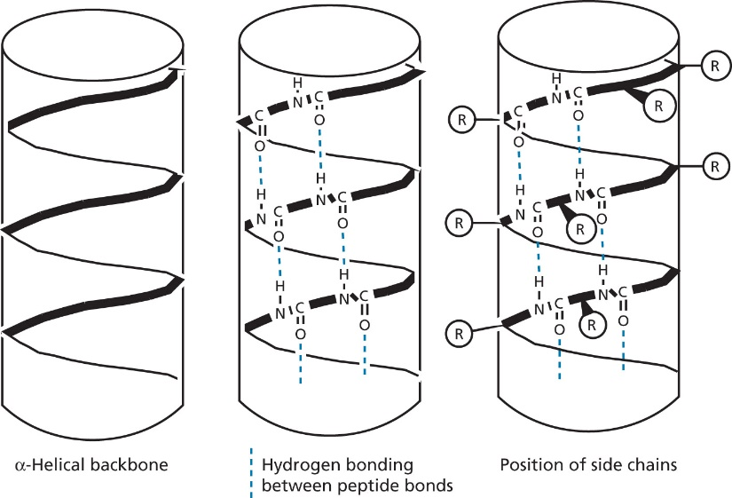
    - Strong rod like structure

  - Beta Sheet
    - Hydrogen bonds between two strands
    - Strands can be parallel or antiparallel
      - Antiparallel = stronger
    - Several strands can associate together = b-sheet
    - Large sheets curl around themselves forming cylinders = b-barrel

  - Beta Turn
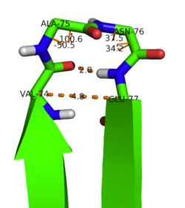
    - Point where there is a 180 degree turn in amino acid
    - Glycine and proline are favorable for beta turns
- Tertiary Structure
  - Structure determines function of protein
  - Overall three-dimensional shape of a protein
  - Result of interactions between non-adjacent regions
    - Amino acid side chains
    - Two secondary structures (two helixes)
  - Contains regions of order
    - Secondary structure
  - Contains less ordered regions
    - Loops
  - Intramolecular forces hold tertiary structures together
    - Ionic bonds (salt bridge)
    - Covalent bonds
    - Sulfide bonds
    - Van der Waals interactions
      - Polar groups outside because proteins are usually in water
      - Forces increase strength of protein
      - Important for maintaining structure of proteins and drug interaction
      - Non-polar environment critical to holding protein together
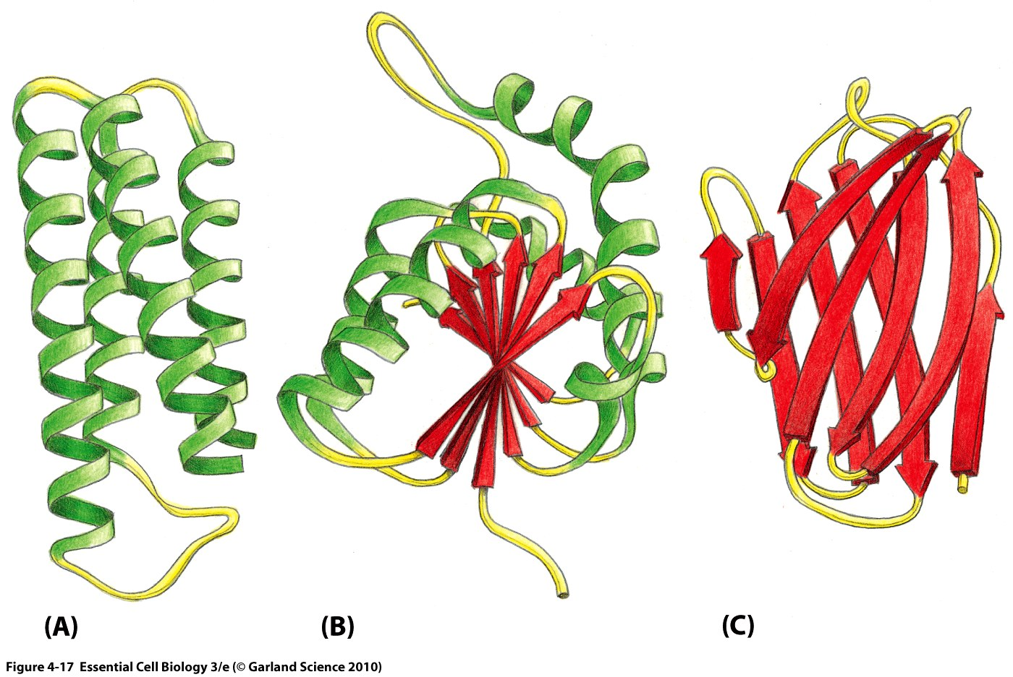
      - Dipole interactions and hydrogen bonds stronger inside hydrophobic environment

- Quaternary Structures
  - Two or more proteins bind together
  - In some cases, 2 subunits are the same and in some, they are different
  - Interaction between 2 proteins is very strong
    - Lots of surface contact area
    - Lots of chemical interactions
    - Exclusion of water from space between
    - Proteins stick together well
    - Difficult to separate some proteins
    - Usually cannot change quaternary structures as binding between proteins is too strong to disrupt protein protein interactions
- Structure = function
  - Most of molecule is scaffold
  - Only small part is normally functional
- Types of Protein Targets for Drugs
  - Enzymes
    - Drug usually stops the enzyme from working
    - Drug exerts effect by preventing the production of the enzyme product
  - Receptors
    - Drug can activate (agonist) or deactivate (antagonist) the receptor
    - Some drugs perform both functions
    - Drug exerts effects by amplifying or suppressing receptor function
  - Ion channel
    - Drug can open or close the channel
    - Some drugs perform both functions
    - Drug exerts effects by amplifying or suppressing channel function
  - Structural proteins (uncommon)
    - Drugs interfere with the assembly or disassembly of certain protein structures
  - Enzyme inhibitor 38 %
  - Receptor antagonist 24 %
  - Receptor agonist 12 %
  - Ion channel modulator 8 %
  - Unknown or Misc. 18 %
Enzymes
- Catalyze reactions
- Lower activation energy by binding to transition state to make reaction go faster
- Provide a “designer solvent” for the transition state of a reaction
  - Best interaction is with reaction transition state
- Enzymes bind very tightly to transition state
- Enzyme active site is relatively small

  - Most of enzyme is scaffold to hold active site in place
  - Only a small part of the enzyme touches the substrate
- Active site
  - Chemistry is complimentary to transition state
  - Has a pattern – positive, negative, hydro bond acceptor/donator
- Process
  - Enzyme binds to substrate
    - Forms the enzyme-substrate complex (ES)
    - Equilibrium
    - Enzyme normally changes shape to accommodate substrate
    - Substrate also changes shape
    - Shape changes can be subtle and turn enzyme from inactive form to active form
    - Very flexible, semi random procedure
  - Reaction occurs
    - The components in the ES complex (ES) now is correct alignment to facilitate reaction
    - Substrate is converted into the product in the active site
    - Enzyme may change shape during this process
    - 3D network of different atoms that bind to transition state
  - Product is released
    - The components in the ES complex (ES) now is correct alignment to facilitate reaction
    - Substrate is converted into the product in the active site
    - Enzyme may change shape during this process
    - Product may not fit enzyme as well which initiates release
    - Enzyme goes back to its original shape
- Theories of Enzymatic Conformational Change
  - Lock and key (older)
    - Enzyme binding pocket is the exact shape for the substrate
  - Induced fit
    - Binding of substrate or other molecule changes conformation of the enzyme
    - Conformational change “activates” or “deactivates” the enzyme
    - Remember that the substrate is also flexible and will change conformation during binding
  - Molecules are not static
    - Enzymes and substrates are constantly flexing
    - Shape changes are not instant nor always symmetrical
    - Boltzmann distribution gives the distribution curve for energy of all molecules
    - After random motions and reactions between the two, the ligand ends up in the right place on the molecule
    - No two binding events are ever the same – can wiggle in many ways
- Mcihaelis-Menten Kinetics
  - Way of measuring kinetics of enzyme function
  - Ratio of K_{cat} and K_{m} used to compare efficiency of enzymes
  - K_{d} good for medicinal chemistry – need drug to beat out enzyme
  - K_{cat} = turnover rate
    - Measure of how efficiently ES complex produces product
    - Larger K_{cat} = easier reaction
  - K_{m} = [S] at ½ V_{max}
    - Ratio of K_{cat}/K_{m} used to index enzyme efficiency
    - High ratio = more efficient enzyme
    - Also, used as a specificity constant
    - Compare ratios for different substrates
  - K_{d} = dissociation constant = k_{f}/k_{r}
    - Measure of binding between E and S
    - Small k_{d} = tight binding
  - Lineweaver-Burk Plot creates linear relationship that can be used to analyze inhibition modes

- Enzyme Inhibition
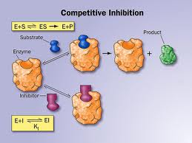
  - Competitive inhibition
    - Inhibitor molecule competes with substrate molecule for active site
    - Binding is in the active site
    - Substrate cannot bind
    - Substrate fits into active site that causes reaction
    - Create drug that mimics substrate so that enzyme is inhibited from making a product
    - Disulfiram (Antabuse) is competitive
      - Blocks aldehyde dehydrogenase
      - Generates rapid and severe hangover when drinking
      - Given to alcoholics, when drinking alcohol, gives immediate hangover
    - Changes slope of plot
      - Maximum speed is unaffected
      - Km affected

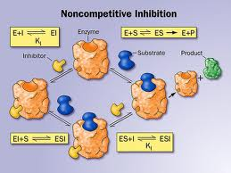
  - Non-competitive inhibition
    - Inhibitor binds to enzyme but not in active site
    - Substrate binds to active site
    - Inhibitor binding preventing ES complex from forming (prevents or alters conformational change)
    - Binds in different location – affects overall confirmation of enzyme
    - Fluconazole is non-competitive
      - Blocks cytochrome P₄₅₀2C9
    - Changes slope and intercept of plot
      - Km appears unaltered
      - Slope and intercept change
      - Affects maximum velocity you can attain in this reaction

  - Uncompetitive inhibition (very rare)
    - Inhibitor binds to ES complex
    - Binding destroys catalytic ability of ES complex
    - Lithium is uncompetitive
      - Blocks inositol monophosphatase
      - Used to treat manic depression
      - Exact mechanism of action unknown
    - Changes intercept of plot
      - Vmax and Km decreased

  - Irreversible Inhibitors
    - Also, known as suicide inhibitors
    - Bond covalently to enzyme
    - Inhibit by altering conformations
    - Specific inhibitors usually bond in the active site
    - Cannot restore activity
    - Penicillin is an irreversible inhibitor
      - Blocks transpeptidase, enzyme used to finish cell wall construction
      - 4 Key D amino acids (bacteria have in their body) – humans do not, therefore cannot hurt you
      - OH Penicillin = OH-Penicillin
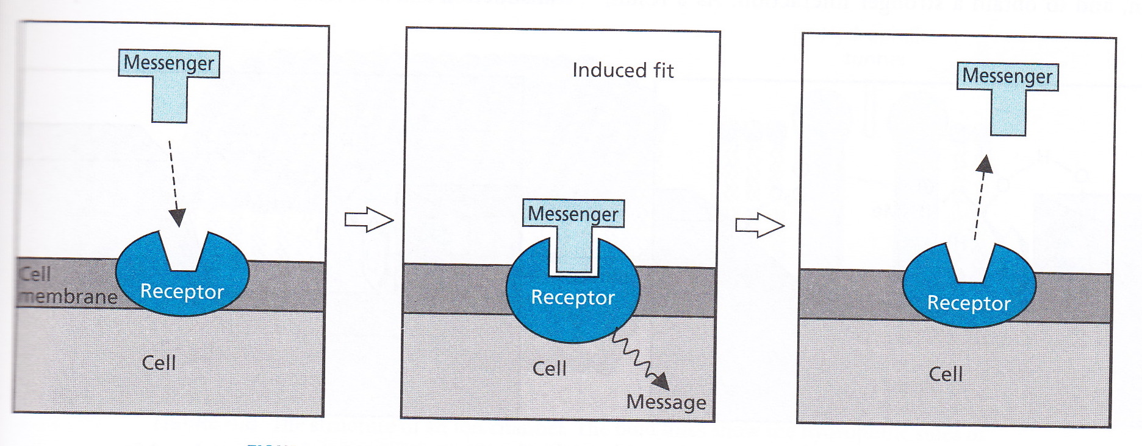
Chemical Messaging
- Messengers work by inducing shape changes
- Chemical interactions between messenger and receptor change the shape of the receptor
- Receptors = proteins found on membranes to carry information from inside to outside or vice versa
- Shape change occurs on both sides
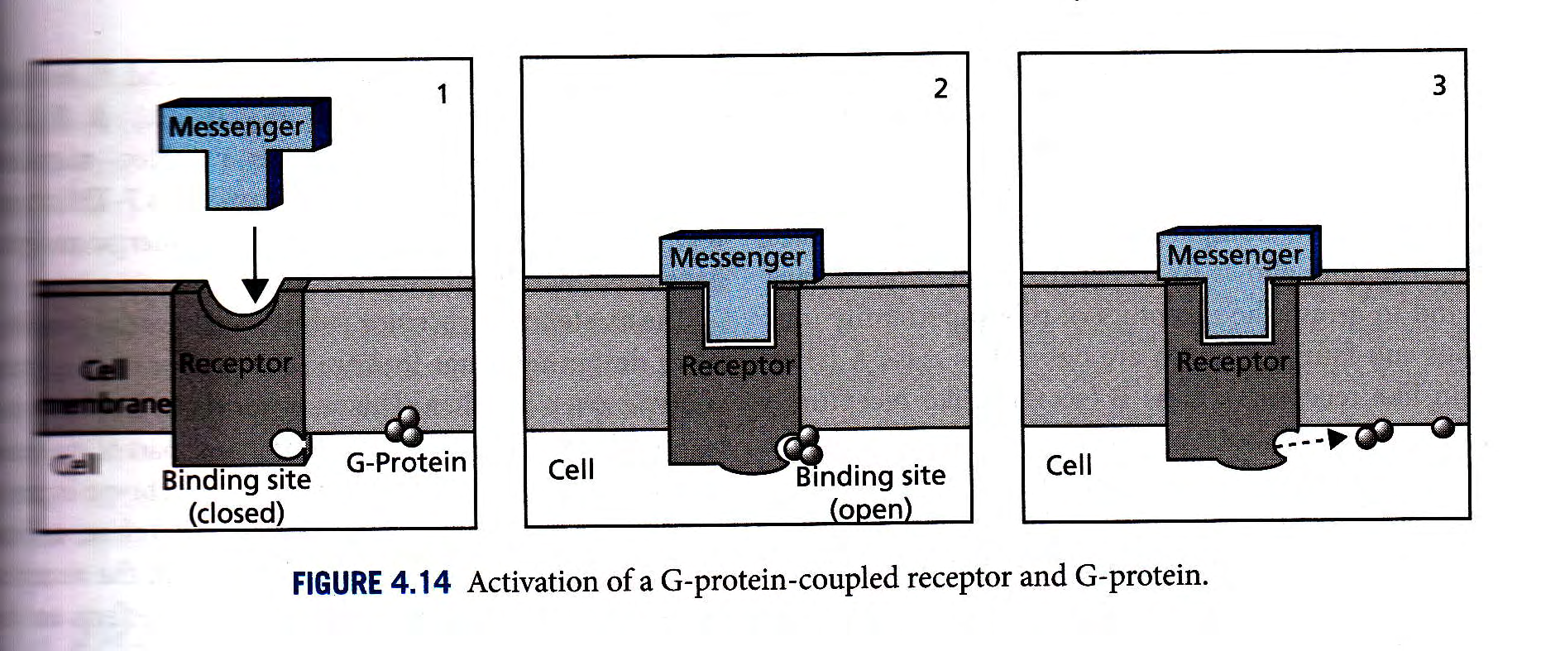
- Messaging via Binding
  - Chemical interactions between messenger and receptor change the shape of the receptor
  - Shape change allows second messenger to bind or to be released
  - Bind receptor, shape change allows different messengers to attach at different points
- Messaging via Catalysis
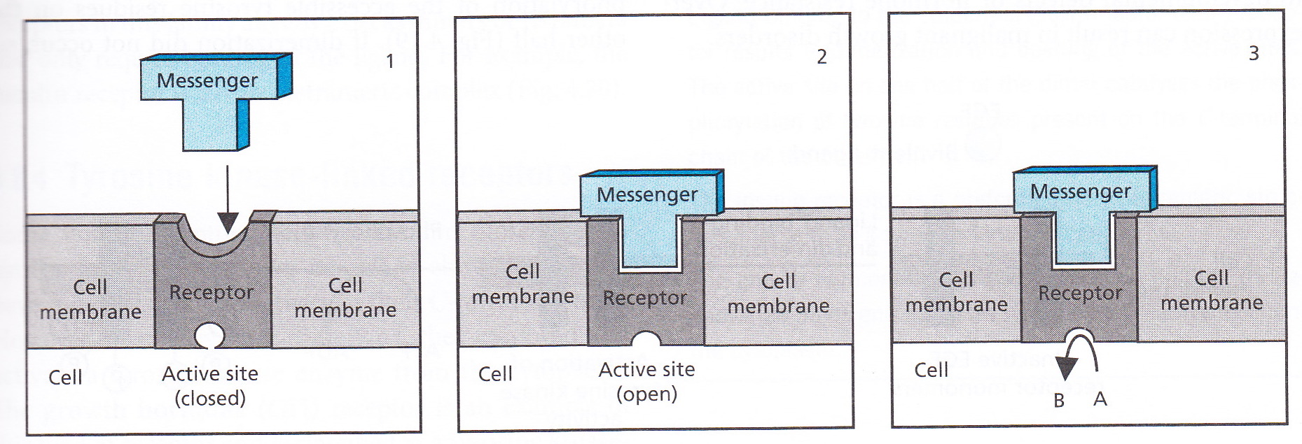
  - Chemical interactions between messenger and receptor change the shape of the receptor
  - Shape change allows creates/destroys catalytic function
  - Can amplify functions
- Receptors can be switched off or on
  - Agonists
    - Simulate the normal messenger
    - Agonist binding induces shape change that results in transmission of a signal
    - Usually bind at same location (active site) as messenger
    - Some agonists bind at other locations (allosteric sites)
      - Allosteric modulators
    - Asthma drugs = adrenaline agonists
      - Adrenaline receptors in lungs stimulate bronchial opening when activated
      - Bind to active site of the noradrenaline receptor
      - Drug mimics adrenaline which helps open airways
    - Benzodiazepine = allosteric modulators (bind at different place)
      - Binds allosterically to GABA_{A} ion channel
      - GABA is an inhibitory neurotransmitter
      - In presence of GABA and benzodiazepines the channel opens more readily and stays open longer
  - Antagonists
    - Block normal receptor function
    - Drugs interfere with normal signaling pathway
    - Decrease signal
    - Reverse signal
    - Antagonist binding induces abnormal shape change that results in no signal transmission
    - May bind at same location (active site) as messenger
    - May bind at other locations (allosteric sites)
    - Tagamet = active site antagonist
      - Binds to a histamine binding site
      - Distance between main binding domains is larger than in histamine
      - “Stretches” the active site and produces antagonism
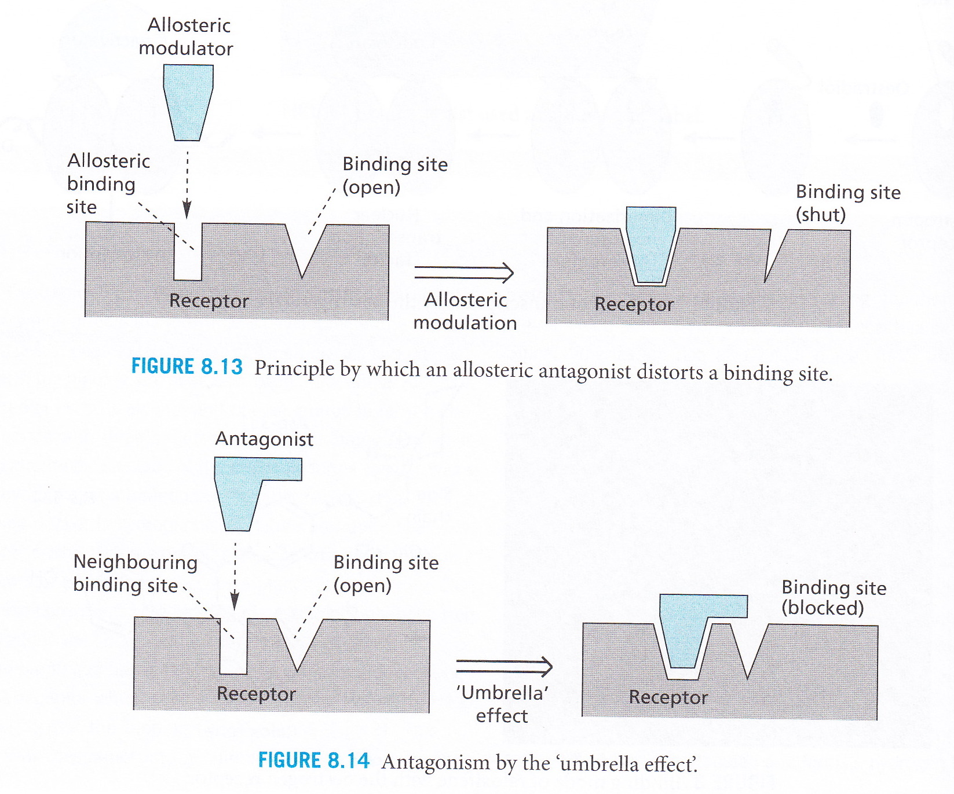
    - Allosteric antagonists
      - Can bind near or even partly inside the active site
      - Can bind in a distal location
      - Bind to a receptor but don’t bind to a normal place but messes something up, changes shape
      - Render the receptor inactive
  - Partial Agonists
    - Agonist binds to receptor and produces non-ideal conformational change
      - Weak signal is sent (short duration)
    - Agonist capable of binding to receptor in more than one way
      - One binding mode gives agonism
      - Other binding mode gives antagonism
    - Can act in 2 different ways
    - Close to ideal change but not exactly
    - Naloxone = partial agonist of opioid receptor
      - Used to block the effects of opioid poisoning
  - Inverse Agonist
    - Some receptors have a “background” activity
    - Receptor shows weak function in absence of messenger
    - Antagonist changes normal conformation, shutting off this background activity
    - Result is an apparent reversal in response
    - Receptors slowly send signals
    - Normal messenger = amplify signal
    - Agonist = shuts of weak signal along with actual signal
    - Clozapine shows inverse agonist behavior
      - Originally shown to be a weak D₂ (dopamine receptor) antagonist
      - Recently found to be an inverse agonist of D₂
      - Used to treat schizophrenia
Measuring Drug Behavior
- Use a biological assay
  - High throughput screening
    - Quick, easy, cheap for thousands of chemicals
    - Emphasis on speed
    - Usually qualitative
    - Fully automated
    - Preferred detection method is fluorescence
    - Some assay may use radioactivity to measure effects
    - Usually performed on 384 or 1536 well plates
  - Routine SAR work
    - More accurate information
    - Emphasis on accuracy
    - Usually quantitative
    - Semi-automated or manual
    - Preferred detection method is fluorescence
    - Some assay may use radioactivity to measure effects
    - Radioactivity is used less and less because signals are so small
  - Kinetics or special studies
  - Cell-based
    - Antibiotics, antivirals, metabolism studies
    - Usually quantitative
    - Require skilled technicians
    - Usually slow
    - Sometimes difficult to interpret results
      - “black box”
    - Industry uses some standard cell-based assays
      - Metabolism (liver microsomes)
      - Carcinogenicity/mutagenicity (Ames)
      - Toxicity
      - Permeability (CACO-2) this uses an artificial tissue
  - Tissue based
    - Permeability
- Qualitative (yes/no)
- Quantitative (number)
- In vitro
  - Using biological chemicals, cells or tissues
- In vivo
  - Tests done in living animals
- In vitro methods are ALWAYS preferred
  - Animals cost too much
  - In vivo usually result in complicated answer “black box” fuzzy

