Type of Data
Goal | Measurement (from Gaussian Population) | Rank, Score, or Measurement (from Non- Gaussian Population) | Binomial  (Two Possible Outcomes)
Describe one group | Mean, SD | Median, interquartile range | Proportion
Compare one group to a hypothetical value | One-sample t test | Wilcoxon test⁴ | Chi-square⁸
Compare two unpaired groups | Independent t test (for mean) ¹  Levene’s Test (for variance)² | Mann-Whitney test⁵ | Fisher's test⁹  (chi-square for large samples)
Compare two paired groups | Paired t test ³ | Wilcoxon test⁴
Compare three or more unmatched groups | One-way ANOVA⁶  Two-way ANOVA⁷ | Kruskal-Wallis test (non parametric ANOVA) | Chi-square test⁸
Quantify association between two variables | Pearson correlation¹⁰ | Spearman correlation¹¹  Kendall correlation ¹¹
Predict value from another measured variable | Simple linear regression¹²
Predict value from several measured or binomial variables | Multiple linear regression¹³
You cannot conclude that null hypothesis is true, but you can state that there is insufficient evidence that null hypothesis is false.

 | 1 sample T test | Normal distribution  Kolmogrov – smirnov  Shaprio-Wilk test | Independent T test¹ | Paired T test³ | Wilcoxon test⁴ | Mann-Whitney test⁵
Assump |  |  | - Subjects are obtained independently  - Subjects are obtained randomly and act as a good representation of the general population  - Subjects within each sample is obtained independently  - Data are sampled from populations where the variable is approximates a normal distribution | - Each pair are obtained independently  - Subject pairs are obtained randomly and act as a good representation of the general population  - Pairs must be matched before hand  - Distribution approximates a normal distribution | - Each pair are obtained independently  - Subject pairs are obtained randomly and act as a good representation of the general population  - Pairs must be matched before hand  - Distribution that is approximately symmetric but not normal | - Subjects are obtained independently  - Subjects are obtained randomly and act as a good representation of the general population  - Subjects within each sample is obtained independently  - Does not follow a particular distribution but must have the same shape
Hypo | Null: u = mean (or what you want)  Alternative u =/= mean | Null: the distribution of the variances are normal | Mean A = Mean B | Mean A = Mean B | Median A= Median B | Median A = Median B
 | If the 95% confidence interval does not have the null #, reject the null hypothesis. |  | Must check for Levene’s test first (variance)²  - Null hypothesis: variances are equal  - Alternative hypothesis: variances are not equal
DF |  |  | DF=N1+N2 - 2 | DF = N-1

 | 1 Way Anova | 2 Way Anova |  |  | Non parametric ANOVA - Kruskal- wallis test | Confidence interval
Assump | - samples are obtained independently  - samples are obtained randomly and in reflection of a larger population  - same variances are assumed and also the assumption of homeoscedasity  - normal distribution | - samples are obtained independently (not paired)  - the subjects are randomly selected and in reflection of a larger population  - variances must be equal  - population are normally distributed |  |  | - Data must be independent samples from populations for which the variable has the same shape  - samples are obtained independently  - randomly selected subjects in each sample | - fixed # of trials  - trials are independent  - 2 categories of outcomes  - probability remains constant
DF | DF1=K-1 DF2=n-K K= number of sets n=number of subjects | Subject of interest a | a-1 |  | DF = k-1
DF | DF1=K-1 DF2=n-K K= number of sets n=number of subjects | Subject of interest b | b-1 |  | DF = k-1
DF | DF1=K-1 DF2=n-K K= number of sets n=number of subjects | Interaction | (a-1)(b-1) |  | DF = k-1
DF | DF1=K-1 DF2=n-K K= number of sets n=number of subjects | Error | ab(n-1) |  | DF = k-1
DF | DF1=K-1 DF2=n-K K= number of sets n=number of subjects | Total | abn-1 |  | DF = k-1
Conclu | (Test, F=#, P=#, DF= #,#) | Interaction statement | there is insufficient evidence to state that there is an effect of subject A and B to the mean of (what we are trying to test) | (Test, F (interaction, error)=#, P=#) | (Test, Chi square value, P=#, Df (k-1)
Conclu | (Test, F=#, P=#, DF= #,#) | Subject A statement | there is a sufficient/insufficient evidence to state that (what we are trying to test) differs btwn the 2 things of subject A | (test, F(subjectA, error)=#, p=#) | (Test, Chi square value, P=#, Df (k-1)
Conclu | (Test, F=#, P=#, DF= #,#) | Subject B statement | there is a sufficient/insufficient evidence to state that (what we are trying to test) differs btwn the 2 things of subject B | (test, F (subjectB, error)=#, p=#) | (Test, Chi square value, P=#, Df (k-1)
Hypo | Mean is the same for all variables  H0: u1=u2=u3 | mean is the same for all variables |  |  | Median is the same for all variables  H0: median 1= median 2=median 3 | Null: U = the mean  Alternative: u =/= the mean
 | mean is different for at least one variable | mean is different for at least one |  |  | Median is different for at least one
 | Chi-square⁸  1-WAY GOF test | R x C cross tabulation table (contingency table) or 2X2 | Pearson correlation¹⁰ | Spearman correlation¹¹  Kendall correlation ¹¹
Assump | - each observation must be independently (no pairing) - each individual can appear only once in the data set, the categories of the variable cannot overlap  - Subjects are obtained randomly and act as a good representation of the general population  - The sample data consist of frequency counts for the k different categories (ex. Not converted to proportions or %)  - probabilities remain constant and independent during the experiment - with small populations, sample with replacement, use random sampling | - Each pair are obtained independently  - Subject pairs are obtained randomly and act as a good representation of the general population  - The data must form a contingency table. The values must be the actual number of subjects observed, not percentages or proportions. The categories that define the rows and columns must be mutually exclusive  - The sample size should be large enough that no expected frequency (E) is <1 and no more than 20% are <5). | - paired samples, each subject must have both X and Y values  - Subject pairs are obtained randomly and act as a good representation of the general population  - independent observations - sampling one subject does not influence changes of sampling another - X and Y measured independently  - Both variables must follow a normal distribution in the statistical population | - paired samples, each subject must have both X and Y values  - Subject pairs are obtained randomly and act as a good representation of the general population  - independent observations - sampling one subject does not influence changes of sampling another - X and Y measured independently  - Both variables do not follow a normal distribution in the statistical population
Hypo | Extrinsic  H0: the ratio is equal to the given ratio  H1: the ratio is not equal to the given ratio | H0: there is no association  H1: there is an association | 𝛒 = 0 (no correlation between the variable)  𝛒 =/= 0 (correlation between the variable)  one tailed = if they want positive and negative correlation – it should be different  r squared = how much variability of one factor can be caused by its relationship to another factor
 | If O and E are close -> small chi square value, large P  If O and E are far -> large chi square value, small P | Fisher’s test⁹  Model 1: no fix  Model 2: one variable fix  Model 3: both variables are fixed  Expected =(row x column) / grand total | Linear relationship btwn 2  - Between -1 and 1
DF | Extrinsic (DF=K-1)- know the proportions before doing the experiment  Intrinsic (DF=K-2) - have to calculate the expected proportions after the experiment is done | (R-1)(C-1) | DF = N-2
Concl | Chi-square GOF test, X^2=#, P=#, d.f.=#

 | Simple linear regression¹² | Multiple linear regression¹³ | Non linear regression
Assump | - Each subject (or each XY pair) was randomly sampled from the population, or at least they are representative of the entire population  - Each subject (or XY pair) was selected independently (picking one subject from the population should not influence the chance of picking anyone else)  - The relationship between X and Y must be linear in the population  - The equation defines a line that extends infinitely in both directions (no matter how high or low a value of X you propose, the equation can estimate (or predict) a Y-value) | - Random sample : each subject is randomly sampled from the statistical population, or at least the sample is representative of the population (depends on experimental design)  - Linearity : increasing a X variable by 1 unit changes (increases or decreases) Y by the same amount at all values of X  - No interaction among predictor variables : increasing a X variable by 1 unit changes (increases or decreases) Y by a certain amount, regardless of the values of the other X variables  - Independent observations : knowing Y for any particular subject provides no information about Y in other subjects (depends on experimental design)
Hypo | H0: 𝛃 = 0 (population slope)  H1: 𝛃 =/= 0 | H0: 𝛃 = 𝛃 = 𝛃 = 0  H1: at least one of the 𝛃 =/= 0
 | Ŷ= a + bX = 𝓔 | Ŷ = ….. | Y is a measured variable, and there is a single X variable, but, a graph of X versus Y is curved.
DF | N-2 | (regression, k), (residuals, N-K-1)
Concl | Ŷ=a+bX  a = Y intercept  b = slope
Null is actual ->  But we do: | FALSE | TRUE
Reject | Correction (alpha) | Type 1
Accept | Type 2 | Correction (power = 1-b)
Left tailed (smaller)  Negative correlation  H0: u > or = some value  H1: u < some value | Right tailed (larger)  Positive correlation  H0: u < or = some value  H1: u > some value
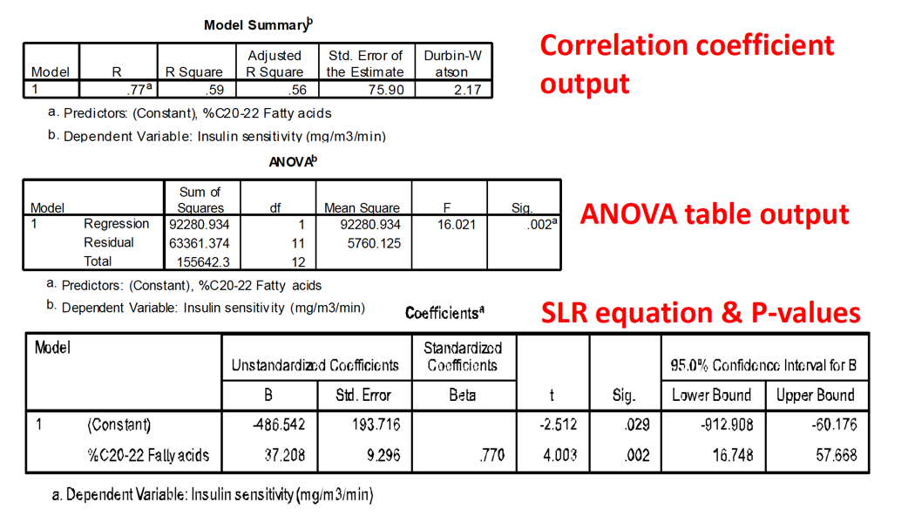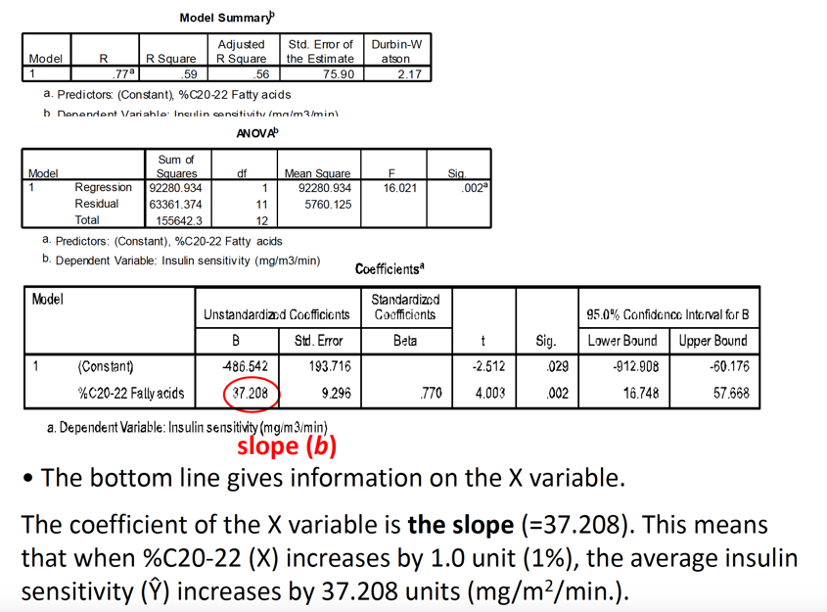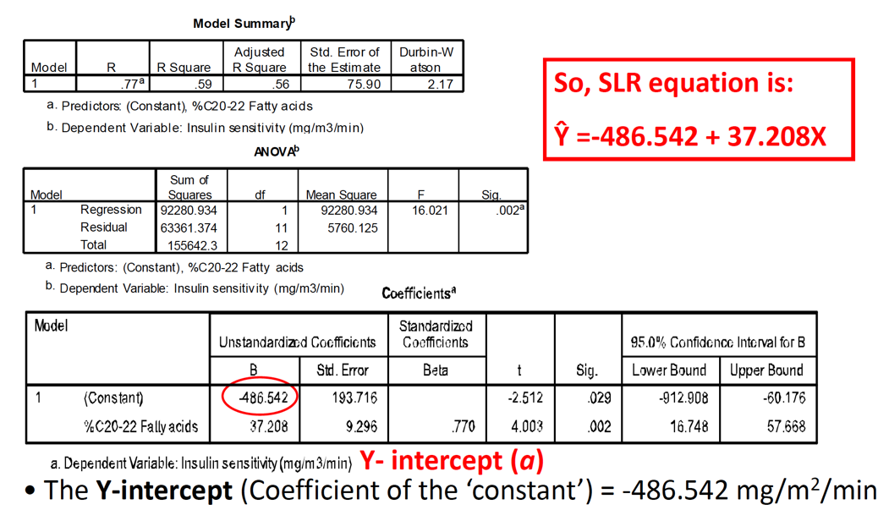
2 Tailed:
H0: u = some value
H1: u = some value

Nominal – no order
Ordinal – order
Interval – no zero
Ratio – zero

