Outline 18: Drama, Medicine and Healing Cults
Tuesday, November 21, 2017

Reading:
Part I: Drama: C/F 74 - 75, 134-137 & Greek Theatre Plan below!!
Part II: Medicine and Healing Cults: C/F p. 160-161

Please note: the following information from pages 160-161 applies to Roman Greece which we will not be studying:
- Amphiarios
- Cult of Asklepios at Pergamon or
- Galen

Υ υ upsilon
Part I: Drama
What is drama?
Drama
4 types: dithyramb(chorus), tragedy, satyr play, comedy
Context: Athens: City Dionysia
- 5 day festival
- March/April
- Tyrant Peisistratos
- Drama competitions
- City Dionysia: day 1
  - Procession w/ phalloi
  - Sacrifice
  - Feasting
  - Tribal chorus competitions
  - Komos
- Day 2-4 : Tragedy Competitions
- Day 5: Comedy competitions
Program: komos
Sanctuary of Dionysos
The Theatre (see attached plan below)
- theatron (A)
- orchestra (B)
- thymele (C)
- proskenion (D)
- skene (E)
- parodos (F)
Competitions
Drama Competitions:
- 1 judge
- Special seats
- Prizes for actors, producers and writers
- More than 1st prize
Performers: chorus, Thespis, Thespians, actors
- Always male
- Thespis: 1st actor
- Chorus:
  - Enters from parados
  - Remains in orchestra the entire pay
  - Chants and dances to the flute in between scenes
  - Sometimes interacts with actors
  - Unifies the play
- Actors
  - Play multiples parts
  - 3 / tragedy
  - 4/comedy
  - Perform in proskenion
  - Paid by polis
  - Costumes differed from the chorus
Costumes:
tragedy: actors: himation, chiton, kothornoi (p. 134)
      - Masks
      - Contemporary clothing
satyr play: chorus
- Masks with pointy ears and beards
- Furry loin cloths
- Tails
- Leather phalloi
comedy: chorus & actors
- Grotesque masks
- Padded clothing
- Flat slippers
- Leather phalloi
Producer: choregos, eponymous archon, choregic monument (p. 137)
- Choregos = producer
- Appointed by eponymous archon
- Form of taxation
- Prize : Tripod cauldron
- Displays wealth and success
Writers
- Selected by eponymous archon
- Play form and structure
Tragedy
  - characteristics: themes, obscene, ekkyklema
  - Poetry form
  - Myth based
  - Theme : Struggle. Conflict
  - Violence off stage
    - Ekkylema
Tragic Playwrights
Aeschylus
- Innovations
  - Second actor and props
- The Persians (choregos: Perikles)
- trilogy: Oresteia (Klytemnestra, Agamemnon, Orestes)
- death
  - Died in Sicily
Sophokles
- Innovations
  - Added third actor and backdrops
- Theban Plays: Oedipus Tyrannos, Oedipus at Kolonnos, Antigone
- Freud: Oedipus Complex
Euripides
  - Macedonia
- Least successful
  - female protagonists: Medea, ekkyklema, mechane
  - death
    - Died in Macedonia
Old Comedy
  - Aristophanes
  - Characteristics
    - Ludicrous predicaments
    - Body humor
    - Political and social satire
    - Slapstick action
New Comedy
- Characteristics
  - Sitcom ancestor
  - realistic setting
  - Domestic plots
  - Stock characters
- Menander
Role of the polis in drama
- Controlled, financed, organized drama
- Paid actors
- Appointed writers and producers
- Paid poor to attend
Asklepios, god of healing
- Son of Apollo
- Chiron the centaur
- Hygeia , Panacea (daughters)
- Raised dead with Gorgon blood
- Hero became god
Asklepion
- Incubation in the abaton
- Snakes and dogs
- Votive offerings
Images: parts of theatre (see below), tragic actor (p. 134), masks (p. 134), choregic monument (p. 137)

Words to Remember
People: Thespis, Thespian, Lysikrates, Aeschylus, Sophokles, Euripides, Aristophanes, Menander
Places: Athens
Terms: dithyramb (chorus), tragedy, satyr play, comedy, City Dionysia, komos, theatron, orchestra, thymele, skene, proskenion, parados, tragedy, satyr, comedy, chiton, himation, kothornoi, phalloi, choregos, obscene, ekkyklema, mechane

Think About It!
- How does the architecture of the ancient Greek theatre influence modern theatres?
- How does ancient Greek drama influence modern drama?
- What aspects of ancient Greek drama are absent in modern drama (stage, screen, TV, etc.)?
- Violence in Greek tragedy was off-stage (obscene) but vividly described by an actor. Which do you think is more effective, ‘live action’ or a description that leaves the action to be imagined by the audience?

Part II: Medicine and Healing Cults

Asklepios: (p. 161) omphalos, Cheiron, Hygieia, Panacea
Asklepieion: incubation, abaton, votive offerings
Epidauros
Hippocrates of Kos
- The Oath
- 4 Humours
Medical Vocabulary

Images: Asklepios (p. 161), votive body parts (p. 161);

Words to Remember
People: Asklepios, Cheiron, Hygeia, Panacea, Hippokrates,
Places: Epidauros, Kos
Terms: Asklepieion, omphalos, incubation, abaton, votive offerings

Recommended: Greek Tragedy and Comedy in 10 minutes: http://www.youtube.com/watch?v=RK-dbLiaGvU
Note that this video says that the Drama Festival took place at the Panathenaia instead of the City Dionysia.

Close to the real experience: masked male actors and chorus perform Agamemnon, the first play of the Orestaia trilogy by Aeschylus. Look for a classic example of obscene and the use of the ekkeklyema. https://www.youtube.com/watch?v=O7sdZQ1BDs0 (46 min.)

Parts of the Greek Theatre (see above) 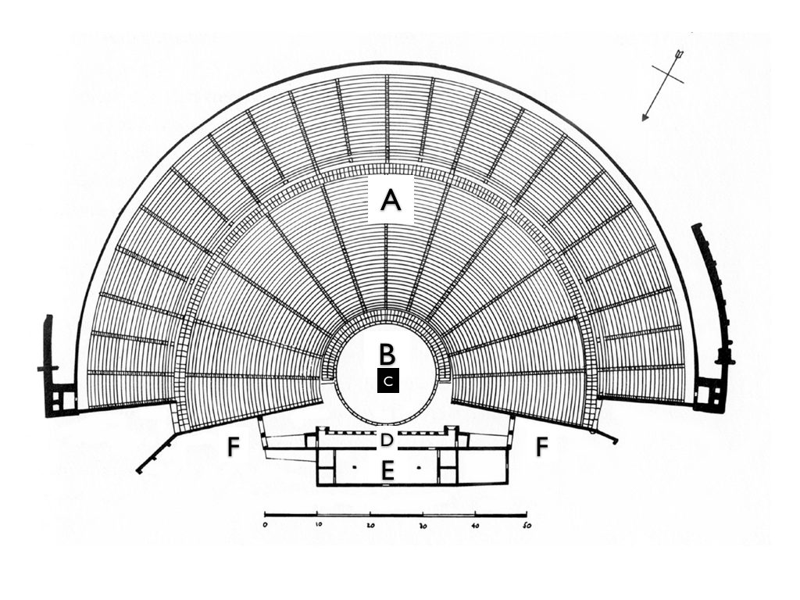
- theatron (A)
- orchestra (B)
- thymele (C)
- proskenion (D)
- skene (E)
- parodos (F)

