Outline 16: Athens I: The Agora and Democracy
Tuesday, November 14, 2017

Reading: C/F 116-125
***See attached plan of the Athenian Agora and http://plato-dialogues.org/tools/agora.htm

Σ ς/σ sigma is for symposium

Democracy
  - definition
  - basis
    - Liberty and equality
  - Demos : People
  - Kratos: Power
Athens: Early Archaic demos = 4 tribes
Oligarchy
  - archons: King Archon, Polemarch, Eponymous Archon + 6 thesmothetes
  - Areopagus Council
  - Ekklesia
  - 9 Archons:
    - King Archon, Polemarch, Eponymous Archon + 6 thesmothes
  - Areopagus council:
    - Ekklesia
      - Aristocrates, farmeers, craftsman
How to achieve rule by the people (democracy):
Drako: legal reform/Draconian
- 1st written law code in Athens
- Death penalty widely used
- Dracion : Excessively harsh
Solon:
- Softened Draconian Laws
- legal reform: Heliaia,
- Poor now eligible for jury duty = power for the poor
- political reform
  - 1.Increased ekklesia membership
  - 2.$$$ only qualification for office
  - 3.Economic classes
  - 4. Council of 400
  - Ekklesia,
  - qualification for office,
  - economic classes,
  - Council (Boule) of 400
- economic reform
  - 1. Outlawed slavery for debt
  - 2.Cancelled debts of poor
  - 3.Established commercial base
    - debt
    - commerce
Peisistratos: typical tyrant
- Public works
- Festivals
- Patron of the arts
- Succeeded by sons
  - Tyrannicides: Harmodius, Aristogeiton (p. 118)
    - Assassinated Hipparchos
    - Brother Hippias: last mainland Greek tyrant
Kleisthenes (father of Democracy): political reforms
- 10 new tribes
- New Boule: Council of 500
  - Chosen by lot
- Increased size of Ekklesia
  - Moved to Pnyx
  - tribes
  - council (Boule) of 500
  - lottery
  - ekklesia: Pnyx
  - ostracism: Ostraka (p.122)
    - Safeguard against tyranny
    - Ostraka
- Results of Kleisthenes Reforms
  - End of aristocratic control
  - More power and rights for demos
  - Only upperclass can be archons
Themistokles: political reforms
  - Ostracism
    - 1st to use ostracism
- Introduced selection of archons by lot
  - lottery
Perikles: political reform
  - pay for public duties
  - Pay for
    - Heliaia
    - Boule
    - Ekklesia
Athenian Democracy
- Participatory
- Direct
- Disadvantages
  - No continuity
  - Open only to minority of population
5 Athenian Reformers
- Drako
- Solon
- Kleisthenes
- Themistokles
- Perikles

The Agora and Democracy
Asty: Areopagus, Pnyx, agora
Multi-purpose Agora (see plan below):
1. social
  - Stoas: Poikele (Painted), Zeus, South Stoa
  - Enneakrounos
2. administrative:
  - (Royal) Stoa Basileus
    - Laws were displayed
    - Tyrannicides
  - Shrine of the Eponymous Heroes
3. political:
  - bouleterion: old & new
  - prytaneion (tholos)
4. legal: Heliaia
  - klepsydra
  - ballots (p. 123)
5. military: strategeion (strategos/strategoi)
- 10 elected strategoi
- No limit to # of times
- Not paid
6. religious: Panathenaic Way, Altar of the 12 Gods, Hephaisteion
- Altar of the 12 gods
- Doric temple of Hephaistos and Athena
7. competitive
8. economic: mint
Summary

Images: Tyrannicides: Harmodius, Aristogeiton (p. 118), Ostraka (p.122), ballots (p. 123); plan of the Athenian Agora (from http://plato-dialogues.org/tools/agora.htm) see below.

Words to Remember
People: Theseus, Drako, Solon, Peisistratos, Tyrranicides, Hippias, Hipparchos, Themistokles, Perikles
Places: asty, chora, Pnyx, Altar of the 12 Gods, Stoa Basileus, Stoa Poikele, Hephaestion, Old Bouleterion, New Bouleterion, prytaneion (tholos), Shrine of the Eponymous Heroes
Terms: demos, archons, Archon Basileus, Polemarch, Eponymous Archon, thesmothetes, Areopagus Council, Ekklesia, Heliaia, Council of 400, Council of 500, strategeion, strategoi, klepsydra

Think About It!
- In what ways does ancient Athenian democracy differ from Canadian democracy? How is it the same?
- Do you think Athenian democracy would work in Canada? Explain.
- In what ways does the Athenian agora resemble downtown Ottawa? How does it differ?
- Democracy was not created overnight. How did the following reformers advance the cause of democracy: Drako, Solon, Kleisthenes, Themistokles and Perikles?

Mini Quiz

a. Drako | b. Solon | c. Kleisthenes | d. Themistokles | e. Perikles

- pay for jurors, boule, ekklesia - Perikles
- abolished slavery for debt - Solon
- created 10 new tribes - Kleisthenes
- established law courts (Heliaia) - Themistokles
- harsh law code - Drako
- Boule of 500 (chosen by lot) - Kleisthenes

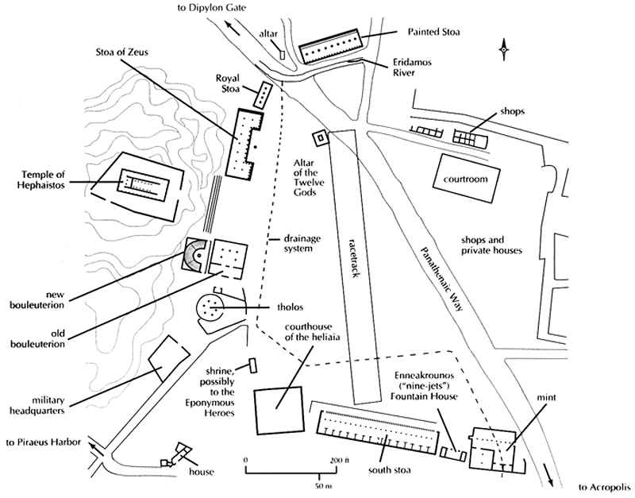

Athenian Agora

