Positive Psych Exam Review
Week 7
Critically Appraising Positive Psychology
Three important dimensions to consider
- Conceptual aspects and theoretical underpinnings of the intervention
- Methodological aspects and bias reduction
- Discussion and implication of the results

Sharma et al. (2014)
- Self-directed stress management and resilience training (SMART) using only written material
- Used Train your brain, engage your heart, transform your life
- Used gratitude, compassion, acceptance, meaning an purpose, forgiveness, etc.
- Resilience increased, perceived stress decreased, anxiety decreased, quality of life increased

Positive Psychology
- Stronger social relationships = 50% increased likelihood of survival

Importance of positive relationships
- Closely associated with physical and psychological well-being
- Key processes
  - Social support
    - Diverse definitions and measures
      - Structural support – number of social ties and interconnections
      - Enacted or received support – support (tangible and emotional) that is actually given or received
      - Perceived availability of support – someone will be there to help if needed
    - Perceived availability is more consistently related to positive outcomes than enacted support
      - Costs associated with receiving support
      - Support not always perceived to be responsive
    - Two models
      - Direct = Support ---------+-------- well-being
      - Buffering = Stress-----(-)---------------------- well-being
^Support^
  - Capitalization
    - Telling another person about a positive event (good news) in order to make the most out of it
    - Importance of considering the response of the other person
    - Dr. Tal Ben-Shahar ‘Active Constructive Responding’ https://www.youtube.com/watch?v=ZzVw-tB7xGQ
      - How we respond to positive information more telling about relationship success than how we respond to negative
      - Classify responses to positive disclosures on two dimension
        - Constructive-destructive response
          - Constructive – positive
          - Destructive
        - Active-passive responsive
          - Active is engaging
          - Passive is detached/indifferent
        - Can be combined to make four different responses
          - Active-constructive
          - Passive-constructive
          - Active-destructive
          - Passive-destructive
  - Self-expansion
    - People are motivated to increase the bounds of their self-concept by incorporating the resources, perspectives, and identities of close others into their own self-concept
    - Associated with positive outcomes (e.g., marital satisfaction)
      - Except if sense of losing personal control or identity (being to close)
    - Measure
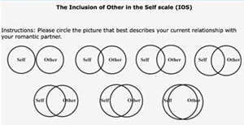

- Positive to negative ratios of 2.9 or greater equal higher self-other overlap in new roommate relationships (based on broaden-and-build theory of positive emotions)

Week 8
Positive Family and Parenting
Family-centered positive psychology
- Framework for working with children and families that promotes strength and capacity building within individuals and systems, rather than one focusing on resolution of problems or remediation of deficiencies
- A family system is more than the sum of its parts
- Key principles of family-centered positive psychology
  - Concerned with process as well as outcomes
  - Use existing family strengths and capabilities to access and mobilize family resources
  - Focuses on family-identified rather than professional-determined needs
  - Promotes acquisition of new skills and competencies through specific types of helping behaviours and professional roles
  - Emphasizes strengthening social support and networks
- Qualities of strong families
  - Promote well-being of families and their members
  - Appreciation of small and large things done by other members
  - Times spent to do things together
  - Sense of purpose allowing to go on in bad and good times
  - Sense of congruence
  - Ability to communicate
  - Rules, values, and beliefs for acceptable behaviours
  - Varied coping strategies
  - Problem solving
  - Be able to be positive/see positive
  - Flexible/adaptable
  - Balance in use of internal/external resources

Family well-being
- State of affairs in which everyone’s needs in the family are met
Child maltreatment --------------------------wellness

Strength Based Parenting
- An approach to parenting that seeks to deliberately identify and cultivate strengths (positive states, processes, and qualities) in one’s children
- Dr. Lea Waters https://www.youtube.com/watch?v=RMhVopiQYzM
- Strengthspotting in children
  - Performance – child is good at it and performs better than others
  - Energy – using the strength makes your child feel energized, motivated and engaged
  - Use – your child will naturally choose to use the strength without you having to prompt them
- Strength-based parenting intervention
  - 3 components
- Noticing children’s strengths
- Encouraging children to use their strengths
- Deploying one’s own strengths while parenting
- 2 parental workshops, separated by a 2-week practice period
- Associated with
- Increased parenting self-efficacy
- Increased positive emotions
- Correlation between teenagers’ and parent’s reports of strength-based parenting levels explain a significant proportion of teenagers’ life satisfaction

Inconsistent findings between lower or higher well-being and being a parent
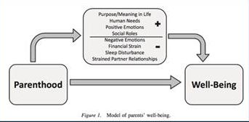

Recovery and PP in Clinical Settings
Well-being and mental health recovery
- Clinical – Reduction of symptoms under clinical threshold
- Personal – A deeply personal, unique process of changing one’s attitudes, values, feelings, goals, skills, and/or roles. It is a way of living a satisfying, hopeful, and contributing life even with limitations caused by illness
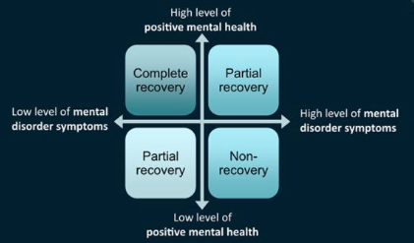

Role of self-management
- Strategies implemented by the person in daily life in order to
  - Reduce symptoms
  - Prevent relapses
  - Optimize well-being
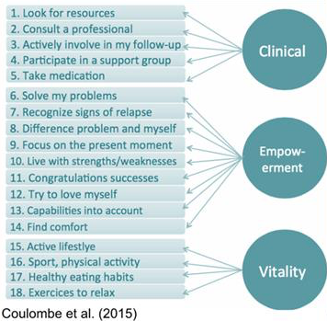

3 types of profiles
- Floundering
- Struggling
- Flourishing
Living alone most vulnerable subgroup, followed by low income, then being a man

Examples of intervention approaches
- Self management support – to support people in developing their personalized self-management plan
- I note what I am already doing
- I think about what I did before and I identify with other people’s strategies
- I take action
- I review my strategies
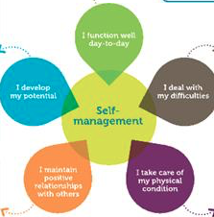

Self-management support tool
- Implemented alone – people’s initial reactions to the tool are enthusiastic, but engagement into
- Support from health care professional – self-management tools are more efficient when support is provided

Well-being therapy
- Short term (8 weeks)
- Based on Ryff’s model
  - Self acceptance
  - Personal growth
  - Purpose in life
  - Environmental mastery
  - Autonomy
  - Positive relations with others
- Phase 1: initial sessions – identification of episodes of well-being
- Phase 2: intermediate sessions – identification of well-being; related automatic thoughts
- Phase 3: Final sessions – Positive cognitive restructuring
- Goal = Balanced, individualized positive functioning
- Effectiveness
  - Treatment
  - Residual symptoms reduction
  - Relapse prevention
  - Used to treat affective disorders such as anxiety, depression, etc.

Solution-focused therapy
- Competency-based model that minimizes emphasis on past failings and problems and instead focuses on clients’ strengths and previous successes
- Asks questions instead of providing directives
- Looking for previous solutions
- Looking for exceptions
- Focusing on preferred future
- 3 miracle questions https://www.youtube.com/watch?v=pAVetI4I3_w
  - What would your day be like without ‘x’ problem
  - What would be a sign that you’re feeling better in the days to come
  - What would be different after said miracle

Week 9
Mindfulness
Raisin Consciousness experiment

Mindfulness
- Conscious awareness with an open, receptive attitude, of what is happening in the present moment
- Intentional regulation of attention toward the present moment
- Gently observing; not judging
- Curiosity toward one’s experience; not trying to get rid of painful experiences; not being resigned

Present experience – various forms of experiences
- Body sensations
- Emotional reactions
- Mental images
- Mental talk
- Perceptual experiences (sounds, smells, etc.)

Mind wandering and well-being
- Our minds wander away from the present experience about 47% of the time
Mind wandering = less happiness
Mindfulness = more happiness

Mindfulness interventions – secular but inspired by Buddhist traditions
- Recent (last 3 decades) interest of psychological scientists in developing interventions to promote mindfulness
- But before: 2500-year of Buddhist scholarship on similar concepts/interventions

Types of mindfulness interventions
- Mindfulness-focused intervention programs (e.g. mindfulness-based stress reduction)
- Interventions integrating mindfulness as one component (e.g. acceptance and commitment therapy)

Mindfulness-based stress reduction (MBSR)
- 8-week group mindfulness training
- Weekly classes with a teacher
- Daily audio-guided practice at home
- Mindfulness retreat (1-day)
- Was initially used with chronic pain patients but now use for other people

Results of randomized control trails of mindfulness programs
- Physical Health
  - Reduced pain-related functional limitations in chronic pain patients
  - Buffer decline of CD4+ T lymphocytes in HIV patients
- Mental health
  - Reduced risks of depression relapse
  - Reduced anxiety-disordered populations
  - Improved substance abuse outcomes

Acceptance and Commitment Therapy
2 core messages
- Accept what is out of your personal control
- Commit to action that improve and enriches your life
- Outcome: mindful, value-guided action Psychological flexibility

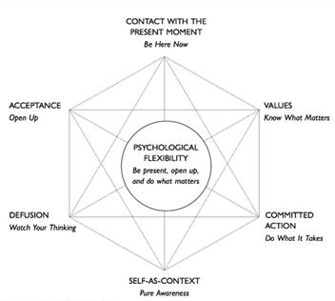
Psychological flexibility

Context: Relational Frame Theory
Theory of human language and cognition
- Implications for psychopathology (and well-being)
- Psychopathology shares some of the same cognitive processes as verbal processing and reasoning
- Attempting to change nodes in the cognitive network tends to increase the importance of these nodes
- If it is possible to reduce the impacts of negative cognitions by changing their functions, no matter if the cognitions continue to exist in the same form or not

Defusion
- Seeing a thought for what it is: nothing more or less than a bunch of words or pictures “inside your head”
- Recognize negative thoughts about yourself but don’t buy into them
- Activities:
  - You take a song that is well-known and sing your thoughts about it. You realize that these thoughts do not matter
  - Take a movie characters voice and say your thoughts with their voice.
  - This shows that these thoughts do not represent reality, basically just that these negative thoughts are meaningless, forget about them.

Positive Health
Duchenne Smile
- Genuine, sincere smile, indicated by the contraction of muscles close to the eyes
- Indicator of the degree of happiness
  - Pictures of MLB 1952 season players
  - Players with Duchenne smile lived 5 years longer

Other studies
- Nun study – positive emotions in journals = longer living nuns
- Cold study – higher positive emotions = less colds
- Twitter study – decreased heart disease mortality risk with positive worded tweets

Beyond the impact of well-being on health: Positive health
- Positive health as a recently new field
- State of health beyond the absence of illness, measurable at different levels
  - Biological
    - Physiological function and anatomical structure – BMI, blood pressure, liver function
  - Subjective
    - Feeling great
  - Functional
    - How well the individual functions – good relationships
- Other positive health assets linked to positive health
  - Optimism
  - Forgiveness
  - Zest and vitality
  - Self regulations
  - Life meaning
- Outcomes - Longevity, greater quality of years in life

Week 10
Positive Education
- Education for both traditional skills and for happiness

Student’s well-being
- Well-being part of definition of success
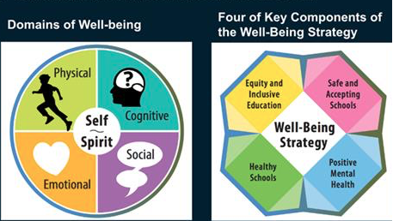

Additional concept: Grit
- Trait-level perseverance and passion for long-term goals
- Correlation with academic performance and retention
- Should focus on grit and cognitive ability together

Growth Mindset
- Buffer against negative impacts of poverty using

Interventions
- We can adapt different contexts at different levels by changing positive psychology interventions for different age groups
  - You cannot give a 3 year old and a 22 year old the same positive psychology interventions and get intended results.
- The critiques say that if you implement an isolated intervention in school, it will not change the school setting as a whole. You have to change the entire social climate of the school
  - Critiques also say we need to involve all the stakeholders of a school and integrate well-being everywhere. This included principles, profs, teachers, deans etc…
- The study/video showed how this can have a long-term implication and effect.

Week 11
PP in the Workplace
Importance of work for well-being
- Higher levels of life satisfaction among employed compared to unemployed individuals
  - Time structure
  - Social contact
  - Collective purpose
  - Social identity and status
  - Regular activity

Work factors
- Work challenges like workload and challenging tasks increase well-being
- Stress factors like unclear role and inadequate resources decrease well-being

Job satisfaction and performance
- .33 correlation between well-being and job performance

Psychological Capital
- Beyond psychological capital
- Made up of four components
  - Self-efficacy
  - Resilience
  - Hope
  - Optimism
- Related to:
  - Stress (-)
  - Turn-over (-)
  - Intent to quit (-)
  - Job searching (-)
  - Creativity (+)
  - Passion (+)

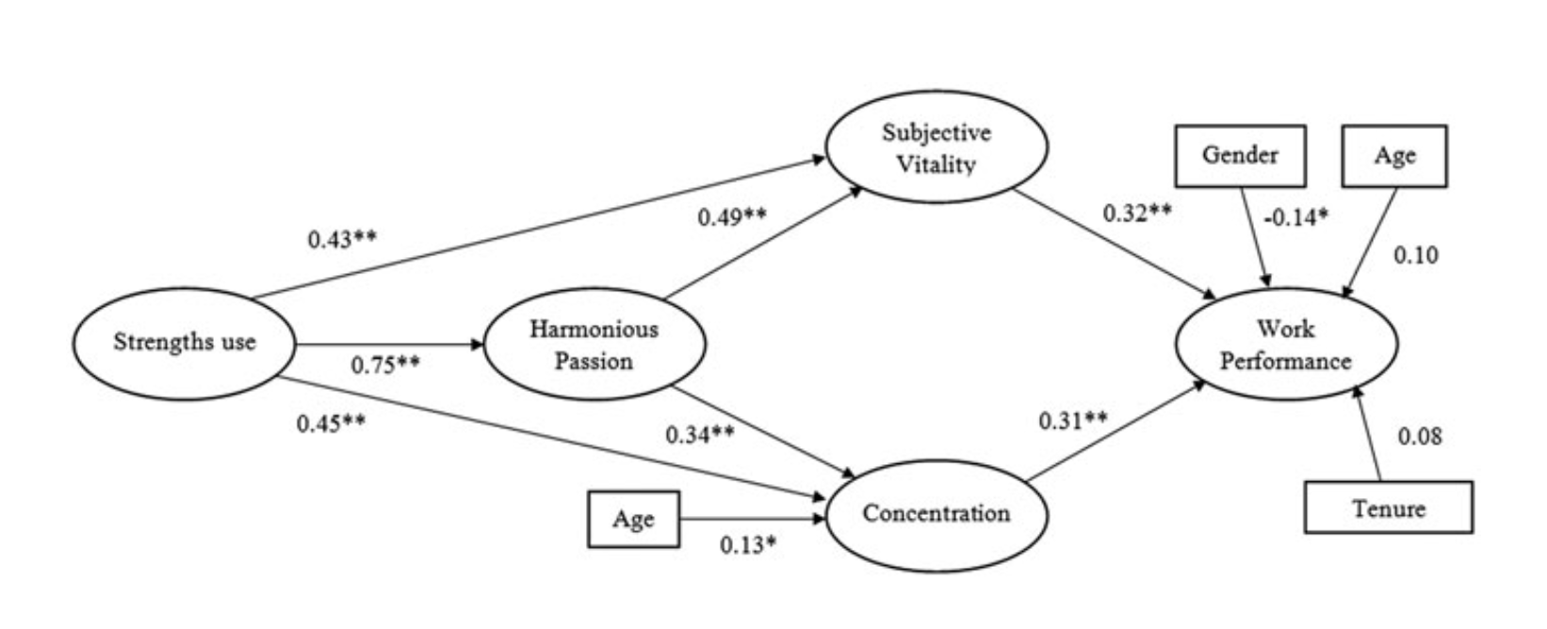
Capitalizing on strengths at work

- The more you can use character strengths in the workplace, the more creativity and passionate about work you will be
- Craft jobs that fit the strengths of people

Appreciative Inquiry
- AI focuses on leveraging an organization’s core strengths, rather than seeking to overcome or minimize its weaknesses
- Steps
  - Discover strengths of the organization
  - Dreams for the future
  - Design it
  - Sustain these changes

PP and Cultural Diversity
- PP criticism
  - Marginalization of the voices of disadvantaged groups
    - Poor
    - Women
    - LGBTQ
    - People of colour
  - Article review 1998-2014
    - Racial and ethnic composition reported in only 37% of studies
      - 57% white
      - 12% black
      - 7% Hispanic/Latino
      - 6% Asian
      - 0.6% indigenous
    - Only 2.8% of articles included discussion of issues related to race/ethnicity
    - Lack of research from non-western POV, in a non-western context
- OBI public talks https://www.youtube.com/watch?v=uCa_oGzviRM
  - Intergenerational trauma

- Diversity related PP work
  - Seemed universal for some strengths to be more prevalent in all countries
  - Overall the patterns are similar

- Examples of diversity-related PP work
  - Positive aspects of minority experience
    - Gay lesbian identity – Families of choice, freedom from gender bound roles, activism
    - Indigenous people – connectedness (awareness of)
    - Strengths embedded in minoritized communities and contexts

Week 12
PP and the Environment
The context that provides individual and collective benefits, also influencing human actions to conserve the present and future sociophysical milieu

- Positivity and P-E interactions
  - Neglect of environmental influence and person-environment (P-E) transactions in PP
  - But: human behavioural predispositions emerge from the interaction between individuals and their environment (e.g. genetic effects: interaction between genetics factor and the environment)
  - Positive human experiences take place in the interaction between people and the environments of their daily lives
    - Geographical environment
    - Natural environment
    - Built environment
    - Social environment

- Happy places
  - Homes
  - Workplaces
  - Third places: café, bars, hangout places, etc.
    - Neutral
    - No status difference
    - Conversation is the main activity
    - Accessible
    - Have regulars but new places are accepted
    - Plain and unpretentious
    - Dominant mood: playful

- Structures of a “good” environment
  - Physical – buildings, roads, green spaces
  - Functional – services, transportation, stores
  - Participatory – opportunities to participate in the political and social life of the community
  - Sociocultural – quality of the social relationships in the neighbourhood, sense of community, mutual aid, shared culture

- Person-environment fit
  - Perceived adequacy between
    - People’s needs, capabilities and aspirations and…
    - Environment’s resources, demands, and opportunities

- Ecological visions of positive environment
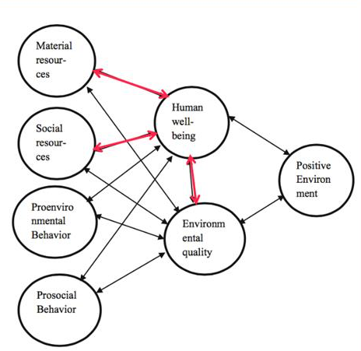

- E.g. social environment
  - Cities and Character Strengths
    - Hot spot cities – creative work force, more patents per capita, hi-tec industries, diversity
    - More people with strength of head in hot spot cities; more people with strength of heart in non-hotspot cities
    - Residents with children and heart strengths r= .55
    - Number of colleges/universities r= .3
    - Heart strength and temperature r= .48
- E.g. Health and natural environment
  - Being exposed to nature when in an urban setting can boast job/task performance (even if nature is just a picture or video)
  - Natural environments are usually providing interaction and good for reducing stress, promoting well-being
  - Well-being is related to the natural environment through physical activity, social contacts, stress, and air quality

- Well-being and Pro Environmental Behaviour (PEB)
  - Positive correlation; 3 explainations
    - PEB need satisfaction WB
    - WB pro social behaviours (PEB)
    - Some factors like instrinsic values and mindfulness cause both WB and PEB
  - PEB have more well-being because they have less cognitive dissonance

Well-being and Wealth
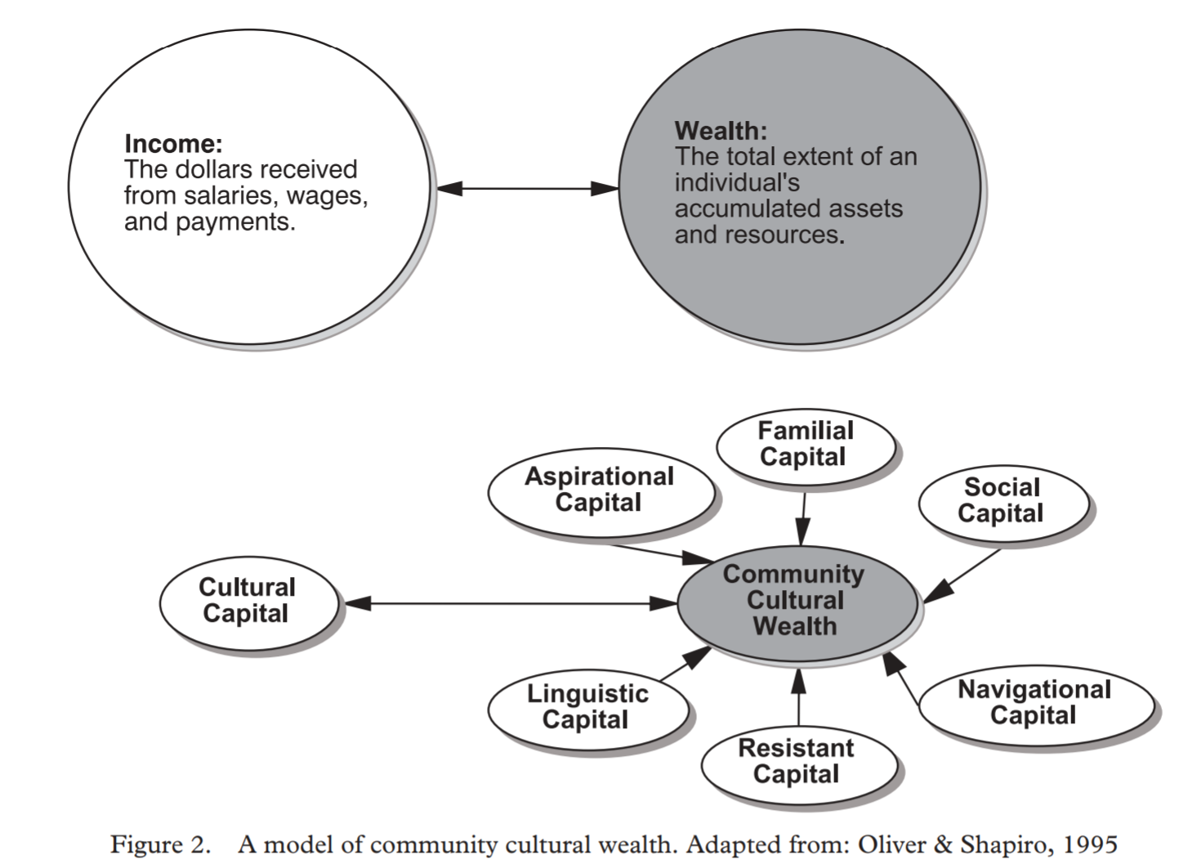
Objective Well-being

Other forms of Wealth

Critical Hope
- The idea we can be critical of society if we want, or not. Just need to see that there is injustice.
- Being hopeful that we can improve this and make change to remove all the injustice in the world.
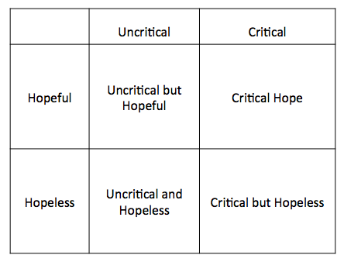

Martin Luther Kind Quote
“There are some things in our society, some things in our world, to which we should never be adjusted. There are some things to which we must always be maladjusted if we are to be people of good will.”
- About being critical of positive psychology.
- We need to focus more on fairness and not well-being and mindfulness
- By telling someone who is discriminated against to be more mindful is offensive and ignorant.

Ho et al.
Development and Evaluation of the Positive Psychology Intervention for Older Adults – Exam Article Review

- Intervention targeting 74 older people
- Uses 8 different themes in intervention – Optimism, gratitude, savouring, happiness, curiosity, courage, altruism, and meaning of life
- Reduced depression; increased life satisfaction, gratitude, and happiness

