MAT 3375 Regression Analysis
Assignment #2

SAS Questions, including inputs and outputs.

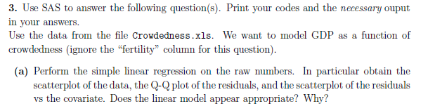
data mat3375.Crowdedness;
input Crowdedness fertility GDP;
datalines;
0.7 1.28 31187
2.1 2.1 853
………………………………………
0.5 2.11 36924
1 2.3 3274
;
run;

symbol1 v=dot h=.8 c=blue;
proc REG data=mat3375.crowdedness noprint;
model GDP = Crowdedness;
output out=crowded r=resid p=fitted;
run;
title 'Assessing Normality';
proc capability data=crowded noprint;
histogram resid / normal(mu=est sigma=est color=yellow w=2)
cframe = ligr cfill = blue;
probplot resid / normal(mu=est sigma=est color=yellow w=2);
qqplot resid / normal(mu=est sigma=est color=yellow w=2);
run;
Proc print
data=mat3375.Crowdedness;
run
;
ods graphics on;
proc REG data=mat3375.Crowdedness;
model GDP = Crowdedness / clb;
run
;
Ods graphics off;

Outputs:
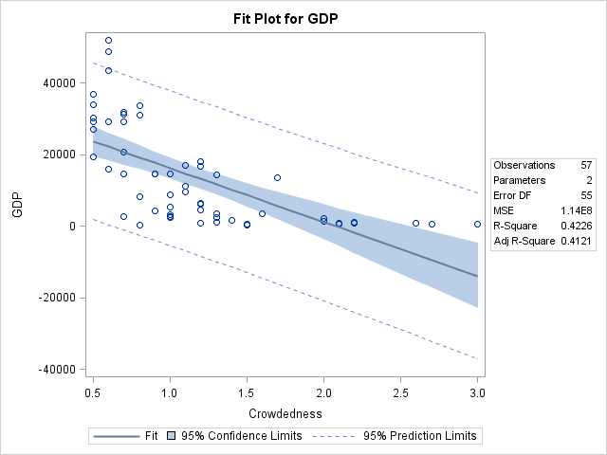
Scatterplot of the data

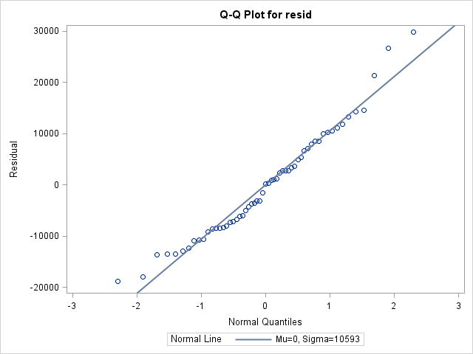
Q-Q Plot of the residuals

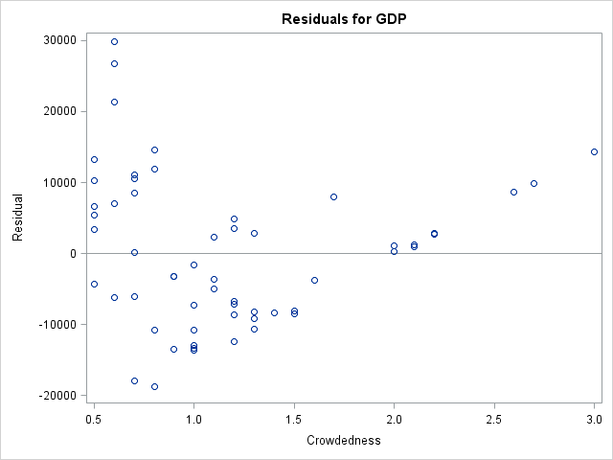
Scatterplot of the residuals vs covariate (GDP)

For this graph, the linear model does not seem to be an appropriate model for this data. The reason for this is because firstly, the correlation coefficient, or R² is 0.4226, appears to be a resourceful observation in identifying appropriateness. The strength of 0.4226 as a correlation coefficient indicates that the correlation is lower than moderate. Also, looking at the Q-Q plot, we can observe how neatly the data points are lined on and around the normal line, however, there are a few points which do not satisfy the expected pattern. In observing the scatterplot which represents the relationship between the two variables, we can see that there is very poor correlation between the variables, in that the data points are not in an expected pattern, but are rather literally scattered everywhere. Because the points do not depict linear line more than moderately, they can be said to NOT represent the linear model for this data set.

proc reg data=mat3375.crowdedness;
model GDP = crowdedness;
run;

proc glm data=mat3375.crowdedness outstat=outGLM;
class crowdedness;
model GDP = crowdedness;
run;

proc print data=outGLM;
run;

data _null_;
set outGLM;
if _source_='ERROR' then call symput('SCEP', ss);
if _source_='ERROR' then call symput('DLEP', df);
run;
%put here is &SCEP &DLEP; /* see LOG window to check computations */

proc GLM data=mat3375.crowdedness outstat=outREG;
model GDP = crowdedness;
run;

data _null_;
set outREG;
if _source_='ERROR' then call symput('SCE', ss);
if _source_='ERROR' then call symput('DLE', df);
run;
%put here is &SCE &DLE; /* see LOG window to check computations */

data LackOfFit;
mcep = &scep/&dlep;
scma = &sce-&scep;
dlma= &dle-&dlep;
mcma = scma/dlma;
f = mcma/mcep;
p_value = 1- cdf('F',f, dlma,&dlep);
run;

title "Lack-of-fit test";
proc print data=LackOfFit;
run;
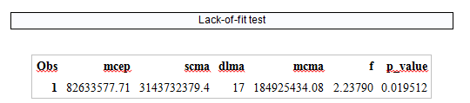
The F statistic for the lack-of-fit test is 2.24 rounded, and 0.019 is the p-value. From these given values, we can compute the following:
If conclude H₀ or H₁, respectively.
In our case,
Since F*=0.0588 > 0.019, we can conclude H₁, meaning that the regression function is not linear.

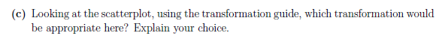
Looking at the scatterplot, alongside the transformation guide, I would have to say that the logarithmic function is the most appropriate transformation. This is because as we can observe in the scatterplot, the data on the left-most of the graph, closer to the y-axis, shows that there are many points outside of the 95% prediction limits, meaning that a linear relationship doesn’t exist. The logarithmic transformation is the best model to fit the data in this question.
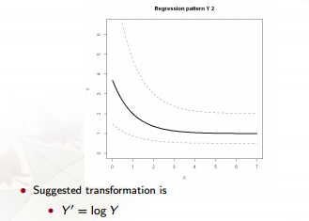

This transformation most portrays the crowdedness data.

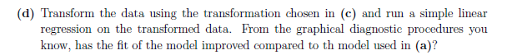

ods graphics on;
proc reg data= mat3375.crowdedness;
model GDP = crowdedness;
run;
ods graphics off;

data transform;
set mat3375.crowdedness;
transform=log(GDP);
run;

ods graphics on;
proc reg data= transform;
model transform = crowdedness /clb;
run;
ods graphics off;

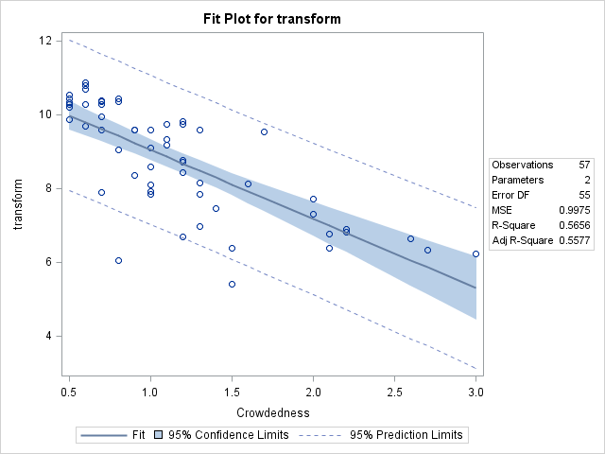
As we can see, the new correlation coefficient after the logarithmic transformation, is now 0.5656, which accounts for a strong, positive correlation between GDP and crowdedness. Therefore, the fit of the model has greatly improved compared to the first model use in part a) of the question.

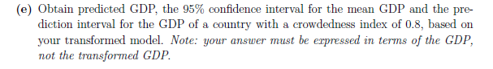
With our new logarithmic model, modelling our situation, we are able to obtain predicted GDP values, 95% confidence intervals for mean GDP and prediction interval for GDP with 0.8 crowdedness index.
From output for part d,
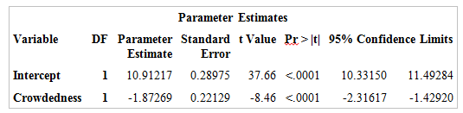
Here we can get that the 95% confidence interval for the GDP of a country with a crowdedness index of 0.8 is (10.33, 11.49). To obtain the value for the transformation, we put each end of the interval to the power of e in order to eliminate the logarithm and obtain the desired confidence interval. By doing this computation, we get . The prediction interval for the GDP, when the crowdedness index is 0.8 is as follows:
proc SQL;
create table lmat3375.PredGDP as
SELECT * from lmat3375.logtransgdp;
INSERT INTO lmat3375.PredGDP VALUES (0.8 . . .);
QUIT;
title "Prediction for 0.8 Crowdedness";
proc reg DATA =lmat3375.predGDP;
model loggdp = crowdedness / clb;
output out=predGDP out r=resid p=fitted stdp=ETmean L95=infP U95=supP L95M=infM
U95M = supM;
run;
proc print data=predGDP out;
run;

Thus, the prediction interval for the GDP for a country with a crowdedness index of 0.8 is [9.10342, 11.4395] using the transformed model.
In terms of our original GDP the interval is [8986, 92921].

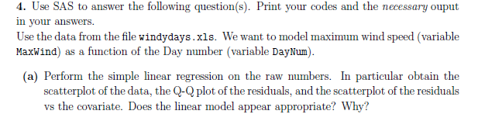
data mat3375.Windyness;
input MaxWind DayNum;
datalines;
6.44 0
11.97 1
……………………
8.61 364
10.56 365
;
run;

symbol1 v=dot h=.8 c=blue;
proc REG data=mat3375.Windyness noprint;
model MaxWind = DayNum;
output out=Windy r=resid p=fitted;
run;
title 'Assessing Normality';
proc capability data=Windy noprint;
histogram resid / normal(mu=est sigma=est color=yellow w=2)
cframe = ligr cfill = blue;
probplot resid / normal(mu=est sigma=est color=yellow w=2);
qqplot resid / normal(mu=est sigma=est color=yellow w=2);
run;

Proc print data= MAT3375.Windyness;
run
;
ods graphics on;
proc REG data= MAT3375.Windyness;
model MaxWind = DayNum / clb;
run
;
ods graphics off;

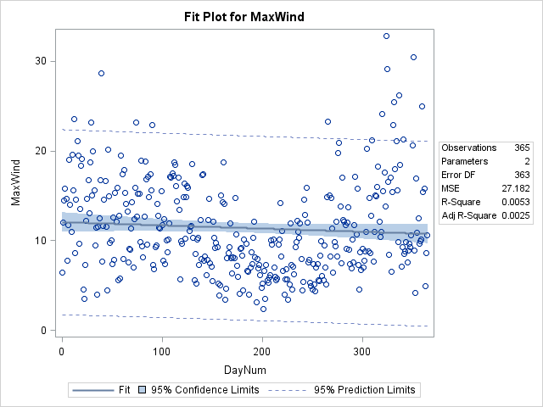
Scatterplot for MaxWind VS DayNum

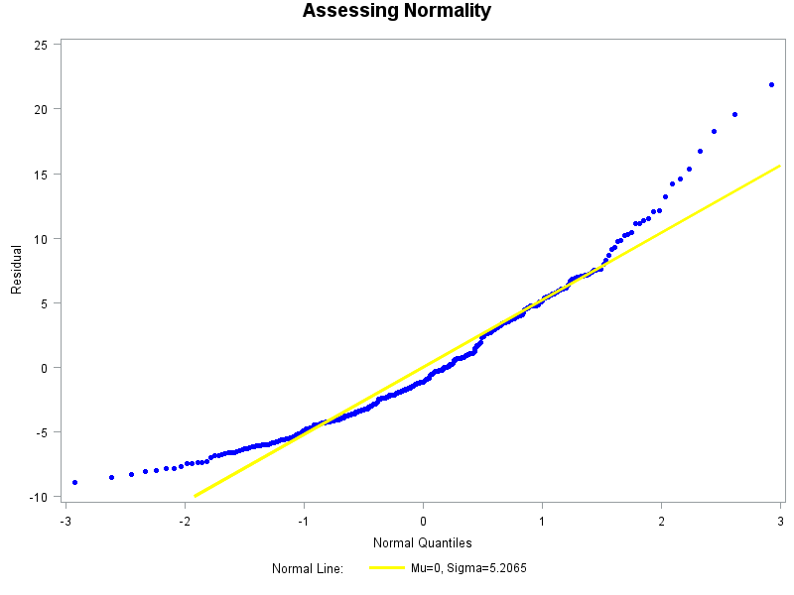
Q-Q Plot for Residuals

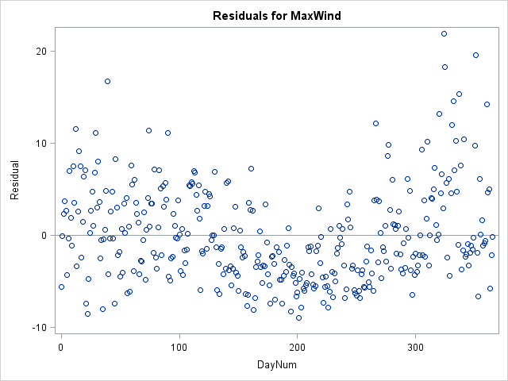
Scatterplot of the residuals v.s the covariate
The linear model for this data does not appear appropriate at all. Just by looking at the graph, we determine that there is no correlation between DayNum and MaxWind. Also, the correlation coefficient, or R², helps to justify this observation. In possessing a regression value of 0.0053, we can confidently state that there is little to no regression relationship between the variables.

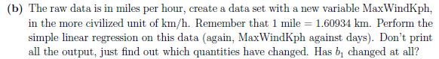

To create the new data set, I used excel and produced a new column, names as MaxWindKph and wrote the equation: =MaxWind * 1.60934 and dragged this equation down to the rest of data points. The input is very similar to part a), except the input name and data set.

MaxWind:
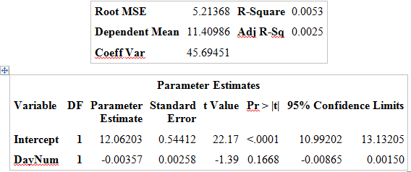

V.S
MaxWindKph:
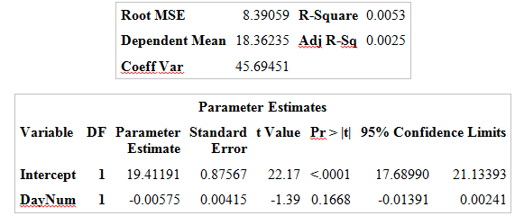

By looking at the above two outputs and by comparing and contrasting, we find that although the correlation coefficient (R²), along with Coeff Var and Adj R-sq did not change between the data sets, we do see that the dependant mean and the root MSE, or variance, did change. Also, the value changed from 12.06 to 19.41. There was also a change observed in the DayNum parameter estimation. The standard errors and 95% confident limits appear to vary between the two data sets. A similarity between the two remains the t-value and the p-value.

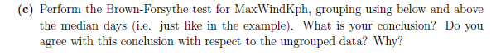
symbol1 v=dot h=.8 c=blue;
proc REG data=mat3375.WindynessKph noprint;
model MaxWindKph = DayNum;
output out=Windy r=resid p=fitted;
run;
title 'Assessing Normality';
proc capability data=Windy noprint;
histogram resid / normal(mu=est sigma=est color=yellow w=2)
cframe = ligr cfill = blue;
probplot resid / normal(mu=est sigma=est color=yellow w=2);
qqplot resid / normal(mu=est sigma=est color=yellow w=2);
run;
Proc print data= MAT3375.WindynessKph;
run;
ods graphics on;
proc REG data= MAT3375.WindynessKph;
model MaxWindKph = DayNum / clb;
run;
ods graphics off;

proc reg data=mat3375.WindynessKph;
model MaxWindKph = DayNum;
output out=Windyresid r=resid p=fitted;
run;

proc univariate data=Windyresid;
var DayNum;
run;

data group;
set Windyresid;
if DayNum >182 then group = 1; else group =0;
run;

proc sort data=group;
by group;
run;
proc univariate data=group noprint;
var resid;
by group; output out=sommaire median=mediane;
run;
DATA deviations;
MERGE group sommaire;
by group;
d=abs(resid-mediane);
run;

proc ttest data=deviations;
class group;
var d;
run;
Necessary Output:
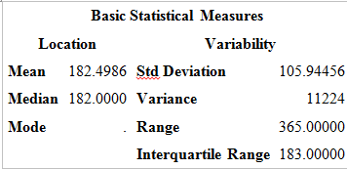
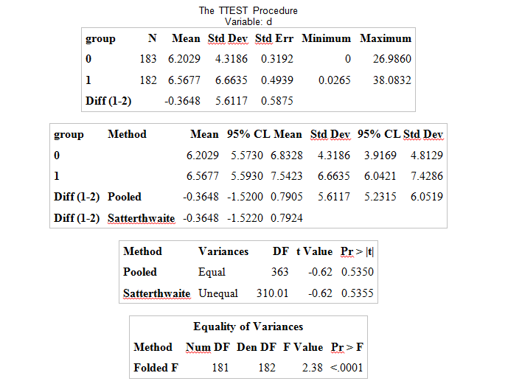
In using the Brown-Forsythe test for MaxWindKph, we had to first determine the median day in order to assign groups to the data. From the necessary output, we found that the median was 182 days. From there we grouped the data greater than 182 as group 1 and DayNum less than 182 to be group 0.
Brown-Forsythe test is used to test the constancy of the error variance and from the above necessary output obtained from SAS, we can compute the following results:

If the test statistic for the Brown-Forsythe test (t*) is less than or equal to the t test, then the error variance in constant and if it is greater than the t test, then the error variance is not constant.

From the table, we can observe the t value is -0.62 with the Pr > |t| of being 0.5350.
But 0.5350 > 0.0001 (Pr > F) therefore the error variance is not constant and we can confidently state that the correlation between the MaxWindKph and DayNum is not strong at all.

symbol1 v=dot h=.8 c=blue;
proc REG data=mat3375.BetterDays noprint;
model MaxWindKph = BetterDays;
output out=Windy r=resid p=fitted;
run;
title 'Assessing Normality';
proc capability data=Windy noprint;
histogram resid / normal(mu=est sigma=est color=yellow w=2)
cframe = ligr cfill = blue;
probplot resid / normal(mu=est sigma=est color=yellow w=2);
qqplot resid / normal(mu=est sigma=est color=yellow w=2);
run;
Proc print data= MAT3375.BetterDays;
run;
ods graphics on;
proc REG data= MAT3375.BetterDays;
model MaxWindKph = BetterDays / clb;
run;
ods graphics off;
proc reg data=mat3375.BetterDays;
model MaxWindKph = BetterDays;
output out=Windyresid r=resid p=fitted;
run;
proc univariate data=Windyresid;
var BetterDays;
run;
data group;
set Windyresid;
if BetterDays >91.5 then group = 1; else group =0;
run;
proc sort data=group;
by group;
run;
proc univariate data=group noprint;
var resid;
by group; output out=sommaire median=mediane;
run;
DATA deviations;
MERGE group sommaire;
by group;
d=abs(resid-mediane);
run;
proc ttest data=deviations;
class group;
var d;
run;

By redoing the Brown-Forsythe test with the groups based on the median of better days, we find the following:
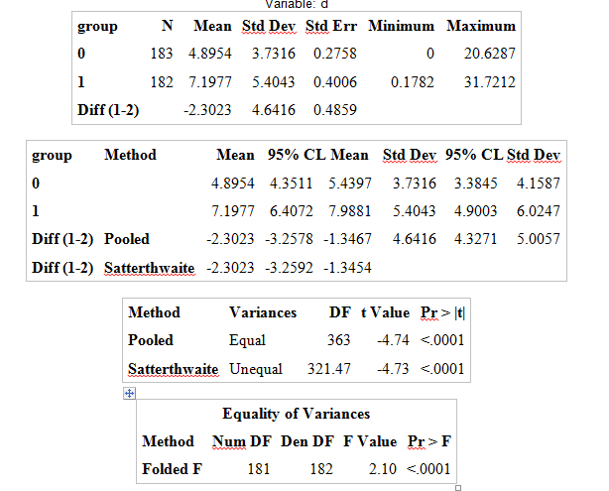

Similarly to part c, we find from the necessary output, that the median was 91.5 better days. From there we grouped the data greater than 91.5 as group 1 and BetterDays less than 91.5 to be group 0.
Brown-Forsythe test is used to test the constancy of the error variance and from the above necessary output obtained from SAS, we can compute the following results:

If the test statistic for the Brown-Forsythe test (t*) is less than or equal to the t test, then the error variance in constant and if it is greater than the t test, then the error variance is not constant.

From the table, we can observe the t value is -4.74 with the Pr > |t| of being < 0.0001.
But 0.0001 0.0001 (Pr > F) therefore the error variance IS constant and we can confidently state that the correlation between the MaxWindKph and DayNum is existent, however not very strong.

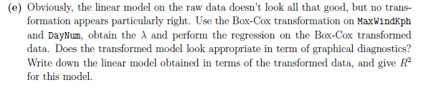
data boxtrans;
set mat3375.windynesskph;
logy = log(maxwindkph);
run;
proc reg data=boxtrans;
model logy = daynum;
run;
proc transreg
data=mat3375.windynesskph;
model boxcox(maxwindkph) = identity(daynum);
run;
Data power;
set Mat3375.windynesskph;
powerwind=maxwindkph**(0.25);
run;
ods graphics on;
proc reg data = power;
model powerwind = daynum / clb;
run;
ods graphics off;

From performing the box-cox transformation on the raw data, we obtain the best lambda of being 0.25. We chose to conduct the following transformation:
The new model looks far better than the original in terms of graphical diagnostics, as shown below:
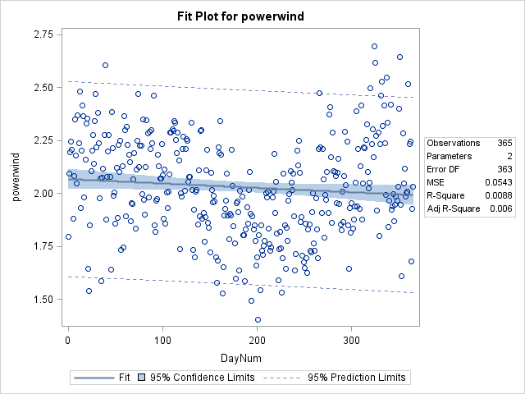
Most of all the data fits within the 95% prediction limits, in comparison to the original scatterplot. The correlation coefficient increased from 0.0053 to 0.0088 which shows a better model for the data. Although the correlation is not as strong as expected, this is the best model to fit the given data.

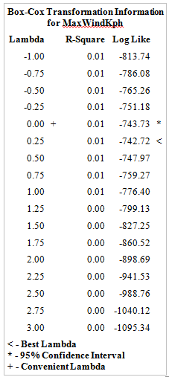

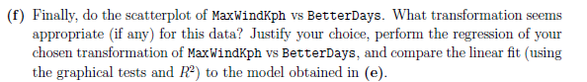
ods graphics on;
proc reg data= mat3375.betterdays;
model Maxwindkph = betterdays;
run;
ods graphics off;

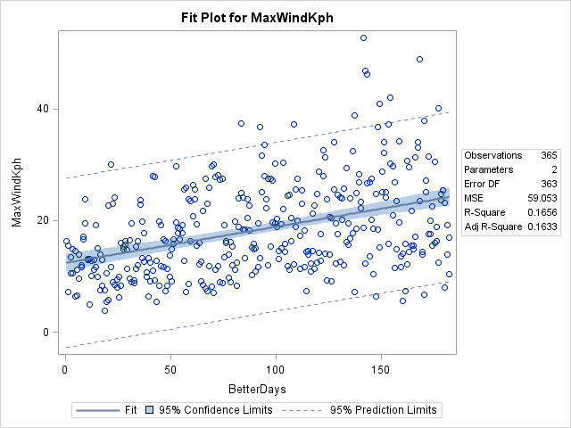

data inverse;
set mat3375.betterdays;
invwind=1/maxwindkph;
run;

ods graphics on;
proc reg data= inverse;
model invwind = betterdays /clb;
run;
ods graphics off;

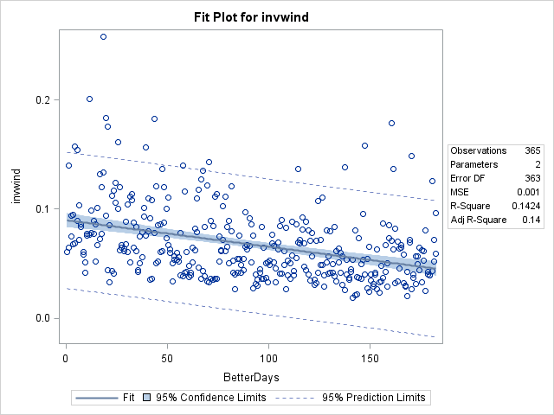
The transformation that appeared to be most appropriate for this data was chosen to be
The reason for this is because the scatterplot of the data best appeared to represent the following curve transformation:
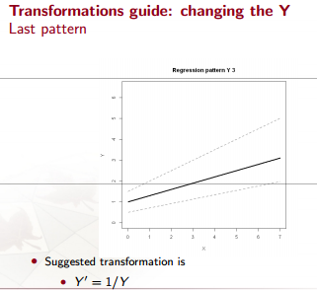
It’s the change in Y that will give us our desired model for the chosen data. The linear best fit appears to work better with this transformation than with box-cox. In the box-cox, we had a correlation coefficient of 0.0088 to 0.1424. This shows a more strong and positive correlation of the variables, in relation to the box-cox transformation. Overall, we can state that although the linear model is the best transformation for the windiness data set, it is not a very strong correlation which can allow one to conclude that there is in fact a relationship between MaxWindKph and BetterDays.

