MAT 3375 Regression Analysis
Assignment #1

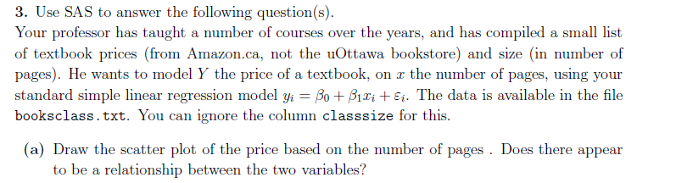
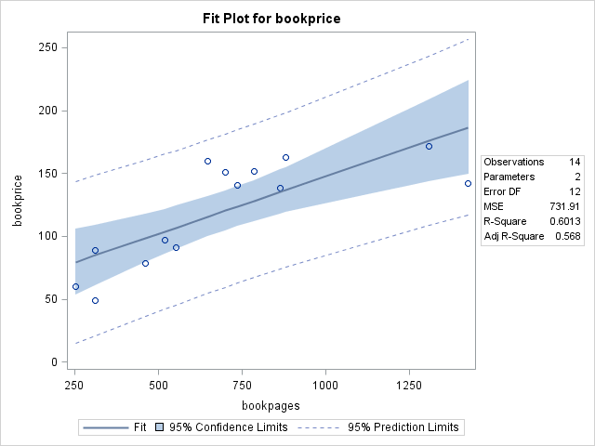
From observing the scatterplot above, it does appear that there is a relationship between the number of pages in the textbook and the price of the textbook. As the number of pages in the textbook increases, generally, the price of the book also increases. This accounts for a positive correlation between the two variables. Also, we can state that all of the data lies within the 95% prediction limits and most of the data is also found within the 95% confidence intervals. The deviations of the data points from the trend are minimal and prove to hold the positive correlation, validating the statement that there is, in fact, a positive relationship between the number of pages in the book and the price of the book.
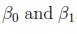
From the regression model, , we can see that represent the y-intercept and the slope of the linear regression, respectively. The parameters estimate chart is copied below:
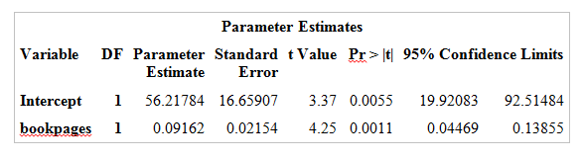
From here, we can gather that the point estimates for are 56.22 and 0.09, respectively.
These values imply the following statement:
A one page addition into a book will generally lead to a 0.09 unit price increase in the price of the book, starting from 56.22 unit price per book.

From the parameters estimate chart in question #3.b, we can see that the 95% confidence limits are given to us for our two parameters.
The 95% confidence intervals of are (19.92, 92.51) and (0.04, 0.14), respectively. At , we can confidently conclude that there IS a positive linear relationship between our two estimated parameters. Since the found p value is < 0.05 for both parameters, we say that the relationship between the two variables exists.
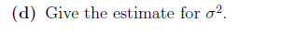
From another table in the SAS output for this data set, as shown below, we can obtain the estimate of :
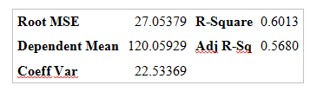
We know that MSE stands for mean square and that it is an unbiased estimator of for the regression model, as stated in (1.23 of Applied Linear Statistical Models). Therefore, we can give the estimate of to be 27.05², which is 731.70.
The percentage of the variability that can be explained by the model is determined by the equation: This result gives us the R² value, which is found on the chart used in question #3.c. This value is computed to be 0.6013.

According to all of the data observed throughout the course of this regression analysis, the following computation has been made:
This means that generally, the book with 450 pages should have a selling price of $96.72.

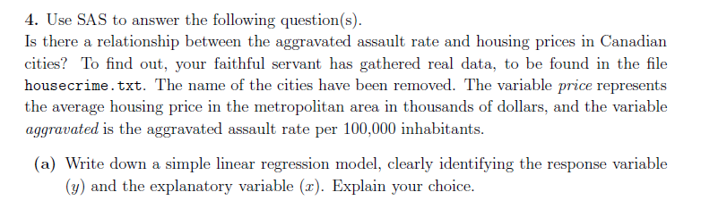
, where P is the house price and A is the aggravated assault rate.
In this case, Y, which is the response variable, represents housing prices and X, the explanatory variable, represents aggravated assault rates. In my opinion, I believe that the prices of houses are dependent on the aggravated assault rate in the area.

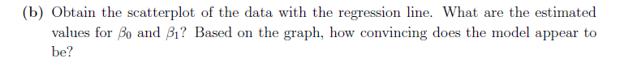
Similarly to question #3, the scatterplot with the data of the regression line is generated through SAS and displayed below. The estimated values of are also generated through the program and are found using the chart shown below.

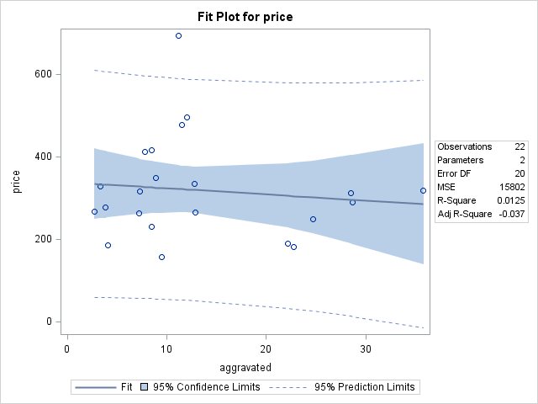

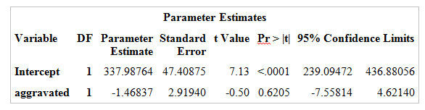
From here, we see that the values for are 337.99 and -1.4684, respectively. For the same reasons as observed in question 3, represent the y-intercept and the aggravated assault rate (slope), respectively.
By looking at this graph, the model does not appear to be convincing, as there is no consistent trend allowing for a relationship to be formed between house pricing and assault rate.

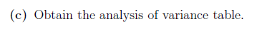
Using SAS, we obtain the following ANOVA table:
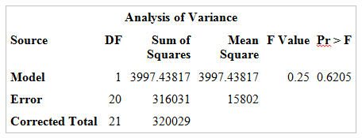

To test of whether there is a linear relationship between the aggravated assault rate and the housing prices, we use hypothesis testing in which the null hypothesis states that there is no linear relationship between the two parameters and the alternative hypothesis states that there is a linear relationship between the two. To test this, we chose a significance level, 0.05, which is given in the ANOVA table in question #4.c and find that p=0.6205 > 0.05. This allows us to reject the alternative hypothesis and accept that there is no linear relationship between the two parameters.
We can also observe that the confidence interval is too wide to allow for 95% confidence. Many of the data points appear outside of this interval.

Using the chart obtained from the SAS output below, we can find the p-value for the test:
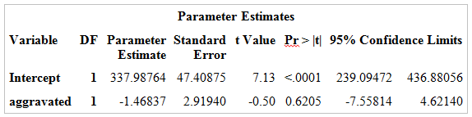
This supports the testing done in question #4.c in which the p-value is less than the significance level of 0.05. Since 0.6205 > 0.05, we reject the alternative hypothesis and say that there is no linear relationship between house prices and aggravated assault rate.

In our data set, we can observe one outlier outside of the 95% predicted confidence limits. Other data points deviate from the trend significantly but this one particular point is completely out of the predicted range.

