Outline 16: Athens I: The Agora and Democracy
Tuesday, November 14, 2017

Reading: C/F 116-125
***See attached plan of the Athenian Agora and http://plato-dialogues.org/tools/agora.htm

Σ ς/σ sigma is for seal stone, symposium
- Tiny bead with warriors depicted on it
  - Minoan/Mycenaean influence evidenced by the swords on the stone
- Found in the tomb of the griffin warrior
- Xi probably on the final exam

Archaic Age (750-479BCE)
- Last battle of the Persian war in Hellas
- Development of many things
  - Colonization
  - Scientific inquiry
  - Coinage
  - Monumental art & architecture
    - Ionian in Eastern Aegean, Doric in Western Mediterranean
  - Democracy

Democracy
- Definition
  - Demos = people
  - Kratos (-cracy) = power
  - Power to the people
- Basis: Liberty (freedom) and equality
  - Equality didn’t extend to women, slaves, resident aliens (people w/ no citizenship)
Athens:
- Said to be the first democracy (not true, others were developed at the same time)
  - Most knowledge about Athens though
- Attica: polis of the Athenians = Asty (Athens) + Chora
- Amalgamation of several Poleis to make the asty of Athens
Early Archaic demos = 4 tribes (kinda like the mafia in Athens)
Oligarchy (power of the few, aristocrats with a lot of land)
- 9 Archons (leaders):
  - King Archon,
    - Responsible for religious affairs
  - Polemarch
    - Responsible for political? affairs
  - Eponymous Archon
    - Civil matters
    - Gave his name to the year
  - + 6 thesmothetes
    - Record the law but not publish the law
- Areopagus Council
  - Met on the hill of Ares
  - After a year of being an Archon they had to retire
  - Administered justice
    - Could pervert the law for their own purposes
  - Supervising and auditing the Archons when they left office
  - Prepared the office for the assembly
- Ekklesia
  - Assembly
  - No poor people were members
  - Aristocrats, farmers, craftsmen

How to achieve rule by the people (democracy):
- Reducing the control of the people
Drako (snake): legal reform/Draconian (excessively harsh)
- wrote the first written law code in Athens
- Death penalty widely used
- Oligarchy lost some of their power bc everyone knew the law
Solon: (aristocrat, not widely liked)
- Poet/songwriter, wrote songs about his reforms, also a businessman
- legal reform: softened the Draconian laws and established the law courts (Heliaia) and made it so poor people could be jurors and pass judgement, gave poor people power and took it away from the Ekklesia
- political reform
  - Ekklesia
    - Increased the membership in the assembly to include the poor
  - qualification for office
    - made it so that the income was the only qualification for office
    - most money got the top jobs, the poor couldn’t hold any office
  - economic classes
    - devided the population in 4 classes
  - Council (Boule) of 400
    - New council
    - 100 men from each of the 4 tribes
    - Prepared the office for the Ekklesia
- economic reform
  - debt
    - outlawed slavery for debt
      - before, aristocrats could enslave people in debt and couldn’t repay the debt. People became perpetual slaves
    - cancelled the debts of the poor
  - commerce
    - established a commercial base
      - no longer only agricultural
      - invited foreign craftsmen to come to the polis and make stuff in exchange for citizenship
    - basis for future prosperity
- In all,
  - more participation in government
  - powers of aristocracy reduced
  - established a foundation for democracy
  - prosperity = tyranny
Peisistratos: typical tyrant
- public works
  - improving water system
    - fountain w/ 9 spouts
- festivals
  - making them bigger and better
  - pride and prosperity
- patron of the arts
- succeeded by son(s)
- Tyrannicides: (hipp = horse)
  - Brothers ruled together for a while
  - Hipparchos was assassinated (514BCE)
  - Hippias (brother)
    - Last mainland Greek tyrant
    - (510 BCE) Left Athens and went to Persia and thought he would be re-installed as a tyrant so he went with Xerxes to Hellas
  - Tyrannicides (killers of the tyrants) Harmodius, Aristogeiton (p. 118)
    - Big heroes in Athens
    - Assassinated for personal reasons
      - One of the mens sister was insulted by Hipparchos
Kleisthenes: (father of Democracy 508BCE) political reforms
- Tribes
  - Created 10 new tribes out of the 4 old tribes
  - Removed the mafia-esque aristocratic leaders and their hold over people
  - Created loyalty to the polis instead of to the families
- council (Boule) of 500
  - 50 from each tribe
  - council
- Lottery
  - Boule chosen by lot (at random, annual lottery and audit)
    - not elected, biggest difference between modern day and ancient democracy
  - a person could only serve on the council 2 times
- ekklesia: Pnyx
  - lowered the age from 30 to 18, thus increasing the size
  - moved from the Agora to Pnyx hill (higher than the hill where the other council met)
  - met approx. 40 times a year
    - decided foreign policy
- ostracism: Ostraka (p.122)
  - safeguard against tyranny
  - annual vote to determine if anyone was aiming to be a tyrant
    - broken bits of pottery (bases of drinking cups) named ostraka
    - everyone had to bring in an ostraka with a name of a person who they thought were aiming to be a tyrant
    - If over 6000 pieces had a name on it, the person was forced to leave the polis for 10 years
- End of aristocratic control over Athens
- More power and rights for people
- Still only aristocrats could be archons
Themistokles: political reforms
- Ostracism
  - 1st to use it to persuade the athenians to create a navy
    - Father of the navy
- Lottery
  - Introduced archons by lot
    - Anyone could hold power (even poor ppl)
- Elected:
  - Water commissioners
  - Treasurers
  - generals
Perikles: political reform
- pay for public duties
  - Heliaia (law courts (jury duty))
  - Boule (council of 500)
  - Ekklesia
- Poor person could sustain themselves to participate in government
- Drako, Solon, Kleisthenes, Themistokles, Perikles (reduced the power to the aristocratic people, powerful public speakers who convinced the Ekklesia to pass the laws)

Athenian Democracy:
- Participatory
- Direct
- Disadvantages:
  - No continuity
  - Only open to a minority of the population
    - Women, slaves, aliens, under 18 couldn’t participate

The Agora and Democracy
Asty:
- Areopagus (old council met (retired archons)), Pnyx (new hill the ekklesia met), agora
- 2 main gates led to the harbours
Multi-purpose Agora (more than a marketplace) (see plan below):
- social
  - Stoas: Porch with no building (long row of columns to support roof and make shelter w/ offices and shops in the back)
    - Poikele (Painted),
      - Military memorial
      - Paintings on the back wall
        - Battles depicted (Marathon)
      - Also hung stolen Persian Shield
      - Where stoic philosophers met
    - Zeus
      - Meeting place for men
      - In the front there was a statue of Zeus
        - Thought he was their savior from persians
      - Military significance
        - Paintings w/ military themes
        - Hung shields of Athenians who died in the Persian war
    - South Stoa
      - Social building for women, close to the 9 fountain house
        - Collecting water was a woman’s job
      - Women carried a hydria (3 handles)
  - Enneakrounos
- administrative:
  - (Royal) StoaBasileus (had his offices there, also laws were displayed)
    - Tyrannicides
      - Had a statue of them in front of it
      - Ended up with original and a copy bc
  - Eponymous Heroes
    - Had notice boards
    - 10 warriors displayed
- political:
  - bouleterion: old & new
    - archive building after the reforms (for 500 men)
    - after Kly reforms built a new one
    - looked like little theatres
  - prytaneion (tholos)
    - city hall
- legal: Heliaia
  - no policemen
    - people could prosecute others
    - no lawyers
    - no judge, only a councilman and jurors
  - klepsydra
    - amount of water from one jug to the other lasted 6 minutes and that was as long as ppl had to make their case
  - ballots (p. 123)
    - disks
    - one with a hole and the other without, covered the hole with their hand
      - discard and voting jar
    - jurors vote on which punishment to give
      - one punishment suggested by the defendant and one suggested by the plaintiff
- military: strategeion (military headquarters) (strategos/strategoi)
  - 10 elected strategoi
  - No limit to # of times
  - Not paid
  - Agora: parade ground
- religious: Panathenaic Way,
  - Altar of the 12 Gods (Olympian gods)
    - Distances measured from
  - Hephaisteion
    - Best preserved Doric temple of the time
    - To Hephaestus and Athena
      - Hephaestus (god of metalworkers)
      - Athena (goddess of female craftsmenship (weaving))
- Competitive
  - Althetic centre
  - Racetrack for men during a festival
- economic:
  - mint
    - made coins out of gold and silver (sometimes copper)
    - Athena and owl on the coin
  - shops

Summary
- social
- admin
- political
- legal
- military
- religious
- athletic
- economic centre

Images: Tyrannicides: Harmodius, Aristogeiton (p. 118), Ostraka (p.122), ballots (p. 123); plan of the Athenian Agora (from http://plato-dialogues.org/tools/agora.htm) see below.

Words to Remember
People: Theseus, Drako, Solon, Peisistratos, Tyrranicides, Hippias, Hipparchos, Themistokles, Perikles
Places: asty, chora, Pnyx, Altar of the 12 Gods, StoaBasileus, StoaPoikele, Hephaestion, Old Bouleterion, New Bouleterion, prytaneion (tholos), Shrine of the Eponymous Heroes
Terms: demos, archons, Archon Basileus, Polemarch, Eponymous Archon, thesmothetes, Areopagus Council, Ekklesia, Heliaia, Council of 400, Council of 500, strategeion, strategoi, klepsydra

Think About It!
- In what ways does ancient Athenian democracy differ from Canadian democracy? How is it the same?
- Do you think Athenian democracy would work in Canada? Explain.
- In what ways does the Athenian agora resemble downtown Ottawa? How does it differ?
- Democracy was not created overnight. How did the following reformers advance the cause of democracy: Drako, Solon, Kleisthenes, Themistokles and Perikles?

Mini Quiz

a. Drako | b. Solon | c. Kleisthenes | d. Themistokles | e. Perikles

- pay for jurors, boule, ekklesia
- abolished slavery for debt
- created 10 new tribes
- established law courts (Heliaia)
- harsh law code
- Boule of 500 (chosen by lot)

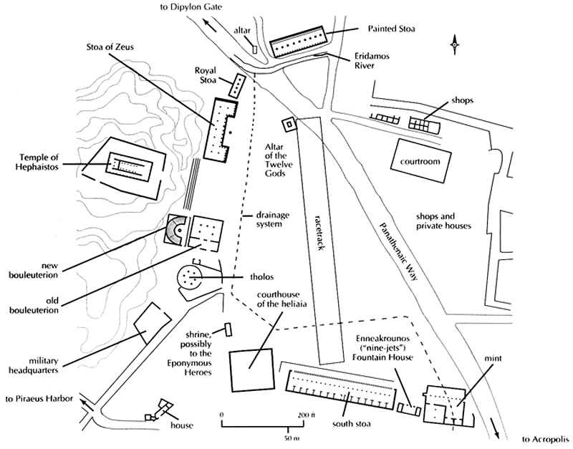

Athenian Agora

