COMM 223: FINAL EXAM

Chapter 1: Defining Marketing & The Marketing Process

Definitions
- Marketing – creating value for customers and building strong relationships in order to capture value from customers in return
  - Discovering and satisfying needs
  - Goal: attract new customers while maintaining current customers

Marketing Process (UDCBC)
- Understand the marketplace and customer needs/wants
- Design a customer-driven marketing strategy
- Construct an integrated marketing program that delivers value
- Build profitable relationships and create customer delight
- Capture value from customers to create profits and customer equity

Understanding the Marketplace and Customer Needs
- Needs, wants, demands
  - Needs – states of deprivation
  - Wants – needs shaped by culture and individual personality
  - Demands – sum of wants and buying power
  - Companies frequently conduct consumer research, analyze data and observe customers as they shop and interact, offline and online
- Market offerings
  - Market offerings – combination of products, services, information, or experiences offered to a market to satisfy a need or want
  - Marketing myopia - mistake of paying more attention to the product than the benefits
- Value and satisfaction
  - Marketers must set the right level of expectations so they buy again
- Exchanges and relationships
  - Exchange – obtaining a desired object by offering something in return
- Markets
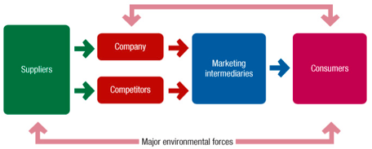
  - Market – all actual and potential buyers of a product or service
  - The entire consuming world
  - These buyers share a particular need or want that can be satisfied through exchange relationships

- Marketing is both a process (identifying and satisfying customer needs) and a cycle (mutual value generated between buyer and seller)

Designing a Customer-Driven Marketing Strategy
- Marketing Management - art and science of choosing target markets and building profitable relationships with them
- What customers will we serve?
  - Market segmentation – dividing markets into groups of customers
  - Target marketing – selecting one or more segments to serve
- How can we best serve these customers?
  - Value proposition – benefits promised to consumers that differentiates the brand
Marketing Management Orientations
- Production concept – idea that consumers favour products that are available and affordable
Focus: improving production and distribution efficiency
- Product concept - idea that consumers favour products that offer quality, performance and features
Focus: product improvement
Risk: can lead to marketing myopia
- Selling concept – idea that consumers won’t buy a company’s product unless it undertakes large scale selling and promotion effort
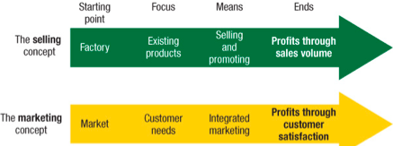
  - Risk: creates sales rather than profitable relationships
  - Usually for unsought goods
- Marketing concept – goals are achieved depending on whether needs and wants of a target market are met
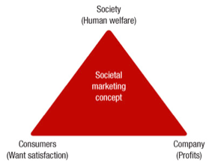
  - Customer-driven
- Societal Marketing concept – considers society’s long-term interests
  - Results in sustainable marketing (socially and environmentally responsible marketing that meets present needs while considering future interests)
  - Shared value – idea that societal needs define markets

Constructing an Integrated Marketing Plan/Program
- Integrated Marketing Plan – analyzes a firm’s current situation and transforms the marketing strategy into action
- Describes the 4 P’s (product, price, place, promotion)
  - Product – need-satisfying market offering
  - Price – charge of the offering
  - Place – how it will be available to target consumers
  - Promotion – communication with target customers to offer and persuade

Building Customer Relationships
- Customer relationship management – building and maintaining profitable customer relationships by delivering superior value and satisfaction
  - Targeting fewer, more profitable customers
  - Building two-way relationships (digital)
  - Attracting rather than intruding upon the market
  - Strategies: loyalty, retention
  - Tactics: frequency, club programs
- Customer-perceived value – customer’s evaluation of the difference between benefits and costs of a market offering relative to competition
- Customer satisfaction – when perceived performance matches buyer’s expectations
  - Meets expectations: loyalty
  - Exceeds expectations: advocacy
- Customer engagement marketing - making a brand a meaningful part of consumers’ conversations
- Goal: produce high customer equity
- Customer equity - total combined customer lifetime values of all the company’s customers
- Consumer-generated marketing – brand exchanges created by consumers
- Partner relationship management – working with partners in other departments and outside company to jointly bring greater value to customers

Capturing Value from Customers
- It’s 5x cheaper to keep an old customer than to acquire a new one
- Customer lifetime value – value of the entire stream of purchases a customer makes over a lifetime
  - Ex: with each customer lost, Leonard’s loses $50,000 in lifetime revenue
- Share of a customer – portion of a customer’s purchasing that a company gets in their product categories
  - Ex: banks want share of wallet, restaurants want share of stomach
- Customer equity – total combined customer lifetime values of all the company’s current and potential customers
  - Ultimate aim of customer relationship management
  - The more loyal the customers, the higher the customer equity
  - Better measure of a firm’s performance than current sales or market share
- Different types of customers require different relationship management strategies
- Butterflies – short-term customers, high profit potential
- True friends – long-term customers, high profit potential
- Strangers – short-term customers, low profit potential
- Barnacles – long-term customers, low profit potential
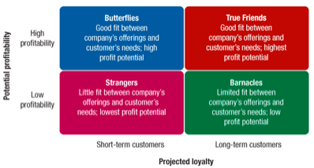

Trends in the Marketing Landscape
- Online, mobile and social media marketing
- Digital and social media marketing – using digital tools to engage consumers anywhere and anytime via their devices
- Ex: websites, social media, mobile apps, ads, online video, email, blogs
- Mobile marketing is the fastest growing digital marketing platform
- Uncertain/changing economic environment
- Canadians now show an enthusiasm for frugality
- Simpler living, more value of a dollar
- Marketers are focusing on value-for-the-money, practicality, and durability
- Not-for-profit marketing
- Not-for-profits face stiff competition for support and membership
- Rapid globalization
- Canadian companies have developed global operations, making and selling their products worldwide
- Managers around the world must take a global view of the company’s industry
- Sustainable marketing (CSR)
- Marketers’ relationships with social values and responsibilities
- Environmental movement

Chapter 2: Partnering to Build Customer Relationships

Strategic Planning
- Strategic planning – developing and maintaining a strategic fit between a company’s goals, capabilities, and its changing marketing opportunities
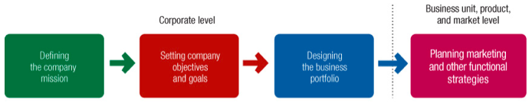
- Involves adapting a firm to take advantage of its constantly changing environment

1) Defining the company’s mission
- Mission statement – statement of an organization’s purpose
- What it wants to accomplish in the larger environment
- Meaningful, specific, emphasizes strengths

2) Setting company goals
- Turning mission into detailed supporting objectives for each level of management
- Ex: business objective is to increase profit, marketing objective is to increase market share

3) Designing business portfolio
- Business portfolio – collection of businesses and products that make up a company
- Best fits the company’s strengths and weaknesses to opportunities
Step 1: analyzing current business portfolio to decide which it should receive more of less
  - Strategic business units (SBUs) - key businesses, company divisions, product lines, or even single products, that make up a company
  - The Boston Consulting Group (BCG) approach is used
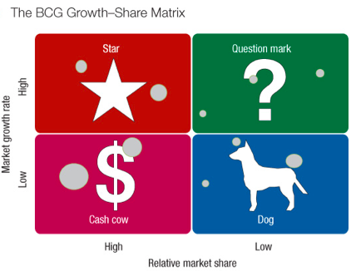
    - It uses market growth rate and relative market share to classify SBUs into four groups
1) Stars - high-share of high-growth market, to be built into cash cow via investment
2) Cash cows - high-share of low-growth market, to be maintained or harvested for cash to build stars
3) Question marks - low-share of high-growth market, to be built into stars via investment or reallocate funding and let slip into dog status
4) Dogs - Low-share of low-growth market, to be maintained or divested
- Problems – can be difficult, time-consuming, costly to implement, and only focuses on classifying current businesses and not future planning
Step 2: shapes the future portfolio by developing strategies for growth or downsizing
- The Product-market expansion grid method is used
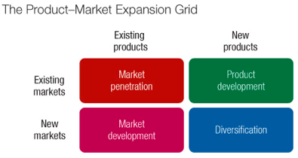
- Market penetration – increasing sales of current products to current market segments without changing the product
- Market development – identifying and developing new market segments for current company products
- Product development – offering modified or new products to current market segments
- Diversification – starting up or acquiring businesses outside the company’s current products and markets
- Downsizing is also a strategy which abandons products or markets that are not profitable

Partnering to Build Customer Relationships
- Marketing provides:
- Philosophy – marketing concept that suggests that company strategy should revolve around building profitable relationships with important consumer groups
- Inputs – provided to strategic planners by helping identify attractive market opportunities
- Strategies – designed to reach objectives
- Partner relationship management – working with internal partners can create an effective value chain, and working with external partners helps create a value delivery network
- Value chain – internal departments that carry out value-creating activities to design, produce, market, deliver and support a firm’s products
  - Coordination of all departments is key
  - As strong as its weakest link
- Value delivery network – network made up of the company, suppliers, distributors, and customers who partner to increase performance of entire system

Marketing Strategy
- Objective – build profitable relationships through value creation
- Market segmentation – dividing a market into groups of buyers based on needs, characteristics and behaviours
- Market targeting – evaluating each market segment and selecting which to enter
- Positioning – make the consumer think a certain way about a brand or product
- Differentiation – differentiating the company’s market offering from competition as to give more value to customers

Marketing Mix
- Marketing mix – set of marketing tools that the firm blends to produce the response it wants in the target market
- Product – the market offering
- Variety, quality, design, features, brand name, packaging, services
- Buyer’s view: customer solution
- Price – amount of money customers must pay
- List price, discounts, allowances, payment period, credit terms
- Buyer’s view: customer cost
- Place – refers to distribution of the product and availability of the service
- Channels, coverage, assortments, locations, inventory, transportation, logistics
- Buyer’s view: convenience
- Promotion – activities that communicate and persuade the benefits of the product
- Marketing communications, advertising, public relations, sales promotions, personal selling, direct marketing, online marketing, social media marketing
- Buyer’s view: communication

Managing Marketing
- Analysis, planning, implementation and control (APIC)
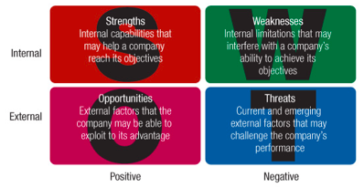
1) Marketing analysis
- SWOT Analysis
2) Market planning
- Marketing plan
  - Executive Summary
  - Current Marketing Situation
  - SWOT
  - Objectives and Issues
  - Marketing Strategy
  - Action Programs
  - Budgets
- Controls
3) Marketing implementation – turns marketing strategies and plans into actions to accomplish strategic objectives
- Who? Where? When? How?
4) Marketing control – measuring and evaluating the results of strategies and taking corrective action to ensure objectives are achieved
- Set specific marketing goals
- Measure performance in the marketplace
- Evaluate performance
- Take corrective action to close the gaps between goals and performance
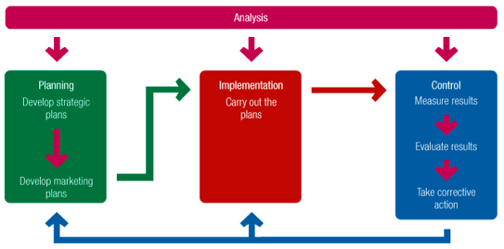
- Operating control – evaluates performance against the annual plan and takes corrective action
- Strategic control – evaluates whether strategies match opportunities

Marketing Department Organization
- Larger companies usually have a CMO (Chief Marketing Officer) and/or other senior executive marketing roles
- Functional Organization – different marketing activities are headed by a specialist
- Geographic Organization – sales and marketing people are assigned to specific countries, regions, and/or districts
- Product Management Organization – one person is responsible for the strategy and marketing program for a single product
- Market or Customer Organization – manager responsible for specific market or type of customer (ex: government buyers)
- Combination Organization - uses some combination of the previous four approaches
- Return on marketing investment (ROI) – net return divided by costs of marketing investment

Chapter 4: Analyzing the Marketing Environment
- Marketing environment – actors and forces outside marketing that affect management’s ability to build and maintain successful relationships with target customers

Microenvironment
- Microenvironment – actors close to the company that affect its ability to serve its customers
    - Forces with direct impact to the company
    - Internal - controlled
    - External - uncontrollable
Actors
- Company
- Ex: top management, finance, R&D, purchasing, operations and accounting
- All departments must work together to provide superior customer value
- Suppliers
- Important link in the overall customer value delivery network
- Provide resources needed to produce goods and services
- Marketers treat suppliers like partners in creating and delivering customer value
- Marketing intermediaries
- Help the company to promote, sell, and distribute its goods to final buyers
- Ex: resellers, physical distribution firms (help move goods from point a to b), marketing service agencies (research firms, advertising agencies, media firms, consulting firms, etc), financial intermediaries
- Competitors
- A company must provide greater customer value and satisfaction than its competitor
- Publics
- Public – any group that takes interest in or impacts an organization
- Financial publics – influences company’s ability to obtain funds
    - Ex: banks, investment analysts, stockholders
- Media publics – carries news, features, editorial opinions
    - Ex: TV stations, newspapers, magazines
- Government publics – government developments must be considered
- Citizen-action publics – consumer organizations, environmental groups, minority groups, etc.
- Local publics – neighborhood residents and community organizations (to provide support)
- Internal publics – workers, managers, volunteers, and board of directors
- General publics – general attitude must be a concern for companies
- Customers
- Most important actor
- Consumer markets, business markets, reseller markets, government markets, international markets

Macroenvironment
- Macroenvironment – larger societal forces that affect the microenvironment
- External forces with direct impact across industries
Major Forces (Deconatechpocu)
- Demographic – study of human populations
- Decisions based on shifts in demographics
- Ex: size, density, location, age, gender, race, occupation, and other statistics
- Marketers watch, anticipate, and react to changing age and family structures, geographic population shifts, educational characteristics, and population diversity
- Changing demographics of the Canadian population is both an opportunity and a threat
- Growing “crowded nest” syndrome
- Fewer families have children
- Average Canadian household shrank to 2.5 people
- More dual-income families
- Growth rates across Canada are not uniform
- Rural to urban migration continues
- Buying habits differ by region
- Growth in telecommuting market
- Baby Boomers
- 9.8 million people born between 1947 and 1966
- One-third of the population
- Wealthiest generation; controls over 50% of country’s wealth
- Recession hit Baby Boomers hard, eating into nest eggs and retirement prospects
- Boomers “think young;” strong targets for financial services
- Gen X
- 7 million born between 1967 and 1976
- Defined by shared experiences:
- Increased parental divorce rates and more employed mothers resulted in latchkey kids
- Less materialistic; prize experiences
- Skeptical of marketing
- Most educated generation to date
- Face economic pressures; spend carefully
- Millennials
- 10.4 million born between 1977 and 2000
- Larger group than Generation X/Baby Boomers
- Includes tweens, teens, and young adults
- Fluent with digital technology
- Personalization and product customization are key to marketing success
- General trends include:
  - Better educated, white-collar population
      - Increased demand for higher quality and understanding of value
  - Increasing diversity
      - Large and growing visible minority market
      - Growth in recognized disabilities
      - Acceptance of LGBT and gay marriages
- Economic
- Factors that affect consumer purchasing power and spending patterns
- Nations vary in levels and distribution of income
  - Industrial economies – rich markets
  - Subsistence economies – consume their own output
  - Developing economies – market opportunities for certain products
- Changes in income:
- Consumption frenzy, record personal debt
- Economic crisis leading to consumer frugality
- Value marketing is key to success
- Changes in spending patterns
- Natural – physical environment and natural resources used to produce goods
    - Focus on creating environmentally-sustainable products
    - Environmental sustainability - effort to create a world economy that the planet can support indefinitely
    - Ex: shortage of raw materials, increased pollution, increased government intervention
- Technological
- Most dramatic force
- Ex: creating new markets, increasing obsolescence, accelerating customer needs, constantly evolving regulations
- Government bans unsafe products and sets safety standards
- Regulations result in higher research costs, and longer time to market for new products
- Political
- Laws, government agencies, and pressure groups
- Regulatory trends - evolving laws influence organizations
  - Protects companies from each other
  - Protects consumers from unfair business practices
  - Protects the interests of society
- Increased emphasis on ethics and socially responsible behavior
- Cause-related marketing – companies linking to worthwhile causes
- Cultural
- Forces that affect society’s basic values, perceptions, preferences and behaviors
- Standard acceptable belief system that affects a society’s basic values
- Core beliefs slow to change
- Secondary beliefs are more open to change
- People’s view of: themselves, others, organizations, society, nature and the universe

Responding to the Marketing Environment
- Reactive responses – firms are passive and simply react to the environment
- Wait for change, then react
- Missed opportunities
- Damage from threats
- Proactive responses - attempt to manage the marketing environment via aggressive actions
- Anticipate change (act now)
- Seized opportunities
- Lower impact of threats
- Ex: initiating lawsuits, hiring lobbyists, filing complaints with regulators

Chapter 5: Marketing Information for Customer Insight
- Companies use competitive insights to gain a competitive advantage
- Customer insights – understandings of customers and the marketplace derived from marketing information
    - Basis for customer value and relationships
    - Customer insight teams are replacing traditional market research departments
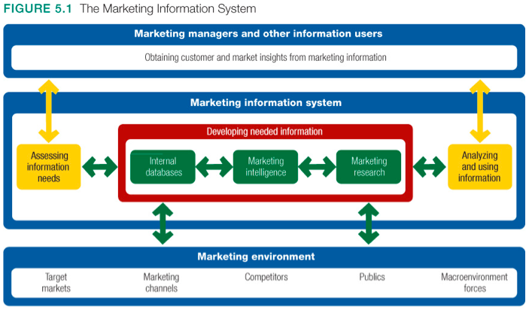
- Marketing information system (MIS) – consists of people and procedures which:
  - Assess information needs
  - Develop needed information
  - Analyze and use information
  - A good MIS balances information wants, needs, and feasibility

Marketing Information
- Internal data - electronic collections of consumer and market information obtained from data sources within the company network
  - Can be accessed more quickly and cheaply than other information sources
  - However, may be incomplete or in the wrong form for marketing decisions
  - Ex: customer databases
- Competitive marketing intelligence – collection and analysis of publicly available information about consumers, competitors, and developments in the marketing environment
  - Can raise ethical issues as some techniques are considered shrewd
  - Ex: observing consumers, quizzing employees, researching on the internet, monitoring social media buzz
- Marketing research – systematic design, collection, analysis, and reporting of data relevant to a specific marketing situation facing an organization

Marketing Research Process
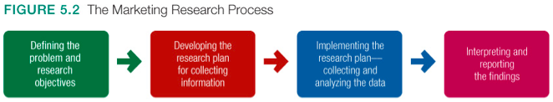

1) Defining the problem and research objectives
1) Exploratory research – gathers information to help define the problem, hypothesis
2) Descriptive research - describes marketing situations or markets
3) Causal research – tests hypotheses of cause-and-effect relationships

2) Developing the research plan
The research plan outlines:
  - Sources of existing data
  - Specific research approaches
  - Contact methods and sampling plans
  - Instruments for data collection
Information needs include:
  - Detailed customer characteristics
  - Usage patterns
  - Retailer reactions
  - Sales forecasts
Research plan calls for gathering primary data, secondary data, or both
  - Secondary data – information that already exists
        - Commercial online databases or internet search engines
        - Advantages: quicker and cheaper
        - Disadvantages: needed information may not exist, must be relevant (fit project’s needs), accurate (reliable), current, and impartial (objective)
  - Primary data – consists of information collected for the specific purpose at hand
        - Must be relevant, accurate, current, and unbiased
        - Research approaches – observations, surveys and experiments
1) Observational research – observing people, actions and situations
  - Ethnographic research – observational research that sends trained observers to watch and interact with consumers in their national environment
2) Survey research – asking people questions
  - Most used method
  - Best suited for descriptive information
3) Experimental – matches groups, gives different treatments, and checks for differences in responses
- Best suited for explaining cause-and-effect (causal) relationships and for descriptive information
- Contact methods – mail, telephone, personal, online
- Mail questionnaires (low cost, no bias, honesty, not flexible, low return rate)
- Telephone interviews (best method, flexible, higher cost, bias)
- Personal interviews (individual or group such as focus groups)
- Online marketing research – online surveys, online focus groups, web-based experiences (low cost, high response rates, don’t know who’s behind screen)
- Tracking consumers’ behavior (or behavioral targeting – tracking data to target advertisements to specific consumers)
- Sampling plan
      - Sample – representative segment of selected population
      - Who? Sampling unit
      - How many? Sample size
      - How to choose? Sampling procedure
1) Probability (random) samples - every subject in a given population has equal opportunity to be contacted
2) Non-probability (non-random) - participants obtained through methods other than randomly (not as accurate)
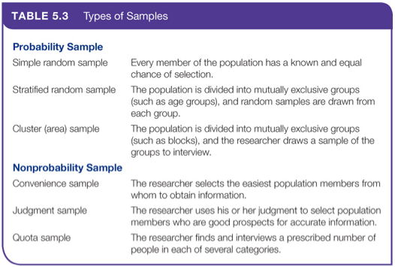

  - Research instruments
        - Questionnaires (common, flexible)
        - Mechanical instruments (checkout scanners, neuromarketing)

3) Implementing the Research Plan
1) Collecting the data:
- Most expensive phase
- Subject to error
2) Processing the data:
- Check for accuracy
- Code for analysis
3) Analyzing the data:
- Tabulate results
- Compute statistical measures

4) Interpreting and Reporting the Findings
- Draw conclusions
- Report to management

Analyzing and Using Marketing Information
Customer Relationship Management (CRM) - manages detailed information about individual customers and carefully manages customer “touch points” to maximize customer loyalty
- Touch points - describe the contact between the customer and company
- Ex: customer purchases, sales force contracts, service calls, website visits, etc.
- Consists of software and analytical tools
- Captures and analyzes information from all customer sources
- Applies the results to build stronger relationships
- Use data warehouses and data mining techniques
- Findings may lead to new marketing opportunities
- Benefits of CRM:
  - Offers better customer service and develops deeper customer relationships
  - Pinpoints and targets high-value customers more effectively
  - Enhances the firm’s ability to cross-sell products and develop offers tailored to customers

Other Marketing Information Considerations
Marketing Research in Small Businesses and Non-Profits:
- Could benefit through observation or informal surveys using small convenience samples
International Marketing Research:
- Many countries have no research services
- Good secondary data is scarce
- International markets vary greatly in economic development, cultures and customs, and buying patterns
- Cultural differences must be considered
Ethics:
- Intrusion on consumer privacy
- Misuse of research findings

Chapter 6: Understanding Consumer/Business Buyer Behavior
- Consumer buyer behavior - the buying behavior of final consumers—individuals and households that buy goods and services for personal consumption
- Consumer market - all the individuals and households that buy or acquire goods and services for personal consumption
- How do consumers respond to various marketing efforts the company might use?
- Goal – create marketing programs that triggered desired behavior

Consumer Buyer Behavior
Factors of Influence (CSPP)
- Cultural
1) Culture – set of values, perceptions, wants and behaviours learned by members of a society
- It is learned from family, church, school, peers, colleagues
- Cultural shifts create opportunities for new products
2) Subculture - groups of people with shared value systems based on common life experiences
  - Ex: regional subcultures, demographic subcultures, founding nations, ethnic subcultures, mature consumers
  - Cross-cultural marketing – including ethnic themes within a brand’s mainstream marketing
3) Social Class
- Divisions based primarily on socio-economic status
  - Ex: occupation, income, education, wealth, and other variables
- Social
1) Reference groups - membership, reference, and aspirational groups vary in how they influence
- Marketers attempt to reach word-of-mouth influencers and opinion leaders (also considered buzz marketing)
- Online social networks allow marketers to interact with consumers
- 2) Family - household “power-brokers” influence buying behavior (parents, children)
  - Gender stereotypes for certain purchases are changing
  - Children have stronger influence on family buying decisions
3) Roles & status
- Role – expected activities
  - Ex: manager, wife and daughter, etc.
- Status – esteem given to a role by
  - Ex: occupation, income, education, wealth, and other variables
- Personal
1) Age and life-cycle stage - needs for different products change
2) Occupation - job affects the products bought
3) Economic situation – personal finances affect buying choices
4) Lifestyle – people buy the lifestyle products represent
5) Personality & self-concept – self-concept theory suggests possessions contribute to and reflect personal identity
  - Generally defined in terms of traits
  - Self-concept theory suggests that people’s possessions contribute to and reflect their identities
  - Brands may also have personalities (sincerity, excitement, competence, ruggedness, sophistication)
- Psychological
1) Motivation
- Motive – a need requiring satisfaction
- Maslow’s hierarchy of needs explains why people are driven by needs at particular times
  - Physiological, safety, social, esteem, self-actualization
2) Perception – process of selecting, organizing and interpreting information to form meaningful pictures
- Influencers:
  - Selective attention – tendency for people to screen out most information
  - Selective distortion – tendency to interpret information to support what they already believe
  - Selective retention – tendency to remember good points about what they favor and forget other points
  - Subliminal advertising – being affected by marketing messages without even knowing
3) Learning – behavioral change based on experience
- Drive – strong internal stimulus that calls for action
- Cues – minor stimuli that determine responses
- Occurs due to an interplay of drives, stimuli, cues, responses, and reinforcement
- Behaviours with rewarding results tend to be repeated
4) Beliefs & attitudes – personal thoughts on subjects and evaluations thereof

Buyer Decision Process
- Need recognition
- Triggered by internal stimuli (ex: hunger, thirst) or external stimuli (ex: advertisement, conversation)
- Information search
- Personal sources – family, friends, neighbors
- Commercial sources – advertising, salespeople, packaging
- Public sources – mass media
- Experiential sources – examining and using the product
- Evaluation of alternatives
- Purchase decision
- Influence by attitudes of others and situational factors
- Post-purchase behavior
- Performance < Expectations = Disappointment
- Performance = Expectations = Satisfaction
- Performance > Expectations = Delight
- Cognitive dissonance – discomfort caused by post-purchase conflict

Buyer Decision Process for New Products
- New product – product is perceived by potential customers as new
- Adoption process (AIETA) – mental process after first hearing about an innovation to final adoption
- Awareness: consumer becomes aware of the new product, but lacks information
- Interest: consumer seeks information about new product
- Evaluation: consumer considers whether trying the new product makes sense
- Trial: consumer tries new product on a small scale to determine its value
- Adoption: consumer decides to make regular use of the new product
- Adopter categories – different rates and readiness to adopt new products
- Innovators – new ideas at some risk
- Early adopters – opinion leaders
- Early mainstream – adopt before average person
- Late mainstream – skeptical, adopt after majority
- Laggards – tradition bound
- Characteristics that influence rate of adoption
  - Relative Advantage - is the innovation superior to existing products?
  - Compatibility - does the innovation fit the values and experience of the target market?
  - Complexity - is the innovation difficult to understand or use?
  - Divisibility - can the innovation be used on a limited basis?
  - Communicability - can results be easily observed or described to others?

Business Markets and Buyer Behavior
- Business-to-Business (B2B):
- Buying behaviour of firms that buy products to produce other products or to resell to others
- B2B market is huge and involves far more dollars and items than consumer markets
- Business markets much larger than consumer markets
- Market Structure and Demand
  - Fewer but larger buyers
  - Demand is derived from consumers
  - May be inelastic or fluctuating demands
- Nature of the Buying Unit
  - More decision participants
  - Professional buying effort
- Types of Decisions
  - More complex & formal decisions
  - Involve large sums of money, complex technical and economic considerations, and interactions among people at many levels of the buyer’s organization
  - Supplier development – networks of supplier-partners to ensure an appropriate and dependable supply of products and materials
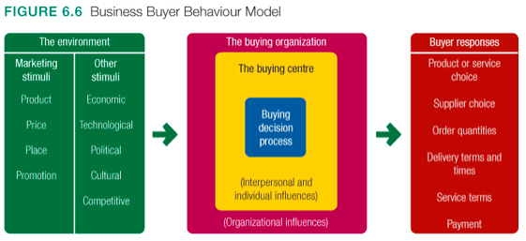
- Business Buyer Behavior Model

- Types of buying situations
  - Straight buy – order without modifications
  - Modified buy – order with modifications
  - New task – first time order of a product
  - Systems/solutions selling – order including multiple elements
- Buying center – participants in a purchase decision
  - Not a fixed or formally identified unit
  - Size and makeup will vary for different products and different situations
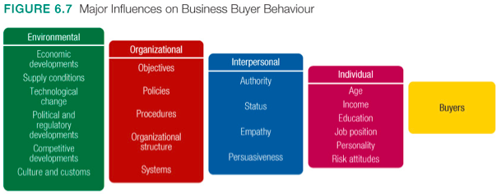
- Influences

Buying Process
- Problem recognition
- General need description
- Product specification
- Product value analysis – thoroughly analyze a product
- Supplier search
- Proposal solicitation
- Supplier selection
- Order-routine specification
- Performance review
- E-procurement – purchasing through electronic connections between buyers and sellers
  - Reverse auctions – businesses put their purchasing requests online and invite suppliers to bid for the business
  - Trading exchanges - companies work collectively to facilitate the trading process
  - Company buying sites
  - Extranet links with key suppliers – direct procurements

Chapter 7: Segmentation, Targeting and Positioning
1) Select customers to serve
- Segmentation
- Targeting
2) Decide on a value proposition
- Differentiation
- Positioning

Segmentation
Segmentation – dividing a market into groups with distinct needs, characteristics, or behaviors that might require separate marketing strategies or mixes
- Geographic segmentation - dividing a market into different geographical units
  - Global regions, countries, regions, provinces, cities, neighborhoods
- Demographic segmentation – diving market based on certain variables
  - Age, gender, family size, life cycle, household income, occupation, education, ethnic/cultural group, generation
  - Age and life-cycle segmentation – consumer needs and wants change with age
      - Different products and marketing approaches are used for different life-cycle stages
      - Ex: Lunchables, Disney Cruise lines
    - Gender segmentation – different products for different genders
      - Neglected gender segments can offer new opportunities
      - Ex: Harley Davidson actively targets women
    - Household income segmentation - refers to total family income, whether one or both parents work
      - Useful for targeting the affluent for luxury goods
      - People with low annual incomes can be a profitable market
      - Troubled economy makes targeting all income groups a challenge
    - Ethnic/cultural segmentation - based on race, ethnicity and language
- Psychographic segmentation - dividing a market based on social class, lifestyle, or personality characteristics
  - People in the same demographic group can have different psychographic makeups
  - Ex: Anthropologie, W Hotels, etc.
- Behavioral segmentation – dividing a market based on consumer knowledge, attitudes, uses or responses to a product
  - Occasion segmentation – division according to occasions when buyers get the idea to buy, actually make their purchase, or use the item
      - Helps firms build up product usage
      - Ex: Halloween, orange juice or the morning, flowers for Mother’s Day
    - Benefit segmentation – division according to benefits that consumers seek
      - Ex: buying bikes for racing, fitness, transportation, etc.
    - User status - non-users, ex-users, potential users, first-time users, regular users
    - User rate – identifying heavy users may be a challenge (light, medium heavy)
    - Loyalty status – division based on degree of loyalty
- Companies usually use multiple segmentation bases
  - Start with a single base and then expand to other bases
  - Multivariable segmentation systems such as PRIZM NE (New Evolution) are becoming more common
Segmenting Business Markets
- Use additional variables such as operating characteristics, purchasing approaches, situational factors, and personal characteristics
Segmenting International Markets
- Geographic location (by region)
- Economic factors (by population income levels)
- Political and legal factors (by type/stability of government, monetary regulations, etc.)
- Cultural factors (by common languages, religions, customs, etc.)
- Intermarket segmentation – divide segments with similar needs and buying behaviors despite different locations
  - Also called cross-market segmentation
  - Ex: H&M targets fashionable and frugal shoppers in 43 countries
Segmentation Requirements
- Measurable – size, purchasing power, profiles
- Accessible - reachable
- Substantial – large enough and profitable enough to serve
- Differentiable – distinguishable in their responses
- Actionable – can design programs for them

Targeting
Targeting – evaluating each market segment’s and selecting which to enter
- Evaluate market segments
- Look at size and growth
- Look at structural attractiveness
- Look at company objectives and resources
- Five Forces (competitors, new entrants, substitute products, buyer power, supplier power)
- Select target market segments (from broad to narrow)
- Undifferentiated (mass) marketing – ignores market segment differences and targets whole market with one offer
- Differentiated (segmented) marketing - targets several segments and designs separate offers for each
- Concentrated (niche) marketing - targets one or a couple small segments
- Micromarketing - tailoring to the needs and wants of specific individuals and small geographic areas
  - Local marketing - tailoring brands and promotions to local customer groups in the same city, neighborhood, or store
    - Ex: location-based apps such as Groupon
  - Individual marketing - tailoring products and marketing programs to individual customers (also known as mass customization)
    - Ex: NikeID program, custom suits, custom M&Ms, etc.
- Factors in choosing a targeting strategy:
  - Company resources
  - Product variability
  - Product’s life-cycle stage
  - Market variability
  - Competitor’s marketing strategies
- Be socially responsible

Differentiation and Positioning
Differentiation – differentiating market offering to create superior customer value
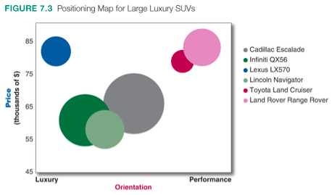
Positioning – arranging for a market offering to occupy a specific place relative to competition in the minds of target consumers
- Product position – consumer perception of a product
- Positioning map

Choosing a Differentiation and Positioning Strategy
- Identify competitive advantages
- Understand customer needs better than competitors, then deliver more value
- Points of differentiation can occur anywhere in the entire customer experience
- Ways to differentiate:
  - Product: Features, performance, style, design
  - Services: Speedy, convenient, or careful delivery
  - Channels: Coverage, expertise, performance
  - People: Training staff better than the competitors
  - Image: Convey distinctive benefits and positioning
- Select competitive advantage(s) on which to create position
- Single difference: Unique Selling Proposition (USP) – main benefit
- Multiple differences (if competition is fierce)
- Differences to promote:
  - Important: The difference delivers a highly valued benefit to target buyers
  - Distinctive: Competitors do not offer the difference, or the company can offer it in a more distinctive way
  - Superior: The difference is superior to other ways that customers might obtain the same benefit
  - Communicable: The difference is communicable and visible to buyers
  - Preemptive: Competitors cannot easily copy the difference
  - Affordable: Buyers can afford to pay for the difference
  - Profitable: The company can introduce the difference profitably
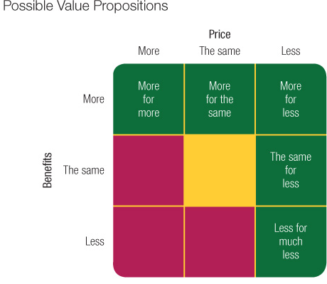
- Develop a positioning strategy
- Value proposition – full positioning of a brand, full mix of benefits
  - More for more - more benefits for a higher price
  - More for same - more benefits for the same price
  - More for less - more benefits for a lower price
  - Same for less - same benefits for a lower price
  - Less for much less - fewer benefits for a much lower price
- Positioning statement – summarizes company or brand positioning
  - To (target segment and need) our (brand) is (concept) that (point of difference)
  - Ex: To always online, socially connected Millennials, the Apple iWatch is a whole new kind of conversation that not only helps you send and receive messages, but lets you express yourself in new, fun and more personal ways

Chapter 8: Developing and Managing Products and Services

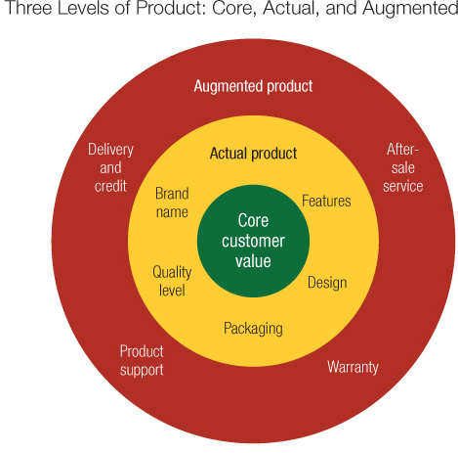
Products
Product – anything offered to a market for attention, use, or consumption that might satisfy a want or need
- Ex: tangible objects, services, events, persons, places, organizations, or ideas
- Service – activity, benefit or satisfaction offered for sale that is intangible and doesn’t result in ownership
- Products are differentiated based on experience in acquiring them

Classifications
- Consumer products – purchased by consumers for their personal use
  - Convenience products – purchased frequently, immediately and with a minimum of comparison and buying effort
  - Shopping product – less frequently purchased products that shoppers compare carefully
  - Specialty product – product with unique characteristics for which a significant group of buyers are willing to purchase
  - Unsought products – product that the consumer either doesn’t know about or knows but doesn’t normally think of buying
- Industrial products – bought by individuals for further processing or for business use
  - Material and parts – raw materials
  - Capital items – aid buyer’s production or operations
  - Supplies and services – operating supplies, repair and maintenance items

New Product Development
- New product development - development of original products, improvements, modifications, or new brands
- New product innovation is expensive and risky
- Most new products fail or underperform (80%)
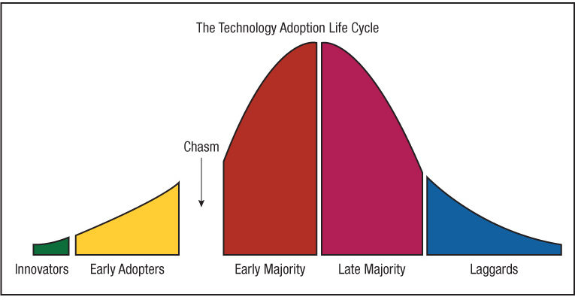
- Diffusion of innovations theory – divides members of a social group into segments according to how likely they are to adopt a new idea
- Technology Adoption Life Cycle
Major Stages
1. Idea Generation – search for new product ideas
- Internal (employees) and external (customers, competitors, distributors) sources
- Crowdsourcing - inviting broad communities of people, such as customers, employees, independent scientists and researchers, into the new product innovation process ideas
  - Ex: trade magazines and shows, advertising agencies, marketing research firms, laboratories, and inventors
2. Idea Screening – filtering ideas to spot good ones and drop poor ones
- Describe product, target market, and competition
- Estimate market size, price, development time and costs, manufacturing costs, rate of return
- Evaluate new-product ideas against a set of company criteria
3. Develop into concept and test
- Product concept – detailed version of the product idea in consumer terms (description, drawing, prototype)
- Concept testing - testing new-product concepts with groups of potential consumers
4. Marketing strategy development - initial marketing strategy and a three-part marketing strategy statement
- Describe the target market, planned value proposition, sales, market share, and profit goals
- Outline the product’s planned price, distribution, and marketing budget
- Describe the planned long-run sales and profit goals, marketing mix strategy
5. Business analysis – review of sales, costs and profit projections
- Positive review triggers product development
6. Product development
- Develops concept into a physical product
- Calls for a large investment
- Prototypes are developed and tested
- Prototypes must have required functional features and convey psychological characteristics
7. Test marketing
- Product introduced into a realistic market
- Gains experience prior to full introduction
8. Commercialization
- Full-scale introduction into the market
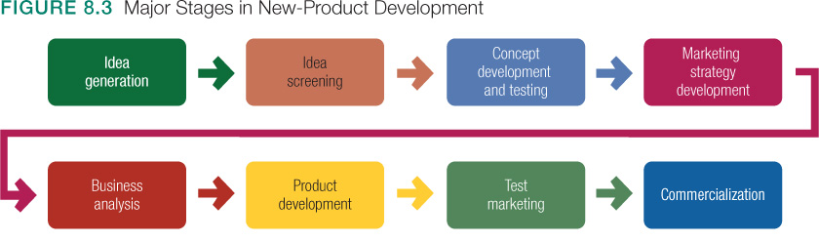

The Product Life Cycle
Product life cycle – course of a product’s sales and profits over its lifetime
1. Product development
- Company finds and develops a new-product idea
- Sales are zero and the company’s investment costs mount
2. Introduction
- Period of slow sales growth as the product is introduced in the market
- Profits are non-existent in this stage because of the heavy expenses of product introduction
3. Growth
- Period of rapid market acceptance and increasing profits
- Competition increases
4. Maturity
- Period of slowdown in sales growth because the product has achieved acceptance by most potential buyers
- Profits level off or decline because of increased marketing outlays to defend the product against competition
- Strategies: modify market, modify product, modify marketing mix
5. Decline
- Period when sales fall off and profits drop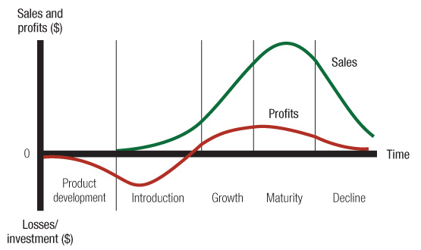
- PLC can apply to styles, fashions and fads
- Style - a basic and distinctive mode of expression
- Fashion - a popular style in a given field
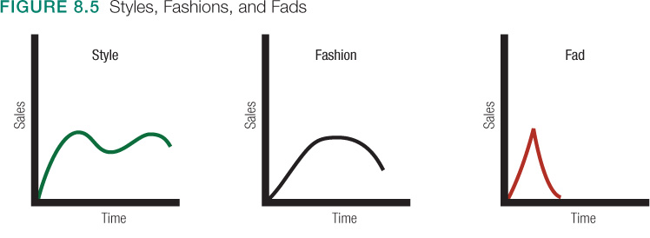
- Fads - temporary periods of unusually high sales driven by consumer enthusiasm
Problems with PLC
- The PLC can help develop strategies for different stages of the PLC
- Difficulties:
- Forecast sales level, length of each stage, and shape of PLC
- Develop marketing strategy because strategy is both a cause and result of the PLC
- Do not blindly push products to next stage
- Seek ways to rescue products and grow sales

Product and Service Decisions
Product line - group of products that are closely related, are sold to the same groups, are marketed the same ways, or fall within given price ranges
Product mix - set of all product lines and items that a company markets
Product decisions
- Physical attributes such as quality and design
- Packaging - protects, provides information, important promotional tool
  - Sustainable packaging – meets requirement while minimizing environmental, economic and social impacts of its product and package
- Labelling – identifies, describes product
- Product support services – customer support services
Product line decisions
- Product line length
- Line filling or line stretching
Product Mix decisions
- Width
- Length
- Depth – number of versions of a product
- Consistency – how closely related the various product lines are
International Product Marketing Decisions
- Adapted to suit local markets
- Have someone “on the ground” who understands local culture

Services Marketing
- Most important industry in Canada’s economy (70% of GDP)
- Government services - hospitals, military, police, mail service, schools, not-for-profits
- For-profit business services – financial institutions, tourism, real estate, professional services, entertainment
Service Characteristics
- Service intangibility – cannot be seen, tasted, felt, heard or smelled before purchase
- Service inseparability – cannot be separated from their providers
- Service variability – quality of services depends on who provides them, when, where and how
- Service perishability – cannot be stored for later sale or use
Marketing Strategies for Service Firms
- Service-profit chain - the chain that links service firm profits with employee and customer satisfaction
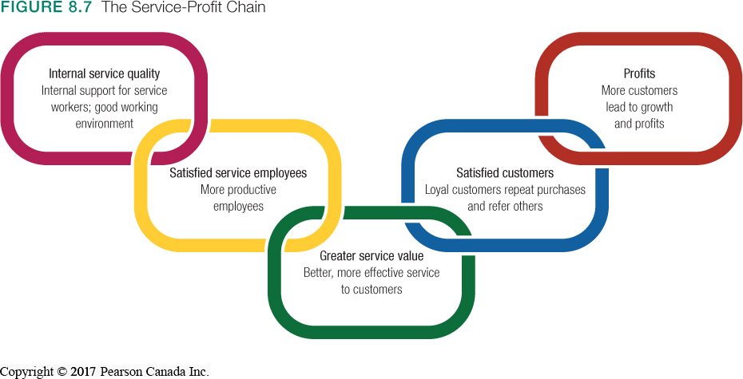

- Internal marketing - orienting and motivating customer-contact employees and supporting service people to work as a team to provide customer satisfaction
Marketing Tasks
- Service differentiation - innovative features that set one company’s offer apart from competitors’ offers
- Service quality - customer-driven quality movement
- Service productivity - train current employees better, hire new ones, increase quantity of their service by giving up some quality

Chapter 9: Brand Strategy and Management
Brand – a name, symbol, icon, design or combination of these that identifies the maker of a product
- Adds value to a product
- Provides legal protection for unique product feature
- Has status, value, personality
- Involves emotions
- Signifies quality
Brand meaning: key is to get consumers to associate brand with one word
Trademarks:
- Names, symbols, characters, shapes
- Has monetary value
- Indicated with a superscript TM
Brand relationships
- Key factor in consumers’ relationships with brands is what they believe about them
People as brands
- Celebrities and politicians aim to achieve brand power in their name
- Their name takes on meanings that transcend the person

Brand Characteristics
- Brand equity – financial value attributed to the brand based largely on intangible qualities
Brand strength measured through:
- Differentiation – how does it stand out
- Relevance – how consumers feel it meets needs
- Knowledge and esteem
- Customer equity
- Brand personality – human attributes and emotions they inspire toward customers
- Brand elements – name, logo, icon (shape, colors, etc.)
  - Logos support the brand’s positioning and adds personality
  - Companies now aim to make logos more approachable, upbeat, engaging

Branding Strategy & Management
- Brand name selection
- Should suggest something about the products
- Should be easy to pronounce and remember
- Should be distinctive
- Should be extendable
- Should be pronounceable in many languages
- Should be capable of registration and trademark protection
- Brand positioning
- 3 levels of positioning
  - Product attributes (least strong)
  - Desirable benefit (strong)
  - Beliefs and values (strongest)
- Should establish a mission and vision of what the brand must be and do
- Everyone in a company must live the brand
- Brand sponsorship
- National brands – created and owned by a producer of a product
  - Ex: Samsung Galaxy, Kellogg’s Frosted Flakes
- Private brands – owned by a reseller of a product
- Ex: Superstore Joe Fresh
- Private brands are growing faster than national brands
- Consumers are more price-conscious
- Licensing - buying and selling of the rights to use a brand name, logo, character, icon, or image
- Co-branding – using established brand names of 2 different companies on the same product

- Line extensions – extending an existing brand name to new forms, colors, sizes, ingredients or flavors of an existing product category
  - Ex: Honey Nut Cheerios and MultiGrain Cheerios
  - Advantages: low cost, low risk, familiarity
  - Risks: over-exposure of brand name
- Brand extensions – extending a brand name to new product categories
  - Ex: KitKat extended to KitKat Chunky, KitKat Peanut Butter, etc.
  - Advantages: instant recognition for new products
  - Risks: may confuse brand image or meaning
- Multibrands – same manufacturer produces many different brands in the same product category
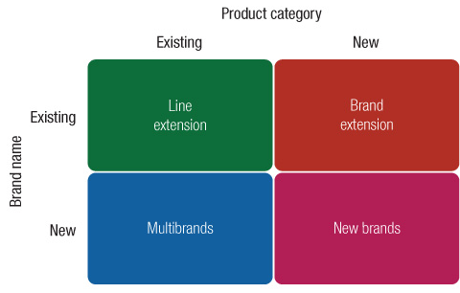
  - Ex: Whirpool Corporation has its own brand but also has Maytag, KitchenAid, etc.
  - Advantages: appeals to different segments
  - Risks: separate brands may be weak individually
- New brands – whole new brands created for new products or product lines
  - Advantages: best when new product doesn’t fit within any existing brand names
  - Risks: new brands require significant resources to launch and maintain

Brand Communications
Brand experiences and touchpoints
- Touchpoints – advertising, marketing communications, personal experience, word of mouth, social media, company websites, store displays, etc.
- Sensory, affective, behavioral and intellectual
Brand icons and characters
- Brand icons – objects with distinct shapes, colors and patterns associated with a brand
- Brand characters – lifelike brand icons, or mascots, that can move, speak, interact and have personality traits
- Brand engagement – interaction between consumers and brands, based on emotional connection
- Brand ambassadors – real people who, under contract, acts as a spokesperson for the brand
Brand stories
- When brand managers tell stories about brands, the details of the characters, place and action is all information we keep in our heads (information maps)
- Psychologists refer to these information maps as schemas
- Good strategy for inspiring loyalty among consumers
- Branded content – any form of information or story written and produced by a brand marketer
- Brand entertainment – form of entertainment, usually video, that is created with the cooperation or financial support of a marketer
Brands and social media
- Brand managers must create social groups, fan pages, and host dialogue with consumers
- In the era of the social web, brand managers must engage consumers online
- Brand advocates – promote their favorite brands, results from:
  - Trust with potential advocates
  - Create advocates close to home
  - Include customers/employees in the brand story
  - Deliver an experience that gets people talking
  - Outperform for advocates when they need it

Chapter 10: Pricing
Price – total value that customers exchange for the benefits of having or using the product or service
- Sum of all values that customers give up to gain the benefits of a product
- Increasingly becoming a less important element
- Most flexible marketing mix element

Pricing Strategies
- Customer value-based – pricing based on buyer perception
- Asses customer needs and value perceptions
- Set target price to match customer perceived value
- Determine costs that can be incurred
- Design product to deliver desired value at target price
  - Good-value pricing – offering just the right combination of quality/service at a fair price
    - Overall benefits = price
  - Value-added pricing – attaching value-added features and services to differentiate a company’s offers and charging higher prices
    - Overall benefits = same or higher price
- Cost-based – pricing based on seller costs
Steps
- Design a good product
- Determine product costs
- Set price based on cost
- Convince buyers of products’ value
- Costs set the floor for the price
- Fixed costs – don’t vary with production or sales level
- Variable costs – vary directly with the level of production
- Total costs – sum of both
- Cost-Plus Pricing – adding a standard mark-up to the cost of the product
- Break-even pricing – setting to breakeven on the costs of making and marketing a product
- Competition-based – pricing based on competitors
  - Consider competitors’ offering, marketing position, strengths and weaknesses
  - Above, at, or below pricing

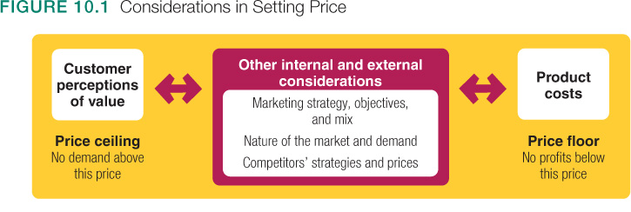

Factors Affecting Price

External Factors
- Market & demand
- Price elasticity
- Econ. conditions
- Regulations
- Social awareness & concerns
Internal Factors
- Corporate strategy and objectives
- Other marketing mix elements
- Desired position
- Brand

- Overall marketing strategy, objectives and marketing mix
  - Company decides marketing strategy before setting price
  - Pricing helps accomplish objectives
  - Pricing decisions coordinate with packaging, promotion, distribution
  - Positioning based on price
- Target costing - starts with an ideal selling price, and then targets costs that will ensure that price is met
  - Other firms choose not to position on price, or select high price strategies to enhance product prestige
- Organization considerations:
  - Who within the organization should set prices?
  - Varies on size and type of company
  - Some firms maintain pricing departments
- External factors
  - The market and demand
  - A firm’s flexibility in setting price varies depending on nature of the market
  - Pure competition – market consists of many buyers and sellers trading in a uniform commodity (ex: wheat, copper, financial securities)
    - Sellers don’t spend much on marketing strategies
  - Monopolistic competition – market consists of many buyers and sellers who trade over a range of prices rather than a single market price
    - Sellers invest in product differentiation
  - Oligopolistic competition – market consists of a few sellers who are highly sensitive to each other’s pricing and marketing strategies
  - Pure monopoly – market consists of 1 seller
  - The economy
    - Recession, inflation, interest rates
  - Government
  - Social concerns
  - Resellers
Price-Demand relationship
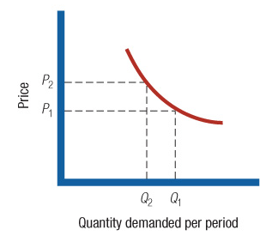

New-Product Pricing
- Price skimming – setting a high price for a new product to skim maximum revenues layer by layer from the segments willing to pay the high price
- The company makes fewer but more profitable sales
- Use when:
    - Product quality supports high price
    - Cost of low volume doesn’t cancel the benefit of higher price
    - Competitors can’t easily enter the market and undercut price
- Market-penetration pricing – setting a low initial price for a new product to attract a large number of buyers and market share
  - Use when:
    - Market is price-sensitive; low price produces market growth
    - Costs fall as sales volume increases
    - Competition can be kept out of the marketing with low pricing

Product Mix Pricing
- Product line pricing – setting prices across an entire product
- Optional-product pricing – pricing optional or accessory products sold with main product
  - Ex: GPS navigation system with a car
- Captive-product pricing – pricing products which must be used with main product
  - Ex: blades for razors
- By-product pricing – pricing by-products to make a main product’s price more attractive
  - Ex: wood by-products
- Product bundle pricing – pricing a bundle of individual products at a price lower than if purchases separately
  - Ex: fast food combo meals

Price Adjustment Strategies
- Discounts – reduction in price
  - Cash discount – discount to those who pay their bills promptly
  - Quantity discount – discount to buyers who buy large volumes
  - Seasonal discount – discount to buyers who buy merchandise/services out of season
- Allowances – promotional money paid by manufacturers to retailers in return for an agreement to feature their products in some way
  - Trade-in allowances – given for turning in an old item when buying a new one
    - Ex: cars
- Segmented pricing – selling a product at two or more prices, where the difference isn’t based on differences in costs
  - Customer-segment pricing – different customers pay different prices for the same product
    - Ex: senior citizens at movies
  - Product-form pricing – different versions of a product are priced differently but not according to their costs
  - Location-based pricing – company charges different prices for different locations, even though cost of offering is the same
  - Time-based pricing – firm varies its price by the season, month, day, hour, etc.
    - Ex: resorts giving weekend discounts
- Psychological pricing – considers consumer thought process, not simply economics
  - Price is used to say something about the product
  - Price influences perceptions of quality
  - Reference prices – prices buyers carry in their minds and refer to when looking at a product
- Promotional pricing – companies will temporarily price their products below list price to increase short-run sales
  - Discounts
  - Special-event pricing (ex: Christmas shoppers)
  - Cash rebates – to consumers who buy the product within a specific time
  - Low interest financing
  - Longer warranties
  - Free maintenance
- Geographical pricing – setting prices for customers located in different parts of the country or world
  - Free on board-origin pricing – responsibility is passed to the customer
  - Uniform-delivered pricing – company charges same price to all customers, regardless of their location
  - Zone pricing – all customers within a given zone pay a single and total price
    - The more distant the zone, the higher the price
- International pricing – adjusting prices for international markets, subject to many considerations
  - Factors to consider:
    - Economic and competitive conditions
    - Laws and regulations
    - Wholesaling and retailing system
    - Consumer perception and preferences
    - Different marketing objectives
    - Costs
- Dynamic pricing – adjusting prices continually to meet the characteristics and needs of individual customers and situations
  - Consider the affects of the internet on pricing
  - Benefits to marketers: mine databases
  - Benefits to consumers: price comparison sites

Price Changes
- Price cuts
  - Excess capacity
  - Falling demand
  - Drive to dominate market
- Price increases
  - Cost inflation
  - Over-demand
- Buyers will react
- Competitors may react
  - Reduce price to match competition
  - Raise the perceived value of its offer
  - Improve quality and increase price
  - Launch a low-price “fighting brand”

Public Policy
- Competition Act governs business practices
- Price-fixing – sellers must set prices without talking to competitors
- Bid-rigging – one party agrees not to submit a bid or tender in response to a call
- Predatory-pricing – selling below cost with the intention of punishing a competitor
- Price discrimination – sellers must offer same price terms to all customers
- Functional discounts – offering a larger discount to wholesalers than to retailers
- Retail price maintenance – manufacturer cannot require dealers to charge a specified retail price for its product
- Deceptive pricing – seller states prices or saving that are not actually available to consumers
- Scanner fraud – computer based checkouts where overcharging occurs

Chapter 11: Marketing Channels

Distribution Channels
- Value delivery network – producers, distributors and customers who improve the performance of an entire system in delivering customer value
- Supply chain
- Upstream: firms that supply raw materials to make products
- Downstream: marketing channel partners link producers to customers
- Marketing channel – interdependent firms that make a product available for businesses and customers
- Channel decisions affect marketing decisions
- Can lead to competitive advantage
- Channel partners add value
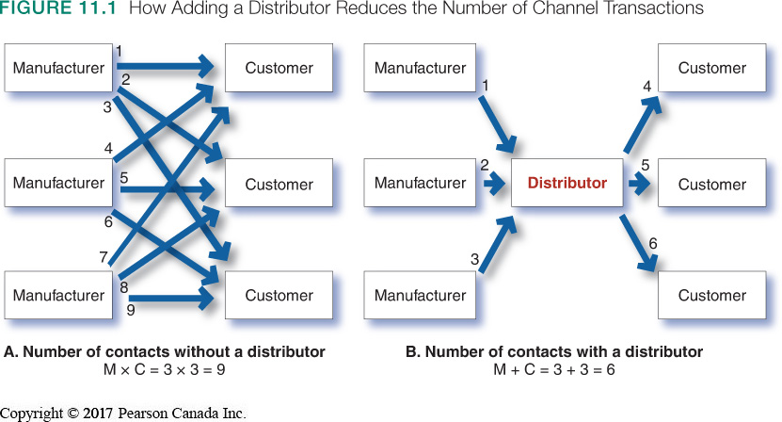

Channel Members – bridge major time place and possession gaps that separate goods/services from who will use them
Functions include:
- Information gathering and distribution - channel partners, such as retailers that are closer to the final customer, have access to information the manufacturer might not have. Channel partners can collect market intelligence and communicate it back to the original producer.
- Promotion at point of purchase - national brand advertising is typically handled by the manufacturer, but promotions at point of purchase, such as locally advertised sales, are handled by distributors and retailers.
- Contact - channel members, such as sales agents operating in the field and in local markets, can find new customers.
- Matching and arranging - channel partners often play a role in adapting the product to fit the buyer’s needs, such as customizing the installation of kitchen cabinets. Channel members such as specialty retailers also display and arrange products to offer customers a choice.
- Negotiation - channel partners such as brokers and agents negotiate price and terms of delivery so that the product can move from one channel member to another.
- Physical distribution - trucking and other transportation companies act as channel members by transporting and storing products as they move through the channel.
- Financing - companies such as Canadian Tire that offer store credit cards, and companies that sell large products such as cars, may have finance organizations as channel partners.
- Risk takin - depending on the partner arrangement, channel members may assume the risk of handling, transporting, and storing the product as it moves through the channel.
- After-sales support - some products, such as electronics and automobiles, require after-sales support and servicing. These functions are typically performed by channel partners.

Types of Intermediaries
- Wholesalers – sell products to those buying for resale or business use
  - Ex: merchant wholesalers, distributors
  - Add value for producers by performing one or more channel functions
  - Merchant wholesaler – independent wholesaler business that takes title to the merchandise it handles
  - Includes full-service wholesalers and limited-service wholesalers
  - Functions: market information, sales and promotion, assortment building and bulk-breaking, warehousing, absorbing risk, transportation, delivery, financing
  - Strategy: segmentation, targeting, differentiation, positioning
  - Marketing mix: product assortment & services, price, promotion, distribution
- Agents – perform only a few functions and don’t take title to goods
  - Ex: manufacturers’ agents, advertising agencies
  - Specialize by product line or customer type
  - Brokers bring buyers and sellers together
  - Agents represent buyers on a more permanent basis
- Manufacturer’s agents – common type that receives commission from manufacturer when selling their goods to buyers
- Advertising agencies – provide marketing communication services
- Retailers – sell products directly to consumers
  - Ex: self-service retailers, limited-service retailers, full-service retailers
  - Low price retailers include discount stores, off-price retailers, factory outlets, warehouse clubs
  - Can be classified by type of organization:
    - Corporate chain stores, voluntary, retailer co-operatives, franchise organizations
- Drop shippers – takes orders and payment from customer, then arranges to have the merchandise shipped to the customer directly
- Rack jobber – wholesaler that buyers merchandise and resells it on “racks” inside a retail store
- Broker – wholesaler that doesn’t take title to goods and whose function is to bring buyers and sellers together and assist in negotiation
  - Generally specialize by product line or customer type

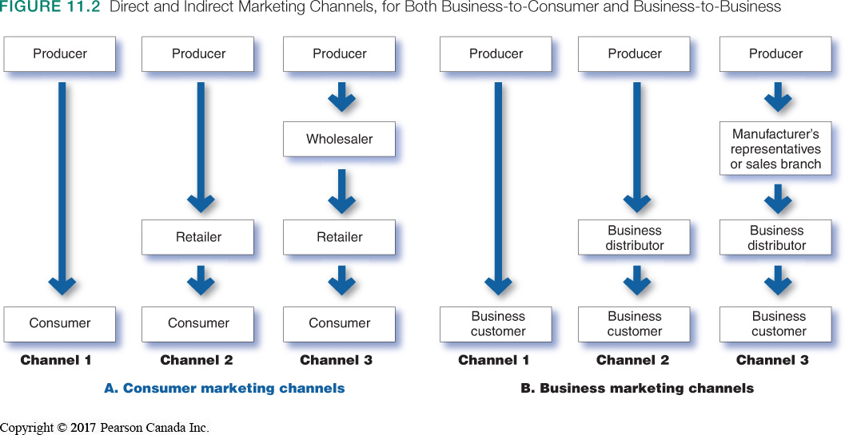
Organization and Management of Channels
Steps
- Select channel partners
- Decide how many channel levels (intermediaries, partners, etc.)
- Decide whether to set up direct or indirect marketing channels
- Decide whether to create a vertical marketing system, horizontal marketing system, or franchise
- Manage and motivate channel partners to avoid channel conflict
- Direct marketing channel – has no intermediaries
- Indirect marketing channel – contains one or more intermediaries
- All channel members connected by flows
  - Flow of ownership, payment flow, information flow, promotion flow
  - Vertical Marketing System (VMS) – a channel structure in which producers, wholesalers and retailers act as a unified system
- One channel member owns the others and has contracts with them
- Types of VMS (CAFA)
- Corporate – all stages of product and distribution are under single ownership
- Contractual – independent firms at different levels of production/distribution contract with each other to obtain more economies of scale
- Administered – coordinates stages of production and distribution through size and power of one of the parties
- Franchise – links several stages in the production and distribution process and controls operations from central head office
  - Franchisor – corporation that owns the rights to the brand
- Manufacture-sponsored retailer franchise system – ex: Ford and its independent franchised dealers
- Manufacture-sponsored wholesaler franchise system – ex: Coca Cola licensed bottlers in various markets that buy its syrup and then bottle and sell finished product to retailers
- Service firm-sponsored retailer franchise system – Boston Pizza franchise owners pay royalties on gross sales
  - Horizontal Marketing System (HMS) – two or more companies at the same channel level join to follow a new marketing opportunity
- Ex: joining forces with competitors or non-competitors
- Ex: Tim Hortons in Esso gas stations
3. Multichannel (Hybrid) Distribution Systems – single firm sets up 2 or more marketing channels to reach one or more customer groups
- Ex: Zara selling online and in-store
- Very common nowadays to distribute through multiple channels
- Advantage: with each new channel, sales and market coverage expands
- Can tailor to the specific needs of diverse segments
- Disadvantage: harder to control and can generate conflict
4. Disintermediation – established intermediary becomes unnecessary and is cut out of the channel
- Ex: Travelocity, Netflix, Uber

Channel conflict – disagreement among marketing channel members over goals, roles and rewards
- Horizontal conflict – among firms that perform the same function at the same channel level
- Vertical conflict – occurs between different levels of the same channel (more common)

Distribution Channel Strategy
1. Intensive distribution – product is stocked in as many outlets as possible
2. Selective distribution – marketer selects a set of retailers that specialize in their product category
3. Exclusive distribution – marketer gives the rights to distribute to 1 retailer

Channel Design Decisions
Marketing channel design – designing effective marketing channels by:
- Analyze customer needs
- Set channel objectives
- Determine the types and responsibilities of channel members
- Decide about international distribution channels
- Some markets are hard to penetrate

Supply Chain Management and Logistics
Logistics Management/Supply Chain Management – coordinating and controlling the physical flow of supplies and products (the logistics)
- Outbound distribution – moving products from the factory to resellers and customers
- Inbound distribution – moving products and materials from suppliers to the factory
- Reverse distribution – moving unbroken, unwanted, or excess products returned by consumers or resellers
- Just-in-time logistics systems – inventory management where small inventories of parts or merchandise are held, and new stock arrives “just in time” when its needed
- Companies can gain a competitive advantage
- Improved logistics can lower costs
- Increase product variety has created a need for improved logistics management
- Improvements in information technology have greater gains in distribution efficiency
- Logistics affect the environment and the company’s sustainability efforts
- Third-party logistics (3PL) – independent logistics provider that performs any or all functions required to get its client’s product to market
- Ex: Canadian Pacific, UPS, DHL, etc.
- Goal: deliver a targeted level of customer service at least cost
Logistic functions
- Warehousing
- Inventory management
  - RFID tags: computer chips to allow tracking
  - Continuous inventory replenishment systems
- Transportation
  - Multimodal (or intermodal) transportation – combining 2 or more modes of transportation
- Logistics information management

Chapter 13: Advertising and Public Relations

The Promotion Mix
- Advertising – any paid form of non-personal presentation and promotion of ideas, goods or services
- Sales Promotion – short-term incentives to encourage the purchase or sale of a product or service
- Public relations – building good relations with the public by favorable publicity, good image, and proper handling of negative rumors or events
- Personal selling - personal customer interactions by the firm’s sales force to make sales and build customer relationships
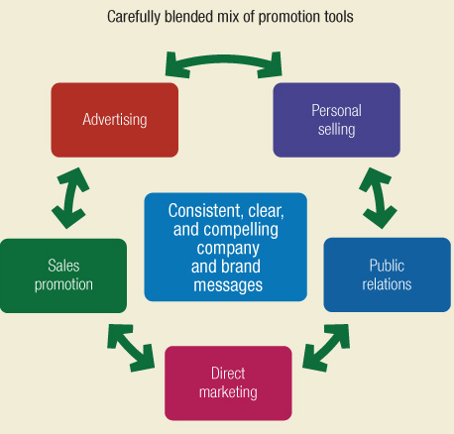
- Direct marketing – engaging directly with carefully targeted individual consumers and customer communities to get an immediate response and build lasting relationships
  - Ex: direct mail, catalogues, and telephone marketing to online, mobile, and social media

Integrating Marketing Communications
- Consumers see “single” messages from companies
- Communication technology is faster
- Marketing strategies must be integrated
- Integrated Marketing Communications (IMC) – integration of communication channels to deliver a clear, consistent and compelling message about the company and its products

 | PROS | CONS
ADVERTISING | - Reaches masses at low cost/exposure  - Repeats message  - Creates trust (legit) | - Impersonal (one-way)  - Sometimes high cost for certain media types
PERSONAL SELLING | - Two-way communication  - Feedback  - Builds relationships | - Long term sales force commitment  - Expensive promotion tool
SALES PROMOTION | - Wide assortment of tools  - Attracts attention  - Incentives to purchase  - Dramatizes product offer  - Invites quick response | - Effects are short-lived
PUBLIC RELATIONS | - Legitimizes credibility  - Reaches people who miss advertising  - Dramatizes a company/product  - Saves money when used proactively | - Tends to be used as an afterthought
DIRECT MARKETING | - Direct communication  - Tailored messages  - Interactivity  - One-to-one relationships | - Perceived as junk-mail/spam

- Push strategy – uses sales force and trade promotion to push the product through channels
- Pull strategy – marketing activities are directed toward final consumers to induce them to buy
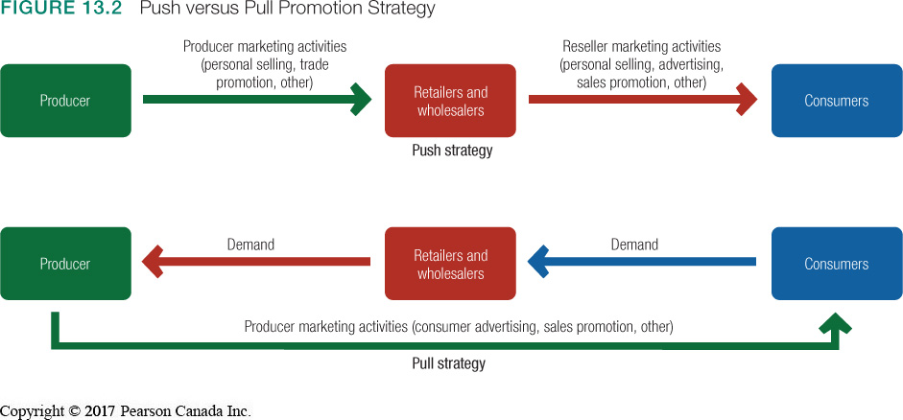Advertising
- Set advertising objectives
- Advertising objective – specific communication task to be accomplished with a targete audience during a specific period of time
- Inform, persuade, remind
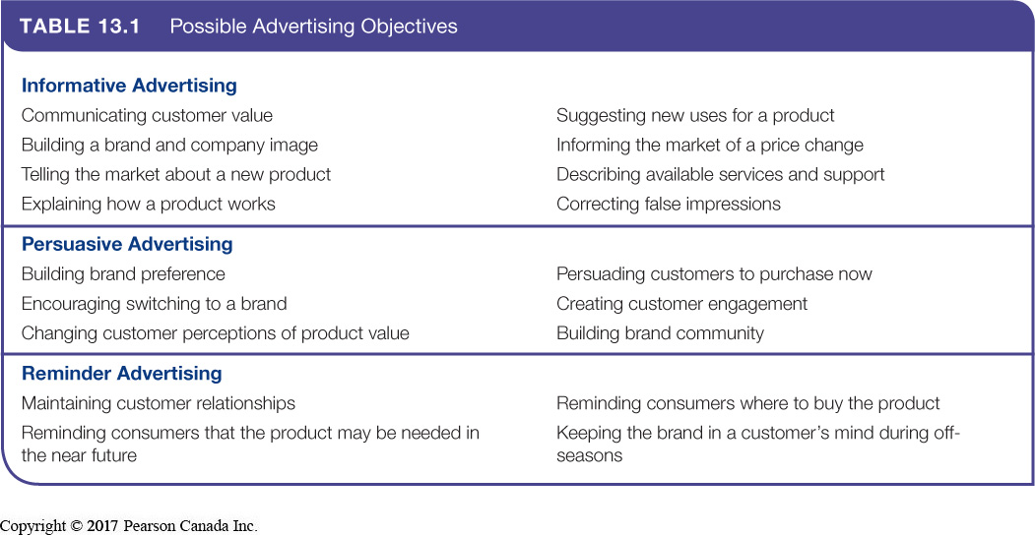
- Set advertising budget
- Advertising budget – dollars and other resources allocated to a product or a company advertising program
  - Affordable method – setting budget at the level the company thinks they can afford
  - Percentage-of-sales method – setting budget at a certain percentage of current forecasted sales or of unit sales price
  - Competitive-parity method – setting budget to match competitors
  - Objective-and-task method – defining specific objectives, then determining tasks performed to achieve them, then estimating cost of tasks
- Develop advertising strategy
- Advertising strategy – strategy by which company accomplishes its advertising objectives
Steps
1. Create advertising message
- Break through clutter
- Madison & Vine – merging ads with entertainment
- Branded entertainment – making the brand an inseparable part of entertainment
- Message strategy – general message
- Creative concept – big idea (meaningful, believable, distinctive)
- Message execution styles:
  - Slice of life – typical people using the product in normal setting
  - Lifestyle – shows how a product fits into a specific lifestyle
  - Fantasy – creates a fantasy around product
  - Mood/image – builds mood or image around product such as beauty, love, intrigue
  - Musical – shows people or cartoon characters singing about the product
  - Personality symbol – creates a character that represents the product
  - Technical expertise – shows company’s expertise in making the product
  - Scientific evidence – presents survey or evidence that the brand is better or more liked than another
  - Testimonial evidence or endorsement – features highly believable/likable sources endorsing product
2. Selecting advertising media
- Advertising media – vehicles through which advertising messages are delivered to their intended audiences
Steps
- Deciding on reach, frequency and impact goals
- Reach – percentage of people exposed to an ad campaign
- Frequency – number of times a person is exposed
- Media impact – qualitative value of a message exposure
- Choose media types
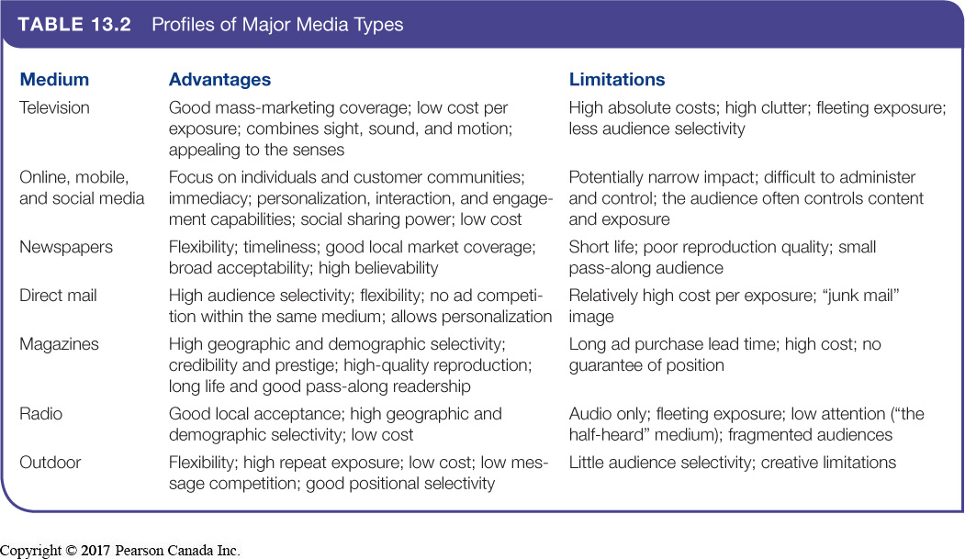
- Select media vehicles
- Media vehicle – specific media within each general media type
- Ex: television vehicles include Modern Family and Hockey Night in Canada
- Decide on media timing
- Whether to follow seasonal pattern, oppose seasonal pattern, or have same coverage all year
3. Evaluating advertising effectiveness
- Return on advertising investment – net return on advertising investment divided by costs of advertising investment
- Measure communication effects of an ad or campaign
- Measure sales and profit effects of an ad or campaign
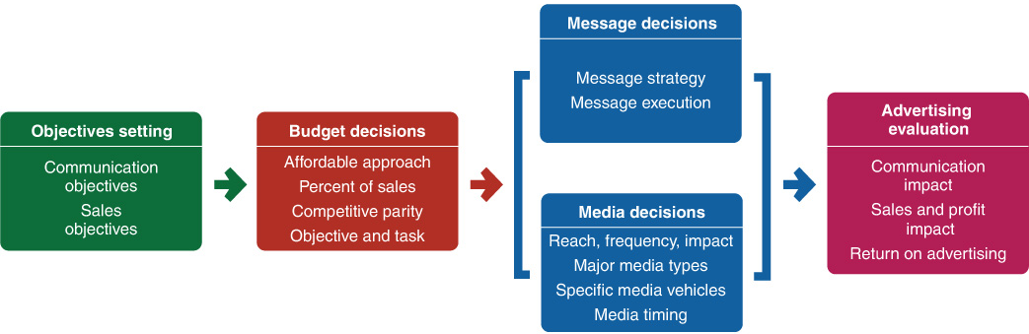
- Advertising agencies – marketing services firm that helps companies in planning and implementing advertising programs

Public Relations
- Used to promote products, people, places, ideas, activities, organizations, etc.
- Has a strong impact on public awareness at lower cost than advertising
Goals
- Obtaining favorable publicity
- Communicating a trustworthy image
- Managing unexpected occurrences, both positive and negative
Types
- Press relations – create and place newsworthy information in the media
- Product publicity – publicize specific products
- Public affairs – building and maintaining national or local community relations
- Lobbying – building and maintain relations with legislators and government officials to influence regulation
- Investor relations – maintaining relationships with shareholders and others in the financial community
- Development – working with donors or members of not-for-profit organizations to gain financial or volunteer support
Tools
- News
- Speeches
- Special events
- Written materials
- Audiovisual materials
- Corporate identity materials
- Public service activities
- Buzz marketing
- Company website

Chapter 14: Personal Selling and Sales Promotion

Personal Selling
Personal selling – personal presentations by the firm’s sales force to make sales and build customer relationships
Salesperson – covers wide range of positions
- Order taker/order getter
- Creative selling
- Social selling
- Relationship building
- Personal selling involves interactions between salespeople and individual customers face to face, by phone, email, twitter, video conference, etc.
- Role of personal selling varies by firm
- Critical link between company and customers
- Firms should bring marketing and sales functions closer

Sales Force Management
Sales force management – analyzing, planning, implementing and controlling sales force activities
1. Design sales force strategy and structure
- Territorial sales force structure – each salesperson is assigned to a geographic area
- Product sales force structure – sales force specializes along product lines
- Customer (or market) sales force structure – salespeople specialize in selling only to certain customers or industries
- Complex sales force structure – combines several types
- Determine sales force size
- Workload approach – firm groups accounts into different classes according to size, account status, and account maintenance efforts to determine # of salespeople needed for each account
- Outside (field) sales force – salespeople who travel to call on customers in the field
- Inside sales force – salespeople who conduct business from their offices (telephone, social media, buyer visits, etc.)
  - Ex: technical sales support people, telemarketers, online sellers
  - Telephone and online selling are growing much faster than in-person
- Team selling – teams of people from sales, marketing, engineering, finance, technical support, etc. to service large, complex accounts
  - Cons: competitiveness, confusion, difficulty to evaluate individual contribution
2. Recruiting and selecting salespeople
- Careful recruiting, selection, and training of salespeople can enhance overall sales performance and minimize costly turnover
- Required skills: intrinsically motivated, discipline, relationship building, ability to close a sale
3. Training salespeople
- Seminars, sales meetings, e-training
- Goal: achieve understanding of company, product, customer and market knowledge
4. Compensating salespeople
- Fixed amount: salary
- Variable amount: commissions or bonuses
- Expenses and fringe benefits
- Compensation should direct sales force toward activities that meet objectives
5. Supervising and motivating salespeople
- Call plan – which customers to call on by which activities
- Time-and-duty analysis
- Sales force automation systems – computerized sales operations letting salespeople work more effectively anytime, anywhere
- Sales quotas – standards stating the amount they should sell and how sales are divided among company
- Positive incentives, sales meetings, sales contests
6. Evaluating salesperson performance
- Sales reports, expense reports, call reports
- Return on sales investment

Selling Digitally
- Sellers are reorienting their selling processes around the new customer buying process
- They’re going “where the customers are” (social media, blogs, etc.)
- Salespeople now use digital tools to monitor customer social media exchanges
  - Spot trends
  - Identify prospects
  - Learn what customers would like to buy
  - Learn how they feel about a vendor
  - Learn what it would take to make a sale

Personal Selling Process (PPAPHCF)
- Prospecting and qualifying - identify qualified potential customers
- Preapproach - learn as much as possible about a prospective customer before a sales call
- Approach - meet the customer for the first time
- Presentation - tell the “value story” to the buyer
- Handling objections - seek out, clarify, and overcome customer objections to buying
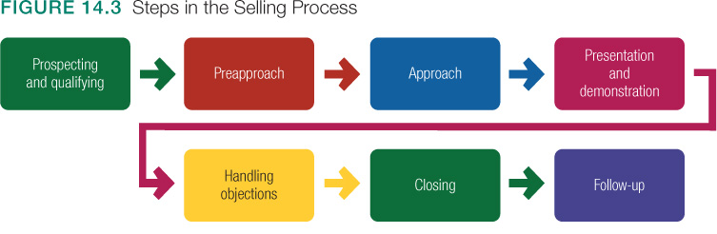
- Closing - ask the customer for an order
- Follow-up - follow up after the sale to ensure customer satisfaction and repeat business
- The selling process is transaction oriented
- Goal: building profitable relationships (not just sales)
- This requires listening to customers, understanding needs, carefully coordinating company’s efforts to create value

Sales Promotion
Sales promotion – short-term incentives to encourage the purchase of a product or service targeted toward:
- Final buyers (consumer promotions)
  - Objective: urge short term sales or enhance customer brand involvement
- Retailers and wholesalers (trade promotions)
  - Objective: persuade retailers to carry new items and more inventory, buy ahead, promote the firm’s brand, and provide more shelf space
- Business customers (business promotions)
  - Objective: generate business leads, stimulate purchases, reward customers, and motivate salespeople
- The sales force (sales force promotions)
  - Objective: gain more sales force support for current or new products or get salespeople to sign up new accounts
- Product managers face more and more pressure to increase current sales
- Companies face more competition
- Advertising efficiency has declined
- Consumers have become more deal oriented
- Result is promotion clutter
Sales promotion tools
- Samples – trial amount of a product
  - Ex: taste sample at supermarket
- Coupons – certificates to save money, such as those dispensed on store shelves
  - Increasing use of digital coupons
- Rebates – price reduction after purchase, such as mail-in proof of purchase
- Price packs – offer discounts from regular price
  - Ex: buy 1 get 1 free
- Premiums – extra goods offered for free with purchase
  - Ex: kid’s meal prize
- Promo products – articles imprinted with company name
  - Ex: t-shirts, hats, etc.
- Point-of-purchase – in-store displays
  - Ex: life-sized celebrity cardboard cut-outs
- Contests/games – entices people to play
  - Ex: Roll Up the Rim to Win
- Sweepstakes – entices people to enter a draw
  - Ex: Home lotteries
- Event marketing – creation or involvement in events, such as concerts
  - Ex: Red Bull hosts hundreds of sports events a year
Developing the Sales Promotion
- Decide on the size of the incentive
- Set conditions for participation
- Decide how to promote and distribute the promotion program
- Determine the length of the program
- Evaluate the promotion program

Chapter 15: Direct, Online, Social Media, and Mobile Marketing
1. Direct or Digital Marketing
- Online marketing
- Social media marketing
- Mobile marketing
2. Traditional Direct Marketing
- Face-to-face selling
- Direct-mail marketing
- Catalogue marketing
- Telemarketing
- Direct-response TV marketing
- Kiosk marketing
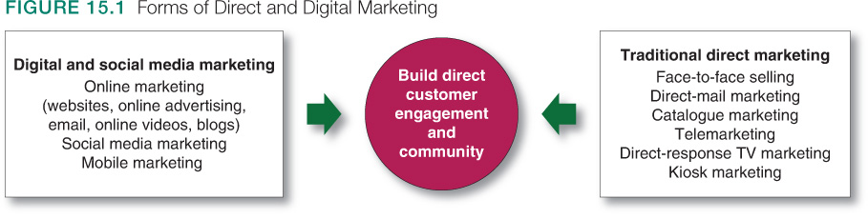

Direct and Digital Marketing
Direct and Digital marketing - engaging directly with targeted consumers and customer communities to obtain an immediate response and build lasting relationships
- Used as a supplemental medium or sole approach
- New model for doing business
- Fastest-growing form of marketing
- More and more internet-based
Benefits to Buyers
- Convenient, easy-to-use
- Private
- Greater control
- Able to compare
- Available to all
- Immediate and interactive
Benefits to Sellers
- Builds customer relationships
- Low-cost
- Easy to reach markets and handle logistics functions
- Flexible and accessible
Types
- Digital and social media marketing – fastest-growing form of direct marketing
  - Ex : Websites, online video, email, blogs, social media, mobile apps, etc.
  - Multichannel marketing - through stores, online and/or offline channels
- Online marketing – via the internet using company websites, online ads, promotions, email, online video and blogs
  - Marketing website – site that interacts with consumers to move them closer to a direct purchase or other marketing outcome
  - Branded community website – site that presents brand content that engages consumers and creates customer community around a brand
    - Don’t sell anything, just present content
  - Online advertising – appears while consumers are browsing online
    - Ex: display ads, search-related ads, online classifieds and other forms
  - Email marketing – sending highly-targeted, personalized, relationship-building marketing messages by email
    - Cost-efficient, high ROI
    - Spam – unwanted commercial email messages
    - Solution: permission-based email marketing
  - Viral marketing – digital version of word-of-mouth marketing
    - Ex: videos, ads etc.
    - Infectious so that customers will seek it out or share it
    - Con: marketers have little controls over where the messages go
  - Blogs/online forums – online journals where people and companies post their thoughts and other content, usually related to narrowly defined topics
    - Marketers entering blogosphere to reach their customer communities
- Social media marketing - independent and commercial online communities where people congregate, socialize and exchange views and information
  - They can use existing social medias or create their own
  - Focused niche networks are emerging which can be used to target special interest groups
  - Platform for brand communities
  - Integrated Social Media marketing – full-scale efforts that blend with and support other elements of a brand’s marketing strategy
Advantages
- Targeted and personal
- Interactive, immediate and timely
- Cost effective
- Engaging and social sharing capabilities
Disadvantages
- Still experimental and difficult to measure results
- Largely user-controlled (campaigns can backfire)
- Mobile marketing – messages, promotions and other content delivered to on-the-go consumers through mobile phones, smartphones, tablets, etc.
- Stimulates buying
- Makes shopping easier
- Enriches brand experience

Traditional Direct Marketing
- Direct-mail marketing - occurs by sending an offer, announcement or reminder directly to a person at a particular address
Advantages
      - Largest direct marketing medium
      - Well-suited for one-to-one communication
Disadvantages
- In decline due to newer digital forms
- Often perceived as junk mail
- Catalogue marketing – print, video or digital catalogues that are mailed to select consumers, made available in stores, or presented online
  - More catalogues going digital, minimizing costs and allowing real-time merchandising
Advantages
      - Print catalogues drive web traffic and create connections
      - Easily convertible to online versions
Disadvantages
- High cost of print both financially and environmentally
- Telemarketing – using the telephone to sell directly to customers
Advantages
      - Still widely used due to success rate
      - Marketers use outbound and inbound calls
      - Outbound – sell directly to customer
      - Inbound – toll-free ordering or order faxing
Disadvantages
- Do-not-call legislation
- Perception of intrusion
- Direct-response TV marketing (DRTV) – via television, including advertising, infomercials, and interactive television advertising (iTV)
  - 1-2 minute TV spots, infomercials, home shopping channels
  - Infomercials - 30-minute or longer advertising program for a single product
  - Home shopping channels - TV channels that sells multiple brands, items, and services
Advantages
      - Seize advantage of visual medium
      - Usually broadcast when audience is captive
Disadvantages
- Perception of “cheapening” the brand/product
- Often a cluttered promotional space
- Kiosk marketing – automated information and ordering machines found in various locations
  - Found in stores, airports, university campuses, etc.
  - Ex: vending machines

Public Policy and Ethics
- Internet fraud (identity theft, financial scams)
- Some marketers accused of taking unfair advantage of impulsive buyers
- Phishing – identity theft that uses deceptive emails and fake online sites to fool users into putting personal data
- Online and digital security (fear that snoopers eavesdrop on their transactions and online media postings
- Access by vulnerable groups such as minors
- Invasion of privacy (they know too much)
Solutions
- Personal Information Protection and Electronic Documents Act (PIPEDA)
  - Consumer knowledge and consent
  - Limitations (of rights to information)
  - Accuracy (of gathered information)
  - Right to access

Chapter 16: “The Global Marketplace”
- Global firm – firm that operates in more than 1 country, gaining R&D, production, marketing, and financial advantages in its costs & reputation that are not available to purely domestic competitors
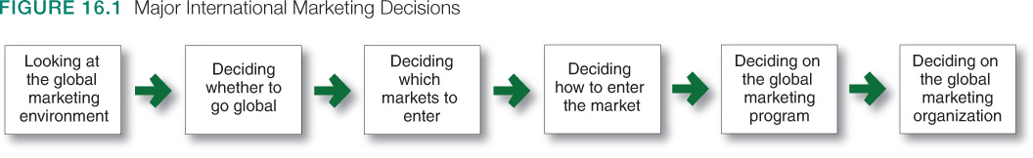
- Since global economy sees the world as 1 market, global branding is emerging
- Must understand international trade system (governments may charge tariffs and duties on imports)
- Quota - limits on the amount of foreign imports they will accept
  - Conserves foreign exchange and protects local industry and employment
- Exchange controls – limit amount of foreign exchange and exchange rate of other currencies
- Nontariff barriers – biases against bids, restrictive product standards, excessive host-country regulations
- General Agreement on Tariffs and Trade (GATT) - promotes world trade by reducing tariffs and other international trade barriers
  - Reassesses trade barriers
  - Imposes trade sanctions
  - Mediates trade disputes
- Economic communities – group of nations organized to work toward common goals in the regulation of international trade
  - Also called free trade zones
  - Ex: European Union (EU), North American Free Trade Agreement (NAFTA), Trans-Pacific Partnership

Factors
Economic Environment
- Industrial Structure
- Subsistence economies - vast majority of people engage in simple agriculture
  - Consume most of their output
- Raw materials exporting economies - rich in one or more natural resources but poor in other ways
  - Most revenue comes from exporting resources
- Emerging economies (industrializing) - fast growth in manufacturing results in rapid overall economic growth
  - Industrialization typically creates a new rich class and a growing middle class
- Industrial economies - major exporters of manufactured goods, services, and investment funds
  - They trade goods among themselves and export them to other types of economies for raw materials and semi-finished goods
- Income Distribution
- Industrialized nations may have wide range of incomes
- Subsistence economies are mostly households with very low family incomes
- Emerging economies may be attractive markets for all kinds of goods
Political-Legal Environment
- Factors to consider:
  - Country’s attitudes toward international buying
  - Government bureaucracy
  - Political stability
  - Monetary regulations
Cultural Environment
- Each country has its own norms, folkways, taboos
- Must understand cultural traditions, preferences or behaviours
- Goal:
  - Avoid embarrassing mistakes
  - Take advantage of cross-cultural opportunities
- Ex: French men use more cosmetics than women, Germans eat more packaged spaghetti than Italians do, Chinese people eat on the way to work
- Well-known U.S. brands have become the targets of boycotts and protests in some international markets

Which Markets to Enter
- Companies must define international marketing objectives and policies before going abroad
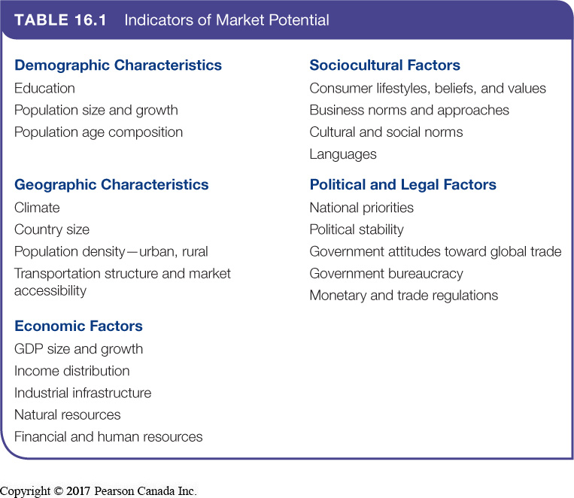
  - Market size, market growth, cost of doing business, competitive advantage, risk level

How to Enter the Market
1. Exporting – entering foreign markets by selling goods produced in the company’s home country
- Indirect exporting – through independent international marketing intermediaries
- Direct exporting – they handle their own exports
  - Bigger investment and risk
2. Joint venturing – entering foreign markets by joining foreign companies to produce or market a product or service
- Licensing – developing an agreement with a licensee in the foreign market
  - Advantages: low risk
  - Disadvantages: low control, giving up profits
- Contract manufacturing – joint venture in which a company contracts with manufacturers in a foreign market to produce its product or provide its service
  - Advantages: faster start, low risk
  - Disadvantages: low control, loss of potential profits
- Management manufacturing - joint venture in which the domestic firm supplies the management know-how to a foreign company that supplies the capital
  - The domestic firm exports management services rather than products
  - Advantages: low risk, yields fast income
  - Disadvantages: prevents company from setting up its own operations for a period of time
- Joint ownership – cooperative venture in which a company creates a local business with investors in a foreign market, who share ownership and control
  - Advantages: merge strengths
  - Disadvantages: partners may disagree
3. Direct investment – entering a foreign market by developing foreign-based assembly or manufacturing facilities
  - Advantages: lower costs, cheap labour, foreign government incentives, freight savings, image improvement by creating new jobs
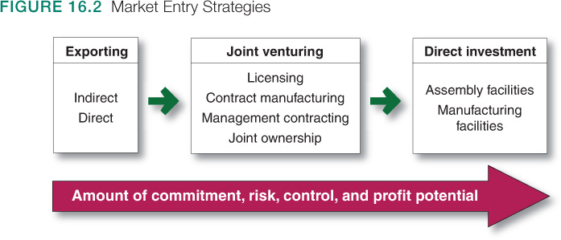
  - Disadvantages: restricted/devalued currencies, falling markets, government changes

Global Marketing Program
- Standardized global marketing – using the same marketing strategy approaches and marketing mix worldwide
  - Argument: with technology, the world is getting smaller, and we are all becoming more similar
  - Result in greater brand power
  - Reduces costs from economies of scale
- Adapted global marketing – adjusting the marketing strategy and mix elements to each target
  - Involves higher costs with the goal of producing a larger market share in return
  - Argument: more effective if tailored to unique needs of each group
- Seek balance

Product
- Straight product extension – marketing a product in a foreign market without making any changes to the product
      - “Take the product and find consumers for it”
      - Can be both successful and disastrous
- Product adaptation - changing the product to meet local requirements, conditions or wants
- Product invention – creating a new product or service for foreign markets
- Ex: Ford developed low-priced Figo model for India

Promotion/Communication
2 strategies:
  - Promotion - adopt the same communication strategy used in the home market
  - Communication adaptation - change it for each local market

Price
- Uniform price globally
      - Might this be too high in poor countries and not high enough in rich ones?
- Charge a rate which fits what consumers would bear
    - This strategy ignores differences in the actual costs from country to country.
- Use a standard markup of its costs everywhere
    - This approach might price the company out of the market in some countries where costs are high

Place/Distribution
    - Whole-channel view – designing international channels that include the entire global supply chain and marketing channel
      - Global value delivery network
      - Channel between nations: moves company products from point of production to borders of countries in which they’re sold
      - Channels within nations: moves products from their market entry points to final consumers
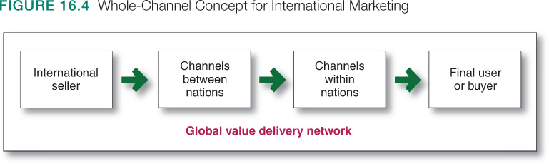

Global Marketing Organization
- Organize an export department
- Create an international division
  - Geographical organizations: country managers responsible for salespeople, distributers, licensees, etc.
  - World product groups: each responsible for worldwide sales of different product groups
  - International subsidiaries: each responsible for their own sales and profits
- Become a global organization

Chapter 3: Sustainable Marketing, Social Responsibility, Ethics
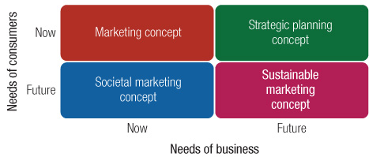
Sustainable Marketing – socially and environmentally responsibly marketing that meets the needs of customers while preserving the ability of future generations to meet customer needs

Impact on Consumers
- High prices
  - High costs of distribution
    - Too many unnecessary middlemen
  - High advertising and promotion costs
  - Excessive markups
- Deceptive practices
  - Pricing: falsely advertising “wholesale” or “factory” prices or large reductions from phony high retail list prices
  - Promotion: misrepresenting a product’s features or performance, or luring consumers to store for out-of-stock items
  - Packaging: exaggerating package contents through design, misleading labeling, or size
  - Greenwashing – companies that claim to be environmentally friendly in some way but aren’t really doing what they claim
Consequences
  - Legislative penalty from Competition Bureau
  - Ontario’s Consumer Protection Act
  - Canada Consumer Product Safety Act (CCPSA)
- High-pressure selling
  - Persuades people to buy goods they had no though of buying
- Unsafe products
  - Poor quality or function
- Planned obsolescence – continually changing consumer concepts of acceptable styles to encourage more and earlier buying
  - Using materials and components that break, wear, rust, or rot before they should
  - Intentionally holding back functional features, then introducing them later to make older models obsolete

Impact on Society
- False wants
- Too much materialism
- Overselling private goods
  - Too few social foods
  - Results in social costs
  - Ex: increase in car ownership (private) requires more highways, traffic control (public)
- Cultural pollution – our senses are constantly assaulted by marketing and advertising
  - Solution: branded entertainment and native advertising

Impact on Other Businesses
- Acquisition of competitors
- Marketing practices that create barriers to entry
- Unfair competitive marketing practices
  - Predatory pricing – setting prices below costs, threatening to cut off business with suppliers or discourage competition

Consumers Take Action
- Consumerism – economic and social policies that encourage consumer spending
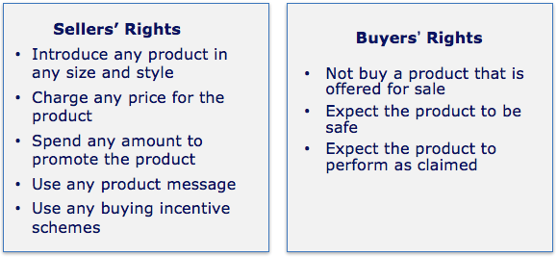
  - Consumer activism - organized movements to improve the rights and power of buyers in relation to sellers

Goals
  - Be well-informed
  - Be protected from bad products/practices
  - Influence products to improve quality of life
  - Preserve the world for future generations
- Environmentalism – organized movement to protect and improve people’s living environment
  - Belief that a marketing system’s goal should be to maximize quality of life
  - Environmental sustainability – management approach in developing strategies that both sustain the environment and produce profits for the company
Evolution of Environmentalism
  - 1960s–1970s: concerned consumers and environmental groups
  - 1970s–1980s: driven by government, resulting in environmental laws
  - Firms accepting more responsibility and are adopting environmental sustainability
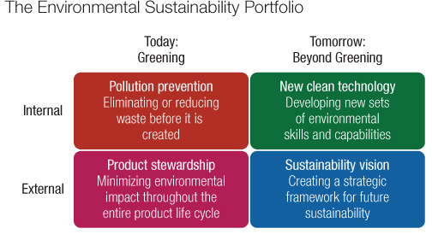

- Pollution prevention
- Product stewardship – minimizing not just pollution from product but all environmental impacts through the full product life cycle (while reducing costs)
  - Design for Environment (DFE) and cradle-to-cradle practices
- New clean technologies – develop new innovative technologies for sustainable strategies
- Sustainability vision – guide to the future

Sustainable Marketing Principles
- Consumer-oriented marketing – marketing activities are viewed and organized from the consumer’s point of view
- Customer-value marketing - company resources go toward customer-value-building marketing investments
- Innovative marketing – company must seek real product and marketing improvements
- Sense-of-mission marketing – company should define its mission in broad social terms rather than narrow product terms

Societal Marketing
- Sustainable marketing seeks to introduce desirable products, rather than those that are deficient, salutary, or simply pleasing
Societal classification of products
- Societal marketing – company should make marketing decisions considering customers wants, company’s requirements, and consumer and society’s long-run interests

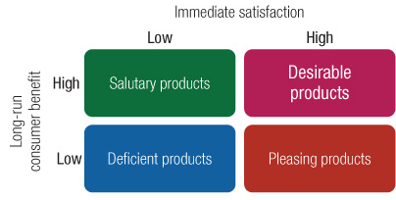
- Deficient products – have neither immediate appeal or long-term benefits
- Pleasing products – give high immediate satisfaction that may hurt consumers in the long run
- Salutary products – have low appeal but may benefit consumers in the long run
- Desirable products – give both high immediate satisfaction and long-term benefits

Marketing Ethics
- Firms develop corporate marketing ethics policies
  - Distributor relations
  - Advertising standards
  - Customer service
  - Pricing
  - Product development
  - General ethical standards

