Biology, Biologists and Biosciences

Ages of sand: An age where all scientific events are divided into 4 stages
- Telescope, (1608) lenses formed to allow humans to look at great distances. Galileo had built several of them after hearing it was invented, using it to look at Space.
- Microscope(1678) lenses were used in order to observe organisms that were too small to be seen by eye. This led to the discovery of the cell and the cell theory.
- Computer chip (1961) silicon based computer chips allowed process. It could perform mathematics very fast and also allowed scientist to create simulated models.
- Fiber optics(1980) glass used in fiber optic cables allows the transmission of data around the world to be really fast. This allowed scientists to connect and communicate with each other, and to work together.

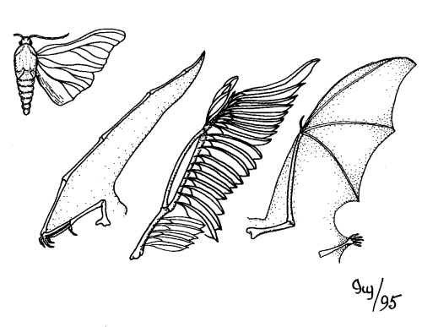
Analogy: Analogy is the same structural or behavioral similarity, but found within different species. These traits have no common ancestors, and are results of convergent evolution. ex) birds wings and insects both have different structures however, both have the function of flight.

Bionomen: Linnaeus introduced a methodology of naming species, in two parts. Genus, and species. When written in italics, it shows that it is in another language; the first letter from Genus is capitalized and first letter of species lower cased.

Binomial nomenclature: Latin genus and species name. For example Apis mellifera is the latin name for honey bee. Apis is the genus and millifera is the species name.

Biogeography: Scientific study of the geographic distribution of plant and animal life of individual species in specific environments. Factors affecting distribution include geologic history of region, climate and soil composition, and presence or absence of natural barriers like deserts, oceans, and mountains. Has three main fields: historical (looks at why species are distributed in a certain fashion), ecological (looks at the current factors that are responsible for distribution in a certain area), conservation biogeography (protection and restoration of nature).

Catastrophe theory: Theory that the Earth is affected by a series of short and violent events, that sometimes are worldwide. Curvier notived that fossil layers represents organisms living in successive layers, suggesting that dramatic events wiped out species (such as a flood); if the age of the rock is known, it is possible to tell the age of the fossil and what type of catastrophe happened.
Cell theory: A theory formed by Schleiden (worked with plants) and Schwann (worked with animals);
- All living organisms are composed of cells; they may be unicellular or multicellular
- The cell is the basic unit of life
- Cells arise from pre-existing cells

Chronological prediction: Random prediction which isn’t based upon logic, more so of a fortune or an estimation.

Cladogram: A tree of life which is used to show phylogenetic relationships and the hypothesized evolutionary sequence. The hypothesized ancestors are showed at each branching point; each branch represents a new species; species coming from a branch node share a common ancestor. Further upon the branch the more common ancestors are present. This relates to Darwin’s theories.
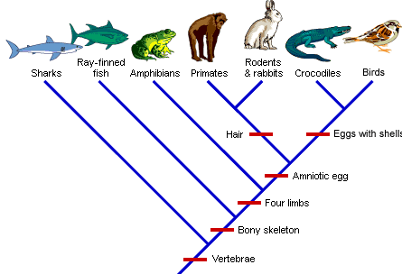
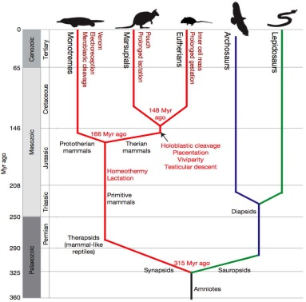

Common ancestry: The idea of which all organisms which are alive are now fossils; tracing back to one or many species. It is assumed that these species has evolved over time into many other versions of species. Evidence of common ancestry include vestigial structures, homologous traits, fossils, embryology, and molecules.

Constancy of Species: States that every organism was created separately, in the same form as their current state, as they did not change or evolve. This is displayed in the Scala Naturae where each organism has its role, and would never change.

Control: Control is a reference which tells us what would have been seen if no variables had been changed within an experiment. These variables are changeable in other experiments, and then comparable to the control to observe the changes from the different variables, and causes; this enables one to make predictions related to the effects.

Convergent evolution: Organisms which have different structures but similar functions; which is due to environment, rather than a common ancestor. This is because based on an environment, some species may evolve to cope and withstand a certain environment. (Ex. Birds and insects both have wings, but don’t share a common ancestor; this is also an example of convergent evolution.)
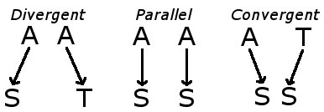
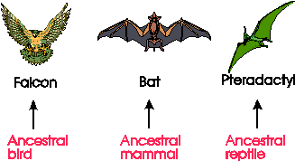

Curvier (Georges): French scientist who had found fossils of animals which hadn’t been discovered during his time. He hypothesized that species must have died before, and had become extinct. Curvier came up with the catastrophe theory, and extinction. (Ex. Mammoth, Irish Elk)

Dawrin (Charles): English biologist who is known for his work and theories in his book on the origin of species by means of natural selection (A process in nature in which organisms possessing certain genotypic characteristics that make them better adjusted to an environment tend to survive, reproduce, increase in number or frequency, and therefore, are able to transmit and perpetuate their essential genotypic qualities to succeeding generations). His work elaborated upon in the genetics and evolutionary beliefs. Darwin formulated 5 theories (no constancy of species, natural selection, multiplication of species, common ancestry, and molecules). Darwin and Wallace had published their works together but Darwin had more evidence hence, he is associated with more. Only no constancy in species and common ancestry was accepted at the time due to fossil evidence ,and the other 3 not accepted due to their lack of knowledge of the mechanisms, and religious beliefs.

Darwin (Erasmus): Translation of Linnaeus’ work from Latin to English and noticed trends in his work. He had then published his work in the form of poems to avoid the church, and religious prosecution.

Deduction: (From general to specific) Deduction is conclusions about a single object based on tested patterns. This is mostly used in physical sciences, and a specific conclusion is made from a general principle. (Example is all humans are mortal, Darwin is a human, therefore Darwin is mortal.)

Descent with modification: Theory that all living organisms arose from species with modifications, which is the passing of traits from an organism to its offspring’s. Darwin proposed natural selection as the mechanism that drives evolutionary change
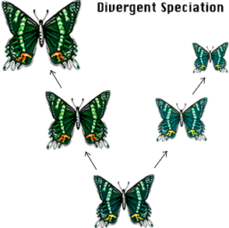
Divergent evolution: Divergent evolution is where one species evolves into 2 or more separate species with different characteristics often due to geographic separation followed by different selection pressures on each of the populations. For a species to adapt to a different environment or to different factors; the two populations of species A evolve differently and after enough changes occur, it becomes species B and species C.

Domain: A new level in taxonomy where all living organisms are dived into 3 groups, eukarya, archea, and bacteria. It emphasizes the separation of eukaryotes(eukarya) and prokaryotes(bacteria and archae). Originally, Linnaeus had split organisms by movement (are the mobile(animals) or immobile(plants))

Empirical observation: Measurable observation produced from or relating to an experiment.

Essentialism: The belief that all organisms have an essence and the essence changes to form new species. It was believed that life occurred spontaneously and did not change (species always created exact copy of itself so it never changed position in the Scala) and stayed in place in the Scala naturae.
Eukaryotes: Cells that have their DNA in a membrane bound nucleus, and the cytoplasm contains specialized organelles. They are multicellular organisms that have cell to cell communication. However, there are some unicellular eukaroyes in the kingdom Protista.

Evolutionary tree: A cladogram showing the evolution of a species starting from a common ancestor.
Extinction: Theory developed by Cuvier as he studied fossils. It is when the last surviving member of a species dies.

Fact: The knowledge or information that is based upon real occurrence, which may be checked and confirmed.

Fitness: An organisms fitness describes how well an organism is suited for its environment, and how many offspring it will produce. If the organism has a relatively high fitness, it will produce many offspring, and life in the population so that its gene frequency within the gene pool increases. A low fitness represents a decreasing population of its gene pool over time.

Fossil record: A fossil record is the accumulation of fossils which provides clues and hints about the past, and a possible organisms taxonomical history. If the age of the rock is known, a relation to other fossils, to make a geological time period. Fossil records provide evidence of Darwinian theories such as the theory of nonconstancy of species, and common ancestor; as fossils show that as time progresses, organisms change thus, are not constant as essentialism requires them to be. Fossils also assisted in the creation of the extinction theory, as well as catastrophe theory, based on results.

Germ theory: The germ theory states that life is not spontaneous, and that it must have come from pre-existing cells; hence, diseases are caused by the presence and actions of micro-organisms within the body.

Historical narrative: A historical narrative is the writing of a story based on a historical event. Formats may include: biographies, autobiographies; having two formats: traditional (focuses on chronological order, and individuals actions) and modern narratives (focuses on trends, and why they occur).

Homology: Homology is where organisms have the same structure, but a different function; due to a common ancestor and divergent evolution; as well as similarities within a structure or development of different species.
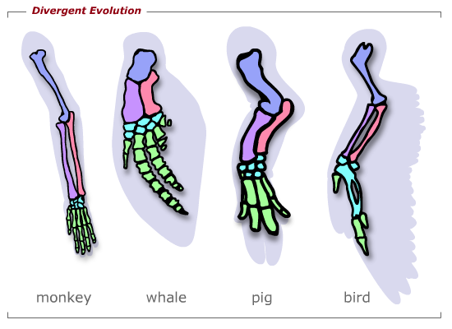
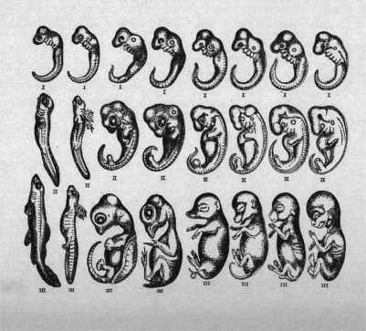

Homoplasy: Homoplasy is where the same function is used by an organism; but has a different structure. This is a result from convergent evolution, and no common ancestry. Homoplasy refers to a general topic. Ex) Bird’s wings and bat’s wings are analogous structures, they are a form of homoplasy.

Huxley (Julian): Huxley researched physiology of species, combining concepts of Mendelian genetics, and Darwin’s theories of evolution, assisting the public to accept his theories. He stated that one needs to know how many genes are within the general population, and how they are distributed, to get proper observations.

Hypothesis: A hypothesis is an explanation for an observation for the natural world. They may be further tested to replicate results providing evidence. Hypothesis’ has two elements: It must be testable (there must be experiments, or observations to prove the hypothesis’ accuracy); must be falsifiable (through observations or experiments being able to show that the hypothesis is false). Many hypothesis’ which are accepted becomes theories; if the hypothesis is falsified, the null hypothesis is deemed to be valid.

Induction: (From specific to generalized) Induction is a method used by natural scientists. One makes many observations and tries to generalize them. (Ex: one observes that 100 insects all have wings, then 1000, then 5000, all having wings; they may hypothesize that all insects have wings, but will not actually be a legitimate fact; because testing the entire deviation is physically impossible).

Lamark (Jean-Baptiste): Lamark proposed transmutation of species (A theory which describes the altering of one species into another). He also proposed the theory of use and disuse. (States that the more a trait is in use, the more likely it will stay, and the traits which are unused would not get passed on to offspring). He also proposed the theory of acquired traits (acquiring traits from parents). Lamark had realized that the environment had a role in factor on the species development, as it influences them to evolve. Lamark provides the public with “the transmutation of species from acquired traits”. He states that the essence is affected by the environment, as he calls it to be the transmutation of species.

Law: (Where theories are proven universally) Laws are statements which describe, predict, and explain why a certain phenomenon occurs; they are strongly supported by evidence, and experiments. Laws summarize facts (which are determined by experiments) in a single statement (generally an equation). Laws can be formulated mathematically, to predict outcomes of experiments. If a law becomes falsified once, it is discarded.

Leclerc (George-Louis – Buffon): Leclerc is the first person to question the validity of the Scala Naturae. He was the first to study biogeography, in which he studied common ancestors of organisms (mostly humans, and apes). Leclerc believed in organic change, as the environment acted directly on organisms. He suggested that the earth was over 6000 years old, since fossils which were found in rocks would take millions of years to be formed.

Linnaean taxonomy: Linnaean taxonomy is a form of classification. Starting from Kingdom, phylum, class, order, genus, species (family was to be added later on). Linaeus originally started with 3 kingdoms (plantae, animalia, minerals) and his taxonomy was the basis for binomial nomenclature (first time to be used).

Linnaeus (Carolous): Linnaeus had started modern theory of classification. He had used binomial nomenclature (which is still used today) and a form of classification of 3 kingdoms, ranging from broad to specific. Linnaeus had spent his life naming and classifying species based upon characteristics.

Logical prediction: Logical prediction is close to deductive method of an experiment; the prediction based on scientific theory and hypothesis. (What is going to happen based on what is already known; if a variable in a controlled experiment is altered; the hypothesis predicts what should happen).

Lyell (Charles): Lyell was a geologist who showed that the deeper the rock layers are, the older in chronological age they were. He had shown that fossils near the top were younger and more similar to current species, than the fossils deeper, which were older and very different. He created the concept of uniformitarianism. (The natural process’ that were occurring before and still occurring now)

Mendel (Gregor): Mendel had published his work in Austria, within the mid 1800s, but had not been rediscovered until the 1900s. He is known for discovering genetics using pea plants. Mendel discovered the inheritance of certain traits followed by patterns; discovering that genes could be dominant or recessive, he had created 2 main principles from his experiments:
- The first is law of segregation which states:
  - that for each trait parent alleles separate and the offspring receives 1 allele from each parent
  - each trait is composed of 2 alleles
  - some alleles are dominant and some are recessive
- The second is law of independent assortment which states:
  - the alleles for a trait separate when gametes are formed and are randomly assorted at fertilization resulting in great diversity.
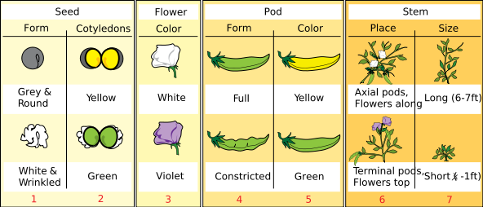
He had created the perfect experiment, because pea plants only have 7 phenotypes and 7 chromosomes (1 for each phenotype).

Modern biology: Modern biology is the study of life, and living organisms; especially within the origin of life, growth, reproduction, behavior, and structure. Current scientists are uncovering the human genome, creating artificial life, and trying to reveal how life on earth had started.

Natural sciences: Natural sciences are the branches of science which explain the rules of the natural world, ran by using scientific methods; branches include: astronomy, biology, physics, chemistry…

Natural selection: Natural selection is the evolutionary process where beneficial traits that increase the chance of survival and reproduction become more and more common within the future generations, and non-beneficial traits becoming less common. Organisms with beneficial traits would be able to reproduce rendering many offspring (meaning they have a high fitness, high frequency within the gene pool) then their offspring will also produce many more. Organisms with non-beneficial traits become less common and produce less offspring (low fitness, low frequency in gene pool) causing them to die off over time. Darwin had stated this to be the main cause of evolution.

Null hypothesis: The null hypothesis states what would have been seen if the hypothesis was falsified. It is a proposition that there is no relationship between the phenomena. If the null hypothesis was found to be true, then there is no relationship (hypothesis is false), if null hypothesis is false, there is a relationship (hypothesis is true).

Organicists: Organicists are the formation of physicalists, and vitalists. All living things live by physical and chemical laws however, the genetic code programs how the chemical and physical laws are applied. The genetic code is a vital force (vitalists believed), they emphasized on the importance of emergence (If all pieces are taken apart, the pieces would do less than if they were all togeather and this is called emergence, in other words; the sum is more than the parts).

Pasteur (Louis): Pasteur is a chemist who had shown the germ theory, and created the process of pasteurization. He had shown that life cannot be spontaneous, and that they must com from other living things. He made the first vaccines for diseases such as rabies and anthrax.

Physical sciences: Physical sciences is any science which analyzes nature, and energy of non-living things. (Their laws can be applied universally since inanimate objects are in use) They are based on empirical observations and experimentations.

Physicalists: The view of science which states that anything that exists is only physical, and no vital force (all living things are machines except humans, if viewed carefully, there are machines and motors making an organism function). They only believed in physical and chemical laws; aswell as the fact that one can take the various machines apart, to make a whole machine work. (The sum is a product of its parts, which is opposite of what vitalists believed in (emergence, sum is more than the parts))

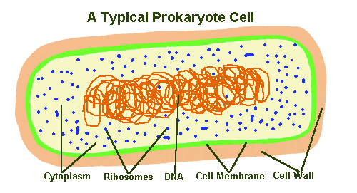
Prokaryotes: Prokaryotes are organisms in which the DNA is suspended within the cell cytoplasm; there are no membrane bound organelles; most unicellular, and no cell to cell communication. They do not produce by meiosis, and the Achaea and bacteria make up the two domains of prokaryotes.

Proximate causes: Proximate causes is an event which is closest to causing something to happen. A+B = C. If B is changed, and view what happens to C; that is a trial of a proximate cause. (The here, and now cause, typical of experiments)

Sampling error: Sampling error is the amount of inaccuracy. In an experiment, it may be due to the size of a population; the larger the population the more trials are required to have a smaller sampling error.

*Scala naturae: The Scala Naturae is a scale made by Aristotle. It ranks organisms from superior to inferior (god to devil). It is the main point in essentialism; as it is viewed because it says that all living things are spontaneously made, and that they are perfect, and thus, do not change position within the Scala, because they are exact copies of themselves. The ranking is as follows from top to bottom: God, Angels, Humans, Flying things, Water things, Land things, Plants, Things in Soil, Demons, Devil.

Schleiden and Schwann Both scientists observed cells under a microscope; and realized that there was small living things (cells), which had a membrane and a dark center. (nucleus) Schleiden observed plants cells, as Schwann observed animal cells. Togeather they had came up with the cell theory that all living things are made up of cells, cells are the smallest functioning units of life, and they come from pre-existing cells. The problem with this theory is that LUCA is irrelevant if all cells had come from pre-existing ones.

Scientific revolution: The scientific revolution is a major development in math, physics, biology, chemistry, etc. It had occurred from 16-18th century. (Biology the latest as religion opposed the concept)

Special creation: Special creation is the belief that the origin of life and the diversity of life was created by God, and each species being created separately.

Synthetic theory of evolution: Theory created by Huxley when he had combined the works of Mendel, and Darwinian theories. The main ideas include:
- Evolution is gradual, not spontaneous
- Natural selection is the main mechanism for change
- A large population must be observed to view changed, as there are many variations. (Both by environmental causes, and geographical)

Taxon (taxa): Taxa is a name designed for a group of organisms which is in a category in the Linnaean taxanomic hierchy.

Taxonomy: Taxonomy is the science of classifying organisms into ordered groups based on their shared characteristics; where each group is given a name and a ranking.

Theory: Theory is an explanation of something within the natural world based on evidence, that has been confirmed through observation and experimentation, and makes predictions on how they will occur. Scientists create theories from many confirmed hypotheses that all had the same outcome based on factual evidence. Physical scientists usually have one theory for something; and once disproven, it must be discredited. In natural science; multiple theories exist, and if one is disproven, it is altered and changed to accommodate it. Theories are much stronger then hypotheses and are usually based for general topics.

Transitional forms: Transitional forms is a species that are in intermediate forms, in an evolutionary sequence. It provides evidence for no constancy of species since we can see that the species changed over time. Transitional forms from fossils (discovered by cuvier) supports Darwinian theories since he explained how species changes over time.
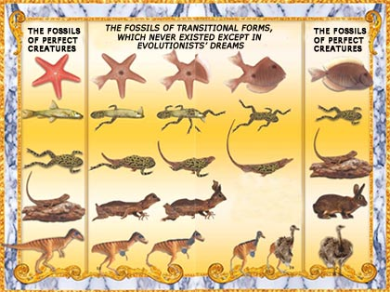

Transmutation: Transmutation is an essence which is being changed dramatically; spontaneously to form a new species. (Ex. A cat giving birth to a dog; this is an essentialist view)

Transmutation of species: Transmutation of species is a theory formulated by Lamark; such that species are affected by the environment over long periods of time, hence they change in order to adapt, survive. These traits would be passed to their offspring. (Acquired traits)

Ultimate causes: The actual cause of occurrence. (Why did something work this way?) This is to understand why something happened, and what brought it about. (Ex. Sequence in a same gene within 100 organisms and builds evolutionary tree to see the big picture)

Uniformitarian theory: The natural processes that occurred on earth in the past, are the same processes which are occurring now. Lyell had created this theory while he was studying strata’s of rocks.

Vestigial structures: A vestigial structure is in an organism that has no function for that organism, but does for another species. (Ex. Appendix, nictating membrane) They help prove that no constancy in species are true, because the species had changed over time, and no longer requires that part of the body; also being evidence for common ancestry, since different species have similar body parts but some don’t use them like others.

Vitalists: Vitalists are a group of people who believed in physical, and chemical laws, but also believed that there was a vital force present; and emergence. (Now known to be the genetic code; sum is more than the parts)

Other Notes:

Hippocrates(father of medicine): Studied human conditions and recorded them.

Aristotle(father of plants): Student of Hippocrates. He had kept a record of all animals that he saw and made a list from insects to animals. He had also created a list from superior to inferior called the Scala naturae.

Theophrastus(father of taxonomy): Organized plants like Aristotle did with animals because he wanted to have information about plants for medicine. Plants create chemicals and poisons to protect them selves. He wrote 10 book about plants and medicinal properties and organizes by how the plant pollinates (still same way as it is organized now)

Aviceena: A philosopher during this time and took writings of the 3 great cultures (islamic, Indian, and Roman medicine) and made a new compendium of human biology.

Al baitar: Developed a pharmaceutical list (how much to use, what to use, how to use it, how long, etc…) and was used even until the 1800's.

Copernicus: Stated that the Sun was at the center, he published his works on death bed to avoid purgatory.

Galileo: Found more evidence for sun at center, and bragged so he was sent to purgatory.

PHYSICAL SCIENCE began much earlier then natural because of church problems and people didn’t take bio seriously. SCIENTIFIC REVOLUTION 16-18TH CENTURY.

van Leeuwenhoek: Created microscope.

Kingdoms:
Animalia(heterotrophs)
Plantae(autotrophs)
Fungi(saprotrophs)
multicellular
have cell to cell communication

Protista and eukaryotes
(specialized organelles and reproduce sexually through meiosis)
no communucation

Monera(bacteria and archaea)
- prokaryote(have no organelles, single strand dna in cytoplasm and all internal processes occur in the cytoplasm)
- both have no communication

Archaea: Extremophiles, are thought to be the first species of life, could have came from space, they live in very hostile places and don’t need H2O or O2 to survive.

Comparative embryology: Every single animal starts as a cell, then 2 cells, then 4 cells. once they reach 4 cells, they split in a plane and produced 8 cells.(HAPPENS IN EVERY ANIMAL)

Physical science | Natural science
Inanimate objects | Animate objects
Physical and chemical laws | Physical and chemical and genetic laws
Universal | Not yet universal
Based on empirical observations | Based on historical narratives
Experimentation preferred method | Induction most used method
Single theory | Multiple theory
If theory falsified it is discredited | If theory is falsified, it is modified to work

LITERATURE AND DISTRIBUTION OF FACTS

- Journal selection-must choose right journal, most premiere are nature and science
- make a manuscript
- The manuscript gets peer edited
- When it gets sent out and received by publisher
- He sends it to random editors(don't always know identity so there is less bias)
- They send back with corrections and then you make the changes and publish, it typically takes a year to publish

- Primary is written by the person who did the work (original paper, all information there, all references, and all data, best source)
- Secondary is when an expert in the same field does a review article (has references)
- Tertiary is literature made by someone in science but not same field and has no references (textbooks/magazines)

