Midterm 2
BIODIVERSITY – Evolution and Ecology

General Biodiversity Topics
Global Biodiversity:
- The total outcome of the two opposing processes:
  - Speciation – increase in diversity (development of a new species)
  - Extinction – decrease in diversity (disappearance of a species)
- These two processes are needed to understand the diversity of life

Biodiversity:
- The variation of species, organisms within the species, ecosystems and their ecological processes
- Comprised of three scales of variation: genetic, species and ecosystem

Species Richness:
- The number of species present in an area (such as a community or ecosystem)
- The appropriate sampling intensity required to estimate richness is determined by plotting the number of new species observed with each sampling unit (as shown below) – sampling species richness is complete when the species area curve is saturated (levels off)
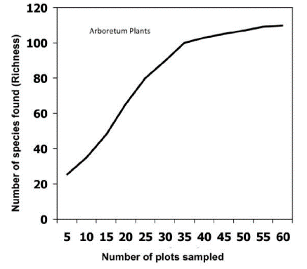

Species Interactions:
- Different species apart of the same ecosystem/community interact in many ways:
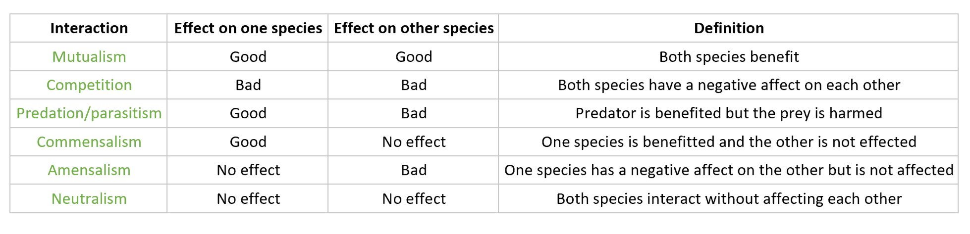
- Examples of species interactions:

  - Mutualism can be obligate (must live with its partner species) or facultative (can live without its partner species)
- Example of ants, plants and aphids:
  - Aphids feed on the sap within phloem cells of plants which negatively affects the plant (predation)
  - Ants and aphids benefit from each other because the ants benefit from the excess sap due to the aphids and the aphids are benefited by the ants because in return, the ants protect the aphids from predators (mutualism)

Abundance:
- Species abundance – how common a species is in a defined area
  - Can be measured as percent cover (measure of influence), biomass (fuel developed from organic matter) or frequency of individuals per species
- Relative abundance – refers to the comparison of the species abundance within a defined area and relates to the “evenness” of the distribution of individuals in a species within a community. Although different communities may have the same species, they can differ in the relative abundance
  - Example: each community may contain 10 species and 210 individuals, but in one community all species are equally common (21 individuals of each species = high evenness) and in another community some species are common and others are rare (low evenness)

Abiotic:
- The physical and chemical features of an environment (non-living) that affect the ability of organisms to survive and reproduce
- Abiotic features include:
  - light (radiation)
  - temperature (heat)
  - water (availability, composition and flow)
  - chemical products
  - atmosphere
  - soil conditions (nutrients and porosity)
- Influence of light on a species:
  - Plants – some plants require a lot of light to survive and reproduce and others only require some light (shade tolerant) plants also depend on light to sense seasonal changes
  - Animals – insects need UV light to differentiate between flowers when harvesting nectar or pollen which is important for pollination in plants AND birds position themselves by the reflection of UV light by the objects on land (different types of forests, water, rocks, etc.)
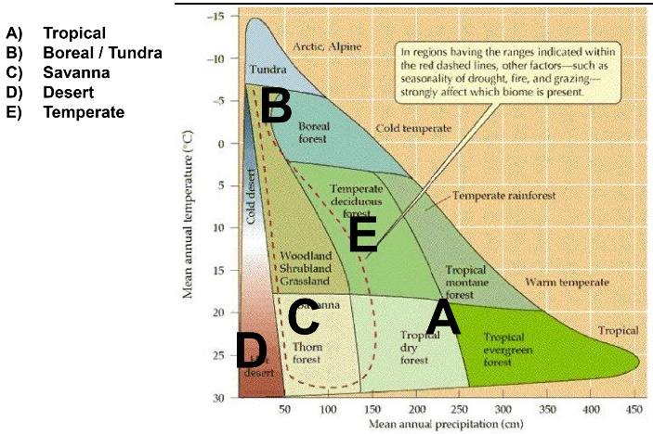
- Terrestrial Biomes are classified into two abiotic gradients:

Biotic:
- The living things that live within and shape an ecosystem (living)
- Biotic features include: producers (plants that convert the suns energy into chemical food), consumers (organisms that eat other plants/animals) and decomposers (organisms such as bacteria or fungi that eat dead things)
- The interactions (ex; competition) among individuals or species plays an important role in determining species survival and range limits

Intermediate Disturbance Hypothesis (IDH):
- Predicts that the highest species richness will occur at an intermediate level of intensity/frequency of natural disturbance:
  - Low levels don’t create many habitats to support a variety of species
    - An non-severe fire may transform a maple woodlot into a woodlot that is dominated by ash
    - When a tree falls in a woodlot it creates a “gap” that has higher levels of light – this gap supports a new community of species that are suited to high light conditions and establish themselves by out-competing other shade tolerant species
  - High levels eliminate many habitats that support species diversity
    - Large disturbances – floods, forest fires and hurricanes
    - A severe fire could transform a woodlot into an open field dominated by herbs and grasses
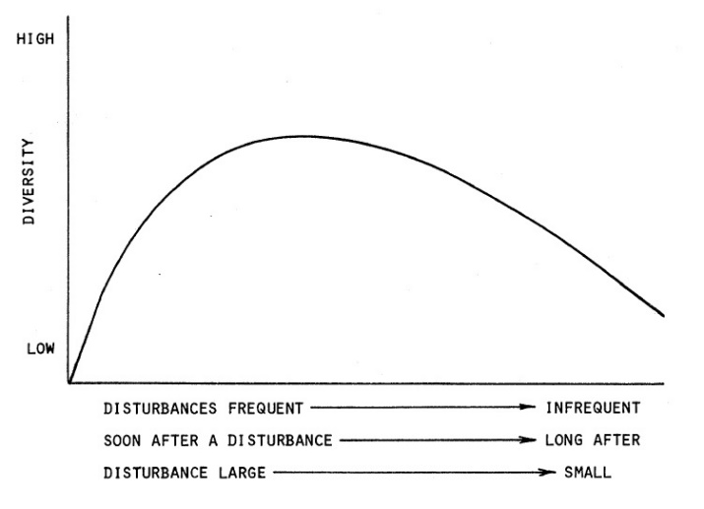

Niche:
- Niche is the set of abiotic and biotic conditions in which a species is able to persist and maintain stable population sizes
- The ecological niche theory:
  - Environmental space – the space that an organism occupies in regards to the environmental variables to which the species responds
- The ecological niche is sub-divided into the fundamental and the realized niche:
  - Fundamental niche – the environmental conditions that a species can survive and persist with; however, the species may not be present within all of this space
    - Ex: geology, landscape, soil
  - Realized niche – the environmental and ecological conditions that a species can actually survive and persist with
    - Ex: dispersal ability
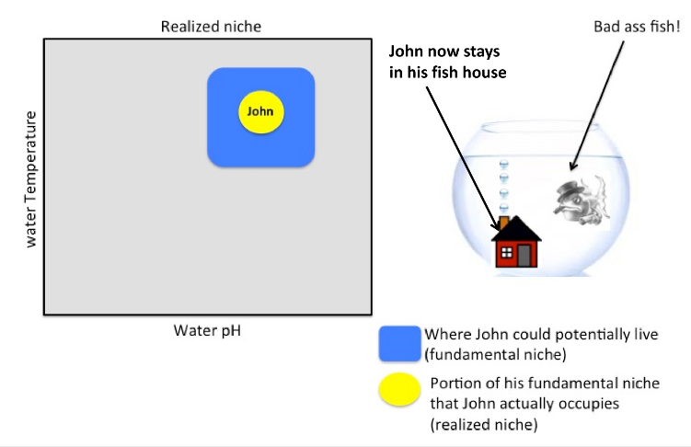
- The image below on the left shows the fundamental and realized niche’s of moisture and temperature of a woodlot and the example below on the right is a specific example of fundamental and realized niche
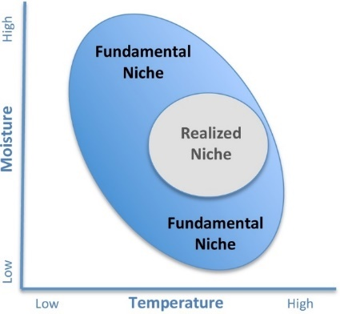

Urbanization:
- Urbanization can increase species richness – especially at intermediate levels of development (related to the intermediate disturbance hypothesis)
- Not all plants and animals respond in the same way to disturbances:
  - A study found that butterfly diversity was highest in areas of intermediate disturbance but another study found that intermediate disturbances facilitated the establishment of non-native ant species that would normally be displaced by native ant species
- Biotic Homogenisation:
  - The domination or urban natural areas by non-native species.
  - An invasion may increase the total species richness but decrease the diversity of native species
  - Urbanization = increase in non-native species and decrease in native species
Population:
- The collection of individuals in a species within an area at a specific time
- Population ecology factors include: population size, population density, patterns of dispersion, age distributions and population growth
- Population studies may involve questions related to how species abundance changes over time and the factors that affect population growth (ex; food, habitat, disease, predation)
- Population Growth:
  - The change in the # of individuals throughout a period of time
  - Calculated using demographic data:
    - population growth rate = birth rate – death rate +immigration – emigration
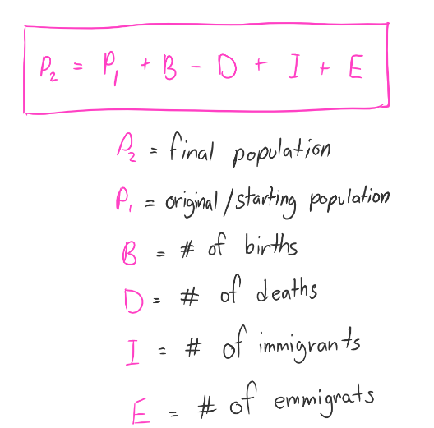

- Population Control:
  - Density-Dependence – factors that affect birth and death rates (population growth/decline) in a way that depends on population density (ex; the effect is stronger/weaker depending on whether the population is dense/sparse)
    - Ex: availability of food, predation, migration and disease
  - Density-Independence – factors that affect birth and death rates in a way that does NOT depend on population density
    - Ex: natural disasters and unusual weather
      - Ex: a hard freeze diminishes the supply of food or prey

Community:
- The collection of species (within its own population) living in an area at a point in time
- Community ecology is the study of the structure and dynamics of animal and plant communities
- Community studies examine how populations of species interact with each other (ex; predators and their prey or competitors that share common resources)
- Community structure includes the species and their abundances within a specific area and includes different types of interactions (as in the species interactions chart)

Ecosystem:
- A community of organisms that interact with each other and environmental factors (ex; abiotic factors)
- Ecosystem ecologists focus on the process that influence the composition and distribution of organisms (ex; transfer or energy and cycling or nutrients)
- The Dairy Bush is a forest ecosystem
- Ecosystem Processes:
  - Elements are continuously recycled from ecosystems – the flow of energy and the cycling of materials
  - Flow of energy – must be continuous because heat energy cannot be recycled
    - The light energy is captured by plants through photosynthesis which results in the production of organic molecules which are later converted to heat through respiration
  - Cycling of materials:
    - Elements occur within ecosystems through processes such as breaking down of parent molecules (ex; rock)
    - Plants take up elements from the soil, water or air which animals consume from the plants or they may directly consume them from the environment through water or consuming mineral soil. Animals release minerals through excretion and bacteria and fungi facility the decomposition of these minerals
- Ecosystem Function:
  - Includes the exchange or energy and nutrients among plants, animals and their environment
    - Ex: in a woodlot there is carbon in the form of branches, logs and leaf litter that is decomposing and producing biomass that organisms (such as insects, bacteria and fungi) feed off of, keeping them from piling up on the woodlot floor
    - Ex: there is a fungus decaying log on the floor of the Goose Walk woods in the arboretum
    - Ex: there is a stand of choke cherry that has an infection or pathogenic fungus in the Dairy Bush

Habitat:
- A habitat is the environment where a species is known to occur
- Can be considered environmental space (the space that an organism occupies which is influenced by abiotic and/or biotic environmental variables
- Can include any characteristic of the environment (food quality) and the use of a specific geographic area by an animal or plant (mountain meadow)
- Habitats can be either large or small
  - Large – the woodland caribou’s habitat is boreal (northern region) forest biome
  - Small – a species of lichen may only occur on acidic rocks
- You must understand habitat diversity within an ecosystem to sample biodiversity since if you miss key types of habitats then you may not have sampled all of the biodiversity within the ecosystem
- Higher habitat diversity usually means there is higher species richness in ecosystems

Functional Traits:
- Functional traits define how species function and perform within a community or ecosystem
- Species have functional traits that are uniquely adapted to the ecological niche and determine how a species will interact with other species and the environment
- Functional Diversity:
  - A measure of biodiversity that accounts for the diversity of functional traits of all the species in a community/ecosystem
- Examples of functional traits:
  - Body size
  - Tolerance and sensitivity to environmental conditions
  - N-fixation ability (ability of nitrogen to be converted into ammonia or other molecules that are needed by plants, animals and other organisms)
- Example:
  - Shade tolerance of plants in a woodlot or forest ecosystem – shade tolerant plants are at an advantage in the woodlot understory because they are able to compete with other not shade tolerant plants and survive while the not shade tolerant species of plants cannot survive or establish tree seedlings (this is the competitive exclusion principle)

Carrying Capacity:
- # of individuals that can survive on the available resources in an area
- Carry Capacity is not fixed because it can be altered by disturbances
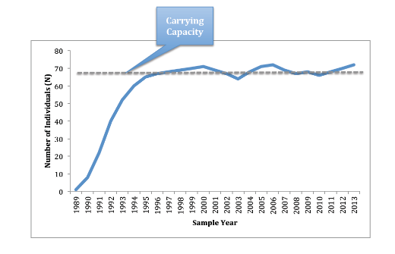
- Decrease in resources = decrease in carrying capacity, therefore decrease in population size
- The graph to the right shows a population growing over time – the population size reaches a maxium that can be sustained by the resources; this is shown by the line labeled “carrying capacity”

Ecosystem Engineering:
- Ecosystem engineers are organisms that can control the availability of resources to other species – they can change, sustain and develop new habitats and influence the niche of other species
- Niche construction is a feedback mechanism (a response in a system that influences the activity/productivity of the system – can be positive or negative feedback) of natural selection communication forces on the abiotic niche
- Organisms can modify conditions locally (ex; a woodlot) and globally (ex; boreal forest region) over time and even after death (ex; decaying logs)
- Example - the influence of Alder shrubs on the progression in the boreal forest ecosystem:
  - Alder species have a symbiotic relationship (mutual beneficial) with Frankia alni.
  - Frankia alni is a nitrogen-fixing bacterium; take nitrogen from the atmosphere and convert it to a form that is used by plants such as an Alter tree and in return, Alder provides Frankia alni with carbon that the tree produces during photosynthesis – BOTH BENEFIT (symbiotic)
  - Alder is one of the first woody plants to establish itself after a disturbance (pioneer species). It improves the fertility of the soils where it grows and helps provide additional nitrogen for the following establishing species (such as balsam fir and spruce)

Adaptive Management:
- Uses ecosystem management (aims to conserve ecological services and restore natural resources) to alter the functioning of an ecosystem
- Identifies uncertainties and then establishes the methods to test the hypotheses concerning those uncertainties
- For example:
  - A woodlot manager wants to change a conifer-dominated woodlot into a hardwood dominated woodlot. This approach could include a strategy based on a hypothesis concerning the growth requirements of hardwood species after manipulating the light from the existing conifer canopy
- There are many steps used in the adaptive management cycle – outlined in the image below
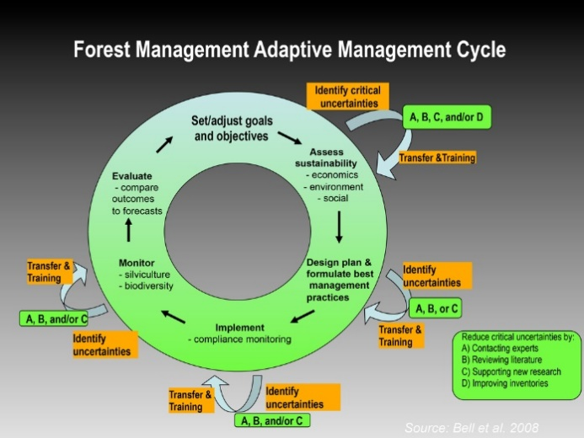

Invasive Species

Zebra Mussels:
- The Zebra mussel is native to Eurasia and most likely invaded our area by ballast water (water discharged by ships), most likely in the larvae state

Garlic Mustard:
- This invasive species very concerning because it is shade tolerant (can survive without direct sunlight – the forest understory)
- It is altering forest composition and productivity in all of the woodlots on campus
- Mechanisms for success:
  - Release secondary compounds
  - Soil biota (life in soil) feedbacks
  - Escape predators
  - Competitor
  - Early phenology (cyclic and seasonal phenomena’s)
  - High phenotypic plasticity
  - High reproduction
- Impacts of invasion:
  - Decreases native plant diversity
  - Decreases native plant growth
  - Decreases mycorrhizal fungi abundance (important relationship between fungi and plants)
  - Decreases native butterfly survival
  - Alters soil nutrient cycling
- Garlic Mustard is a bad invasive species because it has negative effects on the woodlot it invades.
  - Decreases native plant diversity and growth which therefore decreases the resources for wildlife since it forms dense patches and has numerous seeds which dominate over native plant species
  - Decreases mycorrhizal fungi abundance which means the native plants do not have as much water and nutrient absorption and the fungi does not have carbohydrates formed through photosynthesis from the plant – this decreases the survival of native plants and fungi
  - Produces a toxin that kills the soil fungi that plants depend on – decreases native plant growth

Emerald Ash Borer (EAB):
- EAB is the most destructive and costly forest insect to invade North America
- It may actually extirpate ash from North America:
  - The Dairy Bush is home to a rare species of ash, the blue ash, who may not be susceptible to the EAB
- There is a beetle detecting wasp that feeds on EAB and therefore it is proposed that the wasp could help us monitor for the EAB

Possible Explanations (hypotheses):
- Endemism – it evolved here and is only found in this region
- Range expansion – it evolved elsewhere (nearby) and then expanded its range to also include this area.
- Range shift – it evolved elsewhere and used to be found elsewhere, but its range shifted to include only the current distribution and not the former distribution
- Dispersal/non-native/introduced/invasive – it arrived from somewhere else not nearby (ex; seeds transported by birds or introduced by humans)
- Vicariance – it evolved elsewhere, but then the physical landscape itself changed (ex; continental drift)

How could we test these hypotheses?
What happens to the ecosystem when a species is extirpated?

Woodlot Biodiversity and Conservation
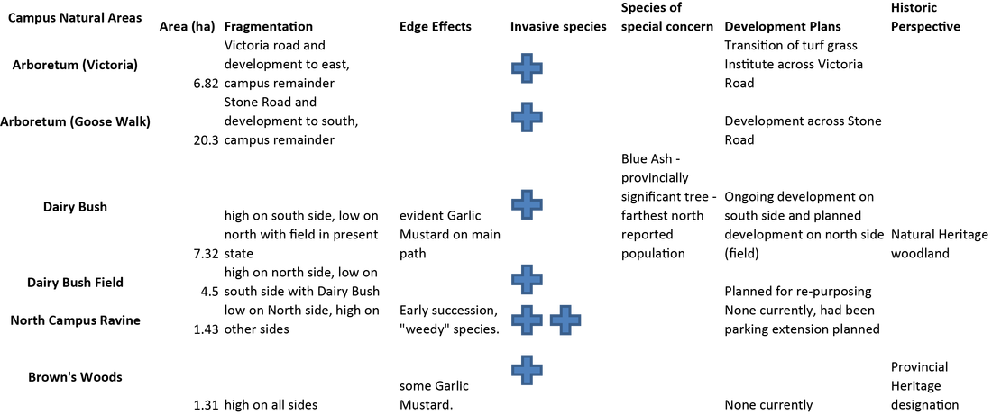

Woodlot size order (smallest to largest):
- Brown’s Woods
- North Campus Ravine
- The Dairy Bush
- The Arboretum

Brown’s Woods:
- Small woodlot (1.3 ha) but has importance that is not predicted by its size
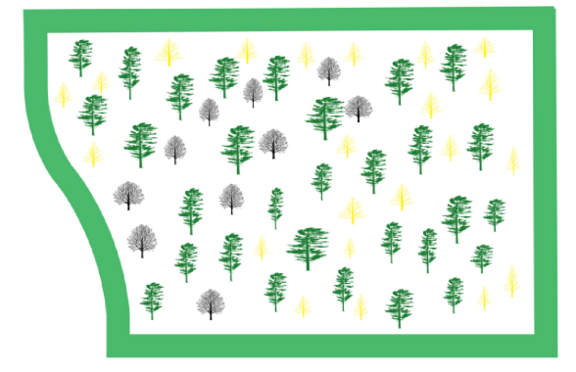

North Campus Ravine:
- Small woodlot (1.43 ha)
- Many of its species have been introduced to the woodlot
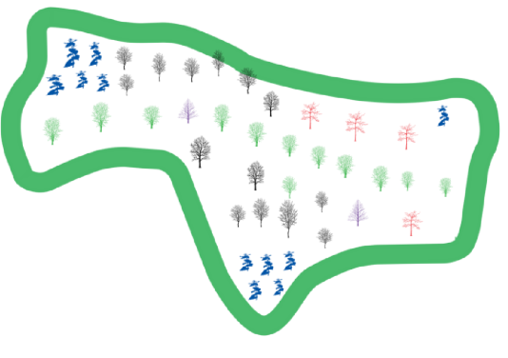

The Dairy Bush:
- Known as the “natural laboratory” – one project seeks to document the numerous arthropod species that are abundant there
- The old field beside the Dairy Bush is slated for “re-purposing” and residential development
- Characteristics:
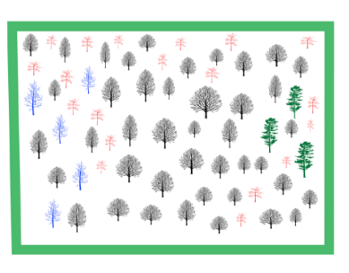
  - Many trees

  - Many plants
  - Many animals
- Development on the University of Guelph Campus:
  - Planned development impact on Dairy Bush:
    - Natural areas are often sacrificed to urbanization in southern Canada due to its extremely high value
    - The intrusion of urbanization (ex; housing developments) has led to increased traffic within the Bush – which will lead to increased degradation
  - Development within the campus happens under the Campus Master Plan
  - Campus Master Plan:
    - Describes the history of the campus and provides guidelines of future development
    - “The Dairy Bush should be protected in any new development, including the use of buffers from streets and new development”
    - “development should not encroach within 10 meters (10m is a minimum buffer, 50m is suggested) of natural areas – these buffer areas naturalize and should be manages as part of the larger natural area”
Dairy Bush under the proposed development plan
Current Dairy Bush
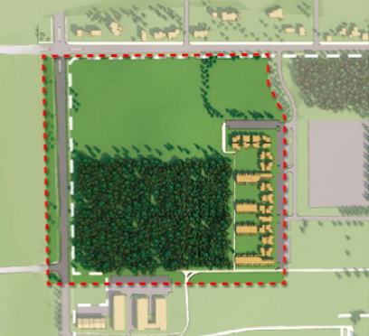
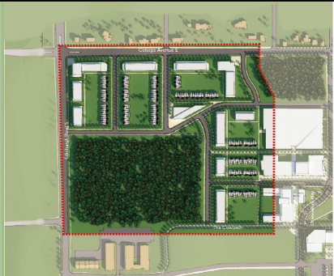

Vs.

  - Edge Effects:
    - The differences between the quality of habitat between interior habitat and habitat close to the edge
    - There is more solar radiation, temperature, humidity, access to resources, moisture and wind in habitats that are closer to the edge (abiotic)
    - There are many species interactions (ex; predators prey more on bird’s nesting in edge habitats – biotic)
    - Edge habitats often become intermediate between the two adjacent habitats (ex; between the forest and the field – the forest edges become hotter and drier with solar radiation than the interior)

The Arboretum:
- Large area of woodlot habitat and gardens – the two largest woodlots are the Victoria Woods and the Wild Goose Woods
- The biodiversity in the Arboretum is quite different than in the Dairy Bush:
  - There is a lot of light in places such as the boardwalk, therefore only species of plants that can survive with a lot of direct sun can survive in this area
  - There is a lot of flooding in the spring with the snow melts in some areas of the Arboretum which means species of trees, such as red maple, and invertebrates are found here but not in the Dairy Bush because they can live in very wet environments
  - Sugar maple is in dominant canopy (high up) and hemlock is in sub canopy (low down) because sugar maple’s have bigger leaves and can therefore grow far faster than hemlocks – sugar maples are more competitive

Forest Biodiversity
Characterizing Diversity:
- Within a habitat:
  - Alpha (α) species diversity - # of species within a habitat
    - We know the measurement is accurate if we know the number of species per specified collection/sample OR if we know the specified number or individuals
  - Species evenness – relative abundance of species in an area
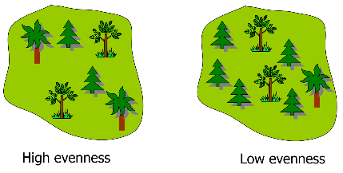
    - High evenness vs. low evenness

    - Described using the Shannon Diversity Index (SDI): H’ = - ∑ ni x ln(ni)
      - SDI is a way of calculation how abundant each species is relative to the abundance of the other species in a habitat – measures EVENNESS
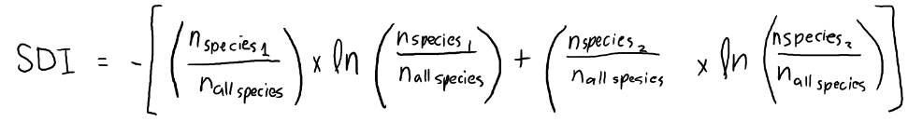
      - Common sense version of equation:

- Across habitats:
  - Beta (β) species diversity – a measure of how different diversity is between different habitats
    - Example:
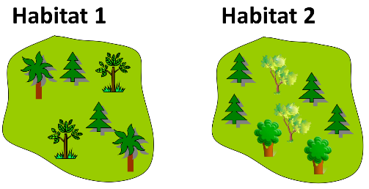

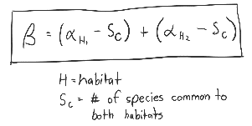

  - Gamma (γ) species diversity – total # of species across all habitats
    - Example:
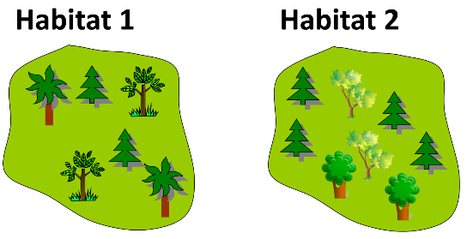

      - Within habitat 1: α-diversity = 3 species
γ-diversity = 5 species
      - Within habitat 2: α-diversity = 3 species

Tree Range Limits and Temperature:
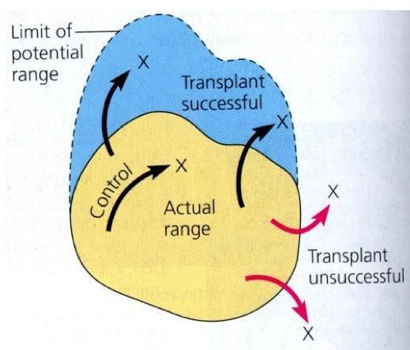

- Tree Line:
  - The edge of the habitat where trees are capable of growing
  - It is found at high elevations and in cold environments
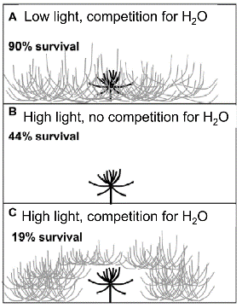
  - Trees cannot tolerate the environmental conditions beyond the tree line (usually cold temperatures or a lack of moisture)
  - Factors that limit the tree line:
    - Shade (cool) – competition for water
    - Full sun (hot) – no competition for water
    - Full sun (hot) competition for water

- Treatments:
  - Underneath herbaceous canopy (shaded, competition for water)
  - On bare soil (a lot of light, no competition)
  - On bare soil, surrounded by herbaceous canopy (a lot of light, competition for water)

Overlapping of Competitors:
- Competitive exclusion – one of the species disappears from that area
- Character displacement – both species continue to co-exist, but they diverge to occupy slightly different ecological niches within the shared habitat
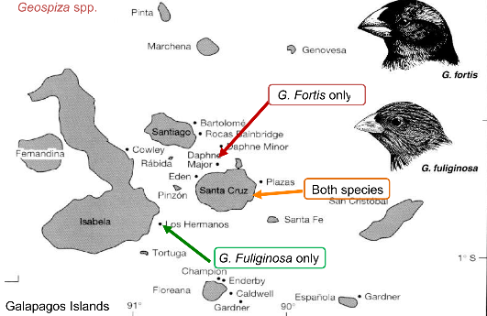
  - Example:
Niche differentiation (realized niche) – natural selection for larger and smaller beak sizes due to competition for food

- Co-existence at reduced carrying capacity – both species continue to live in the area, but at lower numbers of individuals per species

