Midterm 1 Notes
Lecture 2

Evolution:
- The process by which different organisms have developed and diversified from earlier forms

Biological species concept:
- Species are groups of interbreeding natural populations that are reproductively isolated from other such groups

Levels of Biological Organization:
- Domain
- Kingdom
- Phylum
- Class
- Organism
- Family
- Genus
- Species
- Ecosystem
- Community
- Population
- Organ system
- Organ
- Tissue
- Cell

Mussels:
- Formal name of zebra mussels – Dreissena Polymorpha
- Velingers – the larval form of dreissenids
- Glochidia – the larval form of unionids
- Unionids – a family of freshwater mussels, generally having separate sex. They are obligate parasites where glochidia (larvae) are released and must attach to the gills of a fish host in order to complete development.
- Obligate parasitism – must parasitize a host
- Marsupium – modified pouches of the female’s gills where the embryos develop
- Conglutinates – glochidia enclosed in membranous capsules that mimic host prey
- Host Capture – mussel physically grips host and pumps glochidia over gills
- Lures – modifications of tissue that already existed for other reasons (unmodified mantle tissue is used to produce shell)
- Means of host attraction:
1. Ovisacs: membranous capsules that mimic host prey
2. Conglutinates: packets of glochidia that stick to host fish
3. Host capture: grip host fish with ridges on edge of shells then release glochidia into fish mouth and gills
4. Simple lures: modified mantle tissue to catch fish’s attention
5. Complex lures: modified tissue that mimic fish or crustaceans and can move in water to attract the fish’s attention
- Unionid life cycle:
1. Males release sperm into water where it taken up by the female through siphons
2. Fertilization happens internally within the female
3. Larvae grow within the marsupium of the female
4. The mussel using some means to attract a host fish and then deposits glochidia in its gills
5. Glochidia enter parasitic life stage
6. Turn into young mussels
7. Turn into adult mussels
- Veliger larvae life cycle: (no parasitic stage)
1. Fertilization happens with eggs and sperm externally
2. The larvae float around and grow
3. Larvae turn into juvenile mussels
4. Mussels continue to grow into full size adults
- Extinction:
  - Extinction: loss of existing species
  - Geographical barriers: factor preventing gene flow (ie. mountain range)
  - Endangered: abundance has dwindled severely (need protection)
  - Extirpated: species still exist, but they are no longer found in an area where they did once
  - Background extinction: loss of small numbers of miscellaneous species
  - Mass extinction: 50% or more of existing species may be lost in a relatively short period
  - Faunal turnover: following a mass extinction, new niches are opened and surviving
  - Lineages diversify - substantial reorganization of biodiversity
  - Holocene extinction event: mass extinction event almost entirely caused by anthropogenic factors (human activity)

Unionid Life Cycle:
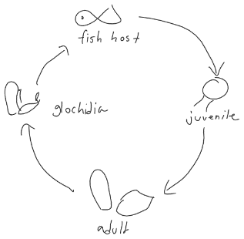
- Must find a host (cannot reproduce without a host)

Unionid Larvae:
- Called glochidia – different species, different sizes
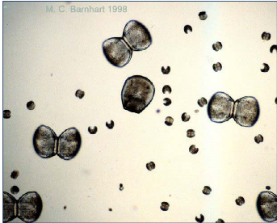
- Can not swim or crawl
- Attach to host fish gills

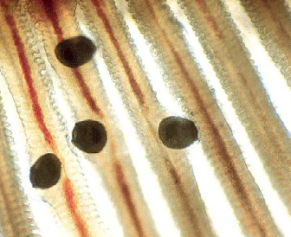
- Cysts around glochidia in fish gills

Strategies for Infecting Fish hosts: baits and traps (lures):
- Conglutinates:
  - Glochidia enclosed in membrane capsules that mimic host prey so that they eat what they think is an edible prey and by the time they realize it is not what they think it is the glochidia is already in the fish host
- Mussel physically grips host and pumps glochidia over the fish gills
- To capture glochidia take a fish head, attach a pipet and put a mussel to latch onto fish head
- Simple lures - modified mantle tissue mimics fish or invertebrate prey item to attach fish host

Phenotypic Difference:
- Example; mussels of one species are shaped in a slow river vs. how a mussel of the same species is shaped in a fast river
- They have changed their morphology (through natural selection to live more comfortably/efficiently in the environment they are in.

Morphological Variation:
- Differences in form and structure of an organism compared to a different organism’s structure.
- Example: thick fur/blubber
- Disparity – how physically different species are from each other
  - Mussels are not very disparate (they look similar)
- Diversity – a measure of the number of species
  - Mammals are not very diverse but they are very disparate
- Abundance – number of individuals variation, differences among individuals in a species, different measure of variability at different scales
  - Genetic and/or phenotypic differences among populations within a species.
  - Human populations in Africa vs. in southeast Asia
  - Genetic and/or phenotypic differences among individual organisms within populations
  - Your classmates vs. you

Lecture 3

Genetic Variation:
- Differences at the DNA level among individuals within a population or species.
- Can change within populations in many ways – mutations, natural selection, genetic drift and gene flow.
- The primary source of genetic variation is mutation. It can also result from recombination.
- Alleles – different versions of the same gene

Mutations:
- They DO NOT occur to benefit the organism
- You do not have variation without mutation
- The origin of new genetic variation
  - MUTATION is the source of new variation – the repeated two-step interaction of mutation and natural selection is what leads to the evolution of new adaptive features.
  - Mutation is random – it is a genetic error that occurs without regard for what happens to the organism. Natural selection is non-random – therefore, it is a misconception to consider that adaptation happens by chance.
  - Mutations occur with all three possible outcomes
    - Neutral (no phenotypic effect)
    - Deleterious (harmful effects)
    - Beneficial (positive effects) – rare and deliver only a minor advantage
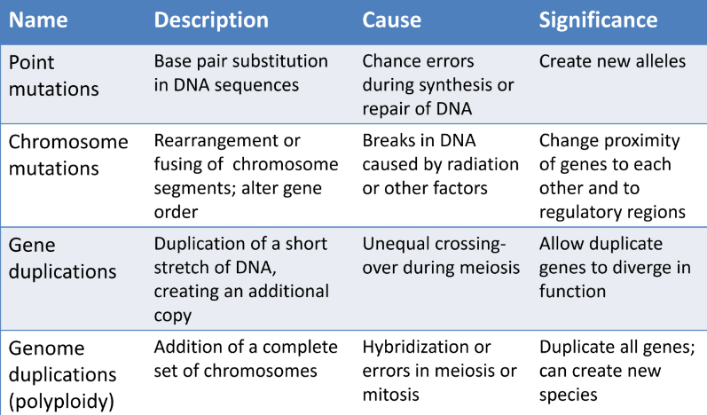

Natural Selection:
- NON – random survival and reproduction among individual entities on the basis of differences in heritable characteristics.
- Does not involve changes to individual organisms in response to pressures and it does not cause an individual to “become” resistant
- Two steps involved
  - Getting the variation, which is usual from mutations
  - The process of what happens to that variation after it arises
- Important things about natural selection:
  - Natural selection does not create new traits by itself; it only changes the proportion of variation that is already present in the population – increases variation because some variants are eliminated.
  - No organism change as the population adapts – the proportion of beneficial traits across multiple generations change.
  - The direction in which change occurs is dependent on the environment – a change in the environment can make previously beneficial traits neutral or harmful.
  - Adaptation does not result in optimal characteristics – it is constrained by historical, genetic and developmental limitations and trade-offs among features.
  - It does not matter what an “ideal” adaptive feature might be – the only relevant factor is that variants that happen to result in greater survival and reproduction relative to alternative variants that are passed on more frequently.
  - The process of adaptations are always to the conditions experienced by generations in the past – not on the grounds that it may become beneficial sometime in the future.
  - Natural selection is not the only mechanism of evolution – mutation, genetic drift and gene flow can also change the proportion of variants in a population

Genetic Drift:
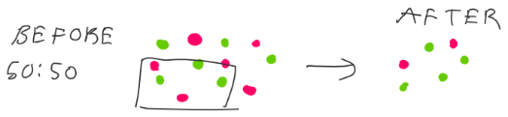
- Evolution by chance due to sampling error

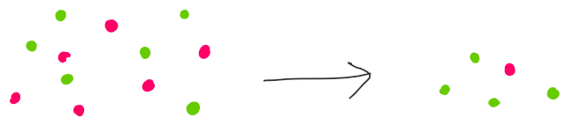
- Cause of genetic drift #2: founder effect

- Gene flow:
  - movement of genes among populations
  - causes two populations to become more similar to each other
  - decreases genetic variability

Lecture 4

How to interpret data:
- What patterns do we observe?
- What can we conclude?
- What are the limitations?
- How might sampling be problematic?
- What questions might we further ask?

Lecture 5
Clade:
- A group of organisms that consists of a common ancestor and all of its linear descendants.
- Must include:
  - The common ancestor
  - ALL of the descendants
- Monophyletic – a clade
- Paraphyletic – not a clade (missing either common ancestor or the descendant)

Hierarchies:
- Linear – one level to another
- Nested – one level is defined as a bunch of sublevels

How do new species form?
- The formation of new species is called speciation
- This usually involves an ancestral species splitting or branching into two descendant species.
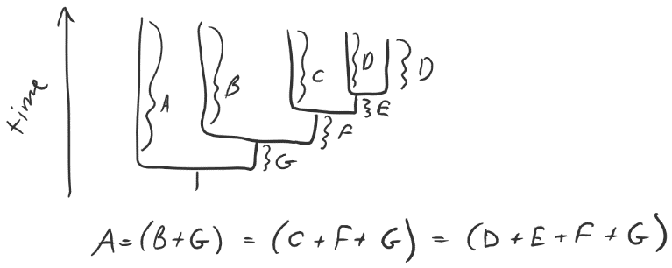
- The lineages of all living species have been evolving for exactly the same amount of time because they all go back to a shared ancestor.

Lecture 6
Traits:
- Traits can be morphological, biochemical, developmental, behavioral and ecological

Other Terms:
- Dioecious: have separate males and females
- Sexual dimorphism: differences between males and females
- Ontogeny: significant changes in morphology from youth to old age
- Phenotypic plasticity: same genotype produces different phenotypes depending on the environment
- Microsatellites: regions of the genome that do not code for proteins and vary widely in quantity among individuals
- Phylogenetics: the particular ways in which living things are related to one another through their common ancestors (shown in trees)
- Phylogeny: The history of the evolution of a species or group, especially in reference to lines of descent and relationships among broad groups of organisms.
- Sister taxa: closest relatives descended from a single recent ancestor
- Root: common ancestor shared by all species depicted
- Branches: connections between ancestors and descendants
- Terminal nodes: living species
- Internal nodes: extinct ancestors
- Topology: order of branching - shows relationship
- Cladogenesis: ancestral species splitting or branching in two separate lines / descendent species
- Cladistics: classification based on evolutionary relationships
- Convergent evolution: The process whereby organisms not closely related (not monophyletic)/ in independent lineages, independently evolve similar traits as a result of
- having to adapt to similar environments or ecological niches
- Divergent evolution: development of different functional structures from a common ancestral form
- Ecological speciation: the process by which ecologically based divergent selection between different environments leads to the creation of reproductive barriers between populations.
- Genetic isolation: Group of organisms that are genetically separate from others of the species, with no gene flow to or from other groups (can result in speciation)
- Ontogenic variation: changes to an animal that occurs as it goes through life (so not evolution)
- Alleles: alternate forms of a gene
- Genotype: set of genes possessed by an organism
- Phenotype: physical expression of the genotype in combination with environmental factor

