MARK 201 FINAL STUDY GUIDE

Final Exam Format

- Part 1: Compulsory Comprehensive Questions (case study): 65 marks (11 questions)
- Part 2: 35 multiple choice

Most Important Topics for case study:

Different Microenvironment/Macro Environment Factors

The microenvironment consists of actors close to the company that combine to form its value delivery network or that affect its ability to serve its customers.

- The company: In designing marketing plans, marketing management takes other company groups into account
- The suppliers: Suppliers form an important link in the company's overall customer value delivery network. They provide the resources needed by the company to produce its goods and services.
- The Marketing intermediaries: help the company promote, sell, and distribute its products to final buyers.
- The Competitors: The marketing concept states that, to be successful, a company must provide greater customer value and satisfaction than its competitors do. Thus, marketers must do more than simply adapt to the needs of target consumers.
- The Publics: The company's marketing environment also includes various publics. A public is any group that has an actual or potential interest in or impact on an organization's ability to achieve its objectives.
- The Customers: Customers are the most important actors in the company's microenvironment. The aim of the entire value delivery network is to serve target customers and create strong relationships with them.

The macro environment consists of larger societal forces that affect the entire microenvironment. The six forces making up the company’s macro environment are:
- Demographic
- Economic
- Natural
- Technological
- Political/Social

Segmentation variables

Geographic segmentation: Subdividing markets into segments based on location, the regions, countries, cities and towns where people live and work is geographic segmentation. The reason for this is simply that consumer wants and product usage often are related to one or more of these subcategories. Geographic characteristics are also measurable and accessible.

Demographic segmentation: Demographics are the most common basis for segmenting consumer markets. They are frequently used because they are often strongly related to demand and relatively easy to measure. The most popular characteristics for demographic segmentation are age, gender, family, life-cycle, income and education.

Psychographic segmentation: Psychographic segmentation divides buyers into different groups based on social class, lifestyle or personality characteristics. People in the same demographic Group can have different psychographic makeup. So psychographic segmentation helps the marketer in examining attributes related to how a person thinks, feels, and behaves

Behavioral Segmentation: In behavioral segmentation, buyers are divided into groups on the basis of their knowledge of, attitude towards, use of, or response to a product. Behavioral segmentation includes segmentation on the basis of occasions, user status, usage rate loyalty status, buyer-readiness stage and attitude.

B2B Business customers (difference between business market and customer market)

Business-to-Business (B2B)

- Buying behavior of firms that buy products to produce other products or to resell to others
- B2B market is huge and involves far more dollars and items than consumer markets

The business market comprises all organizations that buy goods and services for use in the production of other products and services or for the purpose of reselling or renting them to others at a profit. As compare with customer markets, business market usually have fewer, larger buyers who are more geographically concentrated. Business demand is derived demand, and the business buying decision usually involves more, and more professional, buyers.

Business buyers make decisions that vary with the three types of buying situations: straight rebuys, modified rebuys, and new tasks.

The business buying decision process has eight basic stages:
- Problem recognition
- General need description
- Product specification
- Supplier search
- Proposal solicitation
- Supplier selection
- Order routine specification
- Performance review

Grid for value proposition

Create value for targeted customers

Select customers to serve | Decide on a value proposition
Segmentation  Divide the total market into smaller segments of buyers with different needs, characteristics, or behaviours. | Differentiation  Differentiate the market offering to create superior customer value
Targeting  Evaluate each market segment’s attractiveness and select one or more segments to serve. (building the right relationships with the right customers) | Positioning  Position the market offering in the minds of target customers

Brand development strategy

Marketing managers responsible for brands must make high-level strategic decisions that govern the management of the brand and guide the public and market perceptions about the brand. The main branding strategy decisions are brand name selection, brand positioning, and brand sponsorship. In addition, because brands are valuable corporate assets, they must be carefully developed, either by creating line extensions or brand extensions, pursuing a multibrand strategy or creating entirely new brands.

Brand name selection

A good name can add greatly to a product’s success. However, finding the best brand name is a difficult task. It begins with a careful review of the product and its benefits, the target market, and proposed marketing strategies.

After that, naming a brand becomes part science, part art, and a measure of instinct. According to brand experts, here are the things to consider when coming up with a new brand name:

- It should suggest about the type of product it will brand: Beautyrest, Facebook.
- It should be easy to pronounce, recognize and remember: Tide, Crest
- It should be distinctive: Google, Lexus
- It should be extendable, that it not tied too closely to one product. Good names that illustrate this example: Apple, Amazon and Nike
- It should be pronounceable in many languages such as Kodak
- It should be capable of registration and protection as trademark. A brand name cannot be registered if it infringes on existing brand names. Unique, “made up” names wok best for this: Yahoo!, Ugg.

Brand positioning

- Positioning is very important for brands, because they are intangible.
- Brands can be positioned based on product attributes.
- Consumers are more interested in what the products will do for them, so a better positioning strategy is to associate the brand with a particular benefit.
- The strongest brands go beyond attributes or benefit positioning: they are positioned on strong beliefs and values, and as such engage consumers on a deep, emotional level.

Brand sponsorship

- Important branding strategy decision
- “To brand or not to brand?”
- Not all products are branded, but those that are may be national brands or private brands.
- Marketers may chose licensing as a method of branding a new product, or they may partner with another firm to co-brand a product.

Brand Development

Brands are powerful, valuable assets that must be carefully developed. In general, a company has four options when it comes to developing brands. It can create line extensions or brand extensions, pursue a multibrand strategy or create entirely new brands.

Line extensions: occur when a company extends existing brand names to new forms, colours, sizes, ingredients, or flavours of an existing product category; example, Honey Nut Cheerios and Multigrain cheerios are extensions of the cheerios product line. A company might use line extension as a low-cost, low-risk way to introduce new product. Or it might want to meet consumer desires for variety, to use excess capacity, or simply to command more shelf space from resellers. However, line extension involve some risks: might lose its specific meaning, or might take over other items in the line.

Brand extension: extend a current brand name to new or modified products in a new category. For example, Campbell Soup extended its V8 juice brand to a line of soups, and Ritz extended its brand to mini Ritz Bits Sandwiches. A brand extension gives a new product instant recognition and fater acceptance. It also saves the high advertising costs usually required to build a new brand name. At the same time, a brand extension strategy involves some risk. Brand extensions such as Cheetos lip balm, Heinz pet food and Life Savers gum met early deaths. The extension may confuse the image of the main brand. And if a brand extension fails, it may harm consumer attitudes toward the other products carrying the same name brand name.

Multibrands: Multibranding is a brand development strategy in which the same manufacturer produces many different brands in a given product category. A major drawback of multibranding is that each brand might obtain only a small market share, and none may be very profitable. The company may end up spreading its resources over many brands instead of building a few brands to a highly profitable level. This happened to General Motors, which was forced to cut several unprofitable brands from its portfolio, including Saturn, Oldsmobile, Pontiac, Hummer and Saab.

New brands: Sometimes a company that has a long-established name and hes been in business for many years decides to adopt a new strategy- to brand itself and its products. More frequently, an established company creates a new brand when it develops a new product or product line. For example, Toyota created the Scion brand to appeal to Millennials, and Grocery chain Sobeys redesigned some of its suburban stores under the banner of a new brand name, FreshCo.

Product mix pricing strategy

The strategy for setting a product’s price often has to be changed when the product is part of a product mix. In this case, the firm looks for a set of prices that maximizes the profits on the total product mix. Pricing is difficult because the various products have related demand and costs, and face different degrees of competition.

Pricing Situation | Description
Product line pricing | Setting prices across an entire product line
Optional-product pricing | Pricing optional or accessory products sold with the main product
Captive product pricing | Pricing products that must be used with the main product
By-product pricing | Pricing low-value by-products to get rid of them
Product bundle pricing | Pricing bundles of products sold together

Direct/indirect channel mix

What is a channel?

Few producers sell their goods directly to the final users of their products. Instead, most use intermediaries to bring their products to market. They forge a marketing channel (or distribution channel)- a set of interdependent organizations that help make a product or service available for use or consumption by the consumer or business customer.

Direct vs Indirect

Companies can design their distribution channel to make products and services available to customers in different ways. Each layer of marketing intermediaries that performs some work in bringing the product and its ownership closer to the final buyer is a channel level. Because both the producer and the final consumer perform some work, they are part of every channel.

The number of levels of the channel, or number of channel members that function as intermediaries between the producer and the consumer, constitutes the length of a channel.

The shortest possible channel is a channel with no intermediaries:
Direct marketing channels where the producer of the goods sells directly to the final customer.

Most channels, however, have one or more intermediaries, and are therefore:
Indirect marketing channels involve intermediaries between the producer and consumer.

Communication mix (five components)

A company’s total promotion mix- also called its marketing communications mix- consists of the specific blend of
- Advertising: includes any paid form of non-personal presentation and promotion of ideas, goods, or services by an identified sponsor.
- Personal Selling: is personal presentation by the firm’s sales force for the purpose of making sales and building customer relationships.
- Sales Promotion: provide short term incentives to encourage the purchase or sale of a product or service
- Public Relations: focuses on building good relations with the company’s various publics.
- Direct and Digital Marketing Tools: firms seeking immediate response from targeted individual consumers and consumer communities use direct, digital, and social media marketing tools to engage consumers and cultivate relationships with them.

The company uses these communication mix to persuasively communicate customer value and build customer relationships.

Goals of having a website

Building an Effective Web Presence

An e-business website can:

- Broaden customer bases
- Provide immediate access to current catalogues
- Accept and process orders
- Offer personalized customer service

Review Chapter 1 – 13

MARKETING 201 MID TERM STUDY GUIDE

Chapter 1

What is marketing?

The activity, set of institutions, and processes or creating, communicating, delivering, and changing offerings that have value for customers, clients, partners, and society at large.

The process by which companies create value for customers and build strong customer relationships in order to capture value for the customers.

Marketing is NOT Sale
It’s everything that is done in support of sales.

The Marketing Process

- Create value for customers
- Build strong customer relationships
- Capture value from customers

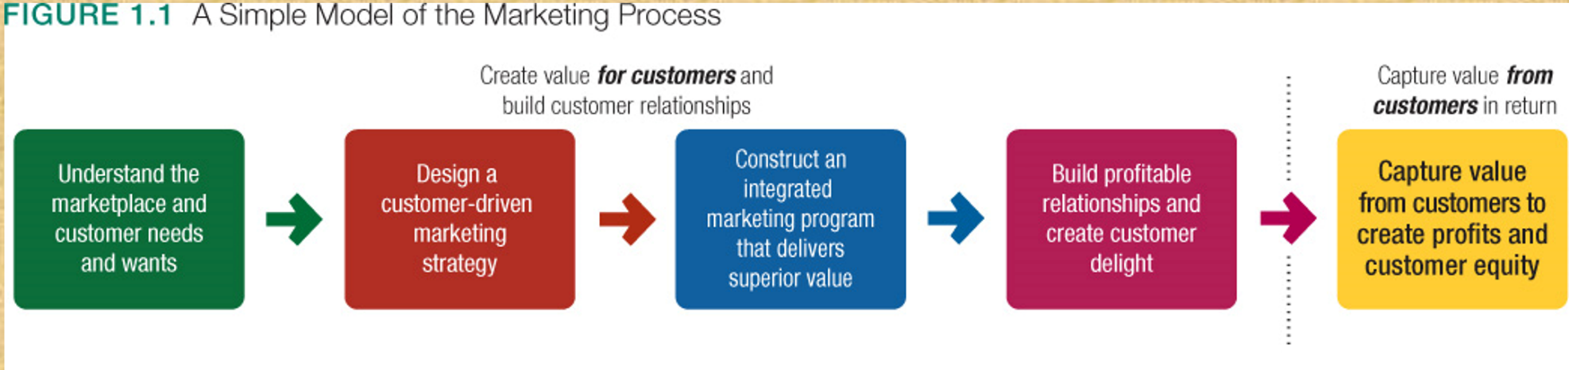

NEED VS WANTS VS DEMANDS
NEED: state of felt deprivation (physical, social)
WANTS: the form human needs take as they are share by culture and individual personality
DEMANDS: the human wants that are backed by buying power

Market offerings: products services, experiences
- Marketing myopia the product itself is more important than the needs.
- Always remember customer is King

MARKET

- A market is the set of all actual and potential buyers of a product or service. These buyers share a particular need or want that can be satisfied through exchange relationships.
Designing a customer driven marketing strategy

- What customers will we serve (what’s our target market)
- How can we serve these customers best (value proposition)?

Marketing management
Choosing target markets and building profitable relationships with them

- Selecting customers to serve
- Segmenting
- Targeting

Marketing management is not finding as many customers as possible and increasing demand. Its about segmenting
Example Dollarama low income vs holt Renfrew high income

- Choosing a value proposition

Five alternative concepts: production, product, selling, marketing, and social marketing concepts

- The production concept
Marketing strategy should focus on improving production and distribution efficiency
- The product concept
Marketing strategy focuses on making continuous product improvements.
- The selling concept
Marketing strategy should focus on large scale selling and promotion
- The marketing concept
Focus on customer and value are the paths to sales and profits.
“Sense and respond” philosophy
- The social marketing concepts: a company marketing decisions should consider Society, Consumers & Company.

Preparing an integrated marketing plan and program

Marketing mix:

Product
Price
Place
Promotion

Building Customer Relationships

- Customer relationship management: the overall process of building and maintaining profitable customer relationships by delivering superior customer value and satisfaction
- It deals with all aspects of acquiring, keeping and growing customers

Customer relationship building blocks:

- Customer-perceived value : Customer’s evaluation of all benefits and all costs of a market offering relative to the competitors.

Building customer equity

- The total combined customer lifetimes values of all the company’s current and potential customers
- The more loyal the firm’s profitable customers, the higher its customer equity.
- Customer equity may be a better measure of a firm’s performance than current sales or market share

Chapter 2

Marketing Strategy and the Marketing Mix

Objective: build profitable customer relationships through value creation

- Segmentation: Dividing a market into segments of buyers according to needs
- Targeting: Evaluating each segment and selecting which to pursue. Depends on company’s marketing resources (quality, efficiency)
- Positioning: Attempting to occupy a desirable place in the minds of target consumers
- Differentiation: Creating unique and superior customer value
Marketing mix

The set of tactical marketing tools

- Product
- Price
- Place
- Promotion

Chapter 3
Sustainable Marketing
- Socially and environmentally responsible marketing (business) that meets the needs of customers while preserving the ability of future generations to meet their needs

Figure 3.1 Sustainable Marketing

Social Criticisms of Marketing
- High Prices
  - High Costs of Distribution
  - High advertising and promotion codes
  - Excessive markups
- Deceptive Practices
  - Pricing
  - Promotion
  - Packaging
- Greenwashing

Social Criticisms of Marketing
- High-Pressure Selling
- Unsafe Products
- Impact on society has been criticized as:
  - Encouraging materialism
  - Overselling private goods
  - Creating cultural pollution
- Marketing practices reduce competition by:
  - Acquisition and shrinking of competitors
  - Creating barriers to entry
  - Unfair practices such as predatory pricing

Planned Obsolescence
- Using inferior materials and components
- Continuous changing of acceptable styles
- Delaying features until follow up version

Consumer Actions to Promote Sustainable marketing

Consumerism:
- Organized movement to improve the rights and power of buyers in relation to sellers
Environmentalism:
- Organized movement to protect and improve people’s living environment

Consumer Activism

Seller’s Rights | Buyer’s Rights
Introduce any product in any size and style | Not buy a product that is offered for sale
Charge any price for the product | Expect the product to be safe
Spend any amount to promote the product | Expect the product to perform as claimed
Use any product message
Use any buying incentive schemes

Consumer advocates call for more rights in order to:
- Be well informed about aspects of the product
- Be protected from bad products and practices
- Influence products to improve “quality of life”
- Preserve the world for future generations of consumers

Environmentalism:
- An organized movement to protect and improve people’s living environment

Consumerism and Environmentalism

Environmental Sustainability Portfolio

Figure 3.2 The Environmental Sustainability Portfolio

Sustainable Marketing Principles

Consumer-Oriented Marketing:
- Marketing activities are viewed and organized from the consumer’s point of view
Customer-Value Marketing:
- Company resources go toward customer value building marketing investments

Principles of Sustainable Marketing
- Innovative Marketing
- Sense of Mission Marketing

Societal Marketing
Societal Marketing considers:
- Consumer’s wants and interests
- The company’s requirements
- Society’s long-term interests

Chapter 4

Marketing Environment

Definition

The actors and forces outside marketing that affect marketing management’s ability to build and maintain successful relationships with target customers.

The Microenvironment

All actors close to the company that affect, positively or negatively, its ability to create value for and relationships with customers.

The Company

The Suppliers
- Ikea currently relies on more than 2000 suppliers in 50 countries to stock its shelves

Marketing Intermediaries
- Resellers
- Physical distribution firms
- Marketing services agencies
- Financial intermediaries

Competitors
- Strategic advantage by positioning their offerings

Publics
Financial publics, media publics, government publics, citizen action publics, local publics, general public, internal publics

Customers

The Macro environment

- Demographic forces & environment
- Economic forces & Environment
- Factors that affect spending
- Natural forces & Environment
- Technological forces & Environment
- Political forces & Environment
- Cultural forces & Environment

Chapter 5

Managing Marketing Information to Gain Customer Insights

Customer insights

Fresh understandings of customers and the marketplace derived from marketing information that become the basis for creating customer value and relationships

Marketing Information System

People and procedures dedicated to assessing information needs, developing the needed information, and helping decision makers to use the information to generate and validate actionable customer and market insights.

Marketers can obtain the needed information from internal data, marketing intelligence, and marketing research.

Competitive Marketing Intelligence: Goal is to improve strategic decision making

Marketing research: the systematic design, collection, analysis and reporting of data relevant to a specific marketing situation facing and organization.

Three types of Marketing research

- Exploratory research -> to gather preliminary info
- Descriptive research -> to describe things
- Casual research -> test hypotheses about cause and effect relationships

Data Sources

Secondary vs Primary

Primary Data:
- Information collected for a specific problem
- Must be relevant, accurate, current and unbiased

Secondary (Existing)Data:
- Advantages: quicker and cheaper
- Disadvantages: relevance, currency, accuracy
Rarely provides all necessary info

Secondary Data:
- Internal database
- External information sources: general database services such as Dialog, Pro-Quest, and LexisNexis put an incredible wealth of information
- Every industry association, government agency, business publication and news medium. Offers free info
- Internet search engines

Research Approaches
- Observational
- Survey
- Experimental

Chapter 6

Understanding consumer and business buyer

Consumer market

All the individuals and households that buy or acquire goods and services for personal consumption

Consumer buyer behavior

The buying behavior of final consumers – individuals and households that buy goods and services for personal consumption

Characteristic affecting consumer behavior
- Cultural
- Social
- Personal
- Psychological

Five stages in the buyer decision process:

- Need recognition
- Information search
- Evaluation of alternatives
- Purchase decision
- Post purchase behavior

The buyer decision process for new products

Adoption process
Influence of product characteristics on rate of Adoption

- Relative advantage
- Compatibility
- Complexity
- Divisibility
- Communicability

Business Markets and Business Buyer behavior

- Business-to-Business (B2B)

Business Markets

- Market structure and demand
- Nature of the buying unit
- Types of decisions

Stages of the Business Buying Process

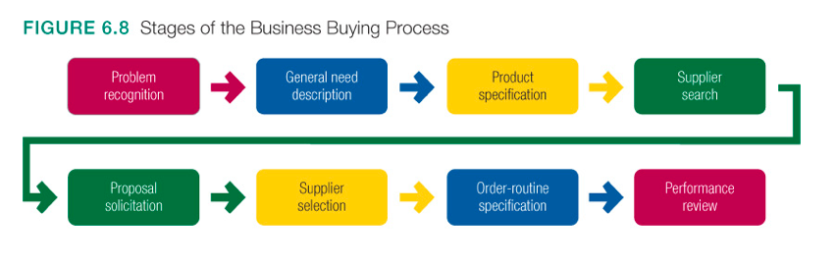

Chapter 7

Segmentation, Targeting and Positioning

To design a winning marketing strategy, we must answer two questions:

- What customers will we serve (what’s our target market)?
- How can we serve these customers best (what’s our value proposition)?

Create value for targeted customers

Select customers to serve | Decide on a value proposition
Segmentation  Divide the total market into smaller segments | Differentiation  Differentiate the market offering to create superior customer value
Targeting  Select the segment or segments to enter | Positioning  Position the market offering in the minds of target customers

Market segmentation

Grouping buyers based on needs, traits, or behaviors that might require separate marketing strategies or mixes.

Segmenting consumer markets

- Geographic Segmentation
- Psychographic Segmentation
- Demographic Segmentation
- Behavioural segmentation

Segmenting Business Markets
Segmenting International Markets

Requirements for Effective Segmentation

To be effective, market segments must be:
- Measurable
- Accessible
- Substantial
- Differentiable
- Actionable

Market Targeting

- Market Targeting | - Target Marketing
Evaluating segments  - Profitability  - Growth  - Corporate objectives? | - Undifferentiated marketing  - Differentiated marketing  - Niche marketing  - Micromarketing
Selecting Segments

Differentiation and Positioning

Product Position:

- Consumer perception of products
- Place the product occupies in minds of consumers relative to competitors

Choosing a differentiation and positioning strategy

A differentiation and positioning strategy involves:
- Identifying competitive advantages
- Selecting competitive advantages on which to create position
- Developing a positioning strategy

Identifying Possible Value differences and competitive advantages

- Understand customer needs better than competitors, then deliver more value
- Point of differentiation can occur anywhere in the entire customer experience

Differentiation and Positioning

Choosing the Right Competitive Advantages
- How Many Differences to Promote
- One unique selling proposition (USP)

Chapter 8

Marketing mix
The set of tactical marketing tools – product price place and promotion – that the firm blends to produce the response it wants in the target market

What is a Product?

Product
Anything that can be offered to a market for attention, acquisition, use, or consumption that might satisfy a want or a need.

Service
- Services are a form product
- An activity, benefit, or satisfaction offered for sale that is essentially intangible and does not result in the ownership of anything.

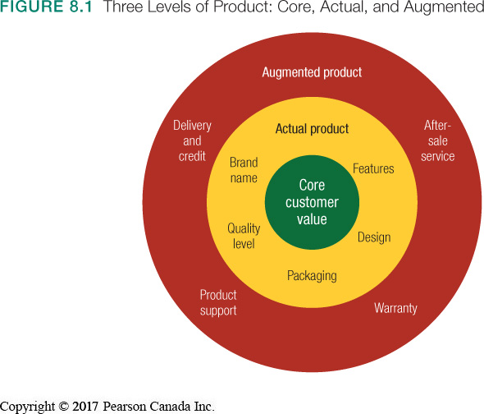

New Product Development:
- Development of original products, improvements, modifications, or new brands
- New product innovation is expensive and risky. Most new products fail or underperform
- Diffusion of innovations theory

Influence of product characteristics on rate of adoption

- Relative Advantage
  - Superior to existing products?
- Compatibility:
  - Aligned with values of the market?

Major stages in new product development

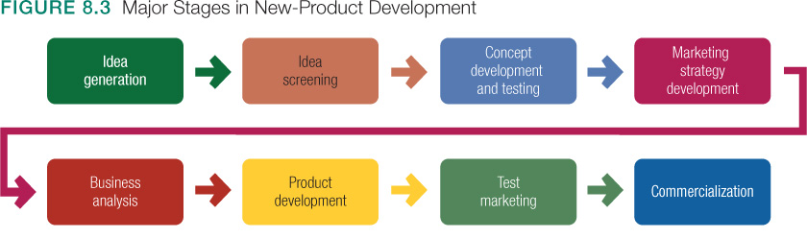

Special characteristics of Services

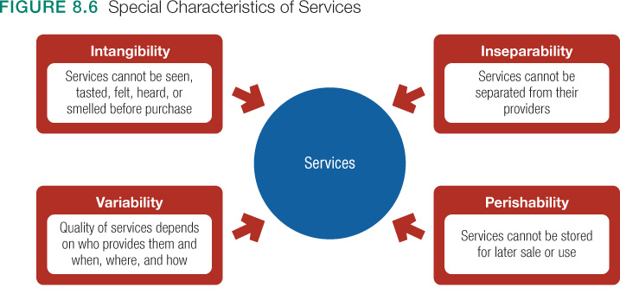

The service profit chain

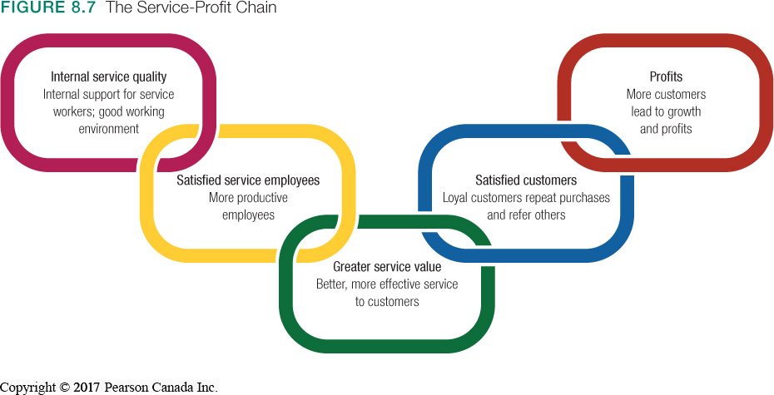

Chapter 9

What is a brand?

- A brand is the image which stands behind the name, symbol, icon, design, or combination of these, that identifies the maker or marketer of a product
- Branding can add value to a product

More than names or symbols, brands:
- Have a status and value
- Have personality
- Involve emotions
- Signify emotions
- Signify quality
- Provide legal protection

Video – What is a Brand
Brands are built by actions, not by words. Your brand is your promise, it’s what you stand for.
Trademarks

Trademarks can be:

- Names, symbols, characters, shapes
- Has monetary value
- Indicated with a superscript TM

Brand meaning

- Brand expert A1 Reis says that
They key to communicating brand meaning is to get consumers to associate your brand with just one word, so that your brand “owns” that word in terms of brand positioning.

Chapter 10

What is Price?

The total value that customers exchange for the benefits of having or using the product or service.

Price is the most flexible “P” in the 4 P’s.
Cost-based pricing
Design a good product – Determine product costs – Set price based on cost – Convince buyers or product’s value

Value-based pricing
Assess customer needs and value perceptions – Set target price to match customer perceived value – Determine costs that can be incurred - Design product to deliver desired value at target price

Chapter 11

Products come through a supply chain:
- Upstream producers supply raw materials and components necessary to create products
- Downstream marketing channel partners link producers to the customer

Value delivery network:
- Producers, suppliers, distributors, and customers who improve the performance of the entire system in delivering customer value
Marketing Channel:
- Interdependent firms that make a product available for businesses or consumers
  - Channel decisions affect other marketing decisions
  - Channel decisions can lead to competitive advantage
Vertical marketing system (VMS)

- VMS – A channel structure in which producers, wholesalers, and retailers act as a unified system
- One channel member owns the others, has contracts with them, or has so much power that they all co-operate

Chapter 13

The Promotion Mix

Tools used to persuasively communicate customer value and build customer relationships

- Advertising
- Sales promotion
- Public relations
- Personal selling
- Direct marketing

Integrated marketing communications

- Communication with/to customers is changing:
  - Consumers see “single” messages from companies
  - Communication technology is richer, faster
  - Marketing strategies must be integrated
Advertising

Pros
- Reaches masses at low cost per exposure
- Repeats message many times
- Creates consumer trust (view of advertised products as more legitimate)
Cons
- Promotes impersonally, one-way
- Costs are high for some media types

Personal Selling

Pros
- Communicated personally two-ways
- Builds preferences, convictions, and actions
- Allows relationship building
Cons
- Requires long-term commitment to sales force
- Most expensive promotion tool

Sales Promotion

Pros
- Includes a wide assortment of tools
- Attract consumer attention
- Offers strong incentives to purchase
- Dramatizes product offers
- Invites quick consumer response
Cons
- Effects are short-lived

Public Relations

Pros
- Legitimizes credibility, very believable
- Reaches people who resist advertising
- Dramatizes a company or product
- Saves money when used proactively
Cons
- Tends to be used as an afterthought

Direct Marketing

Pros
- Communicates more directly with targeted customers
- Reaches customers with tailored message
- Creates interactivity
- Builds one to one relationships

Cons
- Often perceived as junk-mail/spam

Chapter 16

Direct Marketing Benefits

What is a global firm?

- A firm that, by operating in more than one country, gains R&D, production, marketing, and financial advantages in its costs and reputation that are not available to purely domestic competitors

Decisions in International Marketing
The International Trade System

- Tariffs or duties
- Quotas
- Exchange controls
- Nontariff trade barriers

The World Trade Organization

- Replaced GATT
- Promotes world trade
- Reassess

Regional Free Trade Zones
Economic Communities
- European Union
- North American Free Trade Agreement (NAFTA)
- Trans-Pacific Partnership

Economic Environment
Two economic factors reflect the country’s attractiveness as a market:

Deciding How to Enter the Market: Joint Venturing
- Licensing
- Contract manufacturing
- Management contracting
- Joint ownership

Deciding How to Enter the Market: Direct Investment
- Developing a foreign-based assembly or manufacturing facility
- Ford has made major direct investments in several countries, such as India, China and Thailand, to help satisfy Ford’s burgeoning demand in Asian markets

Different book:

Chapter 4: Digital Marketing and Social Media: Living in the Connected World

Contemporary Marketing, Fourth Canadian Edition
Social Media

Different forms of electronic communication through which users can create online communities to exchange.

- Information
- Ideas
- Messages
- Other content such as videos or music

Categories of Social Media

Social Media Platform – Type of software or technology that allows users to build, integrate, or facilitate a community, interaction among users, and user-generated content

Social Media Tool

Enables users to communicate with each other online
Why Should Marketers Turn to Social Media?

Social Media is a tool for marketers to:

- Build relationships with customers
- Strengthen brands
- Launch new products
- Enter new markets
- Boost sales

Social Media Marketing (SMM)

Uses social media portals to create a positive influence on consumers or business customers toward an organization’s:

- Brand
- Goods and services
- Public image
- Website

SMM contains three essential features:

- Creates a buzz
- Creates ways for customers or fans to engage in conversations with each other and the organization
- Allows customers to promote the firm’s messages themselves

How Consumers Use Social Media

Search engines:
- Provide shoppers with the greatest amount of information about products and companies
- Help with comparison shopping, particularly when it comes to price

