4.1 Macroeconomic Performance

- Output, price, & employment are 3 key dimensions of macroeconomic activity.
- Output & its rate of growth are measured in terms of real gross domestic product (RGDP): the qty of final goods & services produced by the economy in a specified time period measured in the market prices of a base year
- By measuring RGDP in the prices of a base year, the changes seen in RGDP are the result of changes in the qtys of goods & services produced, & not the result of changes in prices
- Important distinction: increased qtys of goods & services provide for increased standards of living in the economy, increases in prices do not
- As a result, economic growth is defined as an increase in RGDP, & the annual rate of economic growth is the annual percentage change in RGDP

- Price level: a measure of the average prices of all goods & services produced in the economy
- Consumer Price Index (CPI): a measure of the cost of living in any one year compared to the cost of living in a base year (for ex: compares the cost of a fixed basket of goods & services bought by the typical HH at a specific time w/ the cost of that same basket of goods & services in the base year)
- CPI most widely used indicator of prices in Canada & often referred to as the “cost of living”
- Price Index: a measure of the price level in one year compared w/ prices in a base year

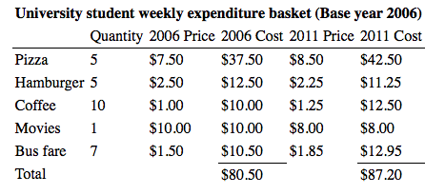

- Inflation: a persistent rise in the general price level

- Labour Force Canadian individuals 15 years of age or over, excluding full-time members of the armed forces, those persons living on Indian reserves, & those in institutions such as penal institutions, hospitals, & nursing homes
- Labour force: adults employed plus those not employed but actively looking for work
- Employment: number of adults employed full-time & part-time & self-employed
- Unemployment: number of adults not working but actively looking for work
- Participation rate: % of the population that is either working or unemployed
- PR measures the size of the LF relative to the surveyed population
- Discouraged workers want to work but are no longer looking for work b/c they believe work is not available
- As result, they are excluded from the measurement of the LF & reduce the PR
- Changes in the PR change the size of the LF & the UR even if employment & the pop are constant
- Unemployment rate: the number of unemployed persons as a percentage of the LF
- Size of LF depends on the PR, which reflects the choices ppl make about looking for work
- The UR will rise if ppl become more optimistic about job prospects & begin to look for work, increasing the PR & the LF
- On other hand, the UR will decline if some ppl become discouraged & give up looking for work, reducing the PR & the LF
- Cyclical unemployment: would be eliminated by higher levels of economic activity. (*would be eliminated by a higher level of economic activity w/out putting increased pressure on wage rates & inflation.)
- Frictional unemployment: a result of the time involved in adjusting to changing LF & employment opportunities. (*comes from the dynamics of the labour market as changing LF participation & employment opportunities mean that it takes time to match job openings w/ job candidates.)
- Structural unemployment: caused by changes in economic structure relative to labour characteristics.
- Natural unemployment rate: the unemployment rate at “full employment”
- Frictional & structural make up the “full employment” level of unemployment

- Employment rate: % of the pop 15 yrs + that is employed
- ERs provide a diff perspective on labour market conditions b/c they are not affected by changes in the PR, which can change URs
- If some ppl become discouraged & stop looking for work the PR, the LF, & the UR rate decline, but the ER is unchanged

- Employment must grow faster than the growth in the LF if unemployment is to decline

4.2 Canadian Economic Performance

- The ideal would be an economy in which, starting w/ full employment of labour & capital equipment, the rate of growth of RGDP matched the rate of growth of the LF & growth in labour productivity, at a low & stable rate of inflation. Sometimes referred to as a “Goldilocks Economy”—neither too hot nor too cold, just right.

- Recession: decline in economic activity, often defined as 2 consecutive quarters of negative growth in RGDP

- Fluctuations in growth rates & inflation rates are also accompanied by fluctuations in unemployment rates.
- When job creation has at times fallen short of the growth in the LF, unemployment rates rise.
- At other times, strong RGDP growth & job creation have lowered the unemployment rate.

4.3 National Accounts

- National accounts provide the framework that is essential for consistent definitions & measurement of spending, output, & incomes.
- Circular flow diagrams: show the flows of money payments, real resources, & goods & services b/w HHs & businesses
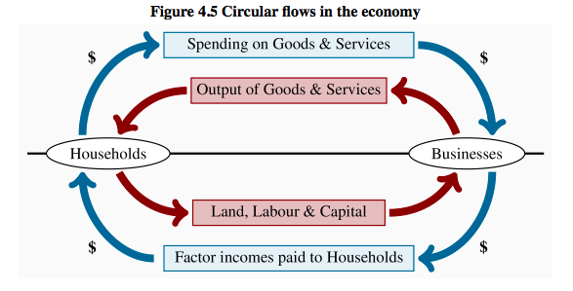
- There are only HHs & businesses; no gov & no trade w. other countries
- HHs own the factors of production: labour, land, capital, & entrepreneurship
- Businesses use these factors of production to produce outputs of goods & services
- Businesses pay HHs for the factor services they use & recover these costs by selling their output to the HHs

- Upper half of diagram: shows the outputs of goods & services supplied by business to HHs & HH expenditures on those goods & services
- Lower half: shows the factor services of labour, land capital, & entrepreneurship supplied by HHs to business in exchange for the factor incomes: wages, rent, interest, & profit

- Inner loop: shows the flows of real factor services b/w HHs & businesses. HHs provide factor services to business & get goods & services in return. This exchange of factor services for goods & services is facilitated by the use of money as a means of payment.
- Outer loop: shows the flows of money payments made by business to buy factor services, & by HHs to buy goods & services produced by business. Business pays wages, rent, interest, & profits to HHs & finances those costs w/ their receipts from sales to HHs

- Diagram shows 4 ways to measure economic activity (4 rectangles in diagram):
- The output of goods & services at market prices
- The total expenditure on goods & services at market prices
- The inputs to the production of goods & services costed at market prices
- The incomes received by HHs for providing factor inputs to production

- The accounting framework gives the same measure of total economic activity whether we use the market value of output, total spending on that output, inputs to production, or the factor incomes received by HHs in return for those inputs.
- Circular diagram kept simple to show the basic accounting principle:
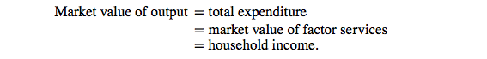

4.4 Measuring GDP

- Nominal GDP is the market value at current prices of all final goods & services
- Final goods & services: goods & services are purchased by the ultimate users
- National accounting measures nominal GDP at current prices. The CSNA produces 3 measurements of nominal GDP:
- Output-based GDP is the sum of value added (output less the cost for goods & services purchased from other business) by all industries in Canada
- Income-based GDP records the earnings generated by the production of goods & services
- Expenditure-based GDP is equal to expenditure on final goods & services produced
- Nominal GDP: the output of final goods & services, the money incomes generated by the production of that output, & expenditure on the sale of that output in a specific time period

- The output & income measures describe the supply side of the economy in terms of goods & services produced, & cost of production
- The expenditure measure of GDP describes the demand side of the economy

Output-based GDP

- To measure output in the economy we use the value-added approach
- It measures the NET output of each industry
- To find: the costs of the goods & services purchased from other businesses & industries are deducted from the value of the final product
- National, or all-industry GDP, is then the sum of GDP by industry
- Value added: the difference b/w the market value of the output of the business & the cost of inputs purchased from other businesses

- If we were to add up the outputs of auto parts manufacturers, cheese makers, meat processors, pizza makers, General Motors, & Honda in our measurement of nominal GDP, we would overstate GDP by double counting. The cheese would be counted at the cheese factory & again in the pizza.
- To avoid double counting, we use value added, the increase in the value of goods & services as measured by the difference b/w market value of output & the cost of intermediate inputs bought from other businesses. Or we could count only the outputs sold to FINAL users.
- Intermediate inputs: services, materials, & components purchased from other businesses & used in the production of final goods

- Industry outputs are measured by value added
- However, when our main interest is in the total level of economic activity rather than its industrial structure, the expenditure-based & income-based measures of GDP are used

Expenditure-based GDP & Income-based GDP
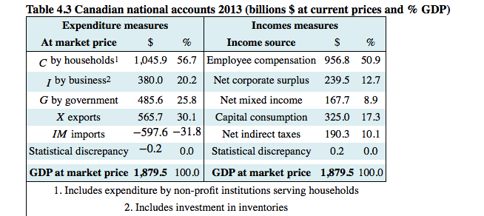
- Expenditure-based nominal GDP adds up the market value of all the final goods & services bought in a given time period.
- 5 main categories: consumption, investment, gov expenditure, exports, & imports

- Income-based GDP adds up the factor costs of production of all goods & services plus the net indirect taxes included in market price
- Labour income, corporate profit, unincorporated business income plus investment income, & depreciation
- Income categories: employment compensation (W), net corporate surplus (profit) (NCS), net mixed income (unincorporated business income + investment income) (NMI), capital consumption allowance (CCA) & net indirect taxes (T_{IN})

- This income based GDP measures total cost of production
- The 1st 3 components (W, NCS, NMI) are factors of production
- CCA is depreciation of capital equipment used in production
- Net indirect tax is the revenue generated by taxes applied to goods & services & included in final price
- An aggregate supply function for the economy involves these costs of production in relation to total output
- Aggregate expenditure at market prices is the revenue that producers receive to cover these costs

4.5 Nominal GDP, real GDP, & the GDP deflator

The GDP deflator

- GDP deflator: index of current final output prices relative to base year prices
- GDP deflator differs from CPI
- 1st, the CPI is based on a “representative basket” of goods & services that consumers buy, while the GDP deflator is comprehensive & covers all the goods & services included in national accounts
- 2nd, the CPI changes over time w/ changes in the price of the basket of consumer goods & services
- GDP deflator by contrast, is built on the base year prices. It changes over time as the current prices change relative to base year prices.
- In other words, the GDP deflator is used to “deflate” the dollar value of current output to what value it would be in base year prices, while the CPI measures the increase in the cost of the “basket” of consumer goods & services

- Summarizing from the national accounts gives 3 components of cost per unit of output:
- Employee compensation per unit of output, W/Y
- Gross business income per unit of output, (NCS + NMI + CCA)/Y
- Net indirect tax per unit of output, T_{IN}/Y
- Changes in the sum of these 3 components of the price level must change both price & nominal GDP, whether we measure nominal GDP by the income or expenditure approach.
- The GDP deflator is an index of this price level in any particular year relative to a chosen base year.
- However, the accounting framework does not explain the causes of change in the price level.
- That requires explanations of changes in unit labour costs, of producer output & pricing decisions & info on the net indirect tax rate.
- Those explanations are parts of an economic model of the supply side of the economy.



4.6 Per Capita RGDP

- Per capita RGDP: RGDP per person


Limitations of RGDP

- Problems when including all production in GDP
- 1st, some production causes noise, pollution, & congestion, which do not contribute to economic welfare
- Many valuable goods & services excluded from GDP b/c not marketed & .:. hard to measure, these include home cleaning, maintenance, & improvements HHs carry out for themselves & any unreported jobs/incomes in the economy
- High GDP & high per capita GDP not necessarily good measures of economic well-being
- HDI provides a summary measure based on life expectancy, adult literacy, & RGDP per capita
- More equal distributions of income, life expectancy, & education contribute to higher standards of living

