Introduction:
When dealing with gases, there are a few variables that has correlation with each other, namingly volume, pressure and temperature. Robert William Boyle was the first to discover such relationship. In the seventeenth century, he discovered that the pressure of a gas is linked with its volume. He further discovered that pressure is inversely proportional to the volume that a gas occupies under a constant temperature. It can be denoted as:$Pα\frac{1}{V}$, where P stands for pressure; V for volume. It can also be rearranged to: $PV=K$, where K is a constant. In this lab, the purpose is to discover Boyle’s Law constant, which only deals with the volume and pressure of gas.
There are a couple of limitations for this specific lab. First off, the room temperature; in order to test for Boyle’s law, a constant temperature within the system of reaction is required; however no steps in the procedure has ensured this specification is met, consequently the results will be inaccurate. Second limitation is the inaccuracy of measuring device; the marks on the syringes were thick, which hinders the accuracy of measurements. Third limitation is the faulty equipment; the connection between the syringe and the gas pressure is not very secure, which might have leaked gas to the outside, which will disrupt the consistency of the data as the experiment goes on.

Procedure:
As described in the lab manual (“Do I Dare Disturb The Universe”(T. S. Eliot) Verification of Boyle’s Law, Dr. V. Rashmi, 2017, Exp.1, page 4-5)

Data and Observation Results:
Observations:
- Clear, transparent and odorless gas inside of the syringe throughout the experiment
- As the plunger gets closer to the bottom of the syringe (0 mark of the syringe), the harder it is to be pushed in and the easier it is to be pulled backwards
- As the plunger gets further away from the bottom of the syringe, the easier it is to be pushed in and the harder it is to be pulled backwards.

Data for trial 1 - Volume VS Pressure:
Volume(mL) | Pressure(kPa)
10.8(original mark) | 102.07
20.8 | 52.66
5.80 | 194.90
15.8 | 69.37
8.80 | 126.56
12.8 | 86.52
10.8(original mark) | 102.56

Graph of trial - Volume VS Pressure:
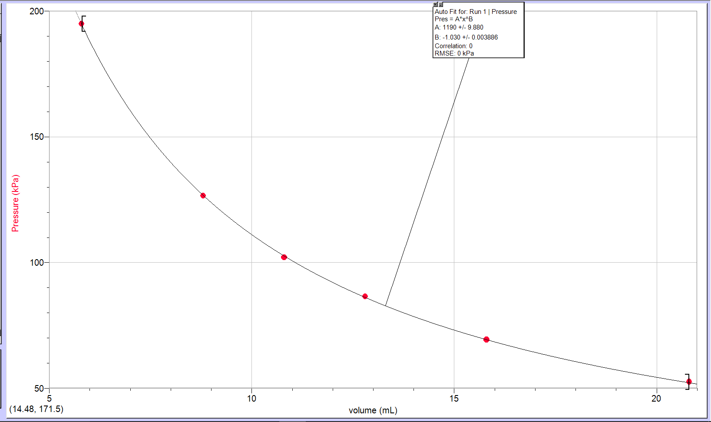

Data for trial 2 - Volume VS Pressure:
Volume(mL) | Pressure(kPa)
10.8(original mark) | 101.78
20.8 | 52.53
5.80 | 194.87
15.8 | 69.84
8.80 | 127.71
12.8 | 86.27
10.8(original mark) | 102.77

Graph for trial 2 - Volume VS Pressure:
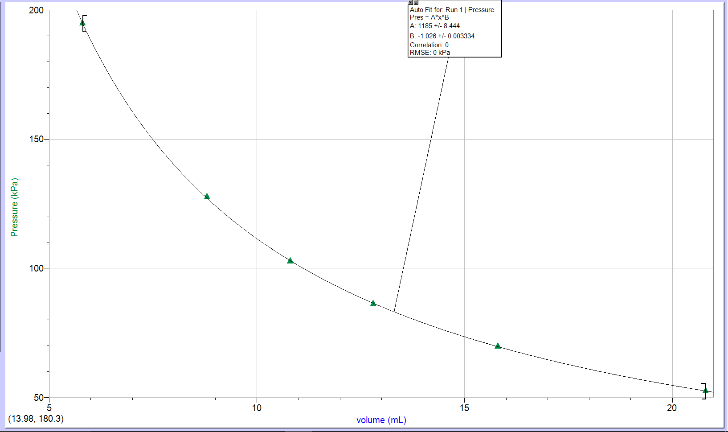

Data for trial 3 - Volume VS Pressure:
Volume(mL) | Pressure(kPa)
10.8(original mark) | 101.82
20.8 | 52.66
5.80 | 195.52
15.8 | 69.83
8.80 | 127.49
12.8 | 86.33
10.8(original mark) | 102.75

Graph for trial 3 - Volume VS Pressure:
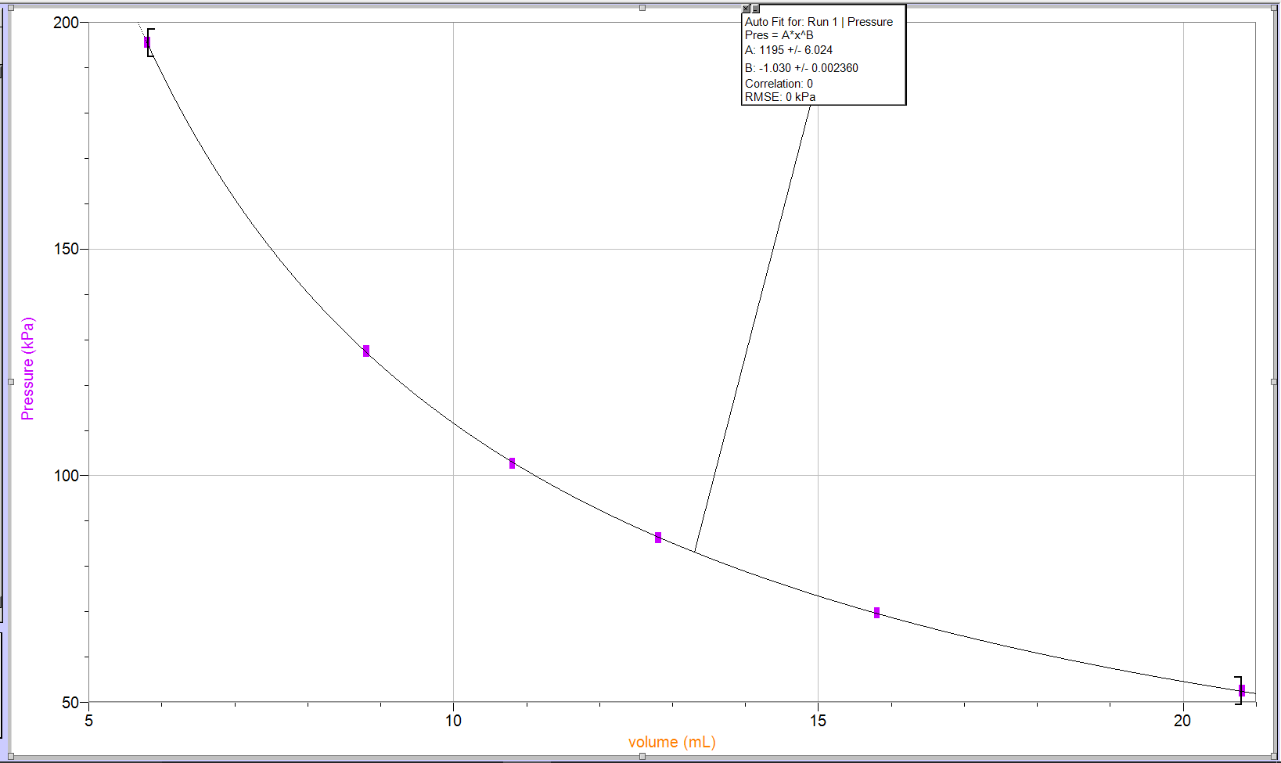

Data for pressure VS inverse of volume for trial 1:
Volume(mL) | Pressure(kPa)
1/10.8 | 102.07
1/20.8 | 52.66
1/5.80 | 194.90
1/15.8 | 69.37
1/8.80 | 126.56
1/12.8 | 86.52
1/10.8 | 102.56
Graph of pressure VS inverse of volume for trial 1:
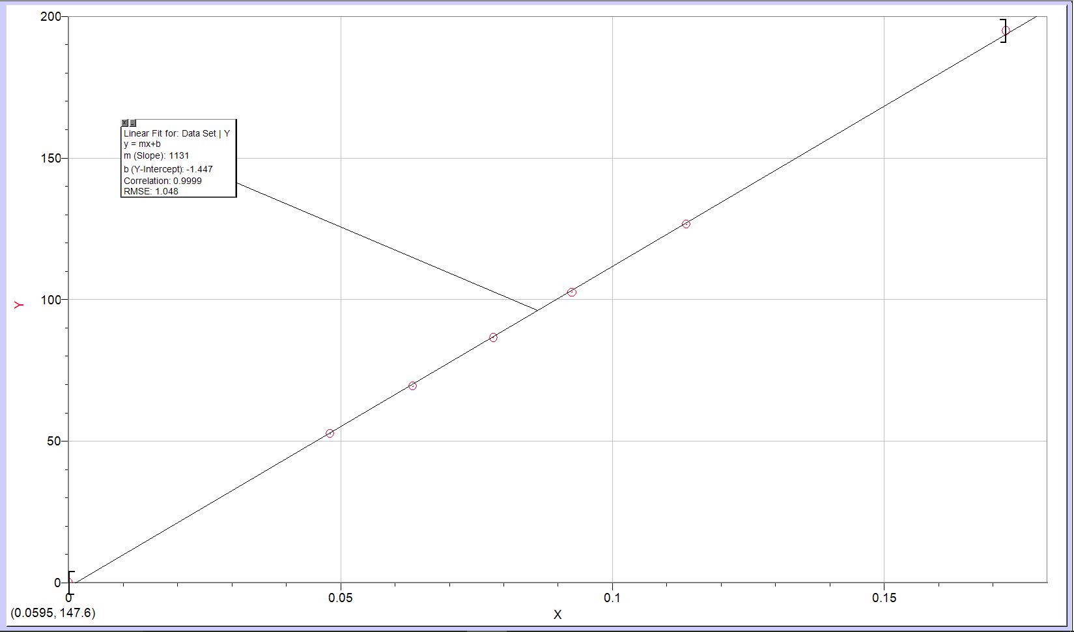

Data for pressure VS inverse of volume for trial 2:
Volume(mL) | Pressure(kPa)
1/10.8 | 101.78
1/20.8 | 52.53
1/5.80 | 194.87
1/15.8 | 69.84
1/8.80 | 127.71
1/12.8 | 86.27
1/10.8 | 102.77

Graph of pressure VS inverse of volume for trial 2: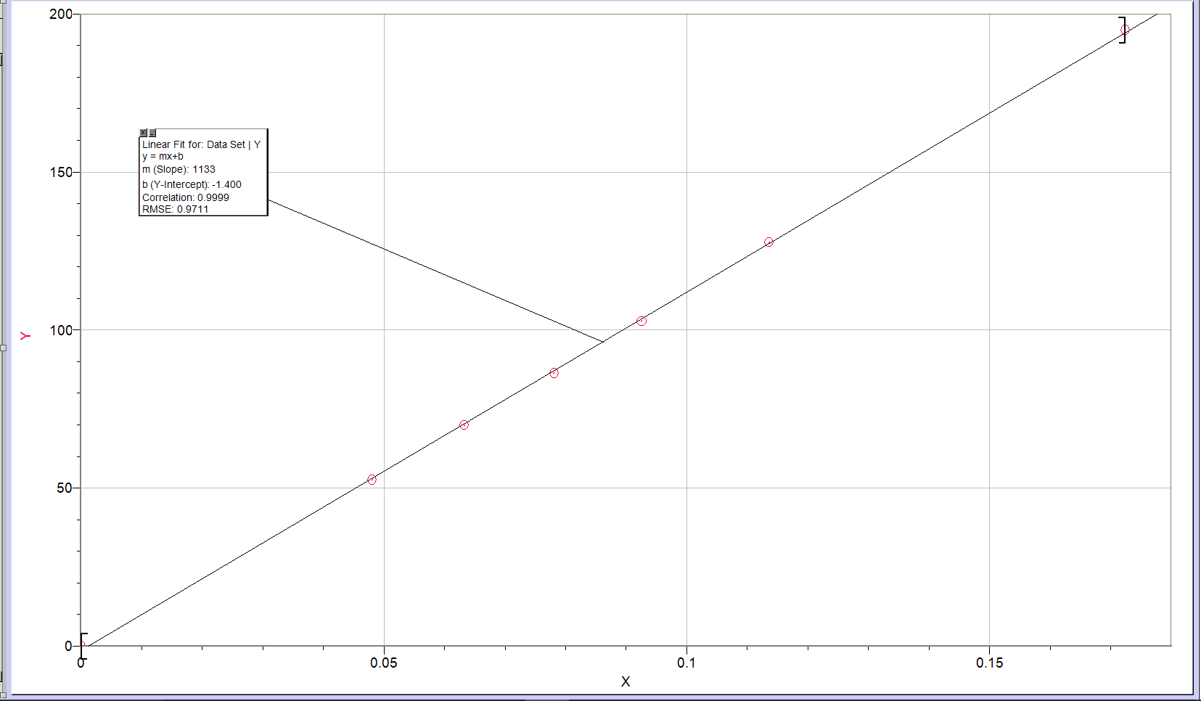

Data for pressure VS inverse of volume for trial 3:
Volume(mL) | Pressure(kPa)
10.8 | 101.82
20.8 | 52.66
5.80 | 195.52
15.8 | 69.83
8.80 | 127.49
12.8 | 86.33
10.8 | 102.75

Graph of pressure VS inverse of volume for trial 3:
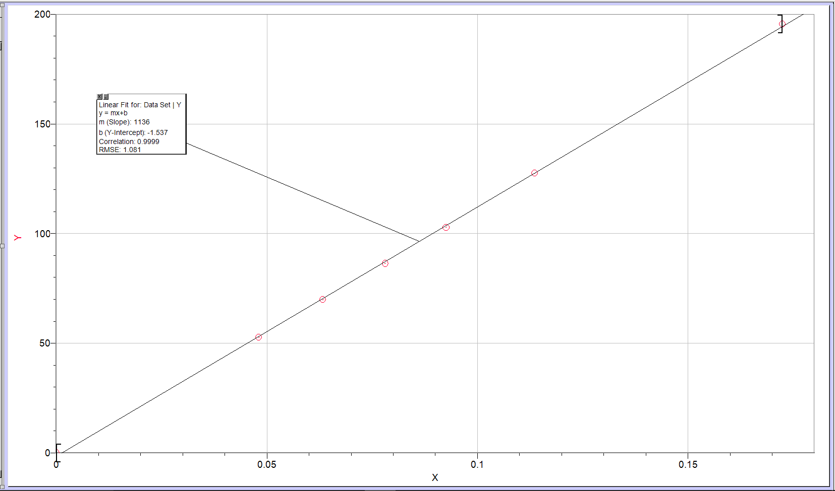

Calculation:

To calculate Boyle’s law constant, K, simply multiply the volume and the pressure together. Since three trials were performed in this experiment, an average of K value is required in order to determine an overall acceptable K value taking in account of every trial.
K = PV
= (102.07 kPa)(10.8 mL) (data taken from trial 1 - Volume VS Pressure)
= 1102.356 kPa*mL
= 1.10 x 10³ kPa*mL (3 significant digits)
K values for trial 1:
Volume(mL) | Pressure(kPa) | K value(kPa*mL) | K value with significant digits(kPa*mL)
10.8(original mark) | 102.07 | 1102.356 | 1.10 x 10³
20.8 | 52.66 | 1095.328 | 1.10 x 10³
5.80 | 194.90 | 1130.42 | 1.13 x 10³
15.8 | 69.37 | 1096.046 | 1.10 x 10³
8.80 | 126.56 | 1113.728 | 1.11 x 10³
12.8 | 86.52 | 1107.456 | 1.11 x 10³
10.8(original mark) | 102.56 | 1107.648 | 1.11 x 10³

K values for trial 2:
Volume(mL) | Pressure(kPa) | K value(kPa*mL) | K value with significant digits(kPa*mL)
10.8(original mark) | 101.78 | 1099.224 | 1.10 x 10³
20.8 | 52.53 | 1092.624 | 1.09 x 10³
5.80 | 194.87 | 1130.246 | 1.13 x 10³
15.8 | 69.84 | 1103.472 | 1.10 x 10³
8.80 | 127.71 | 1123.848 | 1.12 x 10³
12.8 | 86.27 | 1104.256 | 1.10 x 10³
10.8(original mark) | 102.77 | 1109.916 | 1.11 x 10³

K values for trial 3:
Volume(mL) | Pressure(kPa) | K value(kPa*mL) | K value with significant digits(kPa*mL)
10.8(original mark) | 101.82 | 1099.656 | 1.10 x 10³
20.8 | 52.66 | 1095.328 | 1.10 x 10³
5.80 | 195.52 | 1134.016 | 1.13 x 10³
15.8 | 69.83 | 1103.314 | 1.10 x 10³
8.80 | 127.49 | 1121.912 | 1.12 x 10³
12.8 | 86.33 | 1105.024 | 1.10 x 10³
10.8(original mark) | 102.75 | 1109.7 | 1.11 x 10³

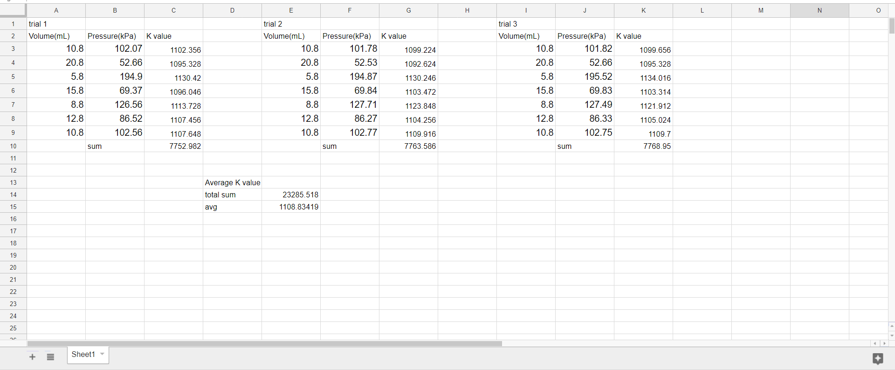
Average K value will be :
K_{avg} = (sum of all K value from 3 trials) / (3 trials * 7 data points)
= 23285.518 / 21
= 1108.83419 mL*kPa
= 1.1 x 10³ mL*kPa (2 significant digits)

Discussion:
1. To determine Boyle’s law constant, multiply the value of volume with the value of pressure, the product will be Boyle’s law constant which has the unit of mL*kPa
K = PV
K = (102.07 kPa)(10.8 mL)
K = 1102.356 kPa*mL
K = 1.10 x 10³ kPa*mL (3 significant digits)

2. From the prelab reading, we know that pressure is inversely proportional to volume, $Pα\frac{1}{V}$, we also have our experimental K value, which is the product of pressure and volume. With these 2 pieces of information, we can now formulate an equation that describes the relationship between pressure and volume
PV = 1.10 x 10³ P = (1.10 x 10³) / V V = (1.10 x 10³) / P

3. It is important to take multiple readings of dependent variable(pressure) for the same value of the independent variable(Volume) for the reason of confirming the limitation did not greatly affect the result of this experiment. For example, if there were a air leakage in the syringe to the outside, then the final reading of original pressure will be very different from the initial original reading; if the temperature change in the laboratory while the experiment is ongoing, the readings for the same independent variable will be different as well.

4. There are 2 variables for the gas to watch out while doing the experiment, the temperature and the amount(mole) of gas particle present. The procedure of the lab did not fully take in consideration of those 2 variable. For the temperature, not a single thermometer was set up in order to detect potential change in the laboratory; for the amount of gas particle present in the system, the only precaution was to tighten the syringe against the gas pressure sensor, however we could have added tape to the edge of connection to ensure no gas leakage. On the grand scheme of things, these uncontrolled variable only affected our results slightly as the results are still accurate enough for us to produce a meaningful graph.

Conclusion:
In this experiment, the goal is to determine Boyle’s law constant through the relationship PV = K, where P stands for pressure, V for volume, and K for Boyle’s law constant. To make sure that the experiment goes smoothly, we have to make sure that the temperature stays the same at all time and that the amount of gas in the syringe is constant. The result of the experiment shows that the constant, K, is approximately 1.1 x 10³ mL*kPa.

The Editors of Encyclopædia Britannica. (2014, April 16). Boyle's law. Retrieved September, 2017, from https://www.britannica.com/science/Boyles-law

