MAT2377 EXAM SHEET

Typicap Union Problem
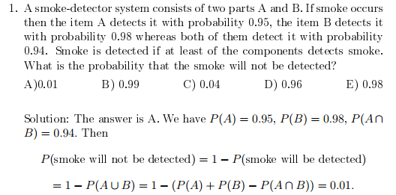

Defective Item Problem, using Combinations and Permutations

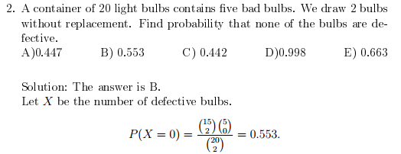

Proportion Problem, estimating with Z score

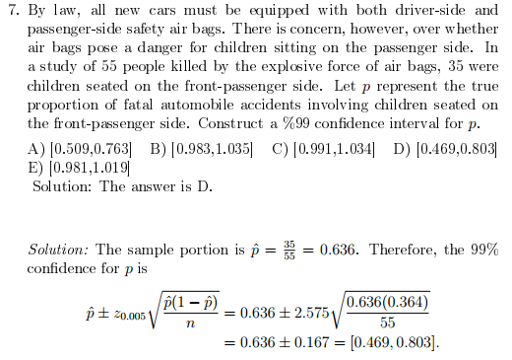

Expontential Distribution
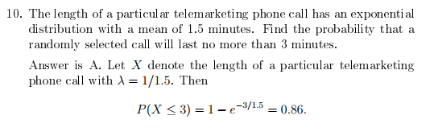

Poisson Process Distribution

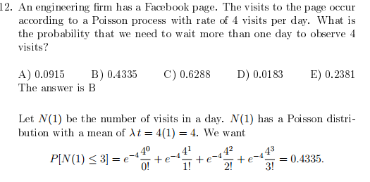

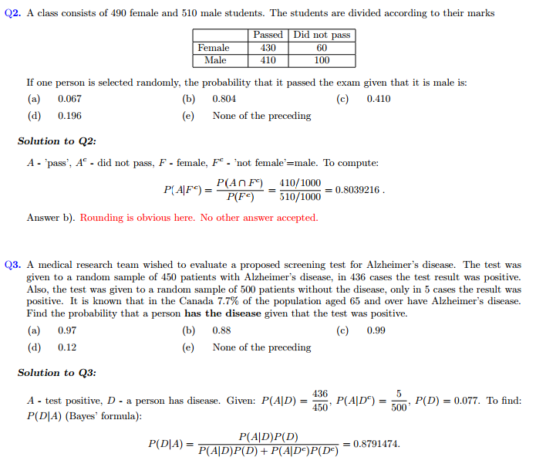
Bayes Rule
Normal Distribution with Two Sample Sets

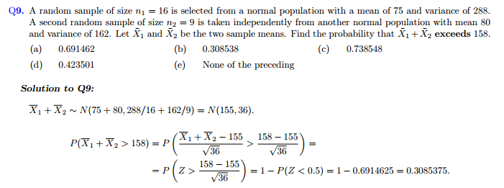
Standard Error Problem

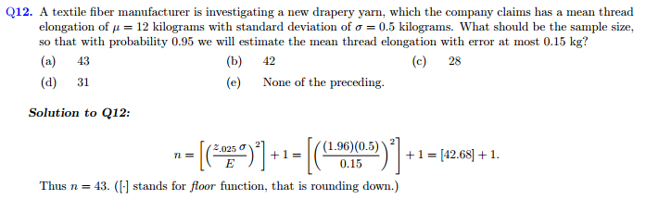
Expected Value, Variance
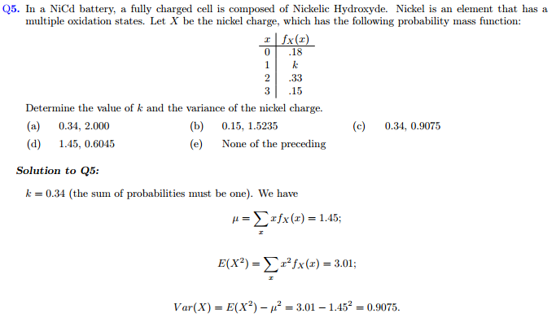

Two Sample Test with Variance Addition

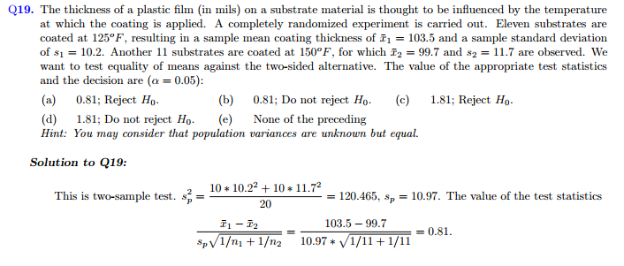
Linear Regression



