Verification of Boyle’s Law
Nathan Hay 300014757 & Kyle Campbell 300015181
26 September, 2017

Theory:
An ideal gas is as a hypothetical gas that exists under low pressure and high temperature conditions defined by with two characteristics. First, they undergo completely elastic collisions and therefore do not attract or repel each other and second, they have negligible volume. Gases are affected by variations in factors like pressure, volume and temperature. Using the ideal gas equation PV=NRT certain factors can be calculated for. Boyle’s Law compares volume to pressure, while temperature is held constant. It states that as either pressure or volume increases the other will decrease by some constant K. It can be modelled using PV=K.

Procedure:
- Prepare the Gas Pressure Sensor and an air sample.
- Connect the Gas Pressure Sensor to the LabQuest. Turn on the LabQuest 2 and choose New from the File menu.
- Move the plunger of a plastic 20 mL syringe to a chosen volume. Decide which part of the tip of the plunger you will line up on the volume mark, and line up the subsequent volumes the same way throughout the experiment.
- Attach the 20 mL syringe to the valve of the Gas Pressure Sensor.
- Set up the LabQuest 2 data-collection mode.
- On the Meter screen, tap Mode then Change the mode to Events with Entry.
- Enter the Name and units for the variable then select OK.
- Collect and plot measurements.
- Start data collection.
- Hold the plunger at the chosen initial volume mark.
- After the pressure reading stabilizes, tap Keep and enter the volume + 0.8 in mL. Select OK to proceed.
- Move the plunger to change the volume of air in the syringe and hold the plunger in place. After the pressure reading stabilizes, tap Keep and enter the volume (plus 0.8), then select OK to proceed.
- Continue in this manner until the pressure in the syringe has been measured at 6-8 different volumes. For the final volume measurement, move the plunger back to the original volume mark (there is a reason why you are measuring the same volume twice). Stop data collection.
Experimental Data:
Trial 1
Volume (mL) | Pressure (kPa) | K(mL) PV=K
20.8 | 101.43 | 2109.7
18.8 | 111.91 | 2103.9
16.8 | 125.51 | 2108.6
14.8 | 142.05 | 2102.3
12.8 | 164.73 | 2108.5
10.8 | 196.92 | 2126.7
8.8 | 225.85 | 1987.5
6.8 | 225.85 | 1535.8

Trial 2
Volume (mL) | Pressure (kPa) | K(constant) PV=K
20.8 | 101.26 | 2106.2
18.8 | 111.71 | 2100.1
16.8 | 124.82 | 2097.0
14.8 | 141.58 | 2095.4
12.8 | 163.47 | 2092.4
10.8 | 193.93 | 2094.4
8.8 | 225.86 | 1987.6
6.8 | 225.85 | 1535.8

Calculating Average K value *did not include 6.8ml values as they are outliers*
= (2109.7 + 2103.9 + 2108.6 + 2102.3 + 2108.5 + 2126.7 + 1987.5 + 2106.2 + 2100.1 + 2097.0 + 2095.4 + 2092.4 + 2094.4 + 1987.6 ) / 14 = 2087.2 ml*kpa

Run 1
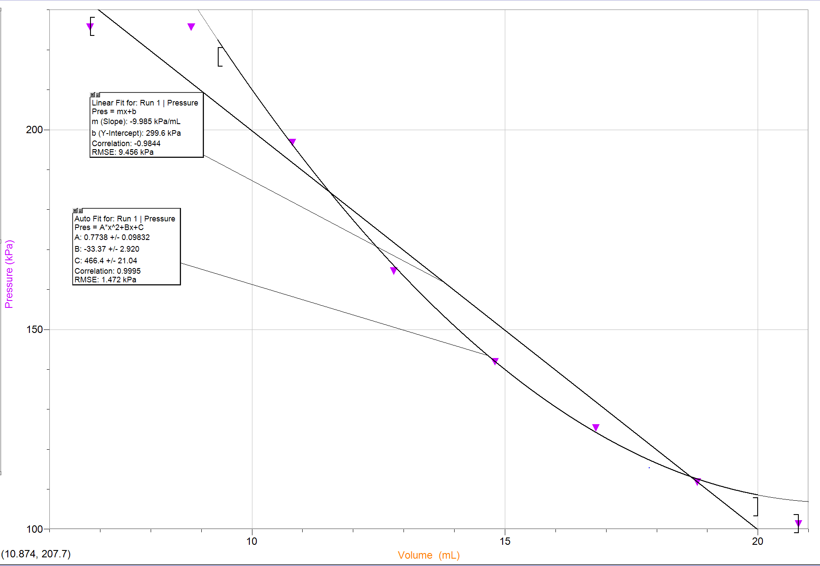

Run 2
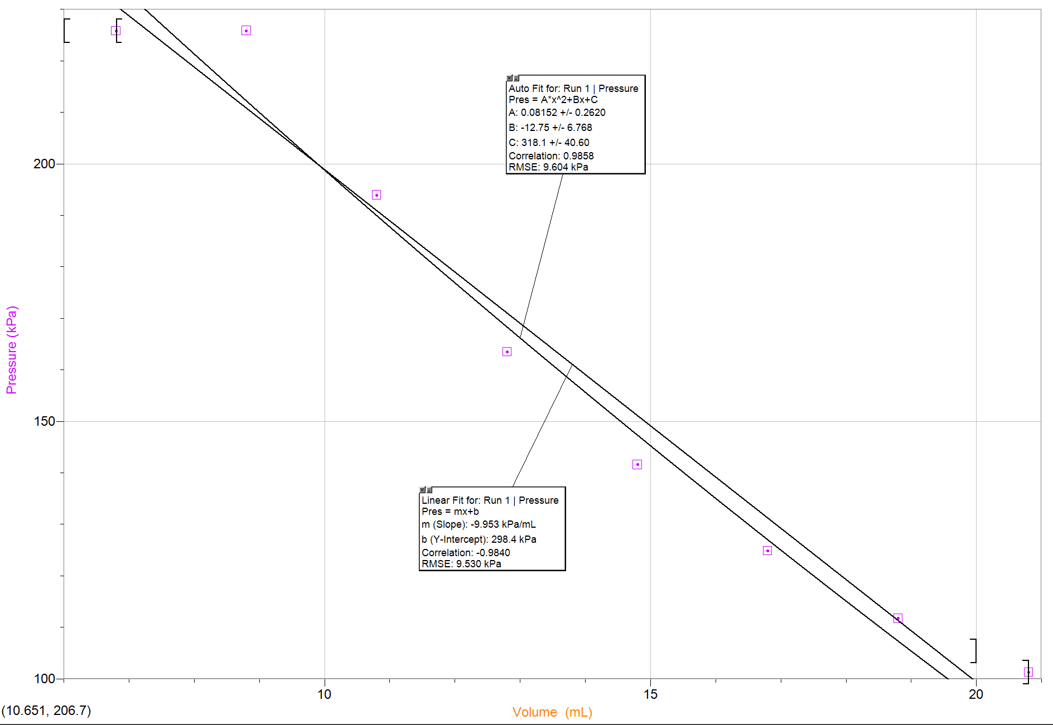

Observations:
As the volume decreased in the syringe the pressure would increase. The pressure stopped increasing when the volume reached 8.8mL.

Discussion:
The data points obtained from the experiment accurately represent Boyle’s law. From analyzing the graphs in both trials an inverse relation was found between the pressure (y-axis) and volume (x-axis) of the air gas trapped in the syringe. As the volume decreased the pressure would increase. Thus, multiplying the pressure and volume results in a constant. Using the constant an equation, K=PV can be made where K=2087.2 ml*kpa, V represents the volume of the gas in mL, and P is equal to the pressure of the gas in kpa. By rearranging the equation either the P or V value can be solved for so long as the other variable is known. In the experiment two variables were measured at the same volume level, 20.8ml. These two values measured with the same volume were graphed but the one that most accurately fit the K value was kept. Temperature was a factor that was not monitored through the lab process and therefore could have contributed to some experimental error. Boyle’s Law requires constant temperature and without confirming this, the data could have been skewed. Another source of error may have been in the accuracy of the volume readings on the syringe. This could cause plus or minus of 1 ml on volume readings resulting in less accurate data.
Conclusion:

The results found in the experiment support Boyle’s Law that pressure and volume have an inverse relationship so long that temperature is held constant. This was proven in the data as the pressure would increase significantly when the volume in the syringe decreased. Using the data recorded a constant K was accurately calculated and the equation PV=K was formed.
Appendix:
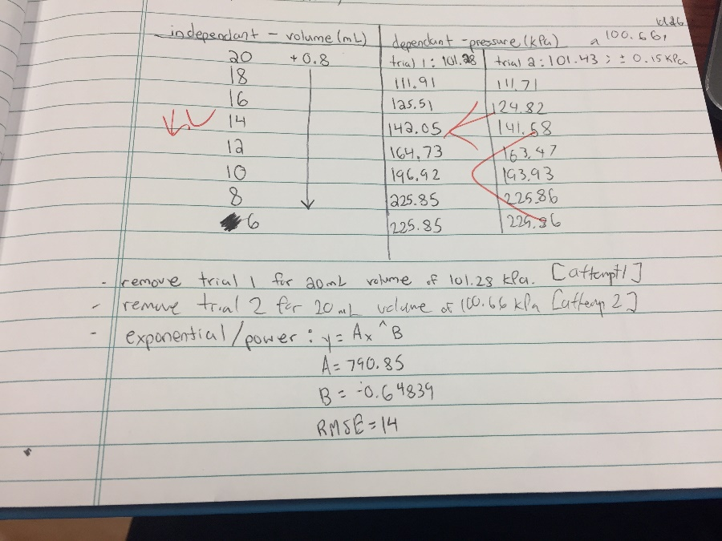

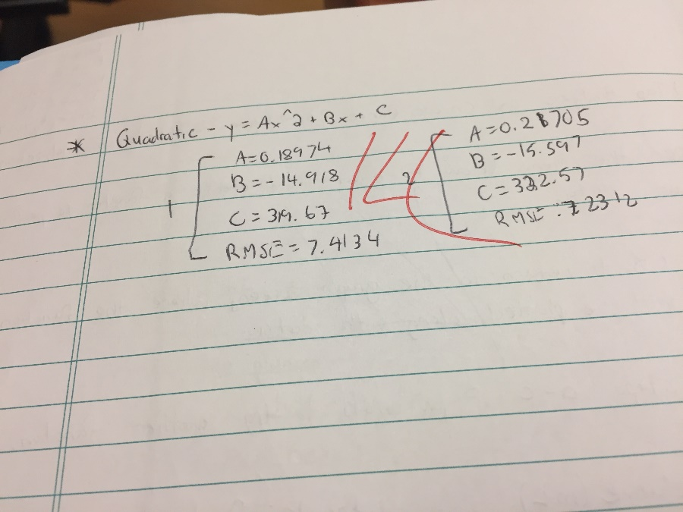

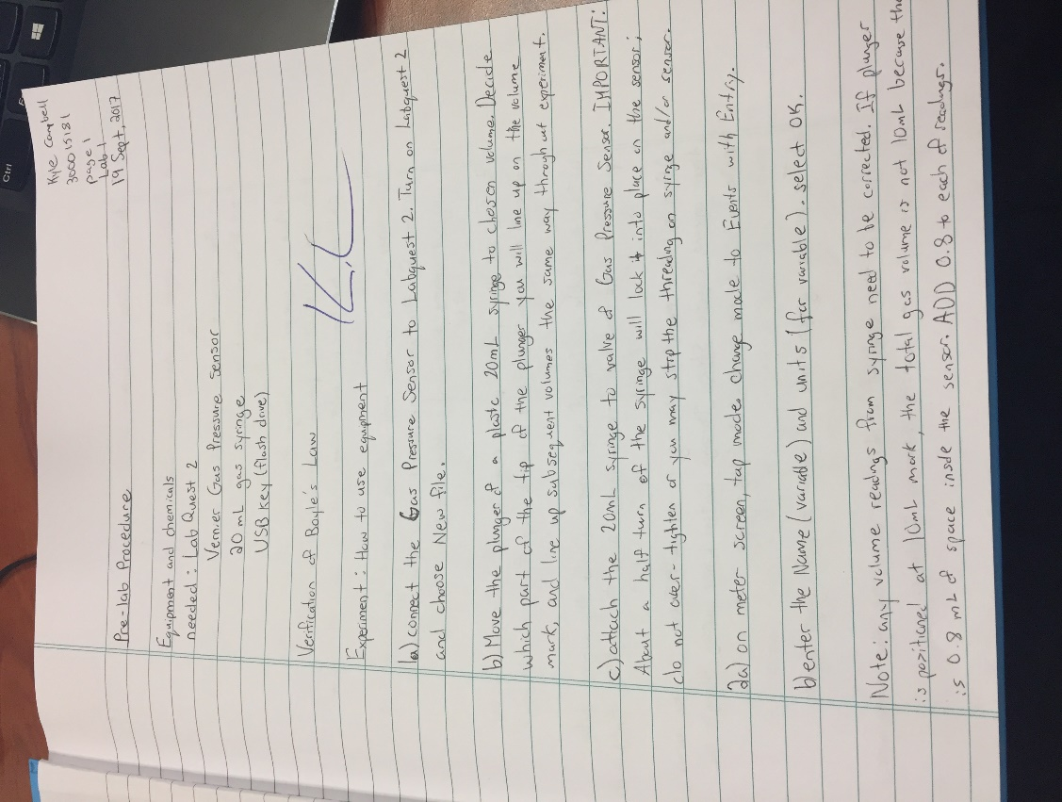
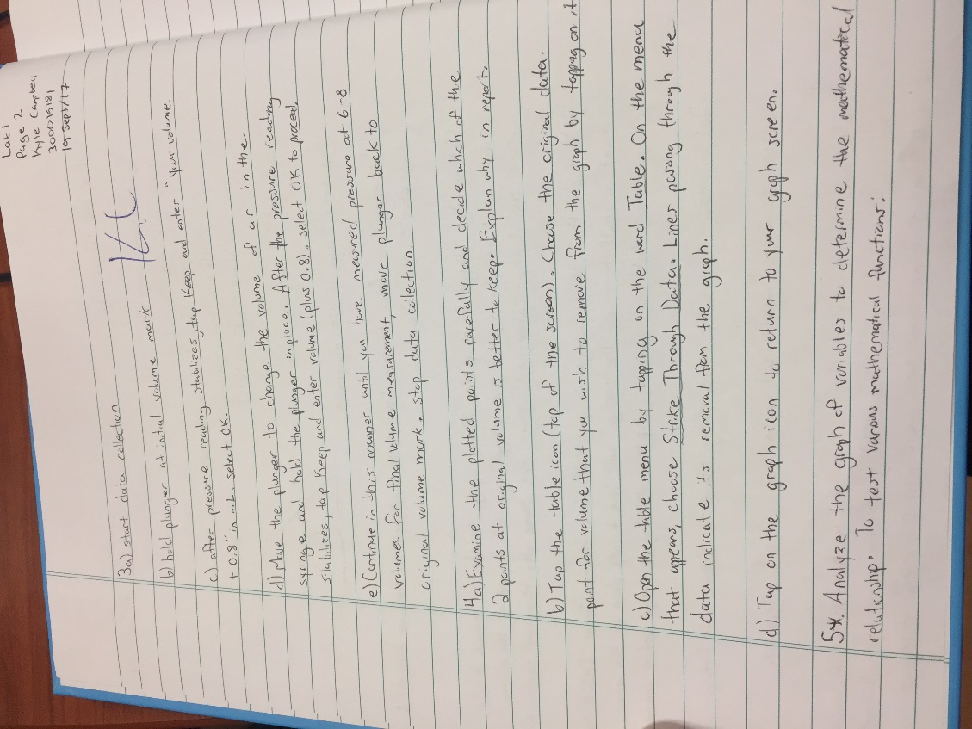

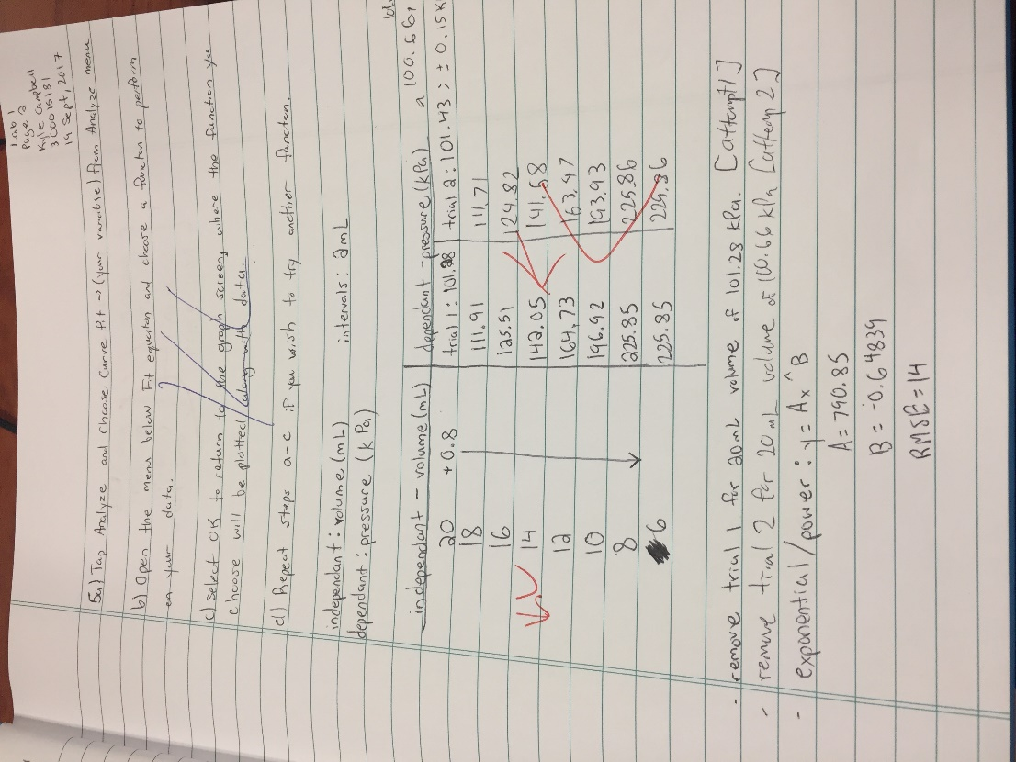

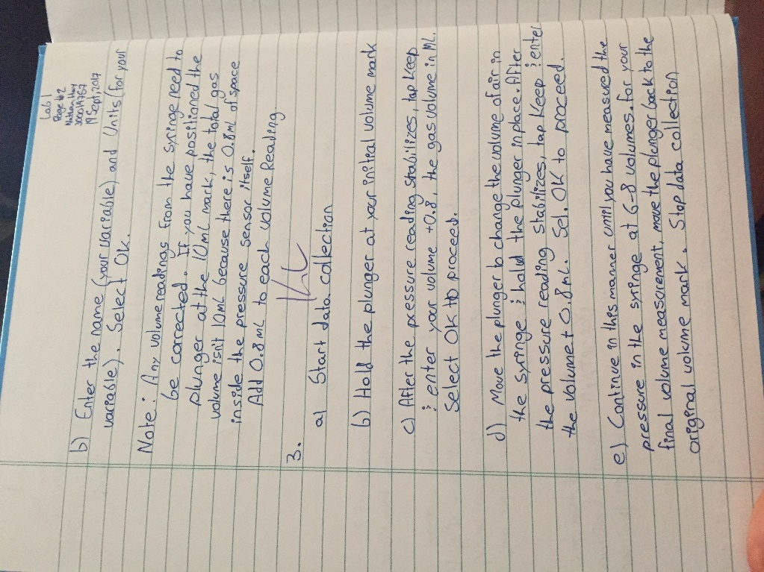
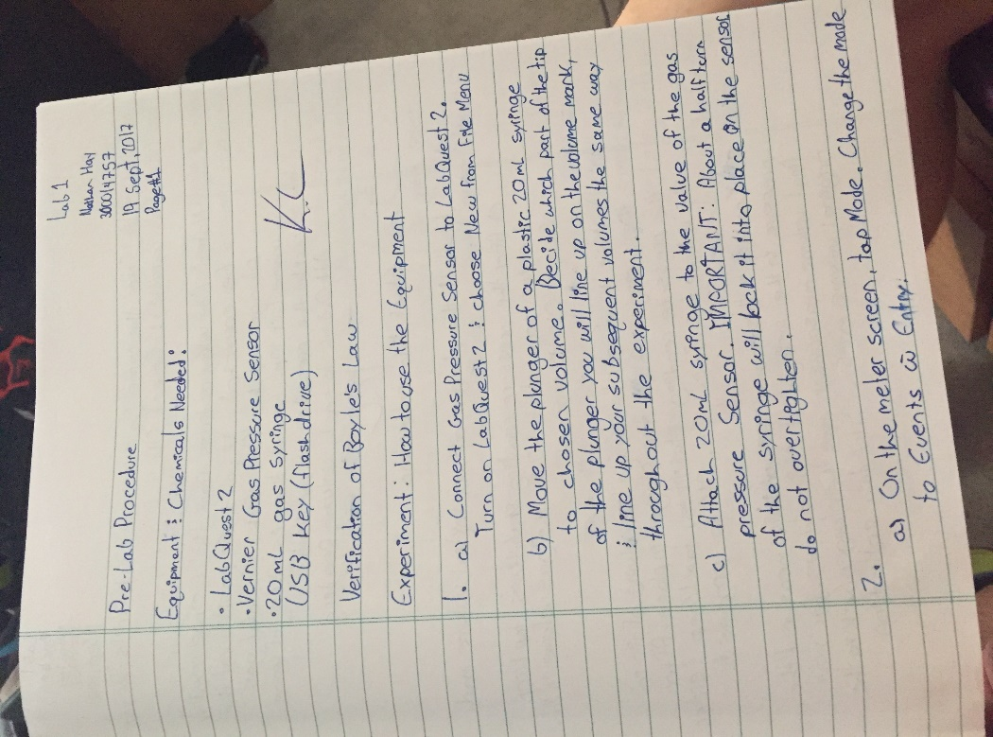
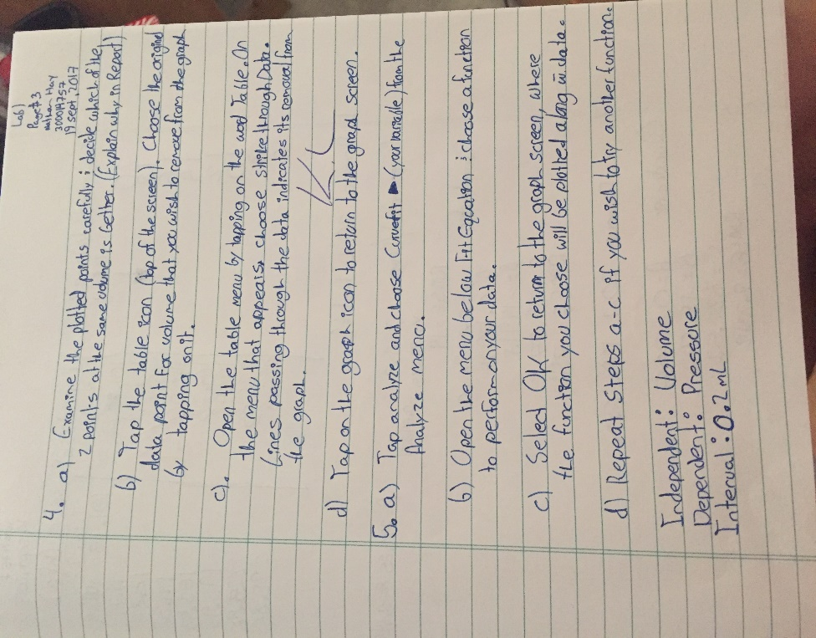
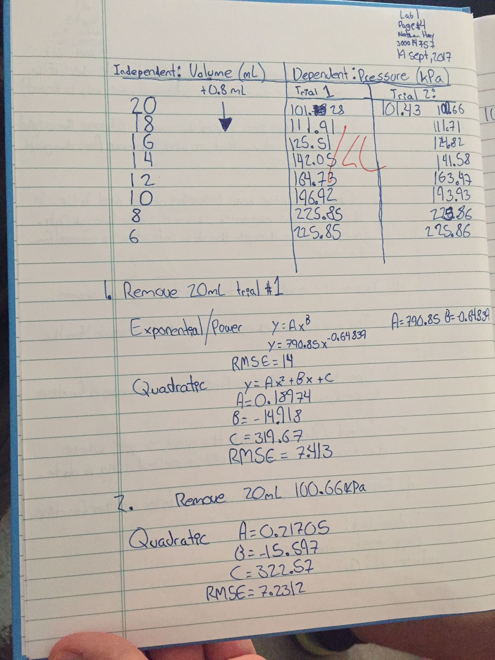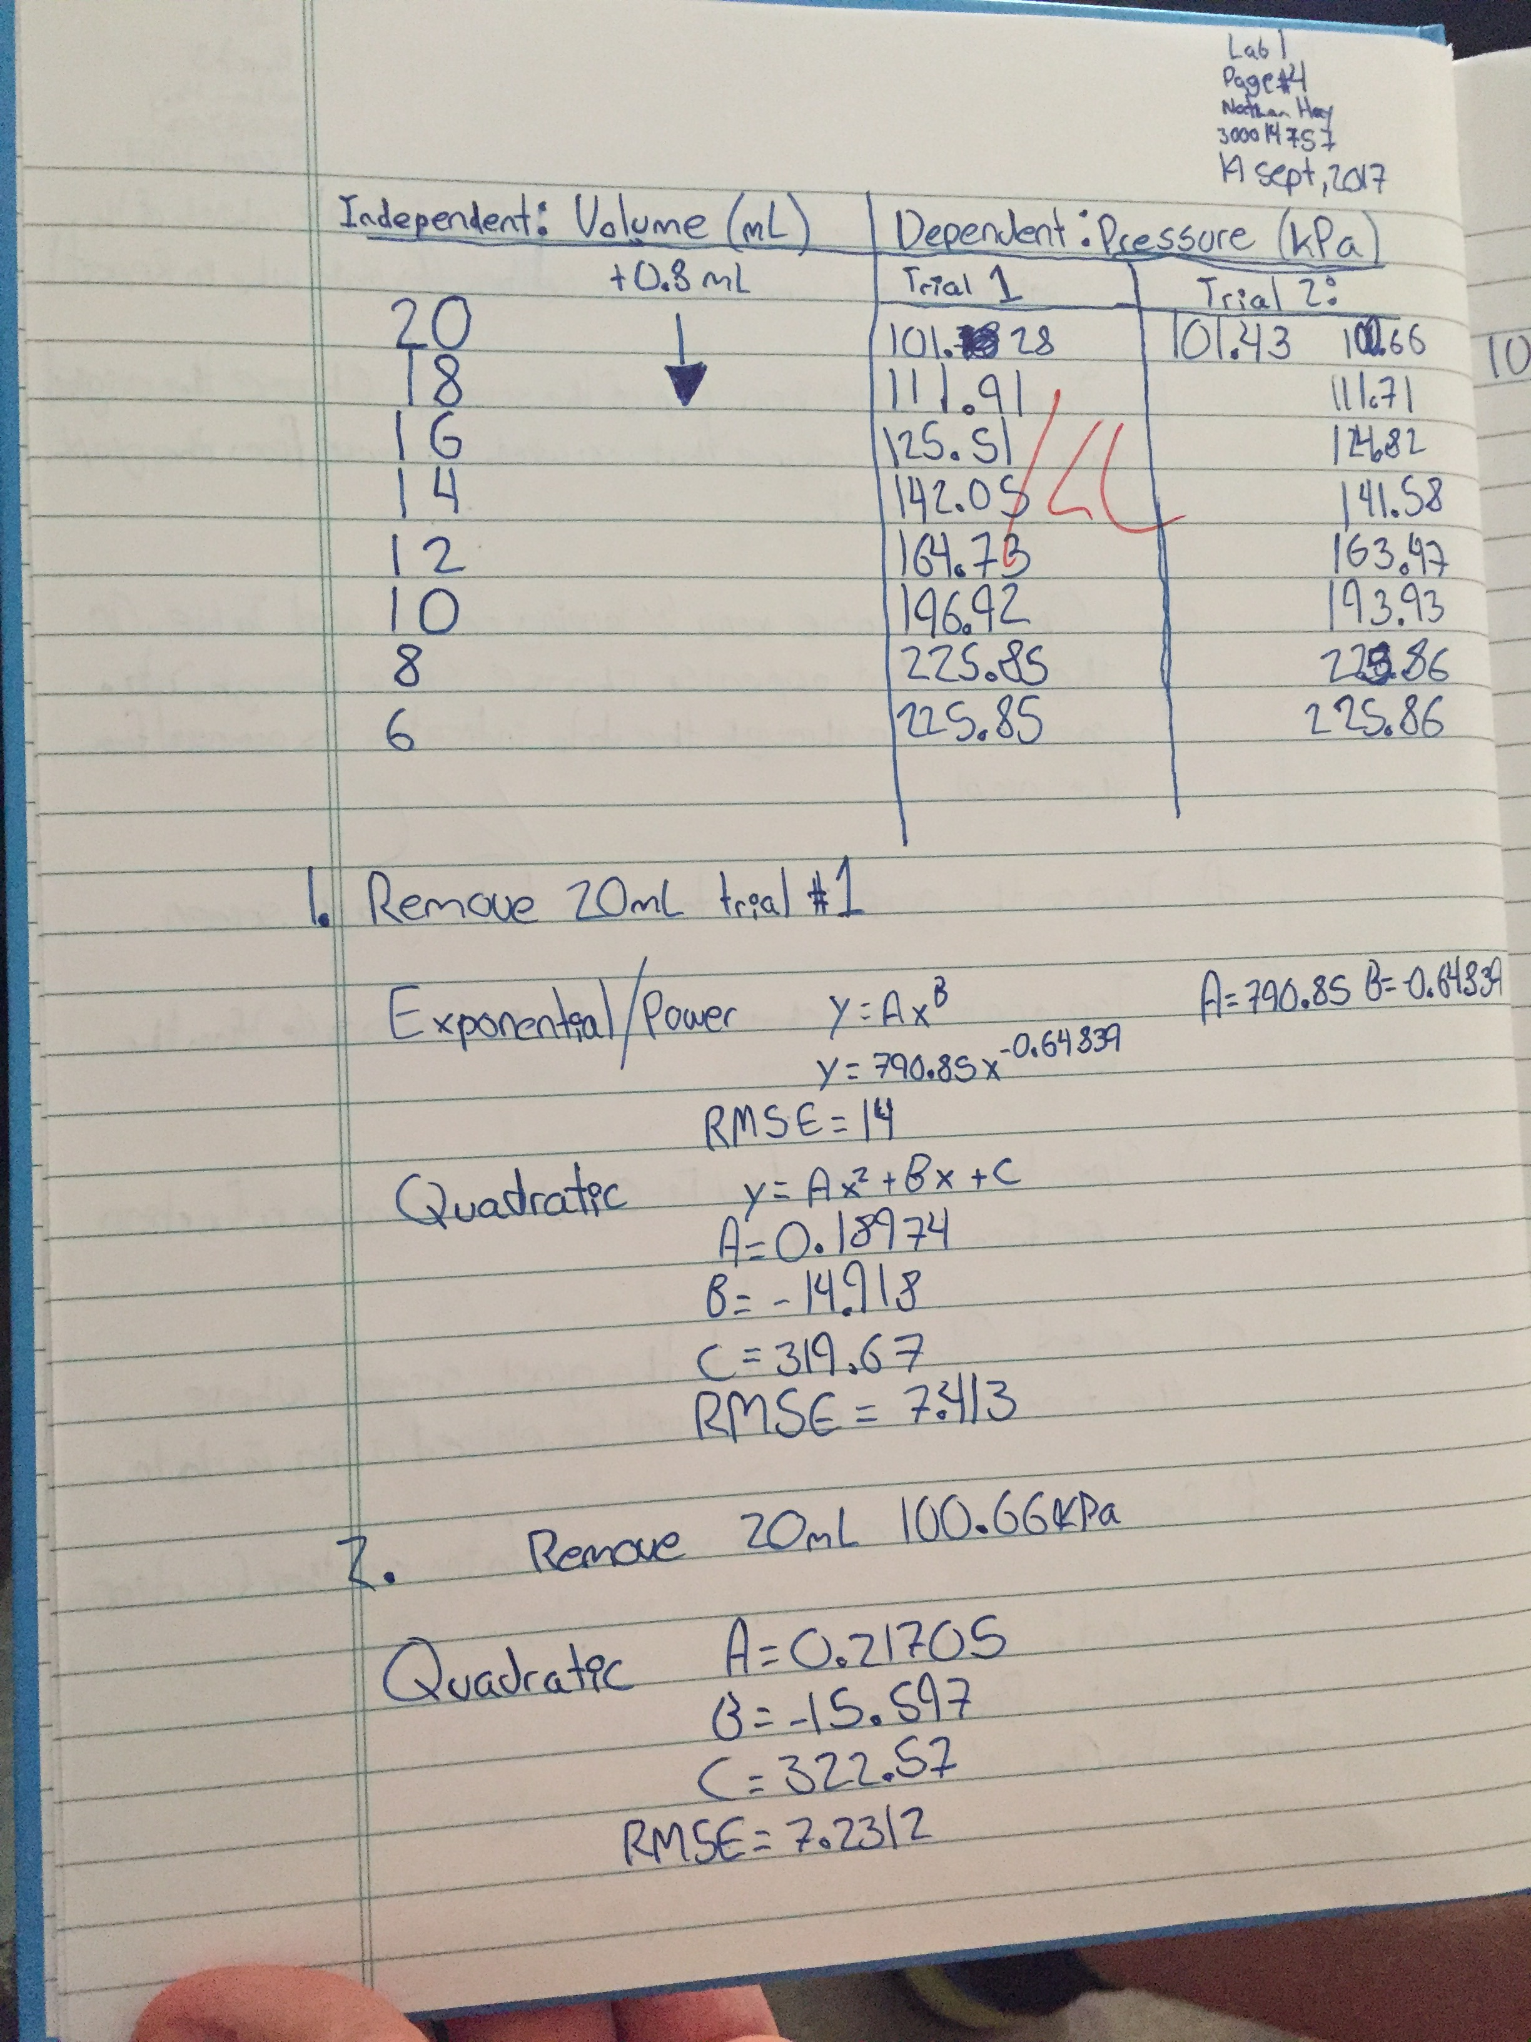

Works Cited
- Olmsted, John, et al. Chemistry. John Wiley & Sons Canada, Ltd., 2016.v
- “Introduction ToBoyle's Law.” Boyle's Law, faraday.physics.utoronto.ca/IYearLab/Intros/BoylesLaw/BoylesLaw.html.

COURSE: CHM1311 TA Name: Keith Lapierre
YOUR NAME (PRINT): Kyle Campbell SIGNATURE:

CONFIDENTIAL PEER EVALUATION FORM FOR EXPERIMENT 1
Each team member must submit one assessment. Teams may consist of 2-18 members.
You may edit this form.
Do not share or discuss the contents or possible contents of this assessment with others.

In assessing the work of your fellow team members, consider the following aspects:
- Quality of work • Ability to get along with others
- Contribution to the work as a whole • Improvements when asked to correct

Team member name | Comments | Grade
Nathan Hay | - Nathan put in solid work when asked to do so on his portion  - The workload was split evenly and everything was done on time and according to our schedule  - We got along very well, there was no problems at all.  - We edited and suggested improvements to each other’s work which benefitted both of us in quality of the lab report. | A
A – Excellent (5) B: Great (4) C: Good (3) D: Fair(2) F: Poor (1)
Note: Do not evaluate yourself on this form

