The ANS

What does the ANS play an important role in doing?
- Maintaining homeostatic control of the internal environment

What part of the brain is used to control HR and chill out?
- Cerebral cortex

What is the control center of the ANS? Why?
- Hypothalamus
- It has instructions for motor efferent

What are the anatomical components of the somatic nervous system?
- Motor cortex -> alpha and gamma motor neurons -> effector of skeletal muscles

What are the anatomical components of the autonomic nervous system?
- Hypothalamus -> SNS or PSNS -> effector of smooth/cardiac muscle glands

What components does the ANS consist of? How is the CNS relevant?
- Motor (SNS and PSNS) and afferent that sends sensory information about the state of internal environment to the CNS

How does the ANS effect its targets?
- By controlling smooth muscle, cardiac muscle, and glands

What are the characteristics of postganglionic neurons?
- Non-myelinated
- Slower conduction

What are the characteristics of preganglionic neurons?
- Myelinated
- Faster conduction

What are the preganglionic neurons like in the SNS?
- Small

What are the postganglionic neurons like in the SNS?
- Long

What are the preganglionic neurons like in the PSNS?
- Long

What are the postganglionic neurons like in the PSNS?
- Short

What are the neurons in the SNS like? Where do they originate? How are they activated?
- Slower
- Outside of the spinal cord in the ganglion chain
- Everything is activated together

What are the neurons in the PSNS like? Where do they originate?
- Faster
- Target tissue

How many neurons does the ANS use?
- 2 in peripheral components

Explain the somatic motor pathway:

Preganglionic neuron: CNS

Axon releases: Ach

Receptor: Nicotinic receptor

Target: skeletal muscle

Explain the parasympathetic pathway:

Preganglionic neuron: CNS

Preganglionic fiber: Long

First axon releases: Ach

Where does first axon release: Ganglion

First receptor: Nicotinic receptor

Post ganglionic fiber: Short

Second axon releases: Ach

Second receptor: Muscarinic receptor

Target: Smooth and cardiac muscles, some endocrine and exocrine glands, some adipose tissue

Explain the sympathetic pathway:

Preganglionic neuron: CNS

Preganglionic fiber: Short

First axon releases: Ach

Where does first axon release: Ganglion

First receptor: Nicotinic receptor

Post ganglionic fiber: Long

Second axon releases: NE

Second receptor: aB receptors which are generalized

Target: Smooth and cardiac muscles, some endocrine and exocrine glands, some adipose tissue

Explain the adrenal sympathetic pathway:

Preganglionic neuron: CNS

Preganglionic fiber: Medium

First axon releases: Ach

Where does first axon release: Adrenal medulla in adrenal cortex

Then what: Neurotransmitters pass through the adrenal cortex and become epinephrine which flows to the blood vessels and is released into blood stream

Receptor: B2 receptor

Target: Smooth and cardiac muscles, some endocrine and exocrine glands, some adipose tissue

What is the differences between the SNS and PSNS?

Receptors:
- PSNS: muscarinic
- SNS: aB adrenergic

Preganglionic fibers:
- PSNS: long
- SNS: short

Postganglionic fibers:
- PSNS: short
- SNS: long

Postganglionic axon releases:
- PSNS: Ach
- SNS: NE

Speed:
- PSNS: Slower
- SNS: Faster

Location of ganglion:
- PSNS: Near target organ
- SNS: Close to spinal cord, primarily in the paravertebral sympathetic chain

Point of CNS origin:
- PSNS: Midbrain, medulla and 2-4th sacral segments
- SNS: First thoracic to second lumbar segments

Inactivation of neurotransmitters at synapse:
- PSNS: Enzymatic breakdown, diffusion
- SNS: Uptake into varicosity, diffusion

Difference between somatic and autonomic pathways:
- Somatic: no ganglion
- Somatic: one receptor on target muscle
- Somatic: Releases Ach only
- Somatic: only one long preganglionic neuron

Where does the SNS originate?
- Thoracic and lumbar of spinal cord

What does the SNS have an important function regulating?
- Blood flow

Where are most of the SNS autonomic ganglion in the spinal cord found?
- Sympathetic ganglion chain outside of the spinal cord

Where does the PSNS originate?
- From brainstem and sacral segements of spinal cord

Where are most of the PSNS autonomic ganglion in the spinal cord found?
- Within or very close to target tissue

What is unique about the ANS control of the adrenal gland?
- No postganglionic fiber
- Releases adrenaline/epinephrine into blood stream
- Receives information from preganglionic fiber only
- Nervous structure
- Postganglionic neuron is a chromaffin cell in the adrenal gland
- Send adrenaline to blood vessel which sends it to the target tissue through the blood

What effects does adrenaline have on body parts? Give an example?
- Has a different effects on different body parts
- Constricts blood vessels everywhere but the heart, instead dilates it so the heart can get more nutrients

Which visceral structures receive innervation from only one branch of the ANS?
- Adrenal medulla

What is a complementary effect?
- Both SNS and PSNS produce the same thing but with differences

What are the complementary effects shared by the PSNS and SNS? Why?
- Saliva production from the salivary glands- both are related but they do not require one another and both act on target organ to produce similar yet separate effects. (SNS secretes mucus and enzymes while the PSNS has a watery secretion)
- Blood pressure- SNS increases it while PSNS decreases it

What is a cooperative effect?
- SNS and PSNS work towards a common goal

What are the cooperative effects shared by the PSNS and SNS?
- Sexual control- erection and ejaculation, erection controlled by the PSNS and ejaculation controlled by the SNS
- Bladder control- SNS relaxes the bladder and PSNS releases urine

The SNS and PSNS are usually:
- Antagonistic

What is the specifity of the ANS divisions?
- PSNS is specific as it only goes to its target cell
- SNS is generalized as all of the actions occur simultaneously such as HR increasing and pupils dilating, preganglionic has many branches and it touches everything around it

 | SNS | PSNS
- Blood vessels | Vasoconstriction/ vasodilation | No response
- Salivary glands | Mucus | Watery
- Sweat glands | Localized | No response
- Adrenal medulla | Adrenaline/Noradrenaline released | No response
- Bladder | Retention of urine | Release urine
- Genitalia | Ejaculation | Erection

What is happening to your body when you are writing a test? What is in play?
- Stressed, blood vessels constrict, kidney filters blood, bladder fills up faster
- SNS

Movement and Motor Control:

What is the basic unit needed to perform any movement?
- 1 motor neuron and all of the muscle fibers that are controlled by that motor neuron

What makes up a motor nerve?
- Many motor neurons

What are muscle fibers controlled by?
- The specific motor neuron that is connected to it

One muscle may have how many motor units? What are they like?
- Many motor units of different fiber types

The motor neurons have dendrites where?
- In the gray matter of the spinal cord

What is meant by a motor unit?
- One somatic motor neuron and all of the skeletal muscle fibers that it innervates

What are alpha motor neurons?
- Cell bodies found in the Ventral Horn throughout the spinal cord that innervates skeletal muscles
- Always excitatory
- Must inhibit the alpha motor neuron to inhibit the muscle

What information does the CNS need information on about the muscles it will move before any movement? How does it obtain this information?
- Which muscle group it will move: learned behaviour
- The present length of the muscle it will move: 1a afferent neuron receptor in the muscle spindles
- The present tension of the muscles it will move: GTO receptor sent to the afferent neuron

How does the brain know which muscles it will use to perform a movement?
- The 1a and 1b afferent neurons

What is the stimulus of the muscle spindle?
- Stretch

Explain what alpha motor neurons do:
- Innervates the extrafusal muscle fiber to initiate a contraction response

Explain what the extrafusal fibers are:
- Regular contractile fiber

Explain what the ymotor (gamma) neuron is:
- Gamma motor neuron that comes from the CNS to innervate the intrafusal fibres by contracting

Explain what the 1a afferent neurons do:
- Tonically afferent sensory neurons that send the muscle spindle stretch activation information to the CNS

What are the intrafusal fibers:
- The pull the slack to cause the muscle to contract in the muscle spindle

What is the main function of the muscle spindle?
- Send information about the muscle stretch to the CNS and responds to the stress
- It only responds to stretch or lengthening and contracts the muscle

When happens to the muscle when it is stretched? What about when it is contracted?
- Length increases when it is stretched, more AP
- Length is shortened when contracted, less AP

What is the actual muscle spindle?
- In parallel with the extrafusal muscle fibers
- Responsible to pick up the information about the length of the skeletal muscle

What is the GTO?
- Consists of sensory nerve endings interwoven in series among collagen fibers
- Senses tension in tendon caused by muscle stretch or contraction
inhibits muscle contraction and causes relaxation or inhibits muscle spindle activity within the working muscle so a deeper stretch can be achieved
- Sits right beside the tendon of a muscle

What is the capsule?
- Surrounds the GTO

What is the type 1b afferent neuron?
- In the GTO reaction, the neuron picks up information from the GTO and sends it to the CNS

What will happen if there is too much tension in the muscle?
- Muscle will shut down

What is the function of the GTO?
- It is protective and prevents the muscle from tearing by inhibiting contraction or allowing for stretch
- Responsible for information about the tension in a muscle

What does tonically active mean?
- Always firing

Explain the muscle spindle process to the spinal cord and back with regards to neuron firing:
- Extrafusal muscle fibers are at resting length but intrafusal fibers are stretched enough to activate tonically active 1a sensory neuron
- Sensory motor neurons monosynaptically synapse on the alpha motor neurons in the spinal cord
- The spinal cord innergrates the function
- Motor neuron is tonically active as well and takes the signal to the same muscle where the muscle spindle is found
- Tonic muscle contraction
- Muscles therefore maintain a basal level of contraction and tension aka muscle tone

What is a reflex?
- An involuntary response to a stimulus which requires the integrity of the nervous system
- End result is a contraction or secretion
- May involve skeletal, cardiac or smooth

What does a voluntary movement require for muscles?
- Only involves skeletal muscle

What does a reflex arc involve?
- A sensory receptor
- An afferent sensory neuron
- A synapse at the CNS or integrating center
- An efferent motor neuron that innervates the effector organ
- An effector such as a muscle or gland

What is the reflex latency?
- A lapse of time between the application of the stimulus and the beginning of the response

What does the reflex latency depend on?
- The latency of the receptors to respond
- The length of the nerve pathway
- The conduction time along the pathway
- The number of synapses in the pathway

What is the motor neuron known as? Why?
- The final common pathway
- Several neurons converge on it

What are the neurons that converge on the motor neuron?
- Sensory, interneuron, excitatory, inhibitory, and upper motor neurons

What is spinal shock? What is it attributed to?
- After spinal cord transection/cutting, reflexes below the section are lost for a period of time
- Attributed to the loss of facilitatory effects from higher centres

Reflex activity returns after spinal shock, why? What is this new reflex action like?
- Cells that have not fired for a period of time become hypersensitive and require a lower threshold to fire
- Exaggerated, hypertonic

What does co-ordination of body movement involve?
- Two or more sets of muscles

What is a reciprocal innervation?
- Sensory impulses to the spinal cord that excite extensor motor neurons also inhibit flexor motor neurons
- When the opposing muscle group of the flexor or extensor relaxes

What will happen when flexors and extensors contract?
- a fixed position will result

How does a monosynaptic reflex work?
- Stimulus
- Receptor
- Sensory afferent neuron
- Spinal cord integrating center
- Motor efferent neuron
- Target cell/effector
- Response

What is a monosynaptic reflex?
- Has a single synapse between afferent and efferent neurons

How does a polysynaptic reflex work?
- Stimulus
- Receptor
- Sensory afferent neuron
- Interneuron
- Motor efferent neuron
- Target cell/effector
- Response

What is a polysynaptic reflex?
- Have two or more synapses, both synapses in CNS

What is the stretch reflex (Patellar Tendon Stretch Reflex)?
- A reflex that activates the main muscle but inhibits the opposite muscle when the knee is struck

How does the stretch reflex work?
- Stimulus: tap to tendon stretches the muscle
- Receptor: muscle spindle stretches and fires
- Sensory Afferent Neuron: carries action potential
- Integrating center: sensory neuron synapses in the spinal cord

5a) Interneuron: inhibits motor neuron

6a) Effector: hamstring muscle

7a) Response: hamstring stays relaxed and allows extension of the leg (reciprocal inhibition)

5b) Somatic motor neuron: carries signal

6b) Effector: Quadriceps muscle

7b) Response: Quadriceps contracts, swings lower leg forward

How does the Cross-Extensor Reflex work?
- Painful stimulus activates nociceptor
- Sensory afferent neuron carries signal to spinal cord
- Sensory neuron diverges into many branches in the gray matter of the spinal cord

4a) One nerve activates ascending pathways for sensation (pain) and postural adjustment (shift in center of gravity)

4b) One activates withdrawal reflex to pull away from painful stimulus

4c) One activates cross extensor reflex to support body as weight shifts away from the painful stimulus

Explain how the muscle spindle reflex works while holding a heavy load:
- Load added to the muscle
- Muscle and muscle spindle stretch as arm extends
- Reflex contraction initiated by muscle spindle restores arm position

-load stretches the muscle and the spindles cause a reflex contraction

Explain how the GTO reflex works while picking up a load to heavy:
- Heavy load causes a muscle contraction to stretch GTO
- Neuron from GTO fires
- Motor neuron is inhibited
- Muscle relaxes as it does not want the muscle to rip
- Heavy load is dropped

Where is the motor cortex found?
- Frontal lobe on the precentral gyrus

What does the motor cortex have a similar functional organization to?
- Somatosensory cortex

Why do certain body parts have a greater representation on the surface of the motor cortex than others do? What is this called?
- The smaller representation body parts receive information from a small receptive field and have densely packed, mall, fine controlled motor units (hands and face)
- Motor homunculus

The motor map is:
- Outgoing

What is the difference between the motor and sensory map?
- They are 99% the same

What is the corticospinal tract also known as? What is it?
- Pyramidal tract
- Primary pathway that leaves the area of the motor cortex to innervate motor neurons in the spinal cord
- For fine motor control

The right side of the body is controlled by what side of the brain?
- Left

Are there two corticospinal tracts?
- Yes, lateral and anterior ventral

What are the differences between the lateral and anterior ventral?
- Lateral: fine motor control and gross movement, crossed pathway, innervates contralateral alpha motor neurons
- Ventral: big gross movements (no fine), uncrossed until it reaches destination, innervates both ipsilateral and contralateral alpha motor neurons, at destination it splits to both sides, ipsilateral control only

How does a brain signal get passed from the primary motor cortex of the left cerebral hemisphere to the skeletal muscles it is trying to affect?
- Primary motor cortex
- Midbrain where some of the signal is picked up by the motor nuclei of cranial sacral nerves to be sent to only selected skeletal muscles
- The rest of the signal continues on to the medulla oblongata where again the motor nuclei of cranial sacral nerves to be sent to only selected skeletal muscles
- Signal reaches the pyramids

5a) At the pyramids most of the signal crosses to the opposite side of the body to the lateral corticospinal tract

5b) A tiny bit remains ipsilateral and goes to the anterior corticospinal tract but at the spinal cord it crosses over to the opposite side
- The somatic motor neuron receives the signal and sends it to the skeletal muscles

Muscle Physiology

Skeletal Muscle Structure:

What is a whole muscle made up of?
- Bundles of fascicles -> fascicles contain bundle of muscle cells/fibers -> muscle fibers contain myofibrils -> myofibrils are made up of myofilaments

What contain the actual proteins responsible for muscle contraction?
- Myofilaments

What are the two types of myofilaments?
- Thin and thick myofilaments

Make a flow chart for the skeletal muscle structure:

Bundles of fascicles -> made of bundles of muscle fibers -> made of myofibrils -> made of myofilaments -> thick or thin myofilaments

Structure of Skeletal Muscle Cell:

Why is a skeletal muscle cell striated?
- From the arrangement of thick and thin myofilaments

What does the number of muscle cells in a whole muscle depend on?
- The size of the whole muscle

What does the length of the muscle cell depend on? How long is the variation of the muscle cell?
- Depending on the whole size of the muscle
- Few mm to 12cm long

Why are skeletal muscle cells unique?
- They are multinucleated unlike most cells in the body (they only contain one nucleus)

What does the muscle cell contain that is essential for both muscle contraction and relaxation?
- Mitochondria to make ATP

Name the parts of the muscle cell and their function:

Sarcolemma: cell membrane that surrounds the cell, cytoplasm lies inside this

Myofibrils: bundles of fibers inside of the cell, composed of thick and thin myofilaments

Thick and thin myofilaments: makes up the myofibrils

Mitochondria: produce ATP

Transverse (T) Tubules: continuation of the sarcolemma, deep down in the muscle cells, wrap around each myofibril, transmit the AP from the surface of the saccrolemma to down inside the muscle cell where the contractile proteins are

Sarcoplasmic reticulum: between adjacent T-tubules, wraps around myofibrils, hollow structure where Ca++ is stored, does not come in direct contact with T-tubule

Lateral sac of the SR: portion of the SR that is directly next to the T-tubule, Ca++ is released here to trigger a muscle contraction

What are the different proteins that a myofibril can be made of? What are they responsible for?
- Contractile proteins- responsible for the actual muscle contraction: thing myofilaments or thick myofilaments
- Structural proteins- hold things in place so the muscle contraction can occur

What is the structural difference between thick and thin myofilaments?

-contain different proteins

Why is there a banding pattern on the myofibril? What is this?
- Arrangement of thick and thin myofilaments, striation

What are thin myofilaments made of?
- G-actin, tropomyosin, and troponin

What is G-actin?
- The “pearls”, each G-actin contains a myosin binding site, when linked to other G-actin molecules, forms a two-stranded alpha-helical chain

What is tropomyosin?
- Rod-shaped protein, made of two protein chains wrapped together in a supercoil, 1 tropomyosin per 6-7 actin globular molecules, in a relaxed muscle it is situated so that it partially covers the myosin binding sites on the actin molecule

What is troponin?
- Attached to tropomyosin and actin in such a way that it holds the tropomyosin molecule over the myosin binding sites on the actin in a relaxed muscle

What are thick myofilaments made of?
- Many myosin molecules

What is the myosin molecule itself made of?
- 2 long polypeptide chains with an alpha-helical tail and a globular head

Where does the tail and head lie?
- Tail: axis of the thick myofilament
- Head: extend out to the sides

Where does the head and tail point on the thick filament?
- Head: away from center of myofilament
- Tail: points toward the center of the myofilament

What does each head of the myosin molecule have?
- A binding site for actin and an ATPase that breaks down ATP to ADP and Pi and also releases energy for contraction

Where are the thin myofilaments joined to each other? What does this do?
- Z-line
- Holds the thin myofilament in position

What is the portion that makes up in between the z-line?
- The sarcomere

What is a sarcomere?
- Smallest functional unit of a muscle cell

What is titin?
- What holds the thick myosin in place

Where does the myosin head stick out towards?
- Within the sarcomere, the myosin head sticks out towards the thin myofilaments

What is a cross-bridge?
- What forms when a myosin head attaches to an actin molecule

What is initiated when a cross-bridge is formed? What does this cause to occur?
- A power stroke, contraction occurs

Where are power strokes directed? Why is this?
- Towards the center of the sarcomere
- Moves the attached thing filaments at the two ends of the sarcomere towards the center

List the events that occur during the sliding filament theory and the interaction of the thick and thin filaments:
- Myosin binds to actin
- Cross bridge is formed
- Myosin changes shape
- Power stroke occurs
- Actin slides past myosin
- Thin and thick myofilaments do not change in length, the sarcomere does however

What is the neuromuscular junction (NMJ)?
- Point of contact between the motor nerve and the muscle fiber/cell

How does neuromuscular transmission work?
- AP on motor nerve depolarizes axon terminal
- Voltage gated Ca++ channels open
- Ca++ flows into the axon terminal
- Ca++ triggers synaptic vesicles to fuse to the axon terminal
- Vesicles release Ach into the synapse
- Ach diffuses across the synaptic cleft to the end plate of the muscle cell membrane
- Ach binds to receptors on chemically gated channels
- Channels open
- At the end plate, Na+ flows into the muscle cell and some K+ leaves
- Muscle cell membrane is now depolarized which causes an EPP but NO AP yet
- EPP causes the voltage gated Na+ channels to open
- Action potential is produced
- AP propagates along sarcolemma
- Triggers muscle to contract
- Ach broken down by ACH-ase into choline and acetate
- Choline and acetate are pumped back into the presynaptic axon terminal to be recycled

What is excitation-contraction coupling?
- When the AP on the sarcolemma leads to the release of Ca++ from the sarcoplasmic reticulum, cross-bridge activity and contraction

How does the AP travel deep into the cell to release Ca++ from the lateral sac of the SR?
- The T-tubules continuous with the sarcolemma wrap around the myofibrils and allow the AP to travel deep into the cell

What are the events that occur within the ECC?
- AP generated at the end plate of the muscle cell
- The AP propagates over the sarcolemma and down the T-tubules
- Voltage sensor T-tubule detects the AP
- Sensor changes shape
- Voltage sensor opens Ca++ release channel on the lateral sac of SR
- Ca++ is released
- Ca++ binds to troponin
- This causes tropomyosin to roll off of the myosin binding sites
- Myosin attaches to actin
- Power stroke occurs
- Actin in thin filament slides over myosin in the thick filament
- Muscle contracts
- Ca++ is actively pumped back into SR up its concentration gradient by Ca++-ATPase pump
- When Ca++ is removed, tropomyosin covers the myosin binding sites
- Relaxation occurs

Explain the Actin-Myosin-ATP cycle:
- New ATP attaches to myosin but myosin is not yet attached to actin
- ATP is hydrolyzed to ADP and Pi
- This energy is transferred to the myosin head
- Myosin now has high affinity for actin
- The myosin head is repositioned
- AP causes Ca++ release from the SR
- Ca++ binds to troponin
- Tropomyosin rolls off myosin binding site
- Myosin is attached to actin
- Cross-bridge is formed but there is NO POWERSTROKE YET
- Pi is released
- Power stroke is now trigged
- Muscle contraction occurs, filaments slide
- ADP is released- cross bridge is still formed and myosin is still attached to actin
- New ATP attaches to myosin
- Cross-bridge breaks
- Cycle repeats

What is rigor mortis?
- The muscles become very stiff 3-4 hours after death and is complete after 12 hours then slowly disappears over the next 24-48 hours

What are the causes of rigor mortis?
- No oxygen and therefore no ATP
- Ca++ can’t be pumped into SR due to no ATP and cross-bridges form
- Actin and myosin can’t dissociate with no ATP so the muscle is permanently fused until it begins decomposing

Define the term motor unit:

-a single motor nerve plus all of the muscle cells it contracts

With regard to motor units, what do you not get?
- Muscle cells innervated by many motor nerves, each muscle cell is only innervated by one motor nerve

What will one AP on the motor nerve cause?
- All of the motor cells in contacts to contract

Define a muscle twitch:
- The muscle contraction in response to one AP on the motor nerve

What is the difference between the duration of the AP and the muscle twitch?
- AP is only 2-3msec
- One twitch is about 150msec

What can the summation of force of a muscle contraction be achieved by?
- Motor unit recruitment
- Summation of twitch contractions

How is the force of a muscle contraction increased?
- Recruiting more motor units

How does recruiting more motor units lead to a greater contraction?
- As more motor units are recruited, more muscle cells are activated and will contract which increases the overall contractile force of the muscle

On a graph, how would the muscle twitch look when more motor units are activated?
- The parabola will get larger and larger in height with the more motor units recruited due to an increase in contractile force

How does summation of twitch contractions work?
- As the AP frequency is increased, the muscle twitch has less time to relax before the next one occurs
- Twitches therefore start to stack up or summate on one another to cause a greater tension and a more forceful contraction

What don’t twitches have?
- A refractory period

What is an unfused tetanus?
- When medium to high frequency APs cause the twitches to summate with little time to relax before the next twitch begins

What is complete tetanus?
- Occurs at very high frequencies with little or no reaction between twitches -> all of the twitches summate to produce a large smooth and sustained contraction

What happens when the muscle contraction is sustained long enough?
- The muscle will begin to fatigue and the force of the contraction will begin to decrease therefore the complete tetanus will decrease

Cardiovascular
- The heart beats 2.5 billion times

General Function, Organization, and Anatomy of Circulation:

What are the principle functions of the cardiovascular system?
- transports oxygen and nutrients to the tissues
- removes carbon dioxide and waste products from tissues
- regulates body temperature and pH
- transports and distributes hormones and other substances throughout the body
- It maintains homeostasis

What is the general organization and anatomy of the transport system of the cardiovascular system?
- A central pump: the heart
- A closed system of blood vessels or tubes
- The fluid medium through which substances are transported: blood

Essentially, what are the two circulatory systems?
- Pulmonary circulation
- Systemic circulation

What does the pulmonary circulation include?
- The blood vessels that carry blood to and from the lungs

What does the systemic circulation include?
- All of the blood vessels that carry blood to and from the rest of the body

Why is the heart excluded from both of these circulatory systems?
- The term “circulatory system” refers only to the blood vessels

What does the pulmonary circulation do?
- With the lungs, it provides exchanges of carbon dioxide and oxygen between the atmosphere and the blood

What ejects blood into the pulmonary artery? What does this blood contain?
- The contraction of the right ventricle
- Blood is low in oxygen and high in carbon dioxide

What happens in the pulmonary capillaries?
- The blood picks up oxygen from the air and removes some of the CO2

Where do the pulmonary capillaries drain? Then where?
- Venules then into the pulmonary vein

What does the pulmonary vein do?
- Carries oxygenated blood back to the left atrium

If blood is in the left atrium, and the atria contract, where does the blood go?
- Left ventricle

Contraction of the left ventricle sends blood where?
- Aorta

What is the beginning of the systemic circulation?
- The aorta

What does the aorta split into? Which splits into what? Which splits even further into what?
- Smaller arteries which splits into arterioles which splits into capillaries

What happens at the systemic capillaries?
- O2 and nutrients pass into the tissues and CO2 and waste products are taken up into the blood

What do they systematic capillaries form into when returning blood to the heart?
- Venules and veins

Where do these systemic veins lead?
- Right atrium

Where does blood flow from the right atrium?
- The right ventricle

What ensures the forward movement of blood?
- Valves in the heart and the veins

What is the normal value for total blood volume in humans?
- 5-6 L

How much of the blood volume does the heart and pulmonary circulation contain?
- 15%

How much of the blood volume does the systemic arterial system contain?
- 10%
How much of the blood volume does the systemic capillaries contain?
- 5%

What has the largest total combined cross sectional area in the circulatory system? Why is this important?
- The capillaries
- When a small amount of blood is exposed to a large surface area, the capillaries facilitate efficient exchange of substances between the blood and tissues

What is the largest part of the blood volume? Where is it contained?
- 70%
- systemic veins

What does the low-pressure environment of the veins require? Why?
- The presence of valves
- To ensure that the blood flows in the direction back to the heart only

Arteries carry blood:
-away from the heart

Veins carry blood:
-to the heart

What colour is blood ALWAYS?
- Red

Function of the following:
- pulmonary capillary beds:
- blood picks up oxygen from the air in the lungs and removes some of the carbon dioxide
- pulmonary veins
- carries oxygenated blood back to the left atrium
- left atrium
- pumps blood to the left ventricle
- left ventricle
- ejects blood into aorta with contraction
- aorta
- beginning of systemic circulation, splits into arteries
- systemic arteries
- carries blood to arterioles
- systemic arterioles
- carries blood to capillary bed in tissues
- systemic capillary bed
- exchange vessels where oxygen and nutrients pass into tissues and carbon dioxide and waste products are taken into the blood
- systemic venues
- return blood to heart
- systemic veins
- return blood to heart
- vanae cavae
- returns blood to heart from lower and upper half of body
- right atrium
- pumps blood to right ventricle through AV vavles
- right ventricle
- pumps blood to pulmonary circuit
- pulmonary arteries
- works with the lungs to provide oxygen and carbon dioxide exchange between the atmosphere and the blood

Which ventricle is thicker? Why?
- Left ventricle; it needs more pressure to pump blood to the rest of the body
List in order the path blood takes through the heart and all of the blood vessels starting from the right atrium:
- Right atrium
- Right AV valve
- Right ventricle
- Pulmonary valve
- Left pulmonary arteries or right pulmonary arteries
- Pulmonary arterioles
- Capillary bed in lungs
- Pulmonary venues
- Left pulmonary veins
- Left atrium
- Left AV valve
- Left ventricle
- Descending or ascending aorta
- Systemic arteries
- Systemic arterioles
- Capillary bed of body tissues
- Systemic venues
- Systemic veins
- Inferior or superior vena cava
- Back to right atrium

Cardiac Function:

What is a myocardial cell?
- Specialized excitatory and conductive cardiac cells that contract very weakly

Why do myocardial cells contract weakly?
- They contain very few contractile elements such as myofibrils

Instead of having contractile elements, what do myocardial cells have?
- Special properties of self-excitability such as being able to spontaneously generate an AP
- Able to rapidly conduct self-made impulses to atrial and ventricular muscles

What do myocardial cells provide to the heart?
- A self-excitatory system for the heart to generate impulses
- A transmission system for rapid conduction of impulses throughout the heart

What are the two types of myocardial cells?
- Contractile muscle cells
- Specialized nodal and conducting cells

What are the specialized nodal and conducting cells similar to?
- Nerve cells

What are the similarities and differences between muscle cells and cardiac contractile myocardial cells?

Similarities:
- Striated
- Ca++ release from the sarcoplasmic reticulum triggers the contractions
- Similar contractile proteins (actin and myosin)

Differences: Cardiac contractile myocardial cells…
- Are short
- Are branched
- 1/3 of their volume is occupied by mitochondria to produce ATP
- Extracts 80% of oxygen from the blood
- Are joined by intercalated disks that contain gap junctions and desmosomes

What do gap junctions allow?
- Movement of ionic currents (AP’s) between contractile cells

What is the purpose of gap junctions moving ionic currents between contractile cells?
- One AP in one contractile cell will spread to all of the other contractile cells to allow for them all to contract at once to pump the heart

Describe the similarities and differences between the nodal and conducting cells of the heart:

Similarities:
- Contain few contractile proteins
- Self-excitable/spontaneously generate AP’s
- Rapidly conduct AP’s through the heart
- More like a nerve

Differences:
- Nodal has SA node and AV node
- Conducting cells have bundle of his and purkinje fibers

How often does the adult human heart contract?
- 70 BPM

Where does the self-excitatory response that triggers each heart beat originate? What controls the rate of the heart beat?
- SA node

Where in the heart is the SA node located?
- Upper posterior wall of the right atrium

What do almost all cardiac cells have the capability to do? What does this lead to?
- Self-excitation
- Leads to automatic rhythmic contractions

Where is the capability of self-excitation the greatest?
- SA node

What does the SA node have over all other areas of the heart?
- The fastest spontaneous generation of the AP

What is the SA node known as?
- Pacemaker

What are the two major characteristics of the SA node that are largely responsible for its self-excitability?
- Cells of SA node has greater sodium and calcium permeability (allow more to leak in)
- Potassium permeability decreases during diastole (less K+ can leave and therefore it builds up in the cell)

What is different about the SA node’s AP? Explain how it occurs:
- Do not have a stable resting membrane potential
- Instead the membrane potential slowly and spontaneously depolarizes to threshold
- Then an AP is produced to contract the heart

What is this slow depolarization to threshold called? What does it do?
- Pacemaker potential
- Determines heart rate

Explain the stages of the SA nodal AP:
- Pacemaker potential
- Slow spontaneous depolarization
- Caused by cells increased permeability to Na+ and Ca++ and decreased permeability to K+
- Up to -40mV

- Depolarizing phase
- Ca++ VG channels open
- Ca++ flows into SA cell
- Membrane potential reaches +15mV

- Repolarization phase
- Ca++ channels close
- K+ VG channels opens
- K+ rushes out of the cell
- Membrane potential returns to -60mV
- K+ channels close
- Returns to -40mV

In order to better understand the cardiac cycle and the events which take place in it, it is important to understand what?
- The electrocardiogram (ECG)

How can we pick up the electrical potentials generated by the heart?
- The heart sits in conducting fluid which allow for the cardiac impulses generated at the SA node to spread to surrounding tissues and a small portion spreads to the surface of the body. If electrodes are placed on the skin around the heart, we can record these electrical potentials.

What is the ECG?
- The sum of both depolarizing and repolarizing electrical events in the heart

Explain the waves of the ECG and what they represent in the cardiac cycle:

Smallest wave: P-wave
- Depolarization of atrial muscle

Largest 3-point wave: QRS
- Depolarization of ventricle muscle

Middle sized wave: T-wave
- Repolarization of ventricle muscle

What can an ECG tell you about the health of the heart?
- Extent of disturbance of rhythm or conduction
- Type of disturbance of rhythm or conduction
- Extent and location of myocardial damage
- Effects of drugs
- HR

What does the cardiac cycle show?
- All the mechanical and electrical events during a single contraction of the heart (most-likely in the left side of the heart)

What does the cardiac cycle include in its graph?
- Pressure changes in the aorta, left atrium, and left ventricle at rest
- Volume changes in the left ventricle at rest
- Valves opening and closing at rest
- ECG at rest

What are the two periods of the cardiac cycle and what do they mean?
-Ventricular systole: contraction
-Ventricular diastole: relaxation
What is each cardiac cycle initiated by? What does this impulse then do?
- SA-node
- Spreads throughout atria and is conducted to AV-node and then ventricles

Where is there a delay of the impulse? For how long?
- At the AV-node as impulse is being passed from atria to ventricles
- 1/10th of a second

Why is this delay of impulse important?
- It allows for the atria to contract ahead of the ventricles and empty blood into the ventricles prior to the ventricular contraction that forces blood into the pulmonary and systemic circulations

What occurs often in the cardiac cycle?
- Changes to pressure and volume within the atria and ventricles

What does isovolumetric mean?
- Volume of the ventricles does not change

Name and explain the five stages of the cardiac cycle:
- Atrial systole
- SA node fires
- AV valve is open already
- Atrial pressure is greater than ventricular pressure
- Atria depolarizes to create even greater pressure
- Atria contracts
- As most blood already in the ventricles, the last needed 30% is forced into ventricles
- EDV produced
- P-wave

- Early ventricular systole (Isovolumetric ventricular contraction):
- Ventricles begin contracting
- Pressure builds in ventricles
- Ventricular pressure exceeds atrial
- AV valve closes
- QRS-wave starts before the contraction and ends during stage 2
- No change in ventricular volume as aortic valve has not opened yet
- Aortic pressure still greater than ventricular

- Ventricular systole (rapid ejection period)
- Ventricles continue to contract
- Ventricular pressure exceeds aortic
- Aortic valve opens
- Blood leaves ventricle (ejection)
- Ventricular volume decreases
- Left with ESV
- Not all blood leaves the ventricles
- T-wave starts near the end of the phase and finishes when aortic valve closes

- Early ventricular diastole (Isovolumetric ventricular relaxation)
- Ventricles begin relaxing
- Ventricular pressure decreases
- Blood in aorta tries to flow back into ventricles but aortic valve closes to prevent this
- Ventricular pressure still greater than atrial
- AV valve still closed
- No blood can enter ventricles so there is no change in ventricular volume

- Late ventricular diastole
- Ventricles continue to relax
- Pressure in ventricles drops below atria
- AV valve opens
- Blood enters ventricles (70% of filling)

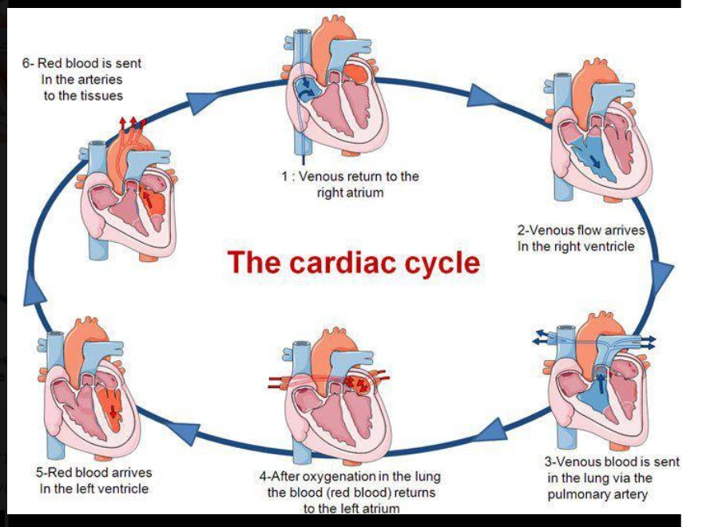

When does most of the blood enter the ventricles? How much?
- When they relax during late ventricular diastole
- 70-80%

How much of the blood enters the ventricles during the atrial systole (when the atria contract)?
- 20-30%

When does blood flow into the ventricles? When does this occur?
- When pressure in the atria exceeds that in the ventricles
- During late ventricular diastole and continues until the atria have finished contracting at the end of atrial systole

Mechanical Performance of the Heart:

What is cardiac output?
- Amount of blood pumped by each ventricle in one minute

What is cardiac output matched to?
- The body’s demand for oxygen

What will happen to your cardiac output when you are exercising? Why?
- Cardiac output will be high
- Working muscle’s demand for oxygen is high so cardiac output will be high to deliver oxygen rich blood to the muscles

How is cardiac output calculated?
- Heart rate bpm X stroke volume

What is stroke volume?
- The amount of blood pumped by each ventricle during one contraction

What ventricle is usually used in calculating stroke volume?
- Left

What is the normal resting values of cardiac output for adults?
- 5L/min

What can cardiac output increase to during exercise?
- 20-40mL/min depending on fitness level

What is the average person’s resting heart rate?
- 70 bmp

How low can a heart rate be? What type of person would have this low of a resting heart rate?
- 40-50bpm
- highly trained athletes

What is the equation for max HR?
- 220- age of person

What is heart rate controlled by?
- ANS

What nerves is the heart supplied with?
- PSNS and SNS

In order to change heart rate, you must change what?
- The pacemaker potential of the SA nodal cells

What do PSNS nerves innervate? What do these nerves release to these areas?
- SA node and AV node and to a minor extent the ventricular muscles
- Ach

What does the PSNS do to heart rate?
- Decrease heart rate and cause a small decrease in the force of contraction

Explain how the PSNS nerves effect HR:
- Ach binds to receptors on SA node
- This increases K+ permeability
- This decreases Ca++ permeability
- This results in not as big of a positive charge build up

- With more K+ leaving the cell is hyperpolarized
- This decreases the slope of the pacemaker potential
- This decreases HR as it takes the pacemaker longer to reach threshold
- The heart is pumped less often

- K+ build up, Na+ and Ca++ leaks

What does the SNS nerves innervate?
- SA and AV nodes and have a stronger influence than the PSNS on the ventricular muscle

What do these nerves release to these areas?
- Norepinephrine

What does the SNS nerves do to HR?
- Increases HR and increases force of contraction

Explain how the SNS nerves effect HR:
- Norepinephrine binds to SA nodal receptors
- This increases Na+ permeability
- This increases Ca++ permeability

- This results in an increases slope of the pacemaker potential
- This increases HR as the pacemaker potential is reached faster

When are the PSNS nerves activated?
- When you’re at rest as the body’s demand for oxygen is low -> therefore CO and HR is low -> PSNS activated

For the PSNS what bpm is required?
- heart rate of less than 100 bpm

When are the SNS nerves activated? What is the result of this?
- During more intense exercise -> high demand for oxygen -> SNS activated -> higher HR so more oxygen can reach the active muscles

What is the bpm needed for the PSNS?
- Heart rate of greater than 100bpm

When will PSNS be deactivated but SNS will not be activated? Give an example of this and what bpm this would occur at. What is this called?
- When your body’s demand for oxygen increases and an increase in CO and HR is needed
- Heart rate of roughly 100 bpm
- Walking or briefly climbing stairs and your muscles need extra oxygen
- Intrinsic rate

What is stroke volume?
- The amount of blood pumped by each ventricle in one contraction

What does increasing stroke volume result in?
- Cardiac output

What is stroke volume at rest?
- 70mL

What can stroke volume reach during maximal exercise? What does this depend on?
- 110-1220mL
- Fitness level

What are the major factors that control stroke volume?
- Input from the ANS
- Preload/end of diastolic volume

How do the two divisions of the ANS control stroke volume? Why? What influence do they have?
- PSNS:
- releases Ach
- Ach closes Ca++ channels
- Less Ca++ flowing into cardiac contractile cells
- Less power strokes
- Decrease in force of contraction
- Decrease in stroke volume and cardiac output

- SNS:
- releases norepinephrine
- norepinephrine opens Ca++ channels
- more Ca++ flows into contractile cells
- more power strokes
- increase in force of contraction
- increase in stroke volume and cardiac output

What is EDV? When does it occur? How many mL is it?
- Filling of the ventricles that increases the volume of each ventricle
- During diastole
- 160mL volume in ventricles

What is SV? When does it occur? How many mL is it?
- When the ventricles contract and empty into the aorta
- During the systole
- Empty 70mL into aorta

What is ESV? How many mL is it?
- What remains after the ventricle has contracted
- 90mL

What is the relationship between EDV, ESV and SV?
- As EDV increases, ESV decreases and therefore SV increases

How can stroke volume be calculated? Where EDV and ESV represent what?

SV= EDV-ESV
- EDV: volume of blood in ventricles at end of diastole, just before they contract
- ESV: volume in blood in ventricles at the end of systole, just after contracting

What will the ESV decrease to after activation of the SNS?
- 10 to 30mL

When large amounts of blood flow into the ventricles how high can the EDV become?
- 200-250 mL

What is preload?
- The load on the cardiac muscle/ventricles just before contraction, a force

What is preload caused by?
- Blood filling the ventricles which then stretched the ventricular muscle

What happens when there are more ventricles that are filled with blood before contraction?
- The higher the EDV and the greater the preload on the heart

What happens when a preload stretch is greater?
- The more forceful the contraction

Explain how preload is related to EDV and how it affects stroke volume and cardiac output:
- Increase in EDV -> increase in preload -> increase stretch of myocardial cells in ventricles -> increase force of these cells when the heart contracts -> increase amount of blood ejected -> increase stroke volume -> increase CO

What is the Starling Law of the Heart?
- Increase in EDV and decreasing ESV= increase in stroke volume (can be by double the resting amount)

During physical exercise what happens to the venous return to the heart?
- It is increased

How does the muscle pump of the body change to increase venous return to the heart in exercise? What does this result in?
- Squeezes on veins that go through the muscles
Results:
- Increase venous return
- Increase EDV
- Increase stroke volume
- Increase CO

How does the respiratory pump of the body change to increase venous return to the heart in exercise? What does this result in?
- Decrease pressure in chest cavity
Results:
- Pulls air into lungs
- Pulls blood back into heart to increase venous return, EDV, stroke volume, and CO

How does the SNS of the body change to increase venous return to the heart in exercise? What does this result in?
- Increases HR
- Increases stroke volume
- Small constriction of veins

Results:
- Increases venous return which increases EDV, stroke volume, and CO

Vascular function:
Explain the pressure, flow and resistance of the circulation vessels:

Aorta-
- Highest pressure
- Very little resistance

Large Arteries-
- High pressure
- Very little resistance to blood

Small Arteries-
- Fall in pressure begins here
- Resistance the blood encounters begins to increase

Arterioles-
- Pressure drops 55mmHg
- Greatest resistance- half the total resistance in the entire circulation system

Capillaries-
- Blood leaving arterioles and entering capillaries has a pressure of 40mmHg and drops to 20mmHg in the capillaries

Venules-
- Blood entering venules has a pressure of 10-15mmHg
- Small resistance

Small veins-
- Low pressure

Large veins-
- Low pressure

Vena Cava-
- Low pressure

What happens to the blood pressure by the time it reaches the atrium?
- It is almost zero pressure

What drives blood flow through the vessels? Give an example and what does not.
- The pressure changes/pressure gradient between two points and resistance in the circulatory system
- Ex: drop in pressure from high pressure in the aorta to low pressure in the veins is what causes blood to flow through the circulation
- Not a concentration gradient

Explain the relationship between blood flow, pressure and resistance:
- Blood flows from high to low pressure (point 1 to point 2)
- Blood flow is decreased by resistance

Give the equation that represents the relationship between blood flow, pressure and resistance:

Blood flow= (P1-P2)/resistance or pressure gradient/resistance

Blood flow= (P1-P2) x radius of the vessel

What factors determine the resistance to flow in a tube/blood vessels?
- Length of the vessel, viscosity of the fluid, radius of the vessel

How does length of the vessel determine resistance to flow?
- Longer vessel= larger resistance
- Shorter vessel= smaller resistance

How does radius of the vessel determine resistance to flow?
- larger radius= decreased resistance
- smaller radius= increased resistance

What is the formula for resistance? What would it be over a short term? Why?
- Resistance= (length of vessel x viscosity of the fluid)/radius of the vessel
- Short term length of vessel and viscosity don’t change so they are constants and the formula is- resistance= (1)/radius of the vessel

What does a small change in radius of the vessel do to the blood flow?
- Large change in blood flow

Let’s say that you had four blood vessels that were all connected and the radius and pressure gradient was the same for all of the vessels. Then you constricted one of the four vessels, what would occur to blood pressure, blood flow, and resistance?

- Blood flow will decrease due to a decrease in radius
- The pressure gradient in that vessel will increase however the decrease in radius over rules it for the impact it has on the blood flow

What can you do to a blood vessel to increase blood pressure?
- Vasoconstrict the vessel
What type of vessels have lower velocity?
- The smaller the vessels, the lower the velocity

What type of vessels have more cross-sectional area?
- Vessels with more branches

Where do we want slow moving blood and lots of surface area? Why?
- Capillaries
- We want lots of gas exchange

What has a lower velocity: vena cava or aorta? Why? What about blood flow?
- Vena cava
- It has a larger diameter but the same blood flow, therefore to have the same blood flow through different sized vessels, the velocity of the smaller diameter vessel has to be quicker
- Blood flow is the same

What is the difference between blood flow and blood velocity?
- Velocity is the speed at which blood is moving through the vessel (cm/sec)
- Blood flow: volume of blood moving through a set of vessels (L/min)

What is blood flow at rest?
- 5 L/min throughout systemic circulation

What are the three layers of arteries and veins? Describe them.
- Tunica Extrena: outermost, composed mostly of fibrous connective tissue
- Tunica Media: middle later, consists of smooth muscle and elastic tissue
- Tunica Interna: innermost, endothelial cells

What do veins contain that arteries do not? Why?
- Valves
- To ensure blood flows in one direction, and that is back to the heart

What are capillaries made of? Why?
- Single layer of endothelial cells
- Thin walls permit diffusion of substances in and out of the body

Rank the blood vessels based on total diameter from largest to smallest:
- Vena cava
- Aorta
- Vein
- Artery
- Arteriole
- Venule
- Capillary

Rank the blood vessels based on wall thickness from largest to smallest:
- Aorta
- Vena cava
- Artery
- Vein
- Arteriole
- Venule
- Capillary

Which blood vessel has the most elastic tissue?
- Aorta

Which blood vessel has the most smooth muscle tissue?
- Artery

Which blood vessel has the most fibrous connective tissue?
- Aorta and veins

How much elastic, smooth muscle and fibrous connective tissue do capillaries have?
- None

How much elastic, smooth muscle and fibrous connective tissue do venules have?
- Only a small amount of fibrous connective tissue only

Explain the properties of the aorta and large arteries:
Blood characteristics:
- Very high blood pressure- pulsates 120/80mmHg
- High blood velocity

Structure:
- Large diameter
- Lots of elastic tissue
- Relatively thin walls
- Easily enlarged
- low resistance to blood flow
- small drop in blood pressure

Purpose:
- shock absorbers
- distribute the blood
Extra Info:
- stretched during systole and recoil during diastole
- little resistance to blood flow

Explain the properties of the arterioles:
Blood Characteristics-
- large drop in blood pressure
- lower blood velocity

Structure-
- small diameter
- very thick walls relative to other blood vessels
- large smooth muscle content innervated by ANS
- causes vasoconstriction or vasodilation
- less elastic tissue

Purpose-
- resistance vessels
- control blood flow to organs via constriction and dilation

Explain the properties of the capillaries:
Blood Characteristics-
- low blood pressure
- very low blood velocity (1-2 cm/sec)
- small drop in blood pressure

Structure-
- blood enters capillaries by arteriole and leaves by venule
- precapillary sphincters contact and relax to close and open entrance to capillary vessels which controls blood flow through capillaries
- only 1 endothelial cell thick (no elastic or muscular tissue)
- extremely large total cross-sectional area (3000 cm)
- very large surface area for diffusion

Purpose-
- exchange vessels for nutrients and other substances between blood and tissues

Explain the properties of venous circulation:
Blood Characteristics-
- very low blood pressure
- low to medium blood velocity 5-10cm/sec
- veins contain 70% of all blood volume

Structure-
- very thin walls
- very large internal diameter
- easily distended (enlarged)
- some elastic tissue
- valves
- some smooth muscle innervated by SNS for vasoconstriction or vasodilation
- internal pressure very low compared to similar sized arteries

Purpose-
- capacitance vessels

What are the two types of exchange in the capillaries?
- Diffusion and filtration/reabsorption

Explain the different diffusion exchange in the capillaries:
- Oxygen and nutrients: high concentration in the blood, diffuse into interstitial fluid
- Water and dissolve substances: diffuse through slits in capillary wall
- Lipid-soluble substances: diffuse through entire length of capillary wall
- Systemic capillaries: CO2 diffuses into the blood and its concentration is high in the tissues
- Pulmonary capillaries: O2 diffuses into the blood and CO2 diffuses into the lung

What does filtration and reabsorption at any point along a capillary depend upon?
- A balance of 4 special forces called Starling Forces

What is filtration?
- Movement of fluid out of the capillary plasma to the interstitial space

What is reabsorption?
- Movement of fluid back into the capillary plasma from the interstitial space

What cannot pass through capillaries?
- Large proteins

What can pass through the pores of the capillaries?
- Water and dissolved substances such as ions

Describe the four Starling Forces:
- Capillary Hydrostatic Pressure of Plasma (Pc)
- Pressure from the blood in the capillary
- Moves fluid from plasma to interstitial space, causing filtration
- Blood pressure falls off over the length of the capillary from arterial end of 25mmHg to venous end of 10mmHg
- Greater hydrostatic pressure that promotes filtration at the arterial end rather than the venous end

- Interstitial Fluid Hydrostatic Pressure (Pif)
- Pressure on the fluid in the interstitial space
- Varies from one organ to another
- Where hydrostatic pressure is positive it will move fluid into the plasma via reabsorption
- Where hydrostatic pressure is negative it will move fluid out of the plasma via filtration

- Interstitial Osmotic Pressure (πif)
- Pressure caused by osmosis due to the few proteins in the interstitial fluid
- Pressure is low, 5mmHg
- Tends to move fluid into the interstitium which causes filteration

- Plasma Osmotic Pressure (πp)
- Pressure is caused by osmosis due to proteins in the plasms
- Moves fluid into the plasma via reabsorption
- Approximately 28mmHg
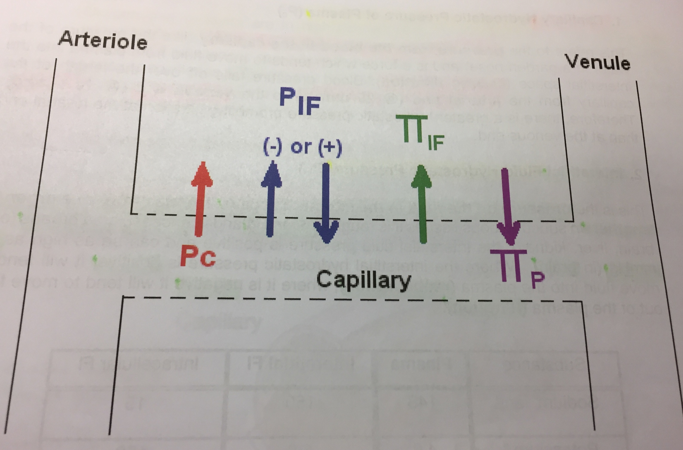
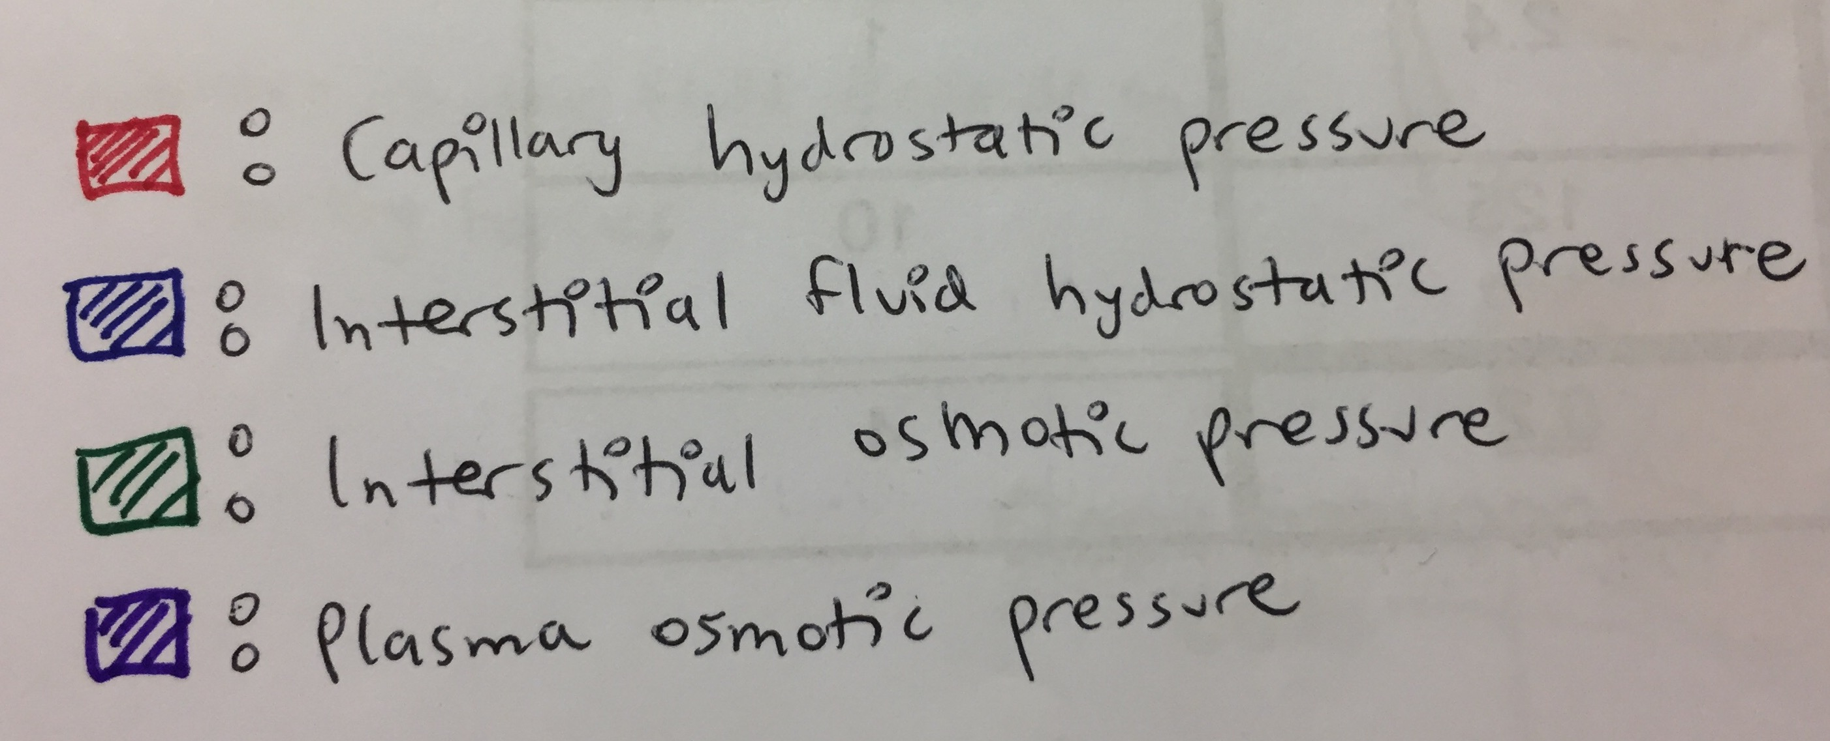

What is the Starling-Landis equation used to calculate?
- The net fluid movement across a capillary bend

What does the balance of the Starling forces determine?
- Net pressure for fluid movement and the direction of fluid movement across the capillary endothelium

What is the equation for the net fluid movement across a capillary?
- Kf([Pc − Pi] − [πc – πi])

What is Kf? What does it represent?
- Filtration coefficient
- It represents the permeability/leakiness of the capillary

What does a higher filtration coefficient mean?
- The leakier the capillary and the more fluid that can move across

What do we assume Kf is?
- 1

What does it mean when net fluid movement comes out positive?
- Direction of fluid movement is from plasma -> interstitial
- Filtration

What does it mean when net fluid movement comes out negative?
- The direction of fluid movement is from interstitial fluid into the vasculature
- Reabsorption

Cardiovascular Regulatory Mechanisms:
What are the overall purpose of all cardiovascular regulatory mechanisms?
- Increase blood supply to active tissues and decrease it to inactive tissues
- Increase or decrease heat loss from the body by redistributing blood
- Maintain blood supply to the heart and brain at all times
- Maintain blood pressure/ mean arterial pressure

What mechanisms regulate the cardiovascular systems circulation?
- Local/intrinsic
- Humoral/extrinsic
- Neural/extrinsic

What do the local intrinsic control mechanisms do?
- Allow most tissues (mostly brain, heart, kidney and skeletal muscle) to have the capacity to control their own blood flow
- Allow the individual vascular beds to maintain a relatively constant blood flow when moderate changes occur in blood pressure

What are the two theories for local control mechanisms?
- Myogenic theory (autoregulation)
- Metabolic theory

Explain how an increase in blood pressure to a capillary bed would result in a decrease in blood flow to that area via the myogenic theory:
- Sudden increase in blood pressure -> walls of arterioles stretch -> smooth muscle walls contract -> vasoconstriction -> decreases blood flow and pressure after constriction

What would an increase in blood pressure in the myogenic theory cause? What about a decrease in blood pressure?
- Increase in blood pressure: contraction of smooth muscle in arterioles (vasoconstriction)
- Decrease in blood pressure: relaxation of smooth muscle in arterioles (vasodilation)

What does the metabolic theory state?
- Activity in a tissue releases VDMs (vasodilator metabolites) that cause a very local vasodilation of the blood vessels in the region of the arterioles which leads to an increase in blood flow to that tissue and vice versa

What are the VDM’s released by active tissue? What do they cause?
- Increased CO2
- Increased concentration of H+
- Increase adenosine
- Increased temperature
-All cause the arteries to vasodilate and increases blood flow during exercise

What happens when there is decreased levels of VDMs in the blood?
- Vessels Vasoconstrict and decrease blood flow through tissue

If you hyperventilate for a long time, you will pass out, why?
- Hyperventilating increases CO2 removal from the blood
- Lower concentration of CO2 in the blood
- Vasoconstriction of blood vessels (metabolic theory)
- Decrease blood flow in the brain
- Pass out!

What is humoral regulation?
- Regulation by substances present in the blood

What do vasoconstrictor agents do?
- Decreases blood flow

What are the vasoconstrictor agents and what do they do?
- Epinephrine-
- Attaches to alpha receptors in blood vessels throughout the body
- Overall weak vasoconstriction

- Angiotensin II-
- Most potent vasoconstrictor in the body
- Production simulated by decrease in bp and Na+ levels

- Vasopressin (ADH)
- Formed in hypothalamus
- High concentration produces vasoconstriction

What do vasodilator agents do?
- Increase blood flow

What are the vasodilator agents and what do they do?
- Epinephrine-
- Attaches to beat receptors in blood vessels of skeletal and cardiac muscles and the liver
- Vasodilation

- Kinins-
- A group of blood proteins involved in inflammation, bp and blood clotting

- Atrial Natriuretic Factor (ANF)
- Powerful vasodilator released by atrial muscle cells

Epinephrine binding to alpha receptors is?
- Constriction

Epinephrine binding to beta receptors is?
- Dilation

Through the Neural Control Mechanisms, describe the effects of the SNS on blood vessels and the results:
- Ach causes release of epinephrine from adrenal glands
- Norepinephrine released onto blood vessel
- Vasoconstriction
-results are increased HR and increase SV

Through the Neural Control Mechanisms, describe the effects of the PSNS on blood vessels and the results:
- Small indirect effect on blood vessels as the SNS is shut off, which causes a weak vasodilation throughout the body

What is a baroreceptor reflex?
- A negative feedback system that works to maintain a mean arterial pressure (MAP) for proper perfusion of tissue throughout the body

How does a baroreceptor reflex do this?
- By regulating CO2 and total peripheral resistance (TRP)

What is the equation for MAP?
- CO (HRxSV) x TPR

What is TPR?
- All the resistance encountered by the blood in the entire systemic circulation

Explain the relations between CO, MAP, radius and resistance:
- CO2 increases, MAP decreases
- CO2 decreases, MAP increases
- Radius decreases, resistance (1/r4) increases, MAP increases
- Radius increases, resistance (1/r4) decreases, MAP decreases

How does MAP maintain MAP at a relatively constant level?
- Baroreceptor reflex

What is the negative feedback system to control MAP?
- A negative feedback system to maintain MAP for proper perfusion of organs throughout the body

Explain the negative feedback system for MAP:
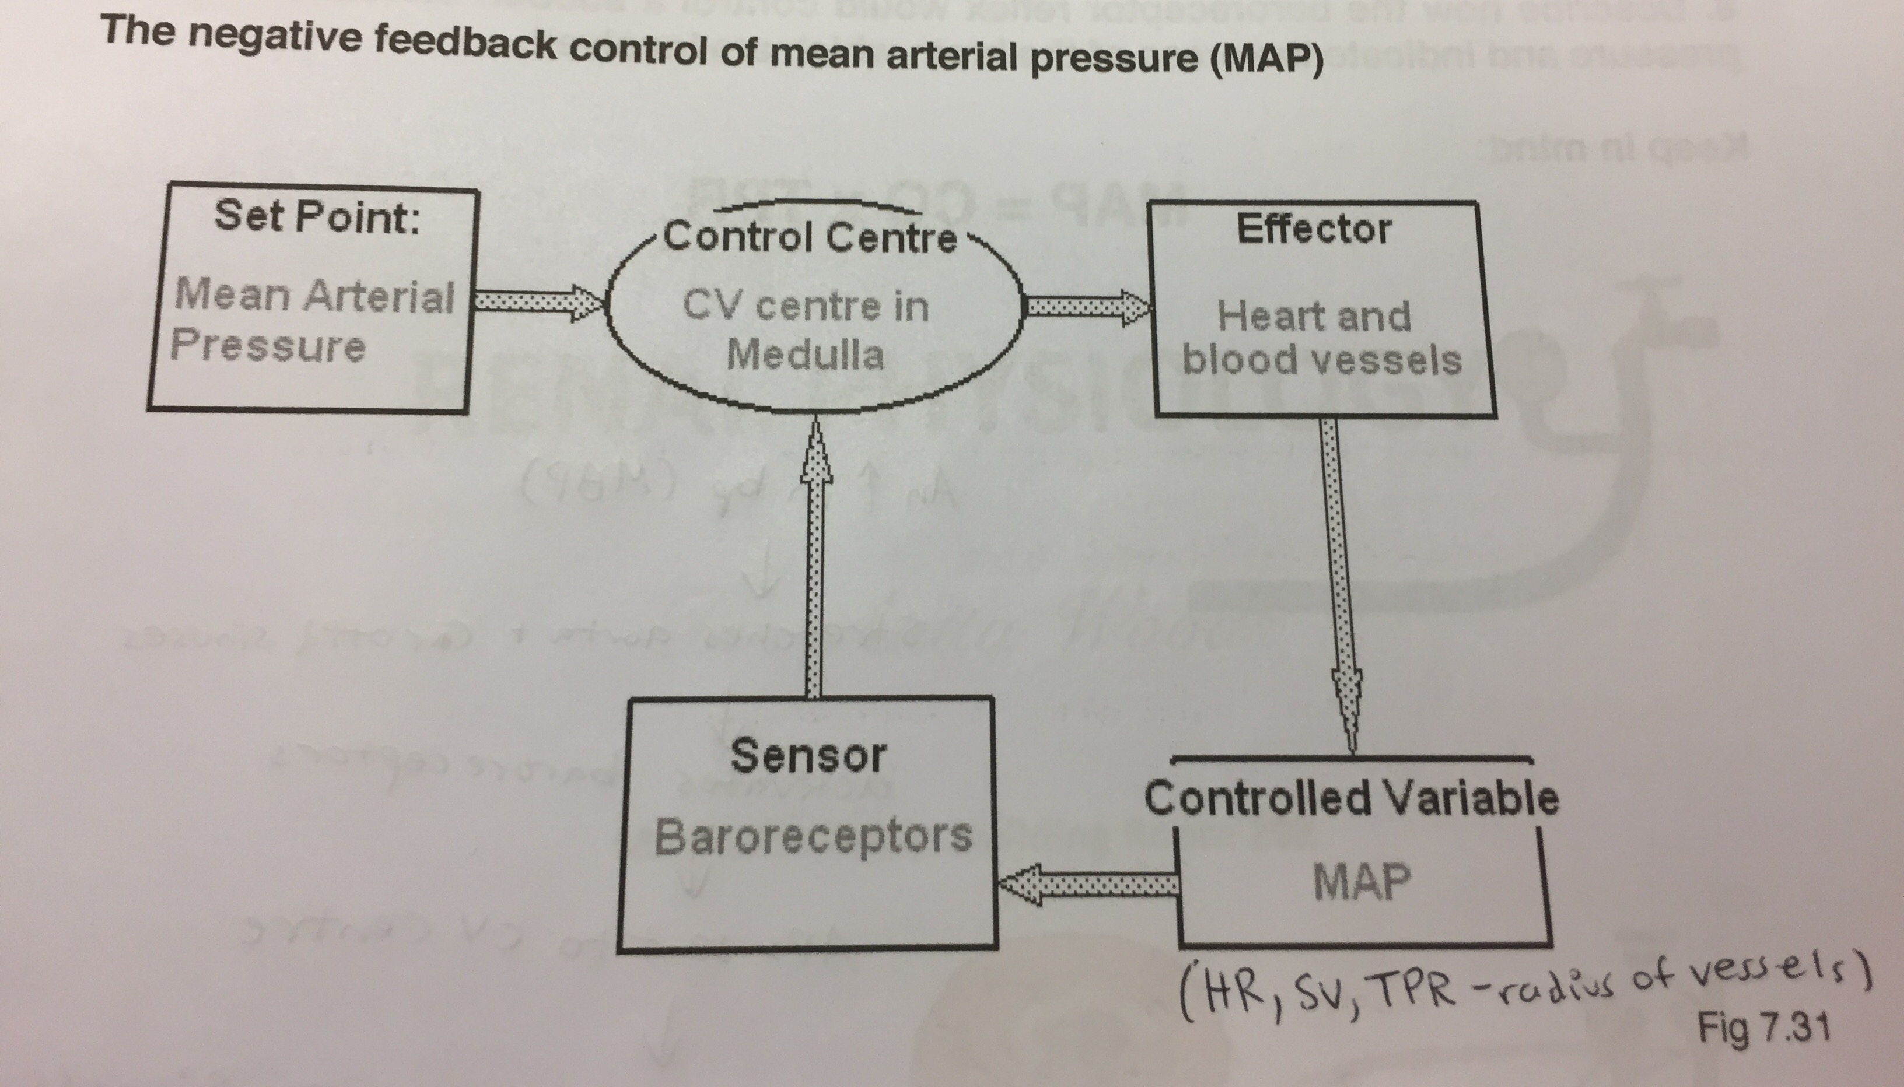

What are baroreceptors?
- Stretch sensitive receptors that monitor blood pressure by sending signals (Aps) back to the cardiovascular center in the medulla of the brain stem

Where are baroreceptors located?
- Walls of aortic arch and carotid sinuses

Describe how the baroreceptor reflex would control a sudden increase in blood pressure and indicate the areas of the brain in which they are involved:
- Increase in blood pressure (MAP)
- Stretches aorta and carotid sinuses
- Activate baroreceptors
- APs are sent to CV center
- CV center compares signals to the set point
- Shuts off SNS and activates PSNS
- CO decreases with decrease of HR and SV and vasodilation occurs which lowers TPR
- Decreases MAP
-vice versa

