3442
Global/international
International Union for Conservation of Nature(IUCN)
Convention on International Trade in Endangered Species(CITES)

Canada’s Federal Legislation: Bill C-5, The Species at Risk Act(SARA).
The impetus for SARA was the UN Convention on the Conservation of Biological Diversity(Requires a listing, recovery processes.
Cost-effective measures to prevent the reduction or loss of the species should not be postponed for a lack of full scientific certainty
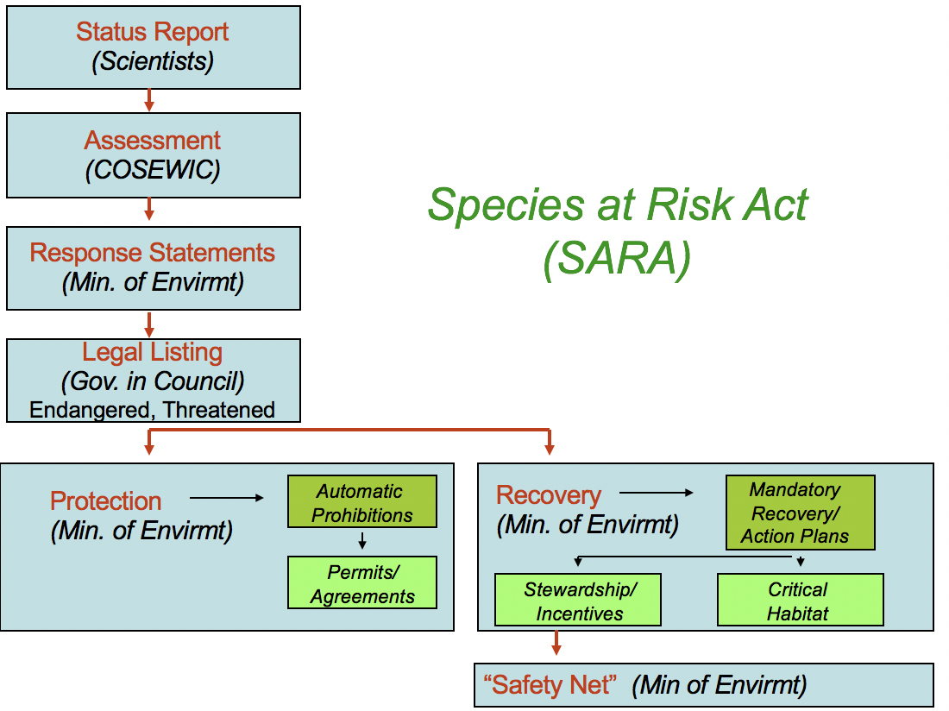
COSEWIC(Committee On the Status of Endangered Wildlife In Canada)
- Given legal status under SARA
- not a federal agency
- consider feasibility of recovery
- useful information
  - Trends in numbers and distribution, habitat threats
  - Harvest, by-catch, removals
  - Introduced predators, pathogens, competitors
  - Life history, habitat requirements, expected threats.

Status recommendation process
- Status report commissioned
- Then drafts are reviewed by COSEWIC SSC(Species Specialist sub-Committees) members, range jurisdictions, external experts, Wildlife Management Boards.
- SSCs meet to make status recommendations. Drafts can be revised
- Final status reports are sent to all voting COSEWIC members.
- Then, COSEWIC has their bi-annual Species Assessment Meeting, and decides the risk category for each species.

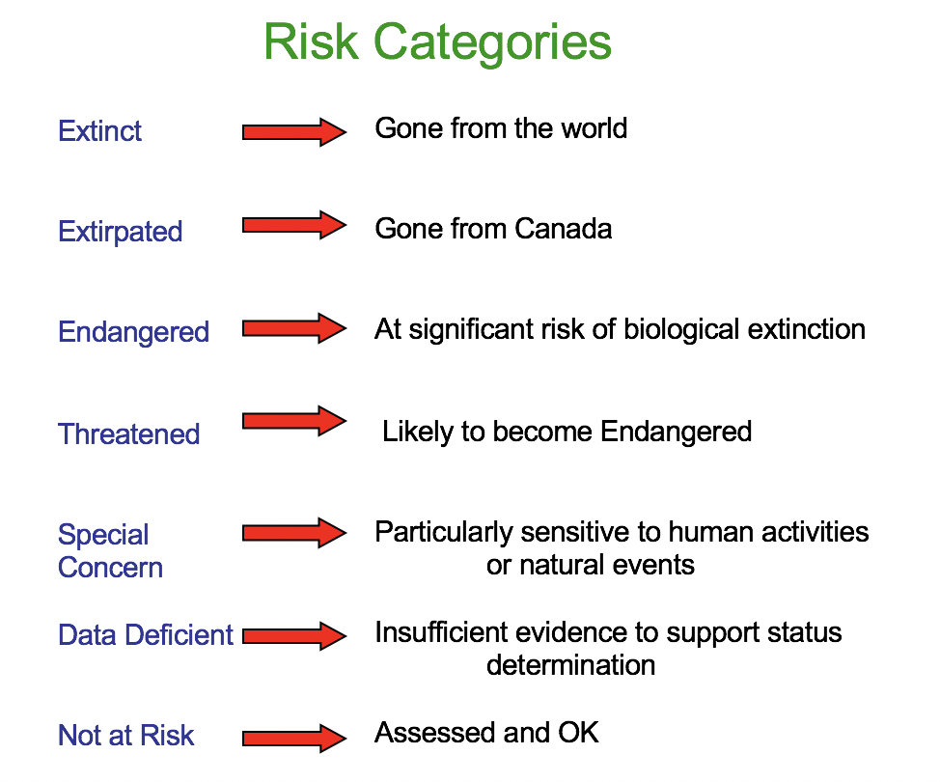

Risk Categories asses using a variety of means
- Decline in total number of mature individuals
- Small distribution, decline or fluctuation
- Quantitative analysis
- Follow criteria in Appendix E3
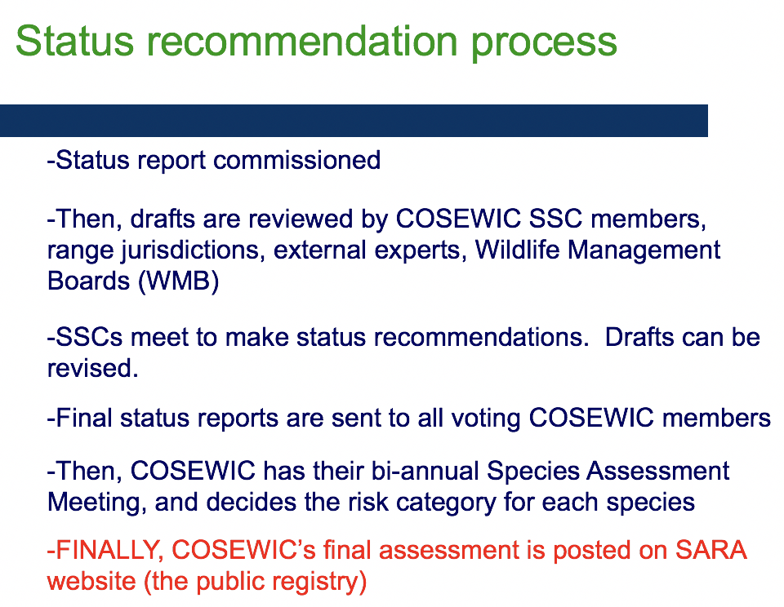
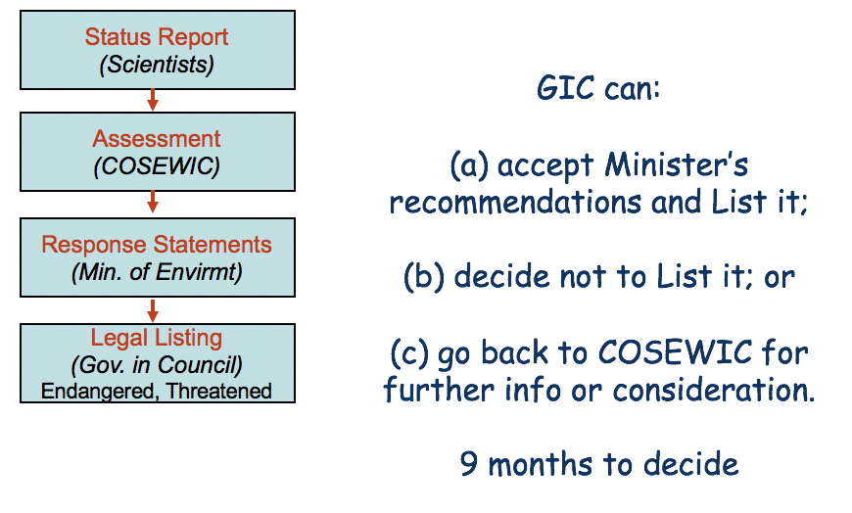
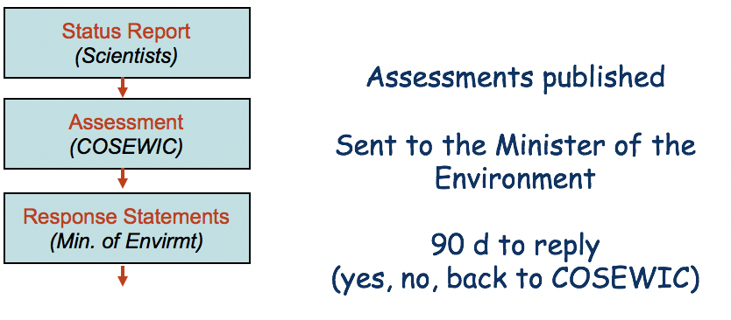
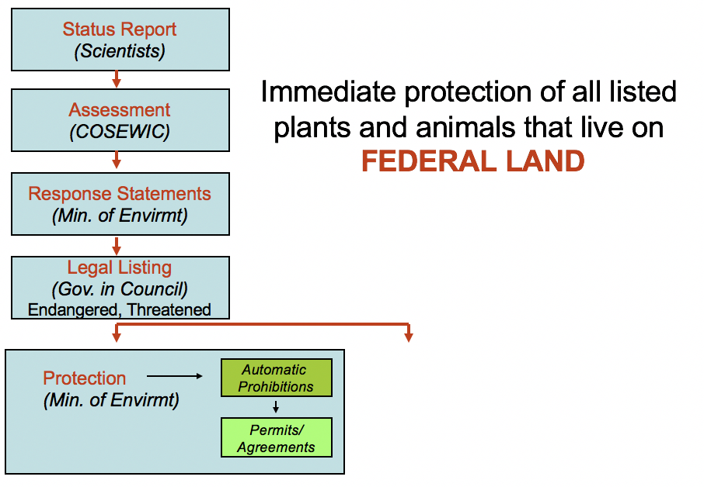

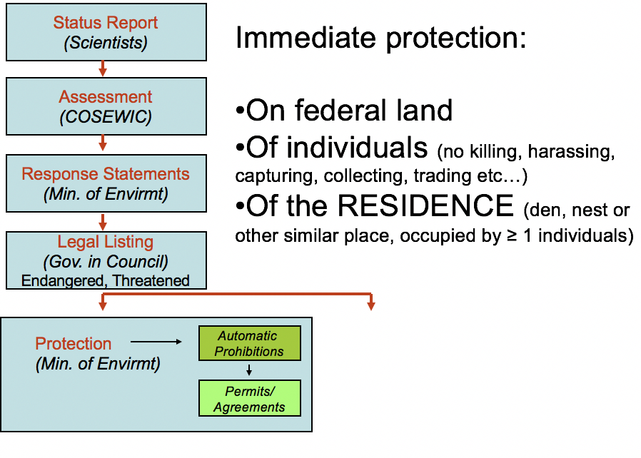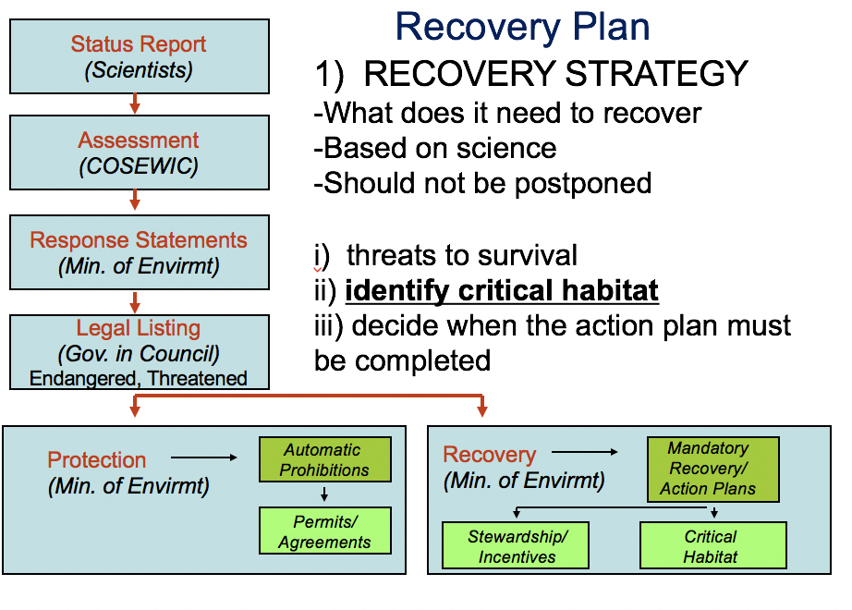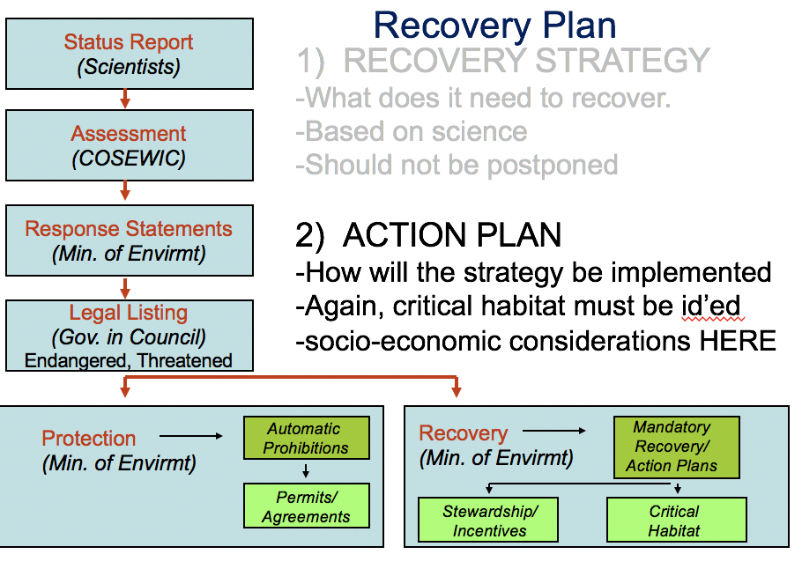
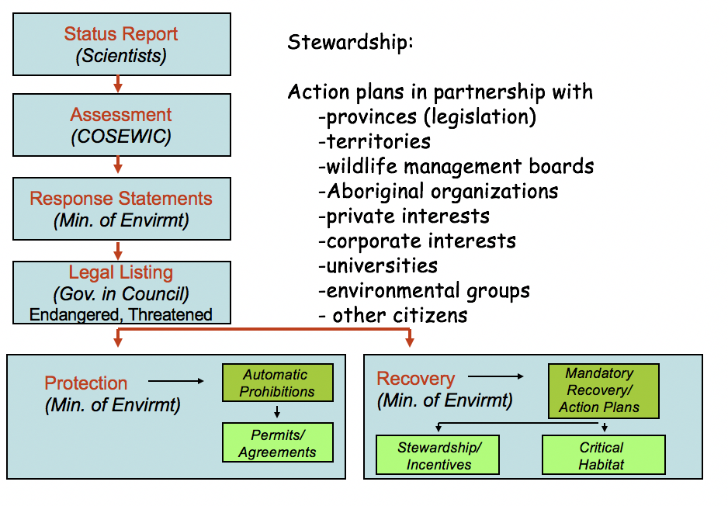

Critical Habitat
- Sara stipulate : Recovery strategies and action plans will identify the critical habitat of a threatened or endangered species needing protection. Once identified, critical habitat will be protected by conservation agreements, provincial or territorial legislation, or federal prohibitions.
How well is SARA Working
- Delays & discretionary powers in listing
- Limitation in habitat protection
- Discretionary powers at recovery
- Funding at recovery
- Plain old breaking the law

Declining population paradigm
- Medical Model
  - Determine if population is on a dangerous decline
  - Identify the causes
  - Fix the problem
- Steps to diagnosis and recovery
  - Determine the STATUS of the species
  - Get a feel for potential causes
  - List and measure all potential causes of decline
  - Test hypotheses by experiment
- Small population paradigm
  - Population IS way past dangerous decline
  - Cause identified already : Population is SMALL
  - Mechanisms = Random Events
  - Limiting factors irrelevant
- 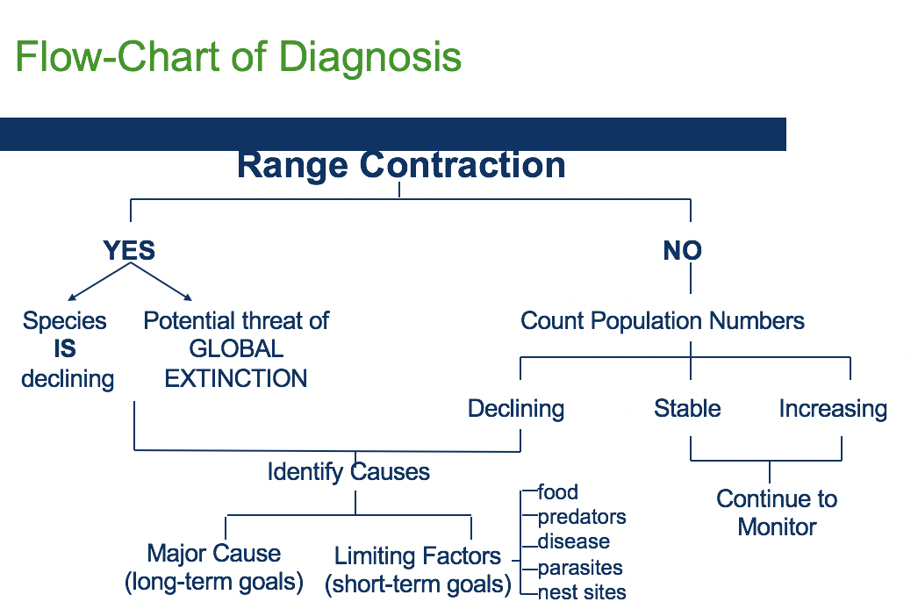

The Four major causes
- Habitat loss and fragmentation
- Overexploitation
- Introductions & Invasive species
- Pollution
Which of the Major Causes is it likely to be?
- Compare where populations are NOW VS where they WERE = changes in distribution.
Limiting factors come into play for your particular popuplations??
- Limiting factors – resources needed for survival(low death rate) and reproduction

Habitat fragmentation : threats to species
- Loss then conversion of habitat
  - Original ecosystem function disabled
  - Edge effects
  - Smaller fragments and more fragmented landscapes will ose the most species
- Fragments are poor quality to start with
- Fragment quality degrades over time

Abiotic: microclimate changes
- More edge means
  - Warmer, drier fragments, smaller fragments more perturbed than larger
  - Warmer, drier landscape fragmented landscapes more perturbed.

Biotic effects of edge: loss of interior species in favour of edge species
- Species composition changes
- Invasives like disturbance. More disturbance on edges.
- Edges have highest predator number, predation rates.

Habitat lost, then insult to injury
- Fragments left behind are the worst habitat to begin with.
  - Steep slopes
  - Poor soils
  - Inaccessible areas.
Edge effects : the eternal external threat
- A continuous homogenization of remnants and surrounding matrix as remnants continue to degrade
- Beta diversity = 0

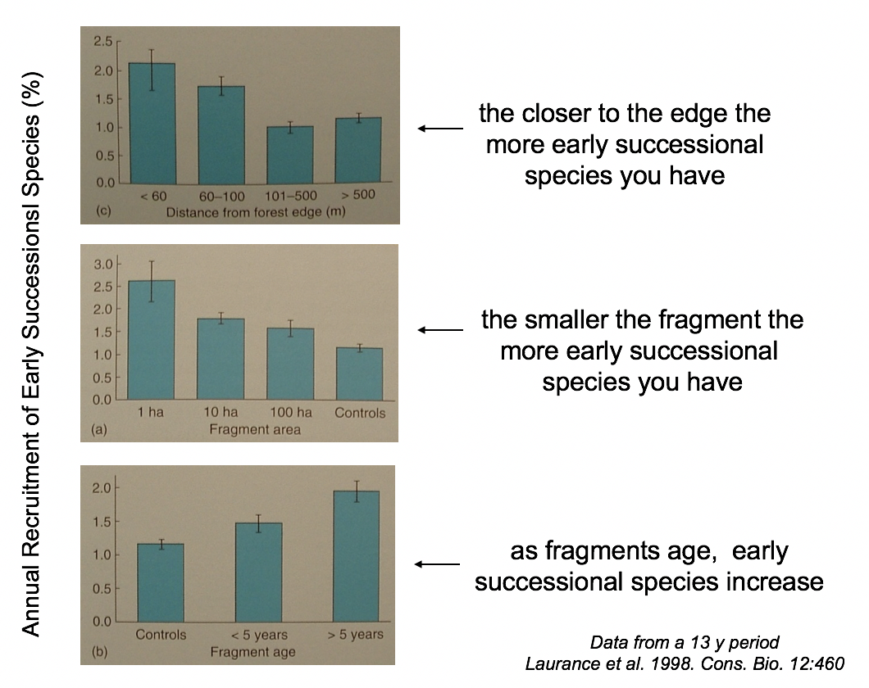

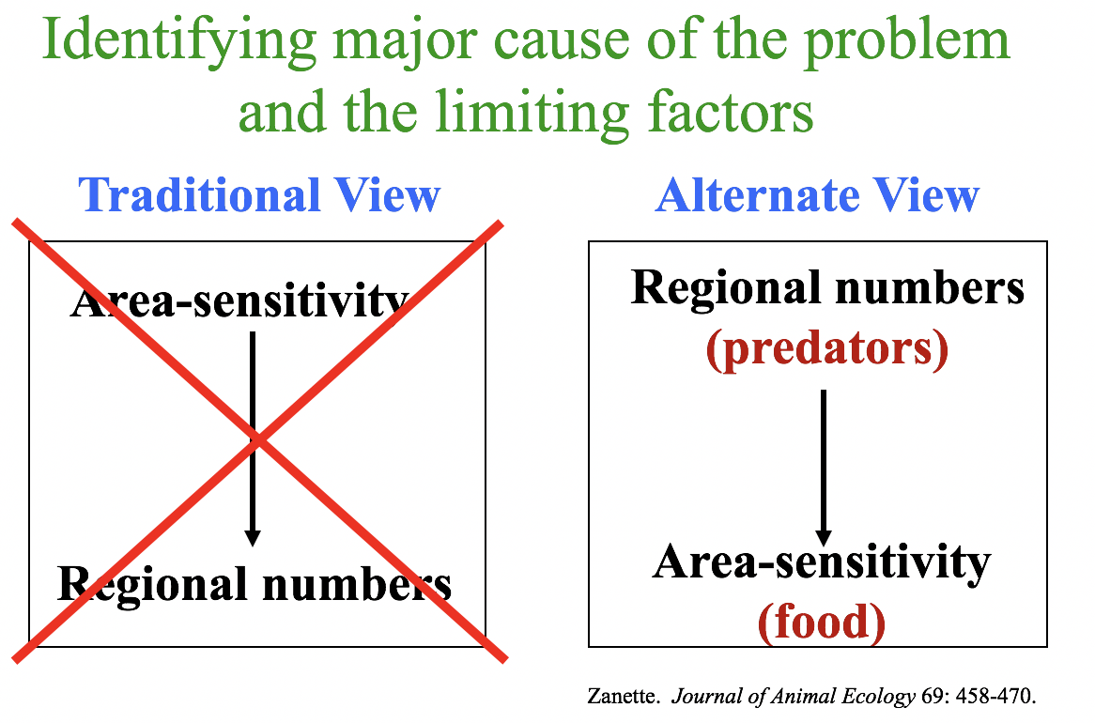

Political economy of conservation
- Supply and demand = market value in rarity
- Discounting = the future has no market value
- Alternative investments = harvest to extinction
- Market ‘ solutions’ = public relations

Two paradigms of conservation biology
- Small population paradigm – maintains rarity, thereby ensuring economic market value. Captive breeding ensures exclusivity of access
- Declining population paradigm – maintains abundance, thereby jeopardizing market value. Emphasis on preservation in the wild jeopardizes exclusive access

Discounting and the time horizon
- Using discounted net present values( the normal market mechanism for evaluating the value of future returns) today’s market value of a dollar that will not be received until ten years from now is approximately zero”

Market values =/= human values

Conservation is a human value
Political economy of conservation
- Supply and demand = market value in rarity
- Discounting = the future has no market value
- Alternative investments = harvest to extinction
- Market’Solutions’ = public relations
- Corporate economics =/=Market Economics

Causes of Species Losses since 1600
- Habitat Loss: 80%
- Hunting/Harvesting : 30~40%
- Introduced Species: 40%
- Pollution : 10%
Humans are “super predators”
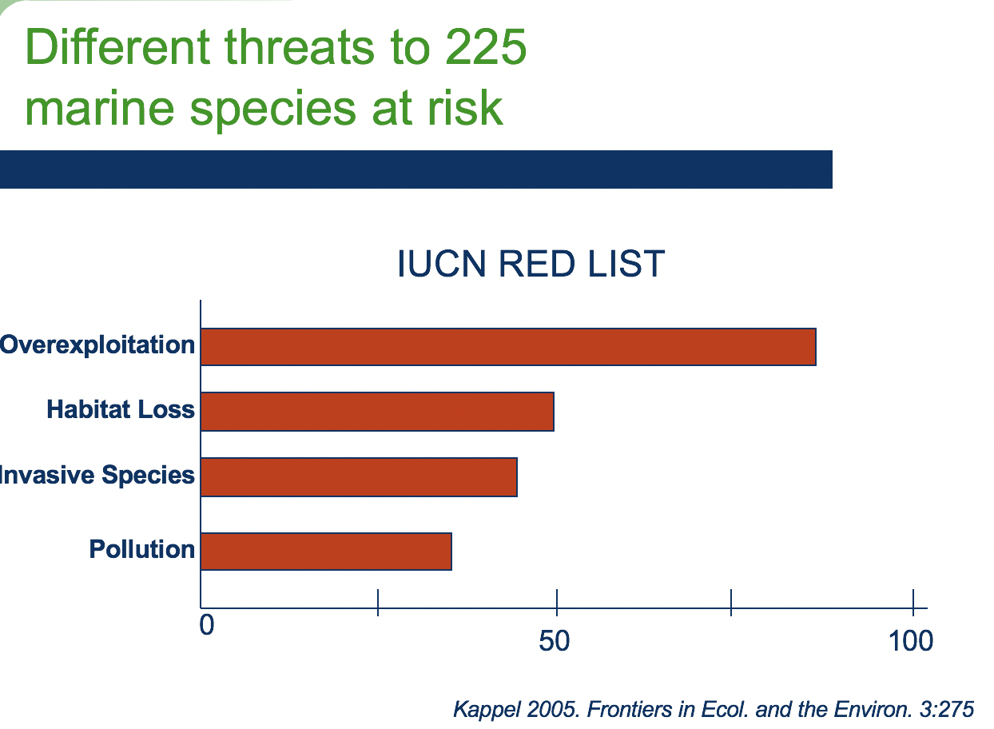

Hunting does not just affect the target : bycatch of marine species ; trophic effects

Multiple species affects if Keystone Species are hunted to extinction
- Species which, if extinct, leads to the extinction of others.
- Supports the ecosystem. Removal = ecosystem collapse
- Impacts on community or ecosystem are larger than expected given relative abundance or total biomass

Intentional introductions
- Acclimation Societies
  - Formed where British went, late 1800’s
- Difficult to control
- Ex : European red fox in Australia

Pollution: persistent toxic chemicals
- Resistant to degradation from abiotic and biotic factors
- Highly mobile in the environment
- Stored in tissue and so
  - Accumulates within individuals
  - Biomagnifies up the food chain

