Chapter 8

Performance management systems
- Performance management
  - Creating a conducive environment to elicit employees’ best performance
- Performance evaluation
  - Rating of employee performance on scale

Steps in the performance management process (Figure 8.1 from book)

- Cycles of PEs:
  - Annually (most popular) or biannually
  - Some organizations find value in conducting them on a quarterly basis
- In many firms, new employees are often put on probationary status for a period of 30,60 or 90 days

The purposes of Performance Management
- What gets measured gets done
- Good performance management systems:
  - Influence employee behaviour an d
  - Improve an organization’s performance
- Studies have shown that organizations with strong pm systems outperform competitors in the ares of:
  - REVENUE GROWTH
  - PRODUCTIVITY
  - PROFITABILITY
  - MARKET VALUE
- TWO OTHER MOST COMMON PURPOSES OF PERFORMANCE MANAGEMENT: (exam)
  - Administrative (image in book)
  - Developmental (image in book)
- Administrative purpose
  - Provide input that can be used in HRM activities: promotions, transfers, layoffs and pay.
    - Studies show..
- Developmental Purposes
  - PM provides management a framework to:
    - Gather information about performance
    - Provides feedback, and
    - Discuss an employee’s goals and how they align with the organization’s goals
  - THe goal is -
    - To build on a person’s strengths,
    - Eliminate potential weaknesses, and
    - Further his or her career while improving the performance of the organization as well
  - Feedback: to improve future competencies and to further careers and not to judge
    - Companies such as EDS, unit of HP, redesigned their performance management programs to focus more on employee development and learning
    - EDS, hopes to shift the role of managers from that of “judge” to one of “coach”
  - Why performance management systems fail?
    - Only 30% of employees said their PE (performance evaluation) actually improved their performance
    - Only 1 of 5 thought it helped
    - Many people believe it discourages teamwork by focusing on workers individual achievements
    - Useful for highly effective or highly ineffective employees. Not as useful to the middle
    - Focus on short term achievements
  - Developing an effective performance management system
    - Company’s HR has primary responsibility
    - Other line managers should participate actively especially during the development of performance goals
    - Employees (with experience) also more likely to accept and be satisfied with a PM system in Which they have the chance to participate and develop
What are the performance Standards?
- Standards derived from a job analysis and reflected in an employee's job description and ob specifications
- Realistic and specific performance standards that are measurable and written down to communicate precise information to employees.
  - For example, The ability and willingness to handle customer orders is not as good a performance standard as all customer orders will be filled in 4 hours
- Strategic relevance
    - Strategic relevance refers to the extent to which the performance standards ….
  - Criterion Deficiency
    - The performance standards should capture the entire range of an employee’s performance.
      - When they focus on a single criterion (such as sales revenues) to the exclusion of other important but less quantifiable performance dimensions (such as customer service)
  - Criterron contamination
    - There are factors outside an employee's control that can influence his or her performance
- Reliability:
  - Refers to the stability or consistency of a standard or the extent to which individuals tend to maintain a certain level of performance over time
- Calibration:
  - During calibration meetings, a group of supervisors, led by their managers and facilitated by an HR professional, discuss the performance of individual employees to ensure that all managers apply similar standards to all the firm’s employees
  - Try to come to a consensus on the employee's performance

- Fairness and Acceptability
  - Organizational politics, a firm’s culture, the orientation of its managers, history, and current competitive conditions can all affect how managers view how well their employees are doing the job as well as rate them
  - Employees who believe the system is unfair….
- Legal issues
  - Because performance evaluations are used to make many personnel decisions, they must meet certain legal requirements.
  - To avoid legal problems, performance evaluations should meet the following legal guidelines:
- Who should appraise an employee’s performance?
  - Given the complexity of today’s jobs, it is often unrealistic to presume that one person can fully observe and evaluate an employee’s performance
  - Raters can include: Supervisors, peers, team members, employees themselves, their subordinates, customers, vendors, and suppliers,
  - Each may be more or less useful for the administrative and developmental purposes we discussed earlier
- Self evaluation
  - A self-evaluation can increase an employee's involvement
- Subordinate evaluation
  - Evaluating the supervisor or managers

Chapter 9 :

Job evaluation systems
-One important component of the wage mix is the worth of the job.
-Organizations formally determine the value of jobs through the process of job evaluation.

Job evaluation: Systematic process of determining the relative worth of jobs to establish which jobs should be paid more than others

Worth of a job may be determined:
- By comparing it to others within the organization
- By comparing it to the scale that has been constructed or this purpose

Job evaluation systems (exam):
- Job ranking systems:
- Simplest and oldest system by which jobs are arrayed based on their relative worth
- Individual experts or committee of managements and employee representatives arrange cards listing the duties and responsibilities of each job in order of importance
- Job classification systems:
- In the job classification system, jobs are classified and grouped according to a series of predetermined grades
- Successive grades require increasing amounts of skill, knowledge, ability or other factors selected to compare jobs
- Point system
- A quantitative job evaluation procedure that determines a jobs relative value by calculating the total points assigned to it.
- The principal advantage – it provides a more refined more valid basis for making judgements than either the ranking or classification systems
- The point system permits jobs to be evaluated quantifiably
- Work valuation
- New job evaluation system for a dynamic business environment
- Seeks to measure a jobs worth through its value to the organization
- Its cornerstone: work should be valued relative to the business goals of the organization
- Serves to direct compensation dollars to the type of work pivotal to organizational goals
- Work is measured through standards that come directly from business goals
- The work evaluation process ends with a works hierarchy that is an array of work by value to the organization
- The work hierarchy is eventually priced through wage surveys to determine individual pays rates

Job evaluation for management positions:
- Because management positions are more difficult to evaluate some organizations do not include them in their job evaluation programs for hourly employees
- Hay profile method (book)
The compensation structure:
- Job evaluation systems provide for internal equity and serve as the basis for wage rate determination
- They do not in themselves determine the wage rate
- The compensation tool used to help set wages is the wage and salary survey
Wage salary survey
- The wage and salary survey is a survey of the wages paid by employers in an organization’s relevant labor market – local, regional, or national depending on the job
- It permits an organization to maintain external equity

Pay scales
- Also known as rate ranges or pay grades
- Wages paid above the range maximum are called red circles rate
- Wages paid below the range minimum are called green circles rates
- Broad banding simply collapses many traditional salary grades into a few wide salary bands.

Rest of chapter 9 on Brightspace

Chapter 10 – Pay for Performance : Incentive Rewards

Introduction:
- The process of pay-for-performance involves:
  - Choosing the right incentive plans based on organizational objectives
  - Setting up performance measures, and
  - Administering those incentive plans

Types of incentive Plans (final multiple choice questions)

In the book

Advantages of Incentive pay Programs:

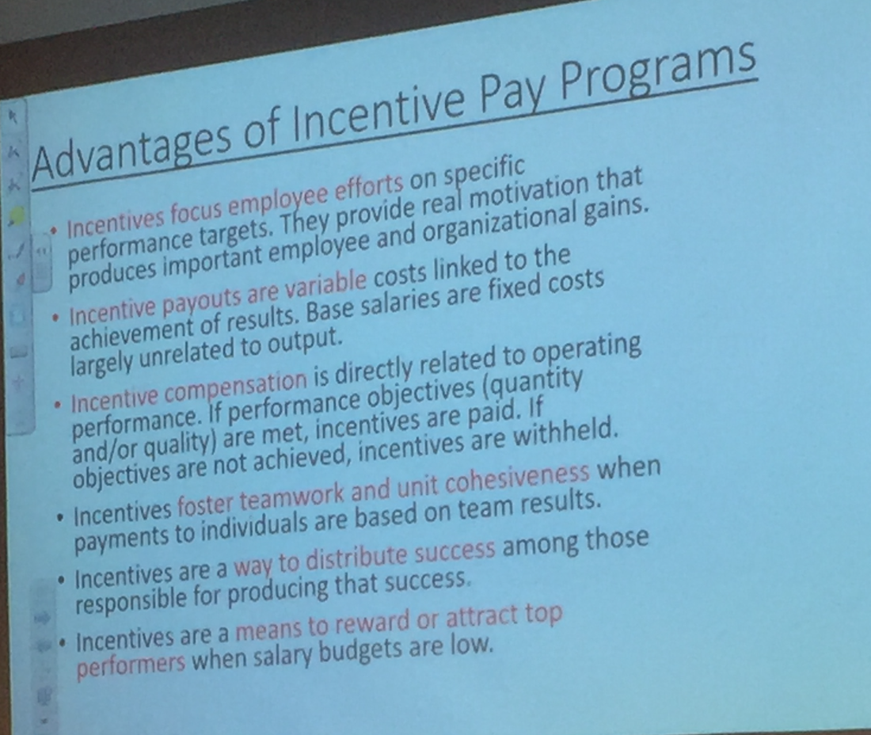

Strategic reason for incentive Plans:
- A major element of strategic compensation management is the use of incentive plans, also called variable pay program, for employees throughout the organization.
- Contemporary arguments for incentive plans focus on linking compensation rewards, both individual and group, to organizational goals and strategy.
- Specific company goals or objectives might be to:
  - Lower labour costs
  - Improve customer satisfaction
  - Expand product markets
  - Maintain high levels of productivity and quality

Strategic Reasons for Incentive Plans:
- Encourage employees to put out more effort to complete their job tasks – effort they might not be motivated to expend under hourly and or seniority-based compensation systems.
- To attract and retain top-performing employees.

Do incentive plans work?
- Yes and no
- Studies show a measurable relationship between incentive plans and improved organizational performance
- The degree of success obtained depends on several factors, including:
  - Identifying important organizational metrics by which to measure employee performance and
  - A customized incentive plan that effectively measures employee output and rewards exceptional employee performance

Chapter 11: Employee Benefits

Requirements for an effective benefits program:
- Providing Flexibility
  - Flexible benefit plans (cafeteria plans): Benefit plans that enable individual employees to choose the benefits that are best suited to their particular needs.
  - Employees generally prefer flexible plans that can be adapted to their life stages
  - Employees are offered a core benefits package (life and health insurance, sick leave, and vacation) and then given credit that they may use to buy other benefits

Communicating Employee Benefits Information:
- It is critical that employers communicate the benefits package to employees
- A number of methods can be used:
  - In hourse publications
  - Group meeting and training
  - Online modules
  - Bulletin Boards
  - Payroll Inserts
  - Specialty Brochures
- Also to be communicated to new hires during orientation
- As the field becomes increasingly complex and employees more sophisticated a certified Employee benefits specialists.

HRIS and employee Benefits:
- Online self-service administration can result in significant cost reductions and flexibility
- Software programs represent a cost-effective way to manage employee benefits programs when employers lack the resouces or expertise
- Security must be of concern when transmitting benefits plan

Concerns with benefits today and management:
- Many variables must be kept in balance for a benefits program to succeed:
  - Unions demands
  - Benefits other employers provide
  - Tax consequences
  - Rising costs
- A list of cost containment strategies: (Conference Board of Canada)
  - Contribution changes
  - Dollar limits or caps on specific benefits
  - Use of preferred providers and flexible benefits

Employee Benefits Required by law:
- Legally required employee benefits amount to approximately 12% of the benefits packages that Canadian employers provide.
- They are:
  - CPP (All of Canada except Quebec)
  - QPP (Quebec)
  - Employment insurance
  - Workers compensations insurance
  - Provincial Medicare (in ON – OHIP)

Canada and Quebec Pension plans (CPP/QPP)
- CPP/QPP cover almost all Canadians employees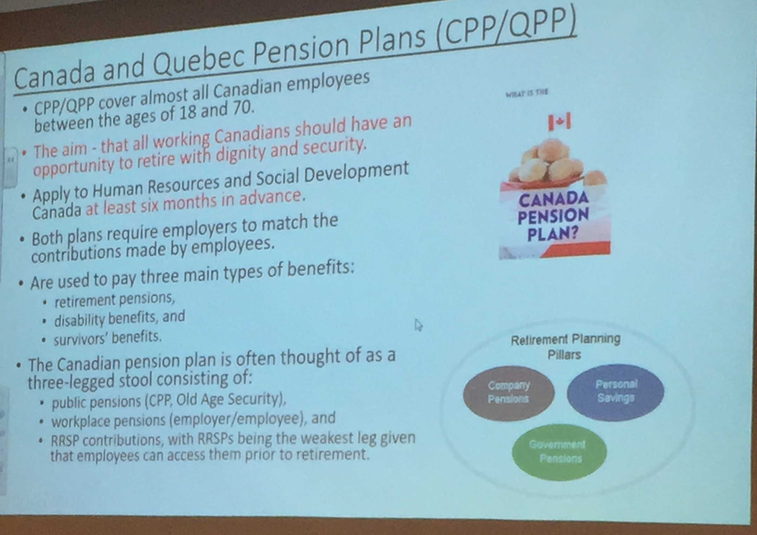

Employment insurance
- Also employees who resign from their jobs or who are terminated for a cause may be ineligible for benefits unless they can proce there was no reasonable alternative to leaving their jobs
- Just causes include:
  - Sexual harassment
  - Helath concerns
  - Moving to another town or city because of a spouse or close relative

Workers compensations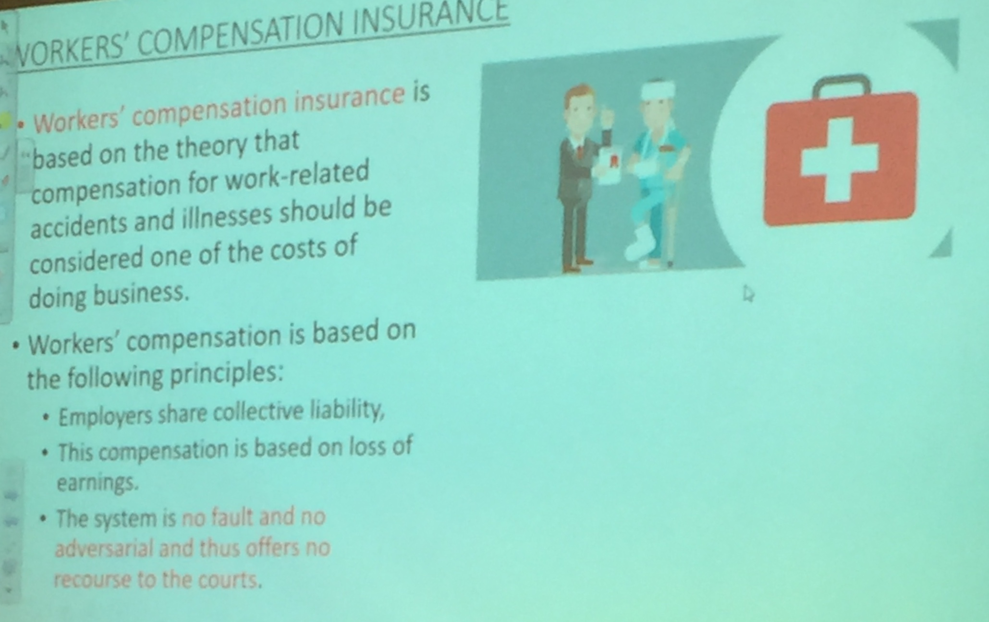

Design a Strategic Benefits Plan
- Assume that you have been hired as the human resources managers of a small computer software firm with 180 employees. The CEO has asked you to design a strategic benefits plan for the firm. Using the knowledge gained in this chapter and book, discuss the key steps you would suggest in such a plan

- Find a team to support the benefits (Create a group)
- Find the companies that offers the best benefits at lower cost
- Create a budget planning
- Find which benefits we want to give to our employee

Needs assessment from a committee of employees (They know what they want)
Benefits package!
Look at companies that offer benefits and compare to check the prices
Ex: insurance company

Attracting employees by giving them benefits
- Employee assistance plans
- Committee should design a survey to know what employees need or want
- Providing flexibility
  - Flexible benefit plans (cafeteria plans): benefit plans that enable individual employees to choose the benefits that are best suited to their particular needs
  - Employees generally prefer flexible plans that can be adapted to their life stages
  - Employees are offered a core benefits package (life and health insurance, sick leave, and vacation) and then given credits that they may use to “buy” other benefits
- Communicating employee benefits information
  - It is critical that employers communicate the beneftis package to employees
  - A number of methids can be used
    - In house publications
    - Group meetings and training
    - Online modules
    - bulletin boards
    - Payroll inserts
    - Specialty brochures
  - Also to be communicated to new hires during orientation
  - As the field becomes increasingly complex and employees more sophisticated a Certified Employee Benefits Specialist (CEBS) may be required
- HRIS and Employee Benefits
  - Online self-service administration can result in significant cost reductions and flexibility
  - Software programs represent a cost-effective way to manage employee benefits programs when employers lack the resources or expertise
  - Security must be of concern when transmitting benefits information
- Concerns of Management
  - Many variables must be kept in balance for a benefits program to succeed:
    - Union demands
    - Benefits other employers provide
    - Tax consequences
    - Rising costs
  - A list of cost containment strategies: (Conference Board of Canada)
    - Contribution change s
    - Dollar limits or caps on specific benefits
    - Use of preferred providers and flexible benefits
- Employee benefits required by law:
  - Legally required employee benefits amount to approximately 12% of the benefits packages that Canadian employers provide
  - They are:
    - Employer contributions to the Canada (CPP) and Quebec pension (QPP)
    - Employment Insurance
    - Worker’s compensation insurance
    - Provincial Medicare (In Ontario – OHIP)
  - Canada and Quebec Pension plans:
    - CPP/QPP cover almost all Canadian employees between the ages of 18 and 70
    - the aim that all working Canadaians should have an opportunity to retire with dignity and security
    - Apply to Human Resources and Social Development Canada at Least 6 months in advance
    - ,….

Chapter 12: Promoting Health and Safety

Podcast: Canadian Center for Health and Safety
Fighting fatigue in the work place:
- Symptom of the season… it’s dark for more of the day
- Number one issue with fatigue: lack of sleep

Canada sleep deprived country:
1/3 of Canadian children are sleep deprived
Why: social media, blue screens before sleep

Responsibility of HR is health and safety but there are health and safety experts

Employers have to train their employees about the workplace dangers

SEE BRIGHTSPACE FOR THE REST OF THE NOTES

Chapiter 13: Employee Discipline

A Respectful Way to Discipline Employees
https://www.huffingtonpost.com/great-work-cultures/a-respectful-way-to-disci_b_5853024.html

Positive discipline
Vidéo youtube: the power of positive discipline

Employment Contract
- Incomplete
- not written (verbal)
- Based on customs and practices rather than written or clearly stated
- Common law judges shaped it through implied terms
- Contracts may be limited, altered, voided by legislation

- Discipline (punishment or coaching)

Privacy –at work and outside
- Era of rights of employees +
- Ease of communication and social networking +
- Surveillance possibilities made the topic prominent
- What are the boundaries to privacy?
Balancing employee rights and discipline may not be easy

The Three Regimes of Employment

- The common law of employment
  - Rights and obligations in an employment relationship rest on the employment contract which may be vague to address particular cases
    - Courts have developed <case law> books (based on decision of particular cases), known as common law of employment
  - The decisions are bases on implied contract terms
  - Important contract implied terms can be:
    - Provide reasonable notice
    - Maintain safe workplace
    - Serve employer with loyalty
    - Obligation to perform competently
    - Obligation to advance employer economic interests
    - Obligation to avoid insubordination
  - Breach of implied terms is like breach of written contract
  - HR managers have to be familiar with implied terms

- Statutory employment obligation
  - Governments not satisfied with common law passed variety of legislation aimed at employment relationship
    - E.g., Federal and provincial – employment equity, pay equity etc.
  - Statutory legislation operates alongside common law
    - Not possible to contract out (to void) protective employment legislation (e.g., discharging without notice)

- Collectivee bargaining legislation and labour arbitration
  - Statutory law allows employees to join forces and bargain a better contract
    - This led to unionized and nonunionized workforce
  - The contract that is bargained in a unionized workplace is known as collective agreement
  - The common law of employment does not apply to a collective agreement
    - For example:
      - A nonunionized employer can terminate an employee for any reason or no reason by simply giving the proper notice
      - A unionized employer usually needs just cause to dismiss a worker
  - Another important difference is the method of enforcement:
    - A nonunion employee must sue the employer in a court for breach of the employment contract
    - A unionized employee files a grievance and if the grievance is not settle it is referred to a labour arbitrator instead of a court
  - Arbitration is much quicker than a lawsuit, and the costs are covered by the unions dues
  - Labour arbitrators have built up their own form of common law, knowns as <arbitration law>
    - Although arbitration law may be the same or similar to common law the two should not be confused

Understanding the individual employment contract
  - Since the individual employment contract is a type of contract, the general rules of contract la developed in the common law apply
  - A valid contract requires <mutual consideration>
    - This means once an employee has commenced employment,
      - Employee cannot unilaterally change or
      - Introduce new terms of employment unless
      - The employee agrees to the change and receives some new benefit in exchange
  - If an employer unilaterally changes a term of the employment contract, the employee can sue for breach and claim that he or she has been constructively dismissed
  - A constructive dismissal occurs when an employer commits a fundamental breach of the contract, such as:
    - Eliminating an important benefit enjoyed by the employee,
    - Reducing compensation or
    - Demoting an employee
  - In that case, the employee may treat the contract as
- Having been terminated by the employer
- Quit, and
- Sue the employer to recover either contractual notice or implied reasonable notice
  - To make a change to the terms of an employment contract without breaching the contract:
    - Obtain the employee’s agreement and provide the employee with some new consideration (benefits) ex: give vacation payed or
    - Terminate the employment contract by giving the required notice and then offer a new contract on the revised terms

The rules governing dismissal
Dismissal of a nonunion employee: Wrongful dismissal
  - Under the common law, the employer or employee can terminate the contract by:
    - Providing the amount of notice specified in the contract
    - Providing reasonable notice if the contract does not include a notice term
  - Reasonable is determined by the court, applying a variety of criteria:
    - Employee’s age and
    - The availability of alternative similar employment
  - However, the 2 most important factors in assessing notice are
    - The length of service with the employer (the longer the length the longer the period)
    - The nature of the job performed by the employee (nonmangeral less than 12 months; managerial as much as 24 months)
  - A non-union employer does not need a reason to dismiss an employee
  - It can dismiss an employee:
    - At any time
    - For any reason or
    - For no reason at all (just needs to give the employee the proper contractual or reasonable notice)
  - An employer may also dismiss a nonunion employee without any notice if
    - The employee has committed a serious breach of contract (such as engaging in significant dishonestly, gross incompetence, sexual harassment, or workplace bullying or violence)
  - When a non-union employer dismisses an employee for cause, without notice, it is called a summary dismissal

Chapter 14:

See chloe’s note

Why employees unionize
- Economic needs
  - Wage, benefits

Organizing steps
- Employee/union contact
- Initial organizational meeting
- Formation of an in house organizing committee Sign authorization card (union membership card, confidential)
- Application to a labour relations board use authorization cards or balloon
- Issuance of a certificate by a labour relations
- ……….

Organizing campaigns
  - Employer tactics
    - Cannont interfere (no threats. Promises, close the business, not be part of the process)
    - Can make the case that employees are free not to join a labour union
  - Union tactis
    - Cannont coerce employees to join
    - Provide fair representation for all employees in the bargaining unit
      - 2 or more employees grouped together for the purpose of collective bargaining
  - Unfair labour practice (ULPs)
……

  - How employees become unionized
    - Certificating (obtain the min. level of membership -40%)
    - Voluntary recognition (employer voluntarily recognizes the union –rare, in construction industry where there is great reliance on union hiring support, except in Quebec)
  - Contract Negotiation
    - Once certification is obtained employer obligated to negotiate and sign contract (usually 1-3 years)
  - Decertification
    - If majority on employee indicate their desire that they do not want to be represented by union
Impact of unionization on managers
- Wages of unionized employees are higher
- Challenge to management decisions:
  - Impact the rights exercised by management to make decision about employees
  - Management Rights –decisions over which management claims exclusive right

Final examen
Chapter 1 not included
Chapters 2-7: about 4 questions each
Chapters 8-15: about 6-8 questions each
Class specific (video others)
- A respectful way to discipline employees
- Japan seeks alternatives to its pay system
- Privacy –burned by the firewall
- Chronic fatigue syndrome and occupational health
- The future of unions in Canada’s private sector (video)

Chapter 15
Introduction: UAE (this is an example)
- Monetary unit: UAE Dirham 1AED=100 fills
- Exchange rate: 1 USD =AED 3.67
- Fiscal Year: 1st January to 31st December
- Weekend: Friday and Saturday
- Official Language: English, Farsi, Hindi, Urdu
- Religion: Islam (practice of all religious beliefs is allowed)
- Literacy rate: 93%

The major advantages in operating in a free zone are:
- 100 % foreign ownership of the enterprise
- 100 %import and export tax exemption
- 100% repatriation of capital and profit
- no corporate taxes for 15 years, renewable for an additional 15 years
- no personal income taxes
- less documentation, mostly in English
- Assistance with labour recruitment, and additional support services such as sponsorship and housing

What type of culture is there in the country is important in HRM
Picture (International Human Resources Management) **posted on brightspace
(read and understand for final maybe it will help)

TIPS FOR FINAL

- Difference between equity and equality
- BFOQ (bona fide occupational requirement)
- Job descriptions: the duties that you need to perform, job specification: qualification, the skills
- Job profiles (of competencies)
- Different occupation: standardize (national occupation classification) website? –Government
- Different type of interviews and test that we can use:
  - Situational: you give a certain situation, if you were in this situation what would you do….
  - Behavioral
  - Assessment centers: ask a candidate to perform a series of activities
- Classifies the type of person: extroversive, introversive (personality tests)
- Validity and reliability
- Bench market?????
- Training and development
    - Training: increase performance (if you want to give a spreadsheet in excel) what would that be? It would be training
    - Development: is coaching
- How do you evaluate training ?
  - pair evaluation: advise.. for you to progress

