Experiment #2: A Tall Cold Drink of Water

By
Samuel McPhail | 8587665
Victor Mercanti | 300005537
Ajulo Victoria | 300028919
Jennifer Runions | 7839789
Jasmine Silver | 300028214

CHM1311

TA: Alex Steeves

Lab Date and Time:
October 6, 2017
2:30 PM- 5:00 PM

Department of Chemistry

University of Ottawa

Introduction
In this experiment,the task assigned was to create a product that would cool a 100 mL drink in a period of 5 minutes in order to refresh and energize the athletes at uOttawa. The relationship between temperature, work, heat and energy is described through the laws of thermodynamics.
To obtain the goal of this experiment, a calorimeter must be used.
A calorimeter is the equipment used to measure the transfer of heat. The transfer of heat is known as calorimetry. Calorimetry is the math that numerically describes the purpose of a calorimeter by measuring the heat exchanged between a system and its surroundings and using this to determine the energy change of the system. In this experiment, the calorimeter is a styrofoam cup with a lid which has a small hole for a thermometer in order to measure the temperature of the liquid. The thermometer will indicate whether the system is undergoing an endothermic reaction or an exothermic reaction. An endothermic will release energy, which will lower the temperature. The desired reaction of the system is exothermic.
Despite releasing energy, the first law of thermodynamics states that the total amount of energy will remain constant. The transferring of thermal energy in its surroundings is known at heat(q).
To determine the temperature difference (ΔT) the final and initial temperatures of the system are required. The final temperature is represented by T_{final} and the initial temperature is represented by T_{initial}in the following equation:
∆T=T_{final-}T_{initial} [1]

Thermal energy of a solution can be calculated by multiplying the specific heat capacity of the solvent by the temperature change of the solvent and by the mass of the solute. That is, the amount of thermal energy required to increase the temperature of one gram of a given substance by a single degree. This equation written as follows:
Q=m(ΔT)C [2]

Where Q is the energy of the system, m is mass of the system, (ΔT) is the temperature change and C is the specific heat capacity.
Two chemicals are initially provided; Ammonium Nitrate (NH₄NO₃) and Ammonium Chloride (NH₄Cl). It must first be decided which chemical should be used in the calorimeter to attain the desired temperature change. As previously mentioned, the desired reaction of the system is exothermic. Thus, the reaction of the surroundings is endothermic. Therefore, it is known that the reaction that either NH₄NO₃ or NH₄Cl undergoes must be endothermic. To decided which chemical will create the desired effects, the change in enthalpy, represented by ∆H, for the dissociation of both chemicals must be calculated. The enthalpy is the amount of energy transferred between the system and its surroundings during a given process. To calculate the change in enthalpy for the dissociation of either chemical, the following formula is used:
Hhydration+Hlattice=∆Hsolution [3]
The conclusion that using ammonium chloride would be the correct chemical to use for this task was reached through calculations which are shown under section Calculations. Ammonium chloride is used over ammonium nitrate because ammonium nitrate is a key ingredient in manure and can be used in explosives. This could cause some health risks for people who may drink the substance being created for this task. Ammonium chloride is a crystalline substance that dissolves in water and is therefore well suited for this experiment. The dissolution of the salt will create an endothermic reaction which is required under the guidelines of the product which is being made.

Duroudier, J.-P. Thermodynamics; Elsevier Science: Oxford, 2016.

Procedure:

Materials:

Chemical Equipment
Ammonium chloride 150mL beaker
Scoopula
Aluminum can
Styrofoam cup and lid
Vernier temperature probe

LabQuest 2
- Plug thermometer probe into LabQuest 2
- Turn on LabQuest 2
- Set duration to 300 seconds on LabQuest 2
Calorimeter
- Get a styrofoam cup and aluminum can from your TA
- Measure the total mass of the cans which will be used by your group
- Calculate the average mass of each can by dividing the total mass of the cans by the number of cans being used
- Record this average mass in data table
- Fill can with 100 mL of water, using a beaker and graduated cylinder
- Repeat step 7 for the styrofoam cup
Dissolution of the salt
- Calculate the theoretical minimum mass of NH₄Cl required when m_{H2O}=100g, C_{H2O}=4.184 J/gºC, and ∆T=5
- Measure mass of sodium chloride (NH₄Cl(s)) as calculated
- Measure and record the temperature of the water inside the can
- Place NH₄Cl(s) in styrofoam cup and using a scoopula, stir quickly for an extremely short amount of time
- Immediately put the can into the styrofoam cup and place the lid on the cup with the thermometer inserted through the lid so that it is submerged in the can. Simultaneously press Start Recording on LabQuest 2
- After 300 seconds, collect the data from the graph created. Record T_{f} and T_{min} in data table
- Repeat steps 7 to 13, two more times, first for a mass of NH₄Cl(s) which is 2g more than the first trial and second using a mass which contains 4g more than the first trial
- Save the graphs from all 3 trials onto a USB
- Clean up your work space

Data

Mass of NH₄Cl₂ (grams) | T_{i}C | T_{f} C | TC | T_{min} C
13.15 | 23.5 | 20.3 | 3.2 | 20.3
15.15 | 23.0 | 18.9 | 4.1 | 18.8
17.15 | 25.1 | 19.5 | 5.6 | 19.3
Table1 Measured initial,final, change in and minimum temperature of water in can for given masses of NH₄Cl_{(s)} . Where the volume of the water in the can = 100mL.

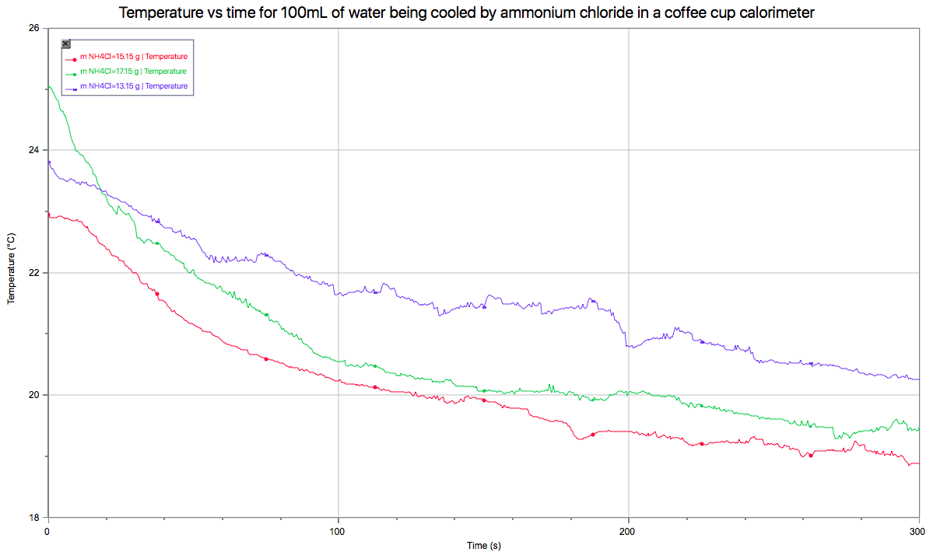
Figure 1 Measured temperature (ºC) of 100mL of water in a coffee cup calorimeter over the 300s time period immediately following the addition of NH₄Cl into the 100mL water jacket.

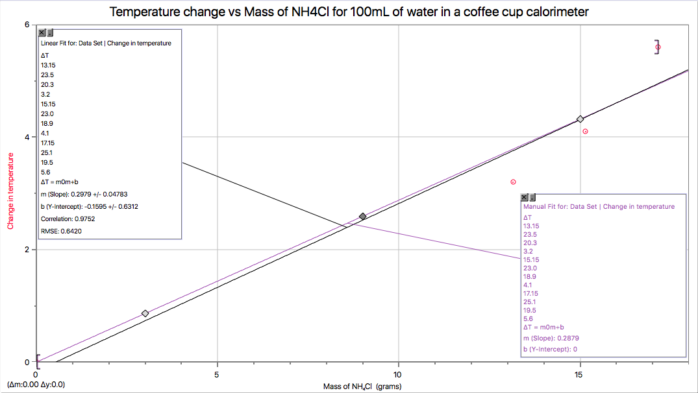
Figure 2 Overall change in temperature of 100mL of water in a coffee cup calorimeter for each of the masses (in g) of NH₄Cl used. The purple line* represents an approximation of the line of best fit whose y-intercept is at (0,0). The black line represents the line of best fit calculated by Logger Pro.
* The purple line is present because it indicates that there should not be a change in temperature if no NH₄Cl is added to the coffee cup calorimeter.

Observations
We observed that ammonium chloride is a white, crystalline, solid substance. When the salt was given to us, it was very clumpy. In order to aid the dissolution, we broke the clumps up using the scoopula. After breaking the salt up, adding it to the water and mixing the solution, the water was clear with no visible trace of the salt. During the experiment we also noted that the lid to the calorimeter lifted, creating a small gap between the cup and the lid.

Calculations
From the pre-lab exercise, we know that the dissociation of ammonium chloride in water is endothermic, meaning it requires energy from the system in order to dissociate. Using equation 3 the exact value of energy required can be calculated.

Lattice Energy of: Cl⁻ = -381 kJ
NH₄⁺= -307 kJ
NH₄Cl = 705

ΔHsol (NH₄Cl) = ΔH(NH₄Cl) + ΔH(NH₄⁺) + ΔH(Cl⁻) [3]
= 705kJ + (-307kJ) + (-381 kJ)
= 17kJ

For every mole of NH₄Cl dissolved in water, it will require 17kJ per mol to properly dissociate.

The quantity of energy required to facilitate the cooling of our system is found by using the specific heat capacity equation, equation 2:

Q= mcΔt

m= 100g H₂O(drink) + 100g H₂O(jacket) = 200g H₂O
c = 4.18 J/g•K
Δt= 5 K

Q= (200g H₂O)(4.18 J/g•K)(5 K)
Q= 4180 J
Q= 4.18 kJ

This indicates that the system will require 4.18kJ of energy to change the temperature by 5 K.

Next the minimum quantity of ammonium chloride that will cool the beverage is found by dividing the system energy requirement by the molar requirement to determine the number of moles of ammonium nitrate that will cool the beverage by 5 K and using simple stoichiometry, determine the mass of NH₄Cl required(molar mass NH₄Cl = 53.489g/mol):

4.18kJ
17kJ/mol = (0.246 mol NH₄Cl) • (53.489g/mol NH₄Cl) = 13.158 g NH₄Cl

The system will require a minimum of 13.158g NH₄Cl to cool the drink by 5 degrees Celsius.

Discussion

In this experiment, our main goal was to cool 100mL of water or our ‘drink’ by 5 degrees within 5 minutes. By looking at our data table and graphs, we can see that we did not attain our goal. Our theoretical minimum mass, 13.15g of ammonium chloride only cooled the drink 3.2 degrees Celsius and our next mass of 15.15g cooled the drink by a mere 4.1 degrees Celsius. Despite these masses creating too little of a change, our top mass of 17.15g cooled the drink too much, by 5.6 degrees Celsius.
Our results may have been a consequence of human or experimental error. Some sources of error during this experiment could have come from flawed equipment. Before beginning this experiment, one of our groups, noticed a small puncture in the bottom of the aluminum can. Luckily, we noticed the flaw in our equipment and our TA gave us another can. We also noticed that our calorimeter lid did not stay fully closed during the experiment. This could have allowed some energy to be released out of the system.
Human error could have also altered the results of our experiment. In Graph 1, you can see some spikes, meaning a fluctuation, in temperature. This could have been a result of us touching the temperature probe and moving the calorimeter during the duration of the experiment. These fluctuations also indicate our lowest recorded temperatures, which are not always our final temperatures. The intensity of the dissolution of the salt may have varied by the way our different teams stirred the salt in the water. The dissolution of salt may have also been altered when pouring the salt into the styrofoam cup. When doing so, we noticed that our salt stayed stuck to the bottom of our beaker. Salt had to be pushed into the solution using the scoopula. Some groups may not have pushed the entirety of the salt into the solution thus affecting the mass we are adding. When dividing our team into three groups, each using a different mass, our experiment was opened to more human error. Each group could have had a different method of stirring or they could have touched the calorimeter during the experiment or they could have had different timing. All of these things could have been avoided by going through the procedure more meticulously and making sure everybody in our group had proper understanding of the experiment.
Another source of error could have been that three trials for every given mass were not done. Instead one trial of each mass was done, giving us three trials and three data sets. If three trials were done for each mass and averaged out our final temperatures,a more accurate data set and a better understanding of any possible mistakes would have been acquired.
For every mass used, 4 different results were recorded. Results recorded were initial and final temperature, which then gave us the temperature difference. Lowest temperature was also recorded. The lowest temperature may not always be the final temperature. This indicates that there is a fluctuation in temperature. The lowest temperature may be the 5 degrees required in our experiment.
Despite not having reached our goal, the mass that came closest to cooling down our drink by 5 degrees in 5 minutes was our mass of 17.15 g. The mass of 17.15g had a final temperature difference of 5.6 degrees Celsius which is ultimately, 0.6 degrees too cold. However, since we do not want to freeze our client’s teeth we could reduce the mass of NH₄Cl used. The mass we could use is taken from Graph 2 when ∆T=5. For the purple line, the resulting ideal mass would be 17.38g. For the black line, the resulting ideal mass would be 17.32g. These numbers are an estimation but because the actual mass of 17.15g exceeded the desired ∆T, these resulting ideal masses are likely to be incorrect. A different solution to this would be to decrease the amount of time that the drink would need to cool down. According to our data, our drink cooled down by 5 degrees in 156.5 seconds when using a mass of 17.15g of NH₄Cl which is 2.61 minutes. In Figure 1, the mass of 17.15g drops in temperature much quicker than the other temperatures. It drops quicker because the reaction rate is higher. The mass and the reaction correlate because the volume does not. This makes our drink cool without being too cold and makes our drink look more efficient.
One consideration not taken into account in the initial calculations for the mass is that during the reaction, the aluminum can absorbs energy from the reaction jacket and it too will be cooled by 5 K. The amount of energy needed can be found by using the specific heat capacity of aluminum and the mass of the can:

Q_{A}=mc∆t
m = 27g/3 cans = 9g Aluminum
c = 0.900 J/g •K
∆t= 5K

Q_{A}= (9g Aluminum)(0.900 J/g •K)(5K)
Q_{A}= 40.5K

With with data, we can now add this to the water sample’s energy total, and now determine a new mass of ammonium chloride required to fully cool the 200g of water by 5K with less loss.

Q_{T}= Q_{A}+Q_{W}
Q_{T}= 4180 J + 40.5J
Q_{T}= 4220.5 J = 4.2205 kJ

With this new total, we can now calculate a mass of ammonium chloride that will more likely cool the beverage by 5 K:

4.2205kJ
17kJ/mol = (0.248 mol NH₄Cl) • (53.489g/mol NH₄Cl) = 13.28 g NH₄Cl

In an additional trial/series of trials, 13.28g of ammonium chloride should be the new minimum mass.

Conclusion 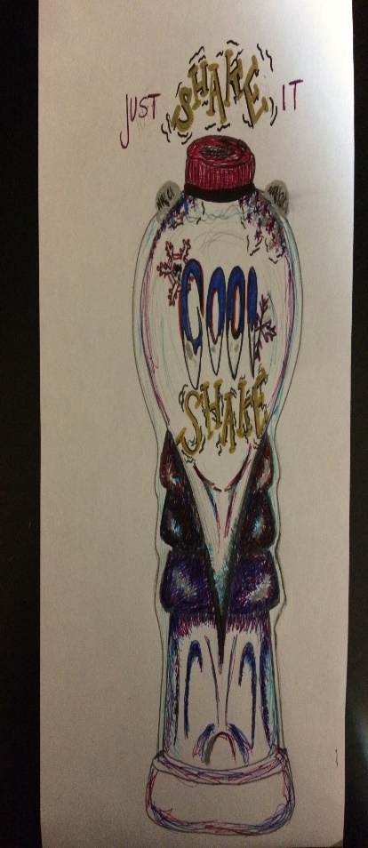

The theoretical minimum mass of 13.15g of NH₄Cl and the second mass of 15.15g of NH₄Cl would not be sufficient to reduce the temperature by 5 degrees in five minutes. The third mass of 17.15g of NH₄Cl however, was too large and cooled down 100mL of water too much in five minutes. The desired temperature change of 5º could be attained in less time with the mass of 17.15g of NH₄Cl or a mass greater than 15.15g and less than 17.15g of NH₄Cl could be used to complete the experiment to attain a result of 5º temperature reduction after 5 minutes.
Despite being unsuccessful in our experiment, the concept of the product worked. Due to human and experimental error, perhaps our results were skewed and could be ameliorated for another trial.

This being said we designed a product called Cool Shake. The product design is displayed below.
The bottle has two layers as shown. The outer layer is thin, surrounds the whole bottle and contains an equivalent amount of water as the drink itself, therefore it contains the water jacket. It is not directly accessible as this acts as the calorimeter. It has two bubble like pockets near the top of the bottle. These pockets are filled with NH₄Cl, which is released into the water jacket of the bottle when pushed. Once the NH₄Cl is released, shake the bottle to catalyze the dissociation reaction of the salt. Next leave the bottle to sit for 5 minutes. Finally, remove the seal off the bottle and enjoy the refreshing taste of cool shake.
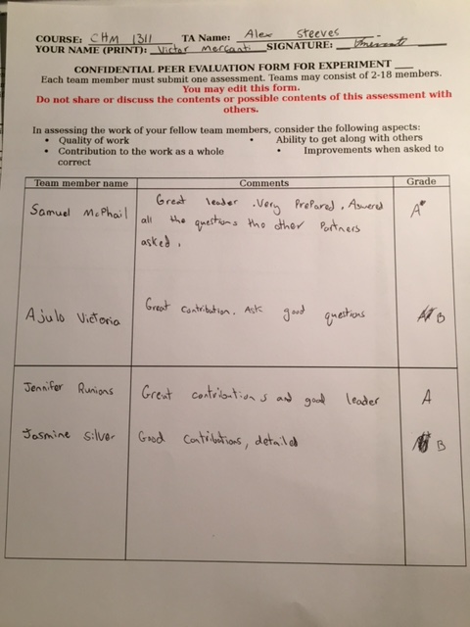
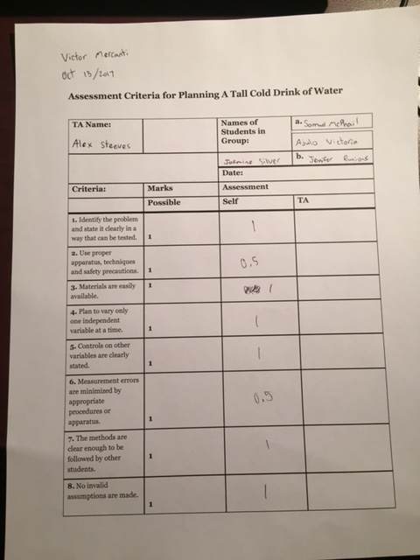

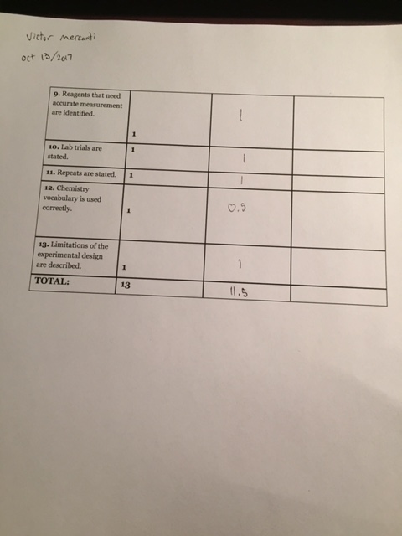

Raw data:


