Marketing – Chapter 13: Retailing and Multichannel Marketing

Apple – taking full responsibility for selling!
- Apple retail stores – crucial to their overall success
- One of Fortune’s Most Admired Companies
- Success is built upon taking full responsibility for their own sales
- One-stop-shop for consumers

Additional notes:
- Per chapter introduction: the case study focuses on the success of Apple – in particular, their retail store concept.
- Apple used to partner with and rely on retailers to sell their products. But those retailers had no special incentive to market Apple products, nor did they have the necessary training to sell the technologically advanced items.
- Apple realized quickly that the only way it could ensure its unique products really stood out was by taking responsibility for selling into its own hands.
- The idea of the Apple retail store was born.
- The Apple store is so successful in that it has become more than just a place to buy products. Consumers can try out products before they buy, they can obtain training, they receive personalized shopping experiences, they offer the Genius Bar, they even offer free workshops and camps for children, families, seniors and more.
- However, despite the success, the novelty of the concept may be waning. To stay on top of its game, Apple will need to demonstrate retail leadership & vision while still producing the best technology & the best customer service in the industry.

Retailing
- Sits at the end of the supply chain
- Marketing meets the consumer
- Fulfilling customer expectations
- Set of business activities that add value
- Stores, catalogues, Internet

Additional notes:
- Retailing is defined as the set of business activities that add value to products & services sold to consumers for their personal or family use
- This includes products bought at stores, through catalogues, & over the Internet, as well as, services such as fast-food restaurants, airlines, & hotels

Factors for establishing a relationship with retailers

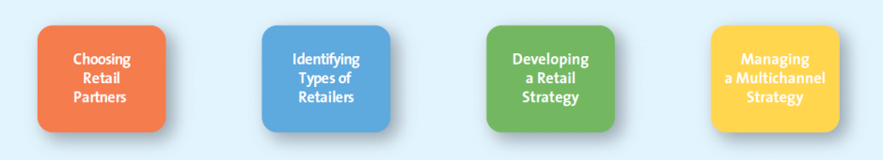

additional notes:
- Exhibit 13.1 illustrates four factors manufacturers consider when developing strategies for working with retailers.
- The slides that follow explain further each one of these fctors.

Choosing Retail Partners
Channel Structure
  - Vertical integration
  - Manufacturer strong brand in marketplace
  - Power of the manufacturer & retailer
Customer Expectations
  - Retailers - Who do customers buy from?
  - Manufacturers – target market expect to find products & those of competitors

Additional notes:
- Channel Structure: degree of vertical integration, manufacturer’s brand, power of manufacturer and retailer
- Ask students to describe what is meant by “degree of vertical integration”. This is discussed in chapter 12 and refers to a supply chain where the members act as a unified system.
- Ask students how vertical integration effects a manufacturer who is introducing a new product and choosing a retail partner. Students will mention that if the manufacturer and retailer already have a relationship from previous products that the retailer will be more likely to accept the new product.
- Customer Expectations: how manufacturers determine which retailers would be best for consumers and where consumers expect to find certain products

Channel Member Characteristics

additional notes:
- Channel Member Characteristics: Larger firms often find that by performing the channel functions themselves, they can gain more control, be more efficient, and save money.
- Distribution channels are difficult to manage.
- Channel members will benefit by working together to develop & implement their channel strategy.

Identifying types of Retailers

- Food retailer supermarket, big box retailers, convenience store
- General merchandise retailers discount store, specialty store, category specialists, department store, drugstore, off price retailers, extreme value retailers

Additional notes:
- This slide can be used as an introduction to a detailed discussion of this topic or as a shortened version.
- Manufacturers need to understand the general characteristics of different types of retailers so they can determine the best channel for their product.
- Example: the characteristics of a retailer that are important to a food manufacturer may be quite different than those of a cosmetics manufacturer.

Food retailers
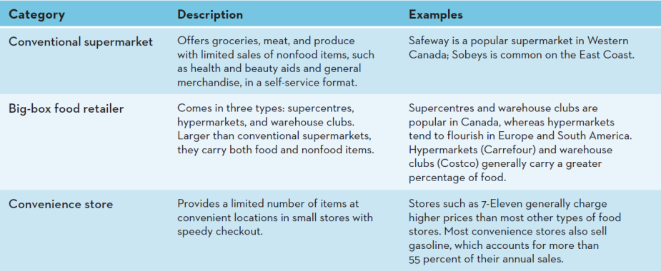

additional notes:
- The characteristics of the three major categories of food retailers are summarized in Exhibit 13.2.
- Ask students: in what circumstances do you shop at each type of food retailer? How do the price, selection, and quality vary across each type?

Breaking the mold in food retailing
- How do you generate excitement for grocery shopping in consumers?
Additional notes:
- This slide sets up the Case in Point which follows.
- Competition among food retailers has prompted new innovations, such as those that cater to more upscale, knowledgeable buyers.

Slide 10

General Merchandise Retailers
- Discount: a broad variety, limited service, low prices
- Specialty: limited number of complementary merchandise in a relatively small store
- Category: a narrow variety but a deep assortment of merchandise
- Department store: broad variety, deep assortment, some customer service, organized into separate departments
- Drugstores: specialty store, health & personal grooming products, pharmaceuticals
- Off-Price retailer: inconsistent assortment of merchandise, low prices
- Extreme-value retailer: general merchandise discount store
- Services retailer: primarily sell services rather than merchandise

Additional notes:
- The main types of general merchandise retailers are noted in the slide.
- Many general merchandise retailers sell through multiple channels, such as the Internet, catalogues.
- Group activity: Identify a retailer in each of these categories. Discuss how that specific retailer creates value for its target consumers.
- Remind students to use the 4Ps framework for this exercise. For example, Abercrombie & Fitch is a specialty store that carries trendy, high-quality, high-priced products. Its edgy advertising appeals to consumers, and stores are located in upscale malls or shopping areas.

Finding the right niche
- Specialty stores need to serve the segment of consumer beyond what bigger retailers provide. How do you fill that niche?
Additional notes:
- Specialty stores must offer their target market something more than what other retailers offer, because they often charge a premium price.

Entrepreneurial marketing 13.1: our ice is cooler
- A commodity product?
- How do you make ‘ice cool’?
- On the Rocks is ice for special events
- Unique: 5cm sphere, melt slowly, don’t dilute drinks as fast
- Bright blue packages makes them stand out

Additional notes:
- As noted in the slide, On the Rocks, is an innovative way to present a very mature, commoditized product, in a whole new light, and therefore, attract new clientele.
- Despite not being successful on The Dragon’s Den, the company has been successful in getting some larger retailers in the Vancouver area to carry the product.

Developing a retail strategy
- This slide introduces how the 4Ps are used in retailing. More in depth slides follow.
- It is extremely important that retailers develop effective retailing strategies & market positioning in order to differentiate themselves in the increasingly competitive landscape & give customers a compelling reason to shop at their stores.

Product (merchandise assortment)
- Providing the right mix of merchandise and services
Additional notes:
- Providing the right mix of merchandise & services that satisfies the needs of the target market is one of retailers’ most fundamental activities.
- Offering assortment gives customers choice & helps attract new & existing customers.
- Ask Students: What is the most important thing that retailers do? Answer: They provide assortments to customers.
- Group activity: divide the class into groups. Tell them that the classroom represents a new store. Have them identify a target market. Ask them to decide what they are going to put into the store. Have them consider both variety (number of categories) and assortment (number of SKUs within a category.)

Price
- Price defines the value of both the merchandise and the service provided
- Group activity continued: Now have them decide the general price range for their store, and justify their recommendation.

How do retailers create value?
- Consumers have changed their preference for price and quality
- Lifestyles have become more casual
- Retailers must go beyond low price to create value

Additional notes:
- Consumers today are very savvy shoppers in that they expect to get a lot for what they are paying.
- Retailers are finding more & more that their customers are looking for much more than just a ‘good deal’ or great pricing.
- Retailers must go above & beyond price. A great example is Giant Tiger , a general merchandise store that has great prices, but offers much more.
- Giant Tiger offers its customers inexpensive merchandise that is of good quality, a convenient & easy shopping experience. Their merchandise offers ‘treasures’ among every day basic items.
- Consumers appreciate this combination & this has clearly contributed to the huge success that Giant Tiger continues to experience.

Promotion
- Retailers use a wide variety of promotions, both within their retail environment & through mass media
Additional notes:
- Good promotion, both within their retail environment & in the media, can mean the difference between flat sales & a growing consumer base.
- A co-ordinated effort between the manufacturer & retailer helps guarantee that the customer receives a cohesive message.
- Discuss how promotions affect consumers’ perceptions of value, patronage intentions, purchase, loyalty, and share of wallet devoted to a particular retailer, both individually and in combination.
- Group activity continued: Tell the students they have a fixed amount to spend on promotion, including personal selling. How would they divide up their promotional dollar? Justify their recommendation.

Presentation (store design & display)
- Promote & showcase what the store has to offer
- Displays are an important type of promotion
- Unusual & exciting store atmospheres
- The goal is to improve ‘shopability’

Additional notes:
- In addition to more traditional forms of promotion, many retailers are devoting more resources to their overall retail environment as a means to promote & showcase what the store has to offer.
- Their displays of merchandise, both in the store & in the windows, have become an important form of promotion.
- Various theories have been developed to explain the structure & evolution of the retail industry. The Wheel of Retailing, as shown in the next slide, offers one view.

The wheel of retailing
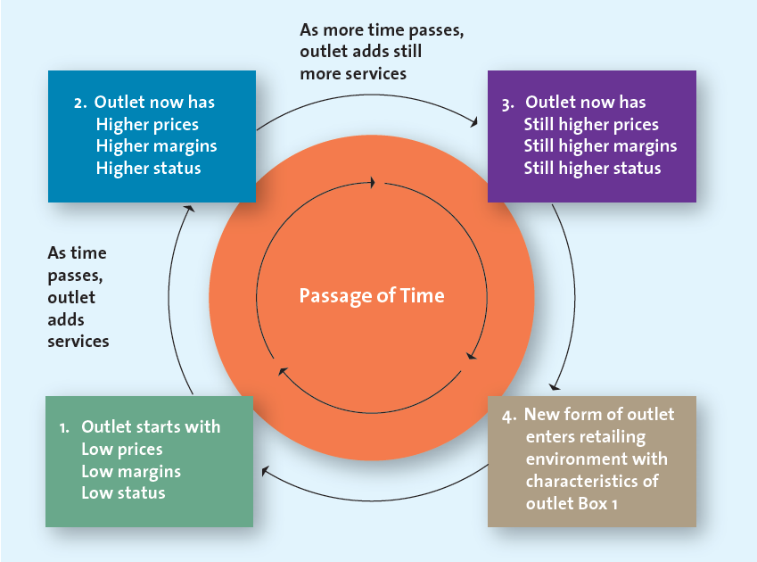

additional notes:
- The Wheel of Retailing offers one view of how new forms of retail outlets compete in the market, as shown in Exhibit 13.3.
- Generally, retailers enter with low prices, low margins & low status. Over time, they add more & more service & other improvements & thus are able to raise prices, earn higher margins & achieve higher status with consumers.
- To illustrate how McDonalds is progressing in the wheel of retailing, click on the links to show photos of two redesigned, upscale restaurants in Europe and in Scarborough, Canada.

Personnel
- Personal selling & customer service representatives are also part of the overall promotional package
- Services: easy to buy & use products
- Retail associates provide information, facilitate the sale
- Augmented by technology: in-store kiosks, Internet, self-checkout lanes
- Provide more value to their best customers

Additional notes:
- As the slide indicates, store personnel are an extremely important part of the promotional mix.
- Customers rely on associates for a number of reasons.
- The goal is to provide more value to a firm’s best customers.

Place
- Convenience is key ingredient to success

Additional notes:
- In retailing there are two aspects to “place.” The first is location, and the second is supply chain management. Both are important.
- Location is important because it is one of consumers’ most important criteria in choosing a retailer and it is a very long-term investment.
- Group activity continued: Have students choose a location and justify it. Also, have them describe how they would design their supply chain, i.e., use of wholesalers versus distribution centers; direct store delivery versus, delivery to distribution centers; traditional warehouses versus cross-docking, etc.

Managing Multichannel Options

additional notes:
- This slide introduces channels for selling to consumers. More in depth slides follow.
- There are many options for a manufacturer to get merchandise to the ultimate consumer: retailers, kiosks, catalogues, Internet

Benefits of Stores for Consumers

additional notes:
- The store channel offers several benefits to customers as noted in the slide that they cannot get when they shop through catalogues or on the Internet.’
- Ask students what they like to buy in stores vs. catalogue vs. online?
- Ask students: Have you ever started shopping online, then visited the store to make the actual purchase? What kind of product did you buy using this method?

Benefits of Internet & Multichannel Retailing

additional notes:
- Shopping over the Internet provides the convenience offered by catalogs and other nonstory formats. However, the Internet, compared with store and catalogue channels, also has the potential to offer a greater selection of products and more personalized information about products and services in a relatively short amount of time. It also offers sellers the unique opportunity to collect information about how consumers shop—information that they can use to improve the shopping experience across all channels.
- The Internet has radically altered the retail marketplace. Many traditional bricks-and-mortar retailers create synergy between online and traditional retailing. Multi-channel customers buy more than single channel customers.

How does the internet improve multichannel shopping?
- The internet can supply research

Perceived risk in internet shopping
- Ask students when they are nervous to enter their credit card information online?
- How do they determine if a site is credible?
- How do they feel about privacy?

Benefits Provided by Different Channels
- Kiosk
- Catalogue

Additional notes:
- Kiosk: By blending stores with Internet-enabled kiosks, retailers can dramatically expand the assortment offered to their customers.
- Kiosks can provide: a broader selection, access to items that are out of stock in the store, access to wish lists & gift registries, access to loyalty programs
- Catalogue: offer the convenience of looking at merchandise & placing an order 24-7.
- Other advantages include: convenience, information, safety,
- Use Exhibit 13.4 in the textbook to initiate a discussion of the advantages students see in each of these unique channels. Many students ay feel that shopping in stores is better than online because they can try things on. Remind students that consumers who shop at multichannel retailers (i.e., store, catalogue, and Internet) typically buy more than those who shop in only one retail channel.

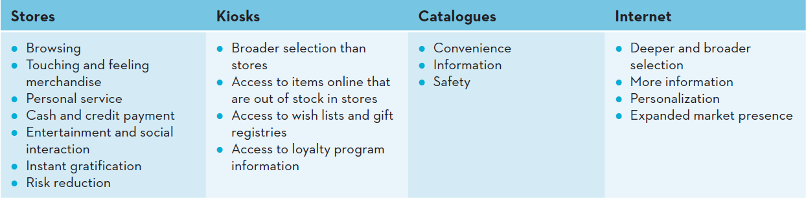

Effective Multichannel Retailing
- Role of Brands
- Using Technology
- Increasing Share of Wallet
- Gaining Insight into customer shopping behaviours

Additional notes:
- Consumers want a seamless experience when interacting with multichannel retailers.
- Adding an electronic channel is particularly attractive to firms with strong brand names but limited locations & distribution.
- There are challenges & advantages in selling merchandise via the Internet.
- For firms that use an electronic channel, the points noted in the slide will help them to be more successful.
- Role of brands: provide a consistent experience for customers.
- Using technology: convert touch & feel information into look and see information
- Increasing share of wallet: using the electronic channel with other channels can result in consumers making more total purchase from the seller.
- Gaining insight: data can be collected to provide key insights.

