Marketing – Module 8 Chapter 5: Business-to-Business Marketing

B2B Marketing
- Buying & selling goods or services to be used:
  - in the production of other goods & services,
  - for consumption by the buying firm, or
  - for resale by wholesalers & retailers
- Distinction between B2B & Business to Consumer (B2C):
  - Who is the ultimate purchaser & user of the product or service?
Additional Notes (bottom):
- Students must understand the distinction between B2B and B2C.
- If the seniors in the picture purchase lemons to make lemonade for themselves, they are engaging in a B2C transaction.
- If the boy buys them to make lemonade to sell to others, it is a B2B transaction.
- There are different types of B2B markets as well as buying processes. There are also several factors that influence the buying process that will be discussed fully. The existence of the Internet has also influenced the way B2B marketing is conducted.

B2B Markets
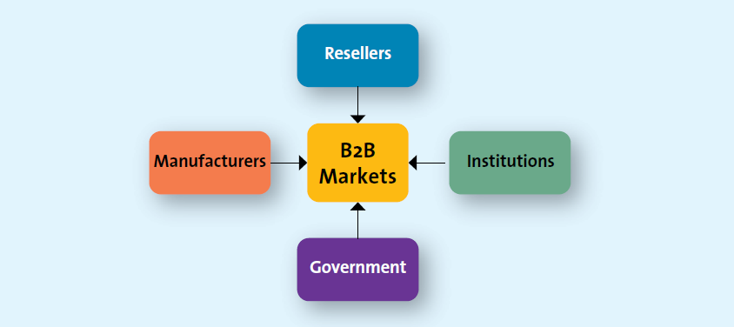

Additional Notes:
- A wide range of businesses participate in B2B transactions. This slide can be used on its own or in conjunction with those that follow, adding more detail.
- In general, manufacturers, resellers, institutions & governments all engage in B2B transactions.

Manufacturers or Producers
- Buy raw materials, components or parts
- Manufacture their own goods

Additional Notes:
- Manufacturers buy raw materials, components & parts that allow them to manufacture their own goods. Car companies are a great example of this.
- When a company like Volkswagen Group, the largest auto manufacturer in Europe, buys raw materials from various suppliers, to build their vehicles , they are engaging in a B2B transaction.
- When Volkswagen sells their vehicle to you, the consumer, via their dealerships, they are engaging in B2C transactions.

B2B or B2C?

Additional Notes:
- Ask Students: Are they familiar with the company Burt’s Bees and the products that they sell? Is a company like Burt’s Bees a B2B or B2C organizations?
- Answer: Both! When they buy raw materials to make their products, it is a B2B purchase. When they sell the products to the retailer it is B2B, when the retailer sells to the end consumer it is B2C. What other products can they think of that are both?
- Tradeshows are common for B2B selling and allows manufacturers to see new raw materials and for resellers to see new products.
- Ask students: if they have attended any B2B tradeshows? If so, what typically happens, what is the environment, what did they learn at the show?

Resellers

Additional notes:
- Resellers are marketing intermediaries that resell manufactured products without significantly altering their form.
- Resellers perform an essential service: They aggregate goods from manufacturers and sell them to retailers or, in the case of retailers, they sell them to consumers.
- Thus, one reseller can represent many different manufacturers, which saves the manufacturers the trouble of finding retailers or consumers and gives retailers or consumers the ability to buy only the desired quantity from the reseller.
Institutions
- Schools, museums, religious organizations

Additional notes:
- Institutions are organizations such as hospitals, educational organizations, prisons, religious organizations & other non-profit organizations. They purchase all kinds of goods and services for the people that they serve.
- Group activity: Have students consider their university as a purchasing institution. What types of products and services must universities purchase?

University Purchasing
- How can a university reduce its environmental impact through its purchasing?

Government
- Canadian Government spends $240B annually buying goods & services
- Provincial and local governments also make significant purchases
- Firms specialize in selling to government
- Canadian government contracts are posted on the Business Access Canada website

Additional notes:
- In most countries, the central government tends to be one of the largest purchasers of goods & services.
- Many firms sell exclusively to government entities and therefore are adept at meeting the unique needs of governmental buyers. For example, firms in the defense industry generally sell exclusively to governments.
- The majority of the federal government’s buying is done centrally by Public Works and Government Services Canada.
- Information about government buying can be obtained from Business Access Canada or from MERX (the most complete source of Canadian public tenders, private tenders, US tenders & private-sector construction news available in Canada).
- Check out the link as noted in the slide ‘Business Access Canada’ to see how tenders works and what opportunities are listed.

Key Challenges of Reaching B2B Clients
- Identify decision makers in organization who authorize or influence purchases
- Understand the buying process of each potential client
- Identify factors that influence the buying process of potential clients

Additional notes:
- For marketers to be effective & successful at B2B marketing, they must master 3 key challenges for each business customer they want to serve, as noted in the slide.
- To address the complexity of B2B markets, many companies have salespeople or a sales team dedicated to specific clients.

Differences Between B2B & B2C Markets
Differences
Between
Business
and
Consumer
Markets
Market
Characteristics
Product
Characteristics
Buying Process
Characteristics
Marketing Mix
Characteristics

Market Characteristics Differences between business & consumer markets

- Demand for business products is derived
- Fewer customers, more geographically concentrated & orders are larger
- Demand is more inelastic

Product Characteristics differences between business & consumer markets

- Products technical in nature, purchased based on specifications
- Mainly raw & semi-finished goods
- Heavy emphasis on delivery, technical assistance, after sale, financing

Buying process characteristics differences between business & consumer markets

  - Buying decisions more complex
  - Competitive bidding, negotiated pricing, complex financial arrangements
  - Qualified, professional buyers - more formalised buying process
  - Buying criteria and objective specified
  - Multiple participants in purchase decisions
  - Reciprocal arrangements common
  - Close long-term relationships
  - Online buying common

Marketing mix characteristics differences between business & consumer markets
  - Direct selling & physical distribution often essential
  - Advertising more technical, promotions emphasize personal selling
  - Price often negotiated, inelastic, affected by trade/quantity discounts

B2B Classification System & Segmentation
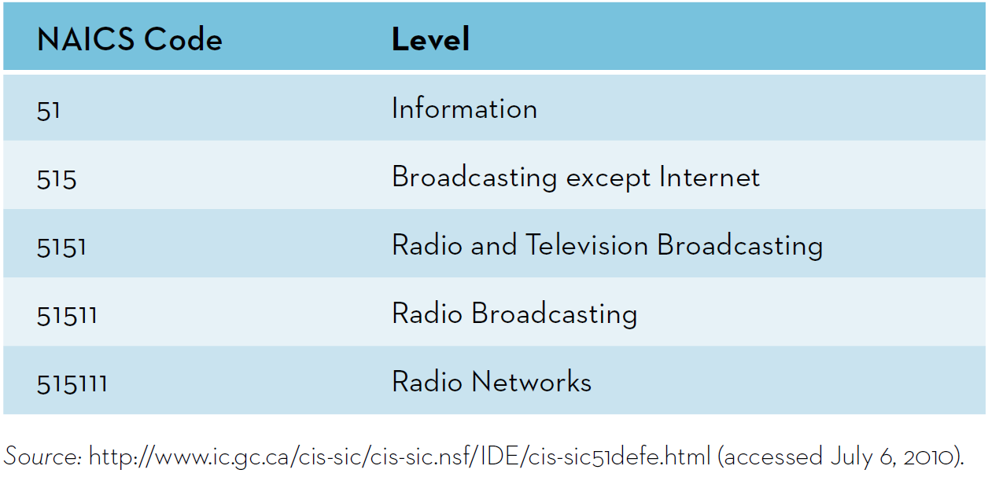

Additional notes:
- Statistics Canada collects data about business activity in Canada through its classification scheme, which categorizes all firms into a hierarchical set of six-digit North American Industry Classification System (NAICS) codes.
- The NAICS was developed jointly by Canada, the United States & Mexico to provide comparable statistics about business activity in all of North America.
- The NAICS codes replaced the Standard Industrial Classification (SIC) system that had been in use since the 1930’s.
- NAICS groups economic activity into 20 sectors & 928 Canadian industries.
- The NAICS six-digit numerical systems works as shown in Exhibit 5.3 in the slide.
- Go to http://www.census.gov/epcd/www/naics.html to visit the NAICS site. Type in a common product (e.g. shoes) and walk students through the classification system.

The B2B Buying Process
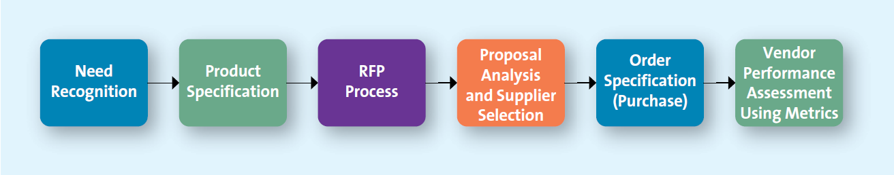

- The B2B buying process (Exhibit 5.4) parallels the B2C process, though it differs in many ways.
- Both start with need recognition, but the information search & alternative evaluation stages are more formal & structured in the B2B process.
- Although B2B and B2C buying processes are similar, this chapter highlights some key differences. This slide can be used on its own to present the B2B buying process or can be expanded on using the slides that follow.

Stage 1: Need Recognition
- Can be generated internally or externally
- Sources for recognizing new needs:
  - Suppliers
  - Salespeople
  - Competitors

Additional notes:
- Just like the consumer buying process, the B2B process begins with need recognition.
- Needs arise from a variety of sources. For example, a salesperson from firm A attends a trade show and visits firm B’s booth, which features a demonstration of a new sorting process. Although firm A had been looking for ways to improve its efficiency, it had not yet considered the possibility of sorting efficiencies.

Stage 2: Product Specification
- Suppliers use to develop proposals
- Can be done collaboratively with suppliers

Additional notes:
- After recognizing the need & considering alternative solutions, the firm will determine a list of potential specifications that vendors might use to develop their proposals.
- Firms & suppliers will often work collaboratively during this process.

Stage 3: Request for Proposal (RFP) Process
- The RFP is a common process through which buying organizations invite alternative suppliers to bid on supplying their required components.
- RFPs enable the buyer to solicit pricing & other information from a variety of suppliers and they also allow suppliers to learn about the buyer and its specific needs.
- Ask Students: In what ways do you feel the RFP process keeps government costs down?
- Answer: Not only do RFPs enable the buyer to solicit pricing and other information from a variety of suppliers, but they also allow suppliers to learn about the buyer and its specific needs.
- The MERX site exists for any firm that wishes to bid on government contracts. Potential suppliers can view the products/services being sought as departments publicly advertise their requirements using the electronic tendering service (refer back to slide 13)

Stage 4: Proposal Analysis & Supplier Selection
- Often several vendors are negotiating against each other
- Considerations other than price play a role in final selection

Additional notes:
- The buying organization, in conjunction with its critical decision makers, evaluates all the proposals it receives in response to its RPF.
- Firms apply different strategies for vendor selection: Some always choose the lowest price, whereas others apply more complicated selection criteria. The government uses preferred contractor programs, designed to offer small and minority-owned firms greater opportunity.

Stage 5: Order Specification (purchase)
- Firm places the order
- The exact details of the purchase are specified
- All terms are detailed including payment

Additional notes:
- In the 5th stage, the firm places its order with its preferred supplier (s).
- After a vendor is chosen, terms of the contract still need to be negotiated. When these terms have been agreed upon, the contract can be signed.

Stage 6: Vendor Performance Assessment Using Metrics
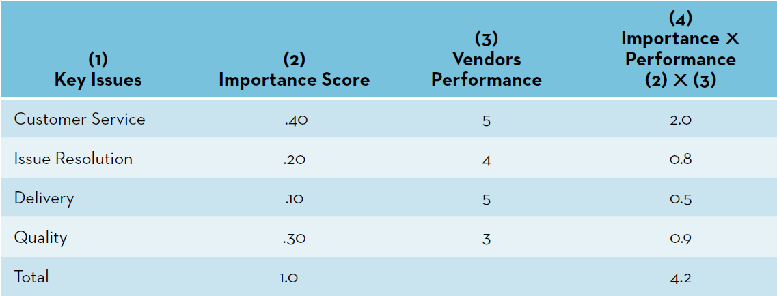
Additional notes:
- Just as in consumer buying process, firms analyze their vendors’ performance so they can make decisions about their future purchases.
- The difference is that, in the B2B setting, this analysis is typically more formal & objective.
- Go to the Toolkits on the OLC. Click vendor analysis. Work through one of the three problems provided. The others could be assigned to students to do.

The Buying Centre

Additional notes:
- The six-stage B2B buying process may be influenced by three factors within the purchasing organization as noted in the slide.
- This slide sets up the slides that follow.

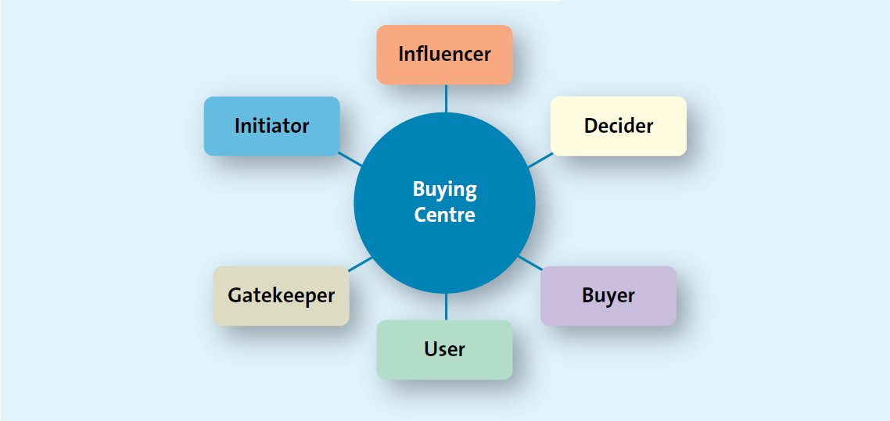

Additional notes:
- The buying centre is the group of people typically responsible for the buying decisions in large organizations.
- Six different buying roles within a typical buying centre can be categorized: initiator, influencer, decider, buyer, user, gatekeeper.
- Group activity: Have the students diagram a purchase situation that involves all of these roles. The book uses the example of a hospital, you and your physician, but many similar examples also exist.

Organizational Culture
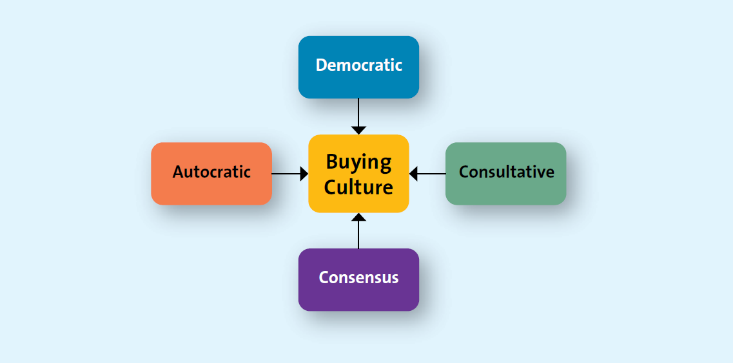

Additional notes:
- A firm’s organizational culture reflects the set of values, traditions & customs that guides its managers’ & employees behaviour.
- Organizational culture can have a profound influence on purchasing decisions.
- Cultures might be divided into 4 general types as noted in the slide.
- Different firms assign different ultimate responsibility for purchase decisions. Even within a firm, different buying groups have unique buying styles. Marketers must understand the dynamics of the buying centre to succeed.
- Ask students: Assume your family or the household in which you live is a buying centre. Is it an autocratic, consultative, or consensus when making group buying decisions such as planning a vacation or shopping for groceries.

Buying Situations
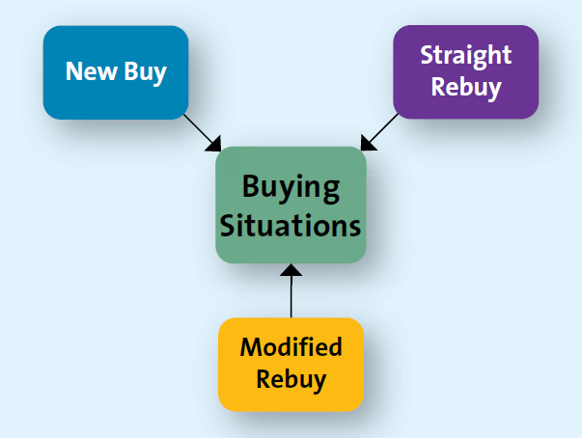

- Purchasing for the first time
- Likely to be quite involved
- The buying centre will probably use all six steps in the buying process
- Buying additional units or products that have been previously purchased
- Most B2B purchases fall into this category
- Purchasing a similar product but changing specifications
- Current vendors have an advantage

Additional notes:
- The type of buying situation also affects the B2B decision process. Most B2B buying situations can be categorized into 3 types: new buys, modified rebuys, & straight rebuys (see exhibit 5.8)
- As in B2C, different B2B buying situations require different levels of effort and the involvement of various parties. The effort required by each situation varies. This slide can be used on its own or the following slides can be used to elaborate on the topic.
- Ask Students: Suppose you represented a private label manufacturer of women’s apparel that was selling to Target. Think about the differences in the three buying situation? Which would be the easiest option for the apparel salesperson to accomplish? Which would be the hardest? Why?

