1. Stock-A stock is a general term used to describe the ownership certificates of any company. Stocks are of two types—common and preferred. The difference is while the holder of the former has voting rights that can be exercised in corporate decisions, the later doesn't.
Bonds-A written and signed promise to pay a certain sum of money on a certain date, or on fulfillment of a specified condition. All documented contracts and loan agreements are bonds.
Similarities:
The main similarity between a stock and a bond is that both are classified as securities. In addition, some forms of bonds are even more like stocks in that they are tradeable securities. This leads to another form of similarity: there is a bond market and a stock market, and combined these both form the Capital Market.
Both the bond and stock market are regulated by the U.S. Securities and Exchange Commission, which is another characteristic that they share.
Difference:
A bond-holder is a lender to a company or government, where a stockholder is a part-owner.
Stocks are indefinite, whereas bonds are held for a set length of time (known as their maturity date).
2. Private saving is the saving of people which is left after paying for consumption expenditure, taxes and receiving transfer payments.
Public saving is the saving of government which occurs due to excess of tax revenue over government spending and transfer payments.
National saving is the sum of private saving and public saving.
An investment is the purchase of goods that are not consumed today but used in the future to create wealth. It increases future wealth of the firm.
3. Live for today means less care for the future and more focus on the current lifestyle which lead to higher consumption in current times and less money for the future period. This would result in lower savings which means less money in the banking system that would mean banks would have low money to lend resulting in lower investments. Lower money supply would result in higher interest rates which will again plunge investments.

4.
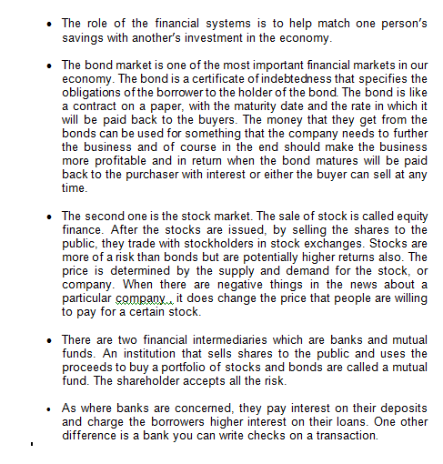

5. Private Saving: is the amount of income that households have left after paying their taxes and paying for their consumption.
Private Saving = Disposable Income – Consumption
Public Saving is the amount of tax revenue that the government has left after paying for its spending
The three variables are related as national saving equal private saving plus public saving.
National Saving = Private Saving + Public Saving
6. Investment refers to the purchase of new capital, such as equipment or buildings or plant and machinery. An investment is made from savings thus it is equal to national saving.
Investment = National Saving
7. Budget deficit: A government budget deficit is a shortfall of tax revenue from the government spending. It arises when the government spends more than it receives as tax revenue.
As a government budget deficit reduces national saving, it raises interest rates, reduces private investment, and thus reduces economic growth.
8. The government accumulate debt through its spending behavior. when the government spends more than its revenues then it accumulates debts. The revenue of government is mainly through taxes which includes, income tax, corporate tax and payroll tax. The government expenditure consists of spending on welfare, defense and healthcare and pensions etc. are the form of government expenditure so when the government expenditure exceeds government revenues then it accumulated its debt.
When the government maintains a budget surplus, then the debt of the government decreases because the budget surplus is used to pay out its debt and hence government debt decreases.
When the government maintains a budget deficit, then the government debt increases.
9.
10. Frictional unemployment:
It is that employment which is always present in economy resulting from temporary transitions made by workers and employers or from workers and employers having inconsistent/incomplete information.
a) An increase in the world price of oil affects every thing badly as prices all across the world increase because dependency of world on oil has increased manifolds overtime. This similarly would bring about a bad effect on firms/industries/corporations as their basic requirement is oil, so they will not induct new people and moreover, would sack off many employees through scrutiny which in turn would bring an increase in frictional unemployment.
b) Yes, it is undesirable. Though it can not be done away with completely but it shows a mirror of economic scenario and can be a standard for further policies' making especially pertaining to employment.
c) Public policies in the given scenario can have effects both ways as per frictional unemployment is concerned .If substitutes of oil viz coal,wood,oil/gas present in own locality are discovered then Frictional unemployment could be lessened.

11.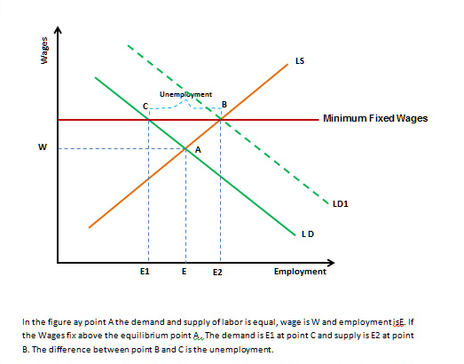
12. Union in the auto industry affects wages and employment at General Motors and Ford in the way that union through its influence makes the authorities bring an increase in the wages of employees. Employment will also increase in this way that the union will ask for a specific quota pertaining to employments. Moreover because of their pressure, the authorities will also give incentives including creating of new jobs for them.
On the other hand, the wages and employments in other industries will also increase as the unions (if exist) there will also follow the same strategy and if unions do not exist, wages and employment will also increase but increment will be less. This increment will be for keeping employees intact.
13. Firms might find it profitable to pay wages above the level that balances quantity of labor supplied and quantity of labor demanded because of following reasons –
a. Payment of wages above equilibrium level helps the firms in preventing their workers from shirking work. This is because payment of wage higher that equilibrium wage increases the cost of job loss for a worker as he may not be able to get the similar paying job if got fired from the present job and thus he concentrate more on work and less on other things which increases his productivity and there by total production at firm.
14. There are mainly three categories in which everyone is divided and these are employed, unemployed, or not in the labor force. The total of employed and unemployed formulates the labor force, The unemployment rate can be seen as the percentage of the labor force which is unemployed.
The percentage of the total adult population which is present in the labor force is termed as labor-force participation rate.
15.
b. When firm pay wages higher than equilibrium wage rate then they are able to attract more skilled and able job-seekers. As firm gets more skilled and able workers, total productivity at firm increases which is a profitable preposition.
c. Firms also pay wages higher than equilibrium wage to minimize turnover. As wages paid by firm is already higher than equilibrium wage, workers working for such firm have less motivation to look for job elsewhere and thus remain committed to said firm. This strategy help the firm in saving money related to training of replacement workers. This is more beneficial in cases where such training is expensive.
d. Some firms also pay wages higher than the equilibrium wage to keep the morale of their employees high. High morale induces the workers to work more efficiently and thus their productivity increases which enables the firm to save cost and thereby increase profit.
16. Frictional unemployment is a temporary unemployment that exists when there is a transition between jobs or a gap that exists during a search for the right job that matches the skills and the tastes of an individual. It is unavoidable because the economy is always changing as some firms are shrinking while others are expanding. Some regions are expanding faster than other regions. Transitions of workers between firms and regions are accompanied by temporary unemployment.
The government by providing information regarding vacancies in different sectors for job seeks can help to reduce the amount of frictional unemployment.
To reduce the frictional unemployment further the government can also provide public training programs that help ease the transition of workers from declining to expanding industries.
17. No.
Minimum wage has very little to do with structural unemployment.
Structural unemployment is that minimum level of unemployment that would happen in an economy at "full employment". There is a constant movement of people in and out of the workforce; people joining or leaving the workforce, and people moving from job to job. That is structural unemployment.
It may very well be that there are some jobs that are not created because of the minimum wage, but they are probably more than covered by the higher aggregate demand that results from a minimum wage. I don't think it is clear if a minimum wage has a significant effect on employment.
The early classical economic models considered a minimum (subsistance) wage. That is the wage so low that below that the working class doesn't have enough money to support themselves or reproduce, and thus the workforce shrinks until supply of labor has gotten low enough to bring wages back up to the subsistence level.
18. Unions affect the natural rate of unemployment by raising the wage above equilibrium level. At this higher wage the quality of labor demanded declines while the quality supplied of labor rises, so there is unemployment.
So unions affect both the insiders as well as outsiders. Insiders are the employees working in the company with the union. Outsiders are the workers who become unemployed, who have 2 choices: they either get a job in a firm is not unionized, or remain unemployed and wat for a job to open up in in the union sector.
As a result, the natural rate of unemployment is higher that it would be without unions
19. The people who advocate unions claim that unions are good for the economy because they can control the market power of larger firms that hire workers and they are also very important in making firms respond efficiently to workers’ concerns.
20. 4 reasons why a firm’s profit might increase when it raises wages above the equilibrium wage rate are:
a. Worker health and productivity: Better paid workers are healthier and more productive. This factor is more determinant in the developing and underdeveloped countries.
b. Worker turnover: Higher wages makes difficult for a worker to get an alternative job which is better paid.
c. Worker quality: Higher wage rate attracts best from the talent pool.
d. Worker effort is increased more.
21. Money is often defined in terms of the three functions or services that it provides. Money serves as a medium of exchange, as a store of value, and as a unit of account.
Medium of exchange. Money's most important function is as a medium of exchange to facilitate transactions. Without money, all transactions would have to be conducted by barter, which involves direct exchange of one good or service for another. The difficulty with a barter system is that in order to obtain a particular good or service from a supplier, one has to possess a good or service of equal value, which the supplier also desires. In other words, in a barter system, exchange can take place only if there is a double coincidence of wants between two transacting parties. The likelihood of a double coincidence of wants, however, is small and makes the exchange of goods and services rather difficult. Money effectively eliminates the double coincidence of wants problem by serving as a medium of exchange that is accepted in all transactions, by all parties, regardless of whether they desire each others' goods and services.
Store of value. In order to be a medium of exchange, money must hold its value over time; that is, it must be a store of value. If money could not be stored for some period of time and still remain valuable in exchange, it would not solve the double coincidence of wants problem and therefore would not be adopted as a medium of exchange. As a store of value, money is not unique; many other stores of value exist, such as land, works of art, and even baseball cards and stamps. Money may not even be the best store of value because it depreciates with inflation. However, money is more liquid than most other stores of value because as a medium of exchange, it is readily accepted everywhere. Furthermore, money is an easily transported store of value that is available in a number of convenient denominations.
Unit of account. Money also functions as a unit of account, providing a common measure of the value of goods and services being exchanged. Knowing the value or price of a good, in terms of money, enables both the supplier and the purchaser of the good to make decisions about how much of the good to supply and how much of the good to purchase.
(Rephrase a little)
22.
23.
24. Money is a set of assets that people regularly use for buying and selling of goods and services.
Money is different from other assets in the economy because it is the most liquid asset available. It can be readily used as a medium of exchange, unit of account and a store value.
While other assets like buildings, lands or shares in a company are valuable and consider as wealth but they cannot easily be used as a medium of exchange.
As the money is readily liquid able it is more prominent than any other asset in the economy. Other assets being less liquid.
25. Commodity money is money that takes form of commodity with an intrinsic value. One of the best examples of commodity money is gold, which is used as a medium of exchange in the olden days. During the World War II cigarettes were also used as a medium of exchange to buy and sell goods thus commodity is money which has some intrinsic value within or the exchange rate depends in its intrinsic value of the commodity.
Fiat money is money which doesn’t have any intrinsic value, but it is accepted as a medium of exchange as it is backed by the government decree thus fiat money (paper money) has no value other than its use as a medium of exchange. At present fiat money is used.
26. Depositors can deposit money in banks, in the form of demand deposits. And they can withdraw or transfer the money in their demand deposits account on demand simply by writing a check.
Demand deposits should be included in the supply of money because they can be used as a medium of exchange.
27. The inflation-control target is set jointly by the Bank of Canada and the federal government and reviewed every five years. However day-to-day conduct of monetary policy is the responsibility of the Bank’s Governing Council.
28. If the Bank of Canada wants to increase the supply of money with open-market operations, it would purchase government bonds from the public in the open market. It is just like creating money from thin air. The purchase increases the number of dollars in the hands of the public, thus raising the money supply of the economy.
29. Banks take deposits at a lower rate and lend them in the form of loans with a higher rate of interest. The difference in the interest makes profit to the bank, if the banks hold 100% reserves than they cannot pay interests to the depositors or salaries to the bank employees. And to store the cash they have to collect charges from the depositor. Thus by not maintaining 100% reserves, banks can lend because it is more profitable to use the reserves to make loans, which earn interest, instead of leaving the money as reserves, which earn no interest.
But banks need to maintain minimum reserve requirement based on the Bank of Canada mandate. The inverse of this reserve requirement is the money multiplier.

Money Multiplier = 1/Reserve Requirement
The lower the reserve requirement the higher will be the excess reserves held by the banks, these excess reserves can be lent and higher will be the money supply due to the money multiplier effect.
31.
32. Reserve requirements are minimum amount of reserves that banks must hold against their deposits. It is fixed by the Bank of Canada. And it uses that as an important tool to control the money supply.
An increase in reserve requirements raises the reserve ratio, which makes the banks to safe keep more proportion of their deposits as minimum requirements. This lowers the money multiplier, and decreases the overall money supply in the economy.
33. Supply refers to the quantity of money in the economy. The supply of money is controlled by the Bank of Canada by using various tools like open-market operations, bank lending, reserve requirements, and interest on reserves. But still then Bank cannot control the supply of money perfectly because the supply of money in the economy is partly influenced by behavior of depositors and bankers – which cannot be predicted easily. (Money)
Of the depositors: The Bank cannot assess the behavior of the depositors. In the banking system can create. Now if the household depositors lose confidence in the banking system, they start withdrawing their deposits and hold more currency, as a result bank loses reserves and creates less money. So the money supply will fall, even without the Bank control. (Behavior)
Of the bankers: The Bank cannot the lending and the lending activity of the bankers. When banks lend the deposited money, more money is created. If for some reason, the banks are little cautious about the economic conditions and decide to make fewer loads and reduce their lending activity, the banking system is said to be creating less money. So the money supply falls because of the banker’s behavior, not because of the Banks control.
36. From the quantity theory of money, an increase in the quantity of money causes a proportional decrease in the real value of money.

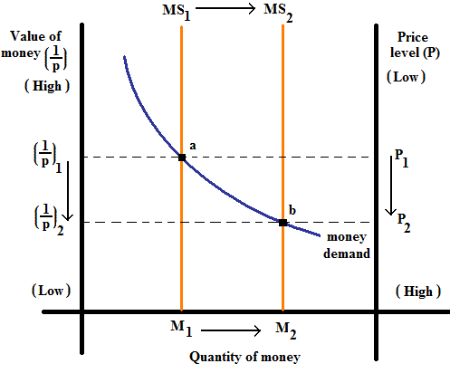

From the graph, we could observe that when the money supply increased from MS₁ and MS₂ the equilibrium shifts and ‘a’ to ‘b’ as the increase in the quantity of money reduces its demand.

Thus the increase in the money supply from MS₁ to MS₂ decreases the value of money from (1/p)₁ to (1/p)₂

37. Quantity theory of money states that the quantity of money available determines the price level in the economy. Suppose, an increase in the quantity of money causes a proportional increase in the price level.

Considering the graph, when the money supply has been increased from MS₁ to MS₂, there is an increase in the price level and a fall in the value of the money as stated in the quality theory of money. This is because the demand and supply of money automatically adjusts to bring them to balance.

Thus, the increase in the quality of money results in the depreciation of the value of money with an increase in the price level resulting in inflation.
38. The Nominal variables are those measured in monetary units, while real variables are measured in physical units. Both the variables are indicating the systematic norms.

Examples of nominal variables include the prices of goods, wages, and nominal Growth Development Product (GDP).

Examples of real variables include relative prices (the price of one good in terms of another), real wages, and real GDP.

According to the principle only nominal variables are affected by changes in the quantity of money. Monetary neutrality will be including the nominal variables.

39. With the deduction of Tax, we lose money along with the purchasing power. In the same way with inflation, the purchasing power of money decrease. In this sense, the inflation is like a tax.

With the government increasing the money supply in the economy increases rapidly effecting in the more loss of purchasing power resulting in hyperinflation. In these circumstances, the government, for its financial funding, uses the inflation tax instead of tax.

40. According to the Fisher effect, the real interest rate corrects the nominal interest rate for the effect of inflation.

Example, the real interest rate tell us the purchasing power of amount we have in a savings account.

Real interest rate = Nominal interest rate – Inflation rate

The nominal rate of interest will be the same amount that the inflation rate increases, which has no effect on the real interest rate. The real interest will be standard.
Examples, the nominal interest rate tells us how fast purchasing power of your savings accpunt rises.

The relationship is given as

Normal interest rate = Real interest rate + Inflation rate

41. The costs of inflation are:
a. The shoe-leather costs – which are incurred due to reduced money holdings,
b. The menu costs – which occur due to the frequent adjustment of prices, increased variability of relative prices.
c. Unintended changes in tax liabilities due to non-indexation of the tax code, confusion and inconvenience resulting from a changing unit of account, and arbitrary redistributions of wealth between debtors and creditors.

In the case of Canada where the inflation is at a low and stable rate, none of these costs are very high.

The most important one is the interaction between inflation and tax code, which may reduce saving and investment even though the inflation rate is low.

42. If the inflation is less than expected, the creditors will be benefit and debtors will lose. This is because; the value of money is likely to depreciate with the effect of the inflation. But, the debtor receives the same amount even after the inflation. This when considered in terms of the value of money is less value when compared to the value before inflation.

Also, the creditors receive the dollar payments from debtors that have a higher real value than was expected. The expected real value will be inflation of prevent section.

43. The net export of a country is the difference between the value of its exports and the value of its imports. It represents the flow of goods and services from one country to the rest of the world.

Net exports = Value of country’s exports – Value of country’s imports

The net capital outflow is the difference between the purchases of foreign assets by the domestic residents and the purchase of domestic assets by foreigners. It represents flow of capital from one country to the rest of the world.

Net capital outflow = Purchase of foreign assets by domestic residents – Purchase of domestic assets by foreigners

For an economy as a whole, net capital outflow (NCO) must always equal net exports (NX) i.e. NCO = NX. Every transaction affects both sides of the equation by the same amount. For example an increase in net capital outflow exactly equals the increase in net exports.

44. Nominal exchange rate ignores price level (inflation) and expresses the price of one currency in terms of another currency. For example, $1 = BDT 65 is a nominal exchange rate that means that, 1 CAN dollar can be exchanged for 65 Bangladeshi Taka.
Real exchange rate considers the level of inflation, and is expressed as:
Real exchange rate = Nominal exchange rate / Price level.
As price level rises (falls), real exchange rate falls (rises) ceteris paribus.
If nominal exchange rate increases from 100 to 120 yen per dollar, it means that now 1 dollar can be purchased in exchange of 120 yens compared to 100 yens earlier. So, value of dollar has gone up, and dollar has appreciated.

45.

46. Same as 43

47. Saving equals domestic saving plus net capital outflow. The domestic investments are mainly treated as saving plans. It is given as

Saving (S) = Domestic Investment (I) + Net capital outflow (NCO)

If any dollar saved can be used to finance accretion of domestic capital or it can be used to finance the purchase of capital abroad. The savings can increase the value of investment.

48. Starting from the Adam Smith a vast literature of explaining the nature & determining the rate of interest was carried out in different situation. Classicals are given much more emphasis to the rate of interest, which is the chief catalyst of capital movement according to them. Basing on the faults & demerits of classical theory of interest, neo-classicals explain lonaable fund theory in which interest rates is determined by the demand for & supply of loanable funds.
The loanable fund theory was developed by K.Wicksell. But in subsquent period, more analytical point is added by his followers. They held the view that the sources of supply of loanable funds are:
1.Dishoarded wealth (H) : This is one of the sources of loanable funds. People may dishoard money from previous stock of hoarded money. So cash balance in previous period may be active balance in the present period. At higher rate of interest people will dishoard more & at low interest rates one will hoard more.
2. Bank Credit or Bank Money (M): It constitutes another source of loanable funds which covers the created credit by different banks.
3. Voluntary Savings (S): It is an important source of loanable funds along with savings. Savings is the most important source of loanable funds, maybe in ex-ante & difference between income & consumption.
The sources of demand for loanable funds arises from three angles like:
1. Investment in different projects, 2. Consumers want to borrow funds for consumption, 3. Holding Ideal cash balances to satisfy the desire for liquidity.
At a higher rate of interest people burrow less because higher loss involved in holding cash balances while at a lower rate of interest, people burrow more money because the loss involved is not so much.
The demand for loanable funds for investment purposes is interest elastic. Also, a lower rate of interest naturally stimulates the demand for the loanable funds for consumption purposes.
The foreign exchange market is the market in which different currencies are bought & sold for one another. For example, Dollars are traded for Marks, Marks for Francs, Francs for Yens or Yens for Dollars.
Thus, the national currencies of all countries are the stock- in - trade of the foreign exchange market.
Structure of Foreign Exchange Markets: The principle participants in the foreign exchange market are banks, foreign exchange dealers, brokers, firms & central banks. There are also authorized money changers who are issued license to transact foreign currencies & encasing travelers’ cheques.
Banks deals with the buying & selling rates of a currency in relation to another currency & are prepared to buy & sell it at those rates.
The broker in the foreign exchange market act as middle man between two banks. They inform banks about rates at which buyer & seller are prepared to buy & sell the specific currency. The brokers strike the deal & collects his commission, but the brokers do not buy or sell currencies themselves.
Firms need foreign exchange for making payments of imports & interest on foreign loans, conversion of exports receipts, hedging of receivables & payables etc. They do not deal with foreign exchanges like banks.
FUNCTIONS: The main functions of foreign exchange markets are: 1. to transfer funds thru one currency of a country to another currency.
2. To provide short term credit to finance trade between two countries thru various credit instruments.
3 To facilitate avoidance of foreign exchange risks or hedging or speculation.
METHODS OF FOREIGN PAYMENTS:
1.Demand Draft
2. Telegraphic transfer
3. Mail transfer
4. Bankers Cheque
5 Bills of exchange
6. Travelers’ Cheque
7 International credit cards like master cards or visa cards
From the point of view of foreign exchange transaction, there are two types of markets.
1. Spot Markets: In this market, the foreign exchange must be made on the spot, usually within two days of the transaction.
2. Forward Market: Here the foreign exchange is bought & sold for delivery at a future date at an agreed rate today. Usually the forward exchange contract rate is for one month, three months, six months, nine months & one year.
The forward exchange rate is linked with the spot rate thru the actions of Hedgers speculators & arbitrageurs.

49.

50. The twin markets – the loanable funds market and the market for foreign-currency exchange form the core of macroeconomics studies.

The market for loanable funds is the macroeconomic market is which savers deposit their savings and borrowers obtain their loans which is used for investment. So the domestic savings constitute the supply of loanable funds while the domestic investment and net capital outflow (NCO). The quality of loanable funds demanded and supplied depends on real interest rate. A higher interest rate borrowing to financial capital projects more costly, discouraging investment and reducing the quantity of loanable funds demanded. A higher interest rate in a country will also lower the net capital outflow. So there is an inverse relationship between rate of interest and quantity demanded of loanable funds; making the demand curve of loanable funds a downward sloping. But there is a direct relationship between rate of interest and quantity supplied of loanable funds; making the supply curve for loanable funds an upward sloping. The intersection of the demand curve for and supply curve of the loanable funds determine the equilibrium interest rate which is shown below in the diagram.

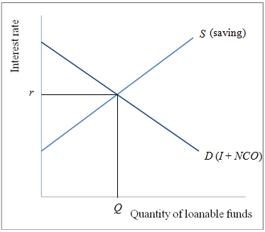

r is the rate of interest which is adjusted to maintain a balance between the demand for loanable funds and supply of loanable funds.

The market for foreign exchange is global currency market in which people or countries trade currencies. Net capital outflow (NCO) represents the quantity of a currency (say dollars) supplied for the purpose of buying assets abroad. Net exports (exports minus imports) represent the quantity of dollars demanded for the purpose of buying country’s net exports of goods and services. The quantity of dollar demanded and supplied is depended on the rate of exchange. A higher exchange rate reduces the demand for dollars because appreciation of the currency makes the goods and service expensive relative for foreign goods; lowering exports and raising imports. A higher exchange rate or a lower one does not influence the supply of dollars for net capital outflow (NCO) is determined not by exchange and quantity demanded for dollars; making the demand curve for dollars a downward sloping. But there is a no relationship between rate of exchange and quantity supplied of dollars; making the supply curve for dollars a vertical straight line. The intersection of the demand curve for and supply curve of the dollars determine the equilibrium exchange rate which is shown below in the diagram.

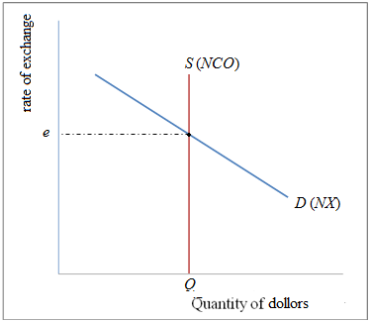

e is the rate of exchange which is adjusted to maintain a balance between the demand for dollars and supply of dollars.

Link between the two markets – market for loanable funds and market for exchange market: It is the net capital outflow that links the 2 markets. NCO is one of the sources of demand for loanable funds but is also a source of supply of foreign currency (dollar). The determinant of NCO is the rate interest. A higher domestic interest rate makes the domestic assets attractive and thus reduces the quantity of NCO; establishing an inverse relationship between rate of interest and NCO; making the NCO curve a downward sloping as shown in the following diagram.

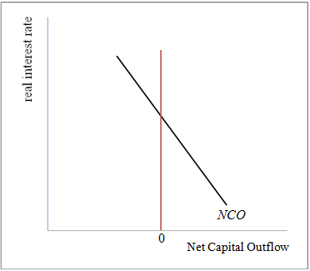
The positive of zero in the diagram indicates that NCO can be positive or negative.
Simultaneous equilibrium in the 2 markets: The link between the 2 markets can be diagrammatically shown as below.

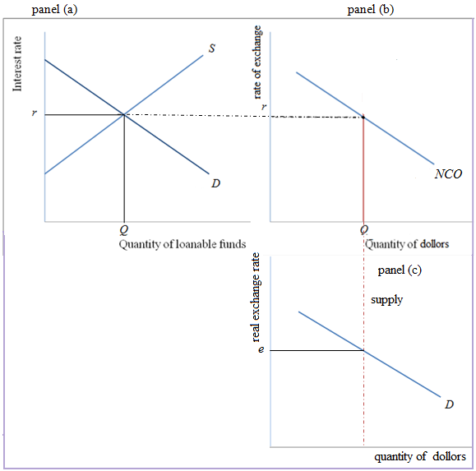

Panel (a) represents the equilibrium condition of the market for loanable funds that determine the real rate of interest. This real interest rate determines the net capital outflow in panel (b) which supplies dollars in the foreign exchange market. This supply of dollars when intersected with the demand for dollars determines the real rate of exchange in panel (c).

51. The impact of fall in investment in the USA on the following:
1) World interest rates:
Since there is a decline in investment demand in the US economy, which implies that there is a lack of demand for money. Hence there will be a decline in the interest rates due to insufficient demand of money. This could be explained using the IS-LM model.

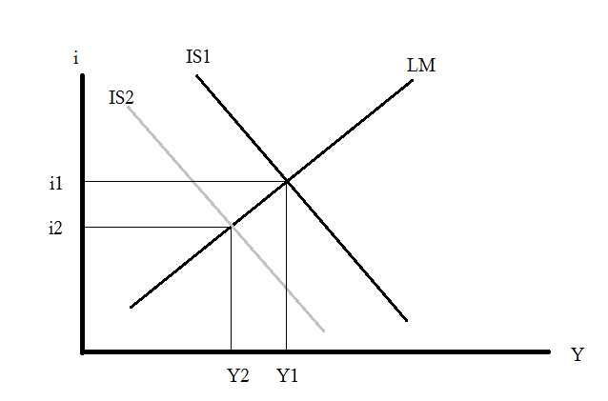
Graph 1

As shown above, when the IS curve (Investment-Savings) shifts towards left, there is a decline in the national income (Y) from Y1 to Y2 & the interest rates also decline from i1 to i2.

2) Canadian savings & investment:
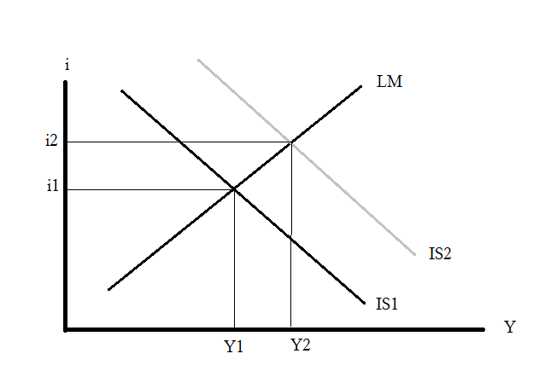
Assuming that Canada has better investment opportunities than the USA, there would be an increase in investments in Canada, which will increase demand for money in Canada & thereby increase the interest rates & savings in Canada. The IS curve will shift towards the right.

Graph 2

However, if we assume that even Canada does not have better investment opportunity, even it will have the same impact as that of the USA. interest rates, savings & investments would decline. The graph would be same as Graph 1.

3) Canadian real exchange rates & net exports:
Assuming, Canada has better investment opportunity, there would be an increase in demand for the Canadian Dollars in forex markets, causing it to appreciate. This would make Canadian exports more costly & imports cheaper, so there would be a decline in net exports.
On the other hand, if we assume the opposite scenario, there won't be demand for the Canadian Dollars due to lack of investment opportunities, causing the currency to decline. This will make Canadian exports more competitive & imports more costly, so this will increase net exports.

52. Capital flight is a large and sudden movement of funds out of a country. Capital flight causes the interest rate to increase and the exchange rate to depreciate. The increased demand for loanable funds causes the equilibrium real interest rate to rise.

53. If a dollar can acquire 100 yen, the actual exchange rate is 100 yen per dollar. The dollar can increase the value of rate.

The real exchange equals the nominal exchange rate times the domestic price divided by the foreign price, which equals to the rate of exchange.

This equals 100 yen per dollar times $10 000 per Canadian car divided by 500 000 yen per Japanese car, which equals two Japanese cars per Canadian car.

54. The economic reason behind the theory of purchasing-power equivalence is that a good must be old for the same price in all location. In other words, a dollar should be able to purchase the same amount of goods in any nation.

The economic reason behind this is to facilitate a nominal exchange rate between the currencies of two nations. Also, the exchange rate would reflect the price levels of those nations.

This implies that the same prices levels. If not people would profit by charming in arbitrage. If the profit can be increase automatically increase the value of cost.

Also, this theory maintains a balance the currencies of the two nations by depreciating the country with highly inflation and appreciating the currency of the country with the low inflation.

55. If the Bank started printing large quantities of Canadian dollars, then the number of Japanese yen a dollar could buy decreases because an expansion of the supply of dollar reduces the value of the dollar in terms of the amount of other currencies it can buy. It would also result in a higher rate of inflation in Canada than in Japan. Hence, the currencies would depreciate relative to the currencies including yen.

56.

