5 general personality traits

OCEAN

-openness
-conscientiousness
-extraversion
-agreeableness
-neuroticism/emotional stability

Openness to experience: curious, original vs. Dull, unimaginative
Important for jobs that involve learning and creativity.
Implies a tendency to seek expanded knowledge, be curious, display imginative thinking, have broad interests

Conscientiousness: dependable, responsible vs. Careless, impulsive

Extraversion: sociable, talkative vs. Withdrawn, shy
Imortant for jobs that require interpersonal interaction, sociability, assertiveness

Agreeableness: tolerant, cooperative vs. Cold, rude
Contributes to performance in jobs that rquire interaction, involve helping and cooperating, entail teamwork

Emotional stability: stable confident vs. depressed, anxious
Person with emotional stability will have more effective interactions with co-workers and customers as they tend to feel more secure.

big 5 is related to work motivation, job satisfaction and life satisfaction

Locus of control
- Set of beliefs about whether one's behaviour is controlled mainly by int. Or ext. Factors

- Internals: opportunity resides within themselves

- Externals: external forces controls their beahviour

Internals:
- are more satisfied with their jobs
- Are more committed to their org
- Earn more money
- Achieve higher org. Positions
- Perceive less stress
- Cope less with stress
- Experiece less burnout
- Engage more careful career planning
- Less likely to be absent from work
- More satisfied with their lives

Self-monitoring

Extent to which people observe and regulate how they appear and behave in social settings and relationships

High self-monitors

- Take care of the image they project
- Concern for socially acceptable behaviour
- Turn into social and interpersonal cues
- Gravitate to jobs that require role-playing and the use of their self-presentation skills
- More involved in their jobs
- Experience more role stress and show less commitment to their org.
- More likely to change employers and locations and to receive promotions
- Not comfortable in ambiguous social settings ( hard to grasp what is socially appropriate)
- Stressful to deal with unfamiliar cultures

Self-esteem

The degree to which a person has a positive self-evaluation

Low self-esteem: tend to be more susceptible to external and social influences: known as behavioural plasticity theory.
Tend to react badly to negative feedback: lowers subsequent performance
Do not react well to ambiguous and stressful situations

High self-esteem: tend to make more fulfilling career decisions, exhibit higher job satisafaction and perfromance and are generally more resilient to the strains of everyday work life.

Org can bloster self-esteem by providing opportunities for: participation, autonomy and interesting work

Learning

Permanent change in behaviour and

- Practical skills:
  - Job-specific skills, knowledge, technical competence
- Intrapersonal skills:
  - Problem solving, critical thinking, alternative work processes, risk taking
- Interpersonal skills:
  - Interactive skills such as communicating, teamwork, conflict resolution
- Cultural awareness:
  - The social norms of organizations, company goals, business operations, expectations, and priorities

Operant learning theory
- Subject learns to operate in the environment to achieve certain consequences
- Behaviour controlled by consequence that follows it
- Used to increase prob. of desired behaviours through reinforcement and reduce risk of undesirable behaviours.

Reinforcement is the process by which stimuli strengthen behaviours
- A reinforcer is a stimulus that follows some behaviour and increases or maintains the prob of that behaviour.
- Reward that has no impact on behaviour is not a reinforce
Positive reinforcers work by their application to a situation
Negative reinforcers work by their removal from a situation: occurs when a response prevents some event or stimulus from occurring, they are defined by what they do and how they work, not by their unplesantness.
Anything you remove from a situation that results in increased perfromance qualifies as negative reinforcer.

Organizational reinforcement errors
- Confusing rewards with reinforcers: no behavioural change means not a reinforcer
- Neglecting diversity in preferences for reinforcers
- Neglecting important sources of reinforcement : only reinforcing via financial incentives
- 2 important sources of reinforcement:
- performance feedback: providing quantitative of qualitative info on past performance for the purpose of changing or maintaining performance in specific ways. Effective when conveyed positively, delivered immediately after observing performance, represented visually, specific to the behaviour that is being targeted for feedback.
- social recognition: involves informal acknowledgement, attention, praise, approval or genuine appreciation for work well done from one individual or group to another. When it is made contigent on employee behaviour it can be an effective means for performance improvement.

Reinforcement strategies
- Continuous and immediate reinforcement are used for fast acquisition of some response
- Partial and delayed are used to create persistent behaviours
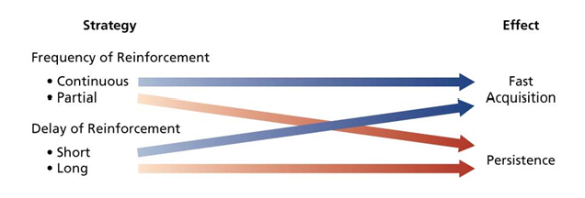

Reducing the probability of behaviour
2 strategies
Extinction: The gradual dissipation of behaviour following the termination of reinforcement: if the behaviour is not reinforced, it will dissipate or be extinguished. Works best when coupled with reinforcement of some desired substitute behaviour.

Punishement: application of an aversive stimulus following unwanted behaviour to decrease the probability of that behaviour.
Problems using punishement: Indicates only what is inapropriate, temporarily suppresses the unwanted behaviour and can provoke a strong emotional reaction from the punished individual.
To use punishement effectively: provide acceptable alternative response for the punished response, limit emotions involved in punishment, make sure the chosen punishement is truly aversive.
Must be used immediately after unwanted behaviour, do not reward unwanted behaviours before or after punishment, do not inadvertently punish desirable behaviour.

Social cognitive theory (SCT)
Puts emphasis on the role of cognitive process in regulating behaviour
People learn by observing the behaviour of others
Regulating behaviour can be done by :
- Thinking about consequences of actions
- Setting performance goals
- Monitoring performance
- Rewarding themselves for goal accomplishement

Human behaviour can best explained through a system of triadic reciprocal causation
- Personal factors and environment factors work together and interact to influence people's behaviour
- Behaviour in turn influences personal factors and the environment
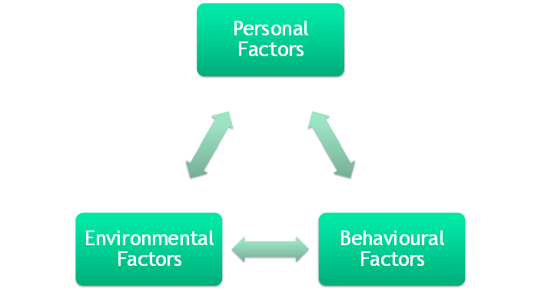

SCT complements operant learning theory in explaining how people learn and organizational behaviour
Observational Learning: Process of observing and imitating the behaviour of others,1. examine behaviour 2. see the consequences 3. thinking about what might happen if we act similarly 4.imitating the behaviour if we expect favourable consequences
Use of self-reinforcement
Attractive, credible, competent, high-status people are most likely to be imitated
Model's behaviour must
- Result in positive consequences
- Be vivid and memorable

Self-efficacy beliefs

Beliefs people have about their ability to perform, cognitive belief that can be changed and modified in response to different sources of info.

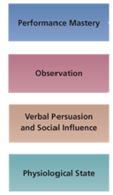

Influences
- Activities people choose to perform
- Effort and persistence devoted to a task
- Affective and stress reactions
- Job performance

Self-regulation
- Use of learning principles to regulate one's own behaviour
- Involves: oberving one's own behaviour, comparing it to standard, rewarding oneself when behaviour meets the standard. Pursuit of self-set goals.
- Collect data
- Observe models
- Set goals
- Rehearse
- Self-reinforcement

Discrepancy reduction: difference between one's goals and performance

Discrepancy production: when individuals attain their goals they are likely to set higher and more challenging ones
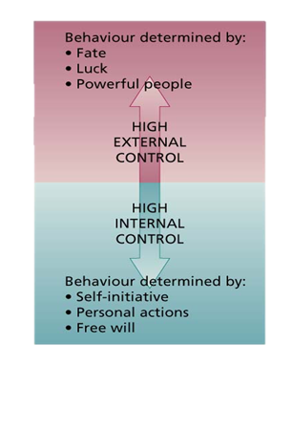

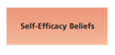

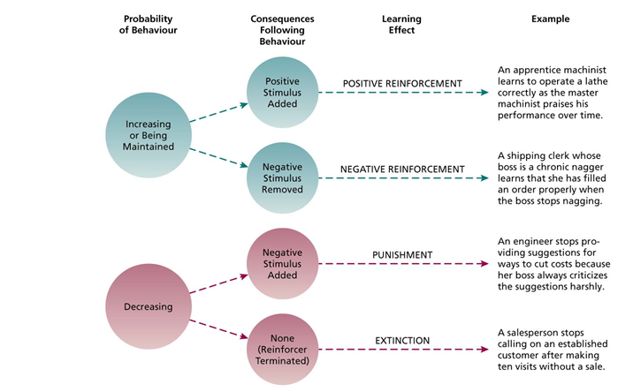

Ch-3

Components of perception
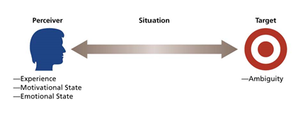
Perceiver

- past experiences lead the perceiver to develop expectations that affect current perceptions
- Needs unconsciously influence perceptions
- Emotions influence perceptions
- Tendency of perceptual system to defend the perceiver against unpleasant emotions
- We perceive things to avoid threatening situations

The target
- Ambiguous targets are especially suscpetible to interperetation and addtion of meaning
- Perceivers have a need to resolve ambiguities but can't use alle info provided by target
- Reduction in ambiguity is not accompanied by better accuracy
The situation
- Perception occurs in some situational context and it can affect what is perceived
- Situation can add info to the target
- Perception of target may change even if perceiver and target remain the same

Bruner's model of perceptual process

The perceiver, when encountering an unfamiliar target, is very open to the informational cues in the target and the situation.
The perceiver will actively seek out cues to resolve ambiguity

- The perceiver will actively seek cues to resolve ambiguity: familiar cues= basic categorization of the target...search for cues becomes less open and more selective
- The perceiver will search for cues that confirm the categorization of the target...categorization will induce to ignore or distort cues that violate initial perception.

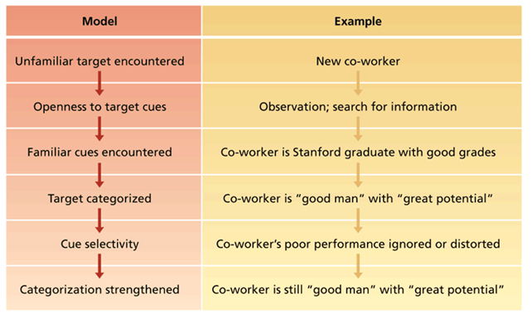
- Perceptual selectivity
Perceiver do not use all available cues, can aid and hinder perceptual accuracy
- Perceptual constancy
Tendency for target to be perceived in the same way over time and across situations
- Perceptual consistency
Tendency to select, ignore and distort cues so that they fit together to form a homogeneous picture of the target

Basic biases to perception

- Primacy and recency effects:

Reliance on early cues pr first impressions, can have a lasting impact, tendency to givre disproportionate weight to recent cues or last impressions

- Reliance on central traits:

Central traits are personal characteristics of a target person that are of particular interest, very powerful influence on our perceptions
Physical appearance is a commonly-used central trait in work settings
Height is viewed as positive vs overweight is considered negative

- Implicit personnality theories

Personal theories about which personality traits go together
E.g.-hardworking people are honest
Some are incorrect

- Projection

Tendency to perceivers to attribute their own thoughts and feelings to others
Form of perceptual defence
Can be effcient and sensible as a perceptual tool
Can lead to perceptual difficulties

- Stereotyping

Tendency to generalize about people in a social category and ignore variatons among them
Specific traits of stereotyping
- Distinguish some category of people
- We assume that the individuals in this category have certain traits
- We perceive that everyone in this category possesses these traits
People can evoke stereotypes with incredibly little info
Stereotypes help us develop impressions of ambiguous targets
Most stereotypes prove to be inaccurate in general, and especially useless when applied to perceptions of individuals
Stereotypes help usprocess info about other quickly and efficiently
It is reinforced by selective perception

Attribution

Process by which we assign causes or motives to explain people's behaviour
- Rewards and punishments in org are based on judgements about what really caused a target person to behave in a certain way
- Important to determine if behaviour is caused by:
- Dispositional attributions: meaning some personality or intellectual characteristic unique to the person is responsible for the behaviour ( intelligence, greed, friendliness or lazinesss)
- Situational attributions: meaning that external situation or environment in which the target person exists was responsible for the behaviour ( bad weather, good luck, proper tools or poor advice)

Attribution cues: we rely on external cues to make inferences
- Does the person engage in th ebehaviour regularly? (consitency cues)
- Do most people engage in the behaviour, or its unique to this person? (consensus cues)
- Does the person engage in the behaviour in many situation, or is it distinctive to one situation? (distinctiveness cues)

High consistency = dispositional attributions
Low consensus = dispositional att.
Low distinctivenesss = dispositional att.

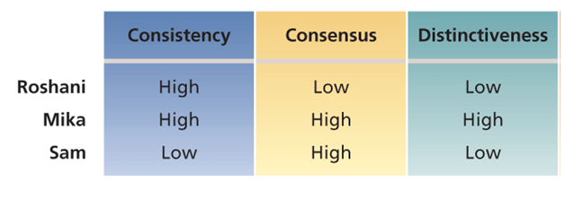

3 biases in attribution

- Fundamental attribution error: tendency to overemphasize dispositional explanations for behaviour at the expense of situational explanations---discount strong effect of social cues and we obeserve people in constrained or constant situation but fail to realize that observed behaviour is distinctive to a particular situation
- Actor-Observer effect: Actor tend to attribute their own behaviour to situational factors, observer are more likely to invoke dispositional causes
- Self-Serving bias: Tendency to take credit for succesful outcomes and to deny responsibility for failures

Workforce diversity

Refers to differences among recruits and employees: gender, race, age, religion, cultural backG, physical ability and sexual orientationworkforce is becoming more diverse but many org have failed to make it a priority.

Valuing diversity can yield strategic and competitive advantage
- Improved problem solving and creativity
- Improved recruiting and marketing
- Improved competitiveness in global markets

Diversity becomes part of corporate strategy

Managing workforce diversity
- Selct enough minority
- Encourage teamwork
- Ensure that managers have accurate info about minorities to avoid stereotyping

Diversity training programs
- Can cause disruption and bad feelings
- Awareness training accompanied by skills training
- Integrate diversity in all practices and policies
- Inclusive culture that values individual differences

Perception of trust
- Most critical factor to judge best workplace in canada
- Psychological state in which one has a willingness to be vulnerable and to take risks with respect to the actions of another party
- Trust perception of management: ability, benevolence and integrity

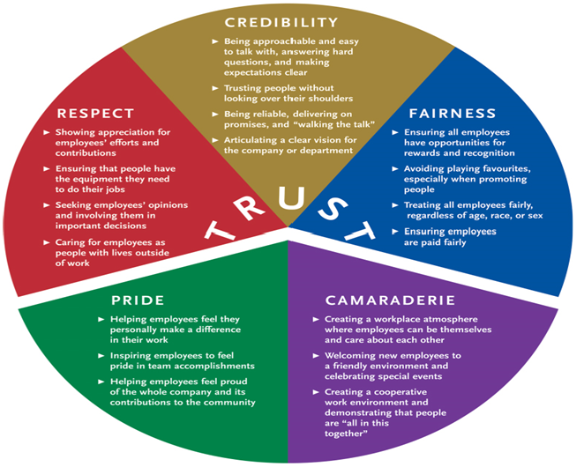

Perceived organizational support (POS)
- General belief that the org values their contributions and cares about their well-being
- When employees have positive POS, they believe their org will provide assistance when they need it

Organizational support theory
- When employees have a good POS, they feel obligated to help the org achieve its objectives
- Greter sense of purpose
- POS can increase job satisafaction , organizational commitment and performance. Also less absenteeism and turnover. Positive mood.
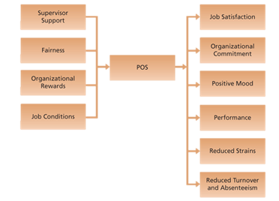

Organizations can provide supportive HR practices to improve POS
- Participation in decision making
- Opportunities for growth and dev
- Fair reward and recognition system
- Equality and diversity programs
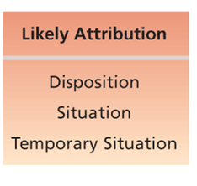

CH-4

Values

How we believe and how we should or should not behave, do not predict behaviour in specific situations
Values are held aorund factors like achievement, power, autonomy, conformity, tradition and social welfare.

Generational differences in values

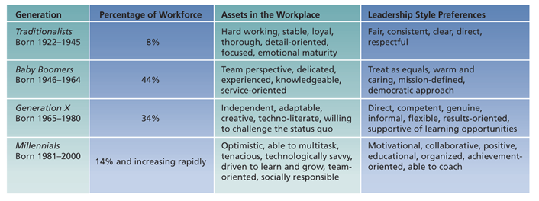

Trad: respect authority and high work ethic
Boomers: otimistic workaholic
Gen X: cynical, confident, pragmatic
Gen Y: confident, social, demand feedback and unfocused

Gen X and Y are more inclined to value money, status and rapid career growth. They see work as less central, value leisure and inclined toward work-life balance

Good person-org fit for values leads to more positive work attitudes and behaviours, reduces chances of turnover

Cross-cultural differences in values

Lack of understanding can cause foreign assignments to terminate early and negociations to fail

Work centrality

Differ from cultures: some have work as a central part of life

Hofstede and bond research

- Power distance: extent to which an unequal distribution of power is accepted by society members ( inequality, accessibility of superiors and display of power differences
- Uncertainty avoidance: extent to which people are uncofortable with uncertain and ambiguous situations) rules and regulations, hard work, conformity, security)
- Masculinity/feminity: differentiate gender role, support dominance of men and stress economic performance-accept fluid gender roles, stress sexual equality, stress quality of life
- Individualism/collectivism: Independence, individual initiative, privacy-interdependence, loyalty to family clan
- Long-term/short-term orientation: Persistence, perseverance,thrift,close atention to status differences-personal steadiness, stability, face-saving, social niceties

Appreciation of cross-cultural differences in values is essential to understanding the needs and tastes of global customers.

Success in translating management practices to other cultures, importing practices and appreciating global customers does not happen by accident.
- Select train an develop employees to have appreciation of diff. In cultural values

Attitudes

Stable evaluative tendency to respond consistently to some specific object, situation, perosn or category of people.
- Invlove evaluations directed toward specific targets: more specific than values
Tendency to respond to the target of the attitude.
Attitude = influence on behaviour( not always consistent)

Belief + Value = attitude which influences our behaviour

Behaviour is most likely to correspond to attitudes when people have direct experience with the target of the attitude and when the attitude is held confidently.

“My job is interfering with my family life.” (Belief)
“I dislike anything that hurts my family.” (Value)
“I dislike my job.” (Attitude)
“I’ll search for another job.” (Behaviour)

Job satisfaction

Collection of attitudes that workers have about their jobs

- Facet satisfaction: most relevant attitudes toward jobs are contained in a rather small group of facets( work conditions, supervision, co-workers, organizational policy)
- Overall satisfaction: summary indicator of a person's attitude toward his or her job that cuts across facets. Average of the attitudes individuals hold toward various facets of the job. ( people, pay, supervision, promotions, work itself)

Job satisafaction is a function of :

- Discrepancy between job outcomes and expected outcomes
- High pay satisfaction if ther is a small gap between amount paid and amount you think you merit

- Fairness
- Distributive fairness: ultimata distribution of work rewards and resources. Comparison with others of inputs invested vs. Outcomes received.
Equity theory
My outcomes = Other’s outcomes
My inputs Other’s inputs

- Procedural fairness: fairness perceived when th eprocess used to determine work outcomes is seen as reasonable, how outcomes are decided and allocated, relvant to outcomes such as performance evaluations, pay raises, promo, layoffs and work assignments
Follows consistent roceduresover time and across people. Use accurate info. Allows 2-way comm in the allocation process. If one believes other procedures should have been used it can create dissatisfaction.
- Interactional fairness: Fairness perceived when people fell that they have received respectful and informative comm about an outcome. Outcomes or procedures can be seen as unfair when inadequatly or uncaringly explained.

- Disposition
- Some people are predisposed by virtue of their personalities to be more or less satisfied despite changes in discrepancy or fairness
- Job satisafaction tends to be fairly stable over time, even qhen change sin employer occur. Can be measured early in adolescence.
- Satisfaction is linked to extraversion, consciousness, neuroticism, self-esteem and locus of control.

- Mood and emotion
- Jobs is a series of events happenings that have a potential to provoke emotions or to influenfe moods, depending on how we appraise these events and happenings
- Emotional contagion
- Emotional regulation: requirement for people to conform to certain display rules in their job behaviour in spite of their true mood or emotions. ( emotional labour).

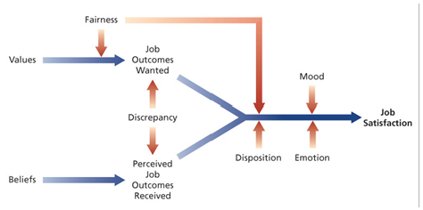

Impact of job satisfaction

- Mentally chllenging work
- Tests employees' skils and abilities and allows them to set their own working pace, provide them with clear performance feedback
- Personally involving but some prefer repetitive, unchallenging work that makes few demands on them
- Adequate compensation
- Pay and satisfaction are positively related
- Some are willing to accept less responsibility or fewer working hours for lower pay
- Career opportunities
- Opportunity for promo is important contributor to job satisfaction
- Cultural and individual differences in what people see as constituting a fair promo system
- People
- Ability of others to help us do our work contribute to job satisfaction when pay is tied to performance and jobs become more complex

Consequences of job satisfaction/dissatisfaction
- Absenteeism: expensive behaviour, link to satisfaction with the content of the work, norm of absence culture might have a stronger effect than an individual employee's job satisfaction
- Turnover: less-satisfied workers are more likely to quit, can be offset by a strong commitment to the overall values and mission of the org. Worker can also be embedded in community or the job market is weak.
- 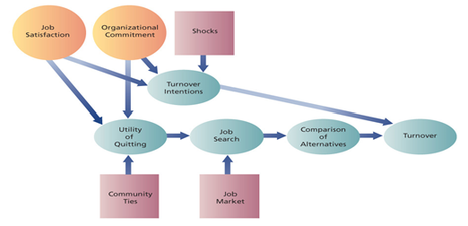

- The honeymoon-hangover effect
- 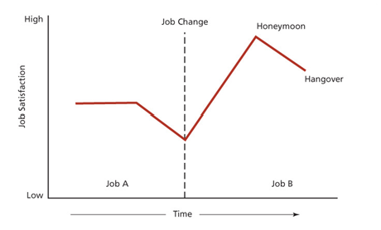
- Performance: link to job satisfaction...relation can be inverted.satisfaction occurs often when performance is rewarded.
- Organizational citizenship behaviour: OCB is voluntary informal behaviour that contributes to organizational effectiveness( helping behaviour, assistance offering, conscientiousness, being a good sport, cooperation) linked to fairness, it contributes to org productivity and efficiency and reduces turnover
- Customer satisfaction and profit:
- Progression and withdrawal: people withdraw their attention or work effort to compensate for dissatisfaction. Reduction in OCB then absenteeism then turnover.
- 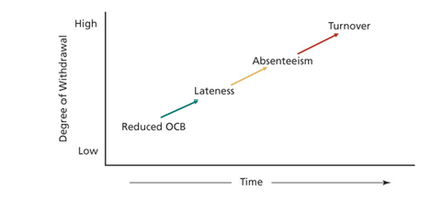

Organizational commitment

Attitude that reflects the strength of the linkage between an employee and an org.

3 types
- Affective commitment: based on a person's identification and involvement in an org. Predictor is interesting, satisfying work of the type found in enriched jobs. Role clarity and expectations met.(want to)
- Continuance commitment: based on the cost incurred if leaving the org. Leaving will result in personal sacrifice( have to)
- Normative commitment: commitment based on ideology or feeling of obligation to an org.( should stay)
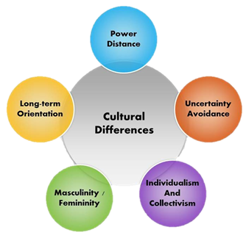

Chapter 5

Motivation - extent to which persistent effort is directed toward a goal

Basic charactreristics
- Effort: strength of the person work's related behaviour, amount of energy( determination) the person exhibits on the job.
- Persistence: Tenacity, diligence and endurance in applying effort for work tasks
- Direction: extent to which workers chanel their efforts to benefit the organization
- Goals: motivated behaviour has some goal or objectives( high productibity, good attendance..) employee goals are sometime contrary to the organization's objectives

Intrinsic motivation
- Motivation that comes from the direct relationship between the worker and the task and is usually self-applied ( achievement, accomplishement, challenge and competence derived from performing the job)

Extrinsic motivation
- Motivation that comes from the work environment and is usually applied by others( pay fringe benfits, policies and supervision)
Some motivators are both intrinsic and extrinsic

Evidence indicates that availlability of extrinsic motivators can reduce the intrinsic motivation stemming from a task

Self-determination theory: theory of motivation that considers whether people's motivation is autonomous or controlled.

Autonomous motivation: occurs when people are self-motivated by intrinsic factors, individuals are engaged in a task because they choose to be.
Facilitates effective performance, especially on complex tasks, also related to other outcomes such as positive attitudes and well-being

Controlled motivation: occurs when people are motivted to obtain a desired consequence or extrinsic reward, individual fell they have no choice and have to engage in a task.

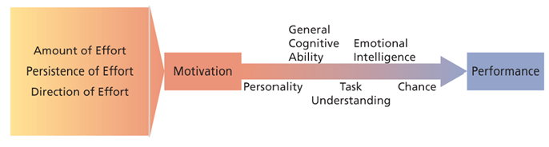

General cognitive activity:
basic info-processing capacities and cognitive resources, overall capacity and efficiency for processing info( e.g. Verbal, numerical, spatial abilities) cognitive ability predicts learning, training and career success and performance.

Emotional intelligence:
Ability to understand and manage one's own and others' feelings and emotions
- Perceive and express emotion: Ability to perceive and to accurately identify one's own emotions and others' emotions.
- Assimilate emotion in thought: ability to assimilate emotional experiences to guide and facilitate one's thinking and reasoning. Using emotions to make decisions
- Understand and reason about emotions: being able to understand emotional info, the determinants and consequences of emotions, and how emotions evolve and change over time. Understanding of how different situations and events generate emotions and its influences on others
- Manage emotions in oneself and others: Ability to manage one's own and others feelings and emotions as well as emotionl relationship. Highest level of EI and requires one to have mastered the previous stages. Ability to regulate adjust and change on's own emotions as wel as others to suit the situation.

Peter salovey and John Mayer
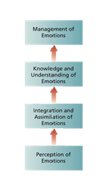

EI research
- EI predicts performance in a number of areas
- EI predicts job performance above and beyond cognitive ability and the big 5 personnality variables.
- Related to job perfromance in jobs that require high levels of emotional labour
- Most important for employees with lower levels of cognitive ability
- Less importance for jobs performance with high levels...

Motivation-performance relationship
- Performance can be low even when individual is highly motivated
- Poor performance causes: personality, general cognitive ability, EI, poor understanding of the task, luck and chance factors. No cognitive ability.
- Motivational interventions will not work if workers lack skills ans abilities

McCelland's theory of needs

- Achievement: strong desire to perform challenging tasks well. Desire for feedback. challenges
- Affiliation: Strong desire to establish and maintain friendly compatible interpersonal relationships. Tendency to communicate. Avoid conflict and competition.
- Power: strong desire to influence others, making a significant impact or impression

- People with high need for achievement:
  - Sales jobs or entrepreneurial positions
- People with high need for affiliation:
  - Social work or customer relations
- People with high need for power:
  - Journalism and management

Most effective managers have:
- Low need for affiliation
- High need for power
- Ability to direct power toward organizational goals
Managerial implications of need theories
- Effective management require 2 key attributes to be motivational for employees
- Appreciation for diversity: Other incentives or goals that correspomd to a diversity of employee needs.
- Appreciation for intrinsic motivation: Be aware of the motivational potential of intrinsic motivators and the existence of higher order needs. Higher-order needs will fail to develop unkess lower-level needs are reasonably well gratified. Basic needs allow job enrichment for stimulation and challenge. Design carrer paths that enable interested workers to progress through a series of jobs that continue to challenge their higher-order needs.

Expectancy theory

Basic components of victor vroom's expectancy theory:

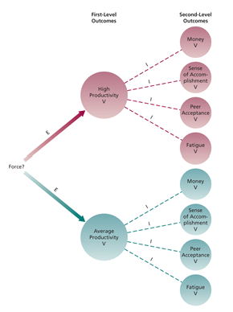

Outcomes: consequences that may follow certain work behaviours
- 1st level outcomes are of particular interest to the organization, expectancy theory is concerned with specifying how an employee might attempt to choose one 1st lvl outcome over another.
- 2nd level outcomes are consequences that follow the attainment of a particular 1st level outcome, they are of particualr interest to the individual worker and involve things such as the amount of pay, sense of accomplishment, accpetance by peers...

Instrumentality( Performance---- outcome link)
- Expected probability that a particular 1st level outcome will be folowed by a particular 2nd level outcome.
High prod = 80% chance of pay increase
Average prod = 30% chance of pay increase

Valence
- Expected value of outcomes: extent to which a given outcome is attractive or unattractive to the individual.
- Sum of products of the associated 2nd level outcomes and their instrumentalities
Valence of particualt 1st level outcome = sum( instrumentalities x 2nd level outcomes)

Expectancy (effort---------performance link)

Expected probability that the worker can achieve 1st level outcome
Ex.
High productivity-----50% certain
Average productivity------100% certain

Force
Represents the relative degree of effeort that will be directed toward various 1st-level outcomes

Force = 1st-level valence x expenctancy

Premises of expenctancy theory
People are motivated to perform in activities they find attractive and that they feel they can accomplish. Attractiveness depends on extent of favourable consequences.

Managerial implications of expectancy theory

Application of the theory means trying to juggle with the expectations attach to expectancies, instrumentalities and valences

- Boost expectancies: Ensure that employees expect to be able to achieve 1st-level outcomes that are of interest to the org. Low expenctancy can be poor tools, lazy co-workers, not understanding what is goor performance. Can be enhanced by training , good equipment, explaining work performance etc.
- Clarify reward contigencies: Clarify the path between 1st and 2nd level outcomes. Employees must know that 1st-level is instrumental fro 2nd level.
- Appreciate diverse needs: Managers should analyze diverse preferences of employees and attempt to individualize motivational packages.

Equity theory

Equity=job satisafaction

Reducing inequity

- Perceptually distort one's own inputs or outcomes
- Perceptually distort inputs and outcomes of comparison group
- Change comparison group
- Alter inputs or outcomes
- Leave exchange relationship

Gender and equity: Workers choose same-sex comparison

Research support for equity theory
Inequity occurs because of underpayment
Tendency to lower inputs or quality of inputs
Overpayment is more tolerated and workers might use perceptual distortion

Goal setting

Object or aim of an action
- Personal performance goals are vague or nonexistent for many organizational members
- Goals are motivational when:
- Specific
- Challenging
- Workers are committed
- Need feedback on progress

Four mechanisms on motivational goals
- Direct attention
- Lead to greater effort
- Increase and prolong persitence
- Lead to discovery and use of task-relevant strategies
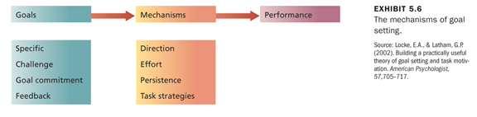

Enhancing goal commitment

- Participation: improve commitment and facilitate performance
- Rewards: pay must match goal achievements
- Supportiveness: managers must demonstrate desire to assist

Research support for gol specific theory
Difficult goal leads to improved performance, same for group goals, when lack of skills goals can induce decrease in performance.

Ch-6

Money as a motivator

Underestimated motivator
- Pay should be highly valent
- Clearly tied to performance

Most important effective motivator
- Financial incentives and pay-for-performance plans increase performance

Job design as a motivator

Refers to the structure, content and configuration of a person's work tasks and roles
- Capitalize on intrinsic motivation
- Goal is to identify characteristics that make tasks more motivating than others

Taylor's principles of scientific management: advocated extreme labour and specialization, careul standardization and regulation of work activities and rest pauses.
NOT intrinsically motivating.
Close supervision and piece-rate pay.
Workers achieved reasonable standard of living and were unlikely to hate their jobs

Job scope and motivation

- Breadth: number of different activities performed on the job
- Depth: degree of dicretion or control worker has over how tasks are performed

High breadth and depth incur high-scope jobs

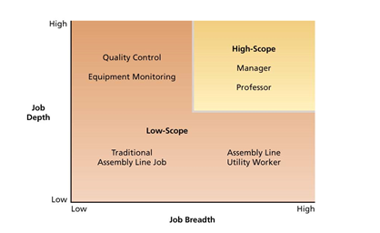

Traditional views= low-scope jobs with heavy specialization
High-scope provides more motivation

Increasing job scope
- Stretch assignments: provide challenging opp. To broaden skills on a variety of tasks.
- Job rotation: employees are rotated to different tasks and jobs, develop new skills and expertise

Job characteristic model

Several core job characteristics that have certain psychological impact on workers. These impacts lead to certain outcomes. Factors called moderators influence the extent of these relationships.

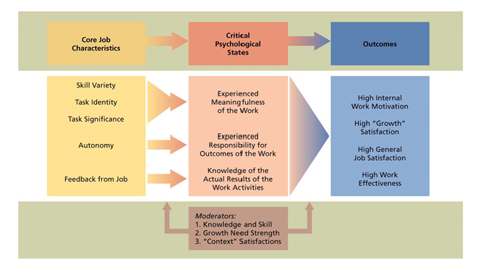
5 core characteristics
- Skill variety: job breadth
- Autonomy: job depth (freedom to schedule one's own activitiesand decide procedures)
- Task significance: impact of the job on other people
- Task identity: extent to which a job involves doing a complete piece of work
- Feedback: info about effectiveness of one's work

Job diagnostic survey (JDS)
Questionnaire to measure core job characteristics
Overall measure of the motivating potential of a job can be calculated.
Skill Task Task
MPS = variety + identity + significance x Autonomy x Feedback
3

Critical psychological states
- Meaningfulness of the work: High skill variety, task significance, task identity
- High autonomy: jobs provide greater personal responsibility for work outcomes
- Knowledge of results: high on performance feedback

Outcomes
- high intrinsic motivation
- High-quality productivity
- Satisfaction with higher-order needs
- General satisfaction with the job
- Reduced absenteeism and turnover

Moderators
- Job-relevant knowledge and skill of the worker
- Growth need strength: desire to achieve higher-orer need satisfaction
- Context factors: low pay may induce a less responsive worker to challenging work

Research evidence
Workers respond more favourably to jobs with higher motivationla potential.
Outcomes are related to all 5 jobs characteristics

Strong response with meaningfulness
Less response with experienced responsibility
No support for role of knowledge of results
Evidence for the roel of growth needs and context satisfaction is weak or contradictory

Job enrichment

Design of jobs to enhance intrinsic motivation, quality of working life and job involvement
Rearrangement of core characteristics.

Job involvement: cognitive state of psychological identification of one's job importance and one's total self-image
Higher involvement=higher satisfaction and OCB

Job enrichment procedures

Many job enrichment schemes include

- Combining tasks: increases the variety of skills employed and might contribute to task identity
- Establishing external client relations: use of new interpersonal skills increase the identity and significance of the job and increase feedback about one's performance
- Establishing internal client relations: ""''
- Reducing supervision or reliance on others: increases autonomy and control one has over theur own work
- Forming work teams: dev of variety of skills, when task is too complex to be completed alone
- Making feedback more direct: worker is identified with their "own" product

Problems with job enrichment procedures
- Poor diagnosis
Problems can occur when it is instituted without careful diagnosis of the needs of the org and the particular jobs in question. Job breadth is increased by giving employees more tasks to perform at the same level while leaving the other cruvial core characteristics unchanged= more boring fragmented routine tasks.
- Lack of desire or skill
Some workers don't want enriched jobs. Some might lack the skills required to performed enriched jobs. Enrichment can entail substantial training costs. Some skills are difficult to change (social skills)
- Demand for rewards
Job enrichment often induces expectations for greater extrinsic rewards.
- Union resistance
Unions often against job enrichment. Companies have dismantle restrictive contract provisions regarding job design. Fewer classifications mean more opp for flexibility by combining tasks ans using team approaches.
- Supervisory resistance
Enrichment can fail due to unanticipated effects on other jobs or parts of org system. Increasing autonomy of employee can make supervisor's job obsolete. Some org have eliminated direct supervision while others have become trainer and developer of individualson enriched jobs.

Management by objectives (MBO)

Elaborate, sytematic, ongoing program designed to facilitate goal establishment, goal accomplishment, and employee dev.

- Objectives for the organization as a whole are developed by top management and diffused down through the organization.

- Organizational objectives are translated into specific behavioural objectives for individuals members.

MBO process

Manager-employee interactions:
- Manager meets with ind. Worker to develop and agree on employee objectives which can include job performance

Alternative working schedules as motivators for a diverse workforce
- Flex-time
- Compressed workweek
- Job and work sharing
- telecommuting
MIDTERM

